**Nationwide Data Initiative: Principles of Approach to Organizational Design and Development**

Andrew Reamer

April 5, 2018

**Introduction**

The Nationwide Data Initiative (NDI) aims to create distributed research networks that integrate administrative data sources in order to analyze and address issues facing state and local governments. This paper’s purpose is to identify—through a literature review—relevant principles of approach to the organizational design and development of the NDI.

Literature on NDI-relevant organizational design and development can be organized into three categories.

* Approaches to organizational problem-solving.
* Approaches to organizational design and development, broadly speaking.
* Approaches to organizational design and development for collaborative networks.

A comprehensive review of this literature (listed in Appendix A) indicates the availability of substantial knowledge, wisdom, and experience to inform NDI design and development. The author sought to identify practical frameworks that collectively would provide NDI developers with a coherent set of principles of approach. The author finds that useful principles for NDI design and development can be found in the following complementary frameworks:

* A practical guide to organizational design and development – the D4 + I Design Framework for Organization Architects offered by John Latham, Organization Design Studio.
* Systems thinking – provided in “The Systems Thinker” publication of Pegasus Communications and articles and books by David Peter Stroh and Daniel Kim.
* A strategy designing a network of interdependent actors – the Shaping Strategies Framework, provided by The Deloitte Center for the Edge in *The Power of Pull: How Small Moves, Smartly Made, Can Set Big Things in Motion* (2010).
* Key elements in network design – provided in Ard-Pieter de Man, *Alliances: An Executive Guide to Designing Successful Strategic Partnerships* (2013) and Michael Leavitt, *Finding Allies, Building Alliances: 8 Elements that Bring--and Keep--People Together* (2013).

Each of these frameworks is described and discussed in the sections that follow. Two examples of distributed research networks that illustrate implementation of the selected principles of approach—the Patient-Centered Clinical Research Network (PCORnet) and the Food and Drug Administration’s Sentinel System—are recognized. No literature evaluating the design of operating collaborative distributed data networks is available, as these networks are new in concept and even newer in practice.

**D4 + I Design Framework for Organization Architects[1]**

John Latham of the Organization Design Studio (Colorado Springs, Colorado) provides a usable framework for NDI organizational design. To Latham, the aim of organizational design is to create sustainable value for the stakeholders. Latham’s approach is grounded in the “design thinking” movement and quotes movement founder Tim Brown of IDEO:

Design thinking can be described as a discipline that uses the designer’s sensibility and methods to match people’s needs with what is technologically feasible and what a viable business strategy can convert into customer value and market opportunity.

Latham indicates that to create sustainable value for stakeholders, an organization requires three sets of core competencies:

* Strategic Leadership – providing policy direction through personal leadership; strategy development and deployment; organizational governance; and ethical, legal, and regulatory guidelines.
* Execution – providing the capacity for excellence in implementation.
* Organizational Learning and Innovation – providing mechanisms and incentives for continuous improvements in strategic leadership and execution.

Latham’s system design process has five phases: Discovery, Design, Develop, Deploy, and Iterate (D4 +I).

The Discovery phase involves organizing eight types of “understanding” that will inform organizational design, as indicated by the eight outer squares in the schematic below. (These are: purpose and requirements, nature of the system, theories and concepts, inspiring examples, unique context, design principles, system integration, and diagnosis).

Based on the understandings obtained in the Discovery phase, the Design phase involves the creation of three organization designs (ideal, doable, detailed).

In the Develop phase, a prototype design is created, tested in a pilot, and refined in light of the results.

The Deploy phase of the design requires a plan, trained staff, adequate resources, and a process to review progress.

The Iterate phase is ongoing and involves “learning loops” to ensure continuous innovation and improvement.



**Systems Thinking[2]**

Systems Thinking is an approach to problem-solving and organizational development suggested by practitioners publishing through “The Systems Thinker” newsletter and website. David Peter Stroh defines Systems Thinking as “the ability to understand and adjust interconnections within a system to achieve a desired purpose.” Observations pertinent to NDI organization design:

* System performance is largely determined by interdependencies among system elements that are indirect, circular, and non-obvious.
* The performance of the whole depends on the relationships among the parts.
* Good organizational design requires identifying and addressing the interdependencies with the largest effect on system-wide performance.

Systems Thinking suggests, then, that in a set of distributed networks such as the NDI, the implementation of Latham’s design process requires particularly attention to the nature of interdependencies.

**Shaping Strategies Framework[3]**

The Deloitte Center for the Edge provides useful observations regarding the nature of interdependencies in an NDI-type ecosystem and the implications for network design. In *The Power of Pull: How Small Moves, Smartly Made, Can Set Big Things in Motion,* the authors offer a process for developing goal-driven networks of independent, interdependent actors through pull-based “shaping strategies”:

In times of rapid change and growing uncertainty, companies . . . can shape the mindsets, economics and knowledge flows among a large number of third-party participants in ways that motivate them to support and amplify the initiatives of the shaping company.

[A] shaping strategy fundamentally alters the structure of a market or industry in ways that transform competitive and market dynamics, as well as industry economics, to favor the position of the shaper… Shaping strategies using positive incentives helps to leverage the efforts of the shaping companies by mobilizing the diverse and specialized resources of a critical mass of third party participants, encouraging distributed innovation and experimentation across this web of participants so that everyone can learn faster, and unleashing powerful network effects so that the value delivered increases exponentially as the number of participants grows.

The NDI ecosystem has a large number of diverse, specialized third party participants (current and potential) facing complexity and rapid change, concerned with risk, in need of guidance and information, and in a multitude of largely independent and ad hoc relationships. Deloitte’s shaping strategies approach offers a useful framework for ascertaining ways that an external “shaper,” the NDI is this case, can successfully catalyze change and participant behaviors that bring into being a robust nationwide, multi-nodal, collaborative data infrastructure.

The four key elements to a shaping strategy are shaping view, shaping platform, shaper acts and assets, and the participants. (See box below.) The key actor is the shaper.

|  |
| --- |
| **Shaping Strategies Framework**  Image result for Shaping strategies framework   1. Shaping View – Communicates a compelling view of the future structure of the market or industry, indicates why this future structure is inevitable and makes explicit how many participants, not just the shaper, can profit from this future state. 2. Shaping Platform -- Provides standards and protocols that significantly reduce the near-term costs of participation by third parties and accelerates and amplifies the rewards that they can generate from their initiatives.    * The most effective shaping platforms foster distinct niches for participants so that they minimize the risk of commoditization through direct competition with all other participants and these platforms also provide the tools and capabilities for participants to experiment or innovate at low risk. 3. Shaper Acts and Assets -- Help to overcome the natural skepticism that potential participants might have in times of high uncertainty. These acts and assets are designed to enhance the credibility of the shaper by demonstrating both the commitment of the shaper and the capability of the shaper to effectively achieve the shaping view and effectively support the shaping platform. 4. Participants – Those members in the shaper’s ecosystem who will rally around the shaper’s view, helping expedite transformative change in their industry.    * Participants are part of a critical feedback loop; the orchestrator must understand their motivations and perspective in order to successfully identify their incentives. This step is necessary in creating positive incentives that will encourage Participants’ involvement in the shaper’s platform and support of the view. |

**Network Design – Key Elements[4]**

Numerous books and articles on the development of alliances and collaborative networks have been recently published. The works of Ard-Pieter de Man and Michael Leavitt are particularly useful for the purposes of NDI organization design and development.

According to de Man, network designers should clearly articulate to participants and clients the value the proposed network will create.

For the network to succeed, Leavitt says that the following key elements are required:

* Focus
  + *A shared problem* that motivates people and groups to work together in ways that could otherwise seem counterintuitive.
  + *A clearly defined purpose:* A driving idea that keeps people on task.
* Structure
  + *A formal charter:* A set of established rules that create stability and help resolve differences and avoid stalemates.
  + *A common information base:* A shared pool of information that keeps everyone in the loop and avoids divisive secrets and opaqueness.
* Leadership
  + *A convener of stature:* A respected and influential presence who can bring people to the table and when necessary keep them there.
  + *Representatives of substance:* A group of collaborative participants who bring the right mix of experience and expertise for legitimacy, along with the authority to make decisions.
  + *Committed leaders:* Individuals who possess the skill, creativity, dedication, and tenacity to move an alliance forward even when it hits the inevitable rough patches.
* Momentum and Belief
  + *The northbound train:* An intuitive confidence that an alliance will get to its destination and achieve something of unique value, and that those who aren't on board will be disadvantaged.

Regarding the specifics of constructing a successful alliance, de Man offers a useful list of formal building blocks:

* Financial Model
  + Sharing of cost, revenues, profits
  + Cash flow projections
  + Property rights
* Legal Structure
  + Legal form of the alliance
* Organization Structure
  + Executive committee, alliance managers, working groups, project teams
  + Staffing
  + Communication structure
  + Team charters
* Decision-making
  + Decision-making method
  + People involved
  + Mandates
  + Conflict resolution/escalation procedures, subsidiarity principle
  + RACI (Responsible/ Accountable/Consulted/Informed) scheme
* Planning and Control
  + Scorecards
  + Planning cycle
  + Reporting cycle
  + Sanctions, liability/indemnity, incentives, audits
  + Risk management
  + Alliance health check
* Competition Clauses
  + Exclusivity
  + Non-compete clauses
  + Confidentiality
  + Change of control
* Exit Agreement
  + Provisions around alliance dissolution
  + Reasons for exiting
  + Term of notice
  + Exit fee

According to de Man, certain norms and values are required for network success:

* Empathy: Seeing things from the partner's perspective
* Flexibility: The attitude that an agreement is a starting point and is to be modified as circumstances change
* Conflict harmonization: Spirit of mutual accommodation; extent to which parties are confrontational or seek consensus
* Solidarity: Belief that success comes from working cooperatively instead of competing against one another
* Mutuality: Attitude that each party's success is a function of everyone's success; one cannot prosper at the expense of one's partner
* Restraint of use of power: Forbearance from taking advantage of one's bargaining position in an exchange
* Spirit of commitment: Staying in the alliance for the longer run; the opposite of opportunism
* Trustworthy behavior: Refrain from consciously damaging a partner
* Proactive: Initiate activities in the alliance rather than wait for the partner to take the first step
* Strategic outlook: Viewing alliances as strategic rather than operational

**Case Examples of Good Organization Design – PCORnet and Sentinel**

Two new distributed research networks (both sponsored by the U.S. Department of Health and Human Services) share many characteristics with, and addressed similar design questions as, NDI and seem to have developed in a manner consistent with the principles of approach laid out above:

* The ***Patient-Centered Clinical Research Network*** (PCORnet) is a large, national distributed research “network of networks” that collects and analyzes data routinely gathered in a variety of healthcare settings to answer practical questions so that patients, clinicians, and other stakeholders can make better healthcare decisions.
* The Food and Drug Administration’s ***Sentinel System*** is an active surveillance system that uses routine querying tools and pre-existing electronic healthcare data from multiple sources to monitor the safety of regulated medical products.

PCORnet and the Sentinel System were conceived by faculty at the Department of Population Medicine, Harvard Medical School and went full-scale in 2014 and 2016, respectively, after multiple years of development. Both are powered by PopMedNet (PMN), an open-source application used to facilitate multi-site health data networks. PMN uses a distributed network design that enables data holders to retain full control of their data. PMN enables investigators to send questions to data holders for review and response, rather than assembling patient records in a centralized repository.

Detailed information regarding PCORnet and the Sentinel System are provided in Appendix B.

**Conclusion**

A review of the literature indicates that principles of approach to the organization design of the NDI can be constructed from several complementary books and articles, including those by John Latham, David Peter Stroh, the Deloitte Center for the Edge, Pieter-Ard de Man, and Michael Leavitt. Implementation of these principles can be seen in the design of PCORnet and the Sentinel System. An in-depth exploration of these two efforts would provide detailed lessons learned for application in the design of the NDI.

**Appendix A: Literature Reviewed**

**Organizational problem-solving frameworks**

**Design Thinking**

Books

* Tim Brown, *Change by Design: How Design Thinking Transforms Organizations and Inspires Innovation*, HarperCollins, 2009.
* Jeanne Liedtka and Tim Ogilvie, *Designing for Growth: a design thinking tool kit for managers*, Columbia Business School Publishing, 2011.
* Jeanne Liedtka, Andrew King, and Kevin Bennett, *Solving Problems with Design Thinking: 10 Stories of What Works*, Columbia Business School Publishing, 2013.
* Jeanne Liedtka, Tim Ogilvie, and Rachel Brozenske, *The Designing for Growth Field Book: a step-by-step project guide*, Columbia Business School Publishing, 2014.
* IDEO, *The Field Guide to Human-Centered Design*, 2015.
* Jeanne Liedtka, Randy Salzman, and Daisy Azer, *Design Thinking for the Greater Good: Innovation in the Social Sector*, Columbia Business School Publishing, 2017.

**Integrative Thinking**

Books

* Jennifer Riel and Roger L. Martin, *Creating Great Choices: A Leader’s Guide to Integrative Thinking*, Harvard Business Review Press, 2017.

**Systems Thinking**

Books

* David Peter Stroh, *Systems Thinking for Social Change: A Practical Guide to Solving Complex Problems, Avoiding Unintended Consequences, and Achieving Lasting Results*, Chelsea Green Publishing, 2015.

Articles

* Daniel H. Kim, “Introduction to Systems Thinking,” Pegasus Communications, 1999.
* Daniel H. Kim, “Systems Thinking Tools: A User’s Reference Guide,” Pegasus Communications, 2000.
* Cristina Mele, Jacqueline Pels, Francesco Polese, “A Brief Review of Systems Theories and Their Managerial Applications,” *Service Science*, 2(1-2): 126-135, 2010.
* John Pourdehnad, Erica R. Wexler, and Dennis V. Wilson, “Integrating Systems Thinking and Design Thinking,” *The Systems Thinker*, Vol. 22, No. 9, November 2011.
* David Peter Stroh and Kathleen Zurcher, “Acting and Thinking Systematically,” *The Systems Thinker*, Vol. 23, No. 6, August 2012.

**Organizational Design**

**General**

Books

* Amy Kates and Jay R. Galbraith, *Designing Your Organization: Using the Star Model to Solve 5 Critical Design Challenges*, Jossey-Bass, 2007.
* Gregory Kesler and Amy Kates, *Leading Organization Design: How to Make Organization Design Decisions to Drive the Results You Want*, Jossey-Bass, 2011.
* Jay R. Galbraith, *Designing Organizations: Strategy, Structure, and Process at the Business Unit and Enterprise Levels*, Third Edition, Jossey-Bass, 2014.
* Richard M. Burton, Borge Obel, and Dorthe Dojbak Hakonsson, *Organizational Design: A step-by-step approach*, Cambridge University Press, 2015.
* John Latham, *[Re]create the Organization You Really Want!: Leadership and Organization Design for Sustainable Excellence*, Organization Design Studio, 2016.

Chapters

* Charles Kiefer and Peter Stroh, “A New Paradigm for Developing Organizations,” in John D. Adams, *Transforming Work*, Miles River Press, 1998.

Guides

* John Latham, “Design Framework for Organization Architects,” Organization Design Studio, 2015.

Articles

* John Pourdehnad and Gnana K. Bharathy, “Systems Thinking and Its Implications for Organizational Transformation,” Proceedings for the 3rd International Conference on Systems Thinking in Management, Philadelphia, Pennsylvania, May 2004.
* John R. Latham, “Management System Design for Sustainable Excellence: Framework, Practices and Considerations,” *Quality Management Journal, 19*(2), pp. 7-21, 2012.
* McKinsey, “The McKinsey 7-S Framework: Ensuring That All Parts of Your Organization Work in Harmony,” from Mindtools [website](https://www.mindtools.com/pages/article/newSTR_91.htm).
* Deloitte, “Unlocking the flexible organization: Organizational design for an uncertain future,” 2016.

**Network Design**

Books

* Nick Goodwin et al., *Managing Across Diverse Networks of Care: Lessons from Other Sectors*, report to the National Co-ordinating Centre for NHS Service Delivery and Organisation R&D (NCCSDO), January 2004.
* John Hagell III, John Seely Brown, and Lang Davison, *The Power of Pull: How Small Moves, Smartly Made, Can Set Big Things in Motion*, Basic Books, 2010.
* Robert L. Cross, Jean Singer, Sally Colella, Robert J. Thomas, and Yaarit Silverstone, *The Organizational Network Fieldbook: Best Practices, Techniques and Exercises to Drive Organizational Innovation and Performance*, Jossey-Bass, 2010.
* Christopher Koliba, Jack W. Meek, Asim Zia, and Russell Mills, *Governance Networks in Public Administration and Public Policy*, Routledge, 2010.
* Anne-Marie Slaughter, *The Chessboard and the Web: Strategies of Connection in a Newtorked World*, Yale University Press, 2017.

Articles

* Dave Brock, “Creating Effective Strategic Partnerships,” Partners in EXCELLENCE, Mission Viejo, CA, 1999.

**Design of Alliances and Partnerships**

Books

* James D. Bamford, Benjamin Gomes-Casseres, and Michael S. Robinson, *Mastering Alliance Strategy: A Comprehensive Guide to Design, Management, and Organization*, Jossey-Bass, 2002.
* Michael Leavitt, *Finding Allies, Building Alliances: 8 Elements that Bring--and Keep--People Together*, Jossey-Bass, 2013.
* Ard-Pieter de Man, *Alliances: An Executive Guide to Designing Successful Strategic Partnerships*, Wiley, 2013.
* Martin Echavarria, *Enabling Collaboration: Achieving Success Through Strategic Alliances and Partnerships*, Lid Publishing, 2015.
* Ezra Schneier, *Structured Strategic Partnership Handbook*, 2016.

**Distributed Research Networks – Case Examples**

**National Patient-Centered Clinical Research Network** (PCORnet)

Articles

* Judith C. Maro, Richard Platt, John H. Holmes, Brian L. Strom, Sean Hennessy, Ross Lazarus, and Jeffrey S. Brown, “Design of a National Distributed Health Data Network,” *Annals of Internal Medicine*, September 1, 2009, 341-345.
* Jeffrey S. Brown, John H. Holmes, Kiran Shah, Ken Hall, Ross Lazarus, and Richard Platt, “Distributed Health Data Networks: A Practical and Preferred Approach to Multi-Institutional Evaluations of Comparative Effectiveness, Safety, and Quality of Care,” *Medical Care*, Volume 48, Number 6, Supplement 1, June 2010, S45-S51.
* Francis S Collins, Kathy L Hudson, Josephine P Briggs, and Michael S Lauer, “PCORnet: turning a dream into reality,” *Journal of the American Medical Informatics Association*, July 2014; 21(4):576-577.
* Rachael L Fleurence, Lesley H Curtis, Robert M Califf, Richard Platt, Joe V Selby, Jeffrey S Brown, “Launching PCORnet, a national patient-centered clinical research network,” *Journal of the American Medical Informatics Association*, July 2014; 21(4):578-582.
* A substantial number of additional articles on individual PCORnet networks and data governance are available in the Journal of the American Medical Informatics Association, July 2014; 21(4).
* Ritu Khare, Levon Utidjian, Byron J Ruth, Michael G Kahn, Evanette Burrows, Keith Marsolo, Nandan Patibandla, Hanieh Razzaghi, Ryan Colvin, Daksha Ranade, Melody Kitzmiller, Daniel Eckrich, and L Charles Baile, “A longitudinal analysis of data quality in a large pediatric data research network,” *Journal of the American Medical Informatics Association*, 24(6), 2017, 1072–1079.

**Sentinel System**

Articles

* Richard Platt, Marcus Wilson, K. Arnold Chan, Joshua S. Benner, Janet Marchibroda, , and Mark McClellan, “The New Sentinel Network — Improving the Evidence of Medical-Product Safety,” *The New England Journal of Medicine*, August 13, 2009.
* Rachel E. Behrman, Joshua S. Benner, Jeffrey S. Brown, Mark McClellan, Janet Woodcock, and Richard Platt, “Developing the Sentinel System — A National Resource for Evidence Development,” *The New England Journal of Medicine*, February 10, 2011.
* Richard Platt and Ryan Carnahan, editors, “The U.S. Food and Drug Administration’s Mini-Sentinel Program,” *Pharmacoepidemiology & Drug Safety*, Volume 21, Supplement 1, January 2012.
* “The FDA’s Sentinel Initiative,” *Health Policy Brief*, Robert Wood Johnson Foundation, June 4, 2015.
* R Ball, M Robb, SA Anderson, and G Dal Pan, “The FDA’s Sentinel Initiative—A Comprehensive Approach to Medical Product Surveillance,” *Clinical Pharmacology & Therapeutics*, Volume 99, Number 3, March 2016.

Presentations

* Ninth Annual Sentinel Initiative Public Workshop, Washington, DC, February 2, 2017.

**Appendix B: Distributed Research Networks – Case Examples**

**National Patient-Centered Clinical Research Network** (PCORnet)

**Introduction**

PCORnet is comprised of 35 [Partner Networks](http://pcornet.org/participating-networks/)--including 13 Clinical Data Research Networks, 20 People-Powered Research Networks, and 2 Health Plan Research Networks--and a [Coordinating Center](http://pcornet.org/about-pcornet/pcornet-coordinating-center/), led by the Duke Clinical Research Institute, Genetic Alliance, and Harvard Pilgrim Health Care Institute that provides technical and logistical support to the Partner Networks.

* Clinical Data Research Networks (CDRNs) – System-based networks that originate in healthcare systems, such as hospitals, health centers, or practice-based networks, and securely collect health information during the routine course of patient care.
* Patient-Powered Research Networks (PPRNs) – Networks operated and governed by groups of patients and their partners, including caregivers, clinicians, researchers, and others. They are focused on a particular condition or population, and their members are interested in sharing health information and participating in research.
* Health Plan Research Networks (HPRNs) – Cover significant numbers of patients in one or more of PCORnet’s CDRNs, as well as PPRNs, and engage in data linkage governance and activities toward successful linkages of claims data with data from Electronic Health Records (EHRs).

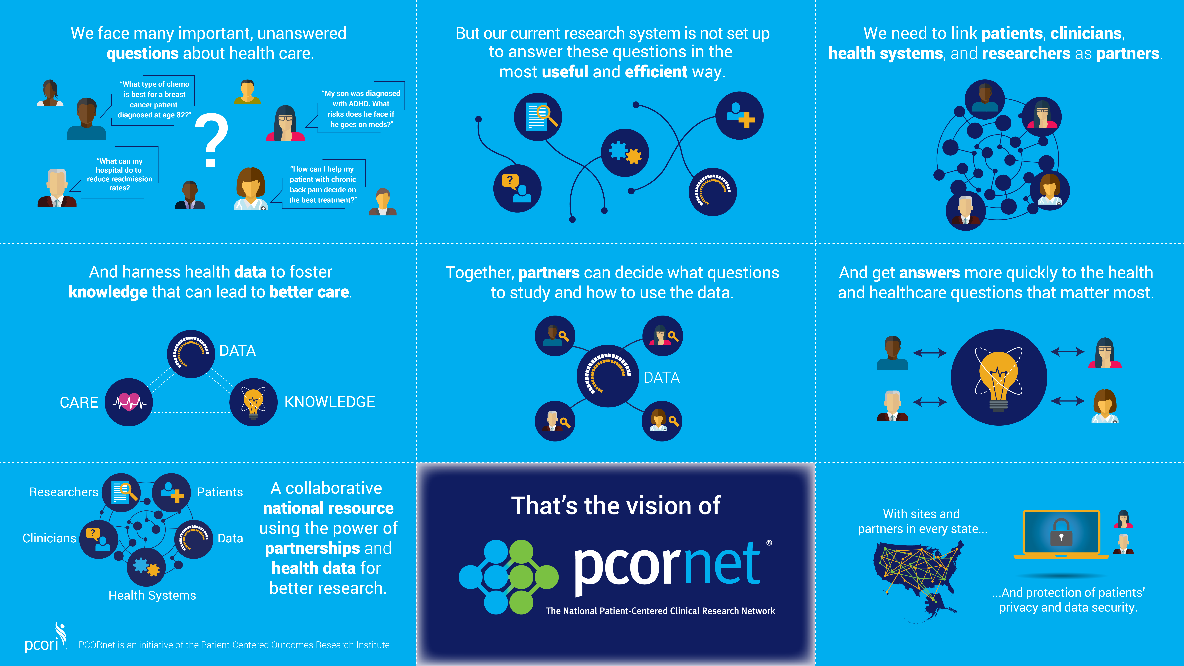

**PCORnet as Distributed Research Network**

In a distributed research network (DRN), each Partner Network securely collects and stores data in a standardized way within their own institutions. When a researcher or user (called a Requestor) submits a research question through an online access point called the “[Front Door](http://pcornet.org/frontdoor/),” that question is reviewed by the Coordinating Center. The Coordinating Center then taps the data of the individual Partner Networks through a specialized query format. A response to the original question is generated and sent back to the researcher. Through this structure, PCORnet allows researchers to ask the same question of millions of people across the country all at the same time.

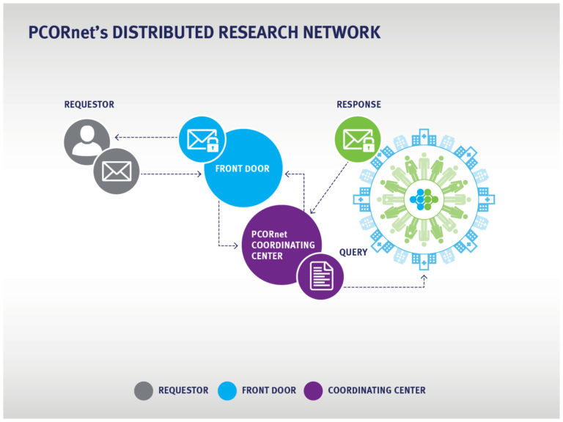



**Governance Structure**

PCORnet relies on a series of committees to oversee decision-making and leadership, stakeholder engagement, PCORnet’s data network, and research partnerships.

* The PCORnet Council serves as a representative advisory body for PCORnet. It operates under principles of shared responsibility, respect, trust, and inclusivity, and strives to foster a shared commitment to realizing the PCORnet vision. The Council also plays an important role in exploring uses of the network by all funders of research.
* Executive Committee
* The Data Committee oversees PCORnet’s data network, advancing informatics and research data innovations that support PCORnet’s goals.
* The Engagement Committee oversees the design and continuous improvement of PCORnet’s system for engaging stakeholders, including patients, clinicians, research, health system leaders, industry representatives, regulators and others, in reviewing and recommending engagement policies and standard operating procedures.
* The Research Committee oversees the design and continuous improvement of PCORRnet’s research activities, which include generating and prioritizing research concepts, ensuring research quality, and developing research partnerships.
* The Nominating Committee convenes before the PCORnet Council schedules annual leadership elections and on an as-needed basis when vacancies occur and nominations are required for candidates for open leadership positions.
* The Advisory Group was established to build relationships between research funders and PCORnet and to ensure coordination with federal and private sector health data and research initiatives that affect PCORnet.

PCORnet’s [governance structure](http://pcornet.org/about-pcornet/pcornet-governance/) provides oversight to ensure that the Network’s resources are used efficiently and appropriately. There is a multi-stakeholder [Executive Committee](http://pcornet.org/about-pcornet/pcornet-committees-members/) that oversees the operations of the PCORnet, as well as Data, Research, and Engagement Committees that address cross-network issues such as research ethics, privacy, patient involvement, and clinical trial designs and methods.

**Coordinating Center**

The PCORnet Coordinating Center (CC) leads the Network’s data and engagement activities, connects with outside research partners, and supports the PCORnet infrastructure. Responsibilities of the Coordinating Center include:

* Coordinating PCORnet’s operational activities.
* Designing, enhancing, and maintaining the PCORnet data infrastructure.
* Identifying research opportunities and implementing PCORnet-wide research.
* Supporting PCORnet pre-research, observational studies, and interventional multi-site research studies.
* Developing new products and services, and implementing engagement and network-building services.
* Communicating with CDRN and PPRN [Partner Networks](http://pcornet.org/participating-networks/) on an individual and group basis to generate collaboration, co-production, and efficiency.

The Coordinating Center is a partnership between PCORI and several organizations with expertise developing infrastructure to support the creation of a National Evidence Development System. These partners have collaborated to create and manage large, complex research networks leveraging rich community engagement as well as electronic health data to support interventional, observational, patient-powered, and health services research.  Participating Coordinating Center organizations are:

* [Duke Clinical Research Institute](https://www.dcri.org/)
* [Genetic Alliance](http://www.geneticalliance.org/)
* [Harvard Pilgrim Health Care Institute](https://www.harvardpilgrim.org/portal/page?_pageid=213,376248&_dad=portal&_schema=PORTAL)

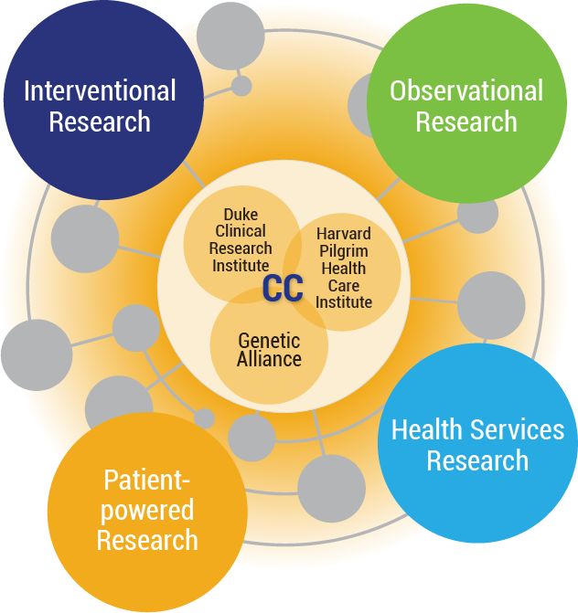

Adrian Hernandez, MD, MHS, Richard Platt, MD, MSc, and Sharon Terry, MA are all co-Principal Investigators of the PCORnet Coordinating Center. In addition to their work for the PCORnet Coordinating Center, [Adrian Hernandez](http://www.pcornet.org/about-pcornet/how-pcornet-is-organized/pcornet-executive-committee/#Hernandez) is an Associate Professor of Medicine, Cardiology with Duke University School of Medicine and Director of Health Services and Outcomes Research for Duke Clinical Research Institute; [Richard Platt](http://www.pcornet.org/about-pcornet/how-pcornet-is-organized/pcornet-executive-committee/#Platt) is a Professor and Chair of the Harvard Medical School, Department of Population Medicine and Executive Director of Harvard Pilgrim Health Care Institute; and [Sharon Terry](http://www.pcornet.org/about-pcornet/how-pcornet-is-organized/pcornet-executive-committee/#Terry), is the President and CEO of Genetic Alliance, Principal Investigator for Community-Engaged Network for All (CENA), parent, and citizen scientist.

**DRN Operations Center**

The Coordinating Center oversees the PCORnet Distributed Research Network Operations Center (DRN OC), which is led by Drs. [Lesley Curtis](http://www.pcornet.org/about-pcornet/how-pcornet-is-organized/pcornet-data-committee/#Curtis), [Keith Marsolo](http://www.pcornet.org/about-pcornet/how-pcornet-is-organized/pcornet-data-committee/#Marsolo), and [Jeffrey Brown](http://www.populationmedicine.org/node/209). The main goal of the DRN OC is to operate, enhance, and maintain the PCORnet Distributed Research Network, which oversees data transformation to the [Common Data Model](http://www.pcornet.org/pcornet-common-data-model/), data quality assessment and remediation, query fulfillment, data science, and facilitation of multi-site patient centered research across the CDRNs, PPRNs, and other interested contributors.

The distributed research network enables the conduct of observational research and clinical trials while allowing each participating organization to maintain physical and operational control over its data.

**Program Management Office**

The PCORnet Program Management Office (PMO) sits at Duke Clinical Research Institute within the PCORnet Coordinating Center. The PMO, led by Lauren Cohen of Duke Clinical Research Institute, provides central coordination, oversees all PCORnet operational activities, and oversees implementation of PCORnet research. Among the activities supported by the PMO are:

* Coordination of all internal and external communication platforms.
* PCORnet leadership support, including PCORnet committee support and coordination.
* PCORnet infrastructure support, including efforts related to single IRB and quality improvement reporting.
* Proposal and project support.
* Meeting planning and logistics.
* Technical assistance for the partner networks, including cross-network support of learning.

**Front Door**

The PCORnet Coordinating Center is home to the [Front Door](http://pcornet.org/frontdoor/) which is the main access point for potential investigators, patient groups, health systems, and funders to reach the PCORnet infrastructure. The Front Door, led by Dr. Adrian Hernandez, provides a systematic, transparent, and efficient approach for research partners to engage in opportunities and data assets within the Network. It works in collaboration with the DRN OC and the PCORnet Research Committee to facilitate an efficient review process of all requests.

The Front Door is currently accepting requests for Study Feasibility Review, Data Network Queries, Network Collaborators, and PCORnet Study Designation.

**PCORnet Commons**

The [PCORnet Commons](http://pcornetcommons.org/) is a public website fostering connection, communication, engagement and learning among people involved in clinical research. The site was created collaboratively with insight and feedback from across the PCORnet community and provides opportunities to increase collaboration, efficiency, and people-centeredness in clinical research. On the PCORnet Commons, you can share and access resources, engage in dialogue, and connect with colleagues and friends.

**Policies**

In order to function effectively and promote network progress, the following policies have been developed to align activities, duties, and responsibilities:

* [Governance Policies for PCORnet, the National Patient-Centered Clinical Research Network](http://www.pcornet.org/wp-content/uploads/2017/01/PCORnet-Governance-Policy-v4-approved-11.14.16.pdf)
* [PCORnet Policy for Affiliate Network Status](http://www.pcornet.org/wp-content/uploads/2016/02/Affiliate-Network-Status-in-PCORnet-Policy-copyedited.pdf)
* [PCORnet Front Door Policy](http://www.pcornet.org/wp-content/uploads/2016/05/PCORnet-Front-Door-Policy_Final_4.15.16.pdf)

Historical Foundation of PCORnet Governance: During its Phase I development stage, PCORnet’s decision-making and policy-making activities were overseen by a governance structure that included PCORI senior leadership and representatives of PCORnet’s various stakeholder communities. That initial structure consisted of a Steering Committee, Executive Committee, and Patient Council. These groups quickly began working to refine the governance structure based on stakeholder feedback and an assessment of the various operational challenges and opportunities that the initiative presented.

The result was a draft document developed by the Executive Committee, Patient Council, a Governance Task Force, individual principal investigators (PIs) from the CDRNs and PPRNs, and individual members of the Steering Committee. The draft was reviewed by the Steering Committee, Patient Council, and PCORI. A working group made up of a senior PCORI representative, a CDRN PI and a PPRN PI then integrated feedback. The Executive Committee and then full Steering Committee approved the document in August 2015.

The resulting Governance Policies created a series of new PCORnet Committees overseeing decision-making and leadership, patient engagement, PCORnet’s data network, participation in PCORnet, and requirements for what constitutes research that may be designated as a “PCORnet Study.” The policies also created a new set of oversight bodies, replacing the previously established Steering Committee, Patient Council, and Task Forces, and reconstituted the Executive Committee.

Certain elements of these policies, and related processes and procedures, remain under development. The overall policies themselves can be amended on an ongoing basis to meet the developing needs of the initiative, with the PCORnet Council, formerly the Steering Committee, undertaking a formal review of all PCORnet policies at least annually.

**Patient Data Security**

PCORnet’s Distributed Research Network uses four layered techniques that maximize the security of personal information.

1. The Network uses a [Common Data Model](http://pcornet.org/pcornet-common-data-model/) that does not include any real patient/member/participant or provider identifiers. Instead, each site within a network contributing data creates a pseudo-identifier for each patient and provider. This pseudo-identifier is not traceable to a specific individual without a separate cross-walk table that each site stores separately from the data and is not part of the Common Data Model.
2. Each Partner Network uses a distributed database. Because each site contributing data holds its own data, a single data breach cannot expose the entire Network’s data.
3. PCORnet encrypts data during transmission.
4. The PCORnet Coordinating Center stores transferred data in a Federal Information Security Management Act (FISMA) compliant tier III data center.

**The Sentinel System**

With the passage of the Food and Drug Administration Amendments Act of 2007, Congress mandated that FDA develop a national electronic system to track the safety of regulated medical products. In response to this charge, FDA launched the Sentinel Initiative in 2008 with the goal of utilizing electronic health care data for post market risk identification and analysis of medical product safety. Since its inception, Sentinel has continued to refine and expand its data infrastructure and capabilities. In recent years, new analytical tools and enhancements to data methods have unlocked access to more diverse sources of data to improve the quality of evidence for safety surveillance operations.

One of the first stages of the development of the Sentinel System included Mini-Sentinel, a pilot program launched in 2009 to test the feasibility of and develop the scientific approaches needed for creating such a national system. In 2014, the FDA began transitioning from the Mini-Sentinel pilot to the fully operational Sentinel System. The Sentinel System builds upon the successes of the Mini-Sentinel pilot and leverage the Sentinel Infrastructure, a distributed database with a Common Data Model to enable the creation of analytical programs to be run remotely in participating data partner’s secure data environment for analysis.

**Distributed Database and Common Data Model**

Sentinel uses a distributed data approach in which Data Partners maintain physical and operational control over electronic data in their existing environments. The distributed approach is achieved by using a standardized data structure referred to as the Sentinel Common Data Model. Data Partners transform their data locally according to the Common Data Model, which enables them to execute standardized computer programs that run identically at each Data Partner site. Data Partners are able to review the results of the queries before sending them back to the SOC. Queries are distributed and results are returned through a secure portal in order to preserve privacy. The combined collection of datasets across all Data Partners is known as the Sentinel Distributed Database (SDD). The figure below illustrates Sentinel’s distributed data approach.

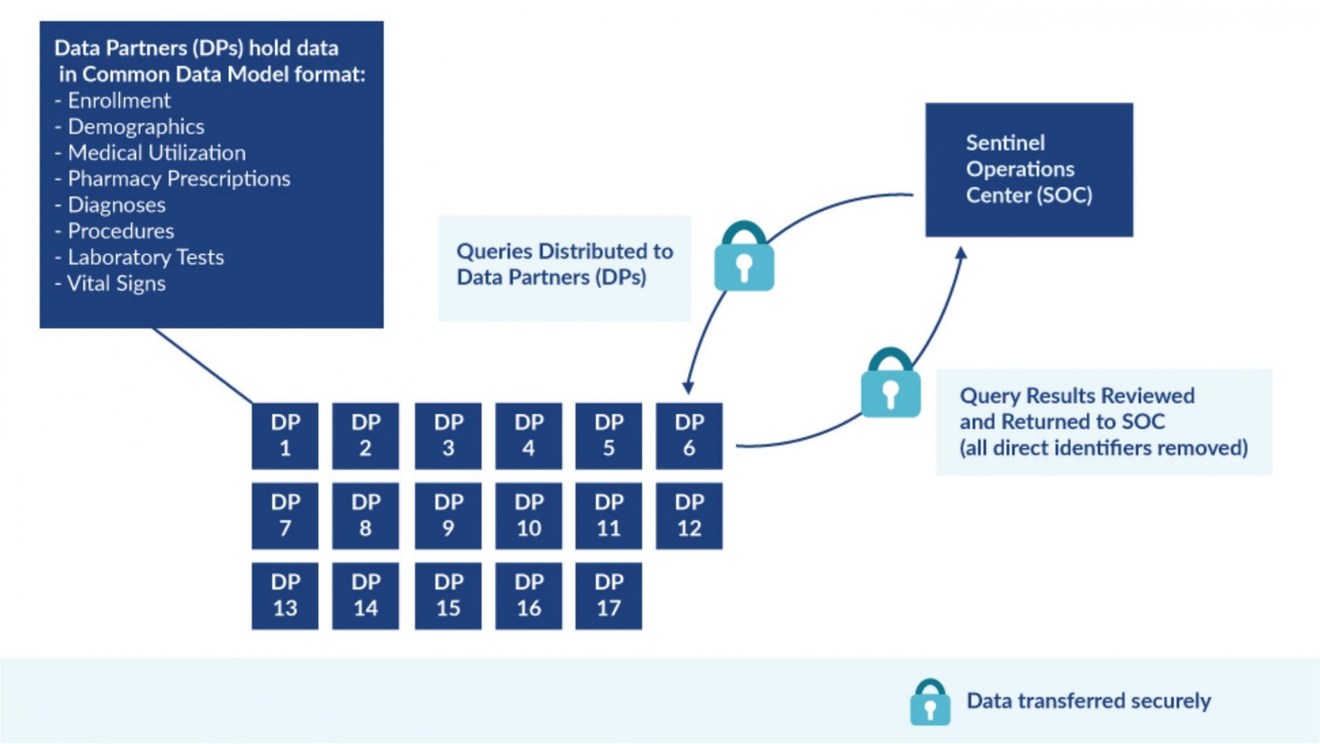

A key benefit of the distributed approach is that it minimizes the need to share identifiable patient information. Additionally, each healthcare data system has unique characteristics, and use of a distributed system better enables the Data Partner’s involvement in running analyses to ensure an informed approach to interpreting results.

**Database Statistics**

The Sentinel Distributed Database (SDD) has:

* 223 million members 2000-2016 (178 million members with both medical and pharmacy benefits)
* 425 million person-years of observation time
* 43 million people currently accruing new data
* 5.9 billion pharmacy dispensings
* 7.2 billion unique medical encounters
* 42 million people with at least one laboratory test result
* *Counts distinct patient ID values in the database.

Essential to the success of the Sentinel Program are two key features: (1) the fact that it is a distributed database, and (2) it makes use of a common data model.

**Complementary Data Sources**

Sentinel is working to broaden the kinds of data available for use in accomplishing FDA’s goal of building an active surveillance system to monitor the safety of FDA-regulated medical products. Complementary data sources include registries and prescribing databases. Collaboration with registries and prescribing databases supplements core claims and administrative data and creates opportunities to validate exposures and outcomes used in Sentinel analyses.

An example of the complexity involved in linking complementary data sources and Sentinel is shown in the illustration below.

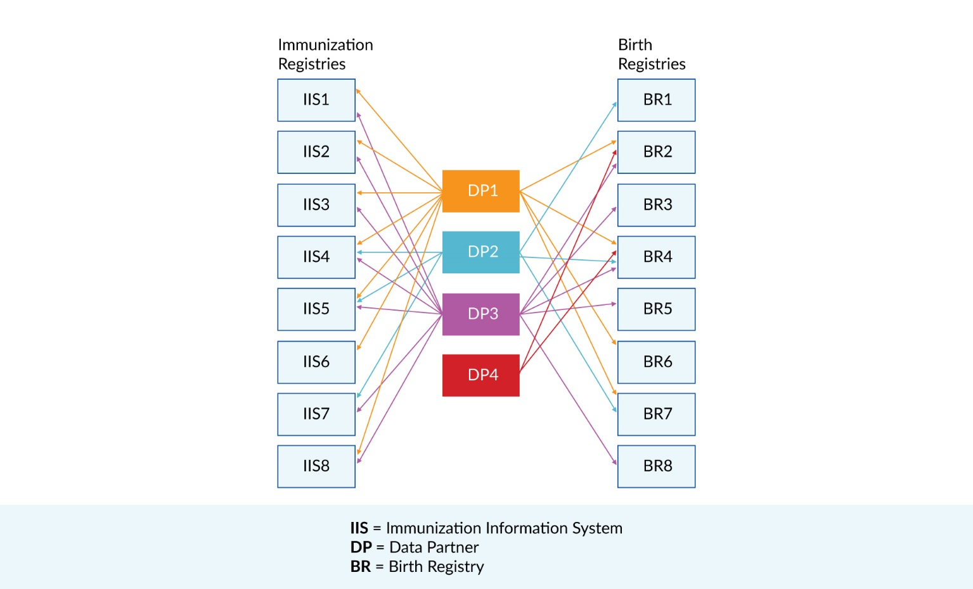

**Coordinating Center**

The Sentinel System Coordinating Center, led by the Harvard Pilgrim Health Care Institute, consists of divisions and advisory groups that work together with the FDA on Sentinel activities.

* **Sentinel Operations Center (SOC)** includes three Divisions:
  + **Applied Surveillance Division** oversees methodological and epidemiological aspects of Sentinel.
  + **Scientific Systems Division** oversees data, programming, and development of routine querying tools.
  + **Administration Division** provides project management support for the Scientific Systems and Applied Surveillance Divisions.

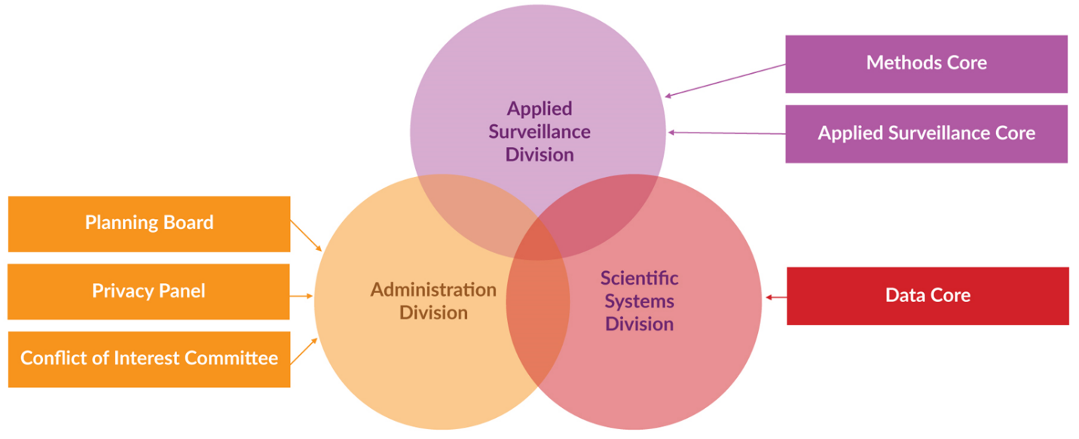

* **Planning Board** includes representatives of the FDA, each of the Collaborating Institutions, and the patient community. The Board advises the Operations Center and the FDA, and it provides a forum for communication among the various entities.
* **Privacy Panel** includes experts in health care privacy law and patient advocates. The Panel advises the Operations Center concerning legal and ethical issues related to the privacy and confidentiality of individual health information used for public health surveillance activities.
* **Conflict of Interest Committee** includes independent legal and scientific experts who oversee implementation of the Sentinel conflict of interest policy.
* **Methods Core** includes investigators from Collaborating Institutions and advises the Applied Surveillance Division.
* **Applied Surveillance Core** includes investigators from Collaborating Institutions and advises the Applied Surveillance Division.
* **Data Core**includes investigators from Collaborating Institutions and advises the Scientific Systems Division.

**Collaborating Institutions**

The Sentinel System Coordinating Center partners with a broad range of Data and Academic Partners. This network of collaborating institutions provides access to both healthcare data and scientific, technical, and organizational expertise. A complete listing of collaborating institutions is provided below:

Aetna*

America’s Health Insurance Plans: Clinical Affairs Department

Blue Cross Blue Shield of Massachusetts*

Brigham and Women’s Hospital: Division of Pharmacoepidemiology & Pharmacoeconomics in the Department of Medicine

Duke Clinical Research Institute

HealthCore, Inc.*

Health Care Systems Research Network

Harvard Pilgrim Health Care Institute*

HealthPartners Institute*

Henry Ford Health System: Public Health Sciences Department

Marshfield Clinic Research Institute*

Meyers Primary Care Institute*

Hospital Corporation of America*

Humana Comprehensive Health Insights, Inc.*

IQVIA

Kaiser Permanente Center for Effectiveness and Safety Research

Kaiser Permanente Colorado*

Kaiser Permanente Hawaii*

Kaiser Permanente Mid-Atlantic*

Kaiser Permanente Northern California*

Kaiser Permanente Northwest*

Kaiser Permanente Washington Health Research Institute*

Optum: Optum Epidemiology​*

Rutgers University: Center for Health Services Research on Pharmacotherapy, Chronic Disease Management and Outcomes at the Institute for Health, Health Care Policy and Aging Research

University of Alabama at Birmingham: Center for Outcomes and Effectiveness Research and Education

University of Illinois at Chicago: Department of Pharmacy Systems, Outcomes and Policy

University of Iowa: Department of Epidemiology in the College of Public Health

University of Pennsylvania School of Medicine: Center for Clinical Epidemiology and Biostatistics and Department of Biostatistics and Epidemiology

Vanderbilt University Medical Center*

Weill Cornell Medicine, Healthcare Policy & Research

* Collaborating Institutions that are also Data Partners

**Major Accomplishments**

* Establishment of the Sentinel Operations Center
* Creation of a common data model and distributed data approach that enables FDA to monitor the performance of medical products while securing and safeguarding patient privacy
* Development of a distributed database with more than 300 million person-years of high quality, unduplicated, curated data
* Development of processes for turning FDA’s safety concerns into queries of the Sentinel distributed data that can be responded to rapidly by Data Partners, often within weeks, in support of FDA’s regulatory needs
* Substantial progress toward development of a mature data analytics system
* Recruitment of a broad group of scientific collaborators who regularly provide the FDA with valuable technical support in evaluating electronic health data
* Development of focused surveillance efforts around vaccine safety with the Postmarket Rapid Immunization Safety Monitoring (PRISM) system and around blood and blood products with the Blood Surveillance Continuous Active Network (BloodSCAN)

**Expanding Data Sources and Core Capabilities**

Currently, the Sentinel Distributed Database is comprised largely of administrative and claims data from health insurers. Efforts are underway to augment this data with:

* Clinical data, including vital signs and laboratory test results
* Electronic health records
* Hospital data
* Medicare data
* Disease registry data

**Integrating the Sentinel System into the FDA’s Regulatory Programs**

The [Active Postmarket Risk Identification and Analysis (ARIA)](https://www.sentinelinitiative.org/active-risk-identification-and-analysis-aria) system enables the FDA to evaluate some safety signals in the postmarket setting more effectively, using Sentinel’s automated tools.

**The Sentinel System Story**

When FDA officially launched the Sentinel System early in 2016, the Agency formed a multi-stakeholder workgroup to raise awareness among four critical engagement partners:

* The Public
* Health Advocacy Groups
* Providers
* Health Plan Members

The workgroup’s mission was to develop messages to inform these engagement partners about the Sentinel System, letting them know what a valuable tool it is and how it works, and to remind them of the FDA’s commitment to protect patient privacy.

1. John Latham, “Design Framework for Organization Architects: An Introduction,” Organization Design Studio, 2015.
2. David Peter Stroh, *Systems Thinking for Social Change: A Practical Guide to Solving Complex Problems, Avoiding Unintended Consequences, and Achieving Lasting Results,* Chelsea Green Publishing, 2015.
3. John Hagell III, John Seely Brown, and Lang Davison, *The Power of Pull: How Small Moves, Smartly Made, Can Set Big Things in Motion*, New York: Basic Books, 2010.
4. Ard-Pieter de Man, *Alliances: An Executive Guide to Designing Successful Strategic Partnerships*, Wiley, 2013; Michael Leavitt, *Finding Allies, Building Alliances: 8 Elements that Bring--and Keep--People Together*, Jossey-Bass, 2013.