KEYWORDS OVERTIME:

Authors:

Akanksha Shaktia  [ass546@nyu.edu](mailto:akanksha.shaktia@nyu.edu)

Zhongheng Li [zl1761@nyu.edu](mailto:zl1761@nyu.edu)

Priyanshi Shah [ps3296@nyu.edu](mailto:ps3296@nyu.edu)

Riya Patni [rsp378@nyu.edu](mailto:rsp378@nyu.edu)

Screenshot of our Project:

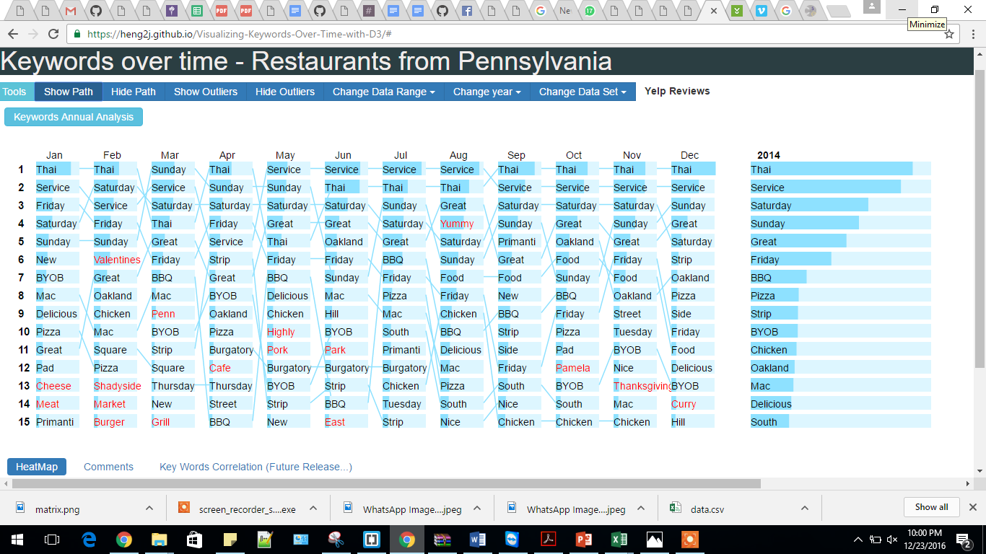

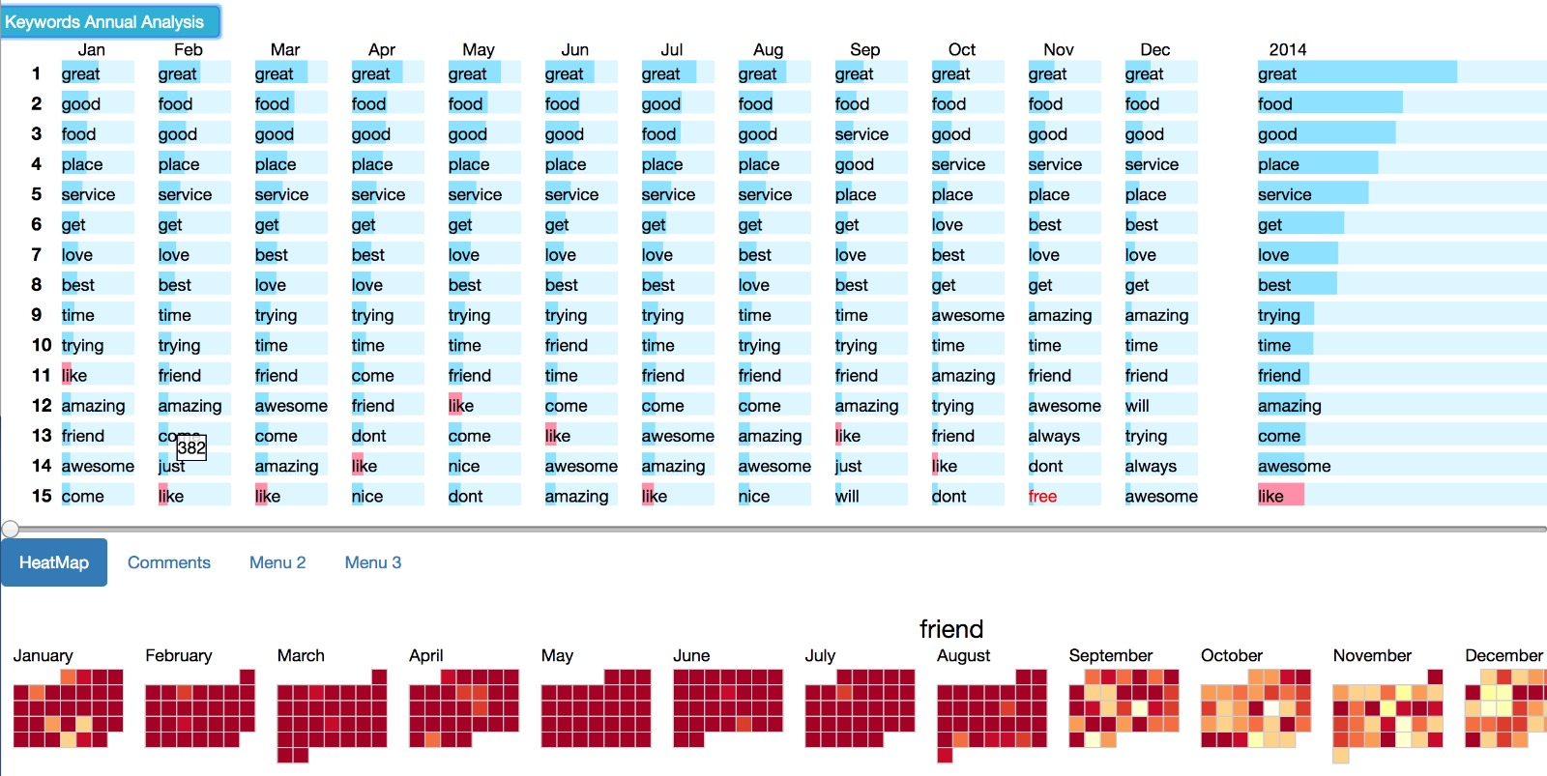

Description:

The problem at hand is to develop a generic technique to visualize the change in keywords extracted from any given dataset over a period of time. The given dataset is Yelp’s (reviews) dataset and the aim is to find the frequently occurring keywords, their changing trends over time, along with their appearance and disappearance over a period of time; augmenting better business decision based on the frequency. Analysis of these trends would help the business owners understand what people talk about their businesses and how these topics change over time.

There are few important questions identified, for which the visualization is developed. In other words, the developed visualization should answer the following questions:

1. What are the top 15 keywords (scalable upto 25) for each month extracted from the dataset over the year?
2. Which of these monthly keywords made it to the top keywords of the entire year – thereby implying they were most frequent throughout the year?
3. How does the ranking of the keywords change over time?
4. Which keywords appear or disappear over a period of time?
5. What are the top 5 reviews/comments that contain a particular word?

Video

Demo

https://nyu-cs6313-fall16.github.io/Visualizing-Keywords-Over-Time-with-D3-Team-16/

Final Project

https://github.com/NYU-CS6313-Fall16/Keywords-Over-Time-16