A 272-layer PyramidNet for CIFAR-10 under five million parameters
Jingyu He, Hongda Wu
Kaggle team: Hongda Wu · NYU Tandon Deep Learning, Fall 2026, Project 1
Public project repository:
We trained a residual classifier for CIFAR-10 with a limit of five million trainable parameters. Our best evidence for spending that budget on depth came from a comparison on 5,000 held-out images: a 218-layer PyramidNet classified 20 more images correctly than a 110-layer model trained with the same optimizer and schedule (98.40% versus 98.00%). For the full 50,000-image training set we trained a deeper, narrower 272-layer model. It has 4,943,934 parameters. After 900 epochs, the raw model scored 0.918 on the public split and 0.899 on the private split. Averaged weights with adjusted batch statistics and class balancing scored 0.915 and 0.900, respectively. Both submissions used one view per image.

1 Introduction
The competition provided 50,000 labeled CIFAR-10 training images and 2,000 unlabeled test images [1]. Each is a 32 × 32 RGB image from one of ten classes. The assignment requires a residual convolutional network [26], caps the entire classifier at five million trainable parameters and rules out external data and pretrained weights.
Our first PyramidNet reached 97.22% on validation at the submitted checkpoint but scored only 0.889 on the public leaderboard. We kept the clean split for paired comparisons and used corrupted copies to see which changes held up when the inputs changed. Public scores also informed our choice of final submissions.

2 Methodology

2.1 Data, evaluation protocol and distribution shift
Validation protocol. The main development runs share a stratified split: 45,000 training images and 5,000 for validation. We normalized images using training statistics. Unless stated otherwise, we report the final epoch with exponentially averaged weights (EMA) and average the class probabilities from the image and its horizontal mirror (“flip”). For matched comparisons we applied the exact McNemar test [2] to disagreements on the same 5,000 images. The final refits used all 50,000 labeled images and have no held-out score.
Train–test differences. We compared all images in the development training split with the competition test set (Table 1). The average test image was brighter and had higher contrast; neighbouring pixels also differed more in intensity. Mean saturation was lower in HSV. These measurements describe a shift in the inputs. Without test labels for individual images, we cannot tell which difference accounts for the loss in accuracy. A similar gap has been reported on recollected CIFAR-10 images [3].
Table 1. Image statistics, with RGB scaled to [0, 1]. Channel statistics use all pixels. Contrast is the within-image standard deviation of grayscale intensity (0.299R + 0.587G + 0.114B); edge strength averages absolute intensity differences between neighbours.
Statistic | Train (45,000) | Test (2,000) | Test − train
Channel mean (R/G/B) | 0.491 / 0.482 / 0.446 | 0.513 / 0.498 / 0.461 | +0.015 to +0.022
Channel SD (R/G/B) | 0.247 / 0.244 / 0.262 | 0.265 / 0.262 / 0.275 | +0.014 to +0.019
Image contrast | 0.19635 | 0.20635 | +0.01000
Edge strength | 0.05656 | 0.06077 | +0.00421
HSV saturation | 0.27344 | 0.25975 | −0.01369
Corrupted validation images (Q08). We applied 13 corruptions at three severities to the same 5,000 images, using CIFAR-10-C [4] as a reference. Four families cover photometric changes (brightness, contrast, saturation and gamma), sharpness (blur and sharpening), noise (Gaussian) and compression (JPEG and pixelation). Each family receives equal weight so the eight photometric conditions do not dominate. We fixed the corruption settings independently of the final submissions. Section 3.3 uses only the mildest severity.

2.2 Architecture exploration
We compared six residual network families using SGD and a cosine schedule (Table 2). Each kept the first feature map at 32 × 32; the models differed in how they spent the remaining parameters. The SE-ResNet had the highest final validation accuracy in this group, but its submission scored 0.865. The basic PyramidNet [5] scored 0.889 and became our starting point. The runs ranged from 200 to 1,800 epochs due to the intensity of regularization.
Table 2. Architecture screen. Validation uses final-epoch EMA with flip. Public scores belong to the submitted CSV, which can use a different checkpoint or weights. Figure 3a pairs like with like.
Family (configuration) | Params | Epochs | Val. (%) | Public | Observation
ResNet, basic blocks, [3,5,3] × [64,128,256], 1×1 projection shortcuts | 4,918,602 | 200 | 96.62 | 0.872 | simple, fast (21 min); budget concentrated in wide late layers
Wide ResNet WRN-22-4, pre-activation [7] | 4,298,970 | 200 | 96.84 | 0.871 | fast; widening further (4.85M) did not help
SE-ResNet, [3,5,3] + SE (r = 16) [6] | 4,956,654 | 200 | 97.08 | 0.865 | highest final validation score here; lowest public score in this screen
ResNeXt-29 32×4d [8][28] | 4,775,754 | 200 | 96.40 | 0.872 | grouped convolutions; lowest final validation accuracy in this screen
Shake-Shake-26 2×40d [9] | 4,561,354 | 1,800 | 96.72 | 0.873 | two residual branches; longest schedule in the screen
PyramidNet-110, basic, α = 98 [5] | 4,963,991 | 300 | 96.84 | 0.889 | gradual width growth, parameter-free shortcuts; best public score
Our PyramidNet follows Han et al.’s implementation [29] and widens gradually. When a block adds channels, the shortcut pads with zeros. When the resolution halves, it uses average pooling. We tested bottleneck blocks (1 × 1, 3 × 3, 1 × 1) with ShakeDrop [10] and reduced the widening factor α as depth increased to stay near 4.9 million parameters. Figure 1(a) shows how accuracy changed within each recipe. With ASAM, moving from 110 to 218 layers raised accuracy from 98.00% to 98.40% (32 errors corrected, 12 introduced, paired p = 0.004). With SGD, the 164-layer run scored slightly below the 110-layer run (98.08% versus 98.16%). However, the first 272-layer refit, T131 supported retaining a deep, narrow design for the subsequent SiLU refit.
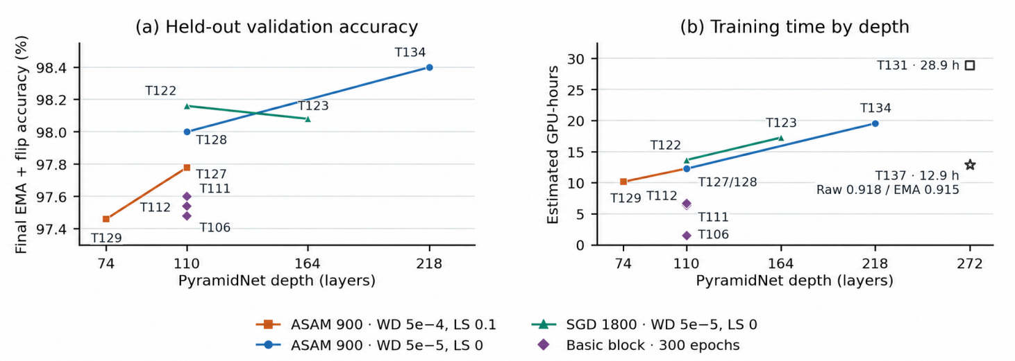
Figure 1. (a) Final EMA + flip accuracy on 5,000 held-out images. Lines connect runs with matched recipes. T106, T111 and T112 used SGD, SAM and ASAM, respectively. WD denotes weight decay and LS label smoothing. (b) Estimated GPU-hours equal the median steady epoch time on the indicated GPU times the scheduled epochs. All points use one 40 GB A100 except T137, which uses one B200. Open symbols mark full-data refits.
Figure 1(b) shows the cost of the accuracy gain. Under the same 900-epoch ASAM recipe, 110 layers took an estimated 12.3 hours on one A100 and 218 layers took 19.6. Both 272-layer refits used all 50,000 images. T131 used ReLU and took 28.9 hours on an A100. T137 used SiLU [11] and took 12.9 hours on a B200. Its single training run produced both selected submissions, scoring 0.918 with raw weights and 0.915 with adapted EMA weights on the public leaderboard.
On the basic PyramidNet, DropPath [14] at 0.1 raised final EMA + flip accuracy from 97.18% (T76) to 97.60% (T77). Other changes were less useful: widening the pre-pooling head cost 0.12 percentage points, and pooling features from several stages cost 0.24. Neither early instance normalization (IBN [12]) nor MixStyle [13] gave us a consistent gain. The later bottleneck models used ShakeDrop.
We first tested the optimizer on this 110-layer basic model. Over 300 epochs, SGD reached 97.48% (T106), SAM reached 97.60% (T111) and ASAM reached 97.54% (T112). SAM corrected 40 of the baseline errors but introduced 34 others, a net gain of six images. These differences were relatively small and did not establish a clear advantage for either SAM or ASAM at this stage. However, given the improvements reported in prior studies [21], we chose to adopt ASAM for subsequent experiments rather than conduct further optimizer comparisons on this smaller model. In later experiments, as we progressively tuned PyramidNet toward its performance limits, we observed a clearer trend, with ASAM consistently outperforming SAM, which in turn outperformed SGD.

2.3 Training recipe
The final model retained policy augmentation and ShakeDrop. Table 3 gives the settings needed to reproduce the refit.
For each training image we applied a padded crop and a random horizontal flip, drew one TrivialAugmentWide operation [15], normalized the pixels and masked a 16 × 16 square with Cutout [16]. AutoAugment [17] and TrivialAugmentWide finished within 0.3 percentage points in three comparisons. Adding Mixup [18] lowered clean accuracy in the families we tested; CutMix [19] also failed to improve our screen.
Table 3. Final training configuration.
Item | Setting
Data | all 50,000 training images for the final refit
Augmentation | random crop 32 (pad 4, zeros) + h-flip → TrivialAugmentWide → normalize → Cutout 16×16
Optimizer | ASAM (ρ = 1.0, η = 0.01) over Nesterov SGD; momentum 0.9, batch 128, LR 0.1, weight decay 5 × 10⁻⁵
Schedule | 900 epochs; 5-epoch linear warm-up, cosine decay to 0
Regularization | ShakeDrop (p_{L} = 0.5, linear in depth); no label smoothing; EMA 0.999
Precision / speed | bf16, channels-last and torch.compile
We used Nesterov SGD with a five-epoch warm-up followed by cosine decay [20]. Adaptive sharpness-aware minimization (ASAM [21], a variant of SAM [22]) takes two gradient passes per update. Both passes replay the same ShakeDrop draws; batch normalization (BN) updates its running statistics once.
With the 110-layer architecture and 900-epoch schedule fixed, T128 reduced weight decay from 5×10⁻⁴ to 5×10⁻⁵ and removed T127’s 0.1 label smoothing. It corrected 30 errors and introduced 19.
We maintained an EMA with decay 0.999 alongside the raw weights. At epoch 50 of the 218-layer run, EMA classified 93.02% of the unflipped validation images correctly, compared with 90.48% for raw weights (Figure 2b). By epoch 450 the gap had narrowed to 0.28 points. At epoch 900 the raw and EMA scores were 98.38% and 98.36%. We kept both sets of weights for inference because the early advantage had disappeared by the end of training.
We also tried distillation [27] from an ensemble trained on the competition data. The student reached 97.18% clean validation accuracy versus 97.36% without distillation; its Q08 score fell from 89.0 to 88.5. But we didn't have enough time to conduct further distillation experiments on the final recipe. We kept the ordinary supervised loss.
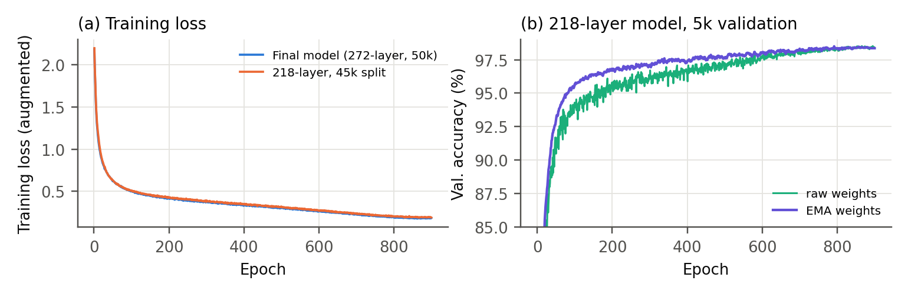
Figure 2. Left: training loss on augmented images for the 272-layer full-data run and the 218-layer development run. Right: on the 218-layer validation split, EMA weights lead raw weights early; their accuracies converge late in the schedule.

2.4 Prediction-time processing
We evaluated two methods permitted by professor. For BN adaptation [23, 24], we reset the BN statistics, passed the unflipped images through the network in equal-size batches and accumulated new means and variances. Only BN layers were in training mode. We blended the new and stored statistics using a weight a on the new values, keeping all learned parameters fixed. Each validation condition supplied its own 5,000 images; competition inference used the 2,000 unlabeled test images. The second method assumes an approximately uniform class distribution. Sinkhorn scaling [25] gives each class equal total probability mass before taking the most likely label. Exact balancing instead assigns a fixed number of images to each class (200 on the test set).

3 Results

3.1 Final model and submissions
The final network has three residual stages (N = 3), each with 30 bottleneck blocks. The middle convolution in each block has a 3 × 3 kernel (F = 3); the surrounding convolutions use 1 × 1 kernels. Bottleneck widths grow from 17 to 88 channels and expand to 68–352 output channels. The shortcuts pool or pad without a learned kernel K. Global 8 × 8 average pooling (P = 8) feeds a 352-to-10 linear classifier (Table 4).
Table 4. Final architecture: PyramidNet-272, α = 72, with SiLU and ShakeDrop. The 4,943,934 trainable parameters include the classifier.
Stage | Output size | Blocks | Block (pre-activation bottleneck) | Output channels
Stem | 32×32 | – | 3×3 conv, 16 → BN | 16
Stage 1 | 32×32 | 30 | BN → 1×1 → BN → SiLU → 3×3 → BN → SiLU → 1×1 → BN → ShakeDrop; + identity (zero-pad channels) | 68 → 160
Stage 2 | 16×16 | 30 | same; first block stride 2, shortcut = 2×2 avg-pool + zero-pad | 164 → 256
Stage 3 | 8×8 | 30 | same; first block stride 2 | 260 → 352
Head | 1×1 | – | BN → SiLU → global 8×8 average pool → FC 352 → 10 | 10
Table 5. Public and private accuracy for the two selected T137 submissions. Both used the epoch-900 checkpoint and a single view per image.
Submission | Weights | Prediction-time processing | Public | Private
Primary | raw | none (single forward pass) | 0.918 | 0.899
Secondary | EMA | BN blend a = 0.25 + Sinkhorn class balancing | 0.915 | 0.900
Our primary submission used raw T137 weights and scored 0.918 on the public split with one forward pass per image. Our secondary submission used EMA weights, a 0.25 BN blend and Sinkhorn balancing and scored 0.915. Two later class-balanced variants, using 10 and 18 views, even scored more than 0.918. each matched the 0.918 public score. We intended to select those variants, but we missed the final switch before the deadline. Table 5 reports the two submissions that were actually scored.
The two selected submissions disagreed on 54 of the 2,000 test images. Raw weights classified three more public images correctly (918 versus 915 out of 1,000). On the 1,000 private images, the adapted EMA submission classified one more correctly (900 versus 899). The leaderboard gives aggregate scores, so we cannot identify which individual disagreements accounted for the reversal.

3.2 Validation accuracy and public scores
Figure 3(a) highlights four full-data PyramidNet submissions above 0.910. Both selected T137 files appear in the upper plot because the refit used all 50,000 training images. The lower plot pairs 32 public scores with matched validation accuracies. Similar validation scores could yield different public results. The continued SE-ResNet (C7) and PyramidNet E5 reached 96.94% and 96.96% on validation but scored 0.856 and 0.882 on the leaderboard.
Figure 3(b) follows the best recorded public score from each selected PyramidNet run in training order. At 110 layers, the score rose from 0.889 (E1) to 0.908 (T122) as we changed the recipe. The next runs scored 0.898 at 164 layers, 0.903 back at 110 and 0.891 at 74. The two 272-layer refits reached 0.916 (T131) and 0.918 (T137), followed by 0.913 at 218 layers (T138). The refits also used more training data, and the submissions differed in inference settings. Figure 1(a) gives a closer comparison by holding the recipe fixed while trading width for depth.
We can match inference more closely for the two full-data SiLU models. Using epoch-900 EMA weights, a single view, a 0.25 BN blend and Sinkhorn balancing, the 272-layer T137 scored 0.915 and the 218-layer T138 scored 0.913. That is a difference of two public images. The 272-layer ReLU run (T131) reached 0.916 with exact balancing, so that score alone cannot tell us whether replacing ReLU with SiLU helped. However, on our self-constructed data augmentation validation set (Q8), the original score of the SiLU scheme is slightly higher than the average scores of various variants (EMA, TTA, BN blend, Balancing) compared to the ReLU scheme.
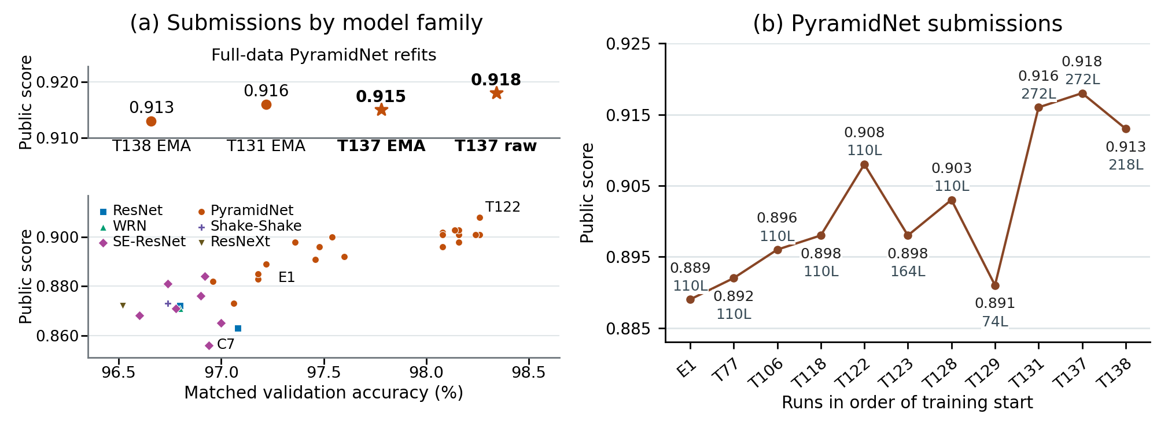
Figure 3. Left: public scores for four submissions from full-data refits (stars mark the two selected T137 submissions), above 32 submissions with matched validation accuracy. Color and shape in the scatterplot identify model families. Right: highest recorded public score per selected PyramidNet run, ordered by training start. L denotes depth in layers. Training and inference settings vary.

3.3 Effect of prediction-time processing
Table 6. T134, final-epoch EMA with flip. Q08 is the severity-1 accuracy averaged equally across the four corruption families; Δ is relative to stored training BN statistics without balancing.
BN statistics | Class balancing | Clean val. (%) | Q08, mild (%) | Δ Q08 (pp)
training (source) | none | 98.40 | 96.53 | –
training (source) | Sinkhorn | 98.54 | 97.15 | +0.62
domain, full (a = 1) | none | 97.46 | 95.97 | −0.56
blend a = 0.5 | none | 98.46 | 97.17 | +0.64
blend a = 0.5 | Sinkhorn | 98.42 | 97.39 | +0.86
On T134, a 0.5 BN blend plus Sinkhorn raised the mild-corruption score from 96.53% to 97.39% (+0.86 percentage points) and clean accuracy from 98.40% to 98.42% (Table 6). Full BN replacement without balancing lowered the mild-corruption score to 95.97%. Blending alone reached 97.17% on mild corruptions, and balancing alone reached 97.15%. Their combination gave the highest mild score in the table, while balancing alone gave the highest clean score (98.54%). The choice of processing depends on which images we expect the model to face.
Most of T134’s gain came from noise and compression. Compared with stored BN statistics and no balancing, the blend plus Sinkhorn gained 2.54 points on noise, 0.81 on compression, 0.055 on photometric changes and 0.04 on sharpness. Across five other runs (T106, T122, T123, T128 and T129), the same method gained 0.97 percentage points on average, while full replacement alone lost 1.18. Both comparisons use final-epoch EMA with flip.

4 Discussion and limitations
Of the 20 net additional correct predictions from the 218-layer ASAM model training on 45,000 images, 16 came from cat and dog images. On the 500 dog images, the deeper model corrected 12 errors and introduced two. On the 500 cat images, it corrected eight and introduced two. The other eight classes accounted for a net gain of four on this split. The SGD depth comparison did not show the same overall trend.
The clean split let us count paired errors, and the corrupted images showed how BN blending performed under specific shifts. On the competition test set, the raw submission’s accuracy fell by 1.9 percentage points from public to private, and the adapted EMA submission’s accuracy fell by 1.5 points. The private scores differed by just one image. These results give little basis for preferring either inference recipe on a new test set.
The matched depth comparison uses one training seed per configuration. Its paired test measures uncertainty over validation images and cannot measure variation across training seeds. On the public leaderboard, one image changes accuracy by 0.1 percentage points. Selecting an epoch on the same 5,000 images used to report its accuracy can also inflate that estimate. We therefore distinguish the submitted epoch from the final epoch in Figure 3 and Table 2.
For the next training run, we would first repeat the 110- and 218-layer ASAM comparison across training seeds, using the same split and the same GPU. We would record the final EMA + flip score, GPU-hours and paired cat and dog errors for each seed. If the gain recurs at a cost we can afford, the next comparison would put 218 and 272 layers on that same held-out split. That would test whether spending still more of the parameter budget on depth helps before committing to another full-data refit.
For submission selection, we would fix the inference choices on development data first. We would compare raw single-view predictions with EMA under the same view, then add BN blending and class balancing one at a time. Recording clean accuracy and all four corruption-family scores would show whether a gain extends beyond noise and compression. We would carry the selected settings into the full-data run before consulting the public leaderboard.

5 Conclusion
In the matched depth comparison, the 218-layer ASAM model reached 98.40% on held-out images within the five-million-parameter budget. The 272-layer full-data SiLU refit produced our best selected private score of 90.0%, using adapted EMA weights. It is noteworthy that the original weights of our final scheme correctly identified 1817 out of a total of 2000 images in the test images (the combination of publish and private benchmarks), surpassing the results achieved after using BN blending and class balancing (1815 images), which is undoubtedly encouraging.

References
[1] A. Krizhevsky. Learning multiple layers of features from tiny images. Tech. report, University of Toronto, 2009.
[2] Q. McNemar. Note on the sampling error of the difference between correlated proportions or percentages. Psychometrika, 12(2):153–157, 1947.
[3] B. Recht, R. Roelofs, L. Schmidt, V. Shankar. Do ImageNet classifiers generalize to ImageNet? ICML, 2019.
[4] D. Hendrycks, T. Dietterich. Benchmarking neural network robustness to common corruptions and perturbations. ICLR, 2019.
[5] D. Han, J. Kim, J. Kim. Deep pyramidal residual networks. CVPR, 2017.
[6] J. Hu, L. Shen, G. Sun. Squeeze-and-excitation networks. CVPR, 2018.
[7] S. Zagoruyko, N. Komodakis. Wide residual networks. BMVC, 2016.
[8] S. Xie, R. Girshick, P. Dollár, Z. Tu, K. He. Aggregated residual transformations for deep neural networks. CVPR, 2017.
[9] X. Gastaldi. Shake-Shake regularization. arXiv:1705.07485, 2017.
[10] Y. Yamada, M. Iwamura, T. Akiba, K. Kise. ShakeDrop regularization for deep residual learning. IEEE Access, 7:186126–186136, 2019.
[11] S. Elfwing, E. Uchibe, K. Doya. Sigmoid-weighted linear units for neural network function approximation in reinforcement learning. Neural Networks, 107:3–11, 2018.
[12] X. Pan, P. Luo, J. Shi, X. Tang. Two at once: enhancing learning and generalization capacities via IBN-Net. ECCV, 2018.
[13] K. Zhou, Y. Yang, Y. Qiao, T. Xiang. Domain generalization with MixStyle. ICLR, 2021.
[14] G. Huang, Y. Sun, Z. Liu, D. Sedra, K. Weinberger. Deep networks with stochastic depth. ECCV, 2016.
[15] S. Müller, F. Hutter. TrivialAugment: tuning-free yet state-of-the-art data augmentation. ICCV, 2021.
[16] T. DeVries, G. Taylor. Improved regularization of convolutional neural networks with Cutout. arXiv:1708.04552, 2017.
[17] E. Cubuk, B. Zoph, D. Mané, V. Vasudevan, Q. Le. AutoAugment: learning augmentation strategies from data. CVPR, 2019.
[18] H. Zhang, M. Cisse, Y. Dauphin, D. Lopez-Paz. mixup: beyond empirical risk minimization. ICLR, 2018.
[19] S. Yun, D. Han, S. Oh, S. Chun, J. Choe, Y. Yoo. CutMix: regularization strategy to train strong classifiers with localizable features. ICCV, 2019.
[20] I. Loshchilov, F. Hutter. SGDR: stochastic gradient descent with warm restarts. ICLR, 2017.
[21] J. Kwon, J. Kim, H. Park, I. Choi. ASAM: adaptive sharpness-aware minimization for scale-invariant learning of deep neural networks. ICML, 2021.
[22] P. Foret, A. Kleiner, H. Mobahi, B. Neyshabur. Sharpness-aware minimization for efficiently improving generalization. ICLR, 2021.
[23] Y. Li, N. Wang, J. Shi, X. Hou, J. Liu. Adaptive batch normalization for practical domain adaptation. Pattern Recognition, 80:109–117, 2018.
[24] S. Schneider, E. Rusak, L. Eck, O. Bringmann, W. Brendel, M. Bethge. Improving robustness against common corruptions by covariate shift adaptation. NeurIPS, 2020.
[25] M. Cuturi. Sinkhorn distances: lightspeed computation of optimal transport. NeurIPS, 2013.
[26] K. He, X. Zhang, S. Ren, J. Sun. Deep residual learning for image recognition. CVPR, 2016.
[27] G. Hinton, O. Vinyals, J. Dean. Distilling the knowledge in a neural network. arXiv:1503.02531, 2015.
[28] kuangliu. PyTorch CIFAR: ResNeXt implementation. https://github.com/kuangliu/pytorch-cifar
[29] D. Han. PyramidNet-PyTorch: reference implementation. https://github.com/dyhan0920/PyramidNet-PyTorch

