Computer Vision William Jiang (wj419)

Professor Fergus 10/31/19

**Hw2 Report**

For this assignment, we will be using neural net to classify an image set of 43 different classes. Two similar approaches will be used to build our model: the base naïve model and a deep convnet model.

The base model consists of 2 convnets and employs dropout, max pooling and linear + Relu compositions. The result within a timespan of 15 epochs is shown below.

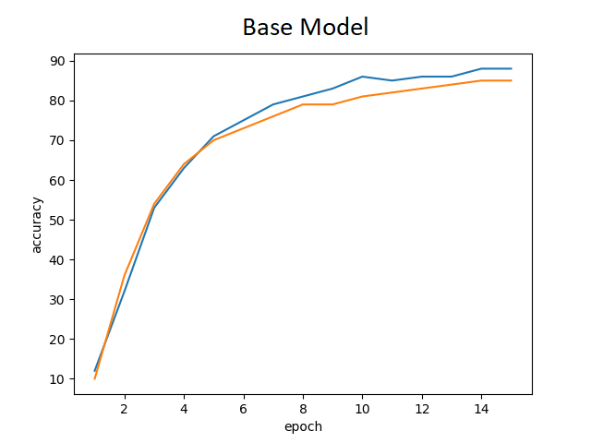

**Figure1: Base convnet model**

The validation accuracy slowly converges to 88%. By changing the depth of the convolutional network, we can achieve better accuracy.

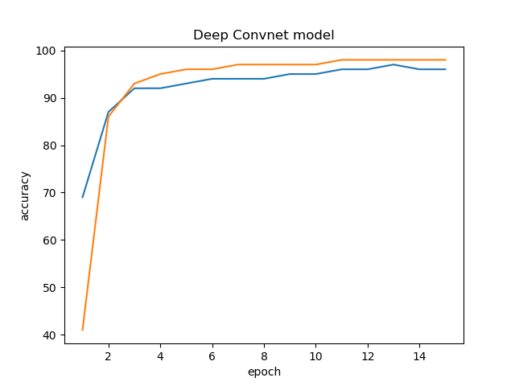

**Figure2: Deep Convnet model**

As shown in the above figure, we were able to achieve a much higher accuracy of 96% as opposed to our naïve approach of 88%. The regression as indicated by the blue line represents the validation accuracy, whereas the orange line shows the training set accuracy. Changes made to the model include 2 additional layers of convnets, 2 final linear compositions, and the addition of dropouts and batch norm to both the convolutional layers and the linear layers. The intent of including the latter 2 additions is so that the model doesn’t easily overfit over our training set. The effect is not only a much higher accuracy, but also an asymptotically faster approach to that limit. The benefit of using this model is that it does not overfit our dataset since the training set accuracy plateaus at 97%. Furthermore, instead of using SGD optimizer, we used an Adam optimizer so as to allow the learning rate to fluctuate. It is possible that our model is non-convex, which may result in our gradient descent being stuck in a local minima.

Kaggle account: <https://www.kaggle.com/willsterj>