# Introduction

This document explains how to create a new empty workspace and how to import the “ExampleProject” and “IO” projects from local git repositories (repos). To begin the process, start E2 Studio. If a default workspace loads, then select “File->Switch Workspace->Other” to start the workspace selection screen. Once the workspace selection screen appears, then type the location and name of the new workspace in the “Workspace” entry field or use the “Browse” button to navigate to the desired directory and add the workspace name. For this example, we directly enter the location of a non-existent project as follows and then press then “Launch” button:

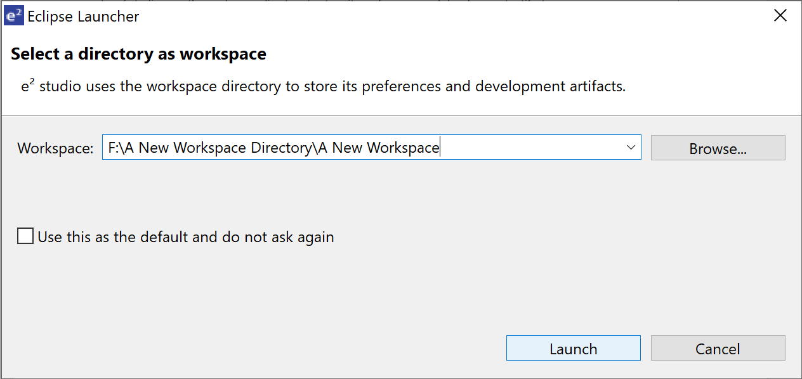

E2 Studio then shows the following screen while it creates and loads the new directory, workspace folder and workspace:

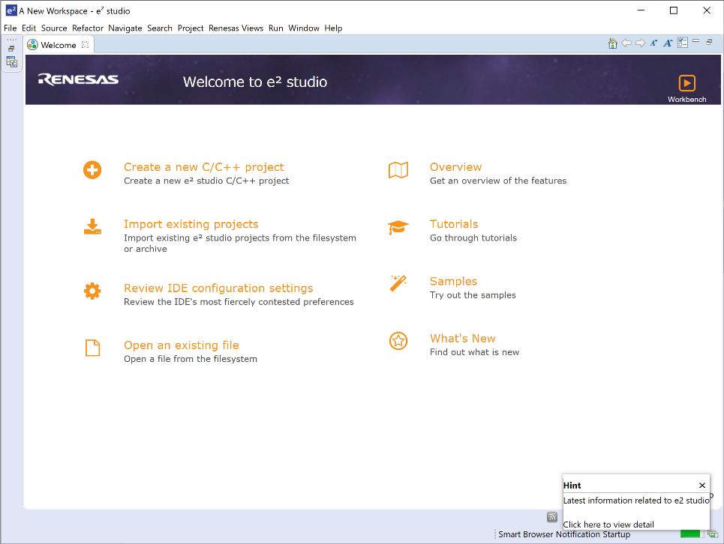After the workspace is created and loaded, the following screen will appear:

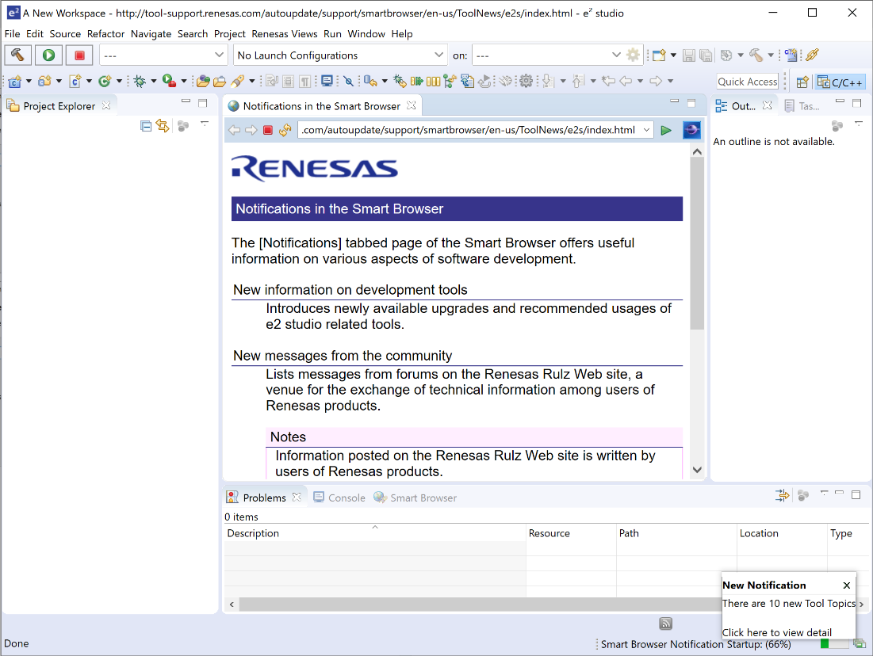Close the startup page and select the project explorer icon on the left side of the screen the follow screen will appear:

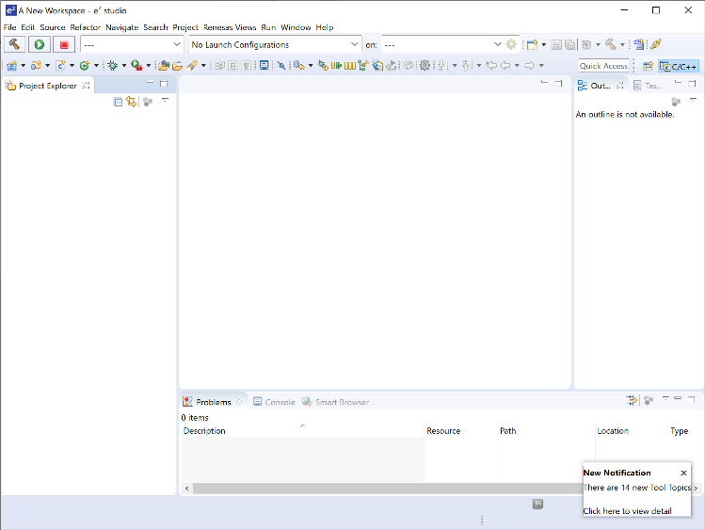Close the “Notifications in the Smart Browser” tab and the screen will appear as follows:

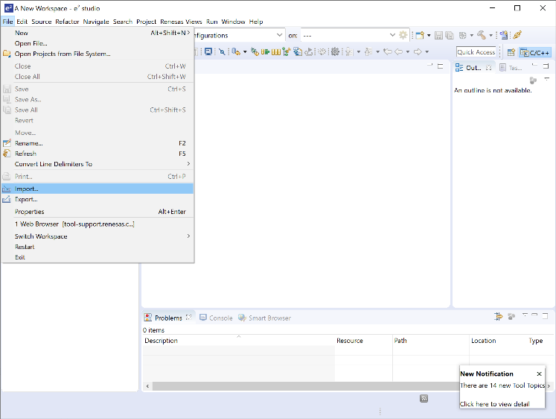

Now we import the “ExampleProject” by selecting “File->Import” as shown in the following screen.

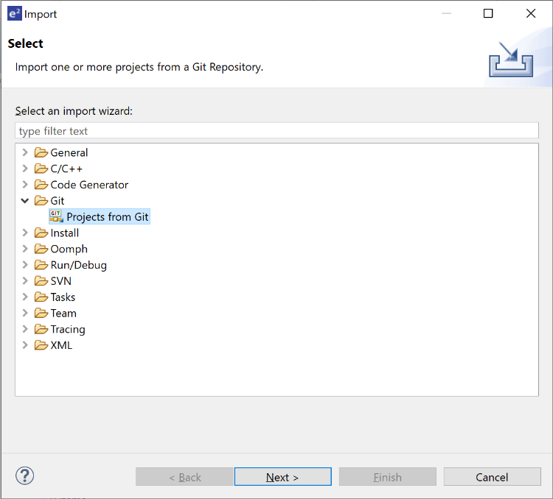When the import screen appears, select “Git->Projects from Git” and press “Next>”:

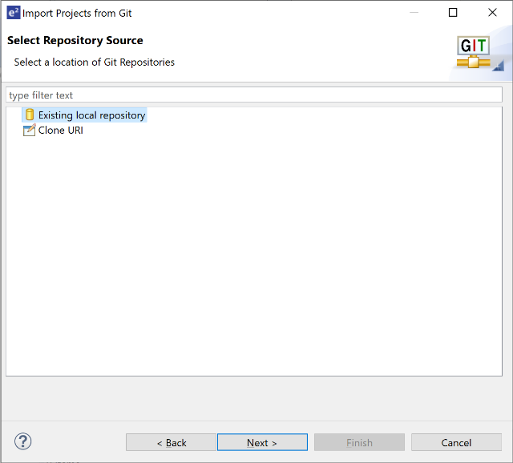Then select “Existing local repository” and press “Next>”

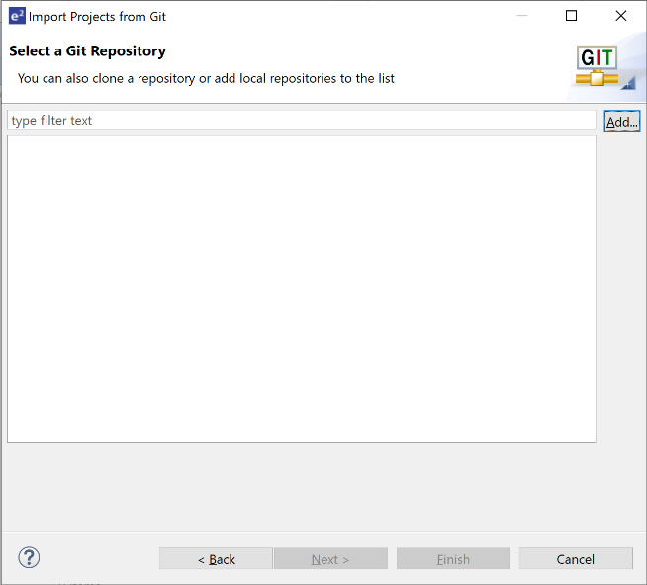

When the following screen appears select “Add”

When the following screen appears, select “Browse”

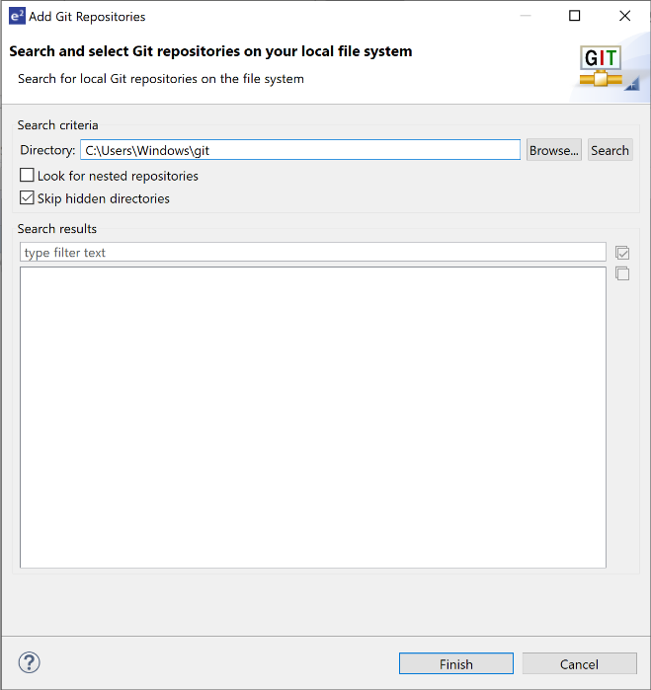

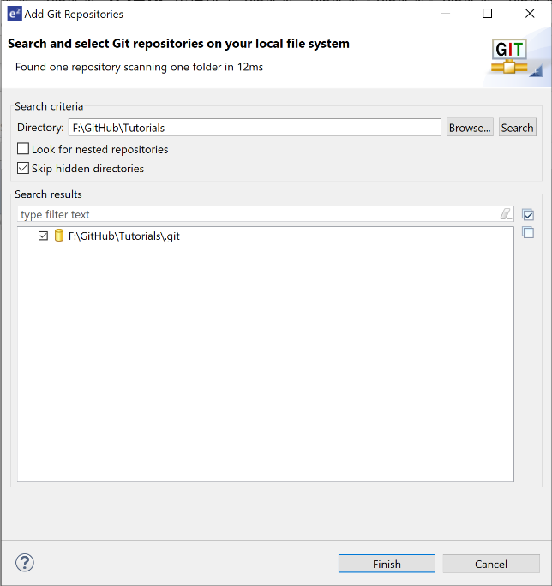And “browse” over to the local github folder that contains the Tutorials Git. Select the “Tutorials” git and press “Finish:.

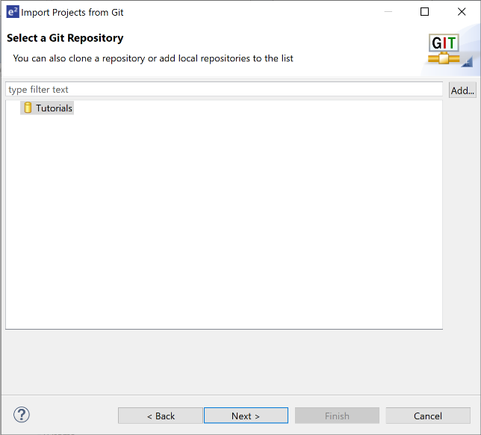When the following screen appears make sure “Tutorials” is selected and press next:

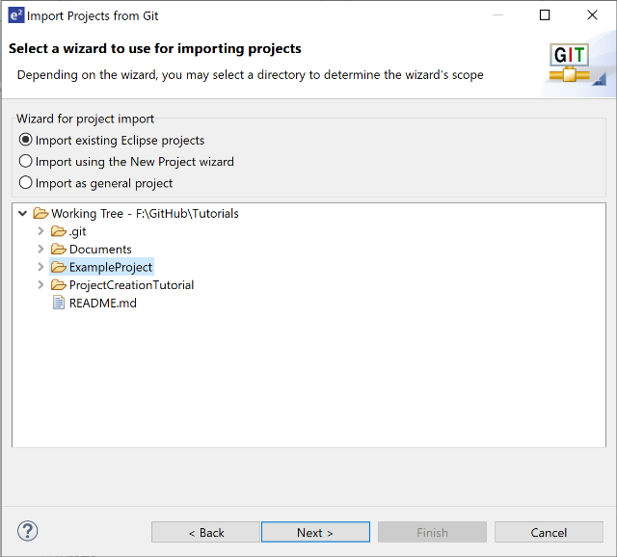

When the following screen appears select “ExampleProject” and press “Next>”.

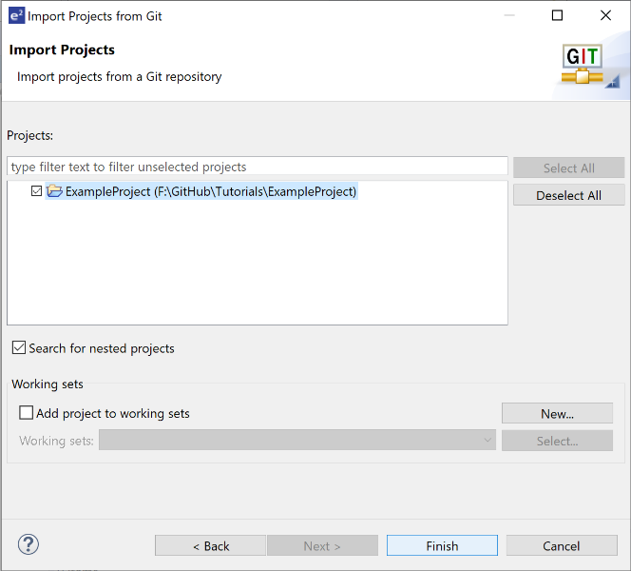When the following screen appears select “ExampleProject” and press “Finish”

The following screen will appear after the ExampleProject has been imported into the workspace.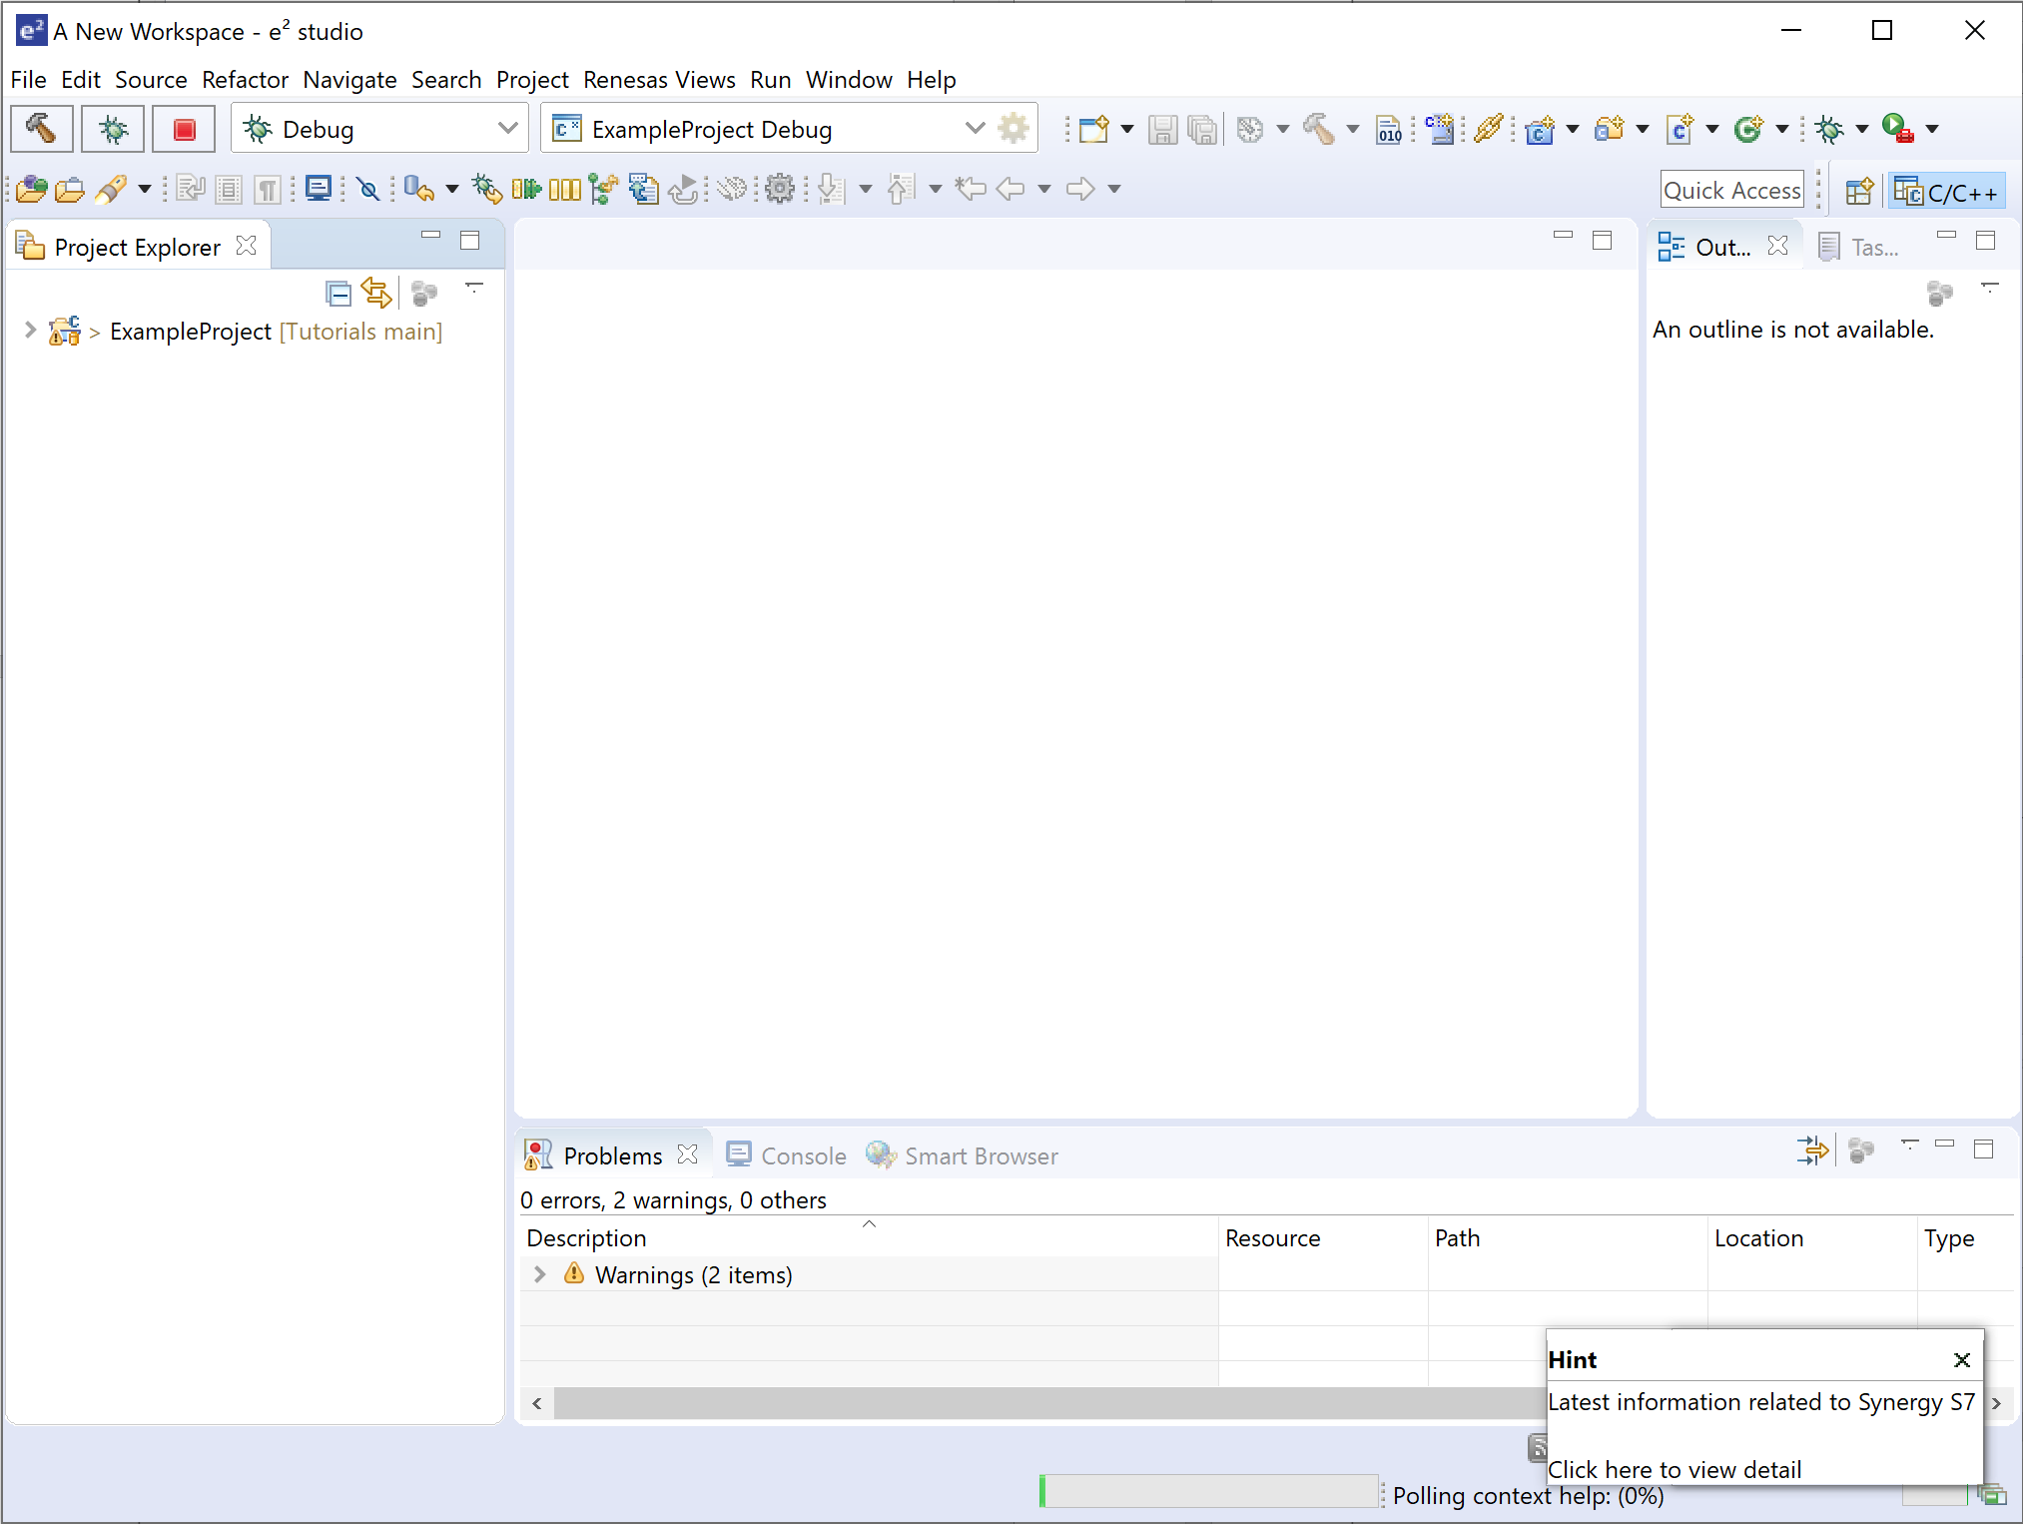

We will now follow the same process and import the IO project.

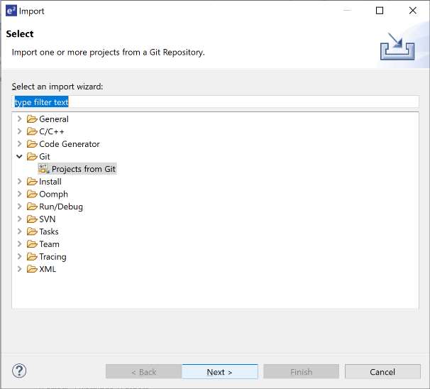From the main menu of E2 Studio select “File->Import” and after the following screen appears select “Git->Projects from Git” and press the “Next>” button.

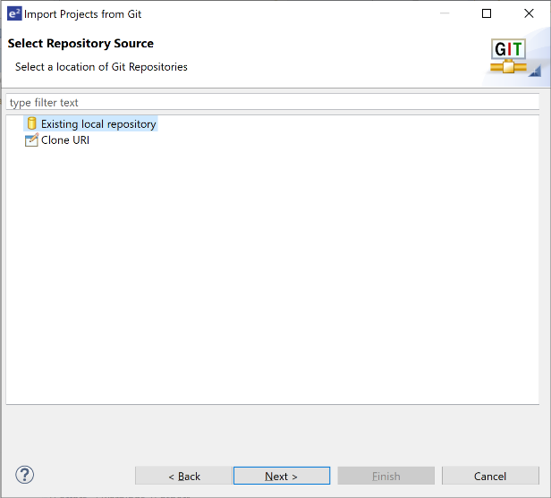When the following screen appears, select “Existing local repository” and press the “Next>” button.

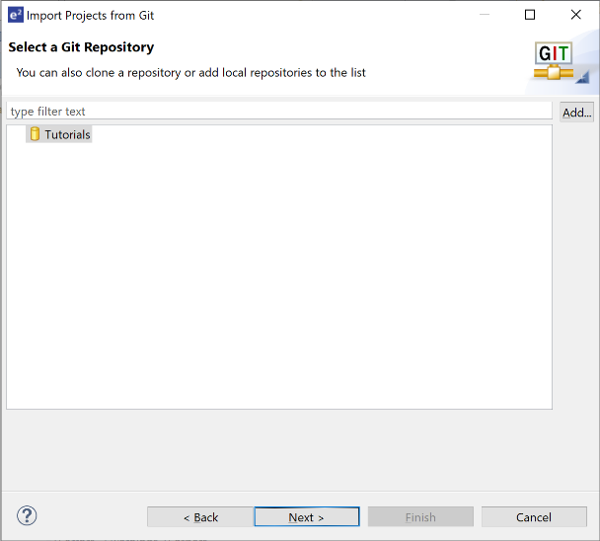When the follow screen appears press the “Add” button.

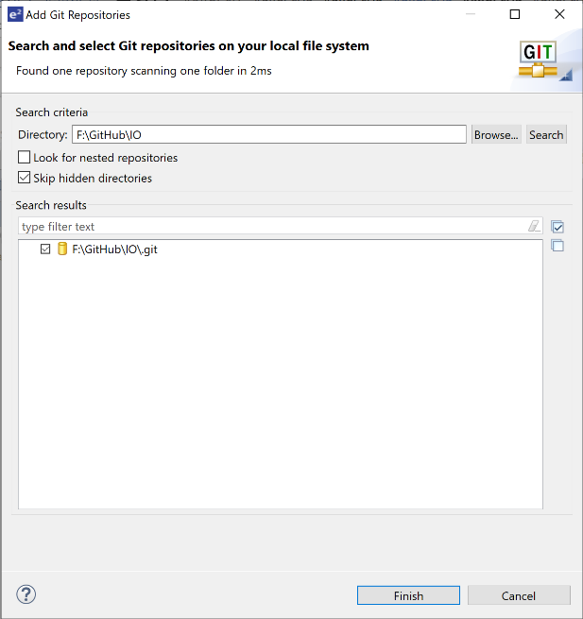When the following screen appears press the “Browse” button and navigate to the local IO GitHub folder, select the folder and press the “Finish” button.

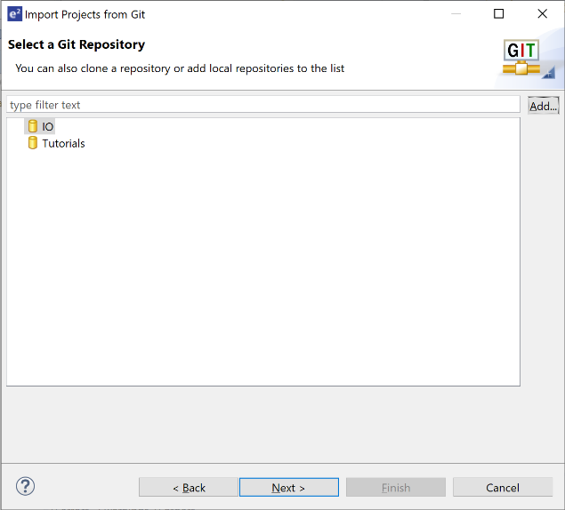

The following screen will appear. Select IO and then press the “Next>” button.

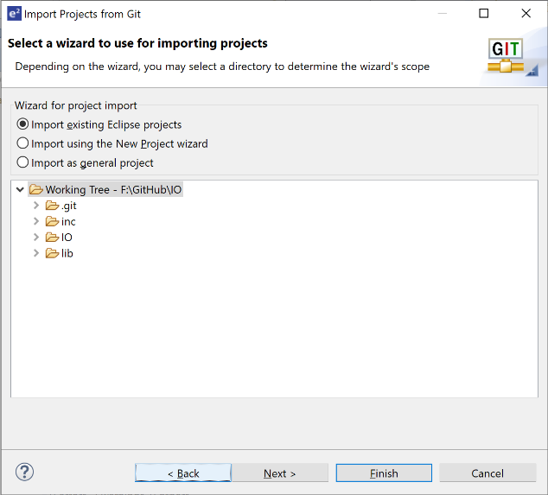The following screen will appear. Select “IO” and press the “Next>” button.

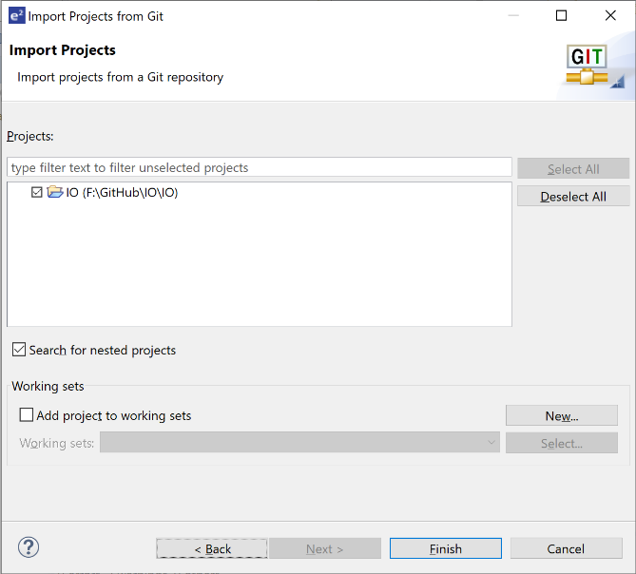When the following screen appears select “IO” then press the “Finish” button.

After the project loads into the workspace, the following screen will appear.

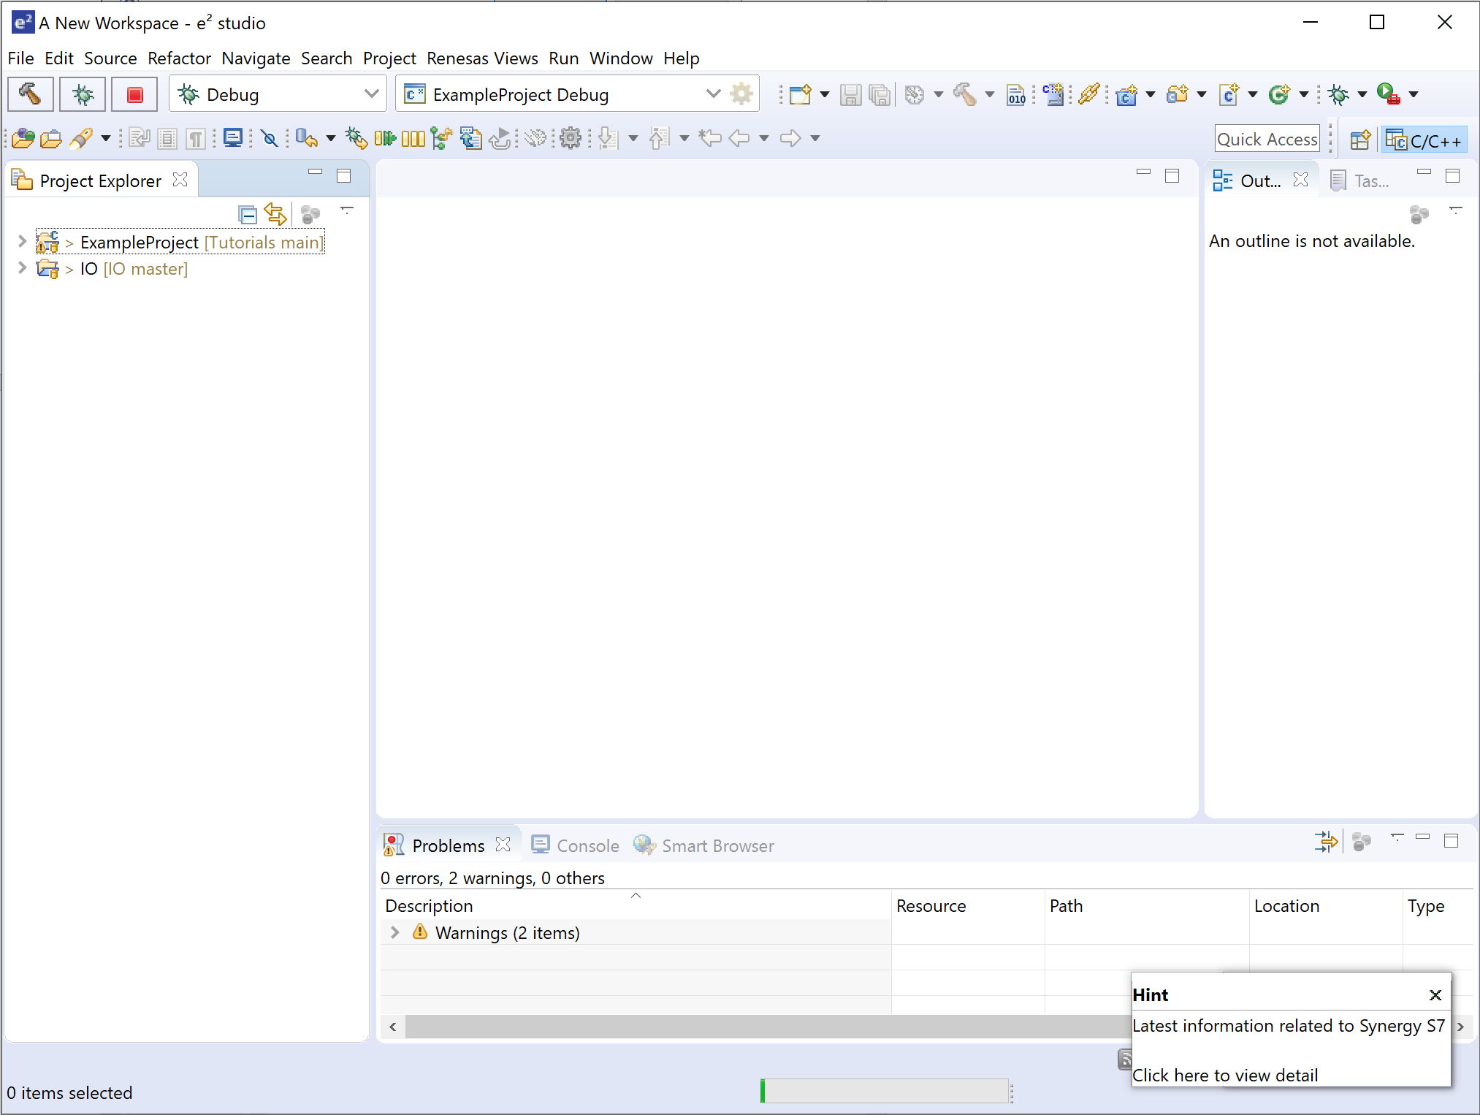

You are ready to proceed with the “ProjectCreationTutorial” example.