USB Device Project Tutorial

Project Creation and Setup

- Create a Renesas Synergy C Executable project. Click Next, and give it a name. Next...

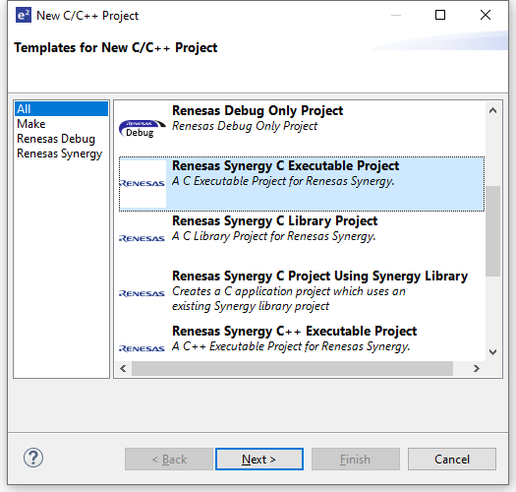
- Select the S7G2SK board. Next...
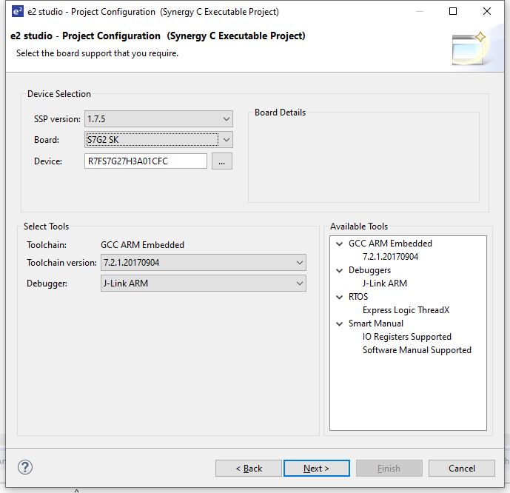
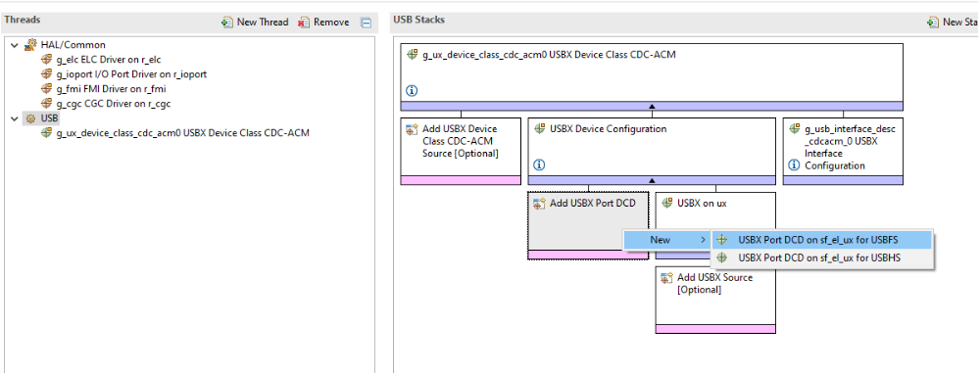

- Copy the supplied configuration.xml file into the project root directory. You can do this either by drag-and-drop from Windows Explorer, or by right-click → Import → File System.
- Open the configuration.xml file. You should see the view in Fig X. Note: by default e2 will open the configuration.xml file when you create a new project, so you will probably have to re-open it to see the new one.
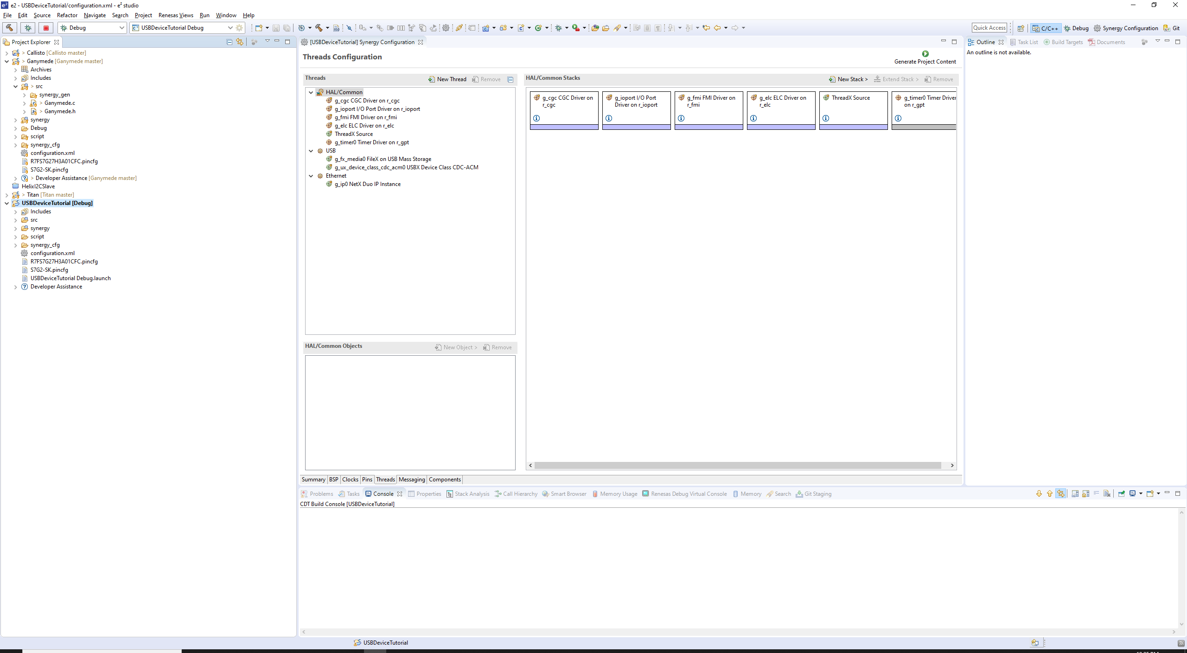
- Now, you will notice that there are Ethernet and USB threads. If you click on the USB thread, you should see the following:

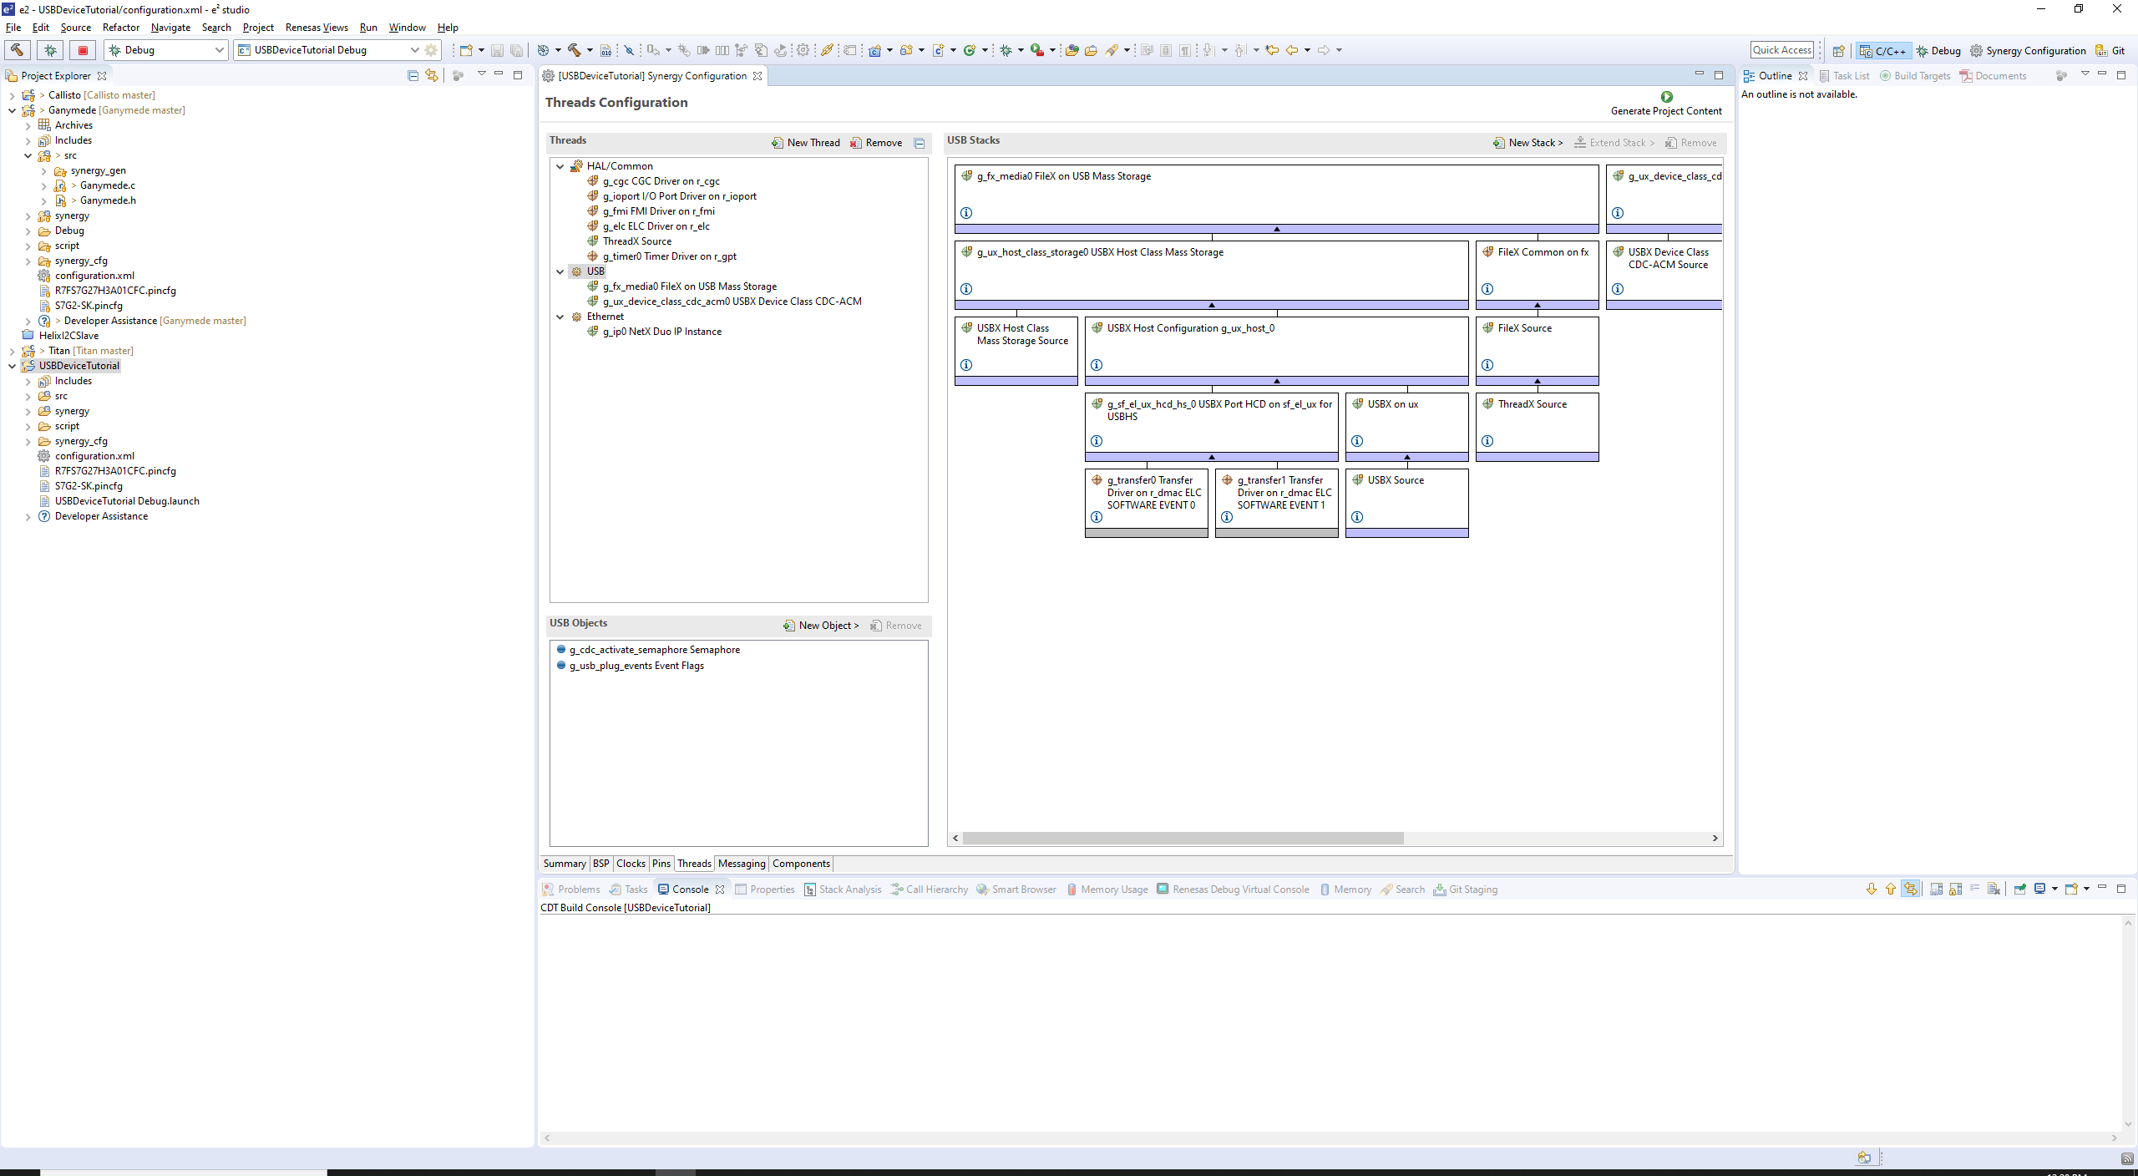
6. Here you can see that there is a USB Host and USB Device stack. The configuration at this point is in its default state with every peripheral available. You can either leave these things as they are, or remove any peripherals or threads that you don't need. Simply use the Remove buttons in the Threads and Stacks views as appropriate.

- At this point everything can be left as default. Some settings you may want to change for your own purposes. If you review the USBX Device Configuration properties, you will settings like Vendor ID and Index of Product String Descriptor. These settings affect the device information that Windows or other systems read when the device is connected. This and other settings have no affect on communications and will be left to the reader to review as desired.
- Generate Project Content...

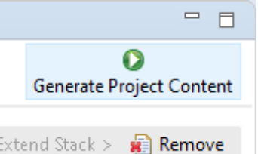
Adding the Ganymede Library and Headers
The Ganymede library contains a variety of functions necessary for the operation of each interface. These include functions for setup and initialization, callback functions, communications, etc... In the case of our USB Device interface the peripheral requires callback functions in order to properly interact with another device, like a PC. When the MCU is connected to a PC with Windows 10, for example, Windows should automatically recognize it as a USB Serial Device, install the correct drivers, and create a COM port device which can be used for communication. The callback functions facilitate this.

To include the Ganymede library into the project, follow the following steps:

- Right-click on the project, and go to Properties → C/C++ Build → Settings → GNU Arm Cross C Linker → Libraries. Add a new library named “Ganymede”. Next, add the “IO/lib” workspace directory to the list of search paths. The following figure is what should be seen after this:

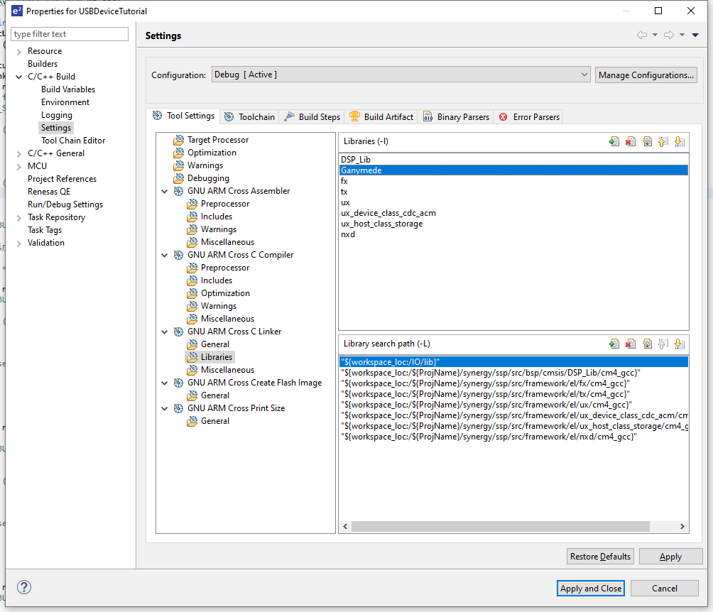
- Go to the GNU ARM Cross C Compiler → Includes, and add the “IO/inc” workspace directory, as shown in the following figure:

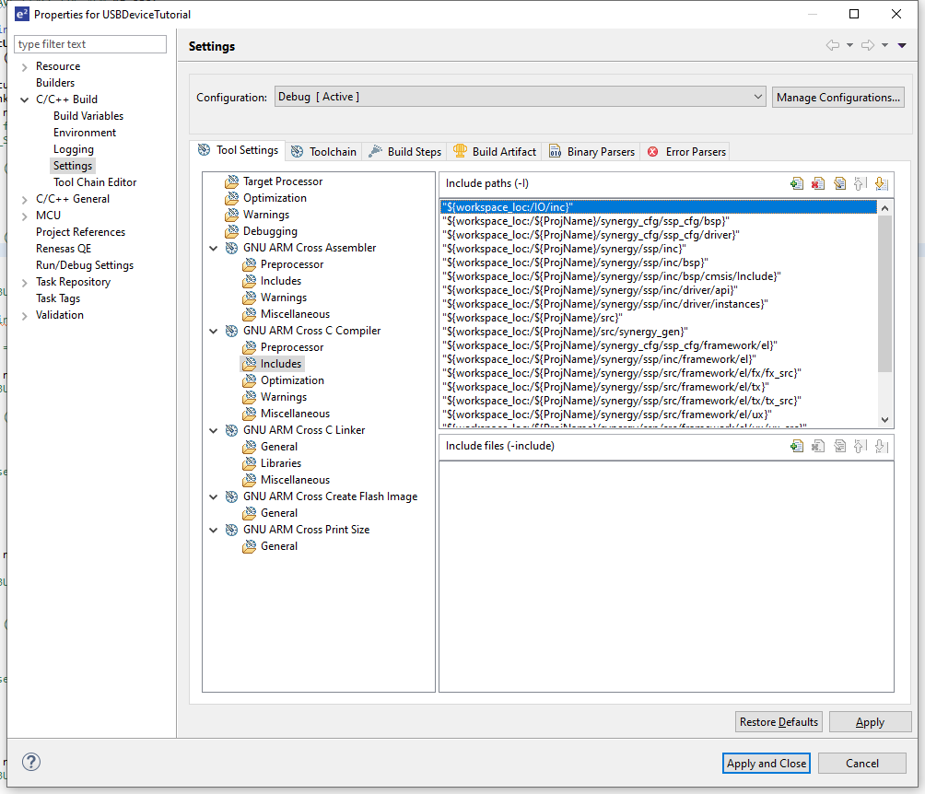
The Ganymede library and header is now available to your compiler.

Callback Functions, Reading, and Writing
First, we'll add the necessary callback functions. The USB Device peripheral requires callback functions in order to properly interact with another device, like a PC. When the MCU is connected to a PC with Windows 10, for example, Windows should automatically recognize it as a USB Serial Device, install the correct drivers, and create a COM port device which can be used for communication. The callback functions facilitate this.

Go to the

