Svpply description:

**Svpply helps you find the products you love, from the people and stores you find interesting.**

* Every one of the 1.1 Million products in our [Shop](https://svpply.com/shop) section has been selected   
  by hand by one of our members, and brought to our site using our [bookmarklet](https://svpply.com/extras/buy_later).
* We bring in a little over 3,000 new products a day from all across the web.
* We unofficially represent over 70,000 stores and brands. We are actively working towards giving them access to their inventory and their audience.   
  (If you’re a store owner, [read more here](https://svpply.com/store_faq))
* In September of 2011, Svpply joined the [eBay NYC family](http://www.ebaynyc.com/).

Problems screen shot;

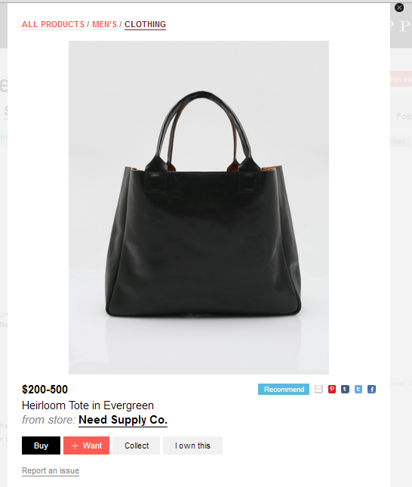

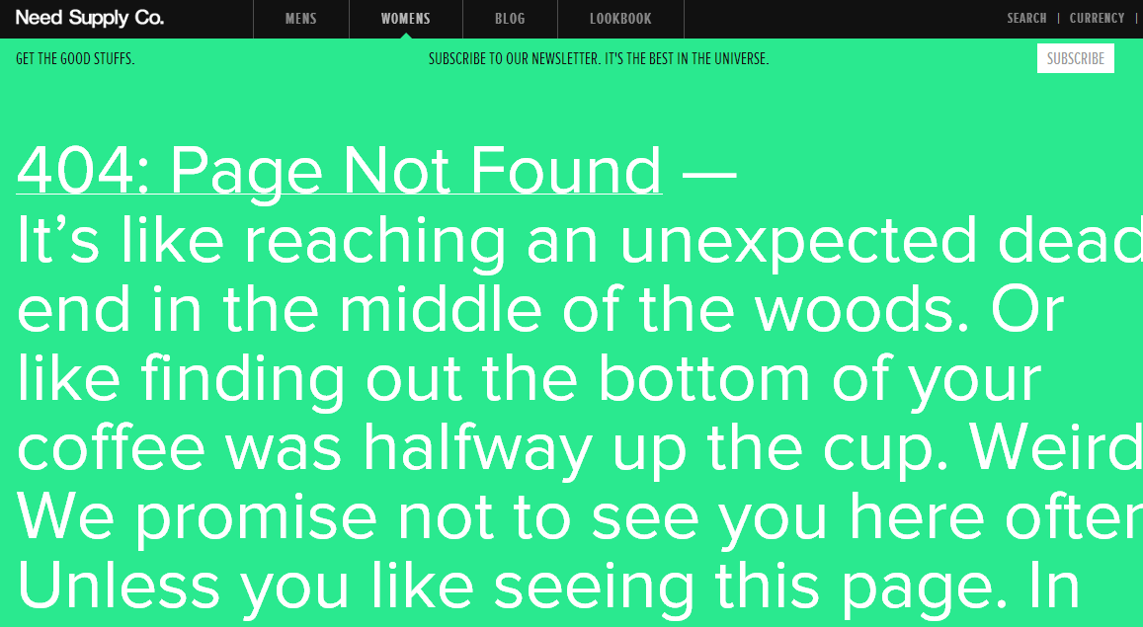

Solution description;

* Page type detection:

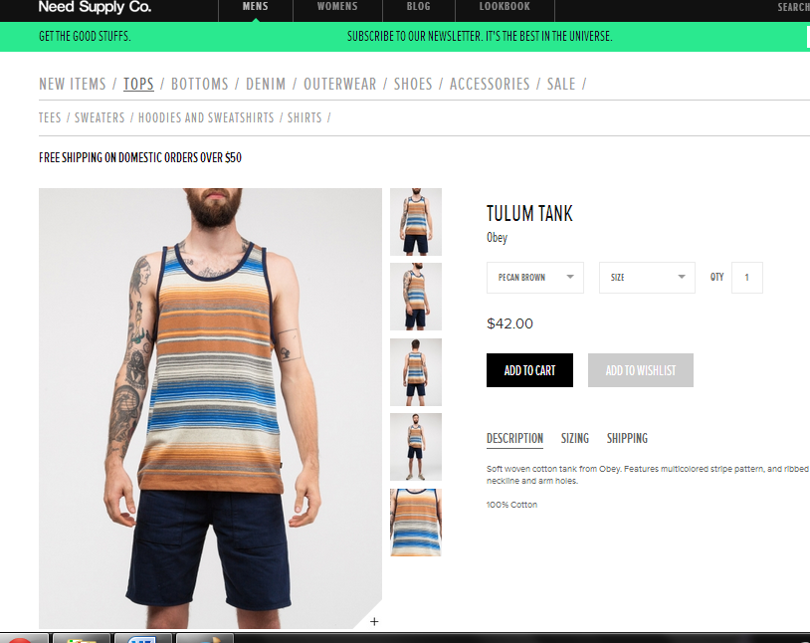

Single product page

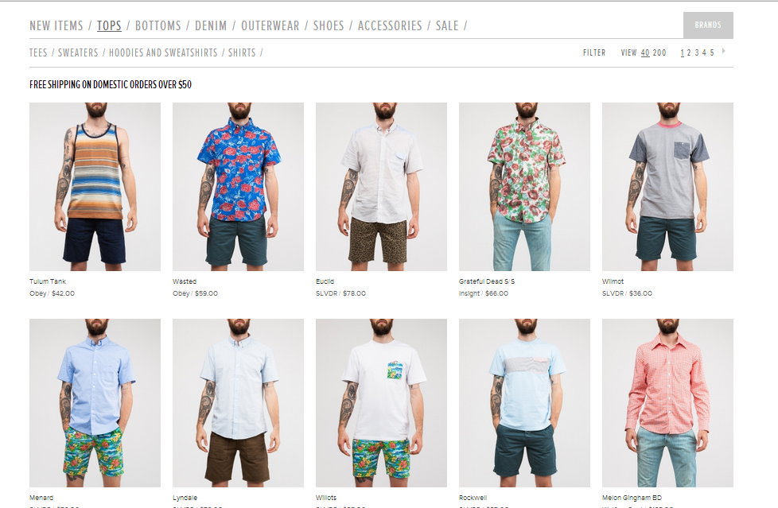

Product list page

Users can add products from either product list page or single product page. We develop a way to detect the type of web pages and using different weighting systems for different page type since these two kind web pages have very different structures.

* Xpath compare

We found product list page has different structure with single product pages. In most cases, in product list page, price and product image are under the same div and in single product pages are not. We add a factor to compare xpath to find out the price share same div with the product image if the page is product list page.

* Position factor:

For Product list page, we add a new factor that consider if the price is under the product image. For some cases, original script catch the price above the product image which is the price of another product since it only consider visual distance and the price above the image is closer. But, in our research, we never see a web page label product above the product images.

* Balance weighting systems

For different web pages, we adjust the weight systems. For product list page, we add weight of xpath compare factor, reduce weight of if the price is bold, since in product list page, bold prices are always shipping fees. For single product page, we add weight of visual distance factor and delete the factor of if image and price are in the same dom since in most of time, price and image are in two different div.