Svpply description:

**Svpply helps you find the products you love, from the people and stores you find interesting.**

* Every one of the 1.1 Million products in our [Shop](https://svpply.com/shop) section has been selected   
  by hand by one of our members, and brought to our site using our [bookmarklet](https://svpply.com/extras/buy_later).
* We bring in a little over 3,000 new products a day from all across the web.
* We unofficially represent over 70,000 stores and brands. We are actively working towards giving them access to their inventory and their audience.   
  (If you’re a store owner, [read more here](https://svpply.com/store_faq))
* In September of 2011, Svpply joined the [eBay NYC family](http://www.ebaynyc.com/).

Problems screen shot;

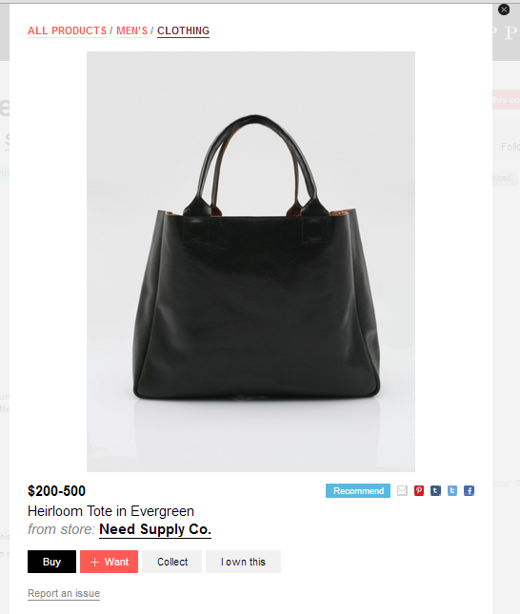

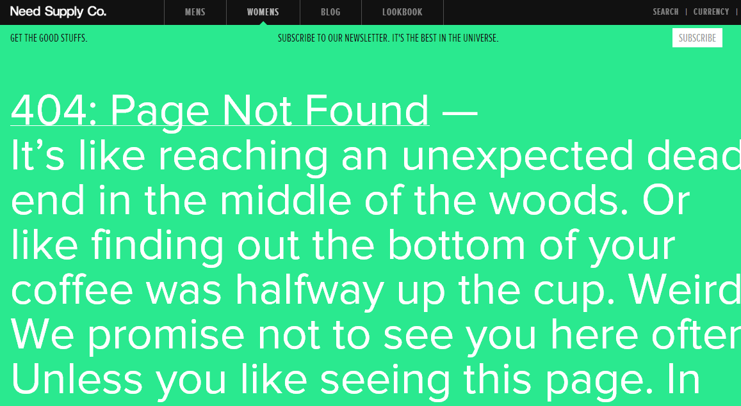

Solution description;

* Page type detection:

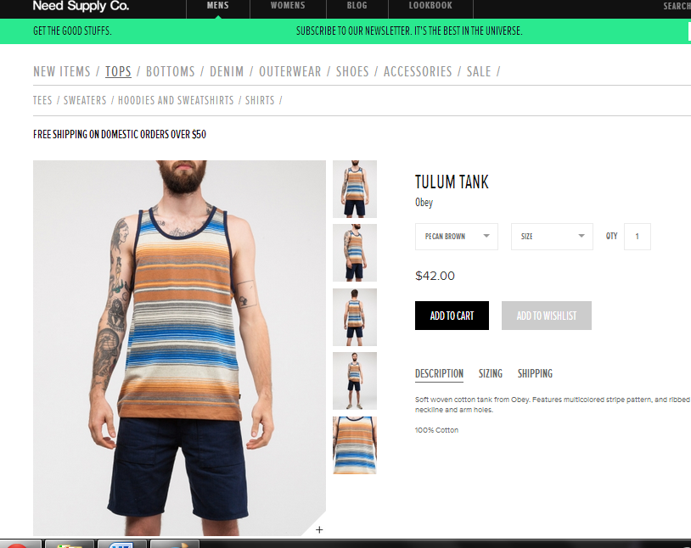

Single product page

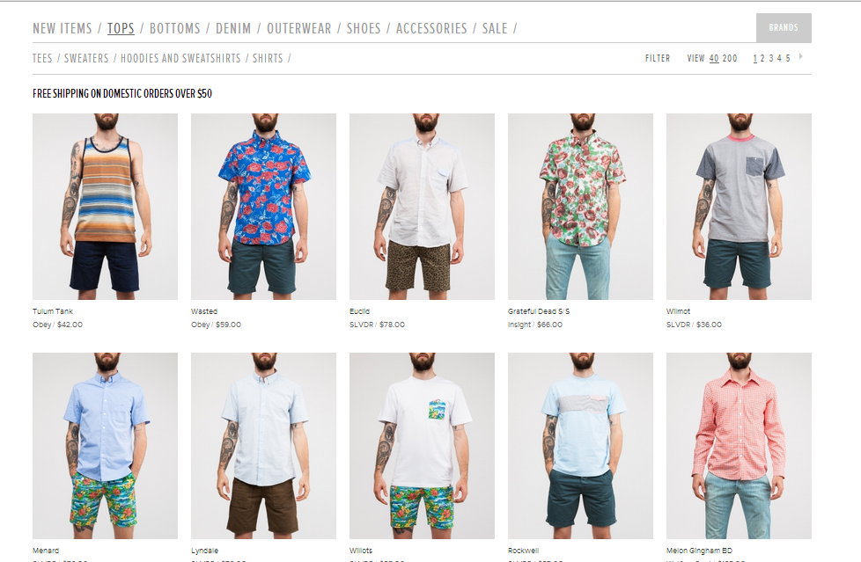

Product list page

Users can add products from either product list page or single product page. We develop a way to detect the type of web pages and using different weighting systems for different page type since these two kind web pages have very different structures.

My recommendation: Detects whether the product was added from a web page containing the single product or a list of products.

* Xpath compare

We found that a product list page has a different structure when compared with a single product page. In most product list pages, the price and product image have the same XPath tree ancestor. This doesn’t usually happen for single product pages. We added a factor to compare Xpath to find out if the price share the same div with the product image if the page is product list page.

My recommendation: Ancestor detection, detects in a product list page if the price and product’s image share a common ancestor in the HTML tree.

* Position factor:

For a product list page, we added a new factor that considers if the price is under the product image. For some cases, original script catch the price above the product image which is the price of another product since it only consider visual distance and the price above the image is closer. But, in our research, we never see a web page label product above the product images.

My recommendation: A price’s relative position to product image. In the price finding algorithm for product list pages we give higher weight to prices located below the image.

* Balance weighting systems

For different web pages, we adjust the weighting systems. For product list pages, we added weight of Xpath compare factor, reduce weight of if the price is bold, since in product list page, bold prices are always shipping fees. For single product page, we add weight of visual distance factor and delete the factor of if image and price are in the same dom since in most of time, price and image are in two different div.

My recommendation: Redesign of weighting system. Besides the previously mentioned improvements, we changed the changed the weighting of prices based on font size and distance to product’s image.