Error case1 : No update info:

In svpply page: show a prodcut on sale with price range from 200-500USD.

In orignal page: show the product has already sold.

This is because, for non-API website, svpply has no way to update information of prodcuts.

We run spider frequently to check if the information in original websites updated.

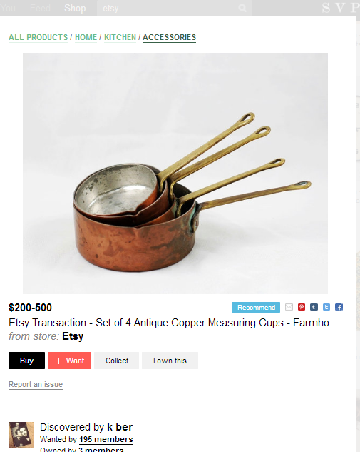

Error cases2:

When add a product from recommend list, the price caught by svpply script is the wrong price. The price it got, is the price of main product’s price.

We add weight of if image and price share a dom to avoid this error.

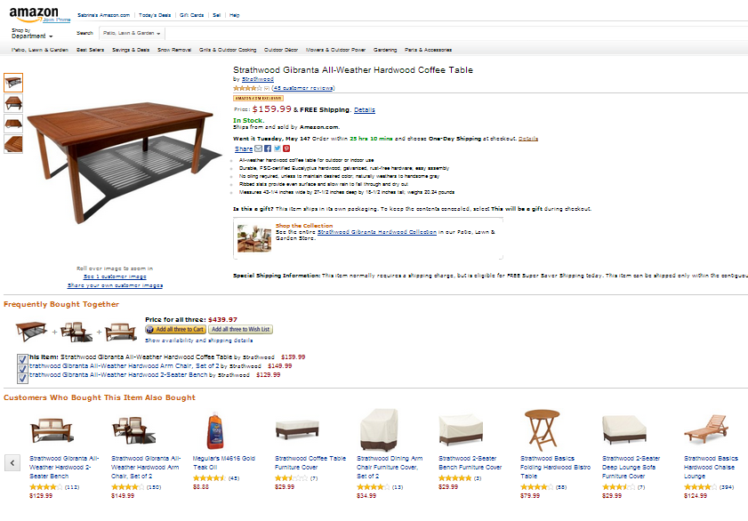

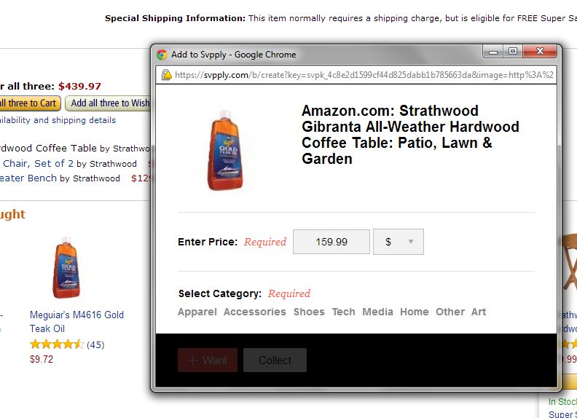

Error cases3:

In product list page, the original script caught the price above the product image since it is the closest price by visual distance.

We add a position factor which is consider if the price is under the image to avoid this error.

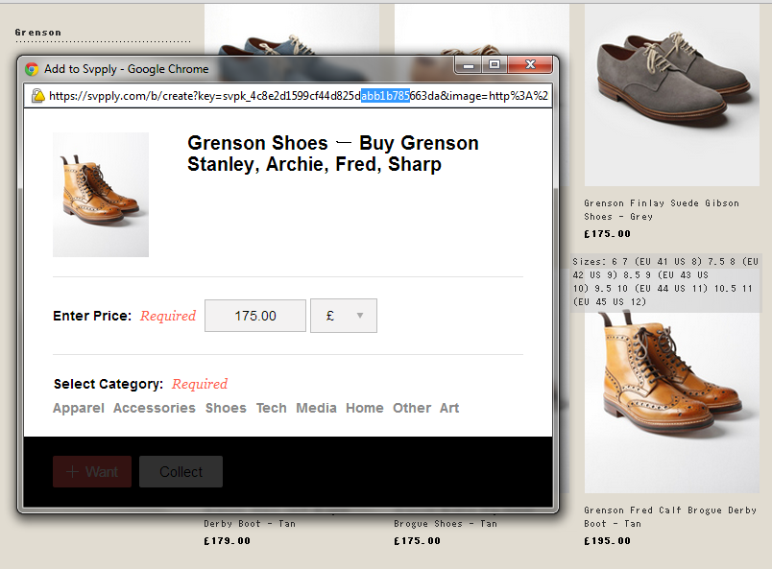

Error cases4:

In svpply page: show a prodcut on sale with price range from 200-500USD.

In orignal page: show the web page doesn’t exsites.

Svpply original script doesn’t test if web page is still available. To avoid this error, we send request to the website by given url, if the web page doesn’t existed, return a message.

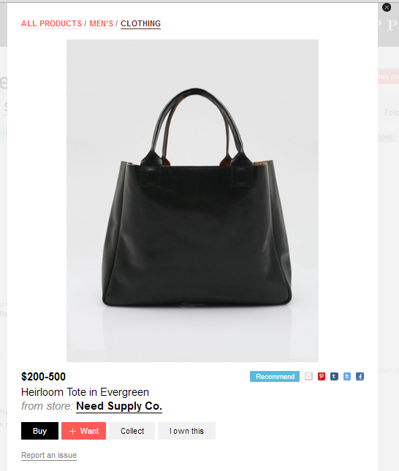

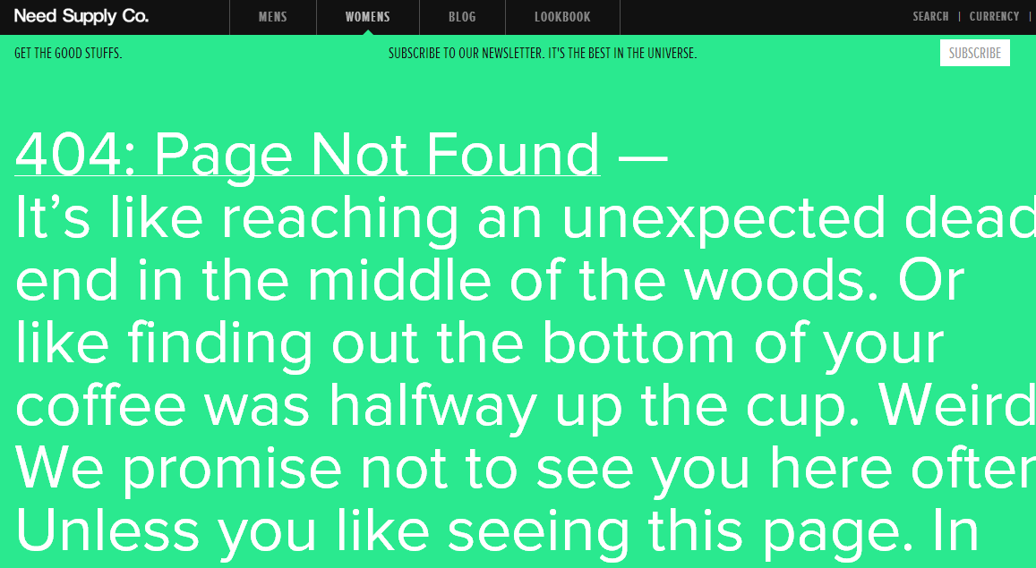

Error cases 5:

In product list page, when add a new product, svpply script catch the wrong price which is bold.

To avoid this error, we reduce the weight if the price is bold in product list pages.

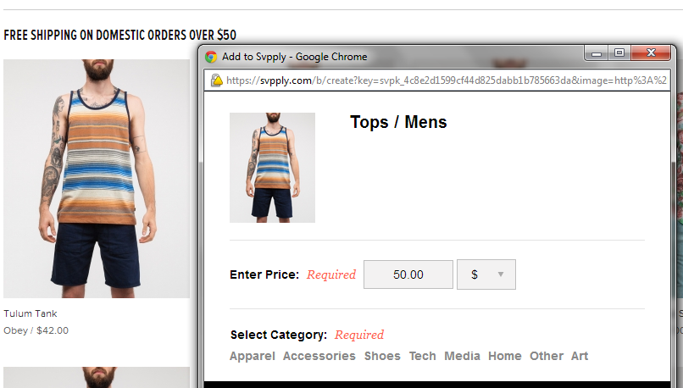

Error cases6:

In original svpply script, it prefer to choose lower price if several candidate prices available. This factor works on single product list page since cheaper one maybe the on sale one, but in product list page, cheaper one maybe is the neighbor product’s price. To avoid this error, we add weight if the image and price share one dom so that it can’t treat price outside the dom as candidate price.

