Extract OCLC numbers from MARC records received from partners (using Python script)

Exporting OCLC records:

Click on Batch 🡪 Enter Bibliographic Search Keys…

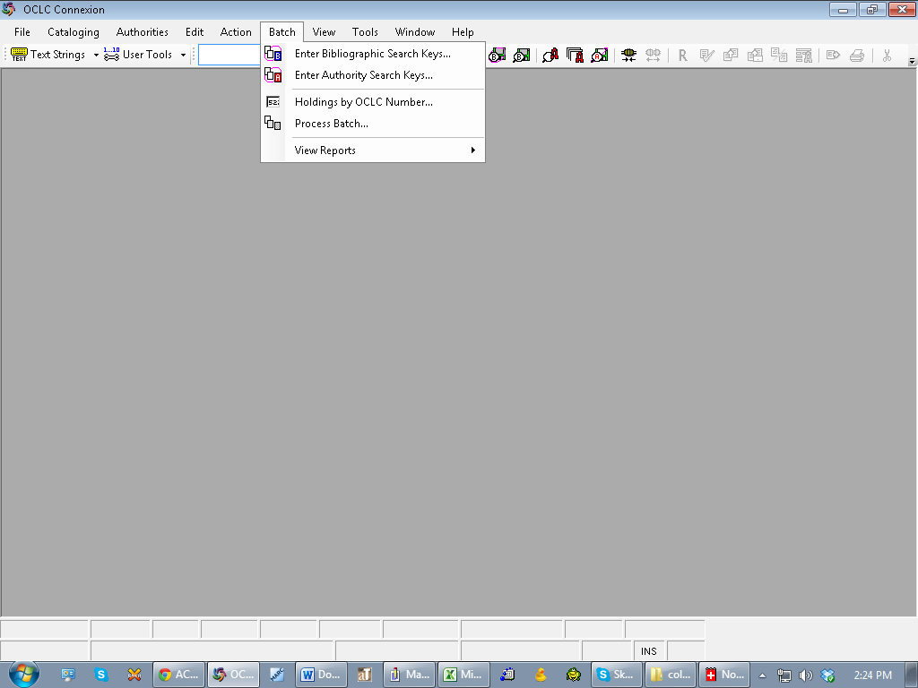

Click on “Local File Manager” and if it doesn’t already exist, create new .db file for the current batch of records titled “ACO.bib.db”

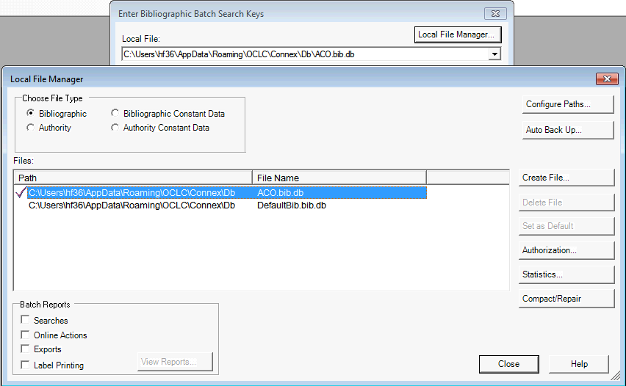

If needed, change the file in the drop down menu to ACO.bib.db

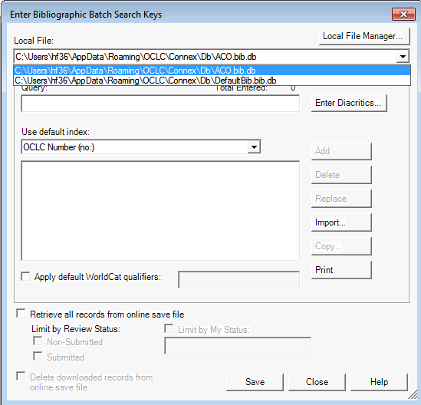

Import the .txt file of OCLC numbers to be searched and

Click on “NO” so that you don’t delete the .txt file, then click “SAVE” and “CLOSE”

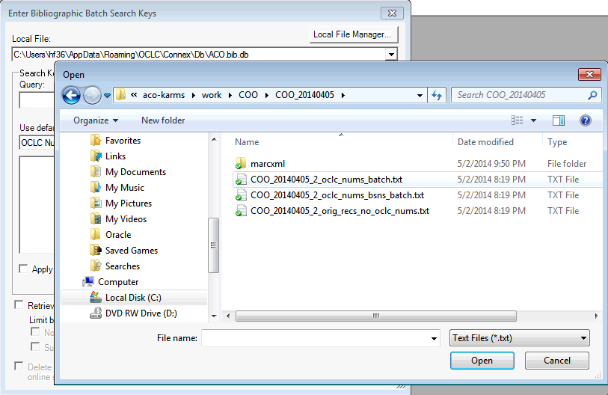

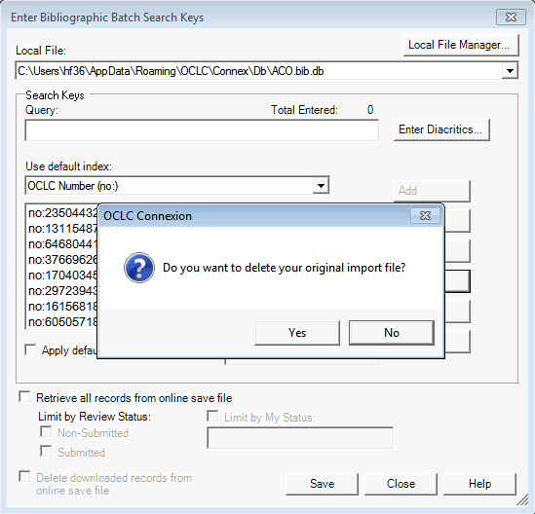

Go to Batch 🡪 Process Batch

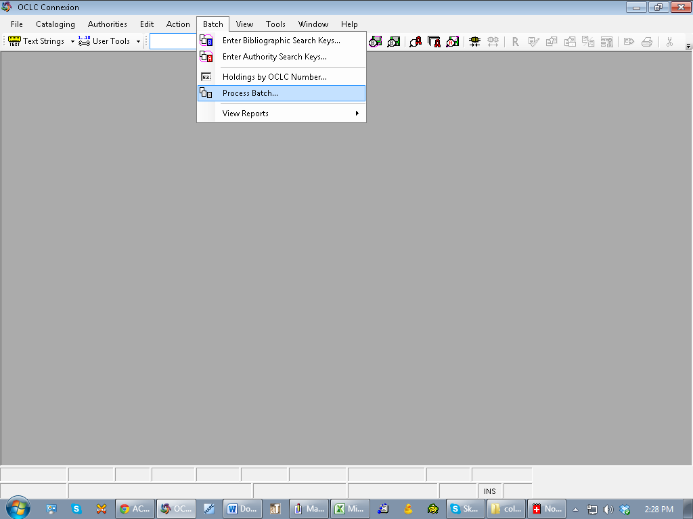

Select the Path for the newly created .db file and also click box for “Online Searches” then

Click OK to process the batch of records

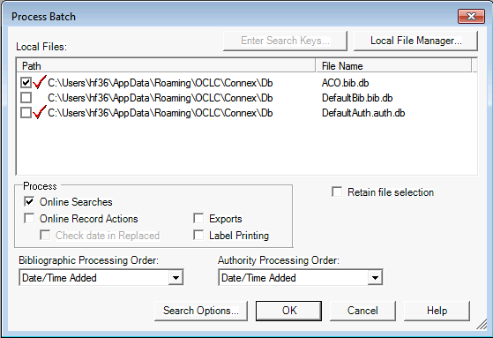

This adds the OCLC records that are found into the .db file and produces a report…

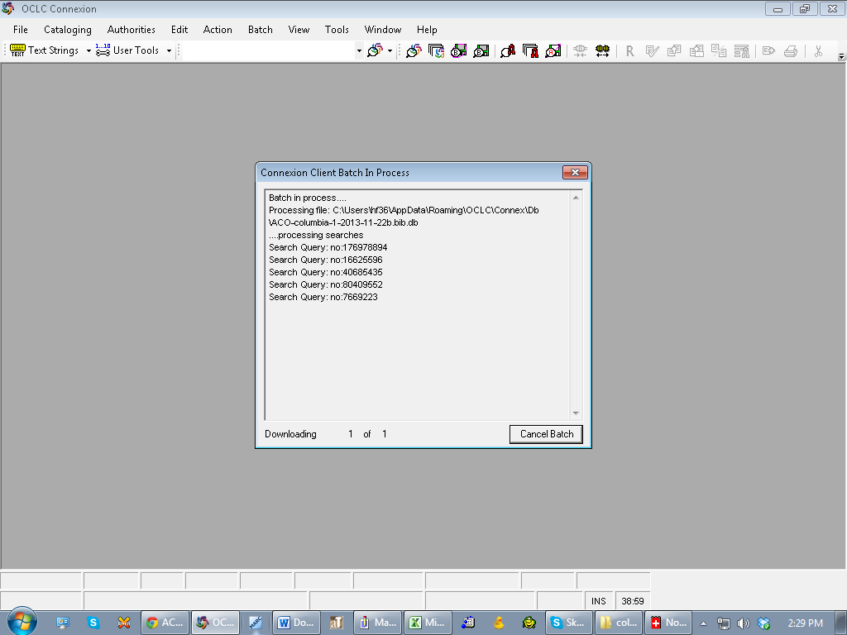

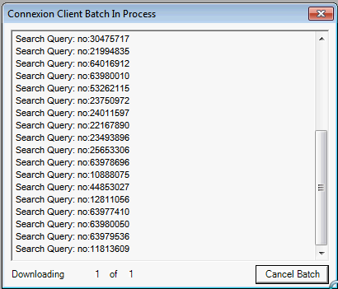

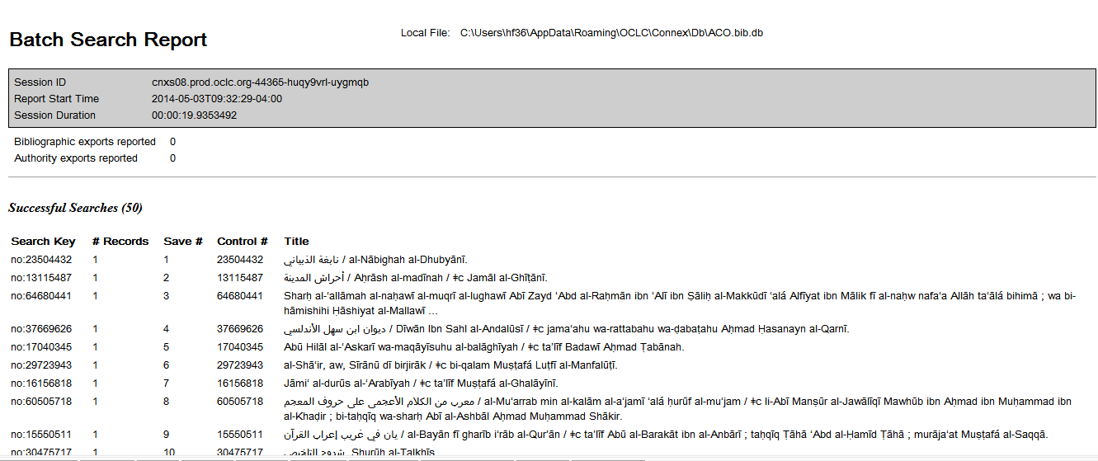

If there are errors:

Run a search of the local save file, specifying the ACO.bib.db local file you want to search (this causes individual files to save to this .db file automatically), then

Search for each of the error records manually and save them to the local save file (F4) (which will be ACO.bib.db)

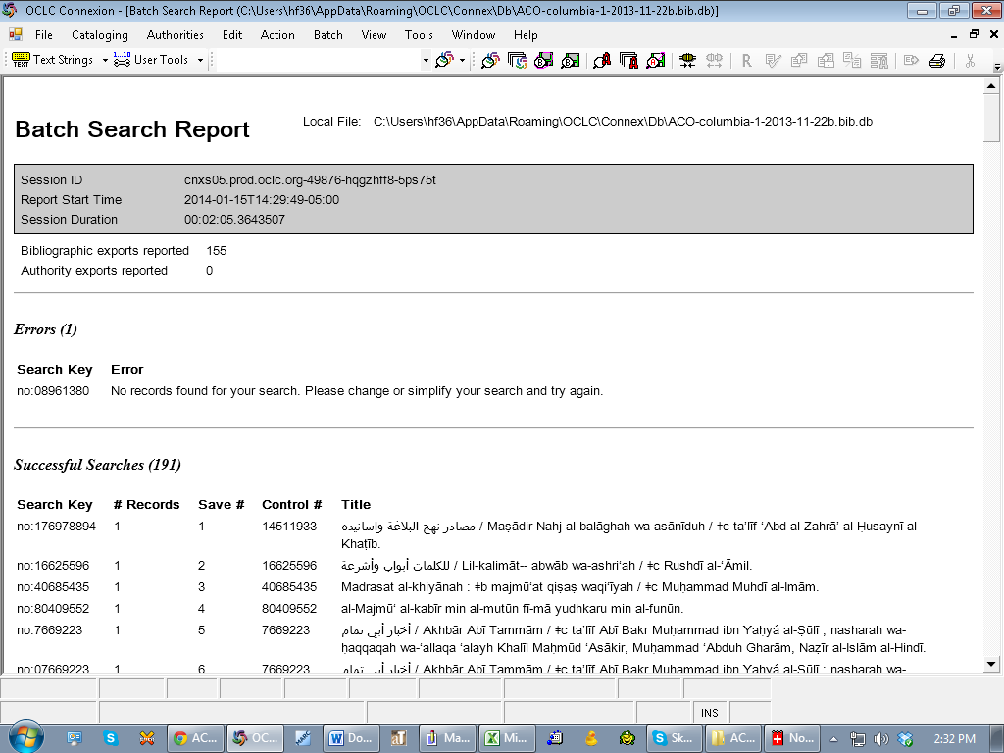

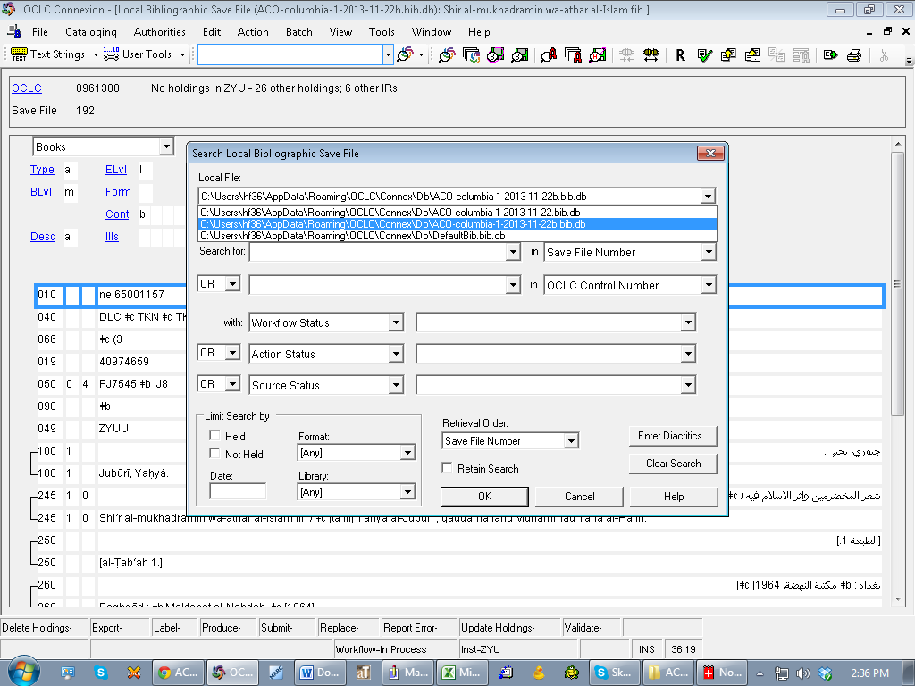

After manually saving any extra records to the .db file, perform another search of the local save file to update the results

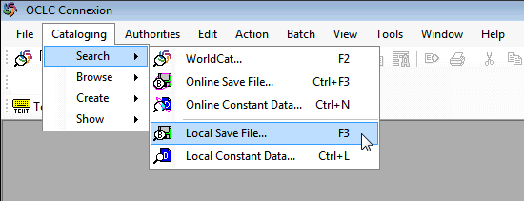

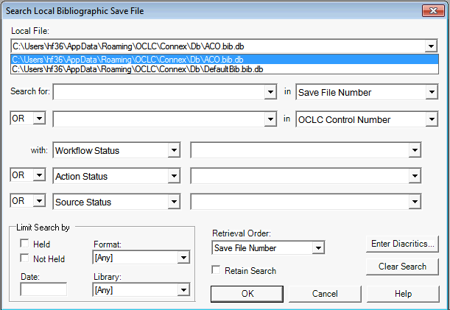

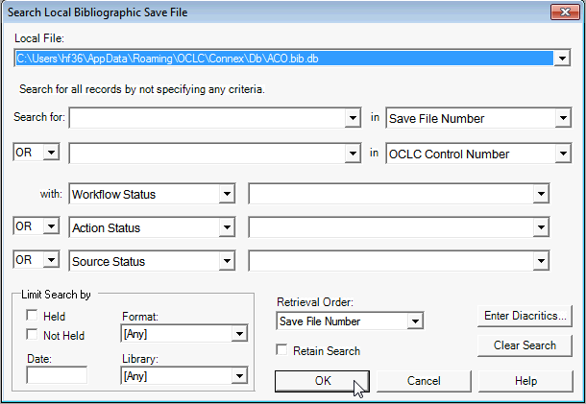

Just Click on “OK” without any search criteria to retrieve all the records in the ACO.bib.db file.

Select and highlight all the rows in the result set in order to export the MARC records.

Open Tools 🡪 Options to change the export settings

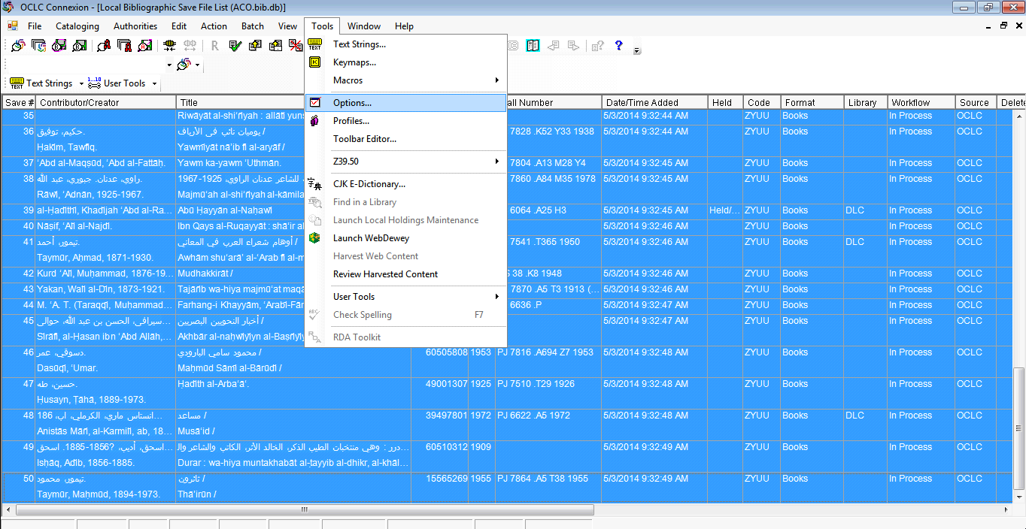

In the “Export” tab on the Options screen:

1. make sure “File (Prompt for filename” is selected for the Destination, and
2. Unclick the option to “Warn before exporting bibliographic records that include unlinked non-Latin script fields” so that all the records get exported automatically

Then click on “Apply” and “Close”

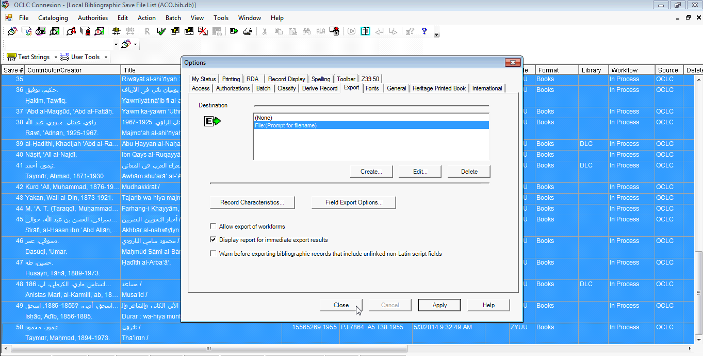

Make sure the previous .dat file is deleted or moved from the directory where the MARC file is being saved.

NOTE: Heidi’s computer is set up to save the file to:

N:/Technical Services/Common/ACO-Arabic Collections Online

Then, choose Action 🡪 Export (or F5) to process the MARC file of records

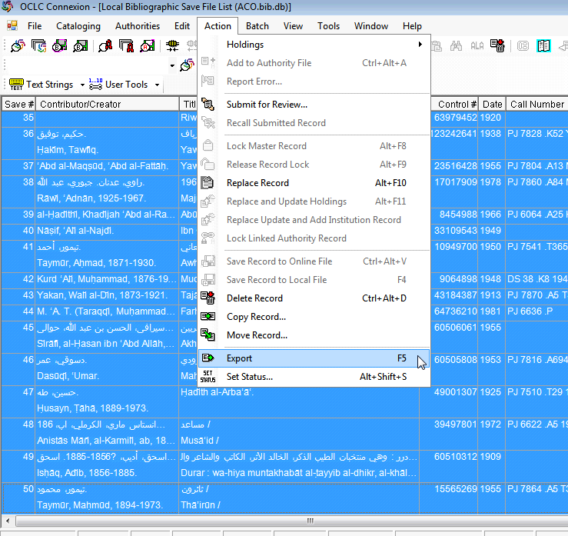

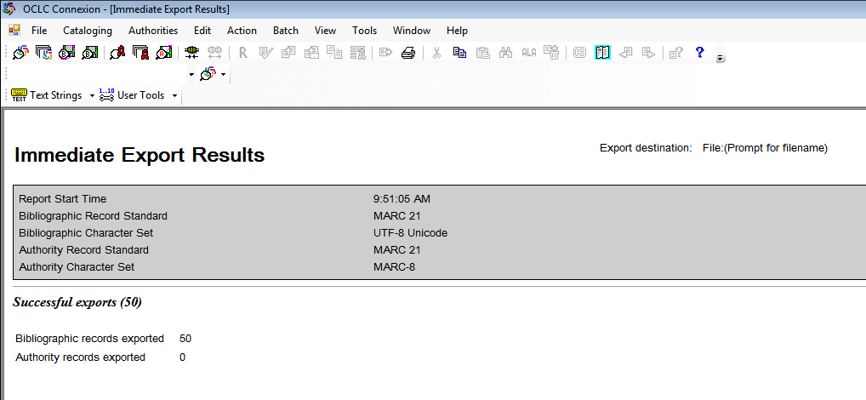

Navigate to the directory where the export file was saved.

NOTE: Heidi’s computer is set up to save the file to:

N:/Technical Services/Common/ACO-Arabic Collections Online/ACO_OCLC_export.dat

Change the name of the .dat file to match the batch name that was processed, and adding the following naming constant at the end and changing the extension from “dat” to “mrc”, for example:

COO_20140405_3_oclc_recs_batch.mrc

Move the file into the corresponding batch folder for the set that was processed, for example:

N:/TechnicalServices/Common/ACO-Arabic Collections Online/git_repos/aco-karms/work/COO/COO_20140405/COO_20140405_3_oclc_recs_batch.mrc

* In the next steps, AFTER Capturing only the linked records, make sure you clear out the Local Save File before running the next batch export. (see procedures below, after the enhancement process)

ENHANCING UNLINKED RECORDS:

Close the report screen, then go to Tools 🡪 Options and change the export settings to get the warnings for unlinked records.

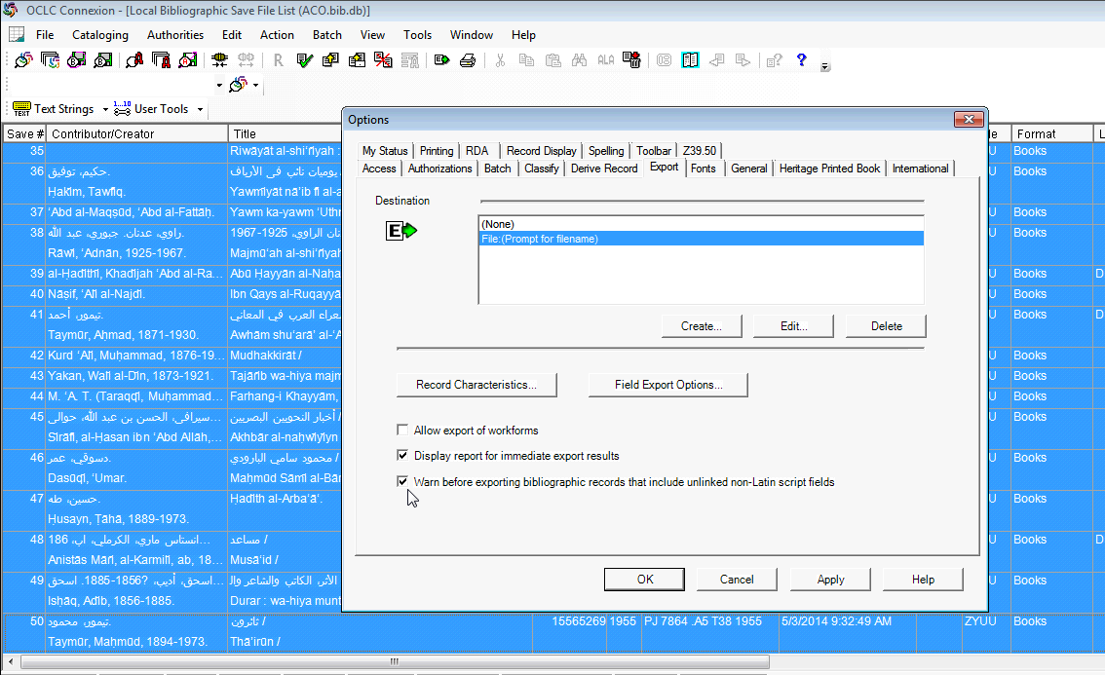

Run Action 🡪 Export on the result set again, clicking “NO” to skip each of the unlinked records – this provides a .dat file of MARC records for *only* those that have linked script fields

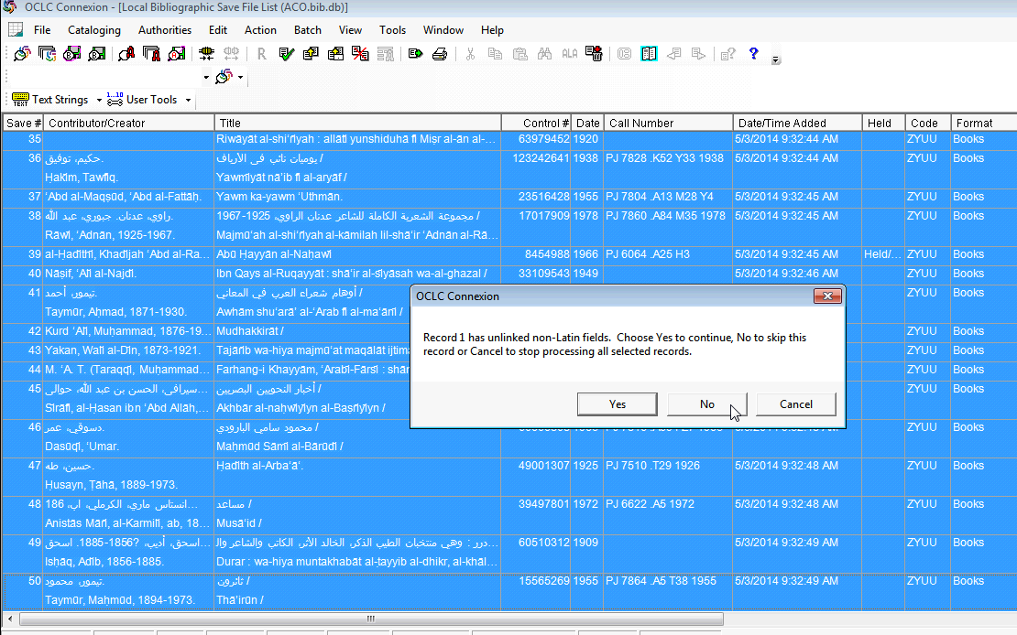

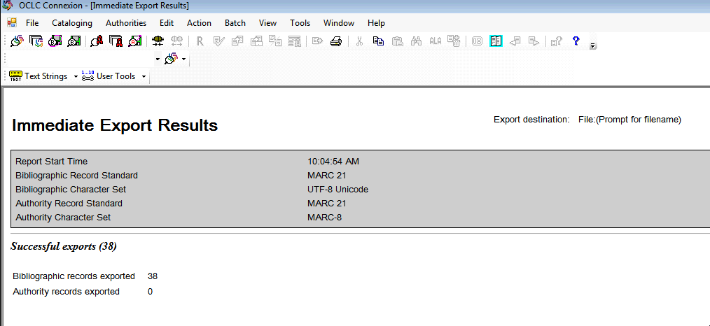

Again, navigate to the directory where the export file was saved.

NOTE: Heidi’s computer is set up to save the file to:

N:/Technical Services/Common/ACO-Arabic Collections Online/ACO_OCLC_export.dat

Change the name of the .dat file to match the batch name that was processed, adding the naming constant at the end, followed by “_linked”, for example:

COO_20140405_3_oclc_recs_batch_linked.mrc

Move the file into the corresponding batch folder for the set that was processed, for example:

N:/TechnicalServices/Common/ACO-Arabic Collections Online/git_repos/aco-karms/work/COO/COO_20140405/COO_20140405_3_oclc_recs_batch_linked.mrc

Process a comparison of the “all” file versus the “linked only” file in order to get a list of OCLC records that need to be linked.

**DELETING Records from the Local Save File:**

Perform a search of the local save file:





Select and highlight all the records in the Local Save File, then click on the Delete icon to remove them from the file:

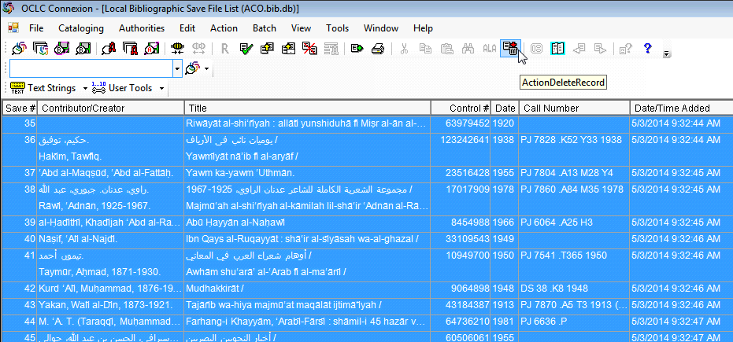

TO-DO:

Write Python code to compare set of all oclc records against linked oclc records to get list of unlinked records – pass on to Guy and Adham to fix in OCLC (need to determine if fixing master record or if saving to local save files and re-exporting)