The Impact of Binance Gold and Silver Perpetuals on ETF Markets: An Event Study

Abstract. We study whether the launch of Binance TRADFI gold and silver perpetual futures (XAUUSDT, XAGUSDT) on 5 January 2026 changed the volatility and liquidity of established gold and silver ETFs (GLD, SLV). Using a daily panel and an event-study design with pre- and post-event comparison, we find that ETF volatility and trading volume increased after the launch. When we control for macro factors (dollar index, VIX, and 10-year yield), the post-event effect remains positive and significant. Rolling correlation between ETF and Binance perpetual returns is high after the launch, consistent with price integration. Limitations include the absence of pre-event Binance data and the short post-event sample.

1. Research question
Did the introduction of Binance TRADFI gold and silver perpetual futures (XAUUSDT, XAGUSDT) change: (1) the volatility of gold and silver ETFs (GLD, SLV); (2) liquidity (volume, Amihud illiquidity); (3) price integration between ETF and perpetual? We have integration data only after the launch (rolling correlation GLD–XAU, SLV–XAG); we do not have pre-event Binance data, so we describe post-event integration only.
Event date: 2026-01-05. We test two hypotheses: H1 — ETF volatility increases after the launch; H2 — volume/liquidity changes (we expect volume to rise).

2. Why this story matters
Gold and silver are traded as ETFs (GLD, SLV) on regulated exchanges. In early 2026, Binance started listing perpetuals on the same assets (XAUUSDT, XAGUSDT). So there are two venues for exposure to the same thing. We ask: did the ETF market change after that? More volatile? More trading? More linked to the new venue? This matters for traders, market-makers, and regulators. Augustin et al. (2023) show that the introduction of derivatives can change spot markets—volatility, liquidity, and how prices move together.
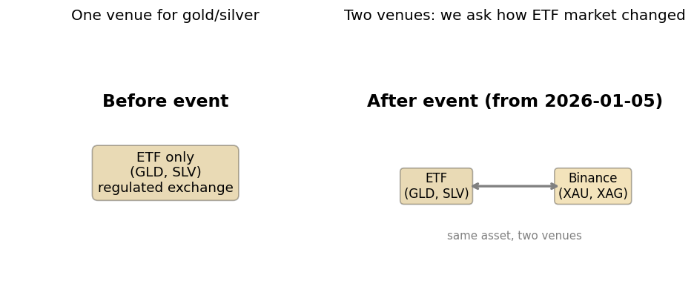
Figure 1: Before the event — one venue (ETFs only); after the event — two venues (ETFs + Binance perpetuals).

3. Data: sources and periods
Source | What we get | Frequency | Rows | Note
Binance API | XAUUSDT, XAGUSDT (OHLCV), funding, OI | 1m | 67k+ | From 2026-01-05 (XAU), 2026-01-07 (XAG)
Yahoo Finance | ETFs: GLD, SLV. Controls: DXY, VIX, TNX. GLD/SLV 1m | Daily; 1m last 7d | 118 daily | 1m only last ~7 days
FRED | DGS10 — 10Y Treasury (macro control) | Daily | in daily panel | Same role as TNX

Panels: Daily = 118 rows (event study, OLS). 1-minute = 67k+ rows (intraday analysis). Integration: post-event only (no Binance before 2026-01-05). DXY = dollar index; VIX = volatility index; TNX / DGS10 = 10Y yield. Used as controls in regressions.

4. How we use the data
Daily panel (features_daily.csv): 118 days × many variables. Used for event study—pre/post means, t-tests, OLS with post_event and controls (DXY, VIX, 10Y). 1-minute panel (features_1m.csv): one row per Binance XAUUSDT 1m candle, daily ETF/controls merged by date; used for intraday return distribution and daily realized vol from 1m. Minute-level correlation: last 7 days where Yahoo 1m (GLD/SLV) overlaps with Binance 1m—same-frequency correlation GLD–XAU, SLV–XAG. Integration (descriptive): rolling correlation in the daily panel; we report post-event level only.

5. Event and method
Design: Event study with pre/post comparison. No control group → we do not use difference-in-differences. Tests: (1) Welch t-tests (pre vs post); (2) OLS with outcome = volatility or liquidity, regressor = post_event + controls (DXY, VIX, 10Y). HAC (Newey–West) SE; winsorization 5%/95%. Why controls? DXY, VIX, 10Y capture general market conditions. By including them, the coefficient on post_event measures the effect of the listing itself, not just the market. Literature: Augustin et al. (2023) use DiD with treatment/control; we have a single market before/after, so we use pre/post + OLS with controls.
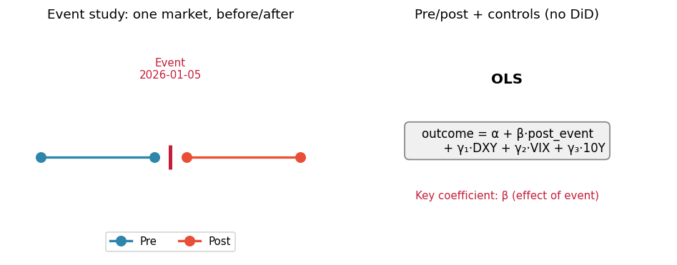
Figure 2: Event-study design — timeline (pre / event / post) and OLS specification (outcome = α + β·post_event + γ·controls).

6. Cumulative returns (ETFs vs Binance)
On the chart, higher line = higher cumulative return. Silver (SLV, XAGUSDT) outperforms gold (GLD, XAUUSDT) in this sample. After the event, all four series move together—that co-movement is the first visual evidence of integration. Binance series are plotted only from the launch date (no data before).
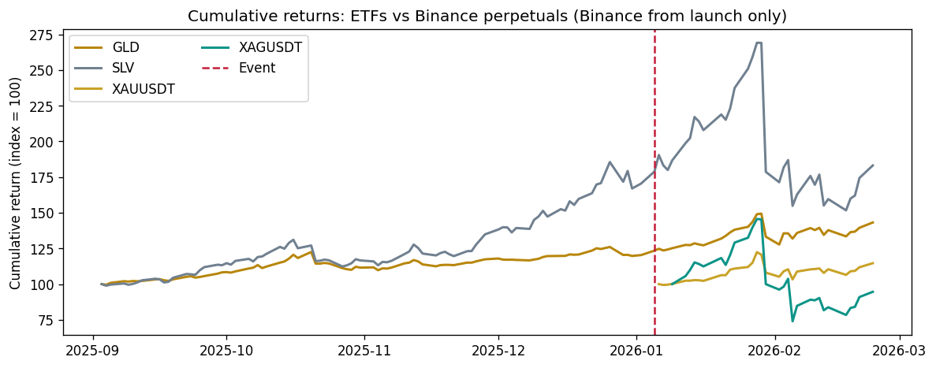
Figure 3: Cumulative returns (index 100). ETFs from first date; Binance perpetuals from launch date only. Silver (SLV, XAGUSDT) outperforms gold in this sample; all four series move together after the event.

7. Volatility and volume over time
Volatility and volume dynamics around the event—basis for H1 and H2. Silver (SLV) reacts more strongly: post-event, both realized and Parkinson volatility, and ETF volume, rise more for SLV than for GLD. Chart titles show percent growth (post vs pre) for each series.
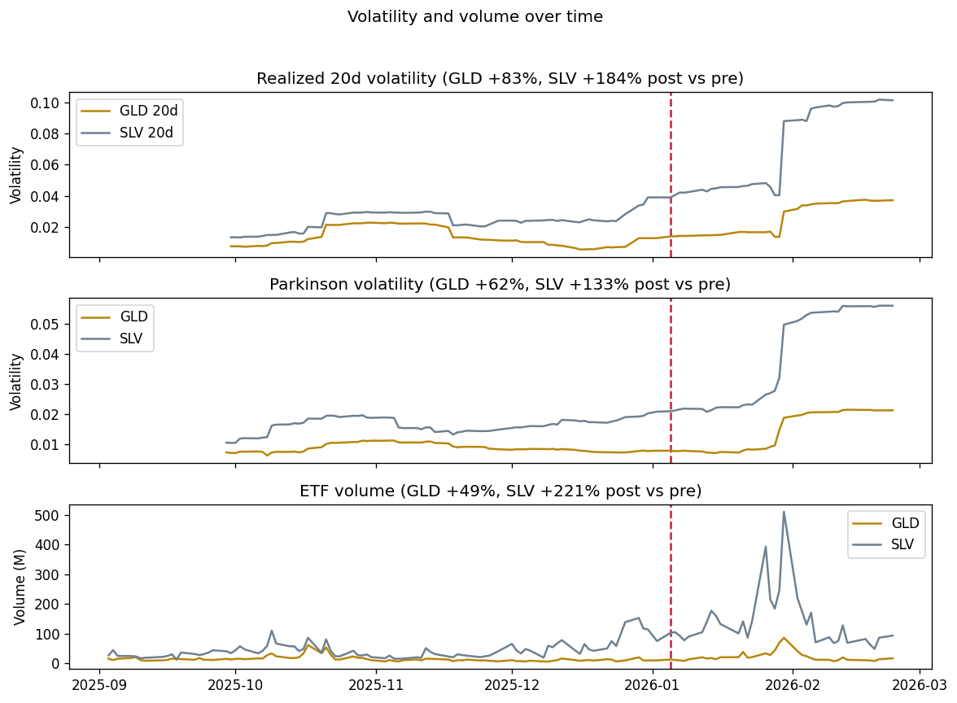
Figure 4: Realized 20d volatility, Parkinson volatility, and ETF volume over time. Vertical line = event (2026-01-05). Silver (SLV) reacts more strongly post-event.

8. Pre vs post: how much did each metric grow?
After the event, volatility and volume increase (positive %); silver (SLV) increases more than gold (GLD). We test whether these changes are statistically significant (two-sample Welch t-test: H₀ mean(post)=mean(pre)). Low p-value (e.g. p < 0.05) → reject H₀ → change is significant. We then control for macro in regressions.
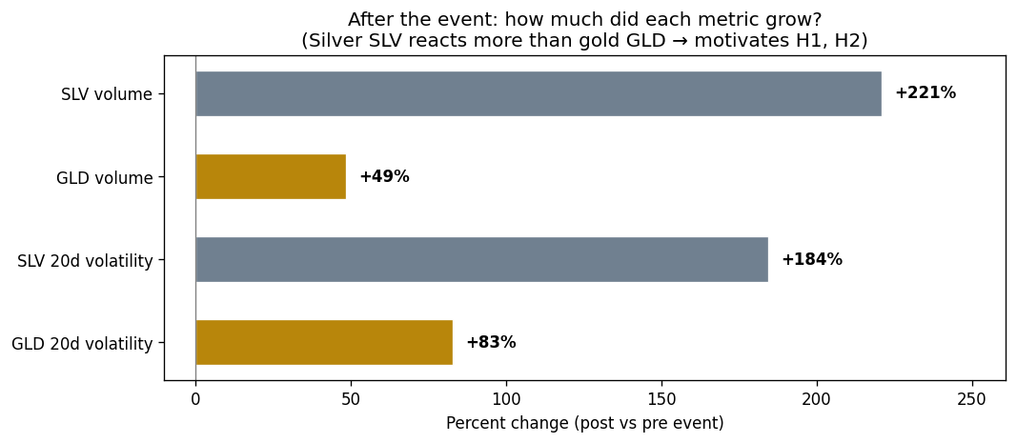
Figure 5: Percent change (post vs pre) for volatility and volume. Silver increases more than gold; same units (%) make the comparison clear.

Table 1: Pre/post means, percent change, t-statistic, and t-test p-value (first four metrics).
Metric | Pre mean | Post mean | Pct | t | t-test p
GLD 20d vol | 0.013439 | 0.024582 | +83% | 5.809 | <0.001
SLV 20d vol | 0.024114 | 0.068572 | +184% | 9.492 | <0.001
GLD volume | 15.123725 | 22.480038 | +49% | 2.377 | 0.0222
SLV volume | 43.889215 | 140.791356 | +221% | 5.913 | <0.001

9. Correlation matrix (key variables)
Pairwise correlations between returns (GLD, SLV, XAU, XAG), macro controls (DXY, VIX, 10Y/TNX), and realized volatility. Red = positive, blue = negative. High correlation between GLD and XAU (and SLV and XAG) in the post-event overlap supports integration; macro variables are used as controls in regressions.
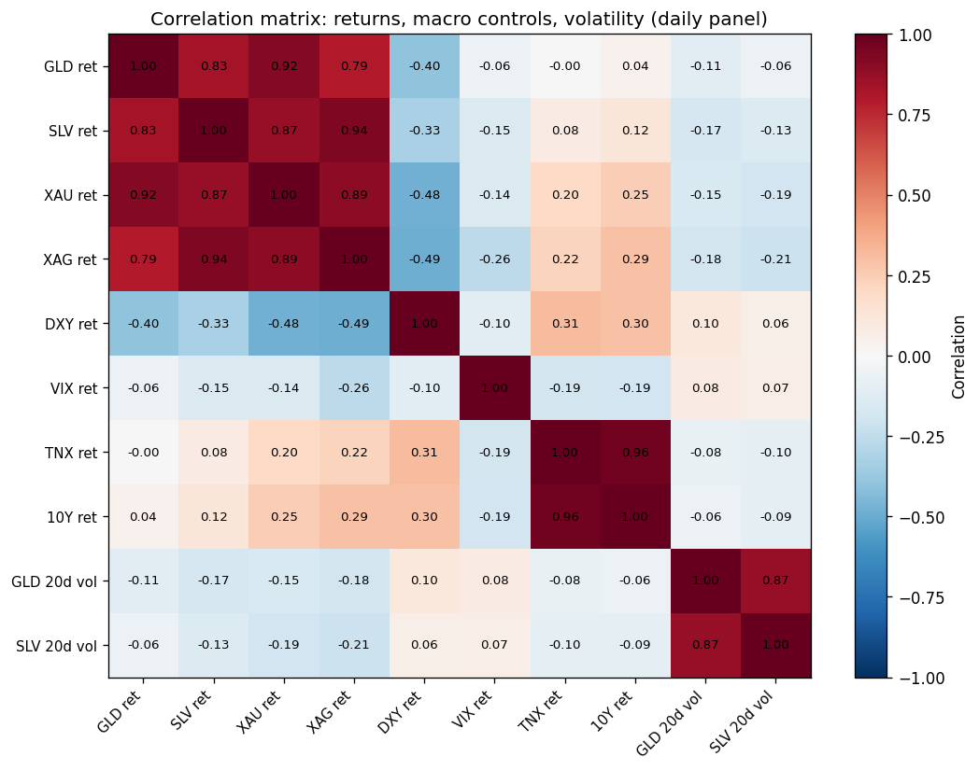
Figure 6: Correlation matrix of key variables — returns (GLD, SLV, XAU, XAG), macro controls (DXY, VIX, 10Y), and realized volatility.

10. Integration: do ETF and Binance perpetual move together?
Rolling 20-day correlation between ETF returns and Binance perpetual returns (GLD–XAU, SLV–XAG). We have data only after the launch; the first point appears ≈20 trading days after the event (rolling window). Values near 0.9–1.0 mean the two venues move in lockstep—one price-discovery process. We cannot test 'integration increased' because we have no pre-event Binance data; we describe the post-event level.
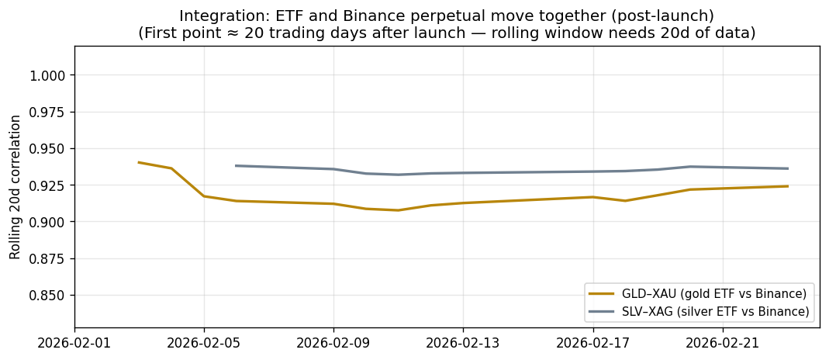
Figure 7: Rolling 20-day correlation between ETF and Binance perpetual returns (GLD–XAU, SLV–XAG). Data only after launch; first point ≈20 trading days (rolling window). High values = integration.

11. Regression results
Key result: Positive and significant coefficient on post_event in volatility regressions (GLD and SLV) when we control for DXY, VIX, 10Y → H1 supported. So the rise in volatility is attributed to the listing, not to general market moves. Volume higher post-event → H2 supported (direction). The table below reports pre- and post-event means, percent change, t-test (t-statistic and p-value), the OLS coefficient on post_event, and the regression p-value for that coefficient (HAC standard errors). Corr GLD–XAU and Corr SLV–XAG have no pre-event values (—) because Binance did not list before the event; their post-event means are our price-integration summary. Higher ETF volatility need not mean chaos—it can reflect more hedging and informed trading across the two venues.
Table 2: Key results — pre/post means, percent change, t-test, OLS post_event coefficient and regression p-value.
Metric | Pre mean | Post mean | Pct | t | t-test p | post coef | reg p
GLD 20d vol | 0.013439 | 0.024582 | +83% | 5.809 | <0.001 | 0.011 | 0.008
SLV 20d vol | 0.024114 | 0.068572 | +184% | 9.492 | <0.001 | 0.0435 | 0.0
GLD volume | 15.123725 | 22.480038 | +49% | 2.377 | 0.0222 | — | —
SLV volume | 43.889215 | 140.791356 | +221% | 5.913 | <0.001 | — | —
Corr GLD–XAU | — | 0.918119 | — | — | — | — | —
Corr SLV–XAG | — | 0.934662 | — | — | — | — | —

12. Conclusions
The listing of Binance gold/silver perpetuals is associated with higher ETF volatility and volume (H1, H2 supported when we control for macro). The two venues move together after the launch—integration is high where we can measure it. New derivatives on a new venue can shift incumbent markets; the story is similar to Bitcoin futures (Augustin et al.).
Findings: Volatility and volume up post-event (t-tests and OLS with DXY, VIX, 10Y). Rolling correlation GLD–XAU, SLV–XAG high after launch. Who cares: ETF market-makers, arbitrageurs, regulators—two venues, one price-discovery process.
Limitations: No pre-event Binance data (no 'integration increased' test); no control group (no DiD); short post window—more data would help. Despite these caveats, the consistency of t-tests and OLS with controls supports the view that the listing is associated with the observed changes in ETF markets.

References
Augustin, P., Rubtsov, A., & Shin, D. (2023). The impact of Bitcoin futures on spot markets. Management Science.

