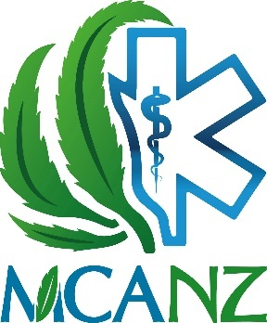Medical Cannabis Awareness NZ

“MCANZ”

*“Green Fairies” are a symptom of unmet demand*

On Newshub’s 6 o’clock news last night, it was revealed 2 of the larger compassionate supplier’s aka “Green Fairies” are being prosecuted by the police, to the detriment of hundreds (potentially thousands) of patients.

**“With over 140k people estimated to use Cannabis at least *sometimes* for medical purposes illicitly, it is no surprise that there are a growing number of compassionate suppliers in both quantity, and scope of their operations”**

**“with the continued failure at the political level to resolve legal supply of safe sterilized Cannabis based products that a sickness beneficiary can actually afford, these people will be seen as martyrs and heroes to the patient community, and unfortunately it reflects poorly on the police”**

**“The police seem quite able to turn a blind eye to the dealing of Class B Cannabis based products if your name was Helen Kelly, however the mere act of cultivating a C drug is viewed as a heinous crime that is beyond police discretion”**

**“Police Discretion is an empty promise by Politicians to dodge the issue, Police I have dealt with fear setting a precedent by exercising discretion”**

Says MCANZ Coordinator Shane Le Brun

MCANZ would like to see a political solution far more ambitious and detailed than provided by either of the major parties. We look to Canada as an excellent example to follow, where Cannabis products are so affordable that less than 2% of Medical Cannabis users seek permits to grow their own.

**“Cannabis-based products are relatively simple, It’s just another Essential Oil”**

**“The Current regime ensures that only expensive products will be vaguely available, and that means patients will continue to break the law, often with the support of their specialists, and making criminals of otherwise law-abiding citizens”**

**“The costs are so high that I am aware of GPs and Specialists that are referring patients to “Green Fairies”**

**“This is a direct response to increasing acceptance of its medical benefit, and the refusal to accept the cost of Sativex which is borne solely by patients”**

Says MCANZ Coordinator Shane Le Brun

The domestic market in Canada is considered by MCANZ to be the closest model to ideal, where products are prescribed by GPs, and the cost per mg of active ingredients are 80% less of what is paid in New Zealand currently. Nevertheless, MCANZ is committed to advocating for patients for legal access in the current system, which can take over a year of advocacy to gain approval under the non pharmaceutical scheme and then months extra again to arrange import.

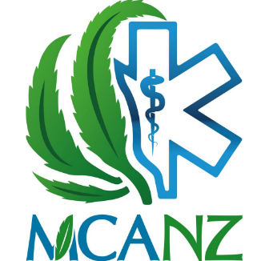

*Shane Le Brun*

Medical Cannabis Awareness Coordinator

[shane@mcawarenessnz.org](mailto:shane@mcawarenessnz.org)

[www.mcawarenessnz.org](http://www.mcawarenessnz.org)

0275818305