**MIDTERM PROJECT**

2019311923 오나현

1. **Introduction**

The title of this website is Lucy, which is my English name meaning the same with my Korean name. I used that name because I wanted to make my own customizing page with various service, I usually use through my smart phone. Knowing that the difference between mobile application and web application and advantages of each, I just hoped to implement all applications through web. Therefore, the purpose of this project is to make customizing web page that provides services such as self-PR page, daily planning and blog, gallery with favorite photos, calendar and some management pages like member registration page and log-in page.

During the project, I tried to use the most of everything I had learned through the Web-programming classes, of course this result submission has a little shortcomings like not providing back-end services. I also focus on componential functions, design, and responsiveness (which is important for web-site) rather than its specific contents (like contents of blog post). Another main reason of the chosen theme of my midterm project is good scalability to the larger web applications providing more services. Not ending this project as a one-time project, I hope to develop it by myself with adding more necessary services, making the website more three-dimensionally and so on.

This document includes overall descriptions and details of my website, and some available evolution.

1. **Constraints**

Since I used title favicon in the head side, this can be supported in most browsers except IE lower than 10.

|  |
| --- |
| * Figures above is from main.html, but all html file has those code for head icon in the head tag. |

1. **Overall View**
2. **Prototype**

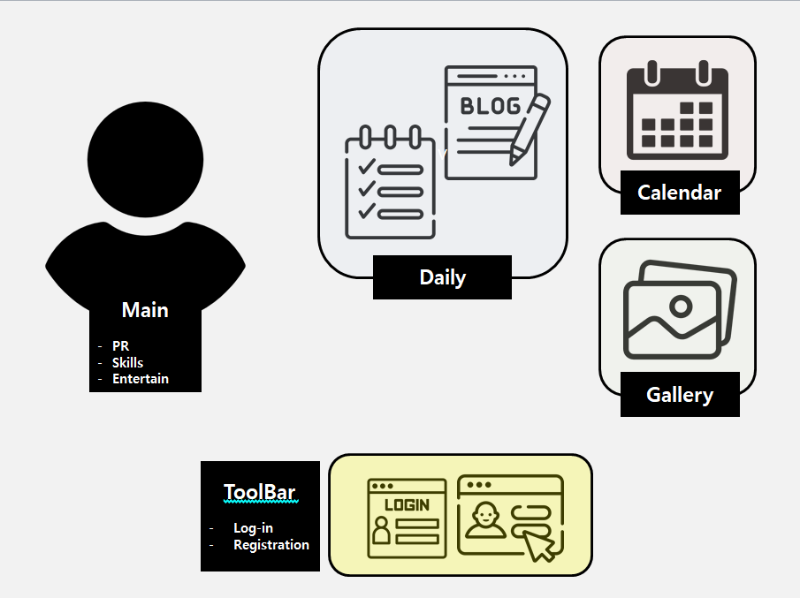

1. **Submission Description**

|  |  |
| --- | --- |
|  | 1. Common Style    * base.css 2. Main page    * main.html    * main.css 3. Services folder   : provided services is written   * + Daily { blog.html blog.css }   + Gallery { photo.html photo.css }   + Calendar { calendar.html calendar.css }  1. toolBtn folder   : some management applications from tool bar on the right side of header   * + Member Registration   { registration.html registration.css }   * + Log-in { log-in.html log-in.css }  1. Images Folder   : some image files I used during the project   1. Problem2 Folder   : submission file and used reference images for Problem2 |

1. **Details**
2. **Common Features**

The common styling features such as main colors, font-family and etcs used in all linked pages are organized in one file, base.css file. The components are following.

* + Overall, I utilized various text-style attributes such as color, text-align, text-decoration for underlining, text-transform for uppercase and etcs.

1. **Header**



* + Used font-family from 1st Google Font is following.

|  |
| --- |
| font-family: -apple-system, BlinkMacSystemFont, 'Segoe UI', Roboto, Oxygen, Ubuntu, Cantarell, 'Open Sans', 'Helvetica Neue', sans-serif; |

* + On the left side, there is a logo. If you click this, you can move to the Main page.
  + On the right side, there is a toolbar with <img> tag. The details is described in the next section.
  + These are displayed with flex box. (space-between)

1. **Toolbar and Dropdown**
   * This is designed according to Week7 Assignment Problem2.
   * When you hover your mouse pointer on the toolbar icon image, then the following dropdown will be shown.

|  |  |
| --- | --- |
|  |  |

* + You can see the current user account and some basic managing tools such as Log-out, Registration, Settings, and Get help. Tools are all made with <a> link tag but only Log Out and Registration are linked to other page when clicking.
  + When you hover your mouse on each text, you can see the change of text-color.

1. **Footer**
   * Image(Multimedia) of Skku logo and some descriptions of each page for footer contents are used.
   * Responsiveness is applied as following.

|  |  |
| --- | --- |
| Normal  for PC |  |
| @media screen and (max-width: 768px)  For tablet and mobile phone |  |

1. **Main page**

The 1st main page you can visit. You can move to other service pages from this page (from nav).

* This page is following the basic (semantic) html form as followed.
  + Responsiveness is applied as following.

|  |  |
| --- | --- |
| Normal  For PC |  |
| @media screen and (max-width: 768px)  For tablet |  |
| @media screen and (max-width: 480px)  For mobile |  |

1. **Header**

Referencing **A. Header** part

1. **Nav**

You can move to other service pages.



* + Implemented with <a> tag and <ul>.
  + These are displayed with flex box. (space-between)
  + Responsiveness is applied under the width of typical mobile phone.
  + When you hover your mouse on each text, you can see the change of text-color and background-color.

1. **Main (Content)**

You can use this main part as Search + self-PR page + Entertaining playground.

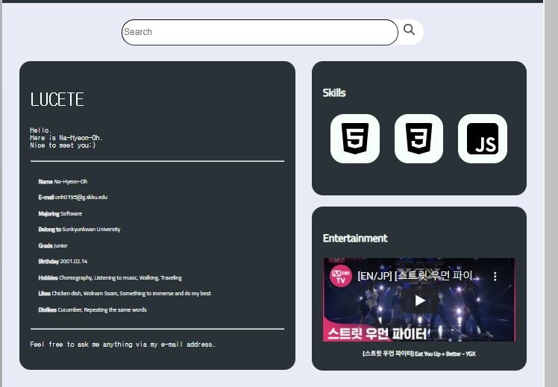

* + Introduction part and { Skills + Entertainment } part are displayed with flex box. (flex-start)
  + Through the Search box, you can enter some wondering search keyword and click search button to connect to Google. Here, I use <input> tag with text type and <img> tag with <a> tag.



This search box has responsiveness.

* + PR page is divided into greeting basic introduction and skills.

Introduction part would contain some information of user with greeting messages for visitors.

Here, I used typing animation on top of Introduction container.

And to express some detail information of user, I used following 2nd Google Font.

|  |
| --- |
| font-family: 'Cairo', sans-serif; |

Skills part is place for explaining what skills do we have.

When you hover your mouse on each text, you can see the animation of each svg images regarding skills. The details are following.

|  |
| --- |
| .skill td :hover{  animation-name: round-shaped;  animation-duration: 2s;  animation-timing-function: linear;  animation-delay: 0s;  animation-iteration-count: infinite;  animation-direction:alternate-reverse;  animation-fill-mode: none;  }  @keyframes round-shaped {  0% { transform: rotate(0deg); border-radius: 0%;}  10% { transform: rotate(10deg); border-radius: 10%;}  40% { transform: rotate(170deg); border-radius: 100%;}  50% { transform: rotate(180deg); border-radius: 100%;}  60% { transform: rotate(190deg); border-radius: 100%;}  90% { transform: rotate(350deg); border-radius: 10%;}  100% { transform: rotate(360deg); border-radius: 0%;}  } |

* + Entertainment part has video multimedia using <iframe> tag to show my recent favorite video.

The form is same with Skills part of PR page.

Under the video, you can see a simple description of that video. If you click it, you can link to the related youtube site. (since I used <a> tag)

Also, if you hover it, you can see the transition of the text. The details are followed.

|  |
| --- |
| .youtube a {  transition: width 5s height 5s border 5s, transform 5s;  }  .youtube a :hover {  color: var(--main-highlight-color);  transform: rotate(180deg);  -webkit-transform: rotate(180deg);  } |

* + Each title of Skills and Entertainment part use following 2nd Google Font.

|  |
| --- |
| font-family: 'Cairo', sans-serif; |

1. **Footer**

Referencing **A. Header** part

1. **Daily page**

You can read and write down your daily diary with your today's to-do check list.

* + Responsiveness is applied as following.

|  |  |
| --- | --- |
| Normal  For PC |  |
| @media screen and (max-width: 768px)  For tablet |  |
| @media screen and (max-width: 480px)  For mobile |  |

* + Font-family in main part is following 2nd Google Font.

|  |
| --- |
| font-family: 'Cairo', sans-serif; |

1. To-do Checklist
   * You can separately manage your done, and not-done list for your daily schedule.

|  |  |
| --- | --- |
|  |  |

* + Font-family on checklist label is following 3rd Google Font.

|  |
| --- |
| font-family: 'Architects Daughter', cursive; |

* This is implemented using <input> (checkbox type) and <label> tag with order and animation attributes. The details are following.

|  |
| --- |
| label {  …  order: 2;  animation: undone .5s;  }  input:checked + label {  order: 4;  animation: done .5s;  }  @keyframes undone {  0% {  opacity: 0;  transform: translateY(20px);  }  50% {  opacity: 1;  }  }  @keyframes done {  0% {  opacity: 0;  transform: translateY(-20px);  }  50% {  opacity: 1;  }  } |

Therefore, if you click any checkbox below the Not Done part, you can make it remove to the Done part and vice versa is also available.

1. Daily Diary
   * This is divided into 2 parts.

First is meta part including main image of that post, author, written dates, and some related tags.

Another is post part that contains actual diary contents such as title, subtitle, initial contents, and Read more button linking to actual posting site. Here, actual posting site and tag-linking site can be more developed IN THE FUTURE.

* When you hover your mouse on each meta elements, the emphasis by changing its background-color is shown.

|  |  |
| --- | --- |
|  |  |

* + Font-family on post contents is following 3rd Google Font.
  + This diary part has responsiveness.

|  |  |
| --- | --- |
| Normal  For PC | * These are displayed with flex box. (space-between) * Using overflow-y property to hidden, diary post contents would be safely shown on the display. |
| @media screen and (max-width: 768px)  For tablet and mobile | * Block property is used to display attribute to make post contents under the meta contents. * When it comes to mobile environment, the image can be oversize so I use overflow property to prevent the image go over the frame. |

1. New Post
   * This is implemented with <a> tag with <img> tag. Therefore, if you click this, you can move to other posting form site. This can be EXTENDED IN THE FUTURE.
   * Position attributes has fixed property so that, regardless of your location on the current page, it would be shown in the same, fixed position.

* When you hover your mouse on this image button, you can see the animation. The details are following.

|  |
| --- |
| .post_btn :hover{  animation-name: round-shaped;  animation-duration: 2s;  animation-timing-function:ease-in-out;  animation-delay: 0s;  animation-iteration-count: infinite;  animation-direction:alternate-reverse;  animation-fill-mode:both;  }  @keyframes round-shaped {  0% { transform: rotate(0deg); border-radius: 0%;}  10% { transform: rotate(10deg); border-radius: 10%;}  40% { transform: rotate(170deg); border-radius: 100%;}  50% { transform: rotate(180deg); border-radius: 100%; transform: scale(1.05,1.05);}  60% { transform: rotate(190deg); border-radius: 100%;}  90% { transform: rotate(350deg); border-radius: 10%;}  100% { transform: rotate(360deg); border-radius: 0%;}  } |

1. **Gallery page**

Not only gallery service, you can also add author name and some hashtags regarding your photo for each one. You can link to the related page through the hashtag.

* + Each image item contains image itself, title, author, related tags and etcs.
  + Main Responsiveness considering display size, each font size and so on is applied as following.

|  |  |
| --- | --- |
| @media screen and (min-width: 1500px)  Most biggest display | * +  Column-count is 8. |
| @media screen and (min-width: 1320px)  Big display | * + Column-count is 6. |
| Normal  For PC | * + Column-count is 4. |
| @media screen and (max-width: 960px)  Usually For tablet | * + Column-count is 3. |
| @media screen and (max-width: 630px)  Usually For mobile | * + Column-count is 2. |

* For being more concentrated on the picture what you are looking at, when you hover your mouse on each image frame, you can see the transformation. The details are following.

|  |
| --- |
| .grid-item:hover {  transform: scale(1.05, 1.05);  z-index: 1000;  } |

|  |  |
| --- | --- |
|  |  |

* Tags of each photos can be linked to related site IN THE FUTURE.

Also, when you hover it, you can see some change effects on background-color.

|  |  |
| --- | --- |
|  |  |

1. **Calendar page**

Basically, it provides today's date and when you hover your mouse on, you can check which should be done at that dates. Additionally, there are some services providing weather and time, and if you click add button on the bottom side of calendar card, you can add your plan.

* + Responsiveness is applied as following.

|  |  |
| --- | --- |
| Normal  For PC |  |
| @media screen and (max-width: 768px)  For tablet |  |
| @media screen and (max-width: 480px)  For mobile | * + When you use mobile environment, the removal of images related to time and weather is shown. |

* + Grid property is applied as following to locate each day and dates in the grid format.

|  |
| --- |
| .calendar_card {  …  display: grid;  grid-template-rows: 8rem auto 10rem;  …  }  …  .card_body-dates {  display: grid;  grid-gap: 3px;  grid-template-columns: repeat(7, 1fr);  …  }  .card_body-dates li {  …  display: grid;  …  } |

* + Used font-family is following 3rd Google Font.

|  |
| --- |
| font-family: 'Architects Daughter', cursive; |

* When you hover your mouse on each day, you can see the change of background color.

|  |  |
| --- | --- |
|  |  |

Especially, if you hover your mouse on some color-bordered circle days, you can see some planning to-do is shown. Orange color means assignments and purple means exam schedule.

|  |  |
| --- | --- |
|  |  |

* Add button on the bottom of calendar-card is implemented using <a> and <img> tag so that it can be linked to other related site (in the future)s.

When we hover the bottom add button, its size becomes bigger because of scale attributes(transform) as below.

|  |
| --- |
| .calendar_card .add :hover{  transform: scale(1.25, 1.25);  -webkit-transform: scale(1.25, 1.25);  } |

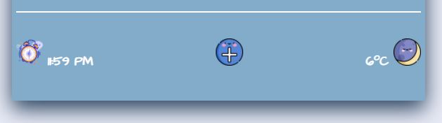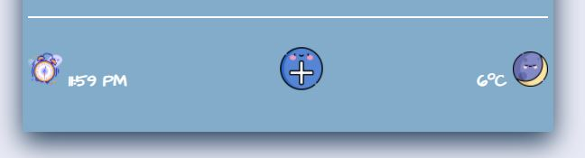

* Adding plan on calendar as scheduler and adding more calendar for flexibility can be done for FUTURE WORK.

1. **Registration page**

This is the page for member registration. Any member who wants to register should enter some answers according to the questions, and some survey questions are not mandatory. After answering all questions, you have to click submit button at the bottom of the page. You can visit here through the dropdown after hovering the toolbar.

* + Some <input> tag using required attributes such as name, e-mail, password and phone number should be entered to submit.
  + Phone number and Password has formation to be satisfied and regarding restriction is referred on the right side of each input element.
  + Responsiveness is applied as following.

|  |  |
| --- | --- |
| Normal  For PC | * + In PC version, I used image tag using float attributes neighboring survey place. |
| @media screen and (max-width: 768px)  For tablet |  |
| @media screen and (max-width: 480px)  For mobile |  |

* + This is the page to collect user information using <form> tag.

This registration form is composed of basic Member-Registration-Form + Survey Form + Submit button.

Here, I used <input> tags with type radio, checkbox, text, password, tel, datetime-local, color and submit.

|  |  |
| --- | --- |
|  |  |

* + Font-family of legend in each fieldset is following 2nd Google Font.

|  |
| --- |
| font-family: 'Cairo', sans-serif; |

1. **Sign-in Page**

If you click Log-out from tool bar in any pages provided in this website, you have to re-log-in to use services. Type your member-id and password then click log-in button. You can visit here (Log-out) through the dropdown after hovering the toolbar.

* + Toolbar design is a little different from another pages since sign-in page is entered when there is no current user account, the state of Log-out.

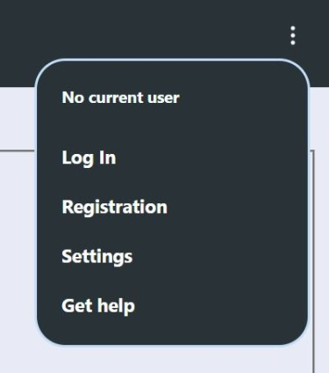

* + Responsiveness is applied through basic Footer.

|  |  |
| --- | --- |
| Normal  For PC and tablet | @media screen and (max-width: 480px)  For mobile |
|  |  |