|  |
| --- |
| https://lh5.googleusercontent.com/Z9Kxd56t4y3uxGNw7kjF6iEKIFB81f6bbEIntqpz4ESiHx8QUBYJQUgzEHH6OF_KH_HmxyrVKUdHZf9g25jZnbNcAkNvOF21ZLdCDwQ3z8FFcMnaakh9WxK00DuCW-2FG52l9Hq7  **Tribhuvan University**  **Faculty of humanities and social sciences**  **Lumbini ICT campus**  **A Sixth-Semester Project Report**  **On**  **“Tech Store Management System”**  **Submitted to:**  **Department of information technology**  **Lumbini ICT campus**  ***In partial fulfillment of the requirements for the bachelor’s in computer application***  **Submitted by:**  Pawan Ghimire  Registration no: 6-2-1194-44-2021  Under the supervision of  Nischal khatiwadaaaa |



**Tribhuvan University**

**Faculty of Humanities and Science Studies**

**Lumbini ICT campus**

**Supervisor’s recommendation**

We hereby recommend that this project prepared under my supervision by Pawan Ghimire entitled “fast food ordering system” in partial fulfillment of the requirements for the degree of bachelor of computer application is recommended for the final evaluation.

……………...........

**Nischal Khatiwada**

**Supervisor**

Faculty of Humanities and Social Science

Lumbini ICT Campus

Gaindakot, Nawalpur



**Tribhuvan University Faculty of humanities and social studies Lumbini ICT Campus**

**LETTER OF APPROVAL**

This is to certify that this project by Pawan Ghimire entitled “Fast Food Ordering System” in partial fulfillment of the requirements for the degree of bachelor in computer application has been evaluated. In our opinion, it is satisfactory in the scope and quality as a project for the required degree.

|  |  |
| --- | --- |
| **……………………**  **Mr. Nischal Khatiwada**  **Supervisor**  Faculty of humanities and social science  Lumbini ICT Campus  Gaindakot, Nawalpur | **………………………**  **Er Mod Nath Acharya**  **Coordinator**  Name and academic Designation  Faculty of humanities and social science  Lumbini ICT Campus  Gaindakot, Nawalpur |
| **…………………**  **Internal Examiner** | **…………………..**  **External Examiner** |

**ACKNOWLEDGEMENT**

We want to express our sincere thanks to the department of bachelor in computer application (BCA) at the Lumbini ICT campus for giving us the information and directions that allowed us to complete this project. We would like to express our gratitude to the IT department for providing us with the opportunity to work on improving our technical skills while working on this project. Special thanks to supervisor Nischal Khatiwada for his wise counsel, encouraging recommendations, vital guidance, assistance, and support in bringing this project to a successful conclusion. Mr.Prakash Acharya, Er. Mod Acharya, Sudip Parajuli Rahul Sharma deserve special thanks for their ongoing support, cooperation, and coordination. Thank you also to all of the teaching and non-teaching personnel, as well as colleagues, who have helped with the project both directly and indirectly by reviewing and recommending improvements. Last but not the least, we would like to express our gratitude to the Lumbini ICT College Administration for inspiring us to continue this project.

**Pawan Ghimire**

Registration no: 6-2-1194-44-2021

# Abstract

The project's goal was to create a responsive online application for the tech store that allows users to order electronic products online and products related to the users and also to eliminate the drawbacks of traditional queuing systems by using techniques introduced to meet their needs, allowing them to store their valuable information for a longer period of time with easy access and manipulation. The necessary software and hardware are widely available and simple to use. The proposed system displays a user interface and automatically updates the product list with all available options. No formal knowledge is needed for the user to use this system. Thus by this all, it proves it is user-friendly. Users can place orders with multiple items and view order details. Users receive an order confirmation. Users enjoy the ease of the online tech shopping system. This system increases product takeaway over visitors. It manages all the information about Products, login, Customers, and Product Item. To improve the quality of service and business in this industry, technological action has become necessary. The implementation and integration of web-based technology for tech stores are described in this text. A developing web utility system was created to receive all of the data from a centralized database. During the development of this functionality, user utility, efficiency, and accuracy were prioritized for better results and services, as well as to reduce the majority of human error. It was found that this system was successful in overcoming the weaknesses observed in previously developed similar systems. Because each Online Tech Store Management System has unique product requirements, we create systems that are customized to your managerial needs. This is designed to aid strategic planning and ensure that your organization has the right level of information and details for your future objectives.  
Furthermore, both in development and in use, this system was very cost-effective.

Contents

**Abstract** iv

**CHAPTER 1: INTRODUCTION** 1

**1.1** **Introduction** 1

**1.2 Problem statement** 2

**1.3 Objectives** 2

**1.4 Scope and limitation** 3

**1.5 Report organization** 4

**CHAPTER 2: BACKGROUND STUDY AND LITERATURE REVIEW** 4

**2.1 Background study** 4

**2.2 Literature Review** 6

**CHAPTER 3: SYSTEM ANALYSIS AND DESIGN** 7

**3.1** **Requirement Elicitation** 8

**3.1.1 Requirement Analysis** 9

**3.1.2 Feasibility study:** 12

**3.1.3 E-R Diagram** 13

**3.1.4 DFD(data flow diagram)** 14

**3.2 System Design** 18

**3.2.2 Database schema design:** 18

**CHAPTER 4: IMPLEMENTATION AND TESTING** 19

**4.1 Implementation** 19

**4.1.1 Tools Used** 19

**4.2 Unit testing** 20

**1.3** **System testing** 25

**CHAPTER 5: CONCLUSION AND FUTURE RECOMMENDATION** 26

**5.1 lesson learned/outcome** 26

**5.2 Conclusion** 27

**5.3 Future recommendation** 27

**Reference:** 27

**Time Plan:** 28

**List of figures**

Figure 1: waterfall model ........................................................................................................... 8

Figure 2: Use case diagram ...................................................................................................... 11

Figure 3: ER diagram ............................................................................................................... 15

Figure 4: 0 level DFD .............................................................................................................. 16

Figure 5: level 1 DFD .............................................................................................................. 16

Figure 6: level 2 admin DFD ................................................................................................... 17

Figure 7: level 2 user DFD....................................................................................................... 18

Figure 8: level 2 kitchen DFD ................................................................................................. 18

Figure 9: Database schema ...................................................................................................... 19

Figure 10: Home Page ............................................................................................................. 30

Figure 11: About Us page ........................................................................................................ 30

Figure 12: Our Product ............................................................................................................ 31

Figure 13: Contact Us .............................................................................................................. 32

Figure 14: Customer login page ............................................................................................... 33

Figure 15: User Registration Page ........................................................................................... 34

Figure 16: Add To Cart Page ................................................................................................... 35

Figure 17: My Cart Page .......................................................................................................... 35

Figure 18: User Profile............................................................................................................. 36

Figure 19: Customer Orders Detail Page ................................................................................. 36

Figure 20: Order Confirmation Page ....................................................................................... 37

Figure 21 : User Change Password Page ................................................................................. 37

Figure 22: User Cancel Order Page ......................................................................................... 37

Figure 23: Admin Login Page.................................................................................................. 38

Figure 24: Admin Dashboard................................................................................................... 39

Figure 25: List of Admin Page................................................................................................. 39

Figure 26: List of Kitchen Admin Page ................................................................................... 40

Figure 27: List of Users Page................................................................................................... 40

Figure 28: List of Orders Page ................................................................................................. 40

Figure 29 : Menu Detail Page .................................................................................................. 41

Figure 30: Menu Update Page ................................................................................................. 42

Figure 31: Add Menu Page ...................................................................................................... 42

Figure 32: Type of Category Page ........................................................................................... 43

Figure 33: Stock Page .............................................................................................................. 43

Figure 34: Sales Report Page ................................................................................................... 43

Figure 35: Admin Registration Page........................................................................................ 44

Figure 36: Kitchen Registration Page ...................................................................................... 45

Figure 37: Admin Change Password Page............................................................................... 45

Figure 38: Kitchen Login Page ................................................................................................ 46

Figure 39: kitchen dashboard page .......................................................................................... 47

Figure 40: List of Orders in Kitchen Dashboard ..................................................................... 47

Figure 41: List of Stocks in Kitchen Dashboar ........................................................................ 47

Figure 42: Kitchen Change Password Page ............................................................................. 48

**List of table**

Table 1: Functional requirement .............................................................................................. 12

Table 2: Test Case for User Registration and User Login ....................................................... 22

Table 3: Test Case for Admin Registration and Login ............................................................ 23

Table 4: Test Case for Homepage ............................................................................................ 24

Table 5: Test Case to Add same item twice in cart by user ..................................................... 24

Table 6: Test Case To Add a New item by admin ................................................................... 25

Table 7: Test Case For Deleting An Item ................................................................................ 25

Table 8: Test Case To Make Order .......................................................................................... 25

Table 9: Test Case For Add To Cart ........................................................................................ 26

Table 10 : Test Case For Cancel Of Order .............................................................................. 26

Table 11: Test Case For System Testing ................................................................................. 27

# CHAPTER 1: INTRODUCTION

## 1.1 Introduction

An online tech store management system is a website or application for ordering and delivering electronic products online. Online tech store systems save time as well as allow people to buy any product of their individual choice from any store. Customers are able to search for a favorite store with various types of products with home delivery facilities. A tech store system consists of an up-to-date product list with all available options in an easy-to-use manner. Customers are able to choose various items according to need and make orders which will be added to their cart. Customers can check all the order details in the cart before checking out and they can log in through the same ID next time. Once the order is placed it is entered into the database. The main purpose of an online tech store management system is to accommodate a huge number of orders at a time and ensure customer satisfaction.  
In today's world of science and technology, the online tech store management system has a very large scope. The purpose of an online tech store system is to facilitate stores to expand their business by allowing customers to place orders online. From the customer point of view, customers can order desired products from desired stores whenever and wherever they want. From the management point of view, the manager will be able to control the store by having all the reports on hand and able to see the records of each customer and order. Tech stores can attract people with various offers, product categories, and affordable price ranges. We will give all of our popular products accessible in our store for the initial implementation of the system. Customers will appreciate the convenience of the online tech shopping system. It eliminates the drawbacks of typical queuing systems. As a result, this system improves the speed and consistency of taking a customer's order. It gives a more effective platform for communication. This application facilitates product ordering in maintaining stock and cash flows, as well as many other features such as recording data, controlling orders, services, billings, controlling workers and their shifts, and so on.  
Furthermore, having an online product catalog allows us to simply maintain our customer information. Customers are attracted to online orders not only because of convenience but also because they can look after products, and can order them with a simple mouse click.

## 1.2 Problem statement

The experience of purchasing in traditional tech stores does not satisfy customers. The more technology is becoming advanced, the more people's expectations are growing day by day. In the context of the online tech store management system, taking a review from some of the existing online tech product websites:  
• Customers must visit physical stores to learn about products before placing an order and paying, which is time-consuming.  
• Customers often have to wait in long queues before they can get assistance or place their orders.  
• After placing an order, the customer must then wait near the counter or checkout area until their product is packed and ready.  
• Another problem with the current system is that customers aren’t able to see detailed specifications or features of the products before placing their orders.  
• The customer does not have a physical copy of the product list and no visual confirmation that the order was placed correctly when ordering over the phone.  
• To provide a smooth purchasing experience and collect payments, every store needs certain personnel to assist customers over the phone or in person.

As a result, to tackle these problems, an "Online Tech Store Management System" has been designed, which simplifies the purchasing experience for both the customer and the store, as well as reduces the store's workload. Our system makes it easy for customers by allowing them to order products whenever and wherever they want without needing in-store assistance, and helps stores handle many orders in a short time while working efficiently and effectively. Also, existing online tech store systems are not user-friendly and most have limited working hours, so our main focus is to be user-friendly, provide service in time, and satisfy customers.

## 1.3 Objectives

* To increase the facilities and improve services provided through better application of technology that will satisfy the customer.
* To fully participate in this competitive world of technology in the context of the online food ordering industry.
* To enable customers to know food ingredients before ordering, make orders, view orders and make changes before submitting their order.
* To design a system able to accommodate a huge number of orders at a time.
* To eliminate the paperwork and increase the level of accuracy.
* To increase the speed of services, sales volume, and being able to get suggestions from the customers.
* To reduce time-wasting by eliminating long queues.
* To improve the communication between the client and the Restaurants and minimize the time of ordering.

## 1.4 Scope and limitation

Scopes include:

* Customer can order desired food from desired restaurant whenever and wherever and whatever.
* Restaurant can manage their own page by adding different photos, and prices with special offers.
* Manager will be able to control the restaurant by having all the reports on hand and able to see the records of each customer and order.
* Web-platform means that the system will be available for access 24/7 except when there is a temporary server issue which is expected to be minimal.

These online food ordering systems have few limitations. Some of the limitations of this system are:

* Price: one of the major drawbacks of an online food ordering system is price. For individuals with a limited food budget, this system is often too expensive.
* Quality of food: One problem with the food ordering system is that the quality of the food served is often worse than eating at a restaurant. Also, food is served in plastic and packaging which may be harmful to health.
* Food may get cold: it will take a long time when food is ordered from a long distance due to which food gets cold.

## 1.5 Report organization

Chapter 1- Topic “Introduction” contains the introduction to the project. It explains the project's objectives, scope, and limitations, as well as provides a brief description and summary. It also explains why we're working on this project.

Chapter 2- Topic “Background Study and Literature Review” present a critical evaluation of the context of our system-critical analysis of existing literature. It includes a description of our perspective of the previous system, as well as what our project wants to accomplish, as well as a comparison of the traditional and our planned system, the Online Food Ordering System.

Chapter 3-Topic “System Analysis and Design” includes a data flow diagram, modules, architecture as well as contains the requirement of the system its hardware requirement, and the software required to run our system. It also relates to shaping organizations, improving performance, and achieving objectives for profitability and growth.

Chapter 4-Topic “Implementation and Testing” includes the process of testing implementations of technical specifications. It consists of all the ways how the functions are implemented and what functions are used to implement them.

Chapter 5-Topic “Conclusion and Future Recommendations” includes how well have we achieved our original aim and objectives, what were the limitations and scopes of our system, what should we do differently next time, consequences for research funding and practice.

# 

# CHAPTER 2: BACKGROUND STUDY AND LITERATURE REVIEW

## 2.1 Background Study

There was no way to provide information about the restaurant’s functions and services in the past. As technology is fast expanding, people are seeking more ways to purchase products with much ease and still maintain cost-effectiveness. The online food ordering system is an advanced technique for fast-food restaurants in this modern era. By this, food items are ordered online and delivered to the respective customer. By looking around our environment Traditional food ordering systems are inefficient for hotels and restaurants, which only deal with crowds at their locations, as well as for customers, who must wait for long periods of time. Nowadays, running a profitable hotel is far too difficult. If the hotel uses a typical queuing system, it will miss out on the customers who buy food online.

Several opportunities are developing on the internet as a result of the increased awareness of the internet and the technologies associated with it. An online food ordering system is one of the businesses that the internet has offered. People are looking for more options to purchase things with simplicity while maintaining cost-effectiveness as industries grow. The traditional method of purchasing food from local food stores is becoming inefficient and time-consuming. Food can be bought online and paid for without having to go to a restaurant, thus there is a need for a wide range of publicity as well as the ability to order, process, and transport food directly through the online system. There will be a system administrator for this system who will have the ability to enter the menu with current prices. The use of an electronic payment system makes this possible. Customers pay with credit cards, although they might be served even before they pay with cash or check. Customers will be able to order food online using the technology developed for this project. As I reviewed some of the companies of online food ordering systems many of us got to know that they are not user friendly and most of them have limited service hours also most of the companies do not have the facilities of order confirmation and rating the food items. They are not providing the detail, so customers may get confused about the specification of the product. Data of customers are recorded in the physical file and tedious work to do and also it is full of risk as anyone can access it and modify the data. The fast-food business is a very competitive business and one way to stand out from competitors is through improving the business process where business process automation can assist business improvement. Although the world is going toward digital platforms, Basically, the online food ordering system is designed to make it easy for both the customer and the restaurant.

Nowadays almost all people prefer online ordering rather than a dining experience, it will be quicker as well as more effective.

## 2.2 Literature Review

In [1] paper, zomato and swiggy are well-known applications that provide services ranging from food menus to online food delivery to customers' homes. The main benefits of ordering food online are that everyone can order at their leisure and that there will be no peer pressure when ordering food, as there is when going out for casual dining. We frequently ask the waiter what this food contains? Is it going to be spicy or not? and sometimes we find ourselves in a situation where the dish we ordered isn't up to par, or we have to order based on the waiter's recommendation because we don't have a brief description of the dish on the menu.

In [2] A food ordering system was designed and implemented using customer feedback for a restaurant. It allows restaurant owners to easily configure the system in a wireless environment and update menu presentations. To facilitate real-time communication between restaurant owners and customers, a smartphone has been integrated into the customizable wireless food ordering system with real-time customer feedback implementation.

Some of the online food ordering systems of Nepal are:

1. FoodMario is an online food delivery in Nepal that connects household cooks to customers. This service has been in operation for over two years now (from 2017). The platform provides creative food made by home-based cooks, especially for you. [FoodMario](https://foodmario.com/) is not just a delivery service, it is also a platform that provides an opportunity for people who want to show their creativity by making foods from their own kitchen. With the help of this app, anyone can order healthy home-cooked food from any of the 15 home chefs. The food is packed and delivered in aluminum boxes to keep food fresh and hot. This delivery service delivers your food within one to one and a half-hour of you ordering it. They deliver food on a bike to ensure timely delivery. FoodMario delivers food in Kathmandu and Bhaktapur.

This service also has a great number of positive reviews and is especially appreciated for the concept.

1. Bhok lagyo is another online food delivery service based on the Kathmandu area. It is in operation since January 2017. It was initially a night-time delivery service from 8 pm to 4 am. But now they have extended their service time from 11 am to 4 am. In Bhok lagyo, you can order your food through phone calls. You can also order from social media like WhatsApp, Viber, Instagram, and Facebook. This service has a variety of food including cuisines and flavors including common foods like momo, burger, desserts, drinks, etc.You can order your food from outside or inside the ring road area. You can get your food delivered to you within 45 min to an hour. The food is perfectly packed inside a special food delivery bag and delivered to you. The feedback is quite good from the costumers. They charge you a certain amount if you order food worth less than 1500, else it is free.

For food delivery inside the ring road, it is NRs 50. And for outside ring road, it is NRs 70.

1. Foodmandu is the first company to deliver food from hundreds of popular restaurants in Nepal. It is in operation since November 2010. And is counted as one of the popular online food delivery services in Nepal. You can place your order through online media platforms like Facebook, Instagram, or through their website. You can also call or order through its app. In Foodmandu, you can easily find your favorite foods and have it delivered to your doorsteps.The service time for Foodmandu is from 11 am to 8:30 pm. Food delivery time takes about an hour or more to get in your doorsteps. They deliver food in Kathmandu and [Lalitpur.](http://mealnepal.com/six-jhamsikhel-restaurants-to-visit-this-weekend/) The reviews of Foodmandu are mostly positive. The delivery charge is NRs 50 if you order food worth NRs 1500 or more within 8kms. For over 8kms they charge NRs 70. And they charge up to NRs 150 based on your location if the order is worth 500 or less.

# CHAPTER 3: SYSTEM ANALYSIS AND DESIGN

For the development of any system, we have to follow the models. As there are many model such as incremental model, waterfall model, spiral model. But among them we have chosen waterfall model because waterfall model is suitable for to develop our system.

I.e. waterfall model is a popular model of the software development lifecycle to make a successful project. The waterfall model describes a development method that is linear or sequential. The whole process of system development is divided into separate phases like requirement analysis, design, implementation and unit testing, integration and system testing and maintenance. Once the one phase is completed the development process to the next phase starts and this is no turning back. Moreover, a waterfall model is suggested for the project because it has clear objectives and solutions. We take the waterfall model for the online food ordering system project mainly because the waterfall model is simple, easy to use, and manage, waterfall model works well for smaller the and project will be completed in a short period of time with a low budget where requirements are very well understood and the main advantage are processed and results are well documented.

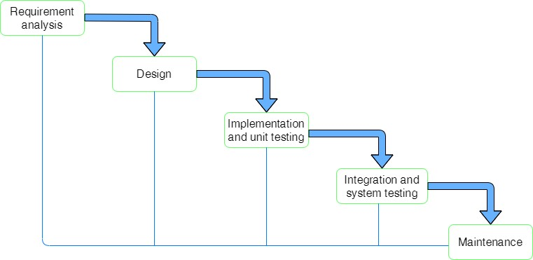

Figure 1: waterfall model

System analysis is the process of collecting facts, identifying the problems, and decomposition of a system into its components. System analysis is conducted for the purpose of studying a system or its parts in order to identify its objectives. It is the problem-solving technique that improves the system and ensures that all the components of the system work efficiently to accomplish their purpose.

## 3.1 Requirement Elicitation

Requirements were gathered by conducting interview which include open-ended interview. We conducted an interview on the involved in the online food ordering system to have a better understanding on how the current system works. We identity that system should include:

* Registration: If customer want to order the food registration is compulsory.
* Users login: The system should allow the users to log in to the system if they provide actual data that they have used in the signup state.
* Admin login: The system should allow the admin to enter to dashboard if they provide Actual data that the admin need to have.
* Adding items to the cart: The system should allow the user to add items to the cart if they are logged in.
* Display the menu in the system, all the items are displayed with their rates.
* Modify menu system like adding or removing food item which are not available. • Review the order before submitting and customer detail should be mentioned properly before submitting order.
* Provide delivery & payment details and provide bill with order no.
* Confirmation of delivery.
* Logout after the order/payment and many more.

After identifying all the requirement and problem encountered in the current system, we analyzed the system needs by creating DFD. We made some necessary recommendation on what should done to improve to current state of enrollment.

### 3.1.1 Requirement Analysis

Requirement analysis also called requirements engineering, allows software engineers to define user needs early in the development process. It helps them deliver a system that meets customer time, budget, and quality expectations. In this article, we review the requirements analysis process and explain various analysis techniques. The goal of this phase is to decompose analyze and detail the requirement across the system design. There may have redundancy and anomalies so to remove such anomalies requirement analysis is done with the review of the supervisor. Furthermore, we add use case diagram for requirement analysis.

The following section presents the complete set of functional and non-functional requirements identified for the online food ordering system. Functional requirements are stated first, in order of importance to the whole system, customers, admin, and kitchen. Non-functional requirements are focused on the system’s operation rather than its behavior. It relates to security, stability, reliability, quality performance, and so on.

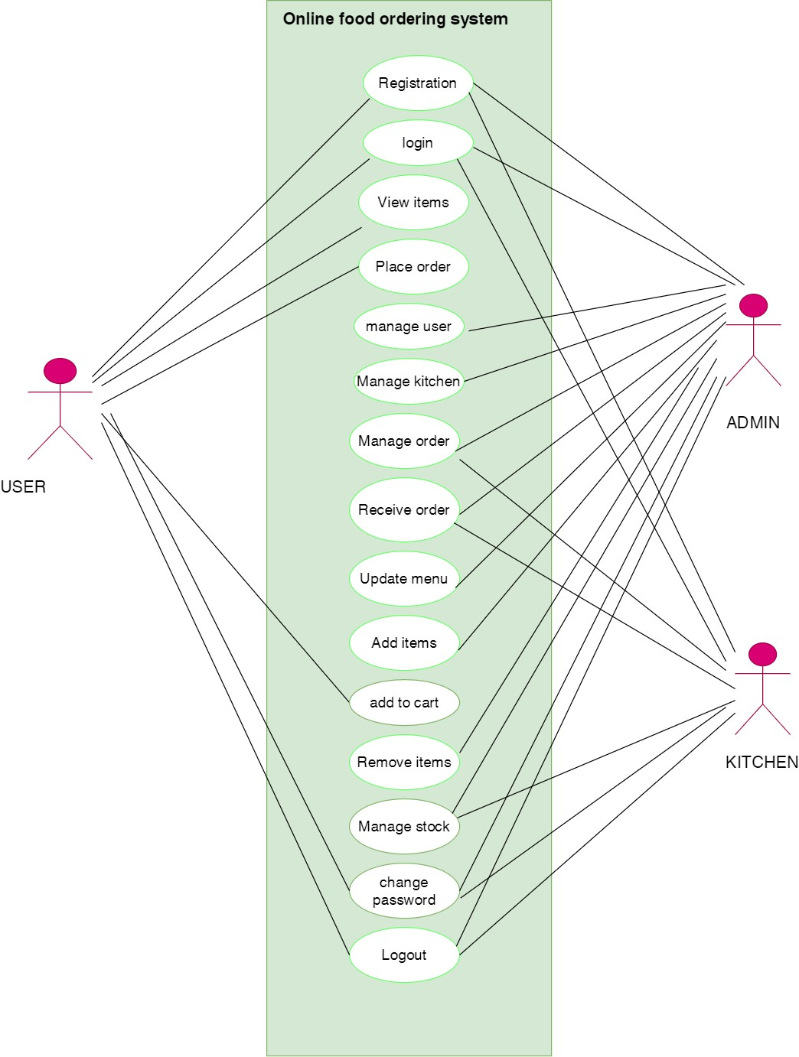

#### Figure 2: Use case diagram

I. **Functional Requirements:**

Functional requirements define the capabilities and functions that a system must be able to perform successfully. Functional requirements are those requirements in the system that are used to illustrate the internal working nature of the system, and explanation of each subsystem. It consists of what task the system should perform, technical information, various processes, and other functionality. The specified functional requirements for the Online Food Ordering System are presented in this section. Use case diagrams are used to describe the functional requirements as they represent the system’s functions at the most basic level. The functional requirements identified are:

|  |  |  |  |
| --- | --- | --- | --- |
|  | **ADMIN MODULE**   * Login/Signup * Manage user * Manage order * Add item * Manage kitchen * Receive order * Update menu * Remove items * Manage stock * Manage sales report * logout | **USER MODULE**   * Login/Signup * View item/product * Place order * Add to cart * Select quantity * Remove order * Review * Change password * logout | **KITCHEN MODULE**   * login/signup * Review orders * Receive orders * Manage stock * Logout |
|  | |  |  |

#### Table 1: Functional requirement

**I. Non-functional requirement**

A non-functional requirement is a requirement that describes the system’s operation capabilities that enhance its functionality. Non-functional requirement deals with issues like portability, maintainability, performance, security, and many more.

* Security: The system should provide a basic level of security and integrity for the data held by the system, with only authorized staff having access to the system's secured page and only users with valid passwords and usernames being able to log in to view the user's page.

* Performance: Under a given workload, performance refers to how quickly a software system or a specific portion of it responds to specific user actions. Given the current number of users, this measure often explains how long a user must wait before the desired operation (the page renders, a transaction is performed, etc.) occurs. But this isn't always the case. Performance requirements may refer to procedures that are not visible to users, such as backup. But, for now, let's concentrate on customer satisfaction.

* Ease of use: Considered the level of knowledge possessed by the users of this system, a simple but quality user interface should be developed to make it easy to understand and use by non-technical users.

### 3.1.2 Feasibility study:

A feasibility study is the initial design stage of any project, which brings together the elements of knowledge that indicate if a project is possible or not. A feasibility study was conducted for the project with the goal to see if a system idea is feasible. So far, during the development of the project Online Food Ordering System, we have four major categories of the feasibility study.

* **Operational feasibility:**

As our project plan satisfies the requirement identified in the requirement analysis phase of system development. Our application is operationally feasible because it is simple and needs only a general idea to operate it is not necessary to have a well-trained expert. Our system has a user-friendly interface that makes it simple for users to utilize.

* **Economic feasibility:**

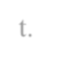As our system utilizes free software such as HTML, CSS, JS, and MYSQL, which will not generate any costs also the application does not spend much more money so our system is economically feasible. But because our project is a college project so we do not need to check whether our project is economically feasible or not.

* **Schedule feasibility:**

Schedule feasibility is the most important for the success of a project after all it analyzed time it will take to complete a project which has a great impact on the organization as the purpose of the project may fail if it can’t be completed on time. As our project is short, the requirement for the system is already fixed and it cannot be changed, we manage a perfect time period for our project by analyzing and discussing with experts, so we summarize that our system is schedule feasible.

* **Technical feasibility:**

For to develop the system we include the correct required resources and technologies such as HTML, CSS, PHP, and MySQL as the server are the main technologies and tools used in our system which are freely available, and the system developer has lots of technical experience. We will conduct systematic information-sharing training with an associated user guide.so, our project is technically feasible.

### 3.1.3 E-R Diagram

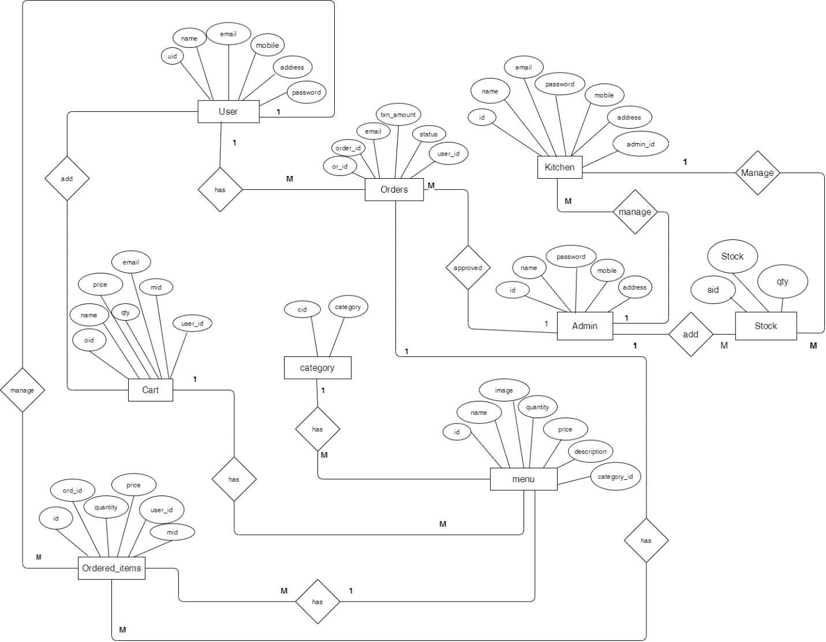

##### Figure 3: ER diagram

### 3.1.4 DFD(data flow diagram)

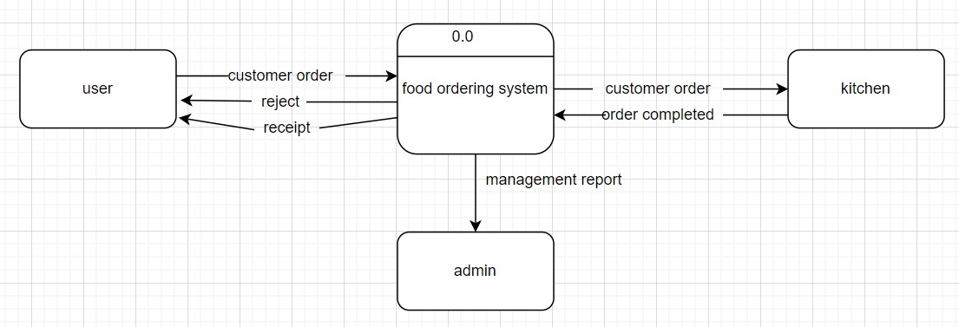

##### Figure 4: 0 level DFD

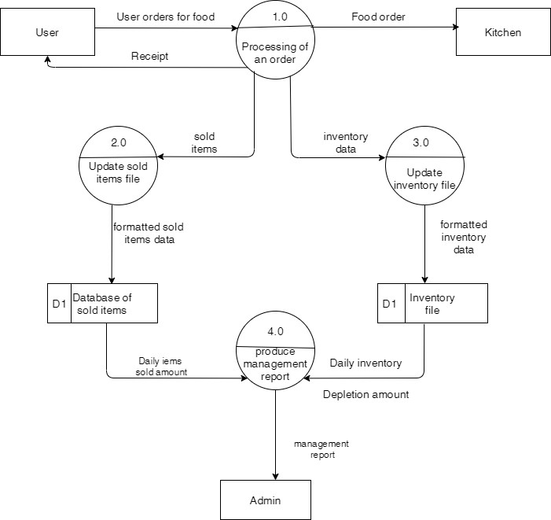

##### Figure 5: level 1 DFD

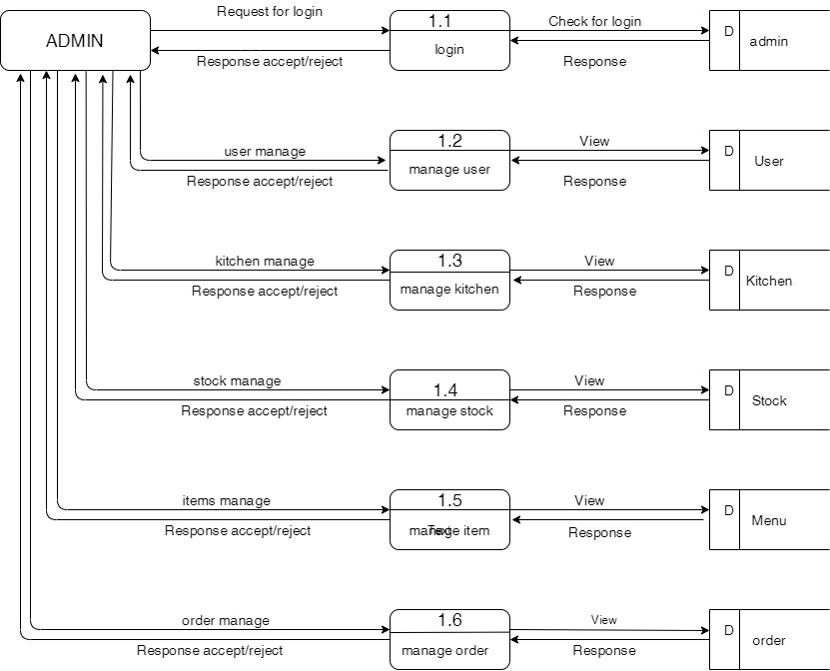

##### Figure 6: level 2 admin DFD

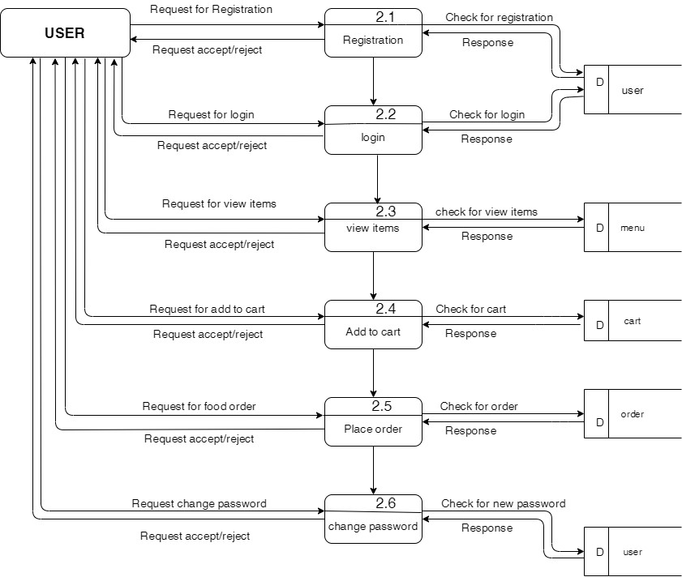

Figure 7: level 2 user DFD

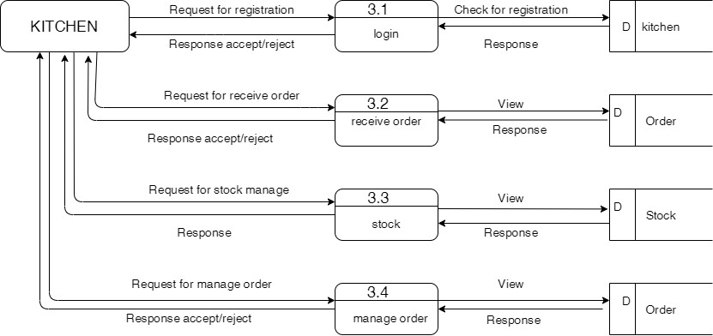

Figure 8: level 2 kitchen DFD

## 3.2 System Design

System design is the process of defining elements of a system like modules, architecture, component, and their interfaces and data for a system based on the specified requirements. System design is the process of defining, developing, and designing systems that satisfy the specific needs and requirements of an organization.

### 3.2.2 Database schema design:

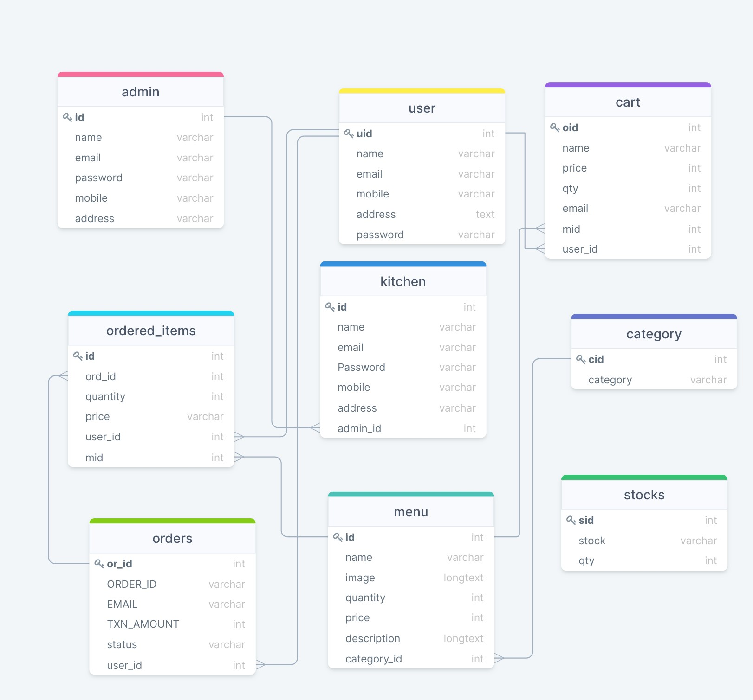

Figure 9: Database schema

# CHAPTER 4: IMPLEMENTATION AND TESTING

## 4.1 Implementation

### 4.1.1 Tools Used

We use different tools and techniques for the development of the system. We use HTML, CSS, and JAVASCRIPT for the frontend and PHP for the backend development. We use SQL for managing databases.

**Html, CSS, and bootstrap:**

HTML is mostly used to construct the user interface and offer support for Bootstrap elements by supplying Bootstrap containers. CSS was utilized to give more detail to the website, while Bootstrap was used to create the portal overall by extending tags from an existing library. Bootstrap is a free and open-source CSS framework directed at responsive, mobile-first frontend web development. It contains HTML, CSS, and JS-based design templates for forms, buttons, navigation, etc.

**JavaScript:** JS is used to add events and triggers to the website. The website also uses JS to acquire the system time for date and time reasons.

**PHP with MySQL:** PHP is a server-side scripting language that allows you to connect to a database, as CRUD actions such as editing, deleting, and searching news is required, PHP is utilized in association with the MySQL database, which stores database tables.

**XAMPP Server:** XAMPP is a popular cross-platform web server that allows programmers to design and test their code on a local webserver. It is used in project development to host the portal locally and centralize the database.

**Visual studio code:** visual studio code is a source code editor its features include support for debugging, code refactoring, etc. Users can change the theme keyboard shortcuts, and install extensions that add additional functionality.

## 4.2 Unit testing

|  |  |  |  |  |  |
| --- | --- | --- | --- | --- | --- |
| **Test code** | **Test case type** | **Test case**  **description** | **Expected values** | **Actual values** | **Result** |
| Test  1 | User registration | Registration details of the user will be  present here | If the user name has a unique identity then the user gets registered successfully. | user is getting authentication | User is  successfully registered. |
| Test  2 | User registration gets failure | Without entering any one of the fields if the user click on signup then an alert message will displayed | The user will not able to register. | An alert will be displayed | An alert will be displayed like entering all the fields. |
| Test  3 | User registration gets failure | when a user tries to register with the same email then user will not get registered. | The user will not able to register. | An alert will be displayed | An alert will be displayed like “Email is already  registered try another”. |
| Test  4 | User login | User details of user are  authenticated | User details are to be correct. | User get login | The user  login successful  and is authorized to use the system. |
| Test  5 | User login failures | User details of user are not authenticated | Login details are to be incorrect | User login fail | The user is failed to  login |
| Test  6 | Login without user details | Trying to login without providing user details | An alert is to be displayed | An alert will be display like “please fill out this field”. | The user login is  failed |

Table 2: Test Case for User Registration and User Login

|  |  |  |  |  |  |
| --- | --- | --- | --- | --- | --- |
| **Test code** | **Test case type** | **Test case**  **description** | **Expected values** | **Actual values** | **Results** |
| Test  7 | Admin  registration | Registration detail of the admin will be present here | If the admin name has a unique identity then the admin get  registered successfully. | Authentication | Admin is  successfully registered. |
| Test  8 | Admin  registration gets failure | Without entering anyone of the field if the admin click on submit then message will  displayed | Admin will not  able to register | An alert will be displayed | An alert will be displayed like enter all the fields. |
| Test  9 | Admin  registration gets failure | When a user tries to register with the same email, then user | Admin will not  able to register | An alert will be displayed | An alert will be displayed |
|  |  | will not get  registered |  |  |  |
| Test  10 | Admin  login | Details of user are authenticated | User details are to be correct | User get login | The user  login successful  and is  authorized to use the system |
| Test  11 | Admin  login failed | Admin details are not  authenticated | Login details are to be incorrect | Admin login  failed | The user login failed and is not able to use the system |
| Test  12 | Login into without admin  details | Trying to login without providing admin details | An alert is to be displayed | An alert will be display | The admin login is  failed |

Table 3: Test Case for Admin Registration and Login

|  |  |  |  |  |  |  |
| --- | --- | --- | --- | --- | --- | --- |
| **Test code** | **Test type** | **case** | **Test case**  **description** | **Expected values** | **Actual values** | **Result** |
| Test  13 | Navigates to  homepage | | The user tries to view the  information | The required information should be displayed | Information is retrieved from database | Information displayed successfully |
| Test  14 | The home page cannot be redirected | | The user tries to view the information but the home page cannot be  displayed | The error page will be displayed | Due to some connection, problem information  of system will not be sent to the database | The page is not available |

Table 4: Test Case for Homepage

|  |  |  |  |  |  |
| --- | --- | --- | --- | --- | --- |
| **Test code** | **Test case type** | **Test case**  **description** | **Expected values** | **Actual values** | **Result** |
| Test  15 | Check adding a item twice to cart from menu | -Go to menu detail page.  -Click on add to cart button in menu.  -Get back to menu page -Add the same  item to cart | The user is redirected to cart page where the updated subtotal and total price show. | As expected item can  twice added | pass |

Table 5: Test Case to Add same item twice in cart by user

|  |  |  |  |  |  |  |
| --- | --- | --- | --- | --- | --- | --- |
| **Test code** | **Test case type** | **test case**  **description** | **test data** | **Expected values** | **Actual values** | **Result** |
| Test  16 | Add new  item | Go to the admin dashboard and select menu item and select add item  option | Pizza | New items should appear  in the table | As expected new items are added | pass |

Table 6: Test Case To Add a New item by admin

|  |  |  |  |  |  |
| --- | --- | --- | --- | --- | --- |
| **Test code** | **Test case**  **type** | **Test data** | **Expected values** | **Actual values** | **Result** |
| Test 17 | Delete items | MOMO | Items should be deleted  from table | As expected items are  deleted | pass |

Table 7: Test Case For Deleting An Item

|  |  |  |  |  |
| --- | --- | --- | --- | --- |
| **Test code** | **Test case type** | **Expected values** | **Actual values** | **Result** |
| Test  21 | Make order | Order request should be sent | Order sent | Pass |

Table 8: Test Case To Make Order

|  |  |  |  |  |
| --- | --- | --- | --- | --- |
| **Test code** | **Test case type** | **Expected values** | **Actual values** | **Result** |
| Test 22 | add to cart | Items added to  cart | Items added | pass |

Table 9: Test Case For Add To Cart

|  |  |  |  |  |  |  |
| --- | --- | --- | --- | --- | --- | --- |
| **Test code** | **Test case type** | **Test steps** | **Test data** | **Expected result** | **Actual result** | **Result** |
| Test 23 | Cancel of order for user | Goto my  orders choose item and cancel the order to be cancelled until admin approved it. | Click on  cancel button | Order should be cancelled | As expected | pass |

Table 10 : Test Case For Cancel Of Order

## 1.3 System testing

|  |  |  |  |  |
| --- | --- | --- | --- | --- |
| **Test code** | **Test case** | **Expected**  **Result** | **Actual Result** | **Remarks** |
| 1 | User signup | The user should be registered and redirected to the login page | User registered and redirected to login page | No error |
| 2 | User login | User should be logged in and redirected to home page | Logged in and redirected to home page | No error |
| 3 | Kitchen registration | Kitchen should be registered and redirected to login page | Registered and redirected to login page | No error |
| 4 | Add product  category | Product category should be added | Product category added | No error |
| 5 | Add product | Product should be added | Product added | No error |
| 6 | Integrate all modules together | System should function well | System worked as expected | No error |

Table 11: Test Case For System Testing

# CHAPTER 5: CONCLUSION AND FUTURE RECOMMENDATION

## 5.1 lesson learned/outcome

At the end of the project, we are able to design software that can successfully handle online food ordering. With the help of this system, people can easily order food. It can also ensure that people do not waste their precious time and use their time productively on other works. Expected to be very easy to use and least maintenance. There are no more limitations as such for this system, however, one needs to take care of the smaller parameters like server breakdown while the system is implemented.

## 5.2 Conclusion

The goal of this project is to create a web application for restaurants. An online food ordering system is developed where the customers can make orders for the food and avoid the hassles of waiting for the order to be taken by the waiter. A systematic methodology has been used in the development of the application. The system was developed using the waterfall model. A working technical prototype of an online food ordering system was successfully constructed as part of the project. This also helps the restaurant to simplify its managerial and operational task and to improve the dining experience of the clients. This also helps the restaurant owners develop healthy customer relationships by providing reasonably good services.

In conclusion, the project accomplished its objectives and fulfilled its purpose. I'm hoping that the software will be able to meet the majority of restaurant online ordering needs.

## 5.3 Future recommendation

In addition to the unfinished requirements, there are other possibilities for further improving the project. This improvement may include:

* Delivery option: add a delivery option
* Payment options: add different payment options such as cash payment, eSewa, etc.
* Restaurant locator; allow to find and choose a nearby restaurant.
* Reward point
* Forget password

# Reference:

|  |  |
| --- | --- |
| [1] | Varsha Chavan, Priya Jadhav, Sneha Korade, Priyanka Teli, “Implementing  Customizable Online Food Ordering System Using Web Based Application”, International Journal of Innovative Science, Engineering Technology(IJISET) 2015. |
| [2] | C. C. Gan, "Online Fast Food Restaurant Ordering System," , 2000. [Online].  Available: http://etd.uum.edu.my/499. [Accessed 16 9 2021]. |
| [3] | Ramesh Kumar Bagla , Jasmine Khan, "Customers' Expectations and Satisfaction with Online Food Ordering Portals," *Prabandhan: Indian Journal of Management,* 2017. |
| [4] | Oracle gloriafood, “online food ordering system”  Available:https://www.gloriafood.com/online-food-ordering-and-delivery-system |

# Time Plan:

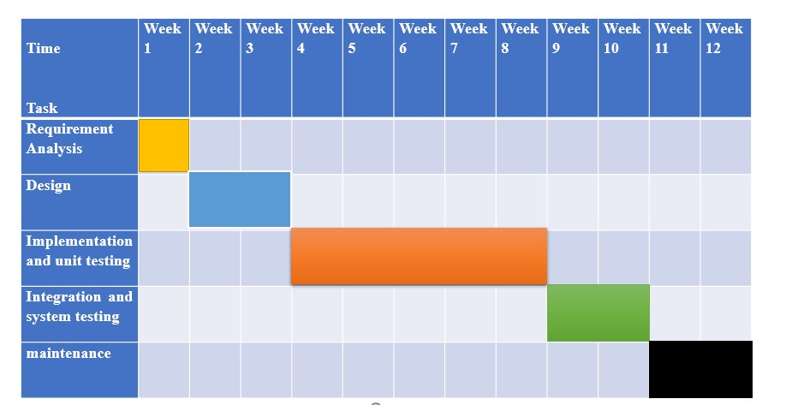

**APPENDIX-I**

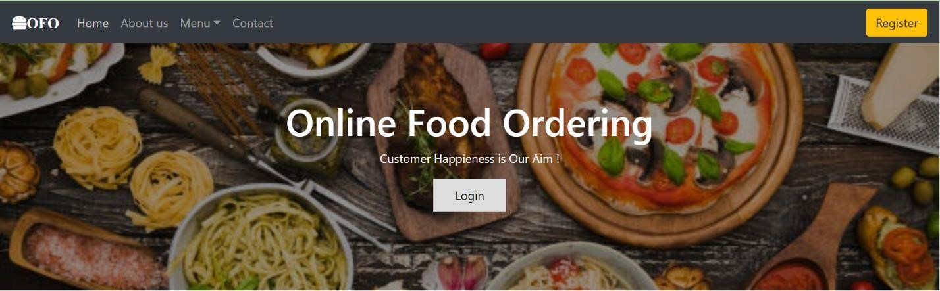

Figure 10: Home Page

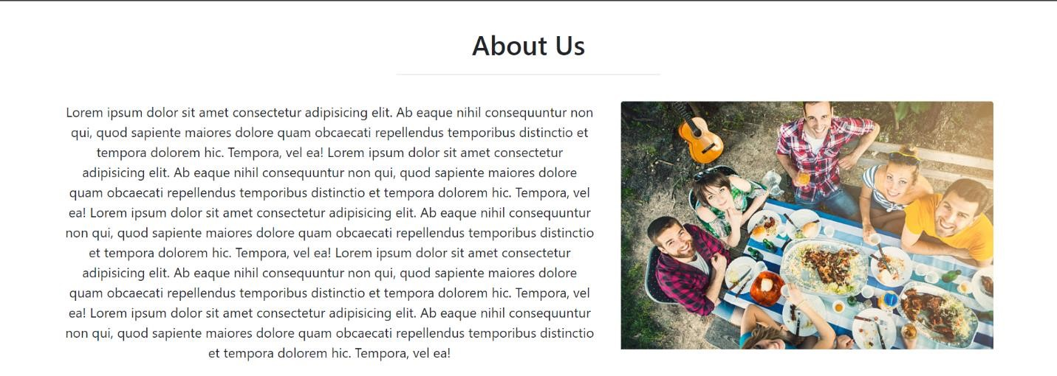

Figure 11: About Us page

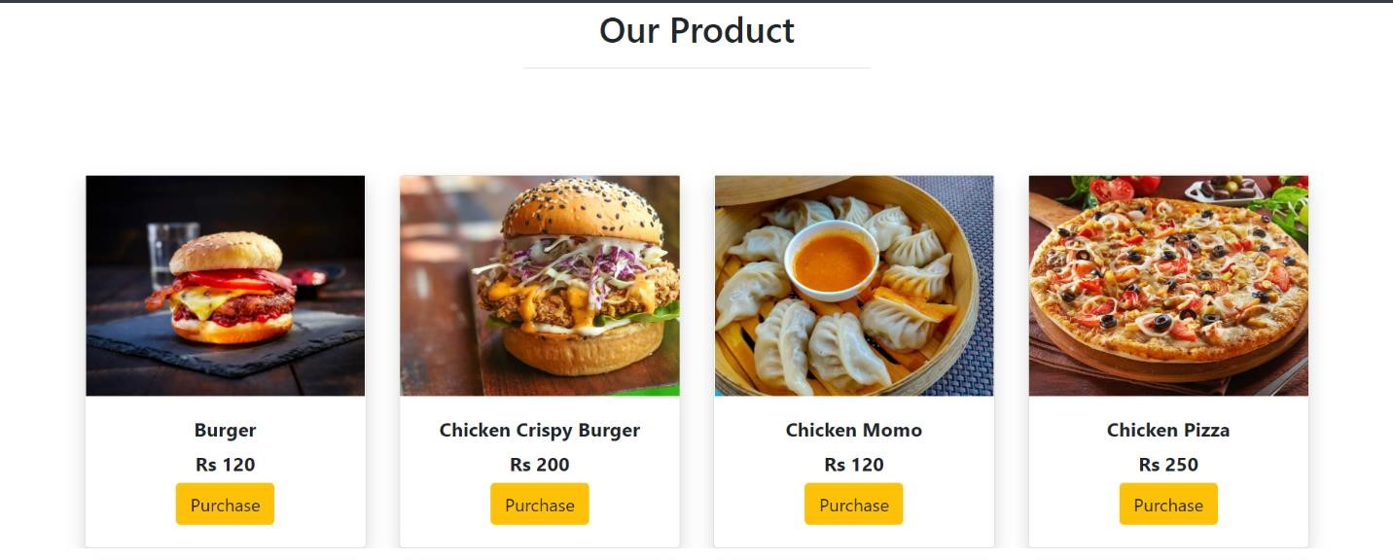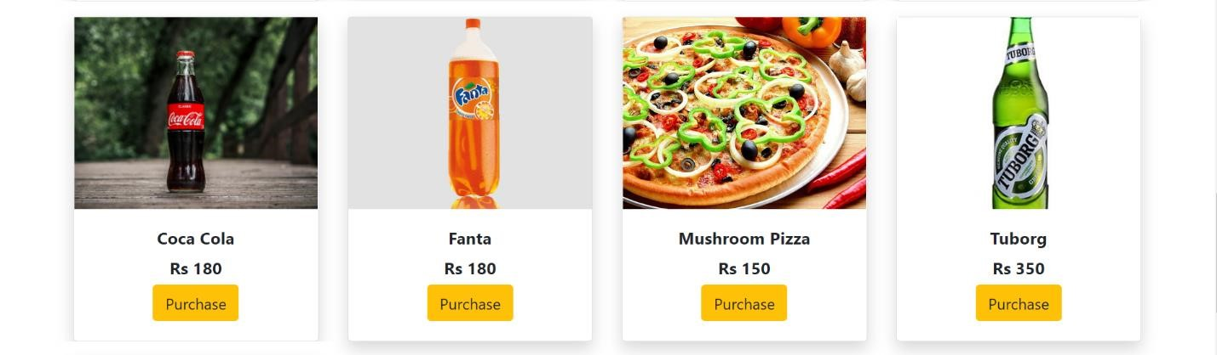

Figure 12: Our Product

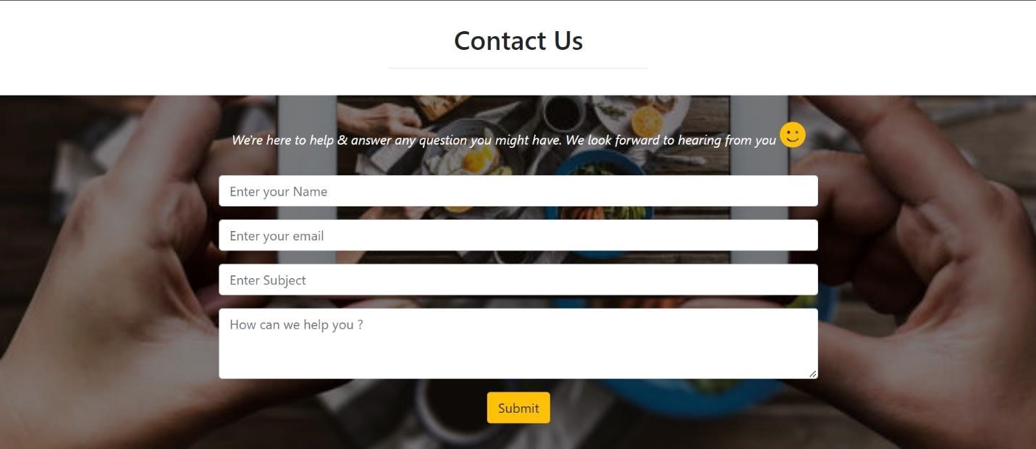

Figure 13: Contact Us

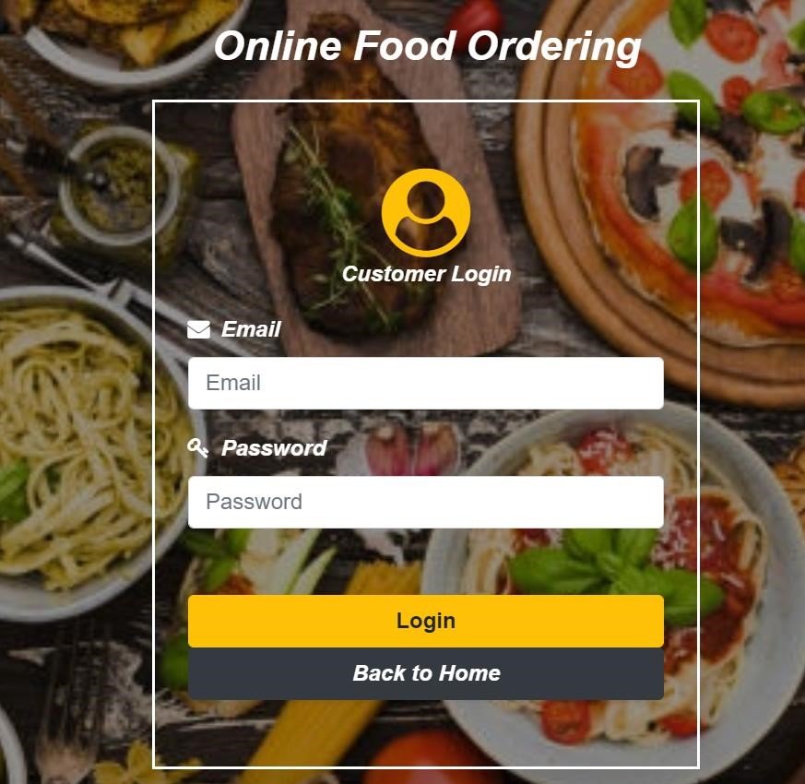

Figure 14: Customer login page

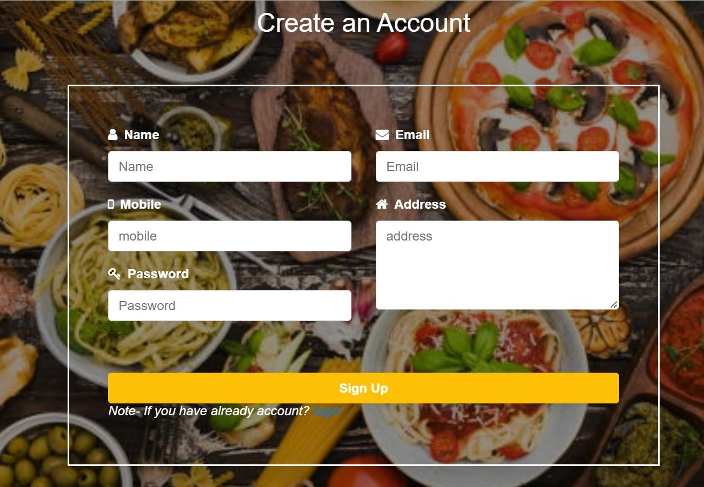

Figure 15: User Registration Page

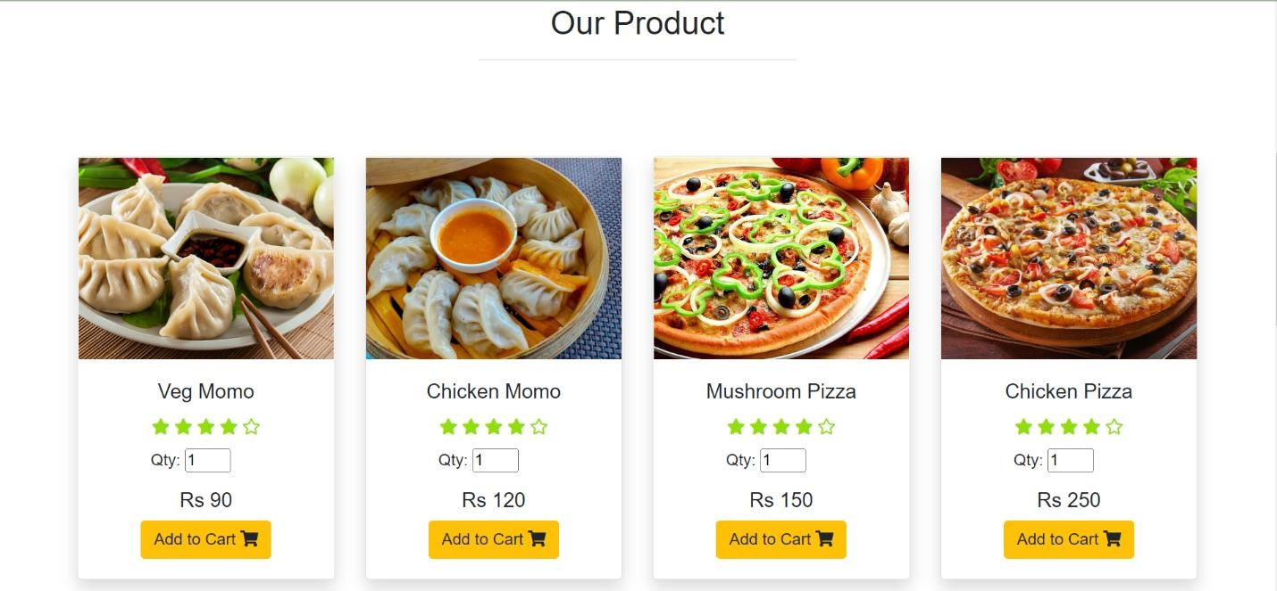

Figure 16: Add To Cart Page

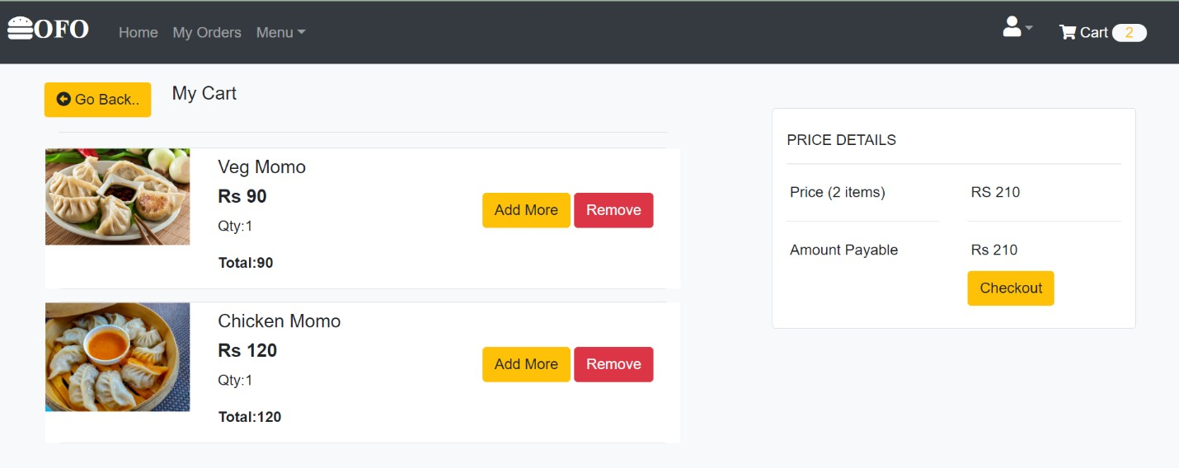

Figure 17: My Cart Page

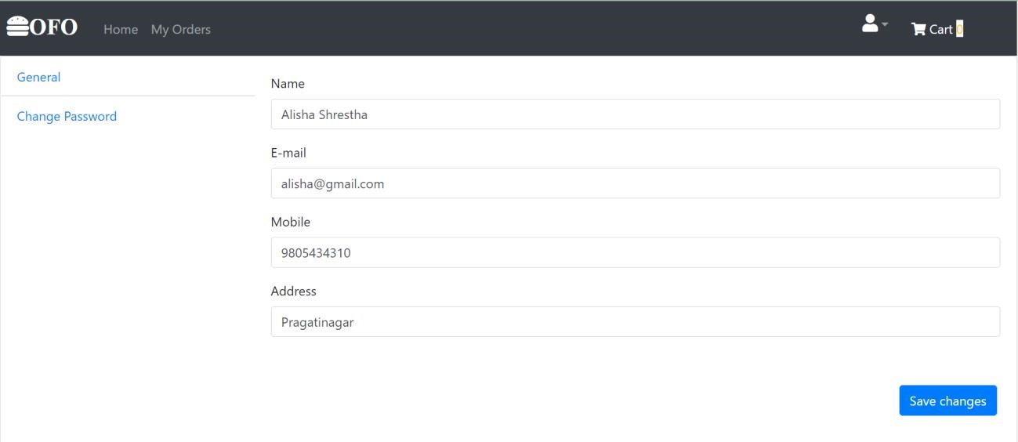

Figure 18: User Profile

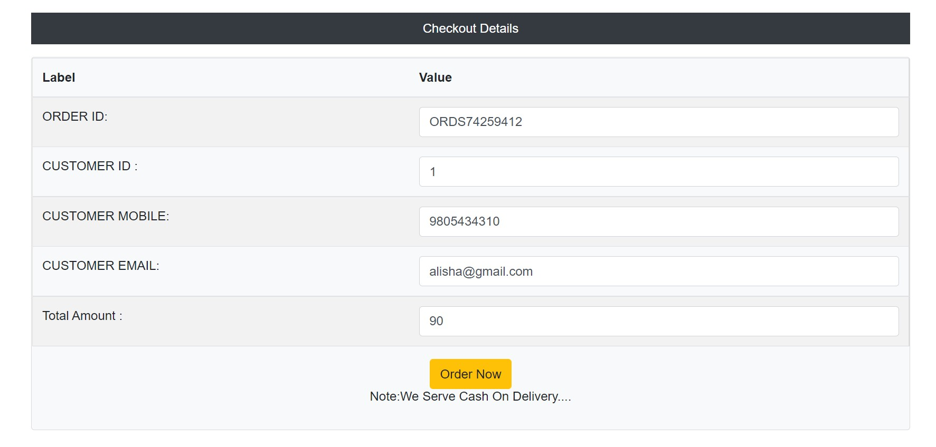

Figure 19: Customer Orders Detail Page

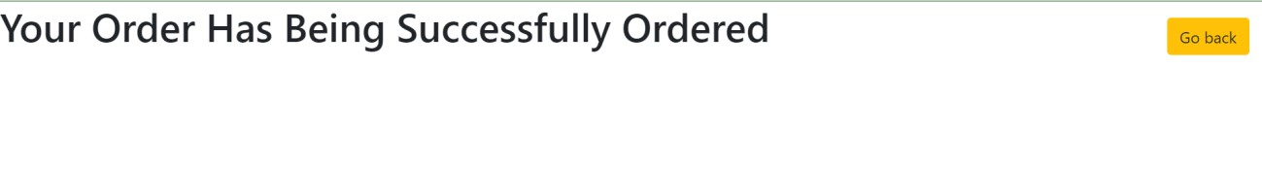

Figure 20: Order Confirmation Page

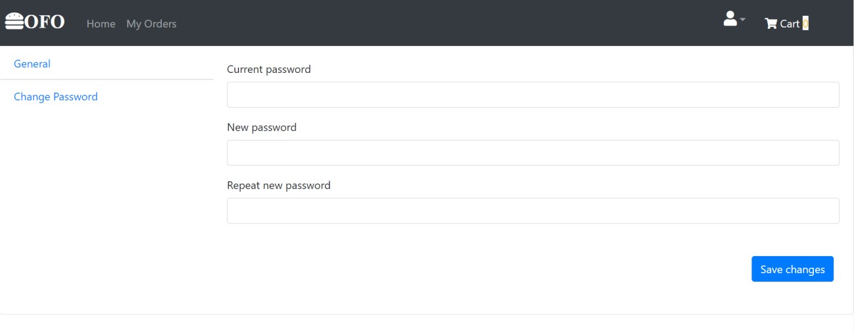

Figure 21 : User Change Password Page

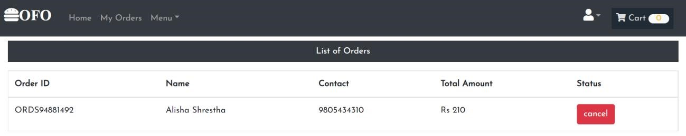

Figure 22: User Cancel Order Page

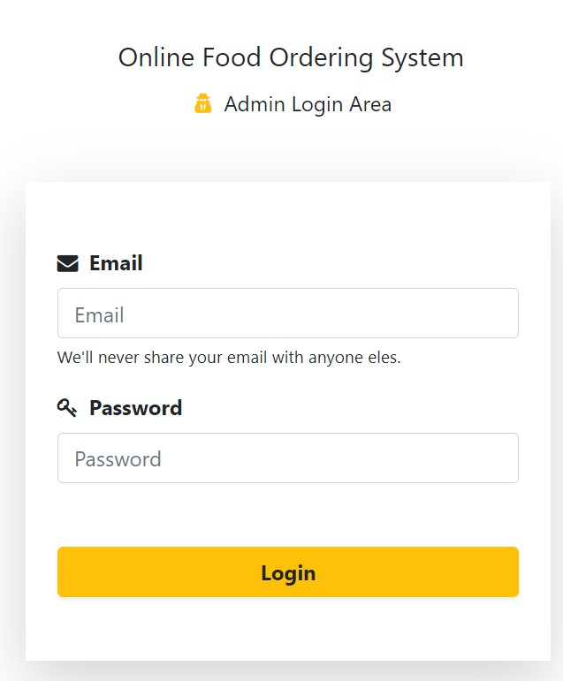

Figure 23: Admin Login Page

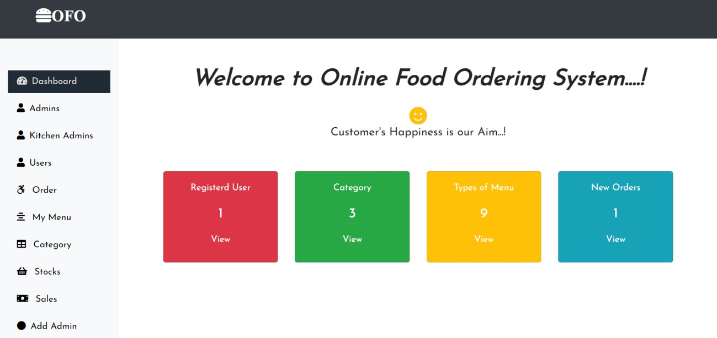

Figure 24: Admin Dashboard

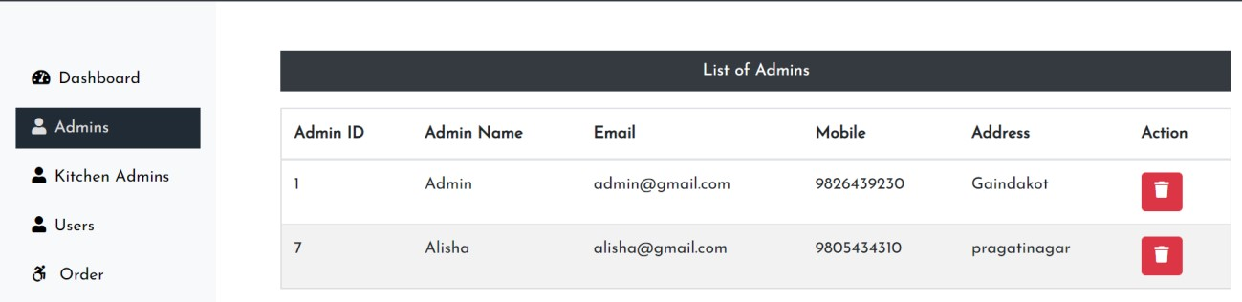

Figure 25: List of Admin Page

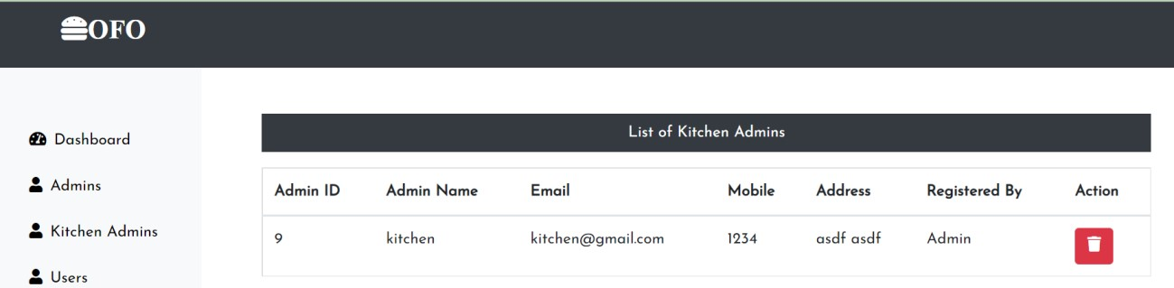

Figure 26: List of Kitchen Admin Page

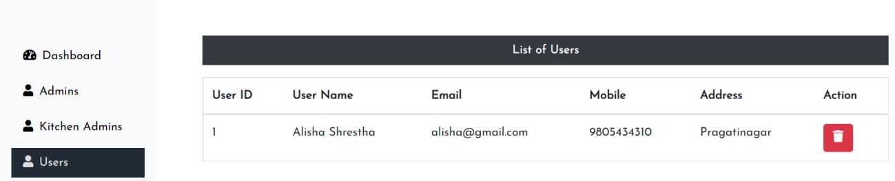

Figure 27: List of Users Page

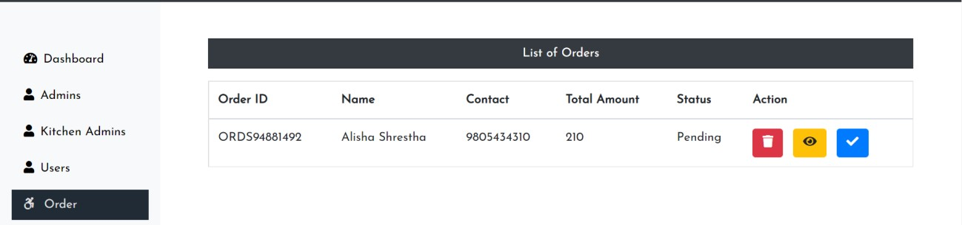

Figure 28: List of Orders Page

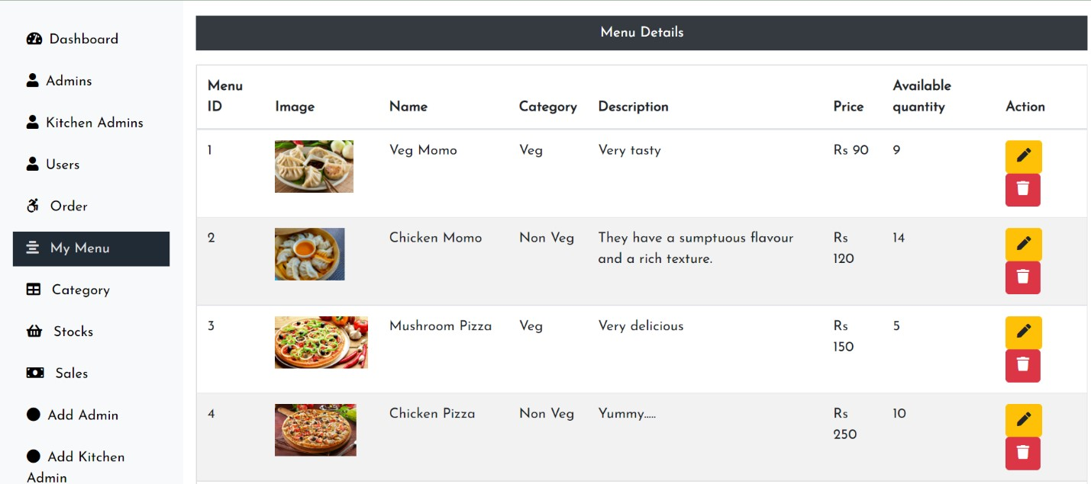

Figure 29 : Menu Detail Page

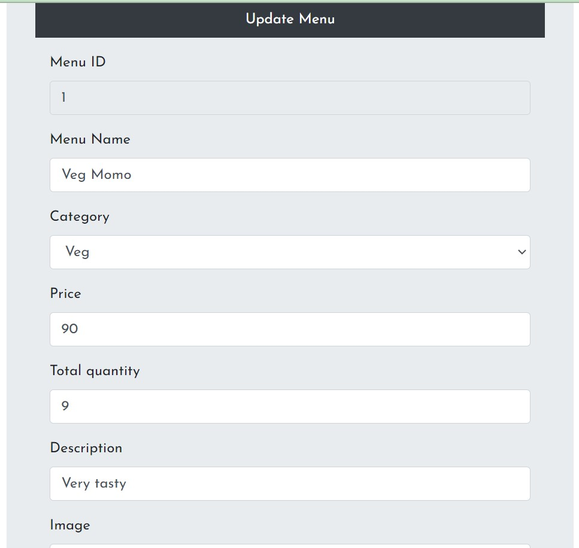

Figure 30: Menu Update Page

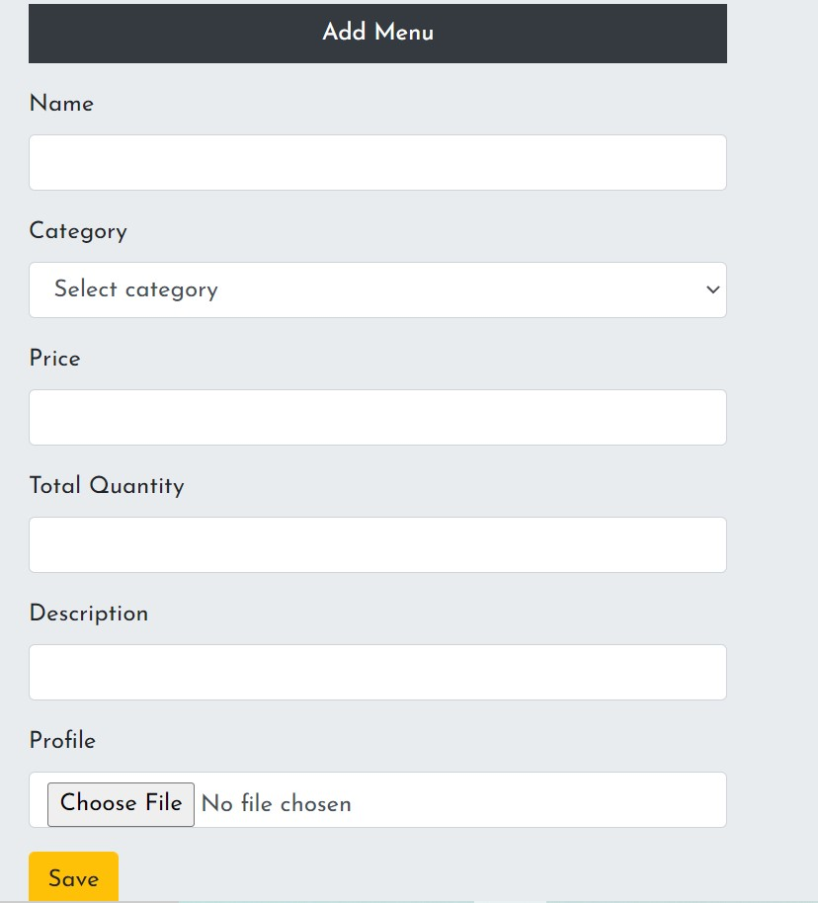

Figure 31: Add Menu Page

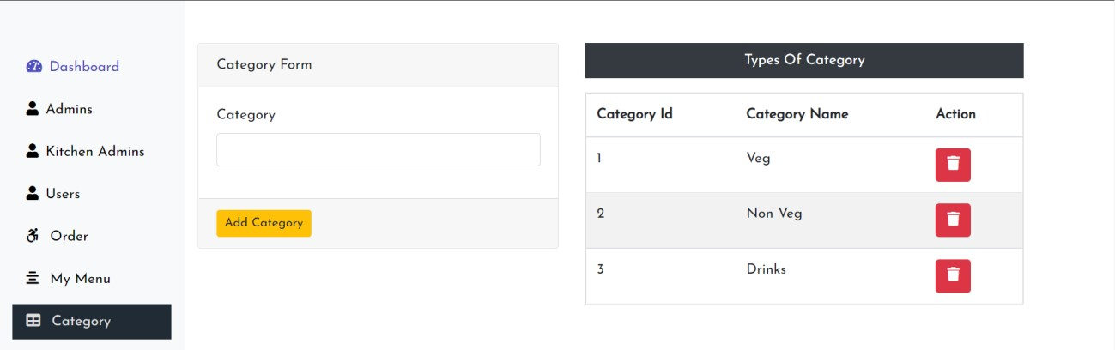

Figure 32: Type of Category Page

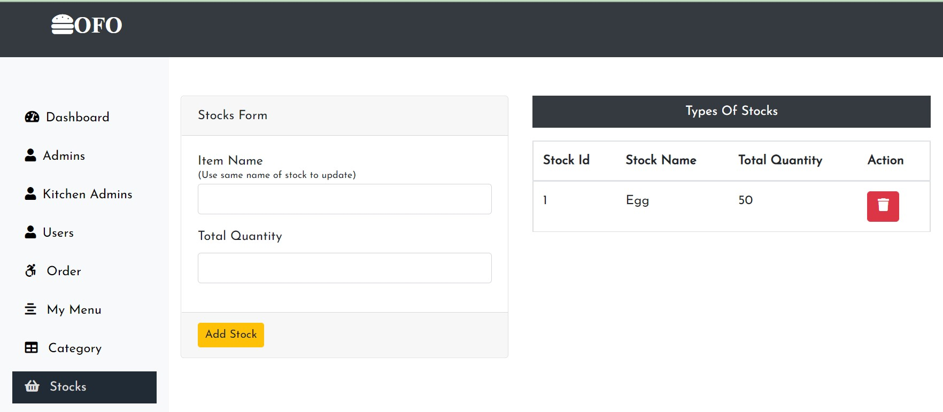

Figure 33: Stock Page

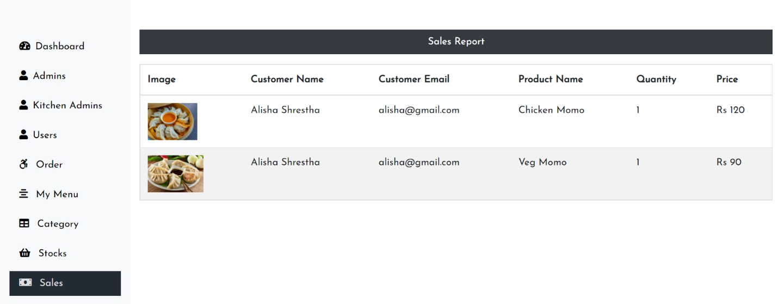

Figure 34: Sales Report Page

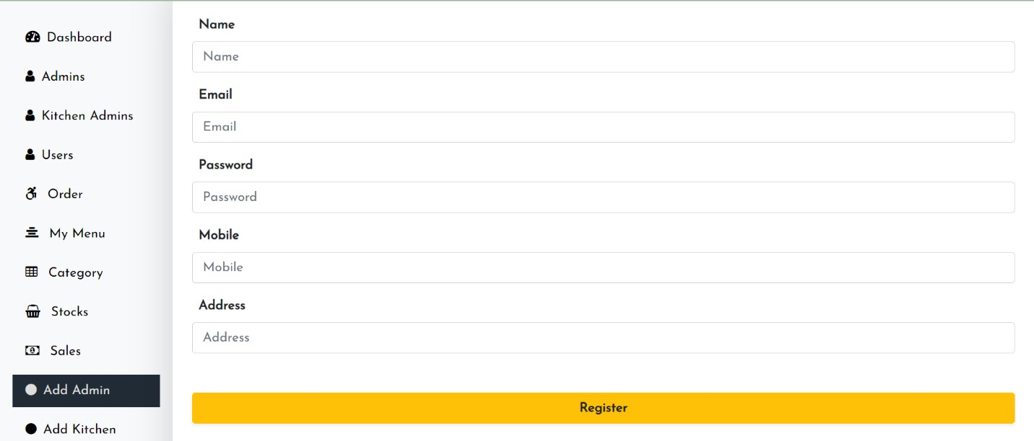

Figure 35: Admin Registration Page

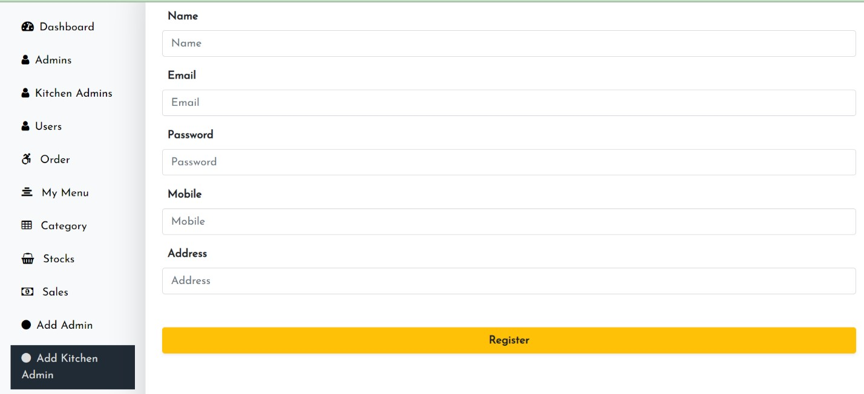

Figure 36: Kitchen Registration Page

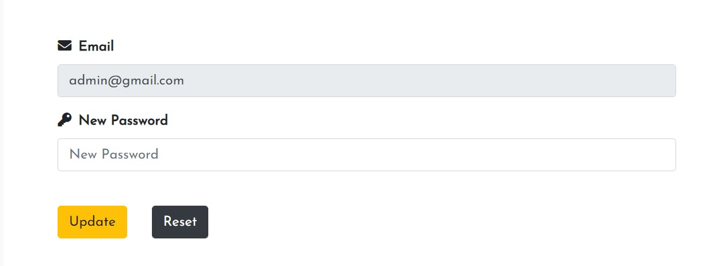

Figure 37: Admin Change Password Page

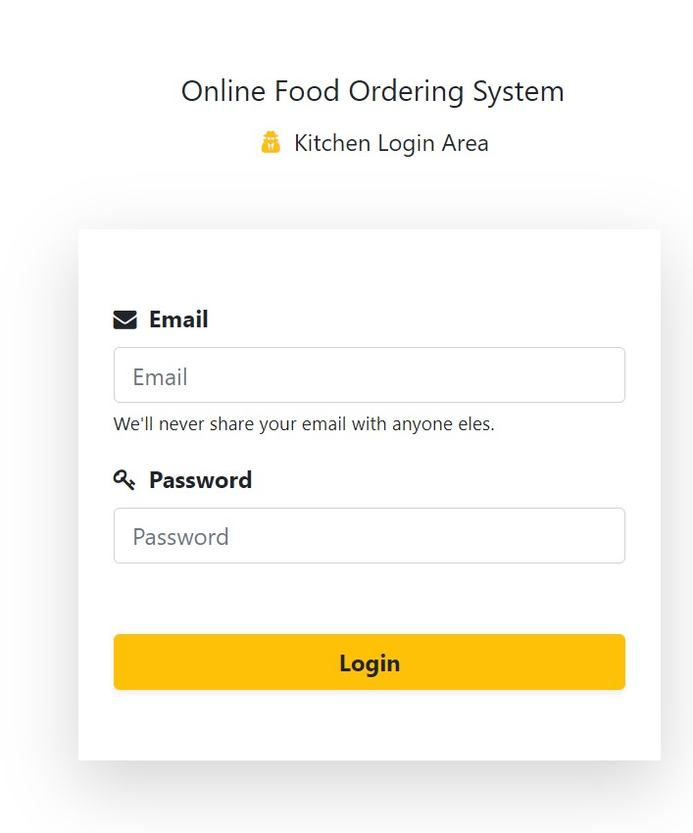

Figure 38: Kitchen Login Page

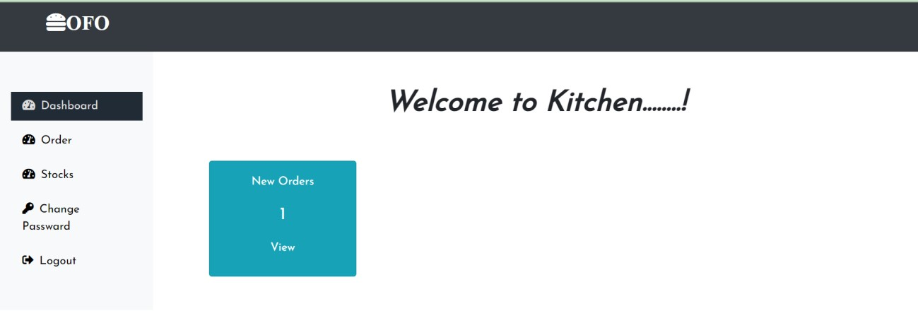

Figure 39: kitchen dashboard page

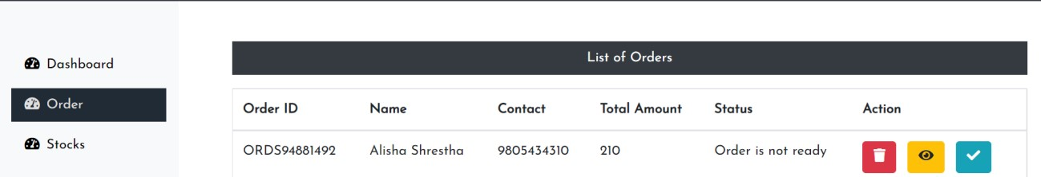

Figure 40: List of Orders in Kitchen Dashboard

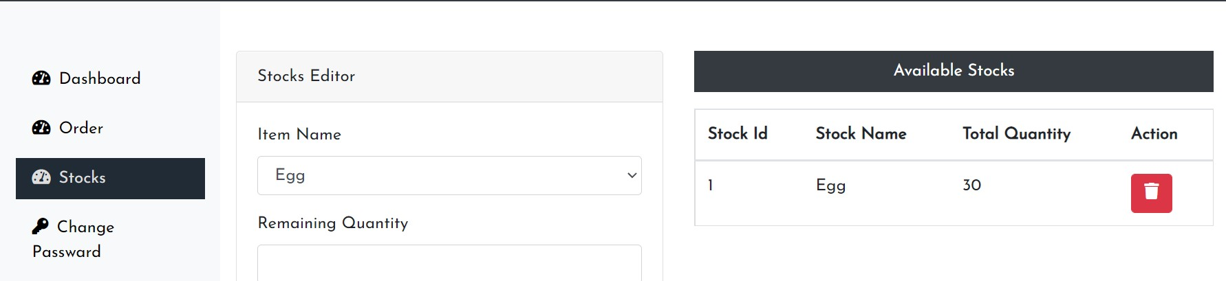

Figure 41: List of Stocks in Kitchen Dashboar

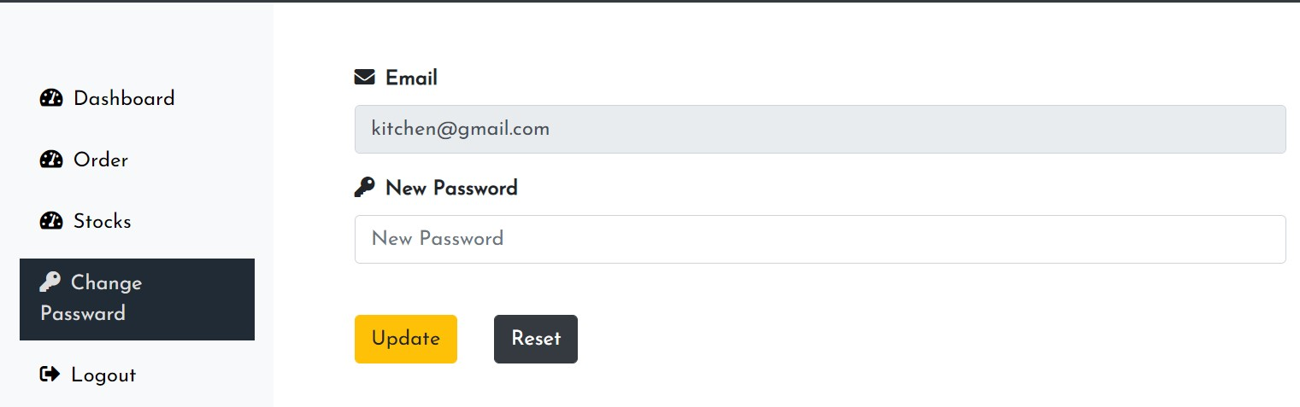

Figure 42: Kitchen Change Password Page