**Introduction:**

PV (Photovoltaic) solar power (Electricity) generation is a common exercise in the field of renewable energy resources in the world as well as Bangladesh. The diminishing cost of PV energy is constantly encouraging us to be more focused on the development and implementation of this source. However, the requirements are intimidating when we consider the space for the generation in a country like ours where spacious places are a big challenge. That is where the rooftop solar comes from which consists of providing surplus energy from solar to the electrical utility grid connected to the project facility.

PV Panels

Power Conditioning Unit with generation metering

2 Way Meter

Utility Grid

Home

Figure 1: Block Diagram of grid connected PV system.

The objective of the assignment is to design a grid connected PV system for a small neighborhood educational institution. The condition to design this system is to make the net energy consumption from the grid by the school over a year should be zero. To conduct this assignment, we are to follow multiple steps:

* Selection of institute
* Yearly load analysis
* Inspection of multiple approach
* Designing the PV system
* Verification of the design

The project will address following course outcomes-

*CO#4 Design simple solar photovoltaic systems.*

**Design Inputs:**

Name of the institution : Amber Preparatory School

Location : House no #63, East Rampura, Dhaka-1219

Google Map Link : [https://maps.app.goo.gl/qvPr4Ms7wMpbuY3m7](https://maps.app.goo.gl/qvPr4Ms7wMpbuY3m7?fbclid=IwAR0Rc-8hBqXMglcv4QXisvg-gIKQ3R_LfFbbnOWYokWPmrSMr5fIuajBnI8)

Area : 3240 Sq. Feet

Number of students : around 88

Number of Staffs : Headmaster 1

Assistant Techer 5

Clerk 1

Total 7

Total Electrical Equipment : Ceiling Fan 4

School schedule : 9:00 am to 2:00 pm

Yearly load consumption:

The table below shows the existing electrical equipment of the school and yearly load consumption according to the authority:

Table 01: Yearly Load Consumption

|  |  |  |  |  |  |  |
| --- | --- | --- | --- | --- | --- | --- |
| Electrical Equipment | Quantity | Power (W) | Daily Use (hr) | Yearly Use (days) | Annual Energy (Wh) | Annual Energy (KWh) |
| Ceiling Fan (Classroom) | 4 | 70 | 5 | 250 | 4*70*5*250 =350000 | 366.8 |
| 3 | 20 | 4*70*3*20 = 16800 |
| 0 | 30 | 0 |
| Ceiling Fan  (Teachers room and Headmaster’s room) | 2 | 70 | 7 | 280 | 2*70*7*280 =274400 | 285.6 |
| 4 | 20 | 2*70*4*20 = 11200 |
| 0 | 30 | 0 |
| LED Light | 4 | 25 | 5 | 280 | 4*25*5*280=140000 | 140 |
| LED Light | 4 | 20 | 6 | 280 | 4*20*6*280=134400 | 134.4 |
| LED Light | 1 | 40 | 7 | 280 | 1*40*7*280=78400 | 78.4 |
| Filament Bulb Light | 1 | 60 | 11 | 365 | 1*60*11*365=240900 | 240.90 |
| Computer | 1 | 300 | 7 | 280 | 1*300*7*280=588000 | 588 |
| Total |  | | | | | 1834.1 KWh |

So, the yearly load consumption of the school is 1834.1 KWh

Calculation:

To establish zero net energy consumption from grid,

$$Surplus energy generated over the year from solar=Energy cosumped from the grid$$

In other words,

$$Generated energy of the solar=Energy consumption of the Institution$$

To find the equipment specifications,

The annual average insolation of Dhaka=4.96 KWh/m2-day

So, the average peak sun hour in Dhaka in year-round = 4.96 h

$$The peak AC generation power=\frac{Generated Energy of solar year round}{Average peak sun hour in a day*Days in a year}$$

$$P_{AC}= \frac{1834.1\frac{KWh}{yr}}{4.96\frac{h}{day}*365\frac{day}{yr}}$$

[The model year chosen is 2023]

$$or, P_{AC}= 1.01 KW$$

Choosing single phase solar on-grid inverter:

The table below shows the relative comparison between some inverters available locally.

Table 02: Attributes of inverters

|  |  |  |  |
| --- | --- | --- | --- |
| Brand Name | **GrandGlow** | **JFY** | **Sunways** |
| Model | TL 1000 | JSI-1500TL | STS-2KTL-S-P |
| AC Power | 1000W | 1500W | 2000W |
| AC Voltage | 190-270 | 190-265 | 220V/230V |
| PV voltage range MPPT | 180-450 | 100-450 | 80-450 |
| Max input voltage | 450 | 450 | 350 |
| Max input current | 9 | 10 | 16 |
| Maximum efficiency | 97.50% | 96.5% | 97.5% |

From the above table, we did not go for Grandglow TL1000 because its AC power is lower than the AC power of our PV system. Even though JFY JSI-1500TL satisfies the power requirements, this would not be a good choice in the event of future expansion. So, we did not opt for it. Therefore, we have decided to go for Sunways STS-2KTL-S-P inverter.

Accounting for losses:

The efficiency of Sunways STS-2KTL-S-P is 97.5%

Let’s assume due to module mismatch, dirt, temperature, resistive loss limits the overall efficiency to 80%. So, the input power that we got after being limited is-

$$Required input DC power of the PV panels combined, P_{DC,STC}= \frac{1.01 KW}{0.975*0.8 }=1.294 KW$$

PV array selection and layout:

Table 03: Attributes of Solar Panels

|  |  |  |  |  |
| --- | --- | --- | --- | --- |
| Brand Name | **Risen Solar** | **Jinko Solar** | **Longi Solar** | **Longi Solar** |
| Model | RSM72-6-325p | JKM390-410M-72H-V | LR6-72HPH- 375M | LR4-72HPH-450M |
| Material | Polycrystalline | Monocrystalline | Monocrystalline | Monocrystalline |
| Rated Power,PDC,STC | 325W | 390W | 375W | 450W |
| Voltage at max power(Vmp) | 37.4V | 41.1V | 40.4V | 41.5V |
| Current at max power (Imp) | 8.7A | 9.49A | 9.28A | 10.85 A |
| Open circuit voltage(Voc) | 45.5V | 49.3V | 48.8V | 49.3V |
| Short circuit current(Isc) | 9.2A | 10.12A | 9.87A | 11.6 A |
| Length(L) | 1.956m | 2.008m | 2.004m | 2.094m |
| Width(W) | 9.92m | 1.002m | 0.996m | 1.038m |
| Efficiency | 16.75% | 19.38% | 18.79% | 20.7% |

Table 04: Number of module calculations

|  |  |  |  |
| --- | --- | --- | --- |
| Number of Modules in the arrangement according to power required | | | |
| **Risen Solar** | **Jinko Solar** | **Longi Solar** | **Longi Solar** |
| RSM72-6-325p | JKM390-410M-72H-V | LR6-72HPH- 375M | LR4-72HPH-450M |
| 1.294kW/325=4(Approx) | 1.294kW/390=4(approx) | 1.294kW/375=4(approx) | 1.294kW/450=3(approx) |

Table 05: Array Layout

|  |  |  |  |
| --- | --- | --- | --- |
| **Risen Solar** | **Jinko Solar** | **Longi Solar** | **Longi Solar** |
| RSM72-6-325p | JKM390-410M-72H-V | LR6-72HPH- 375M | LR4-72HPH-450M |
| 1 string with 4 modules in each:  Vm(149V) Voc(182V) in range | 1 string with 4 modules in each:  Vm(164.4V) Voc(197.2V) in range | 1 string with 4 modules in each:  Vm(161.6V) Voc(195.2V) in range | 1 string with 3 modules in each:  Vm(124.5V) Voc(147.9V) in range |
| 2 strings with 2 modules in each:  Vm(82.2V) Voc(98.6V) in range | 2 strings with 2 modules in each:  Vm(80.8V) Voc(97.6V) in range |

Out of these panels and designs, we have decided to go for Longi Solar LR4-72HPH-450M. From the design, we have selected 3 modules after calculating. Now, if we multiply these module numbers with the rated power of this panel, we will get ($3×450$ W) 1350W. The required input power was 1.31 $kW$. The difference of power between the required input voltage and Longi Solar LR4-72HPH-450M is (1350W-1310W) 40W which is quite low compared to other configurations, this is why we have chosen Longi Solar LR4-72HPH-450M solar panel.

Area needed= $2.094×1.038×3m^{2}$ = $6.521m^{2}$

PDC(STC)=

Schematic diagram of the system:

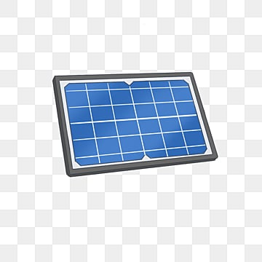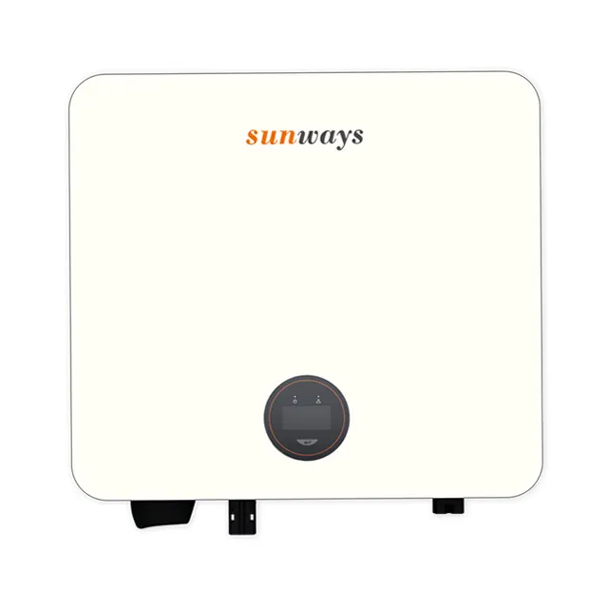

AC Out

Meter

Meter

DC in

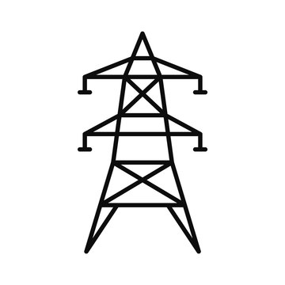

Lightning Arrestor



MCB

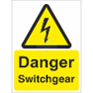

The schematic diagram is followed by the net metering guideline by Ministry of power, energy and mineral resources (2018). The guideline suggests for 3 different meters for generation, grid supply and consumer. A in-built meter is already installed in the inverter. So, a generation meter is unnecessary.

Safety Features:

The first safety feature is also an electrical solution which is circuit breaker. a circuit breaker will prohibit the excessive load supply from the PV panel or as well as the inverter. In fact, two circuit breakers, one for DC output of the PV panels and one for the Inverter output will be provided. Furthermore, a lightning arrestor is to be installed in the rooftop facility. Because the PV panels include metal parts which are highly attracted by lightning and the effect could result in several hazards including destruction of the PV panels. Not to mention, a sticker of “Danger switchgear safety sign” is mandatory to be installed on the distribution box location to provide caution for the local residents. Last but not least, a dedicated fire extinguisher will be installed nearby to prevent fire hazards.

References:

1. sreda

<http://www.sreda.gov.bd/site/page/55f1b362-a4b9-4586-b670-21c0b1fc7593/->

1. Net metering

<http://www.sreda.gov.bd/sites/default/files/files/sreda.portal.gov.bd/notices/b4b969dd_bc8a_4b9b_bc73_b2e96cb81702/2023-10-25-09-27-dd7434e7e46fc773964e4c525f93582a.pdf>

1. Guideline

https://www.google.com/url?sa=t&rct=j&q=&esrc=s&source=web&cd=&cad=rja&uact=8&ved=2ahUKEwj_w-Co-MuCAxW2d2wGHcxGAccQFnoECBIQAQ&url=https%3A%2F%2Fpolicy.asiapacificenergy.org%2Fsites%2Fdefault%2Ffiles%2FNet%2520metering%2520Guidelines%2520-%25202018.pdf&usg=AOvVaw19uFGrQdy_INBLQlXc7dHO&opi=89978449