1.Program to find the factorial of a number

n=int(input("enter the number"))

f=1

for i in range(1,n+1):

f=f\*i

print('factorial of',n,'=',f)

OUTPUT:

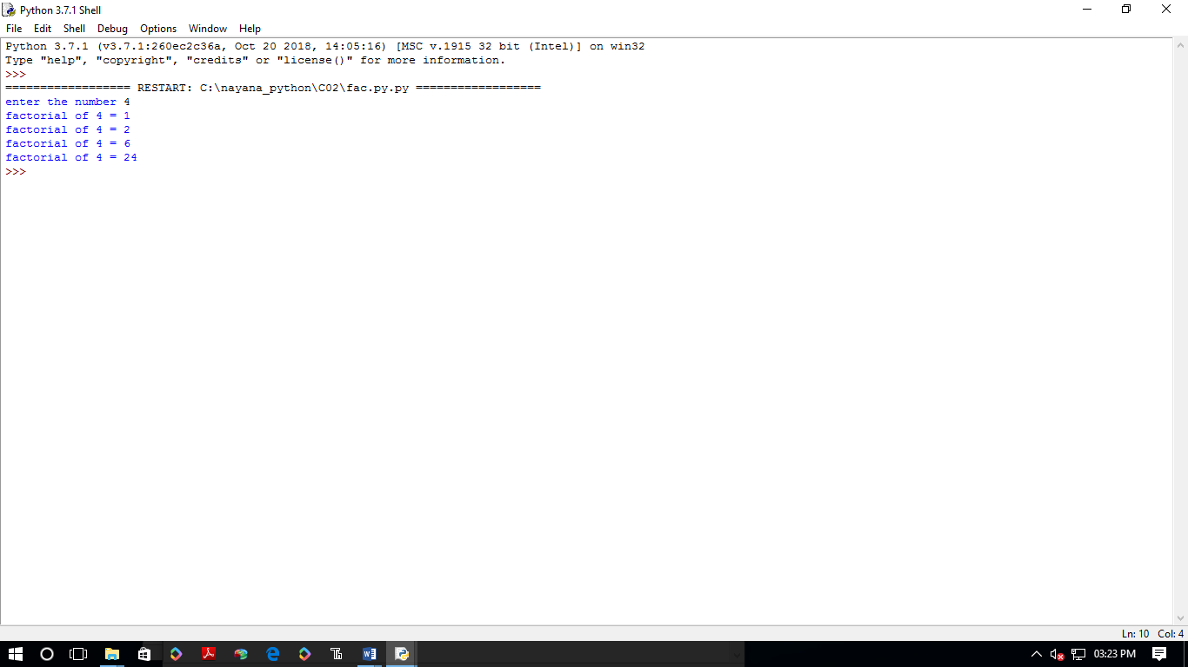

2.Generate Fibonacci series of N terms

n=int(input("enter number"))

a=0

b=1

sum=0

count=1

print("fibonacci series is",end=" ")

while(count<=n):

print(sum,end="")

count+=1

a=b

b=sum

sum=a+b

OUTPUT:

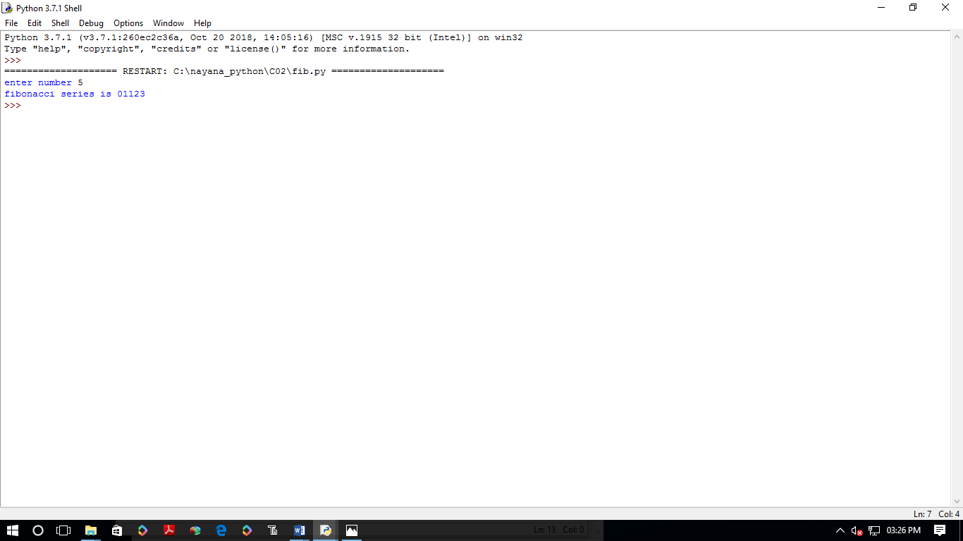

3. Find the sum of all items in a list

list1=[2,4,6]

a=sum(list1)

print("sum of list",a)

OUTPUT:

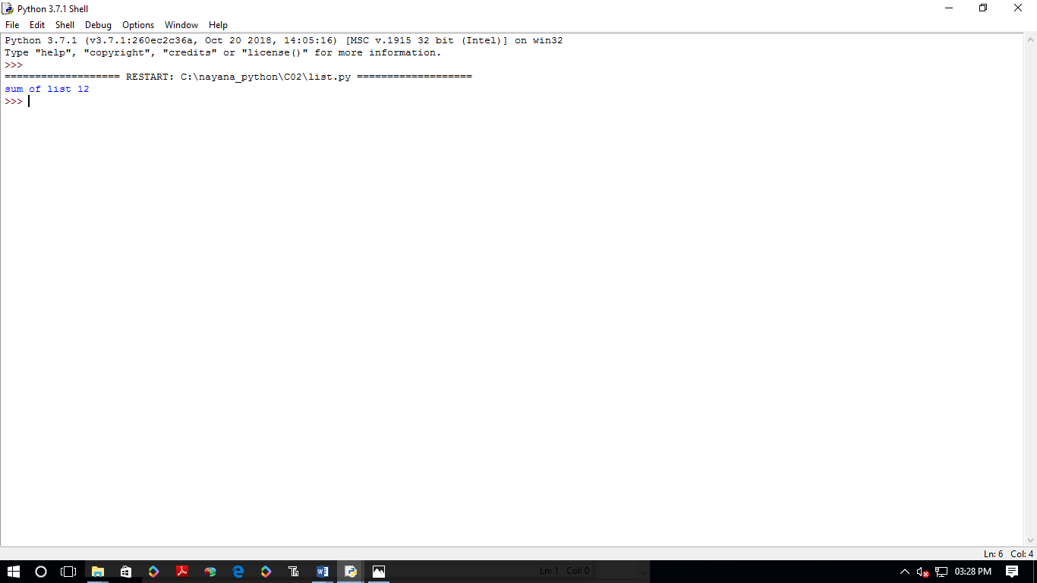

4.Generate a list of four digit numbers in a given range with all their digits even and the number is a perfect square.

from math import sqrt as s

for i in range(1000,10000):

if s(i)==int(s(i)) and i%2==0:

print(i,end=" ")

OUTPUT:

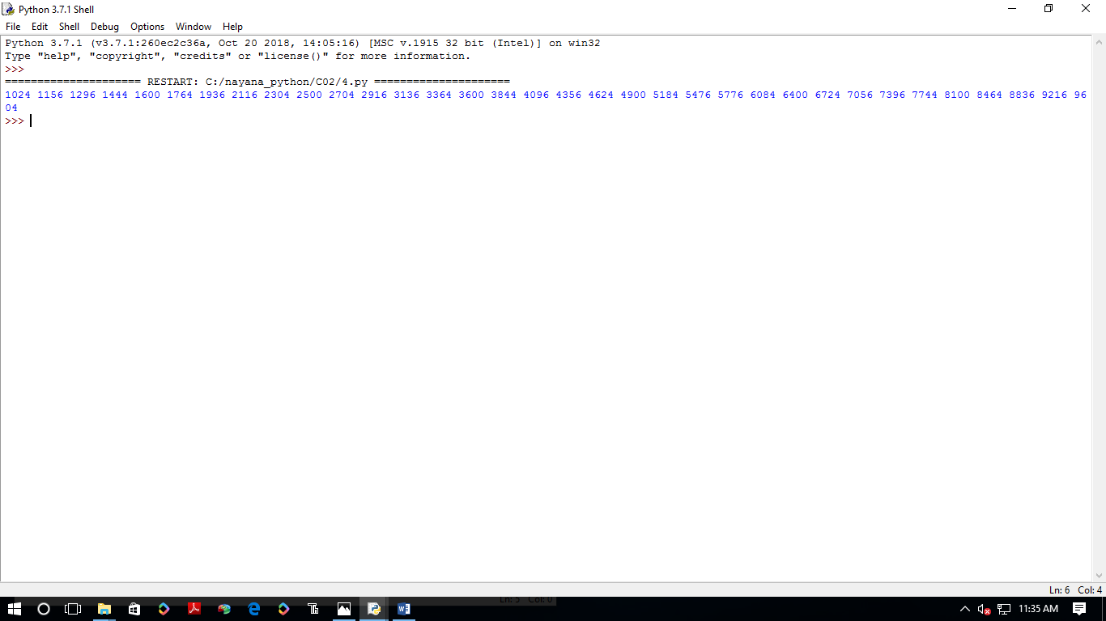

5. Display the given pyramid with step number accepted from user.

rows=int(input("enter the no of rows"))

for i in range(1,rows+1):

for j in range(1,i+1):

print(i\*j,end=' ')

print()

OUTPUT:

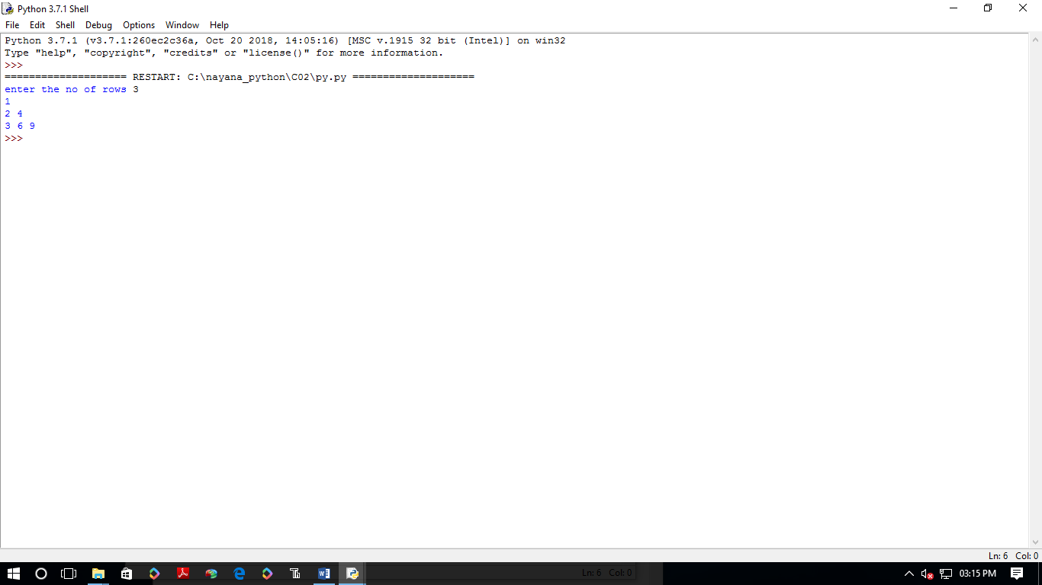

7.Add ‘ing’ at the end of a given string. If it already ends with ‘ing’, then add ‘ly’

str=input("enter string:")

print("string is",str)

if(str.endswith("ing")):

str=str+'ly'

else:

str=str+'ing'

print("the formatted string is:",str)

OUTPUT:

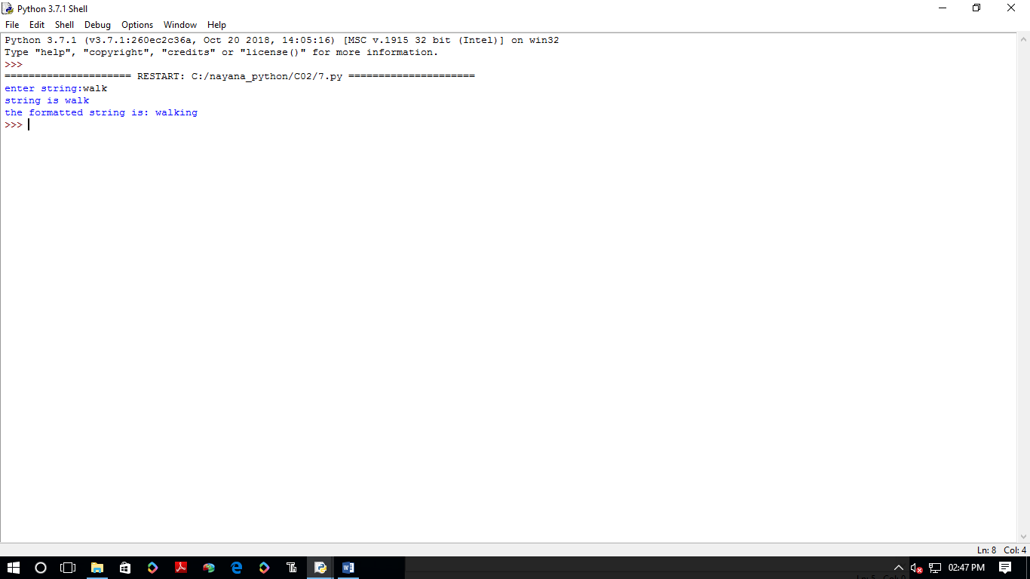

8. Accept a list of words and return length of longest word

a=[]

n= int(input("Enter the number of elements in list:"))

for x in range(0,n):

element=input("Enter element "+ str(x+1) )

a.append(element)

max1=len(a[0])

temp=a[0]

for i in a:

if(len(i)>max1):

max1=len(i)

temp=i

print("Longest Word:",temp)

print("Length of longest word :",max1)

OUTPUT:

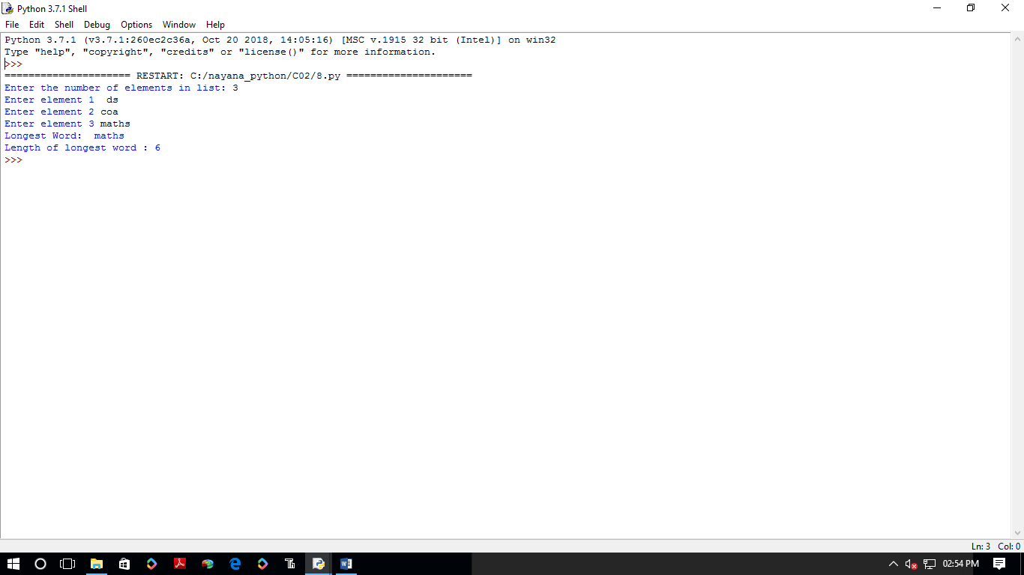

9.Construct following pattern using nested loop

n=int(input("enter the limit:"))

for i in range(n):

for j in range(i):

print('\*',end="")

print('')

for i in range(n,0,-1):

for j in range(i):

print('\*',end="")

print(' ')

OUTPUT:

