1.**Statistics module**

import statistics

print(statistics.mean([1, 3, 5, 7, 9, 11, 13]))

print(statistics.mode([1, 3, 3, 3, 5, 7,9, 11]))

print(statistics.median([1, 3, 5, 7, 9, 11, 13]))

**Output:**

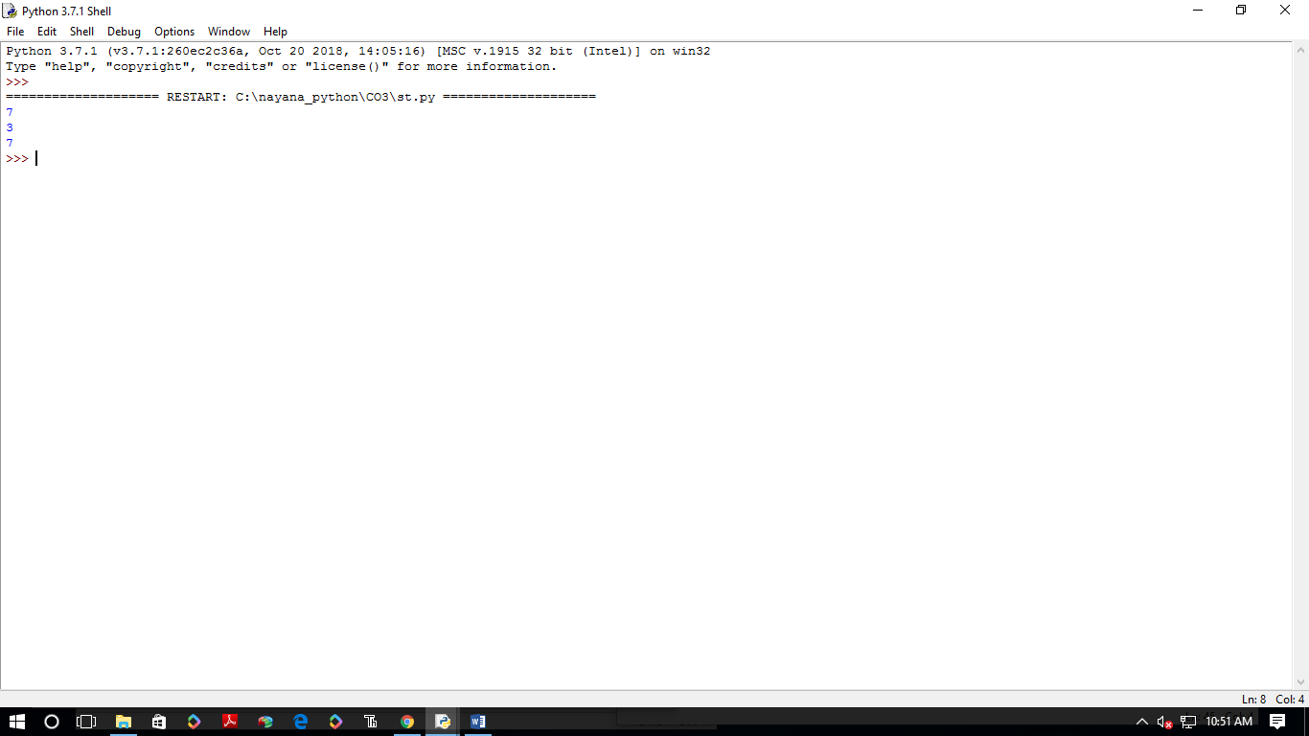

**2.Random module**

import random

list1 = [1, 2, 3, 4, 5, 6]

print(random.choice(list1))

**Output:**

