

American International University-Bangladesh (AIUB)  
Department of Computer Science  
Faculty of Science &Technology (FST)  
Summer 20 21

Section: A  
Advance Operating System

Automated and Remotely Controlled Cat Feeder

A Report submitted

By

|  |  |  |
| --- | --- | --- |
| SN | Student Name | Student ID |
| 1 | Harun, Sayed Naofel Azahar | 17-35862-3 |
| 2 | Haque, Shamiul | 18-38862-3 |
| 3 | Ali, Md. Yeasin | 17-34925-2 |
| 4 | Rahman, Md Ashikur | 16-31971-2 |
| 5 | Sayeed Md Abu | 17-34539-2 |

Under the supervision of   
M. Arifur Rahman

1. **Project Idea:**

Make an automated cat food dispensing Iot device that can be operated remotely

1. **Requirements:**

* Dispensed Food Amount controlled: User can Dispense food amount at will. 1 Oz or 2 Oz
* Can Dispense on scheduled timer
* Cat Can request food through push Button
* Can turn off scheduled dispense and push button request.

1. **Component List:**

* Servo Motor MG996
* Jumper Wire (F-M)
* ESP8266 NodeMCU V3 Development Board with CH340
* 5volt-2amp DC Power supply
* Blynk Applicaton
* Arduino compiler

1. **Implementation:**
2. Examine the product if they meet the description. Because Sometimes they don’t. In our case, it was our Servo motor. The seller provided us with Wrong servo so we had to make adjustments in the code
3. Install Arduino IDE on PC and Blynk application on Smartphone. Install Blynk lybraries and Simpletimer Library
4. Get authentication code from blynk and set it in the code with wifi name and password
5. Attach Jumper cables male ports to servo
6. Attach Servo Signal port to D4 port on NodeMCU board, Ground to ground and + to VIN as VIN provides around 5V.
7. Upload Code to NodeMCU
8. Go to blynk app on smartphone and create a new application as cat feeder
9. Include 3 buttons, make 2 push button and one switch
10. Sellect v3 and v4 virtual pis for the push buttons and v5 pin for switch
11. Connect NodeMCU with Power Supply, the app should be connected
12. V3 and v4 should make the servo rotate 90 degrees and back by 1.5 seconds delay and 3 seconds delay and v5 should rotate servo 90 degree every 15 seconds  
    You can change the delay of v5 by putting time values
13. **Circuit Diagram:**

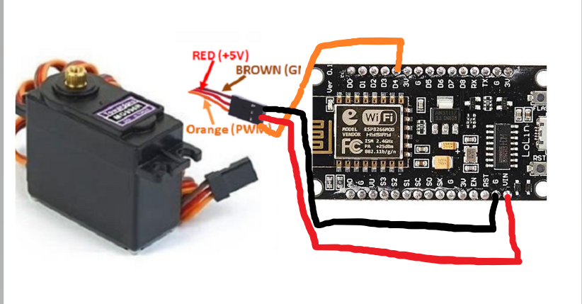

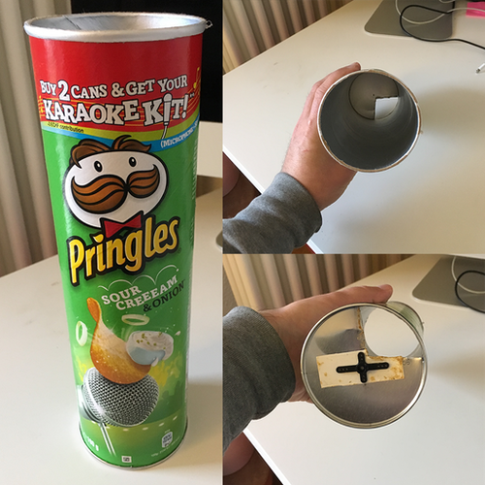

The servo will Move to 0 degree automatically and align them by opposite cuts of the edges of each can. So that the food stay in the upper container and don’t fall out till it’s moved to 90 degree by the servo.

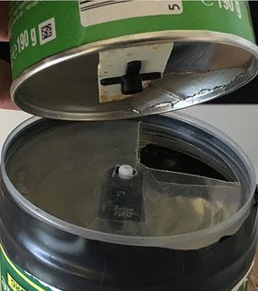

1. **Implemented Code:**

#include <SimpleTimer.h>

#include <Blynk.h>

#define BLYNK_PRINT Serial

#include <ESP8266WiFi.h>

#include <BlynkSimpleEsp8266.h>

#include <Servo.h>

char auth[] = "ESO9eK_WyiAIkLIW-LgJK0QJWyaHNBlh";

char ssid[] = "FreeForAll";

char pass[] = "hqadmin1";

int timerConso;

Servo servo;

SimpleTimer timer;

// function to be called repeatedly

void RepeatTask() {

oneOZ();

setToZero();

}

void oneOZ() {

servo.write(0);

delay(1000);

servo.write(180);

delay(1500);

}

void twoOZ() {

servo.write(0);

delay(1000);

servo.write(180);

delay(3000);

}

void setToZero() {

servo.write(0);

delay(1000);

}

BLYNK_WRITE(V3)

{

int pinValue = param.asInt();

Blynk.run();

if (pinValue == 1) { // if Button sends 1

oneOZ();

} else {

setToZero();

}

}

BLYNK_WRITE(V4)

{

int pinValue = param.asInt();

Blynk.run();

if (pinValue == 1) { // if Button sends 1

twoOZ();

} else {

setToZero();

}

}

BLYNK_WRITE(V5)

{

int pinValue = param.asInt();

//Blynk.run();

if (pinValue == 1) { // if Button sends 1

timer.enable (timerConso);

} else {

timer.disable (timerConso);

setToZero();

}

//return pinValue;

}

void setup()

{

// Debug console

Serial.begin(9600);

Blynk.begin(auth, ssid, pass);

// You can also specify server:

//Blynk.begin(auth, ssid, pass, "blynk-cloud.com", 80);

//Blynk.begin(auth, ssid, pass, IPAddress(192,168,1,100), 8080);

servo.attach(4); //attaches servo to pin 4 (D2 on node mcu)

timerConso = timer.setInterval(15000, RepeatTask);

timer.disable (timerConso);

setToZero();

}

void loop()

{

Blynk.run();

timer.run();

}

1. **References:**

<https://github.com/kiryanenko/SimpleTimer>

<https://github.com/blynkkk/blynk-library/tree/master/src>

<https://community.blynk.cc/t/using-blynktimer-or-simpletimer/53326>

<https://www.electronicwings.com/nodemcu/nodemcu-gpio-with-arduino-ide>