Міністерство освіти і науки України
Національний технічний університет України
«Київський політехнічний інститут імені Ігоря Сікорського»
Факультет інформатики та обчислювальної техніки
Кафедра обчислювальної техніки

Лабораторна робота №2
з дисципліни
«Об’єктно-орієнтоване програмування»
на тему
«Розробка графічного редактора об’єктів»

Виконав: Перевірив:
студент групи ІМ-55 Рекечинський Д. О.
Шило Назар Станіславович
Номер в списку - 31

Київ 2026
Завдання:
- Створити у середовищі розробки новий проект з ім’ям Lab2.
- Скомпілювати проект і отримати виконуваний файл програми.
- Перевірити роботу програми. За потреби налагодити програму.
- Проаналізувати та прокоментувати результати та вихідний текст програми.
- Оформити звіт.

Завдання згідно варіанту:
- Масив вказівників для динамічних об’єктів типу Shape: статичний масив Shape *pcshape[N]; N = 131
- "Гумовий" слід при вводі об’єктів: пунктирна лінія чорного кольору
- Чотири геометричні форми (крапка, лінія, прямокутник, еліпс) можуть мати наступні різновиди вводу та відображення.
- Увід прямокутника: від центру до одного з кутів
- Відображення прямокутника: чорний контур з світло-зеленим заповненням
- Увід еліпсу: по двом протилежним кутам охоплюючого прямокутника
- Відображення еліпсу: чорний контур з білим заповненням
- Позначка поточного типу об’єкту, що вводиться: в заголовку вікна

Текст вихідних модулів:

main.cpp
#include <Window.h>
#include <Editor.h>
#include <memory>
#include <thread>
int WINAPI wWinMain(
_In_ HINSTANCE hInstance,
_In_opt_ HINSTANCE hPrevInstance,
_In_ PWSTR pCmdLine,
_In_ int nCmdShow)
{
lab::EventSystem eventSystem{};
lab::WindowCreateInfo windowCreateInfo = {};
windowCreateInfo.hInstance = hInstance;
windowCreateInfo.nCmdShow = nCmdShow;
windowCreateInfo.pos = { 200, 100 };
windowCreateInfo.size = { 1280, 720 };
windowCreateInfo.windowClassName = L"MainWindowClassName";
windowCreateInfo.windowTitle = L"Lab2";
windowCreateInfo.eventSystem = &eventSystem;
windowCreateInfo.intMenu = lab::Editor::GetMainMenuAsIntResource();
windowCreateInfo.clearColor = RGB(255, 255, 255);
std::unique_ptr<lab::Window> mainWindow = nullptr;
{
lab::WindowError windowCreateError;
mainWindow = std::make_unique<lab::Window>(windowCreateInfo, windowCreateError);
if (windowCreateError.hasError) {
return -1;
}
}
std::unique_ptr<lab::Editor> editor = std::make_unique<lab::Editor>(mainWindow.get(), &eventSystem);
while (mainWindow->IsStillActive()) {
mainWindow->PollEvents();
eventSystem.Dispatch();
mainWindow->Clear();
editor->Render();
mainWindow->Present();
std::this_thread::sleep_for(std::chrono::milliseconds(1));
}
return 0;
}

Window.h

#ifndef LAB2_WINDOW_HEADER
#define LAB2_WINDOW_HEADER
#include <Framework.h>
#include <WindowEvent.h>
#include <EventSystem.h>
#include <string>
namespace lab {
struct WindowError {
bool hasError = false;
std::string errorInfo = {};
}; // struct WindowError
struct WindowCreateInfo {
int nCmdShow = 0;
UINT intMenu = UINT_MAX;
COLORREF clearColor = RGB(255, 255, 255);
HINSTANCE hInstance = NULL;
POINT pos = { 0, 0 };
SIZE size = {};
EventSystem* eventSystem = nullptr;
std::wstring_view windowClassName = {};
std::wstring_view windowTitle = {};
}; // struct WindowCreateInfo
class Window {
public:
class BackBuffer {
public:
BackBuffer() = default;
BackBuffer(const BackBuffer&) = delete;
BackBuffer(BackBuffer&&) noexcept = delete;
~BackBuffer() { Destroy(); }
BackBuffer& operator=(const BackBuffer&) = delete;
BackBuffer& operator=(BackBuffer&&) noexcept = delete;
public:
inline HDC GetHDC() const noexcept { return m_hdc; }
void Create(HWND hwnd);
void Destroy();
void Clear(HBRUSH color);
void Present(HDC frontDC);
private:
SIZE m_size = {};
HDC m_hdc = NULL;
HBITMAP m_bitmap = NULL;
HBITMAP m_oldBitmap = NULL;
}; // class BackBuffer
public:
Window(const WindowCreateInfo& info, WindowError& error);
~Window();
public:
void Clear();
void Present();
void PollEvents();
void ChangeTitle(std::wstring_view newTitle);
inline HDC GetHDC() const noexcept { return m_backBuffer.GetHDC(); }
inline bool IsStillActive() const noexcept { return m_state & _State::Started; }
private:
static LRESULT CALLBACK _WndProc(HWND hwnd, UINT msg, WPARAM wParam, LPARAM lParam);
private:
enum _State : uint8_t {
Started = 0x1
};
std::underlying_type_t<_State> m_state = 0;
HWND m_windowHandle = NULL;
HBRUSH m_clearColor = NULL;
EventSystem* m_eventSystem = nullptr;
EventSystem::EventListenerHandle m_windowCloseListener = EventSystem::EventListenerHandle::Null();
BackBuffer m_backBuffer = {};
}; // class Window
} // namespace lab
#endif // !LAB2_WINDOW_HEADER

Window.cpp
#include <Window.h>
lab::Window::Window(const WindowCreateInfo& info, WindowError& error) {
WNDCLASSEXW windowClass = {};
windowClass.cbSize = sizeof(windowClass);
windowClass.hInstance = info.hInstance;
windowClass.lpszClassName = info.windowClassName.data();
windowClass.lpfnWndProc = _WndProc;
if (!RegisterClassExW(&windowClass)) {
error.hasError = true;
error.errorInfo = "Failed to register window class";
return;
}
HWND hwnd = CreateWindowExW(
0,
info.windowClassName.data(),
info.windowTitle.data(),
WS_OVERLAPPEDWINDOW,
info.pos.x,
info.pos.y,
info.size.cx,
info.size.cy,
NULL,
info.intMenu == UINT_MAX ? NULL : LoadMenuW(info.hInstance, MAKEINTRESOURCEW(info.intMenu)),
info.hInstance,
this
);
if (hwnd == NULL) {
error.hasError = true;
error.errorInfo = "Failed to create window instance";
return;
}
m_backBuffer.Create(hwnd);
m_clearColor = CreateSolidBrush(info.clearColor);
m_windowCloseListener = info.eventSystem->StartListen<WindowCloseEvent>(this,
[](void* ctx, const WindowCloseEvent& e) -> EventResult {
Window* window = (Window*)ctx;
window->m_state &= ~_State::Started;
return EventResult::Propagate;
}
);
ShowWindow(hwnd, info.nCmdShow);
m_windowHandle = hwnd;
m_state |= _State::Started;
m_eventSystem = info.eventSystem;
error.hasError = false;
error.errorInfo = {};
}
lab::Window::~Window() {
if (m_windowCloseListener != EventSystem::EventListenerHandle::Null()) {
m_eventSystem->StopListen<WindowCloseEvent>(m_windowCloseListener);
}
DeleteObject(m_clearColor);
m_backBuffer.Destroy();
if (m_windowHandle != NULL) {
DestroyWindow(m_windowHandle);
}
}
void lab::Window::Clear() {
m_backBuffer.Clear(m_clearColor);
}
void lab::Window::Present() {
HDC frontDC = GetDC(m_windowHandle);
m_backBuffer.Present(frontDC);
ReleaseDC(m_windowHandle, frontDC);
}
void lab::Window::PollEvents() {
MSG msg;
while (PeekMessageW(&msg, NULL, 0, 0, PM_REMOVE)) {
TranslateMessage(&msg);
DispatchMessageW(&msg);
}
}
void lab::Window::ChangeTitle(std::wstring_view newTitle) {
SetWindowTextW(m_windowHandle, newTitle.data());
}
LRESULT lab::Window::_WndProc(HWND hwnd, UINT msg, WPARAM wParam, LPARAM lParam) {
if (msg == WM_NCCREATE) {
CREATESTRUCTW* createStruct = (CREATESTRUCTW*)lParam;
SetWindowLongPtrW(hwnd, GWLP_USERDATA, (LONG_PTR)createStruct->lpCreateParams);
return DefWindowProcW(hwnd, msg, wParam, lParam);
}
Window* window = (Window*)GetWindowLongPtrW(hwnd, GWLP_USERDATA);
switch (msg) {
case WM_COMMAND:
window->m_eventSystem->RegisterEvent<WindowWMCommandEvent>(window, LOWORD(wParam));
break;
case WM_MOUSEMOVE: {
POINT pos = { GET_X_LPARAM(lParam), GET_Y_LPARAM(lParam) };
window->m_eventSystem->RegisterEvent<WindowCursorMoveEvent>(window, pos);
break;
}
case WM_LBUTTONDOWN: {
POINT pos = { GET_X_LPARAM(lParam), GET_Y_LPARAM(lParam) };
window->m_eventSystem->RegisterEvent<WindowMouseButtonEvent>(window, pos, MouseButton::Left, true);
break;
}
case WM_LBUTTONUP: {
POINT pos = { GET_X_LPARAM(lParam), GET_Y_LPARAM(lParam) };
window->m_eventSystem->RegisterEvent<WindowMouseButtonEvent>(window, pos, MouseButton::Left, false);
break;
}
case WM_RBUTTONDOWN: {
POINT pos = { GET_X_LPARAM(lParam), GET_Y_LPARAM(lParam) };
window->m_eventSystem->RegisterEvent<WindowMouseButtonEvent>(window, pos, MouseButton::Right, true);
break;
}
case WM_RBUTTONUP: {
POINT pos = { GET_X_LPARAM(lParam), GET_Y_LPARAM(lParam) };
window->m_eventSystem->RegisterEvent<WindowMouseButtonEvent>(window, pos, MouseButton::Right, false);
break;
}
case WM_CLOSE:
window->m_eventSystem->RegisterEvent<WindowCloseEvent>(window);
break;
case WM_DESTROY:
PostQuitMessage(0);
break;
}
return DefWindowProcW(hwnd, msg, wParam, lParam);
}
void lab::Window::BackBuffer::Create(HWND hwnd) {
HDC hdc = GetDC(hwnd);
m_hdc = CreateCompatibleDC(hdc);
RECT clientRect;
GetClientRect(hwnd, &clientRect);
m_size = SIZE{
clientRect.right - clientRect.left,
clientRect.bottom - clientRect.top
};
m_bitmap = CreateCompatibleBitmap(hdc, m_size.cx, m_size.cy);
m_oldBitmap = (HBITMAP)SelectObject(m_hdc, m_bitmap);
ReleaseDC(hwnd, hdc);
}
void lab::Window::BackBuffer::Destroy() {
if (m_hdc != NULL) {
SelectObject(m_hdc, m_oldBitmap);
DeleteDC(m_hdc);
}
if (m_bitmap != NULL) {
DeleteObject(m_bitmap);
}
}
void lab::Window::BackBuffer::Clear(HBRUSH color) {
RECT fillRect = { 0, 0, m_size.cx, m_size.cy };
FillRect(m_hdc, &fillRect, color);
}
void lab::Window::BackBuffer::Present(HDC frontDC) {
BitBlt(frontDC, 0, 0, m_size.cx, m_size.cy, m_hdc, 0, 0, SRCCOPY);
}

Editor.h

#ifndef LAB2_EDITOR_HEADER
#define LAB2_EDITOR_HEADER
#include <Framework.h>
#include <Shape.h>
#include <EventSystem.h>
#include <WindowEvent.h>
#include <array>
namespace lab {
class Window;
class IShapeEditor {
public:
virtual ~IShapeEditor() = default;
virtual void OnMouseLBPressed(POINT pos) { m_pressedPos = pos; }
virtual void OnMouseRBPressed(POINT pos) = 0;
virtual void OnMouseLBReleased(POINT pos) = 0;
virtual void OnCursorMove(POINT pos) = 0;
virtual IShape* GetIntermediate() const noexcept { return nullptr; }
inline IShape* GetNewShape() noexcept {
IShape* newShape = m_newShape;
m_newShape = nullptr;
return newShape;
}
protected:
POINT m_pressedPos = { -1, -1 };
IShape* m_newShape = nullptr;
}; // class IShapeEditor
class PointEditor final : public IShapeEditor {
public:
virtual ~PointEditor() = default;
virtual void OnMouseLBReleased(POINT pos) override;
virtual void OnMouseRBPressed(POINT pos) override {}
virtual void OnCursorMove(POINT pos) override;
}; // class PointEditor
class ITwoPointShapeEditor : public IShapeEditor {
public:
virtual ~ITwoPointShapeEditor() override;
virtual void OnMouseLBPressed(POINT pos) override;
virtual void OnMouseRBPressed(POINT pos) override;
virtual IShape* GetIntermediate() const noexcept override;
protected:
bool m_hasIntermediate = false;
IShape* m_intermediate = nullptr;
}; // class TwoPointShapeEditor
class LineEditor final : public ITwoPointShapeEditor {
public:
LineEditor();
virtual void OnMouseLBPressed(POINT pos) override;
virtual void OnMouseLBReleased(POINT pos) override;
virtual void OnCursorMove(POINT pos) override;
}; // class LineEditor
class RectangleEditor final : public ITwoPointShapeEditor {
public:
RectangleEditor();
virtual void OnMouseLBPressed(POINT pos) override;
virtual void OnMouseLBReleased(POINT pos) override;
virtual void OnCursorMove(POINT pos) override;
}; // class RectangleEditor
class EllipseEditor final : public ITwoPointShapeEditor {
public:
EllipseEditor();
virtual void OnMouseLBPressed(POINT pos) override;
virtual void OnMouseLBReleased(POINT pos) override;
virtual void OnCursorMove(POINT pos) override;
}; // class EllipseEditor
class Editor {
public:
Editor(Window* window, EventSystem* eventSystem);
~Editor();
public:
static UINT GetMainMenuAsIntResource() noexcept;
void Render();
private:
void _EmplaceNewShapeIfExists();
private:
enum class _ShapeType {
Point,
Line,
Rect,
Ellipse,
Count,
None,
} m_selectedShapeType = _ShapeType::None;
size_t m_shapeCount = 0;
Window* m_window = nullptr;
EventSystem* m_eventSystem = nullptr;
EventSystem::EventListenerHandle m_mouseButtonListener = EventSystem::EventListenerHandle::Null();
EventSystem::EventListenerHandle m_cursorMoveListener = EventSystem::EventListenerHandle::Null();
EventSystem::EventListenerHandle m_wmCommandListener = EventSystem::EventListenerHandle::Null();
IShapeEditor* m_shapeEditors[(int)_ShapeType::Count] = {};
std::array<IShape*, 131> m_shapes;
}; // class Editor
} // namespace lab
#endif // !LAB2_EDITOR_HEADER

Editor.cpp

#include <Editor.h>
#include <Window.h>
#include <resource/EditorMainMenu.h>
lab::Editor::Editor(Window* window, EventSystem* eventSystem) : m_window(window), m_eventSystem(eventSystem), m_shapes() {
m_shapeEditors[(int)_ShapeType::Point] = (IShapeEditor*)::operator new(sizeof(PointEditor));
m_shapeEditors[(int)_ShapeType::Line] = (IShapeEditor*)::operator new(sizeof(LineEditor));
m_shapeEditors[(int)_ShapeType::Rect] = (IShapeEditor*)::operator new(sizeof(RectangleEditor));
m_shapeEditors[(int)_ShapeType::Ellipse] = (IShapeEditor*)::operator new(sizeof(EllipseEditor));
new (m_shapeEditors[(int)_ShapeType::Point]) PointEditor();
new (m_shapeEditors[(int)_ShapeType::Line]) LineEditor();
new (m_shapeEditors[(int)_ShapeType::Rect]) RectangleEditor();
new (m_shapeEditors[(int)_ShapeType::Ellipse]) EllipseEditor();
m_wmCommandListener = m_eventSystem->StartListen<WindowWMCommandEvent>(this,
[](void* ctx, const WindowWMCommandEvent& e) -> EventResult {
Editor* editor = (Editor*)ctx;
switch (e.GetLOWORD()) {
case IDM_MAIN_MENU_OBJECT_POINT:
e.GetWindow()->ChangeTitle(L"Lab2 (Поточний об'єкт: точка)");
editor->m_selectedShapeType = _ShapeType::Point;
break;
case IDM_MAIN_MENU_OBJECT_LINE:
e.GetWindow()->ChangeTitle(L"Lab2 (Поточний об'єкт: лінія)");
editor->m_selectedShapeType = _ShapeType::Line;
break;
case IDM_MAIN_MENU_OBJECT_RECT:
e.GetWindow()->ChangeTitle(L"Lab2 (Поточний об'єкт: прямокутник)");
editor->m_selectedShapeType = _ShapeType::Rect;
break;
case IDM_MAIN_MENU_OBJECT_ELLIPSE:
e.GetWindow()->ChangeTitle(L"Lab2 (Поточний об'єкт: еліпс)");
editor->m_selectedShapeType = _ShapeType::Ellipse;
break;
}
return EventResult::Propagate;
}
);
m_mouseButtonListener = m_eventSystem->StartListen<WindowMouseButtonEvent>(this,
[](void* ctx, const WindowMouseButtonEvent& e) -> EventResult {
Editor* editor = (Editor*)ctx;
if (editor->m_selectedShapeType == _ShapeType::None) {
return EventResult::Propagate;
}
IShapeEditor* selectedEditor = editor->m_shapeEditors[(int)editor->m_selectedShapeType];
if (e.IsPressed()) {
if (e.GetMouseButton() == MouseButton::Left) {
selectedEditor->OnMouseLBPressed(e.GetPos());
}
if (e.GetMouseButton() == MouseButton::Right) {
selectedEditor->OnMouseRBPressed(e.GetPos());
}
}
else {
if (e.GetMouseButton() == MouseButton::Left) {
selectedEditor->OnMouseLBReleased(e.GetPos());
}
}
editor->_EmplaceNewShapeIfExists();
return EventResult::Propagate;
}
);
m_cursorMoveListener = m_eventSystem->StartListen<WindowCursorMoveEvent>(this,
[](void* ctx, const WindowCursorMoveEvent& e) -> EventResult {
Editor* editor = (Editor*)ctx;
if (editor->m_selectedShapeType == _ShapeType::None) {
return EventResult::Propagate;
}
IShapeEditor* selectedEditor = editor->m_shapeEditors[(int)editor->m_selectedShapeType];
selectedEditor->OnCursorMove(e.GetPos());
editor->_EmplaceNewShapeIfExists();
return EventResult::Propagate;
}
);
}
lab::Editor::~Editor() {
if (m_mouseButtonListener != EventSystem::EventListenerHandle::Null()) {
m_eventSystem->StopListen<WindowMouseButtonEvent>(m_mouseButtonListener);
}
if (m_wmCommandListener != EventSystem::EventListenerHandle::Null()) {
m_eventSystem->StopListen<WindowWMCommandEvent>(m_wmCommandListener);
}
for (IShape* shape : m_shapes) {
shape->~IShape();
::operator delete (shape);
}
for (IShapeEditor* editor : m_shapeEditors) {
editor->~IShapeEditor();
::operator delete(editor);
}
}
UINT lab::Editor::GetMainMenuAsIntResource() noexcept {
return IDR_EDITOR_MAIN_MENU;
}
void lab::Editor::Render() {
HDC hdc = m_window->GetHDC();
for (size_t i = 0; i < m_shapeCount; ++i) {
m_shapes[i]->Draw(hdc);
}
if (m_selectedShapeType != _ShapeType::None) {
IShape* intermediate = m_shapeEditors[(int)m_selectedShapeType]->GetIntermediate();
if (intermediate != nullptr) {
intermediate->Draw(hdc);
}
}
}
void lab::Editor::_EmplaceNewShapeIfExists() {
IShape* newShape = m_shapeEditors[(int)m_selectedShapeType]->GetNewShape();
if (newShape != nullptr && m_shapeCount < m_shapes.size()) {
m_shapes[m_shapeCount] = newShape;
++m_shapeCount;
return;
}
if (newShape != nullptr) {
newShape->~IShape();
::operator delete(newShape);
}
}
void lab::PointEditor::OnMouseLBReleased(POINT pos) {
m_pressedPos = { -1, -1 };
PointShape* point = (PointShape*)::operator new(sizeof(PointShape));
new (point) PointShape(pos, RGB(255, 0, 0));
m_newShape = point;
}
void lab::PointEditor::OnCursorMove(POINT pos) {
if (m_pressedPos.x != -1) {
PointShape* point = (PointShape*)::operator new(sizeof(PointShape));
new (point) PointShape(pos, RGB(0, 0, 255));
m_newShape = point;
}
}
lab::ITwoPointShapeEditor::~ITwoPointShapeEditor() {
if (m_intermediate != nullptr) {
m_intermediate->~IShape();
::operator delete(m_intermediate);
}
}
void lab::ITwoPointShapeEditor::OnMouseLBPressed(POINT pos) {
IShapeEditor::OnMouseLBPressed(pos);
m_hasIntermediate = true;
}
void lab::ITwoPointShapeEditor::OnMouseRBPressed(POINT pos) {
m_hasIntermediate = false;
}
lab::IShape* lab::ITwoPointShapeEditor::GetIntermediate() const noexcept {
return m_hasIntermediate ? m_intermediate : nullptr;
}
// ------------------------------------------------- LineEditor -------------------------------------------------
lab::LineEditor::LineEditor() {
m_intermediate = (LineShape*)::operator new(sizeof(LineShape));
new (m_intermediate) LineShape({ 0, 0 }, { 0, 0 }, RGB(0, 0, 0));
((LineShape*)m_intermediate)->SetOutlineStyle(PS_DASH);
}
void lab::LineEditor::OnMouseLBPressed(POINT pos) {
ITwoPointShapeEditor::OnMouseLBPressed(pos);
((LineShape*)m_intermediate)->SetPoints(pos, pos);
}
void lab::LineEditor::OnMouseLBReleased(POINT pos) {
if (m_hasIntermediate && pos.x - m_pressedPos.x != 0 && pos.y - m_pressedPos.y != 0) {
LineShape* line = (LineShape*)::operator new(sizeof(LineShape));
new (line) LineShape(m_pressedPos, pos, RGB(0, 0, 0));
m_newShape = line;
}
m_hasIntermediate = false;
}
void lab::LineEditor::OnCursorMove(POINT pos) {
if (m_hasIntermediate) {
((LineShape*)m_intermediate)->SetTo(pos);
}
}
// ----------------------------------------------- RectangleEditor -----------------------------------------------
lab::RectangleEditor::RectangleEditor() {
m_intermediate = (RectangleShape*)::operator new(sizeof(RectangleShape));
new (m_intermediate) RectangleShape({ 0, 0 }, { 0, 0 }, RGB(255, 255, 255), RGB(0, 0, 0));
m_intermediate->SetOutlineStyle(PS_DASH);
((RectangleShape*)m_intermediate)->MakeTransparent();
}
void lab::RectangleEditor::OnMouseLBPressed(POINT pos) {
ITwoPointShapeEditor::OnMouseLBPressed(pos);
m_intermediate->SetPos(pos);
((RectangleShape*)m_intermediate)->SetPoints(pos, pos);
}
void lab::RectangleEditor::OnMouseLBReleased(POINT pos) {
if (m_hasIntermediate && pos.x - m_pressedPos.x != 0 && pos.y - m_pressedPos.y != 0) {
RectangleShape* rect = (RectangleShape*)::operator new(sizeof(RectangleShape));
new (rect) RectangleShape(*(RectangleShape*)m_intermediate);
rect->SetOutlineStyle(PS_SOLID);
rect->SetColor(RGB(0, 255, 0));
rect->MakeTransparent(false);
m_newShape = rect;
}
m_hasIntermediate = false;
}
void lab::RectangleEditor::OnCursorMove(POINT pos) {
if (m_hasIntermediate) {
POINT halfSize = {
std::abs(pos.x - m_pressedPos.x),
std::abs(pos.y - m_pressedPos.y)
};
((EllipseShape*)m_intermediate)->SetPoints(
POINT{ m_pressedPos.x - halfSize.x, m_pressedPos.y - halfSize.y },
POINT{ m_pressedPos.x + halfSize.x, m_pressedPos.y + halfSize.y }
);
}
}
// ------------------------------------------------ EllipseEditor -------------------------------------------------
lab::EllipseEditor::EllipseEditor() {
m_intermediate = (EllipseShape*)::operator new(sizeof(EllipseShape));
new (m_intermediate) EllipseShape({ 0, 0 }, { 0, 0 }, RGB(255, 255, 255), RGB(0, 0, 0));
m_intermediate->SetOutlineStyle(PS_DASH);
((EllipseShape*)m_intermediate)->MakeTransparent();
}
void lab::EllipseEditor::OnMouseLBPressed(POINT pos) {
ITwoPointShapeEditor::OnMouseLBPressed(pos);
m_intermediate->SetPos(pos);
((EllipseShape*)m_intermediate)->SetPoints(pos, pos);
}
void lab::EllipseEditor::OnMouseLBReleased(POINT pos) {
if (m_hasIntermediate && pos.x - m_pressedPos.x != 0 && pos.y - m_pressedPos.y != 0) {
EllipseShape* ellipse = (EllipseShape*)::operator new(sizeof(EllipseShape));
new (ellipse) EllipseShape(*(EllipseShape*) m_intermediate);
ellipse->SetOutlineStyle(PS_SOLID);
ellipse->SetColor(RGB(255, 255, 255));
ellipse->MakeTransparent(false);
m_newShape = ellipse;
}
m_hasIntermediate = false;
}
void lab::EllipseEditor::OnCursorMove(POINT pos) {
if (m_hasIntermediate) {
((EllipseShape*)m_intermediate)->SetRightBottom(pos);
}
}

Shape.h

#ifndef LAB2_SHAPE_HEADER
#define LAB2_SHAPE_HEADER
#include <Framework.h>
namespace lab {
class IShape {
public:
IShape(POINT pos, COLORREF color) : m_pos(pos), m_color(color) {}
virtual ~IShape() = default;
virtual void Draw(HDC hdc) const = 0;
virtual void SetOutlineStyle(int style) noexcept { m_outlineStyle = style; }
inline void SetPos(POINT pos) noexcept { m_pos = pos; }
inline void SetColor(COLORREF color) noexcept { m_color = color; }
inline COLORREF GetColor() const noexcept { return m_color; }
protected:
int m_outlineStyle = PS_SOLID;
POINT m_pos = { 0, 0 };
COLORREF m_color = RGB(0, 0, 0);
}; // class IShape
// ------------------------------------------- PointShape -------------------------------------------
class PointShape final : public IShape {
public:
PointShape(POINT pos, COLORREF color) : IShape(pos, color) {}
virtual ~PointShape() = default;
virtual void Draw(HDC hdc) const override;
}; // class PointShape
// ------------------------------------------- LineShape -------------------------------------------
class LineShape final : public IShape {
public:
LineShape(POINT from, POINT to, COLORREF color) : IShape(from, color), m_to(to) {}
virtual ~LineShape() = default;
virtual void Draw(HDC hdc) const override;
inline void SetTo(POINT to) noexcept { m_to = to; }
inline void SetPoints(POINT from, POINT to) noexcept { m_pos = from; m_to = to; }
private:
POINT m_to = { 0, 0 };
}; // class LineShape
// ----------------------------------------- OutlineShape -----------------------------------------
class IOutlineShape : public IShape {
public:
IOutlineShape(POINT pos, COLORREF color, COLORREF outlineColor) : IShape(pos, color), m_outlineColor(outlineColor) {}
virtual ~IOutlineShape() = default;
inline void MakeTransparent(bool transparent = true) noexcept { m_hasFill = !transparent; }
protected:
bool m_hasFill = true;
COLORREF m_outlineColor = RGB(0, 0, 0);
}; // class IOutlineShape
// ----------------------------------------- RectangleShape -----------------------------------------
class RectangleShape final : public IOutlineShape {
public:
RectangleShape(POINT leftTop, POINT rightBottom, COLORREF color, COLORREF outlineCOlor) :
IOutlineShape(leftTop, color, outlineCOlor), m_rightBottom(rightBottom) {}
virtual ~RectangleShape() = default;
virtual void Draw(HDC hdc) const override;
inline void SetPoints(POINT leftTop, POINT rightBottom) { m_pos = leftTop; m_rightBottom = rightBottom; }
inline void SetRightBottom(POINT rightBottom) noexcept { m_rightBottom = rightBottom; }
private:
POINT m_rightBottom = { 0, 0 };
}; // class RectangleShape
// ------------------------------------------ EllipseShape -------------------------------------------
class EllipseShape final : public IOutlineShape {
public:
EllipseShape(POINT leftTop, POINT rightBottom, COLORREF color, COLORREF outlineColor) :
IOutlineShape(leftTop, color, outlineColor), m_rightBottom(rightBottom) {}
virtual ~EllipseShape() = default;
virtual void Draw(HDC hdc) const override;
inline void SetPoints(POINT leftTop, POINT rightBottom) { m_pos = leftTop; m_rightBottom = rightBottom; }
inline void SetRightBottom(POINT rightBottom) noexcept { m_rightBottom = rightBottom; }
private:
POINT m_rightBottom = { 0, 0 };
}; // class EllipseShape
} // namespace lab
#endif // !LAB2_SHAPE_HEADER

Shape.cpp

#include <Shape.h>
void lab::PointShape::Draw(HDC hdc) const {
SetPixel(hdc, m_pos.x, m_pos.y, m_color);
}
void lab::LineShape::Draw(HDC hdc) const {
int oldBkMode = SetBkMode(hdc, TRANSPARENT);
HPEN pen = CreatePen(m_outlineStyle, 1, m_color);
HPEN oldPen = (HPEN)SelectObject(hdc, pen);
MoveToEx(hdc, m_pos.x, m_pos.y, NULL);
LineTo(hdc, m_to.x, m_to.y);
DeleteObject(pen);
SelectObject(hdc, oldPen);
SetBkMode(hdc, oldBkMode);
}
void lab::RectangleShape::Draw(HDC hdc) const {
int oldBkMode = SetBkMode(hdc, TRANSPARENT);
HPEN pen = CreatePen(m_outlineStyle, 1, m_outlineColor);
HBRUSH brush = m_hasFill ? CreateSolidBrush(m_color) : (HBRUSH)GetStockObject(NULL_BRUSH);
HPEN oldPen = (HPEN)SelectObject(hdc, pen);
HBRUSH oldBrush = (HBRUSH)SelectObject(hdc, brush);
Rectangle(hdc, m_pos.x, m_pos.y, m_rightBottom.x, m_rightBottom.y);
SelectObject(hdc, oldPen);
SelectObject(hdc, oldBrush);
if (m_hasFill) DeleteObject(brush);
DeleteObject(pen);
SetBkMode(hdc, oldBkMode);
}
void lab::EllipseShape::Draw(HDC hdc) const {
int oldBkMode = SetBkMode(hdc, TRANSPARENT);
HPEN pen = CreatePen(m_outlineStyle, 1, m_outlineColor);
HBRUSH brush = m_hasFill ? CreateSolidBrush(m_color) : (HBRUSH)GetStockObject(NULL_BRUSH);
HPEN oldPen = (HPEN)SelectObject(hdc, pen);
HBRUSH oldBrush = (HBRUSH)SelectObject(hdc, brush);
Ellipse(hdc, m_pos.x, m_pos.y, m_rightBottom.x, m_rightBottom.y);
SelectObject(hdc, oldPen);
SelectObject(hdc, oldBrush);
if (m_hasFill) DeleteObject(brush);
DeleteObject(pen);
SetBkMode(hdc, oldBkMode);
}

Діаграма успадкування класів:
1) Об’єкти:
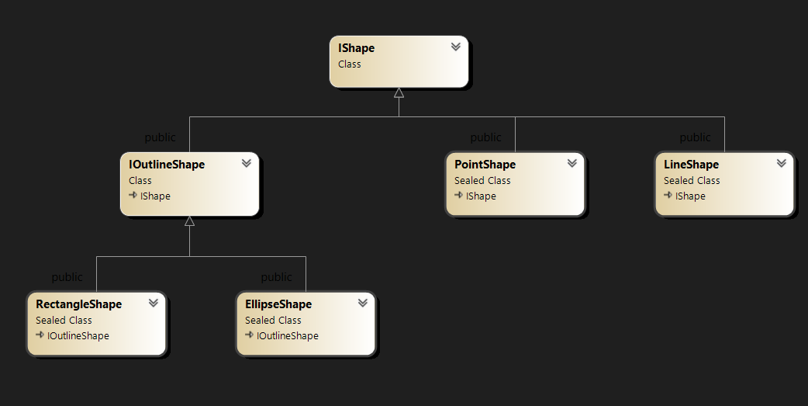

2) Редактори:

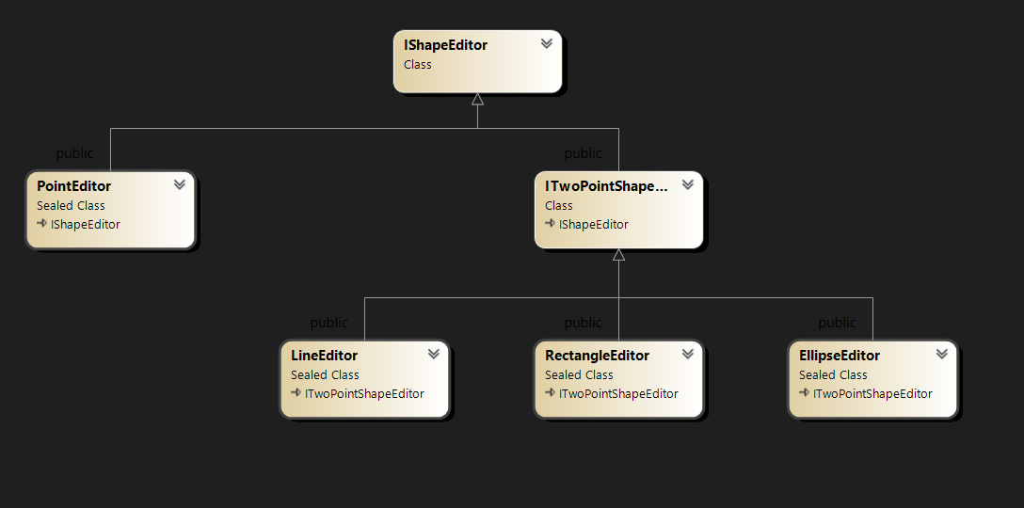

Скріншоти:
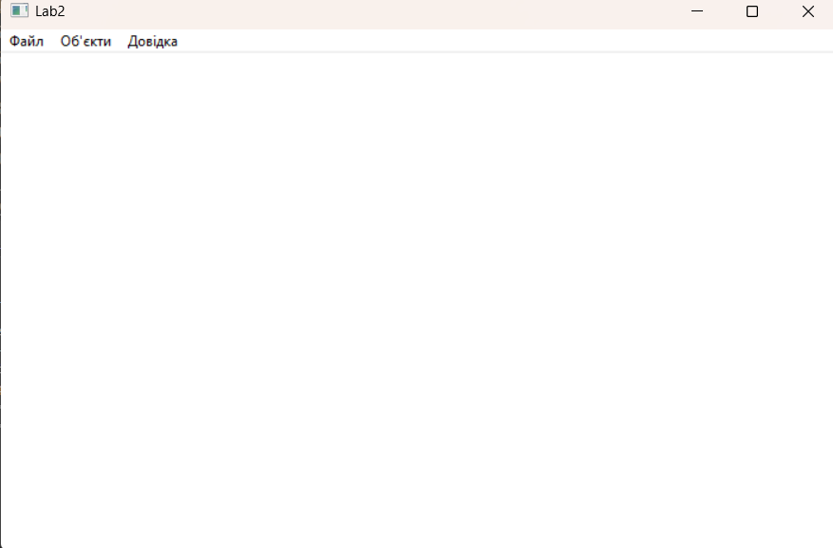

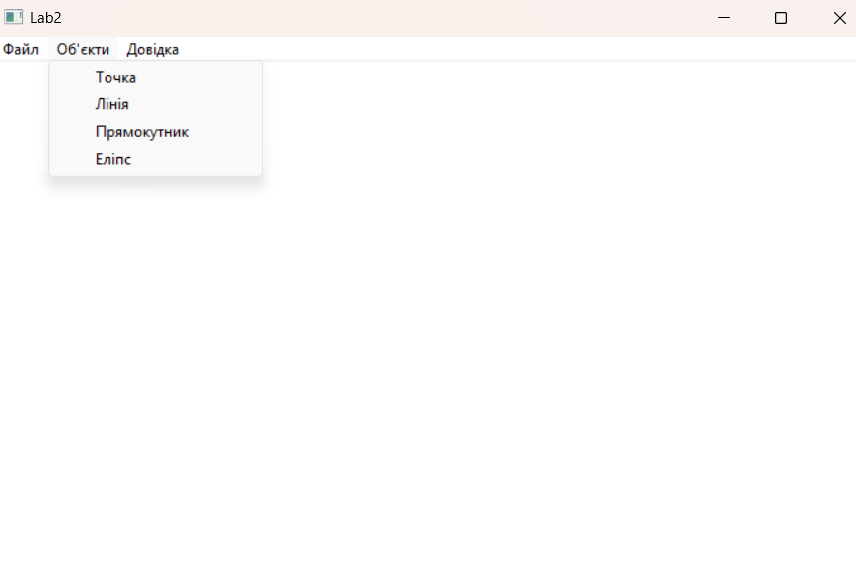

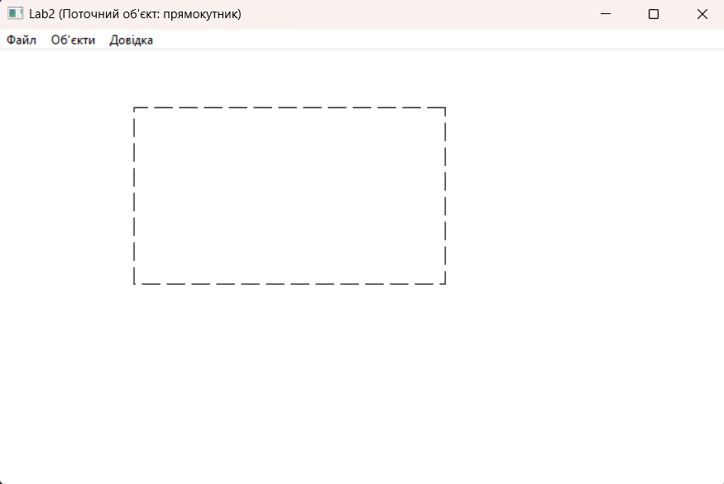

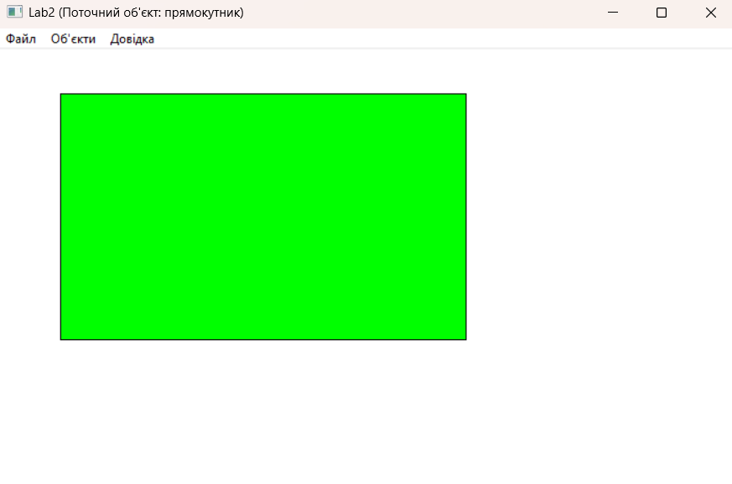

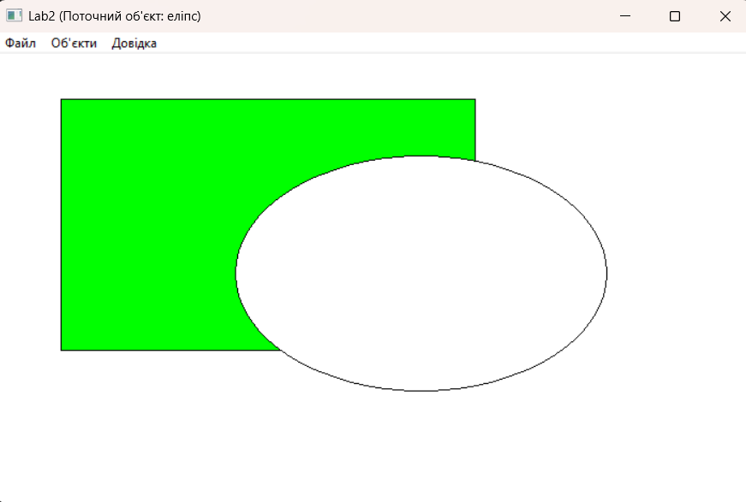

Висновки: отримано вміння та навички з використання інкапсуляції,
абстракції типів, успадкування та поліморфізму на основі класів С++,
запрограмувавши простий графічний редактор в об’єктно-орієнтованому
стилі.

