Міністерство освіти і науки України
Національний технічний університет України
«Київський політехнічний інститут імені Ігоря Сікорського»
Факультет інформатики та обчислювальної техніки
Кафедра обчислювальної техніки

Лабораторна робота №3
з дисципліни
«Об’єктно-орієнтоване програмування»
на тему
«Розробка інтерфейсу користувача»

Виконав: Перевірив:
студент групи ІМ-55 Рекечинський Д. О.
Шило Назар Станіславович
Номер в списку - 31

Київ 2026
Завдання:
- Створити у середовищі розробки проект з ім’ям Lab3.
- Написати вихідний текст програми згідно варіанту завдання.
- Скомпілювати вихідний текст і отримати виконуваний файл програми.
- Перевірити роботу програми. За потреби налагодити програму.
- Проаналізувати та прокоментувати результати та вихідний текст програми.
- Оформити звіт.

Завдання згідно варіанту:
Завдання з другої лабораторної роботи по варіанту з номером 31

Текст вихідних модулів:

main.cpp
#include <Window.h>
#include <Editor.h>
#include <memory>
#include <thread>
int WINAPI wWinMain(
_In_ HINSTANCE hInstance,
_In_opt_ HINSTANCE hPrevInstance,
_In_ PWSTR pCmdLine,
_In_ int nCmdShow)
{
/*AllocConsole();
(void)freopen("CONOUT$", "w", stdout);*/
lab::EventSystem eventSystem{};
lab::WindowCreateInfo windowCreateInfo = {};
windowCreateInfo.hInstance = hInstance;
windowCreateInfo.nCmdShow = nCmdShow;
windowCreateInfo.pos = { 200, 100 };
windowCreateInfo.size = { 1280, 720 };
windowCreateInfo.windowClassName = L"MainWindowClassName";
windowCreateInfo.windowTitle = L"Lab3";
windowCreateInfo.eventSystem = &eventSystem;
windowCreateInfo.intMenu = lab::Editor::GetMainMenuAsIntResource();
windowCreateInfo.clearColor = RGB(255, 255, 255);
std::unique_ptr<lab::Window> mainWindow = nullptr;
{
lab::WindowError windowCreateError;
mainWindow = std::make_unique<lab::Window>(windowCreateInfo, windowCreateError);
if (windowCreateError.hasError) {
return -1;
}
}
std::unique_ptr<lab::Editor> editor = std::make_unique<lab::Editor>(mainWindow.get(), &eventSystem);
while (mainWindow->IsStillActive()) {
mainWindow->PollEvents();
eventSystem.Dispatch();
mainWindow->Clear();
editor->Draw();
mainWindow->Present();
std::this_thread::sleep_for(std::chrono::milliseconds(1));
}
return 0;
}

Window.h

#ifndef LAB2_WINDOW_HEADER
#define LAB2_WINDOW_HEADER
#include <Framework.h>
#include <WindowEvent.h>
#include <EventSystem.h>
#include <string>
namespace lab {
struct WindowError {
bool hasError = false;
std::string errorInfo = {};
}; // struct WindowError
struct WindowCreateInfo {
int nCmdShow = 0;
UINT intMenu = UINT_MAX;
COLORREF clearColor = RGB(255, 255, 255);
HINSTANCE hInstance = NULL;
POINT pos = { 0, 0 };
SIZE size = {};
EventSystem* eventSystem = nullptr;
std::wstring_view windowClassName = {};
std::wstring_view windowTitle = {};
}; // struct WindowCreateInfo
class Window {
public:
class BackBuffer {
public:
BackBuffer() = default;
BackBuffer(const BackBuffer&) = delete;
BackBuffer(BackBuffer&&) noexcept = delete;
~BackBuffer() { Destroy(); }
BackBuffer& operator=(const BackBuffer&) = delete;
BackBuffer& operator=(BackBuffer&&) noexcept = delete;
public:
inline HDC GetHDC() const noexcept { return m_hdc; }
void Create(HWND hwnd);
void Destroy();
void Clear(HBRUSH color);
void Present(HDC frontDC);
private:
SIZE m_size = {};
HDC m_hdc = NULL;
HBITMAP m_bitmap = NULL;
HBITMAP m_oldBitmap = NULL;
}; // class BackBuffer
public:
Window(const WindowCreateInfo& info, WindowError& error);
~Window();
public:
void Clear();
void Present();
void PollEvents();
void ChangeTitle(std::wstring_view newTitle);
inline HWND GetHWND() const noexcept { return m_windowHandle; }
inline HDC GetHDC() const noexcept { return m_backBuffer.GetHDC(); }
inline bool IsStillActive() const noexcept { return m_state & _State::Started; }
inline SIZE GetSize() const noexcept { return m_createInfo.size; }
inline POINT GetCursorPos() const noexcept { return m_cursorPos; }
private:
static LRESULT CALLBACK _WndProc(HWND hwnd, UINT msg, WPARAM wParam, LPARAM lParam);
private:
enum _State : uint8_t {
Started = 0x1,
TrackMouse = 0x2
};
std::underlying_type_t<_State> m_state = 0;
HWND m_windowHandle = NULL;
HBRUSH m_clearColor = NULL;
POINT m_cursorPos = { 0, 0 };
EventSystem* m_eventSystem = nullptr;
EventSystem::EventListenerHandle m_windowCloseListener = EventSystem::EventListenerHandle::Null();
BackBuffer m_backBuffer = {};
WindowCreateInfo m_createInfo;
}; // class Window
} // namespace lab
#endif // !LAB2_WINDOW_HEADER

Window.cpp
#include <Window.h>
lab::Window::Window(const WindowCreateInfo& info, WindowError& error) : m_createInfo(info) {
WNDCLASSEXW windowClass = {};
windowClass.cbSize = sizeof(windowClass);
windowClass.hInstance = info.hInstance,
windowClass.lpszClassName = info.windowClassName.data();
windowClass.hCursor = LoadCursor(nullptr, IDC_ARROW);
windowClass.lpfnWndProc = _WndProc;
if (!RegisterClassExW(&windowClass)) {
error.hasError = true;
error.errorInfo = "Failed to register window class";
return;
}
m_eventSystem = info.eventSystem;
m_windowHandle = CreateWindowExW(
0,
info.windowClassName.data(),
info.windowTitle.data(),
WS_OVERLAPPEDWINDOW,
info.pos.x,
info.pos.y,
info.size.cx,
info.size.cy,
NULL,
info.intMenu == UINT_MAX ? NULL : LoadMenuW(info.hInstance, MAKEINTRESOURCEW(info.intMenu)),
info.hInstance,
this
);
if (m_windowHandle == NULL) {
error.hasError = true;
error.errorInfo = "Failed to create window instance";
return;
}
m_backBuffer.Create(m_windowHandle);
m_clearColor = CreateSolidBrush(info.clearColor);
m_windowCloseListener = info.eventSystem->StartListen<WindowCloseEvent>(this,
[](void* ctx, const WindowCloseEvent& e) -> EventResult {
Window* window = (Window*)ctx;
window->m_state &= ~_State::Started;
return EventResult::Propagate;
}
);
ShowWindow(m_windowHandle, info.nCmdShow);
m_state |= _State::Started;
error.hasError = false;
error.errorInfo = {};
}
lab::Window::~Window() {
if (m_windowCloseListener != EventSystem::EventListenerHandle::Null()) {
m_eventSystem->StopListen<WindowCloseEvent>(m_windowCloseListener);
}
DeleteObject(m_clearColor);
m_backBuffer.Destroy();
if (m_windowHandle != NULL) {
DestroyWindow(m_windowHandle);
}
}
void lab::Window::Clear() {
m_backBuffer.Clear(m_clearColor);
}
void lab::Window::Present() {
HDC frontDC = GetDC(m_windowHandle);
m_backBuffer.Present(frontDC);
ReleaseDC(m_windowHandle, frontDC);
}
void lab::Window::PollEvents() {
MSG msg;
while (PeekMessageW(&msg, NULL, 0, 0, PM_REMOVE)) {
TranslateMessage(&msg);
DispatchMessageW(&msg);
}
}
void lab::Window::ChangeTitle(std::wstring_view newTitle) {
SetWindowTextW(m_windowHandle, newTitle.data());
}
LRESULT lab::Window::_WndProc(HWND hwnd, UINT msg, WPARAM wParam, LPARAM lParam) {
if (msg == WM_NCCREATE) {
CREATESTRUCTW* createStruct = (CREATESTRUCTW*)lParam;
SetWindowLongPtrW(hwnd, GWLP_USERDATA, (LONG_PTR)createStruct->lpCreateParams);
return DefWindowProcW(hwnd, msg, wParam, lParam);
}
Window* window = (Window*)GetWindowLongPtrW(hwnd, GWLP_USERDATA);
switch (msg) {
case WM_COMMAND:
window->m_eventSystem->RegisterEvent<WindowWMCommandEvent>(window, LOWORD(wParam));
break;
case WM_MOUSEMOVE: {
if (!(window->m_state & Window::TrackMouse)) {
TRACKMOUSEEVENT tme{};
tme.cbSize = sizeof(tme);
tme.dwFlags = TME_LEAVE;
tme.hwndTrack = hwnd;
TrackMouseEvent(&tme);
window->m_state |= Window::TrackMouse;
}
POINT pos = { GET_X_LPARAM(lParam), GET_Y_LPARAM(lParam) };
window->m_cursorPos = pos;
window->m_eventSystem->RegisterEvent<WindowCursorMoveEvent>(window, pos);
break;
}
case WM_MOUSELEAVE:
window->m_state &= ~Window::TrackMouse;
window->m_eventSystem->RegisterEvent<WindowCursorLeaveEvent>(window);
break;
case WM_LBUTTONDOWN: {
POINT pos = { GET_X_LPARAM(lParam), GET_Y_LPARAM(lParam) };
window->m_eventSystem->RegisterEvent<WindowMouseButtonEvent>(window, pos, MouseButton::Left, true);
break;
}
case WM_LBUTTONUP: {
POINT pos = { GET_X_LPARAM(lParam), GET_Y_LPARAM(lParam) };
window->m_eventSystem->RegisterEvent<WindowMouseButtonEvent>(window, pos, MouseButton::Left, false);
break;
}
case WM_RBUTTONDOWN: {
POINT pos = { GET_X_LPARAM(lParam), GET_Y_LPARAM(lParam) };
window->m_eventSystem->RegisterEvent<WindowMouseButtonEvent>(window, pos, MouseButton::Right, true);
break;
}
case WM_RBUTTONUP: {
POINT pos = { GET_X_LPARAM(lParam), GET_Y_LPARAM(lParam) };
window->m_eventSystem->RegisterEvent<WindowMouseButtonEvent>(window, pos, MouseButton::Right, false);
break;
}
case WM_SIZE:
window->m_backBuffer.Destroy();
window->m_backBuffer.Create(window->m_windowHandle);
window->m_eventSystem->RegisterEvent<WindowResizeEvent>(window, SIZE{ LOWORD(lParam), HIWORD(lParam) });
break;
case WM_CLOSE:
window->m_eventSystem->RegisterEvent<WindowCloseEvent>(window);
break;
case WM_DESTROY:
PostQuitMessage(0);
break;
}
return DefWindowProcW(hwnd, msg, wParam, lParam);
}
void lab::Window::BackBuffer::Create(HWND hwnd) {
HDC hdc = GetDC(hwnd);
m_hdc = CreateCompatibleDC(hdc);
RECT clientRect;
GetClientRect(hwnd, &clientRect);
m_size = SIZE{
clientRect.right - clientRect.left,
clientRect.bottom - clientRect.top
};
m_bitmap = CreateCompatibleBitmap(hdc, m_size.cx, m_size.cy);
m_oldBitmap = (HBITMAP)SelectObject(m_hdc, m_bitmap);
ReleaseDC(hwnd, hdc);
}
void lab::Window::BackBuffer::Destroy() {
if (m_hdc != NULL) {
SelectObject(m_hdc, m_oldBitmap);
DeleteDC(m_hdc);
}
if (m_bitmap != NULL) {
DeleteObject(m_bitmap);
}
}
void lab::Window::BackBuffer::Clear(HBRUSH color) {
RECT fillRect = { 0, 0, m_size.cx, m_size.cy };
FillRect(m_hdc, &fillRect, color);
}
void lab::Window::BackBuffer::Present(HDC frontDC) {
BitBlt(frontDC, 0, 0, m_size.cx, m_size.cy, m_hdc, 0, 0, SRCCOPY);
}

Editor.h

#ifndef LAB2_EDITOR_HEADER
#define LAB2_EDITOR_HEADER
#include <Framework.h>
#include <Shape.h>
#include <EventSystem.h>
#include <WindowEvent.h>
#include <array>
#include <memory>
namespace lab {
class Window;
class IShapeEditor {
public:
virtual ~IShapeEditor() = default;
virtual void OnMouseLBPressed(POINT pos) { m_pressedPos = pos; }
virtual void OnMouseRBPressed(POINT pos) = 0;
virtual void OnMouseLBReleased(POINT pos) = 0;
virtual void OnCursorMove(POINT pos) = 0;
virtual IShape* GetIntermediate() const noexcept { return nullptr; }
inline IShape* GetNewShape() noexcept {
IShape* newShape = m_newShape;
m_newShape = nullptr;
return newShape;
}
protected:
POINT m_pressedPos = { -1, -1 };
IShape* m_newShape = nullptr;
}; // class IShapeEditor
class PointEditor final : public IShapeEditor {
public:
virtual ~PointEditor() = default;
virtual void OnMouseLBReleased(POINT pos) override;
virtual void OnMouseRBPressed(POINT pos) override {}
virtual void OnCursorMove(POINT pos) override;
}; // class PointEditor
class ITwoPointShapeEditor : public IShapeEditor {
public:
virtual ~ITwoPointShapeEditor() override;
virtual void OnMouseLBPressed(POINT pos) override;
virtual void OnMouseRBPressed(POINT pos) override;
virtual IShape* GetIntermediate() const noexcept override;
protected:
bool m_hasIntermediate = false;
IShape* m_intermediate = nullptr;
}; // class TwoPointShapeEditor
class LineEditor final : public ITwoPointShapeEditor {
public:
LineEditor();
virtual void OnMouseLBPressed(POINT pos) override;
virtual void OnMouseLBReleased(POINT pos) override;
virtual void OnCursorMove(POINT pos) override;
}; // class LineEditor
class RectangleEditor final : public ITwoPointShapeEditor {
public:
RectangleEditor();
virtual void OnMouseLBPressed(POINT pos) override;
virtual void OnMouseLBReleased(POINT pos) override;
virtual void OnCursorMove(POINT pos) override;
}; // class RectangleEditor
class EllipseEditor final : public ITwoPointShapeEditor {
public:
EllipseEditor();
virtual void OnMouseLBPressed(POINT pos) override;
virtual void OnMouseLBReleased(POINT pos) override;
virtual void OnCursorMove(POINT pos) override;
}; // class EllipseEditor
class Editor {
public:
class Toolbar {
public:
enum class Item {
Point,
Line,
Rect,
Ellipse,
Count
}; // enum class Item
class IItem {
public:
IItem(uint32_t id, RECT box) noexcept : m_box(box), m_id(id) {}
virtual ~IItem() = default;
inline bool HitTest(POINT pos) const { return PtInRect(&m_box, pos); }
virtual void Draw(HDC hdc, bool forceHover = false) const;
void OnHover() noexcept;
void OnUnhover() noexcept;
inline bool IsHovered() const noexcept { return m_hovered; }
inline RECT GetBox() const noexcept { return m_box; }
inline uint32_t GetID() const noexcept { return m_id; }
protected:
bool m_hovered = false;
uint32_t m_id = UINT32_MAX;
COLORREF onHoverColor = RGB(0, 212, 155);
COLORREF onUnhoverColor = RGB(255, 255, 255);
RECT m_box = {};
}; // class Item
public:
Toolbar(Editor* editor, RECT toolbarBox, uint32_t itemWidth, COLORREF fillColor) noexcept :
m_toolbarBox(toolbarBox), m_itemWidth(itemWidth), m_fillColor(fillColor), m_editor(editor) {}
~Toolbar() = default;
bool HitTest(POINT point) noexcept;
void Draw(HDC hdc) const;
void ResetHoverStates() noexcept;
void OnCursorMove(POINT pos) noexcept;
void OnResize(SIZE windowSize) noexcept;
inline const RECT& GetBox() const noexcept { return m_toolbarBox; }
inline SIZE GetItemBoxSize() const noexcept { return SIZE{ (LONG)m_itemWidth, m_toolbarBox.bottom }; }
inline uint32_t GetHoveredID() const noexcept { return m_hoveredID; }
inline IItem* GetItem(uint32_t index) noexcept { return m_items[index].get(); }
inline const IItem* GetItem(uint32_t index) const noexcept { return m_items[index].get(); }
template <typename ItemType, typename ... Types>
requires(std::is_base_of_v<IItem, ItemType>)
bool SetItem(uint32_t index, Types&& ... args) {
if (index >= (uint32_t)Item::Count) {
return false;
}
RECT itemBox = {};
itemBox.left = index * m_itemWidth;
itemBox.top = 0;
itemBox.right = (index + 1) * m_itemWidth;
itemBox.bottom = m_toolbarBox.bottom;
m_items[index] = std::make_unique<ItemType>(itemBox, std::forward<Types>(args)...);
return true;
}
private:
uint32_t m_itemWidth = {};
uint32_t m_hoveredID = UINT32_MAX;
COLORREF m_fillColor = {};
Editor* m_editor = nullptr;
RECT m_toolbarBox = {};
std::unique_ptr<IItem> m_items[(int)Item::Count] = {};
}; // class Toolbar
public:
Editor(Window* window, EventSystem* eventSystem);
~Editor();
public:
static UINT GetMainMenuAsIntResource() noexcept;
void SetCurrentShape(uint32_t id);
void OnMouseButton(const WindowMouseButtonEvent& e);
void Draw();
private:
void _CtorInitShapeEditors();
void _CtorInitEventListeners();
void _CtorCreateToolbar();
void _EmplaceNewShapeIfExists();
private:
enum class _ShapeType {
Point,
Line,
Rect,
Ellipse,
Count,
None,
} m_selectedShapeType = _ShapeType::None;
size_t m_shapeCount = 0;
Window* m_window = nullptr;
EventSystem* m_eventSystem = nullptr;
std::unique_ptr<Toolbar> m_toolbar = nullptr;
IShapeEditor* m_shapeEditors[(int)_ShapeType::Count] = {};
std::array<IShape*, 131> m_shapes;
}; // class Editor
} // namespace lab
#endif // !LAB2_EDITOR_HEADER

Editor.cpp

#include <Editor.h> #include <Window.h> #include <resource/EditorMainMenu.h>
#include
namespace { std::wstring_view GetShapeName(uint32_t id) noexcept { switch (id) { case IDM_MAIN_MENU_OBJECT_POINT: return L"Точка"; case IDM_MAIN_MENU_OBJECT_LINE: return L"Лінія"; case IDM_MAIN_MENU_OBJECT_RECT: return L"Прямокутник"; case IDM_MAIN_MENU_OBJECT_ELLIPSE: return L"Еліпс"; } return L""; }
class PointToolbarItem final : public lab::Editor::Toolbar::IItem {
public:
PointToolbarItem(RECT box, uint32_t id, POINT pos, COLORREF color) : IItem(id, box), m_pos(pos), m_color(color) {
m_pos.x += box.left;
m_pos.y += box.top;
}
virtual void Draw(HDC hdc, bool forceHover = false) const override {
IItem::Draw(hdc, forceHover);
lab::PointShape(m_pos, m_color).Draw(hdc);
lab::PointShape(POINT{ m_pos.x + 1, m_pos.y }, m_color).Draw(hdc);
lab::PointShape(POINT{ m_pos.x - 1, m_pos.y }, m_color).Draw(hdc);
lab::PointShape(POINT{ m_pos.x, m_pos.y + 1 }, m_color).Draw(hdc);
lab::PointShape(POINT{ m_pos.x, m_pos.y - 1 }, m_color).Draw(hdc);
}
private:
POINT m_pos;
COLORREF m_color;
}; // class PointToolbarItem
class ShapeToolbarItem final : public lab::Editor::Toolbar::IItem {
public:
template <typename ShapeType>
requires (std::is_base_of_v<lab::IShape, ShapeType>)
ShapeToolbarItem(RECT box, uint32_t id, ShapeType&& shape, void(*onShapeMove)(lab::IShape*, POINT)) : IItem(id, box), m_onShapeMove(onShapeMove) {
m_shape = std::make_unique<ShapeType>(std::move(shape));
m_onShapeMove(m_shape.get(), POINT{
.x = m_box.left + m_shape->GetPos().x,
.y = m_box.top + m_shape->GetPos().y
});
}
public:
virtual void Draw(HDC hdc, bool forceHover = false) const override {
IItem::Draw(hdc, forceHover);
m_shape->Draw(hdc);
}
private:
void(*m_onShapeMove)(lab::IShape*, POINT) = nullptr;
std::unique_ptr<lab::IShape> m_shape = nullptr;
}; // class ShapeToobarItem
}
bool lab::Editor::Toolbar::HitTest(POINT point) noexcept { if (PtInRect(&m_toolbarBox, point) == false) { return false; } for (uint32_t i = 0; i < (int)Item::Count; ++i) { if (m_items[i] && m_items[i]->HitTest(point)) { m_editor->SetCurrentShape(m_items[i]->GetID()); return true; } } return true; }
void lab::Editor::Toolbar::Draw(HDC hdc) const { RectangleShape fillRect{ POINT{ m_toolbarBox.left, m_toolbarBox.top }, POINT{ m_toolbarBox.right, m_toolbarBox.bottom }, m_fillColor, RGB(0, 0, 0) }; fillRect.Draw(hdc);
for (const std::unique_ptr<IItem>& item : m_items) {
if (!item) continue;
item->Draw(hdc);
}
}
void lab::Editor::Toolbar::ResetHoverStates() noexcept { for (std::unique_ptr& item : m_items) { if (item) { item->OnUnhover(); } } m_hoveredID = UINT32_MAX; }
void lab::Editor::Toolbar::OnCursorMove(POINT pos) noexcept { for (uint32_t i = 0; i < (int)Item::Count; ++i) { if (!m_items[i]) { continue; }
RECT itemBox = m_items[i]->GetBox();
if (PtInRect(&itemBox, pos)) {
m_items[i]->OnHover();
m_hoveredID = m_items[i]->GetID();
for (uint32_t j = i + 1; j < (int)Item::Count; ++j) {
m_items[j]->OnUnhover();
}
}
else {
m_items[i]->OnUnhover();
}
}
}
void lab::Editor::Toolbar::OnResize(SIZE windowSize) noexcept { m_toolbarBox.right = windowSize.cx; }
void lab::Editor::Toolbar::IItem::Draw(HDC hdc, bool forceHover) const { if (m_hovered || forceHover) { lab::RectangleShape( POINT{ m_box.left, m_box.top }, POINT(m_box.right, m_box.bottom), this->onHoverColor, RGB(0, 0, 0) ).Draw(hdc); } }
void lab::Editor::Toolbar::IItem::OnHover() noexcept { m_hovered = true; }
void lab::Editor::Toolbar::IItem::OnUnhover() noexcept { m_hovered = false; }
lab::Editor::Editor(Window* window, EventSystem* eventSystem) : m_window(window), m_eventSystem(eventSystem), m_shapes() { _CtorInitShapeEditors(); _CtorInitEventListeners(); _CtorCreateToolbar(); }
lab::Editor::Editor() { for (IShape* shape : m_shapes) { shape->IShape(); ::operator delete (shape); }
for (IShapeEditor* editor : m_shapeEditors) {
editor->~IShapeEditor();
::operator delete(editor);
}
}
UINT lab::Editor::GetMainMenuAsIntResource() noexcept { return IDR_EDITOR_MAIN_MENU; }
void lab::Editor::SetCurrentShape(uint32_t id) { switch (id) { case IDM_MAIN_MENU_OBJECT_POINT: m_window->ChangeTitle(L"Lab3 (Поточний об'єкт: точка)"); m_selectedShapeType = _ShapeType::Point; break;
case IDM_MAIN_MENU_OBJECT_LINE:
m_window->ChangeTitle(L"Lab3 (Поточний об'єкт: лінія)");
m_selectedShapeType = _ShapeType::Line;
break;
case IDM_MAIN_MENU_OBJECT_RECT:
m_window->ChangeTitle(L"Lab3 (Поточний об'єкт: прямокутник)");
m_selectedShapeType = _ShapeType::Rect;
break;
case IDM_MAIN_MENU_OBJECT_ELLIPSE:
m_window->ChangeTitle(L"Lab3 (Поточний об'єкт: еліпс)");
m_selectedShapeType = _ShapeType::Ellipse;
break;
}
}
void lab::Editor::OnMouseButton(const WindowMouseButtonEvent& e) { if (e.GetMouseButton() == MouseButton::Left) { if ((e.IsPressed() && m_toolbar->HitTest(e.GetPos())) || m_selectedShapeType == _ShapeType::None) { return; } IShapeEditor* selectedEditor = m_shapeEditors[(int)m_selectedShapeType]; if (e.IsPressed()) selectedEditor->OnMouseLBPressed(e.GetPos()); else selectedEditor->OnMouseLBReleased(e.GetPos()); } else { if (e.IsPressed() && PtInRect(&m_toolbar->GetBox(), e.GetPos())) { return; } IShapeEditor* selectedEditor = m_shapeEditors[(int)m_selectedShapeType]; if (e.IsPressed()) selectedEditor->OnMouseRBPressed(e.GetPos()); } _EmplaceNewShapeIfExists(); }
void lab::Editor::Draw() { HDC hdc = m_window->GetHDC();
for (size_t i = 0; i < m_shapeCount; ++i) {
m_shapes[i]->Draw(hdc);
}
if (m_selectedShapeType != _ShapeType::None) {
IShape* intermediate = m_shapeEditors[(int)m_selectedShapeType]->GetIntermediate();
if (intermediate != nullptr) {
intermediate->Draw(hdc);
}
}
m_toolbar->Draw(hdc);
if (m_selectedShapeType != _ShapeType::None) {
Toolbar::IItem* selectedItem = m_toolbar->GetItem((uint32_t)m_selectedShapeType);
selectedItem->Draw(hdc, true);
}
if (m_toolbar->GetHoveredID() != UINT32_MAX) {
POINT cursorPos = m_window->GetCursorPos();
std::wstring_view shapeName = GetShapeName(m_toolbar->GetHoveredID());
TextOutW(hdc, cursorPos.x + 10, cursorPos.y - 10, shapeName.data(), shapeName.size() + 1);
}
}
void lab::Editor::_CtorInitShapeEditors() { m_shapeEditors[(int)_ShapeType::Point] = (IShapeEditor*)::operator new(sizeof(PointEditor)); m_shapeEditors[(int)_ShapeType::Line] = (IShapeEditor*)::operator new(sizeof(LineEditor)); m_shapeEditors[(int)_ShapeType::Rect] = (IShapeEditor*)::operator new(sizeof(RectangleEditor)); m_shapeEditors[(int)_ShapeType::Ellipse] = (IShapeEditor*)::operator new(sizeof(EllipseEditor));
new (m_shapeEditors[(int)_ShapeType::Point]) PointEditor();
new (m_shapeEditors[(int)_ShapeType::Line]) LineEditor();
new (m_shapeEditors[(int)_ShapeType::Rect]) RectangleEditor();
new (m_shapeEditors[(int)_ShapeType::Ellipse]) EllipseEditor();
}
void lab::Editor::_CtorInitEventListeners() { (void)m_eventSystem->StartListen(this, [](void* ctx, const WindowWMCommandEvent& e) -> EventResult { Editor* editor = (Editor*)ctx; editor->SetCurrentShape(e.GetLOWORD()); return EventResult::Propagate; } );
(void)m_eventSystem->StartListen<WindowMouseButtonEvent>(this,
[](void* ctx, const WindowMouseButtonEvent& e) -> EventResult {
Editor* editor = (Editor*)ctx;
editor->OnMouseButton(e);
return EventResult::Propagate;
}
);
(void)m_eventSystem->StartListen<WindowCursorMoveEvent>(this,
[](void* ctx, const WindowCursorMoveEvent& e) -> EventResult {
Editor* editor = (Editor*)ctx;
{
RECT toolbarBox = editor->m_toolbar->GetBox();
if (PtInRect(&toolbarBox, e.GetPos())) {
editor->m_toolbar->OnCursorMove(e.GetPos());
return EventResult::Propagate;
}
else {
editor->m_toolbar->ResetHoverStates();
}
}
if (editor->m_selectedShapeType == _ShapeType::None) {
return EventResult::Propagate;
}
IShapeEditor* selectedEditor = editor->m_shapeEditors[(int)editor->m_selectedShapeType];
selectedEditor->OnCursorMove(e.GetPos());
editor->_EmplaceNewShapeIfExists();
return EventResult::Propagate;
}
);
(void)m_eventSystem->StartListen<WindowCursorLeaveEvent>(this,
[](void* ctx, const WindowCursorLeaveEvent& e) -> EventResult {
Editor* editor = (Editor*)ctx;
editor->m_toolbar->ResetHoverStates();
return EventResult::Propagate;
}
);
(void)m_eventSystem->StartListen<WindowResizeEvent>(this,
[](void* ctx, const WindowResizeEvent& e) -> EventResult {
Editor* editor = (Editor*)ctx;
editor->m_toolbar->OnResize(e.GetSize());
return EventResult::Propagate;
}
);
}
void lab::Editor::_CtorCreateToolbar() { uint32_t itemWidth = 48;
m_toolbar = std::make_unique<Toolbar>(this,
RECT{
.left = 0,
.top = 0,
.right = m_window->GetSize().cx,
.bottom = (LONG)itemWidth
},
itemWidth, RGB(255, 255, 255));
SIZE itemBoxSize = m_toolbar->GetItemBoxSize();
{
POINT relativePos = { (LONG)(itemBoxSize.cx / 2), (LONG)(itemBoxSize.cy / 2) };
m_toolbar->SetItem<PointToolbarItem>((int)_ShapeType::Point, IDM_MAIN_MENU_OBJECT_POINT, relativePos, RGB(30, 30, 30));
}
{
uint32_t lineLength = itemBoxSize.cx / 2;
POINT relativePos = { (LONG)((itemBoxSize.cx - lineLength) / 2), (LONG)(itemBoxSize.cy / 2) };
LineShape line{
relativePos,
POINT{ (LONG)(relativePos.x + lineLength), relativePos.y },
RGB(30, 30, 30)
};
m_toolbar->SetItem<ShapeToolbarItem>((int)_ShapeType::Line, IDM_MAIN_MENU_OBJECT_LINE, std::move(line),
[](IShape* shape, POINT newPos) -> void {
LineShape* line = (LineShape*)shape;
SIZE delta = line->GetDelta();
line->SetPos(newPos);
line->SetTo(POINT{ newPos.x + delta.cx, newPos.y + delta.cy });
}
);
}
{
SIZE rectSize = { itemBoxSize.cx / 2, itemBoxSize.cy / 2 };
POINT relativePos = { (itemBoxSize.cx - rectSize.cx) / 2, (itemBoxSize.cy - rectSize.cx) / 2 };
RectangleShape rect{
relativePos,
POINT { relativePos.x + rectSize.cx, relativePos.y + rectSize.cy },
RGB(255, 255, 255), RGB(30, 30, 30)
};
m_toolbar->SetItem<ShapeToolbarItem>((int)_ShapeType::Rect, IDM_MAIN_MENU_OBJECT_RECT, std::move(rect),
[](IShape* shape, POINT newPos) -> void {
RectangleShape* rect = (RectangleShape*)shape;
SIZE rectSize = rect->GetSize();
rect->SetPos(newPos);
rect->SetRightBottom(POINT{ newPos.x + rectSize.cx, newPos.y + rectSize.cy });
}
);
}
{
SIZE diameters = { itemBoxSize.cx / 2, itemBoxSize.cy / 2 };
POINT relativePos = { (itemBoxSize.cx - diameters.cx) / 2, (itemBoxSize.cy - diameters.cx) / 2 };
EllipseShape ellipse{
relativePos,
POINT { relativePos.x + diameters.cx, relativePos.y + diameters.cy },
RGB(255, 255, 255), RGB(30, 30, 30)
};
m_toolbar->SetItem<ShapeToolbarItem>((int)_ShapeType::Ellipse, IDM_MAIN_MENU_OBJECT_ELLIPSE, std::move(ellipse),
[](IShape* shape, POINT newPos) -> void {
EllipseShape* ellipse = (EllipseShape*)shape;
SIZE rectSize = ellipse->GetDiameters();
ellipse->SetPos(newPos);
ellipse->SetRightBottom(POINT{ newPos.x + rectSize.cx, newPos.y + rectSize.cy });
}
);
}
}
void lab::Editor::_EmplaceNewShapeIfExists() { IShape* newShape = m_shapeEditors[(int)m_selectedShapeType]->GetNewShape(); if (newShape != nullptr && m_shapeCount < m_shapes.size()) { m_shapes[m_shapeCount] = newShape; ++m_shapeCount; return; } if (newShape != nullptr) { newShape->~IShape(); ::operator delete(newShape); } }
void lab::PointEditor::OnMouseLBReleased(POINT pos) { m_pressedPos = { -1, -1 };
PointShape* point = (PointShape*)::operator new(sizeof(PointShape));
new (point) PointShape(pos, RGB(255, 0, 0));
m_newShape = point;
}
void lab::PointEditor::OnCursorMove(POINT pos) { if (m_pressedPos.x != -1) { PointShape* point = (PointShape*)::operator new(sizeof(PointShape)); new (point) PointShape(pos, RGB(0, 0, 255)); m_newShape = point; } }
lab::ITwoPointShapeEditor::ITwoPointShapeEditor() { if (m_intermediate != nullptr) { m_intermediate->IShape(); ::operator delete(m_intermediate); } }
void lab::ITwoPointShapeEditor::OnMouseLBPressed(POINT pos) { IShapeEditor::OnMouseLBPressed(pos); m_hasIntermediate = true; }
void lab::ITwoPointShapeEditor::OnMouseRBPressed(POINT pos) { m_hasIntermediate = false; }
lab::IShape* lab::ITwoPointShapeEditor::GetIntermediate() const noexcept { return m_hasIntermediate ? m_intermediate : nullptr; }
// ------------------------------------------------- LineEditor -------------------------------------------------
lab::LineEditor::LineEditor() { m_intermediate = (LineShape*)::operator new(sizeof(LineShape)); new (m_intermediate) LineShape({ 0, 0 }, { 0, 0 }, RGB(0, 0, 0)); ((LineShape*)m_intermediate)->SetOutlineStyle(PS_DASH); }
void lab::LineEditor::OnMouseLBPressed(POINT pos) { ITwoPointShapeEditor::OnMouseLBPressed(pos); ((LineShape*)m_intermediate)->SetPoints(pos, pos); }
void lab::LineEditor::OnMouseLBReleased(POINT pos) { if (m_hasIntermediate && pos.x - m_pressedPos.x != 0 && pos.y - m_pressedPos.y != 0) { LineShape* line = (LineShape*)::operator new(sizeof(LineShape)); new (line) LineShape(m_pressedPos, pos, RGB(0, 0, 0)); m_newShape = line; } m_hasIntermediate = false; }
void lab::LineEditor::OnCursorMove(POINT pos) { if (m_hasIntermediate) { ((LineShape*)m_intermediate)->SetTo(pos); } }
// ----------------------------------------------- RectangleEditor -----------------------------------------------
lab::RectangleEditor::RectangleEditor() { m_intermediate = (RectangleShape*)::operator new(sizeof(RectangleShape)); new (m_intermediate) RectangleShape({ 0, 0 }, { 0, 0 }, RGB(255, 255, 255), RGB(0, 0, 0)); m_intermediate->SetOutlineStyle(PS_DASH); ((RectangleShape*)m_intermediate)->MakeTransparent(); }
void lab::RectangleEditor::OnMouseLBPressed(POINT pos) { ITwoPointShapeEditor::OnMouseLBPressed(pos); m_intermediate->SetPos(pos); ((RectangleShape*)m_intermediate)->SetPoints(pos, pos); }
void lab::RectangleEditor::OnMouseLBReleased(POINT pos) { if (m_hasIntermediate && pos.x - m_pressedPos.x != 0 && pos.y - m_pressedPos.y != 0) { RectangleShape* rect = (RectangleShape*)::operator new(sizeof(RectangleShape)); new (rect) RectangleShape((RectangleShape)m_intermediate);
rect->SetOutlineStyle(PS_SOLID);
rect->SetColor(RGB(0, 255, 0));
rect->MakeTransparent(false);
m_newShape = rect;
}
m_hasIntermediate = false;
}
void lab::RectangleEditor::OnCursorMove(POINT pos) { if (m_hasIntermediate) { POINT halfSize = { std::abs(pos.x - m_pressedPos.x), std::abs(pos.y - m_pressedPos.y) }; ((EllipseShape*)m_intermediate)->SetPoints( POINT{ m_pressedPos.x - halfSize.x, m_pressedPos.y - halfSize.y }, POINT{ m_pressedPos.x + halfSize.x, m_pressedPos.y + halfSize.y } ); } }
// ------------------------------------------------ EllipseEditor -------------------------------------------------
lab::EllipseEditor::EllipseEditor() { m_intermediate = (EllipseShape*)::operator new(sizeof(EllipseShape)); new (m_intermediate) EllipseShape({ 0, 0 }, { 0, 0 }, RGB(255, 255, 255), RGB(0, 0, 0)); m_intermediate->SetOutlineStyle(PS_DASH); ((EllipseShape*)m_intermediate)->MakeTransparent(); }
void lab::EllipseEditor::OnMouseLBPressed(POINT pos) { ITwoPointShapeEditor::OnMouseLBPressed(pos); m_intermediate->SetPos(pos); ((EllipseShape*)m_intermediate)->SetPoints(pos, pos); }
void lab::EllipseEditor::OnMouseLBReleased(POINT pos) { if (m_hasIntermediate && pos.x - m_pressedPos.x != 0 && pos.y - m_pressedPos.y != 0) { EllipseShape* ellipse = (EllipseShape*)::operator new(sizeof(EllipseShape)); new (ellipse) EllipseShape((EllipseShape) m_intermediate);
ellipse->SetOutlineStyle(PS_SOLID);
ellipse->SetColor(RGB(255, 255, 255));
ellipse->MakeTransparent(false);
m_newShape = ellipse;
}
m_hasIntermediate = false;
}
void lab::EllipseEditor::OnCursorMove(POINT pos) { if (m_hasIntermediate) { ((EllipseShape*)m_intermediate)->SetRightBottom(pos); } }

Shape.h

#ifndef LAB2_SHAPE_HEADER
#define LAB2_SHAPE_HEADER
#include <Framework.h>
#include <cmath>
namespace lab {
class IShape {
public:
IShape(POINT pos, COLORREF color) : m_pos(pos), m_color(color) {}
virtual ~IShape() = default;
virtual void Draw(HDC hdc) const = 0;
virtual void SetOutlineStyle(int style) noexcept { m_outlineStyle = style; }
inline void SetPos(POINT pos) noexcept { m_pos = pos; }
inline void SetColor(COLORREF color) noexcept { m_color = color; }
inline POINT GetPos() const noexcept { return m_pos; }
inline COLORREF GetColor() const noexcept { return m_color; }
protected:
int m_outlineStyle = PS_SOLID;
POINT m_pos = { 0, 0 };
COLORREF m_color = RGB(0, 0, 0);
}; // class IShape
// ------------------------------------------- PointShape -------------------------------------------
class PointShape final : public IShape {
public:
PointShape(POINT pos, COLORREF color) : IShape(pos, color) {}
virtual ~PointShape() = default;
virtual void Draw(HDC hdc) const override;
}; // class PointShape
// ------------------------------------------- LineShape -------------------------------------------
class LineShape final : public IShape {
public:
LineShape(POINT from, POINT to, COLORREF color) : IShape(from, color), m_to(to) {}
virtual ~LineShape() = default;
virtual void Draw(HDC hdc) const override;
inline void SetTo(POINT to) noexcept { m_to = to; }
inline void SetPoints(POINT from, POINT to) noexcept { m_pos = from; m_to = to; }
inline SIZE GetDelta() const noexcept {
return SIZE{ std::abs(m_to.x - m_pos.x), std::abs(m_to.y - m_pos.y) };
}
private:
POINT m_to = { 0, 0 };
}; // class LineShape
// ----------------------------------------- OutlineShape -----------------------------------------
class IOutlineShape : public IShape {
public:
IOutlineShape(POINT pos, COLORREF color, COLORREF outlineColor) : IShape(pos, color), m_outlineColor(outlineColor) {}
virtual ~IOutlineShape() = default;
inline void MakeTransparent(bool transparent = true) noexcept { m_hasFill = !transparent; }
protected:
bool m_hasFill = true;
COLORREF m_outlineColor = RGB(0, 0, 0);
}; // class IOutlineShape
// ----------------------------------------- RectangleShape -----------------------------------------
class RectangleShape final : public IOutlineShape {
public:
RectangleShape(POINT leftTop, POINT rightBottom, COLORREF color, COLORREF outlineCOlor) :
IOutlineShape(leftTop, color, outlineCOlor), m_rightBottom(rightBottom) {}
virtual ~RectangleShape() = default;
virtual void Draw(HDC hdc) const override;
inline void SetPoints(POINT leftTop, POINT rightBottom) { m_pos = leftTop; m_rightBottom = rightBottom; }
inline void SetRightBottom(POINT rightBottom) noexcept { m_rightBottom = rightBottom; }
inline SIZE GetSize() const noexcept {
return SIZE{ std::abs(m_rightBottom.x - m_pos.x), std::abs(m_rightBottom.y - m_pos.y) };
}
private:
POINT m_rightBottom = { 0, 0 };
}; // class RectangleShape
// ------------------------------------------ EllipseShape -------------------------------------------
class EllipseShape final : public IOutlineShape {
public:
EllipseShape(POINT leftTop, POINT rightBottom, COLORREF color, COLORREF outlineColor) :
IOutlineShape(leftTop, color, outlineColor), m_rightBottom(rightBottom) {}
virtual ~EllipseShape() = default;
virtual void Draw(HDC hdc) const override;
inline void SetPoints(POINT leftTop, POINT rightBottom) { m_pos = leftTop; m_rightBottom = rightBottom; }
inline void SetRightBottom(POINT rightBottom) noexcept { m_rightBottom = rightBottom; }
inline SIZE GetDiameters() const noexcept {
return SIZE{ std::abs(m_rightBottom.x - m_pos.x), std::abs(m_rightBottom.y - m_pos.y) };
}
private:
POINT m_rightBottom = { 0, 0 };
}; // class EllipseShape
} // namespace lab
#endif // !LAB2_SHAPE_HEADER

Shape.cpp

#include <Shape.h>
void lab::PointShape::Draw(HDC hdc) const {
SetPixel(hdc, m_pos.x, m_pos.y, m_color);
}
void lab::LineShape::Draw(HDC hdc) const {
int oldBkMode = SetBkMode(hdc, TRANSPARENT);
HPEN pen = CreatePen(m_outlineStyle, 1, m_color);
HPEN oldPen = (HPEN)SelectObject(hdc, pen);
MoveToEx(hdc, m_pos.x, m_pos.y, NULL);
LineTo(hdc, m_to.x, m_to.y);
DeleteObject(pen);
SelectObject(hdc, oldPen);
SetBkMode(hdc, oldBkMode);
}
void lab::RectangleShape::Draw(HDC hdc) const {
int oldBkMode = SetBkMode(hdc, TRANSPARENT);
HPEN pen = CreatePen(m_outlineStyle, 1, m_outlineColor);
HBRUSH brush = m_hasFill ? CreateSolidBrush(m_color) : (HBRUSH)GetStockObject(NULL_BRUSH);
HPEN oldPen = (HPEN)SelectObject(hdc, pen);
HBRUSH oldBrush = (HBRUSH)SelectObject(hdc, brush);
Rectangle(hdc, m_pos.x, m_pos.y, m_rightBottom.x, m_rightBottom.y);
SelectObject(hdc, oldPen);
SelectObject(hdc, oldBrush);
if (m_hasFill) DeleteObject(brush);
DeleteObject(pen);
SetBkMode(hdc, oldBkMode);
}
void lab::EllipseShape::Draw(HDC hdc) const {
int oldBkMode = SetBkMode(hdc, TRANSPARENT);
HPEN pen = CreatePen(m_outlineStyle, 1, m_outlineColor);
HBRUSH brush = m_hasFill ? CreateSolidBrush(m_color) : (HBRUSH)GetStockObject(NULL_BRUSH);
HPEN oldPen = (HPEN)SelectObject(hdc, pen);
HBRUSH oldBrush = (HBRUSH)SelectObject(hdc, brush);
Ellipse(hdc, m_pos.x, m_pos.y, m_rightBottom.x, m_rightBottom.y);
SelectObject(hdc, oldPen);
SelectObject(hdc, oldBrush);
if (m_hasFill) DeleteObject(brush);
DeleteObject(pen);
SetBkMode(hdc, oldBkMode);

Діаграма успадкування класів:
1) Об’єкти:
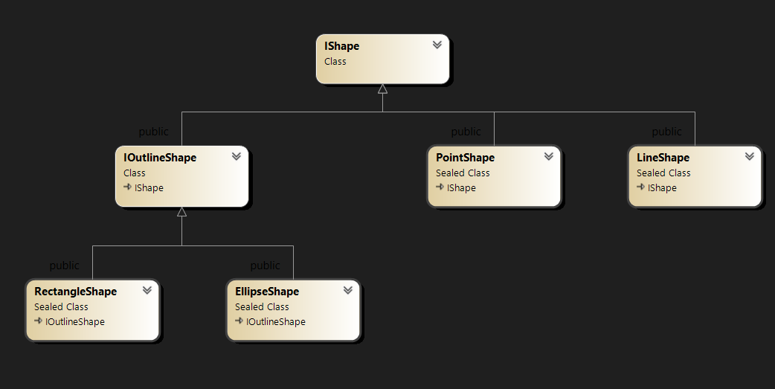

2) Редактори:
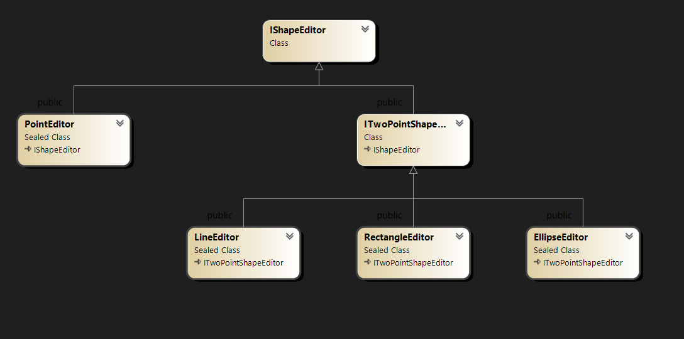

Скріншоти:

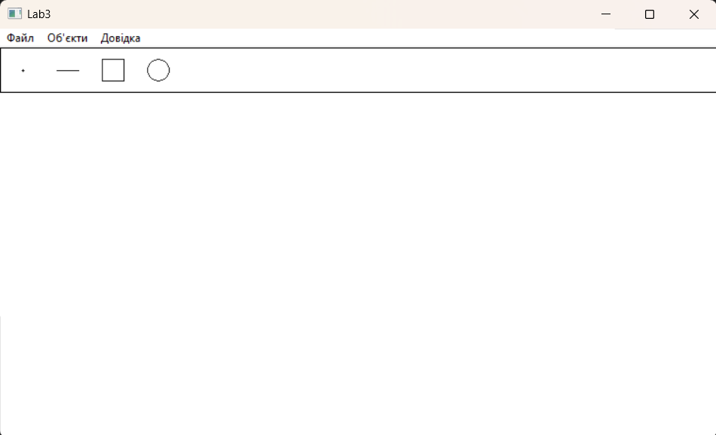

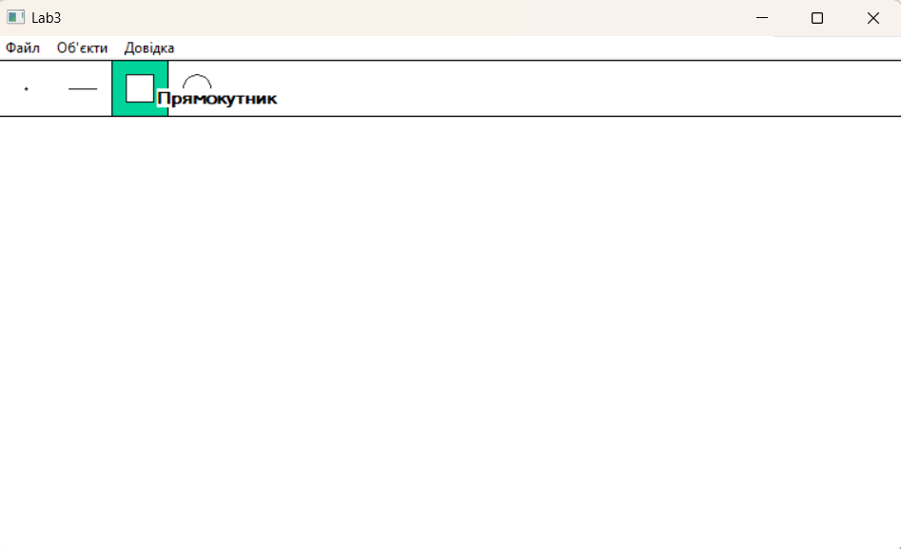

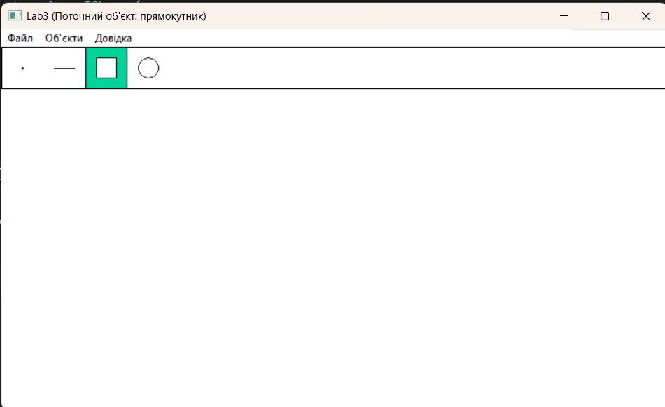

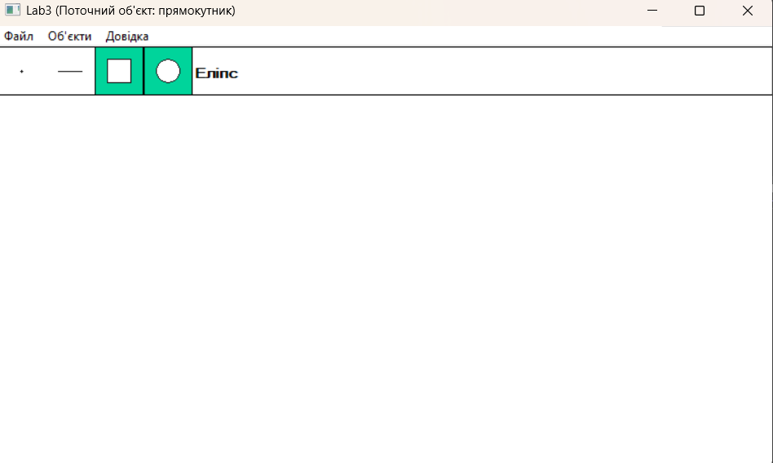

Висновки: отримано вмінь та навичок використовувати інкапсуляцію, абстракцію типів, успадкування та поліморфізм на основі класів,
запрограмувавши графічний інтерфейс користувача.

