N1.

*node-n1.js*

var http = require('http');

http.createServer(function(req,res) {

res.writeHead(200,{'Content-Type':'text/html'});

res.end('Hello World!');

}).listen(8080);

Output

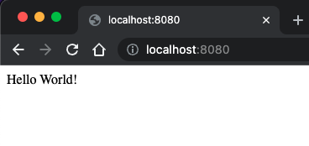

N2.

*// node-n2.js*

var http = require('http');

var myDate = require('./myModule');

http.createServer(function(req, res) {

res.writeHead(200, {'Contenet-Type': 'text/html'});

res.write("The date and time is " + myDate.myDate());

res.end();

}).listen(8080);

*// myModule.js*

exports.myDate = function() { return Date() };

Output

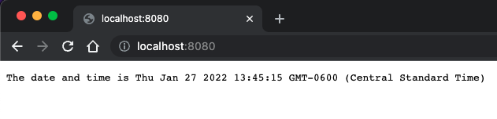

N3.

*node-n3.js*

var http = require('http');

http.createServer(function(req,res) {

res.writeHead(200,{'Content-Type': 'text/html'});

res.write(req.url);

res.end();

}).listen(8080);

Output

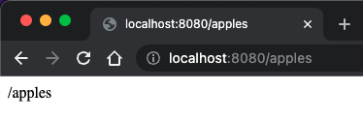

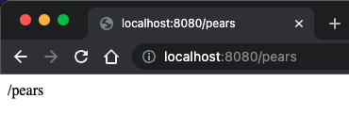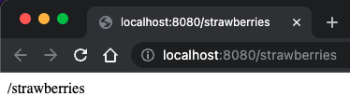

N4.

*// addWebServer.js*

ar http = require('http');

var url = require('url');

var fs = require('fs');

var add = require('./addMod.js');

http.createServer(function(req,res) {

const urlparam = url.parse(req.url, true);

const filename = '.' + urlparam.pathname;

if(filename == './add.js')

add.add(req,res,urlparam.query);

else {

fs.readFile(filename, function(err, data) {

if(err) {

res.writeHead(400, {'Content-Type':'text/html'});

return res.end('404 Not Found.');

}

res.writeHead(200);

res.write(data);

return res.end();

})

}

}).listen(8080);

*// addMod.js*

exports.add = function(req,res,val) {

res.writeHead(200, {'Content-Type':'text/html'})

res.write(

`<!DOCTYPE html>

<html>

<head><meta charset=\"utf-8\"/>

<title>Calculator Web Site</title>

</head>

<body>

<p>The sum is: ${String(parseInt(val.first) + parseInt(val.second))}</p>

</body>

</html>`

);

return res.end();

}

*// SimpleAdder.html*

<!DOCTYPE html>

<html lang="en">

<head>

<meta charset="UTF-8">

<meta http-equiv="X-UA-Compatible" content="IE=edge">

<meta name="viewport" content="width=device-width, initial-scale=1.0">

<title>SimpleAdder</title>

</head>

<body>

<div>Enter two numbers

<form action="http://localhost:8080/add.js">

<input type="text" name="first"> <br>

<input type="text" name="second"> <br>

<input type="submit" value="Click">

</form>

</div>

</body>

</html>

Output

