Online Dictionary

*Nodejs with express, pug, mysql, jquery*

**Nega Mogassa**

Project file structure

*dictionary.js*

*dictionary-database.js*

css/*style-dictionary.css*

img/*loading.gif*

js/*dictionary.js*

views/*dictionary.pug*

// dictionary.js

var express = require('express');

var database = require('./dictionary-database');

var app = express();

app.set('view engine', 'pug');

app.get('/dictionary', (req, res, next) => {

const db = database.database();

db.connect(function(err) {

if(err) throw err;

db.query("SELECT * FROM entries WHERE word = '"+req.query.word+"';", function(err, result, fileds) {

if(err) throw err;

res.send(result);

})

})

})

app.get('/', (req, res, next) => {

res.render('dictionary');

});

app.use('/css', express.static('css'));

app.use('/js', express.static('js'));

app.use('/img', express.static('img'));

app.listen(8080, () => console.log('Server running on port 8080'));

// dictionary-database.js

var mysql = require('mysql');

exports.database = () => {

return mysql.createConnection({

host: 'localhost',

database: 'entries',

user: 'root',

password: 'rootroot'

})

};

// js/dictionary.js

$(function() {

$('#loading').hide();

$('#lookup').on('click', function() {

$.get('/dictionary', {word: $('#word').val()})

.done((result) => {

const rows = (typeof result == 'object') ? result : JSON.parse(result);

rows.forEach((row, i) => {

$('#result').append("<p>"+(i+1)+"("+row.wordtype+") "+row.definition+"</p>")

});

})

.fail(() => $('#result').text("Something went wrong"));

});

$(document).ajaxStart(() => {

$('#result').html('');

$('#loading').show();

})

.ajaxStop(() => { $('#loading').hide() });

});

// views/dictionary.pug

link(rel="stylesheet", href="css/style-dictionary.css")

script(src="https://ajax.googleapis.com/ajax/libs/jquery/3.5.1/jquery.min.js", type="text/javascript")

script(src="js/dictionary.js", type="text/javascript")

div.container

div.center

div.card.border-dictionary

h1 WAP Online Dictionary

span Term:

input(type="text", name="word", id="word")

button(id="lookup") Lookup

div#result

div.loading

img(src="img/loading.gif", alt="loading", id="loading")

// css/style-dictionary.css

https://nagaadev.github.io/css/style-dictionary.css

### **Landing page**

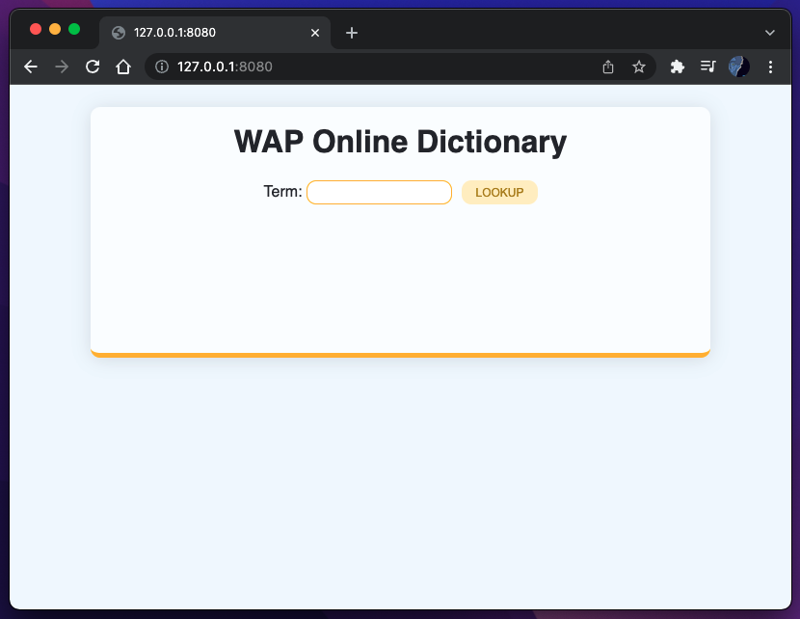

### **Typing in a word**

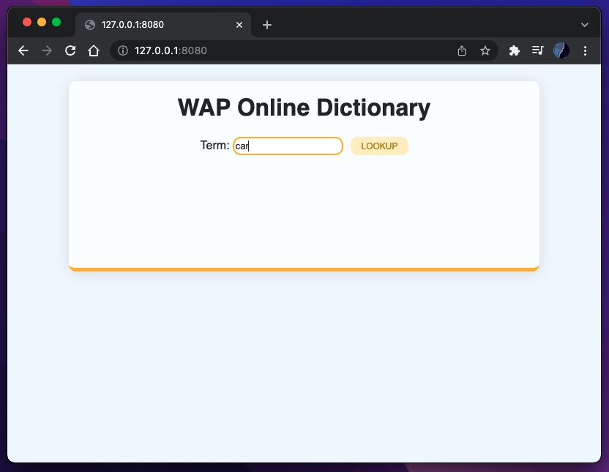

### **Looking up the word**

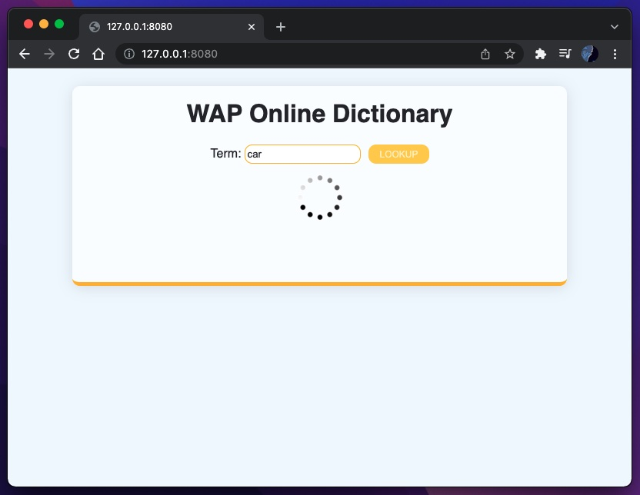

### **Displaying result for the word**

### **Typing in another word**

### 

### **Looking up the word**

### 

### **Displaying result for the word**