Below are the levels of access that need to be followed in the NaRDil Resource allocation tools.

**NaRDil Admin–**

* Admin access can see all the allocation across all of NaRDil.
* Admin can assign the department head license.
* If the admin adjusts the allocation, then need to notify the department head with what are the changes are made.

**Department Head –**

* The department head can create users (Team Leader/Job In charge, member), Project for their department.
* If any user can work with another department that time the department head can assign that person to another department for a certain period
* The department head can allocate tasks for Each team leader and member

**Team Leader/Job In charge –**

* Team leaders can view the allocation of their entire team
* If additional resources are needed the team leader can temporarily adjust the allocation send to approval for the Department head. Department head can approve / Decline that request.

**Member-**

* Members can see only him/her tasks.

Need to edit in the Float-

1. In the user creation Team leader must be shown. Before assigning a user to a team leader, the team leader must be created first.

1. While admin creates the user that time only show the department admin can select the department. If department head create user then should automatically be assigned to the corresponding department. If a user need to change between department only admin can change the department.
2. Add a field for Employee ID
3. In the project creation screen must show the department. While admin create the project that time admin need to assign the department. If department head create the project should automatically be assigned to their department.

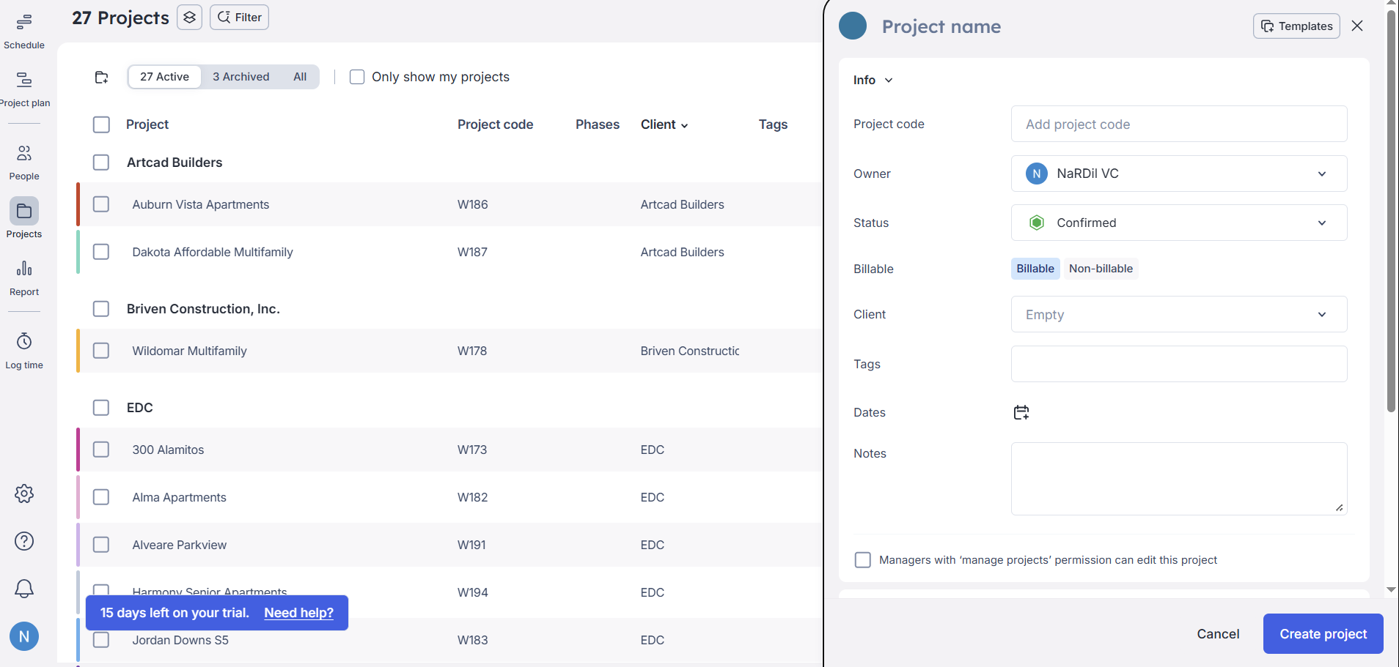

1. While Creating the project at that time, team leaders can be assigned or else while doing allocation for member then automatically assigned team leader for the project corresponding member team leader.
2. If Team 1 and Team 2 doing the same project then Team leader 1 & Team leader 2 Project wise allocation screen shows both team allocations for that specific project.
3. Each project contain multiple task. So, task creation must also be done in the project creation window itself. If needed can create in the allocation screen too.
4. Add field for planned hours for the each task.
5. Add field Client submittal date for each task.
6. The submittal schedule can be exported from this task list.
7. In the allocation schedule view, select one date and select a task; if hours were entered in the project creation tab that hours here shown for reference, along with this the selected task how many hours allocated how many hours remain to be allocated also need to be shown here. In the total hours column should enter the total hours for the task/remaining allocated hours. If needed edit that value and click allocate, and it will automatically calculate the dates and created allocation.

1. The float tool total hours calculates using a fixed per-day hour rate. In this total the per day hour is 8 put total hours as 28 then need to fill 3 day full and 4 hours in the 4th day.
2. Like the float, task need to be moved from one person to another person with ease.
3. A toggle button is needed to choose whether the selected date is the start or end date.
4. If click start date allocation should start from the selected date and continue forward
5. If click end date allocation should end at the selected date and go backward.
6. If required change the Saturday/Sunday/Holiday as working days for all members (admin – whole NaRDil; Department head – Whole department), specific persons.