THE OPEN UNIVERSITY OF SRI LANKA
DEPARTMENT OF ELECTRICAL & COMPUTER ENGINEERING
BACHELOR OF SOFTWARE ENGINEERING
EEI6373 – Performance Modelling
Mini Project - Final Report

Name: I N. Jahan
Registration No: 221428909

System Description and Performance Goals
This project studies a University Hostel Stay Registration Queue System. The system represents a real-world service environment in which students arrive at a hostel office, wait for an available registration officer, complete document checks and room-related registration, and then leave after registration is complete. The selected system is suitable for performance modeling because its behavior varies with the number of arriving students, service times, document conditions, or available staff resources.
The current model contains two registration officers, ST01 and ST02. Students may request a New Registration, Renewal, or Temporary Stay. Some students have incomplete documents, which can increase the time needed to complete the service. Therefore, the system contains several interacting factors that can create queues, high staff utilization, longer response times, and performance bottlenecks.
The main performance goals are to minimize student waiting and response time, maximize registration throughput, identify bottlenecks, measure staff resource utilization, and evaluate whether the system can scale when demand is high. A further goal is to compare the current two-staff configuration with an alternative three-staff configuration.

Modeling Approach and Assumptions
The registration office is modeled as a multi-server queue. Students are the arriving jobs, the waiting area is the queue, and ST01 and ST02 are the service resources. A First-Come, First-Served (FCFS) assumption is used for the scalability simulation. Each arriving student is assigned to the staff member who is available first.
The model combines dataset-based performance measurement with a simple discrete-event style simulation. The observed two-staff data is used to measure waiting time, service time, queue length, throughput, and resource utilization. The same student arrival times and service times are then replayed with three staff members to evaluate scalability. This keeps the workload unchanged and changes only the number of service resources.

The main analytical quantities are:
- Arrival rate (λ) = number of student arrivals / observation time.
- Service rate per staff member (μ) = 60 / average service time in minutes.
- Traffic intensity (ρ) = λ / (cμ), where c is the number of staff members.
- Response time = waiting time + service time.
- Little’s Law: L = XW, using measured throughput X and time in the system W.
Assumptions include: the simulated arrival and service records represent a busy registration period; staff serve one student at a time; service is non-preemptive; the three-staff comparison uses the same arrivals and service requirements; and breaks, system failures, room shortages, and staff skill differences are not explicitly modeled.

Data Description and Methodology
A simulated dataset of 50 hostel registration records is used. Simulated data was selected because real hostel registration records may contain private student information and may not be available for academic analysis. The dataset was designed to represent realistic variation in arrivals, registration types, service durations, document status, staff allocation, and queue conditions.

Dataset Field | Purpose in the Model
Student_ID | Unique student/request
Arrival_Time | Time the student enters the system
Registration_Start_Time | Beginning of service
Registration_End_Time | Completion of service
Waiting_Time_Min | Queueing delay / latency
Service_Time_Min | Processing time
Queue_Length | Number waiting at arrival
Registration_Type | New Registration, Renewal, or Temporary Stay
Staff_ID | Registration resource ST01 or ST02
Document_Status | Complete or Incomplete
Room_Type | Allocated/requested room category
Registration_Status | Outcome of the registration

Detailed Analysis and Findings
The 50 students arrived over approximately 115 minutes, giving an estimated arrival rate of 26.09 students per hour. The average service time was 6.74 minutes. Therefore, one staff member has an approximate service rate of 60/6.74 = 8.90 students per hour. With two staff members, the combined theoretical service capacity is approximately 17.80 students per hour.
The calculated traffic intensity is ρ = 26.09 / 17.80 ≈ 1.47. Since this value is greater than 1, the observed peak arrival demand is higher than the sustainable processing capacity of the two-staff system. This explains why the queue grows and why later students experience longer delays.

Performance Metric | Result
Total students | 50
Average waiting time | 21.98 minutes
Maximum waiting time | 52 minutes
Average service time | 6.74 minutes
Average response time | 28.72 minutes
Average queue length | 5.96 students
Maximum queue length | 12 students
Arrival rate (λ) | 26.09 students/hour
Measured throughput | 17.05 students/hour
Service rate per staff (μ) | 8.90 students/hour
Combined two-staff capacity | 17.80 students/hour
Traffic intensity (ρ) | 1.47

Resource Utilization

ST01 served 25 students and had an estimated utilization of 98.86%, while ST02 also served 25 students, with a utilization of 92.61%. Both officers were highly utilized, suggesting that the bottleneck was not due to an uneven distribution of work. Instead, the results indicate that the two available officers were operating close to their practical capacity during the modeled period.

Document-Related Bottleneck
Document status also has an impact on performance. Students with complete documents had an average service time of about 6.33 minutes and waited an average of 19.77 minutes. In comparison, students with incomplete documents needed around 9.29 minutes of service and waited an average of 35.57 minutes. This suggests that incomplete documentation takes more time to process and can lead to longer waiting times and increased congestion.

Little’s Law Check
Using the measured throughput of 17.05 students per hour and an average waiting time of 21.98 minutes (0.3663 hours), Little’s Law estimates the average number of students in the queue at about 6.24. The observed average queue length was 5.96 students, which is reasonably close to the estimated value given the finite nature of the simulation. Similarly, using the average response time of 28.72 minutes, the estimated average number of students in the entire system is approximately 8.16.

Scalability: Two Staff vs Three Staff
To evaluate scalability, the same 50 student arrivals and the same service times were simulated with three registration officers instead of two. This comparison changes only the number of service resources.
Staff | Avg. Wait | Max Wait | Avg. Response | Final Completion
2 | 21.98 min | 52 min | 28.72 min | 176 min
3 | 1.78 min | 5 min | 8.52 min | 129 min
The simulation shows a substantial improvement when a third staff member is introduced. Average waiting time falls from 21.98 minutes to 1.78 minutes, while maximum waiting time falls from 52 minutes to 5 minutes. Average response time falls from 28.72 minutes to 8.52 minutes. This demonstrates that the system is highly sensitive to service capacity during the selected busy period.

Visualizations

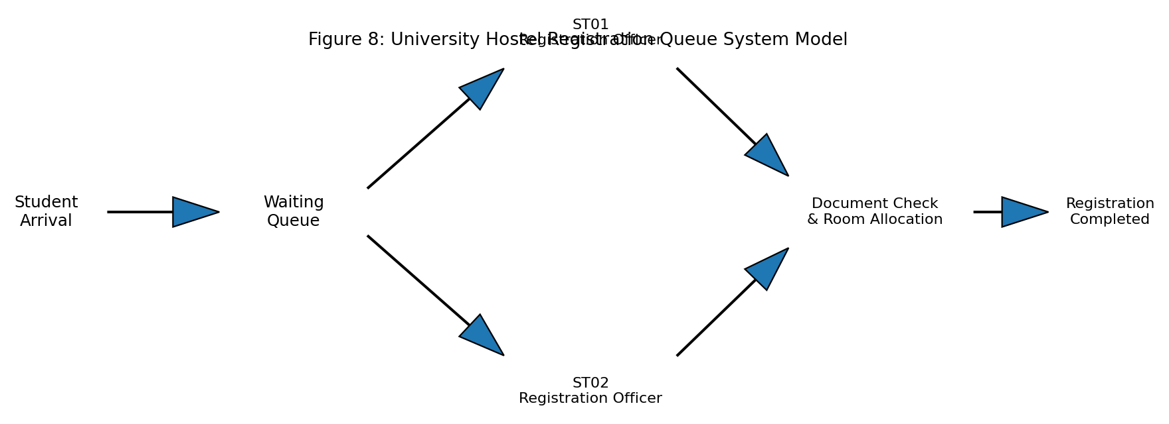
Figure 1. Model of the University Hostel Registration Queue System.
The model shows students entering a common queue and being served by ST01 or ST02 before document checking, room allocation, and completion.
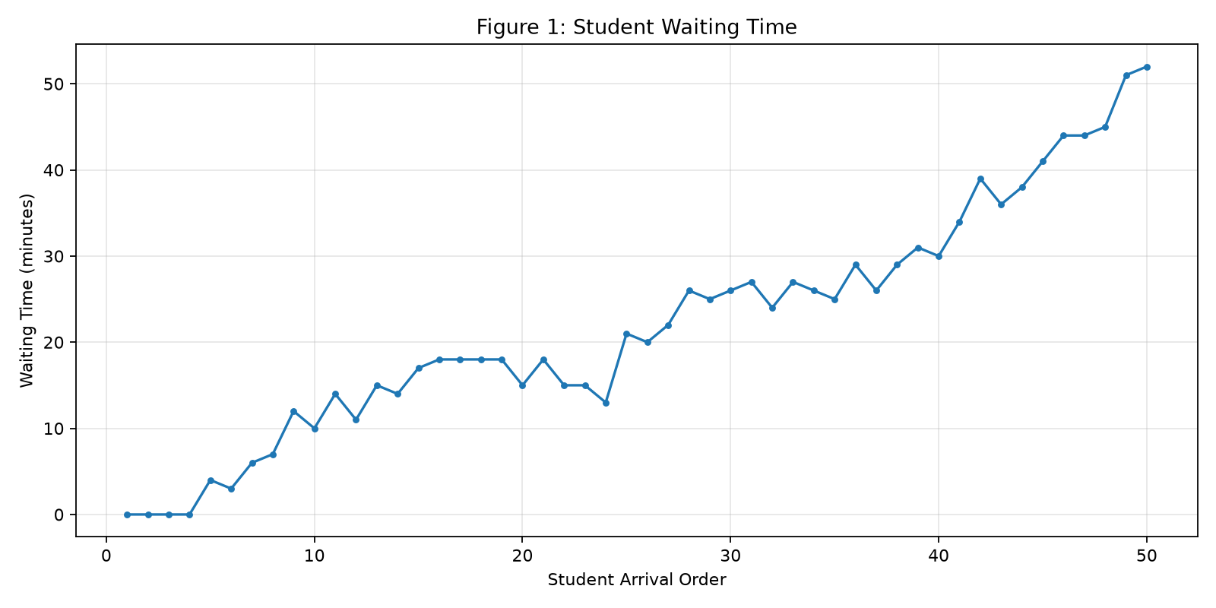
Figure 2. Student waiting time across the registration workload.
Waiting time increases as congestion develops, demonstrating the latency experienced by students.
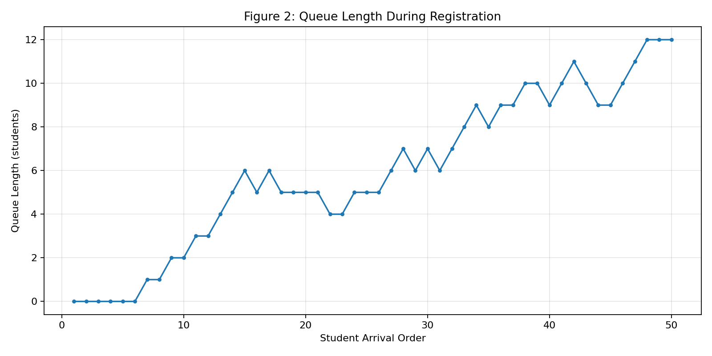
Figure 3. Queue length during registration.
The queue reaches a maximum of 12 students, confirming the presence of a capacity bottleneck.
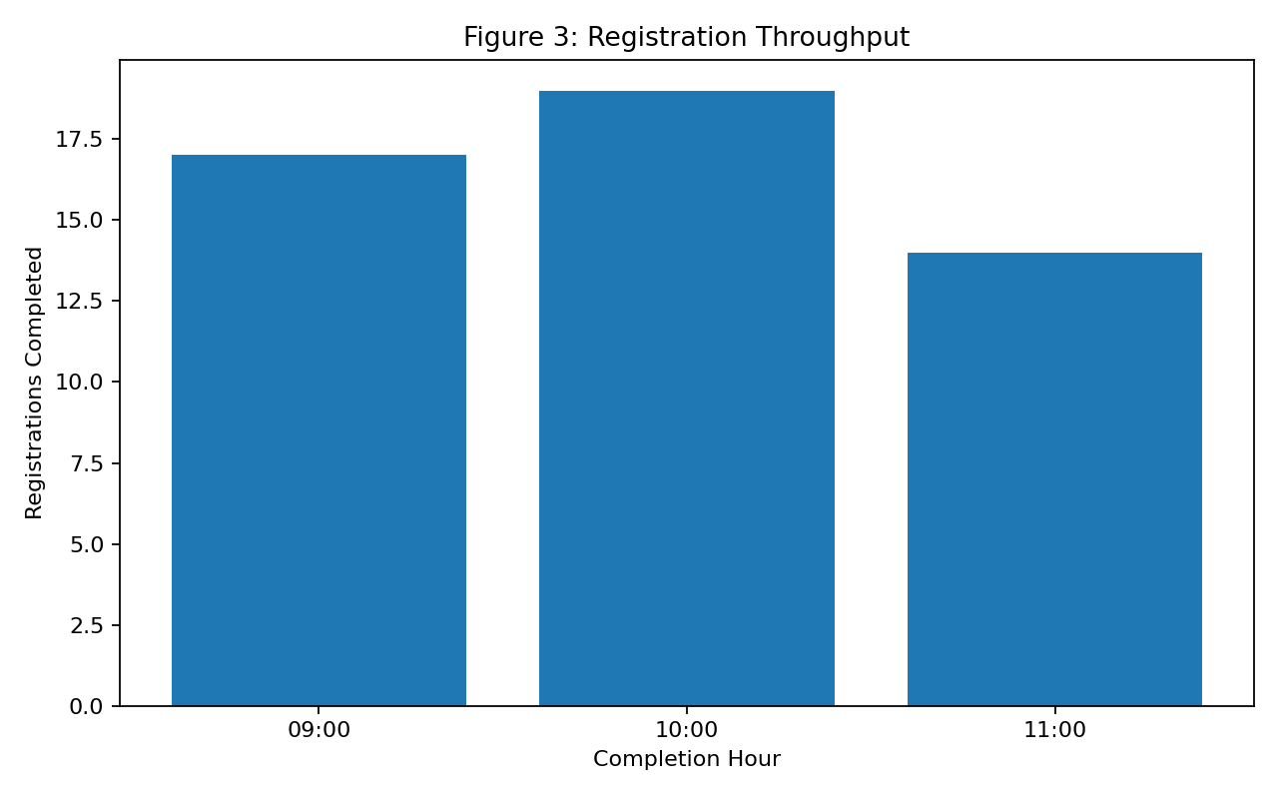
Figure 4. Registration throughput by completion hour.
Throughput shows how many registrations are completed during each time period.
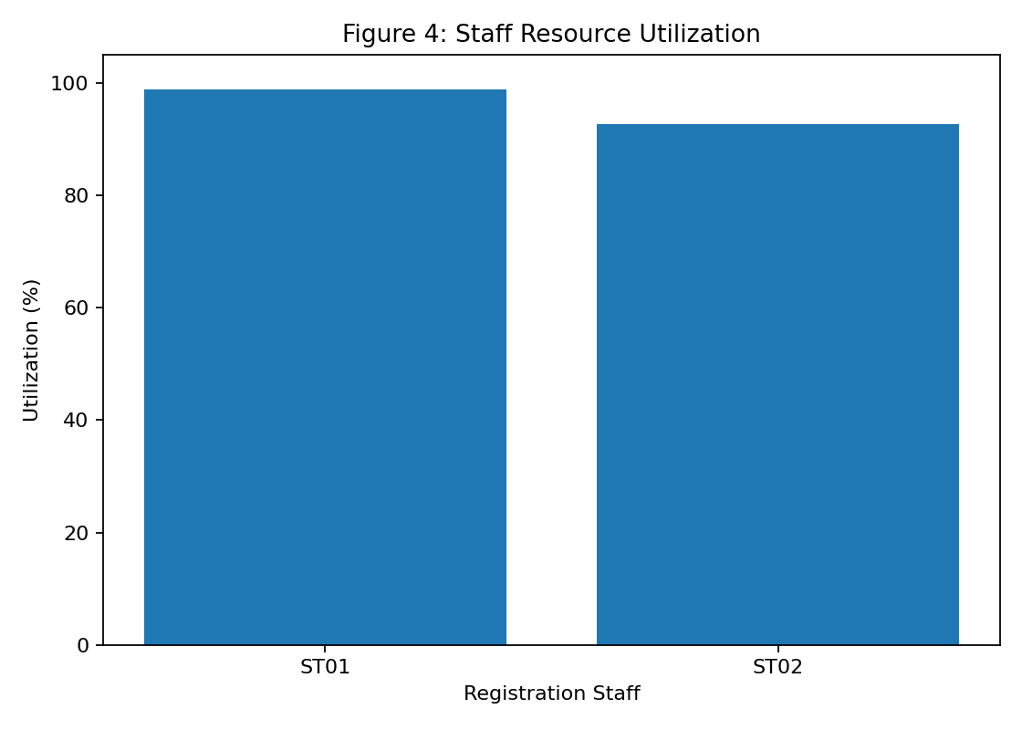
Figure 5. Staff resource utilization.
Both ST01 and ST02 are highly utilized, indicating limited spare service capacity.
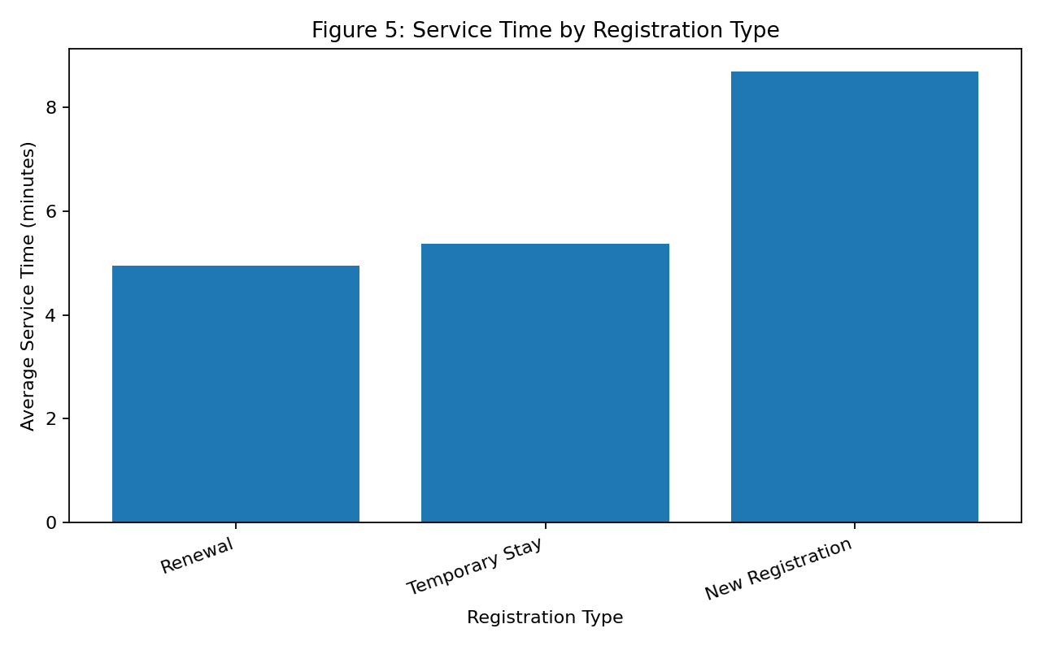
Figure 6. Average service time by registration type.
Different registration types create different service demands and contribute to workload variation.
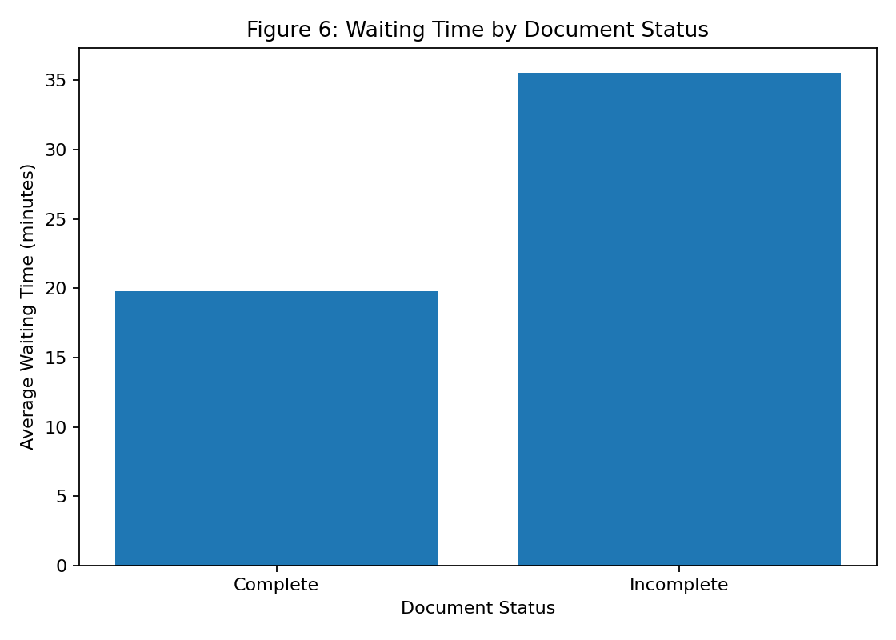
Figure 7. Waiting time by document status.
Students with incomplete documents are associated with longer processing and waiting behavior in the dataset.
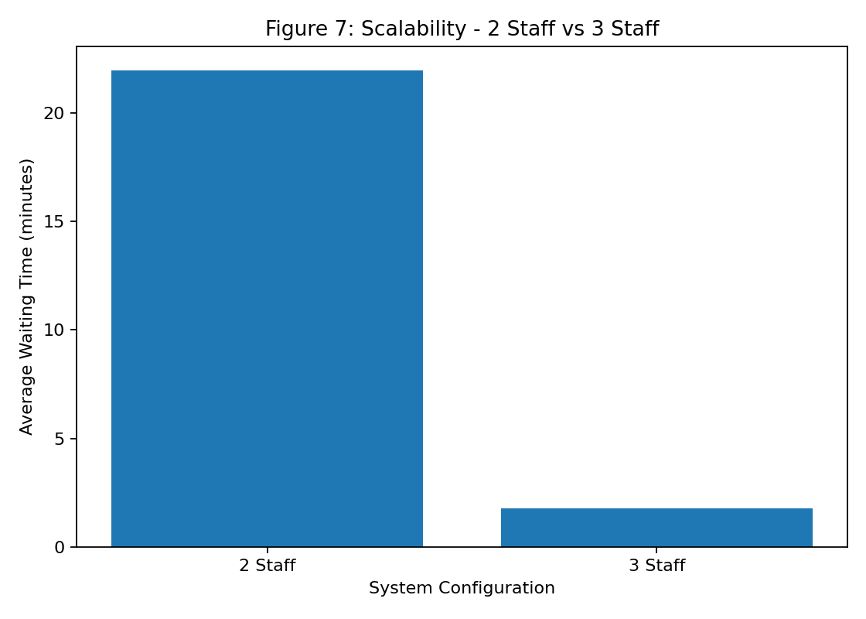
Figure 8. Scalability comparison between two and three staff.
Adding a third officer greatly reduces average waiting time under the same simulated workload.

Recommended Improvements
The first recommendation is to use a third registration officer during peak hostel registration periods. The simulation shows that this intervention can greatly reduce waiting and response time for the modeled workload. A second recommendation is to introduce a document pre-check point or online checklist before students enter the main registration queue. This could prevent incomplete applications from consuming longer service time at the main counter.
Another possible improvement is to separate simple renewals from more time-consuming new registrations when demand is high. Future scheduling decisions could also use expected arrival patterns so that additional staff are assigned only during the busiest periods.

Limitations and Future Extensions
The main limitation is that the dataset is simulated and contains only 50 students. It represents one busy registration period rather than a complete semester. The model also assumes FCFS service and does not explicitly include staff breaks, computer failures, payment system delays, room shortages, priority students, or different staff skill levels. The utilization and queue measures should therefore be interpreted as results of this modeled scenario rather than universal values for every hostel.
Future work could collect anonymized real registration data over several days, fit statistical arrival and service-time distributions, and perform repeated Monte Carlo or discrete-event simulations. The model could also compare separate queues, appointment-based registration, online pre-registration, four-staff configurations, or dynamic staffing based on predicted demand.

Conclusion
This mini project modeled and evaluated a University Hostel Stay Registration Queue System using a 50-record simulated dataset. The system is sufficiently complex to analyze bottlenecks, throughput, resource utilization, latency, and scalability. The analysis found an arrival rate of approximately 26.09 students per hour compared with a two-staff theoretical service capacity of about 17.80 students per hour. Average waiting time was 21.98 minutes, maximum waiting time was 52 minutes, and both staff members were highly utilized.
The findings show that the main performance issue is insufficient service capacity during the modeled busy period, with incomplete documents creating additional processing pressure. A three-staff simulation reduced average waiting time to 1.78 minutes and average response time to 8.52 minutes. Therefore, temporary peak-period staffing together with document pre-checking is recommended as a practical improvement. Overall, the project demonstrates how queueing concepts, measured performance metrics, simulation, and visualization can be combined to understand and improve a real-world service system.

References
[1] L. Kleinrock, Queueing Systems, Volume 1: Theory. New York, NY, USA: Wiley, 1975.
[2] R. Jain, The Art of Computer Systems Performance Analysis: Techniques for Experimental Design, Measurement, Simulation, and Modeling. New York, NY, USA: Wiley, 1991.
[3] J. D. C. Little, “A proof for the queuing formula: L = λW,” Operations Research, vol. 9, no. 3, pp. 383–387, 1961.
[4] University of Kelaniya, “Hostel Facilities and Hostel Registration,” Student Welfare Division, University of Kelaniya, Sri Lanka, 2025.
[5] University of Colombo, “Hostels,” University of Colombo, Sri Lanka.
[6] University of Colombo, “Student Registration System – Documentation,” Student Information System, University of Colombo, Sri Lanka.
[7] The Open University of Sri Lanka, “Temporary Residential Facility,” The Open University of Sri Lanka, Nawala, Sri Lanka.
[8] University of Sri Jayewardenepura, “Hostels – Rules and Regulations for Residential Students,” University of Sri Jayewardenepura, Sri Lanka.
[9] University Hostel Stay Registration Queue System – Simulated Dataset, 50 student registration records created for this performance modeling and evaluation mini project, 2026.

Appendix A
Source Code The complete source code for this project is available at: https://github.com/NaRkIsJaHaN/Hostel-Registration-Performance-System

