**ProBot** 

**Setup**

A chat bot named ProBot : Encouraging inclusive, professional way of team management in Slack environments.

**Built With**

* Node.js - Runtime environment
* Express.js - Node.js web application framework
* [Heroku](https://heroku.com/) - Web hosting platform
* Github – Source version control

**Installation**

Clone this repository using Git:

git clone *https://github.com/Naagraju/ProBotslackapp.git*

Install Node and NPM on your system, then install dependencies.

npm install

Now create a free developer account with Slack API.

Create a new app:

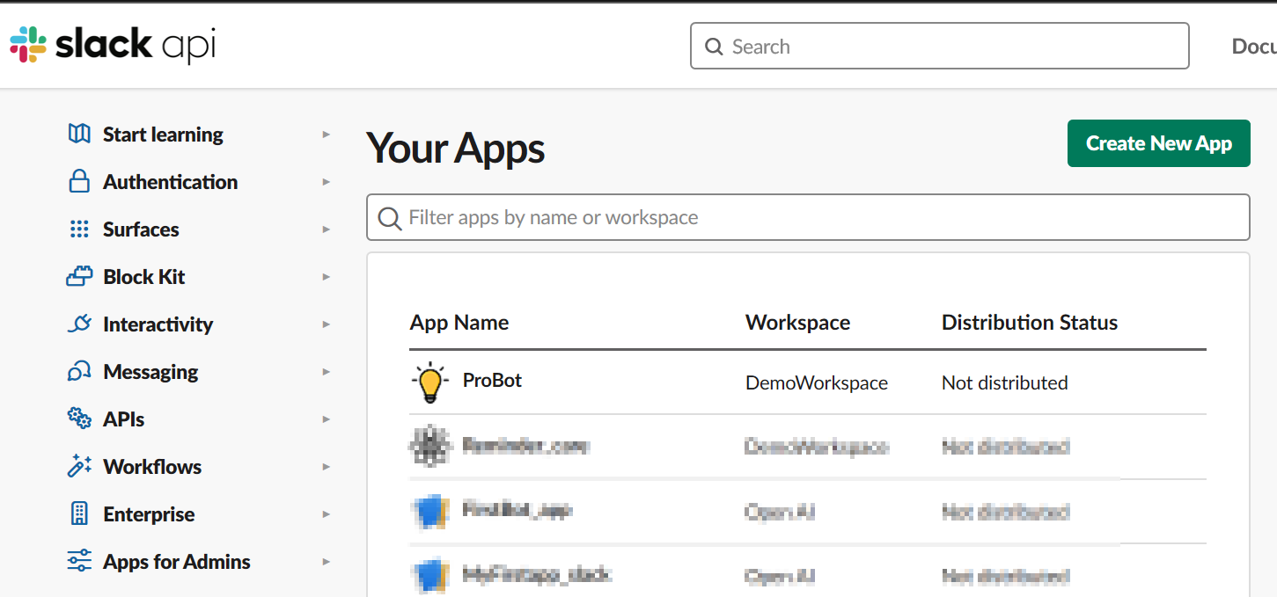

Choose the features and functionality of the app. You will need to select Slash Commands, Bots, Event Subscriptions, and Permissions at the minimum.

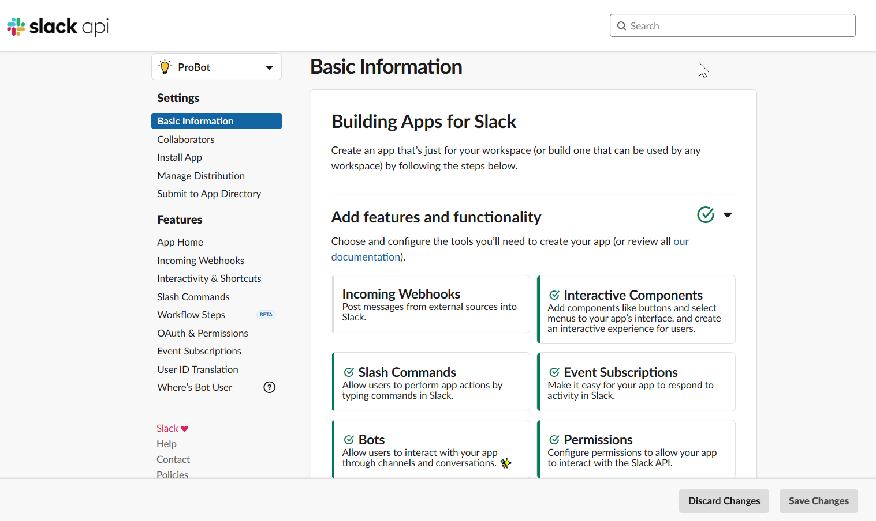

Set up App Credentials. You will need the App ID, Client ID, Client Secret, Signing Secret, and Verification Token. Keep this information private.

Update the display information. Load your bot's avatar and bio here:

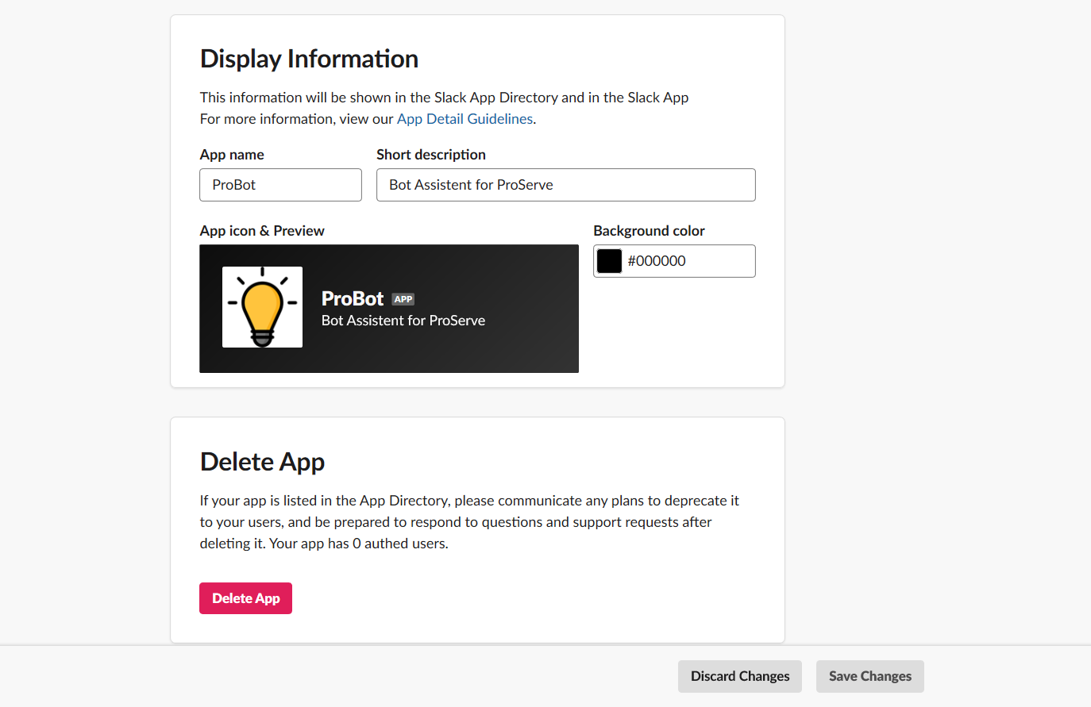

Now return to your code project and update the .env file with your tokens. You will need your Slack token from your Slack workspace.

Create a Heroku account and create a new app with the Free or Hobby (24/7 uptime) plan. Name your app. On the app's settings page you can see that the public address for the app is https://benice.herokuapp.com/ and the Git repo is https://git.heroku.com/benice.git.

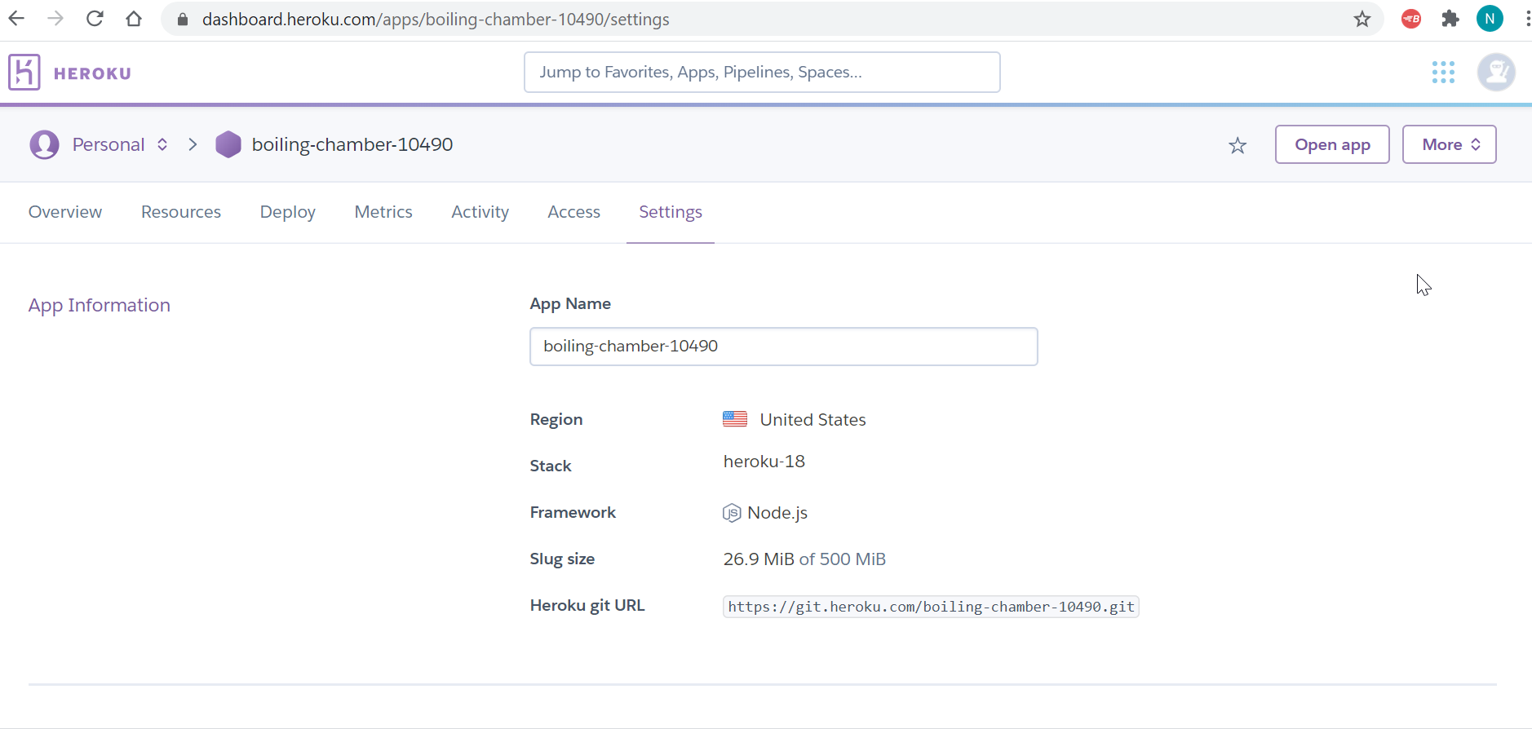

Download and install the Heroku CLI utility so that you can push your code to the server, this is what that looks like :

brew tap heroku/brew && brew install Heroku

Now login to authenticate yourself:

heroku login

Add the remote repo to Git:

heroku git:remote -a <your app name>

You should see that now as a push option if you check git remote -v:

heroku https://git.heroku.com/<your app name>.git (fetch)

heroku https://git.heroku.com/<your app name>.git (push)

Next you will need to set up a couple resources in Heroku.

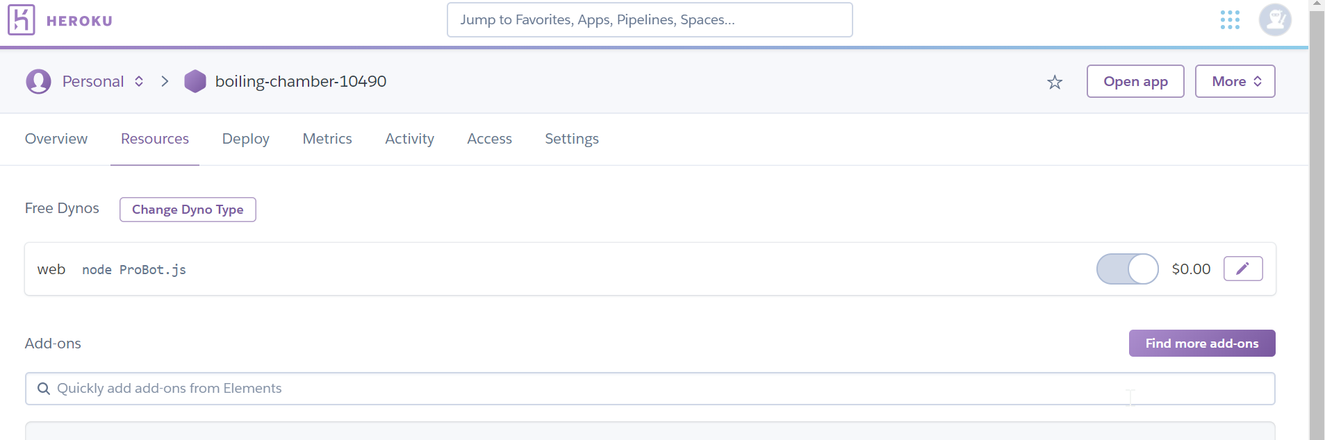

Now you can push your code project to the Heroku server:

git push heroku master

Now we need to go back to the Slack API site and update the redirect URL. Under OAuth & Permissions you should see a section to add the redirect URL. This is your Heroku address. Make sure it is entered as http://<your app name>.herokuapp.com/oauth with /oath appended to the end.

[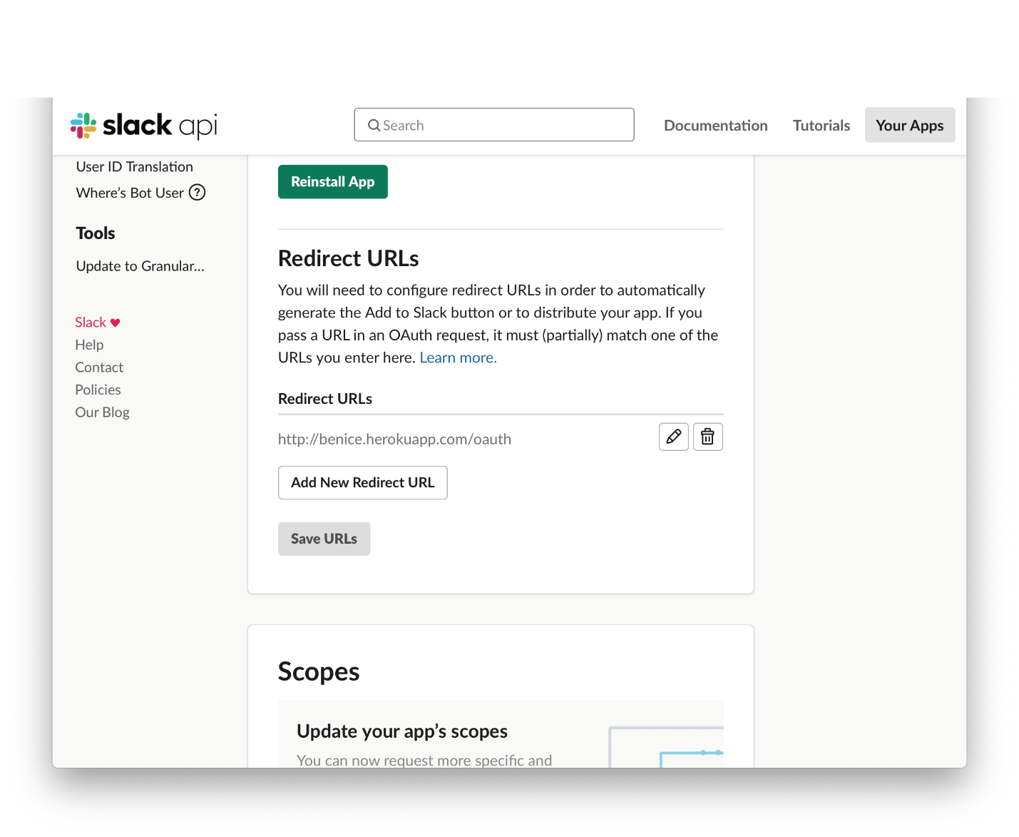](https://github.com/seabirdcassidy/friendly-reminder/blob/master/slack-5.png)

Also while on this page make sure that you have these scopes selected:

* [**app_mentions:read**](https://api.slack.com/scopes/app_mentions:read)

View messages that directly mention @probot in conversations that the app is in

* [**channels:manage**](https://api.slack.com/scopes/channels:manage)

Manage public channels that ProBot has been added to and create new ones

* [**channels:read**](https://api.slack.com/scopes/channels:read)

View basic information about public channels in the workspace

* [**chat:write**](https://api.slack.com/scopes/chat:write)

Send messages as @probot

* [**commands**](https://api.slack.com/scopes/commands)

Add shortcuts and/or slash commands that people can use

* [**im:write**](https://api.slack.com/scopes/im:write)

Start direct messages with people

* [**reactions:read**](https://api.slack.com/scopes/reactions:read)

View emoji reactions and their associated content in channels and conversations that ProBot has been added to

* [**reminders:read**](https://api.slack.com/scopes/reminders:read)

View reminders created by ProBot

* [**users:read**](https://api.slack.com/scopes/users:read)

View people in the workspace

Go to Event Subscriptions and make sure that the Request URL is also entered properly and verified. It should be https://<your app name>.herokuapp.com with /slack/events appended on the end.

Additionally, you will need to subscribe to these bot events:

* app_mention
* im_close
* im_open
* message.channels
* message.groups
* message.im
* message.mpim

Any channel that ProBot is added to will be able to see this stuff. So be careful with people's privacy and do not over-subscribe to things you don't need.

[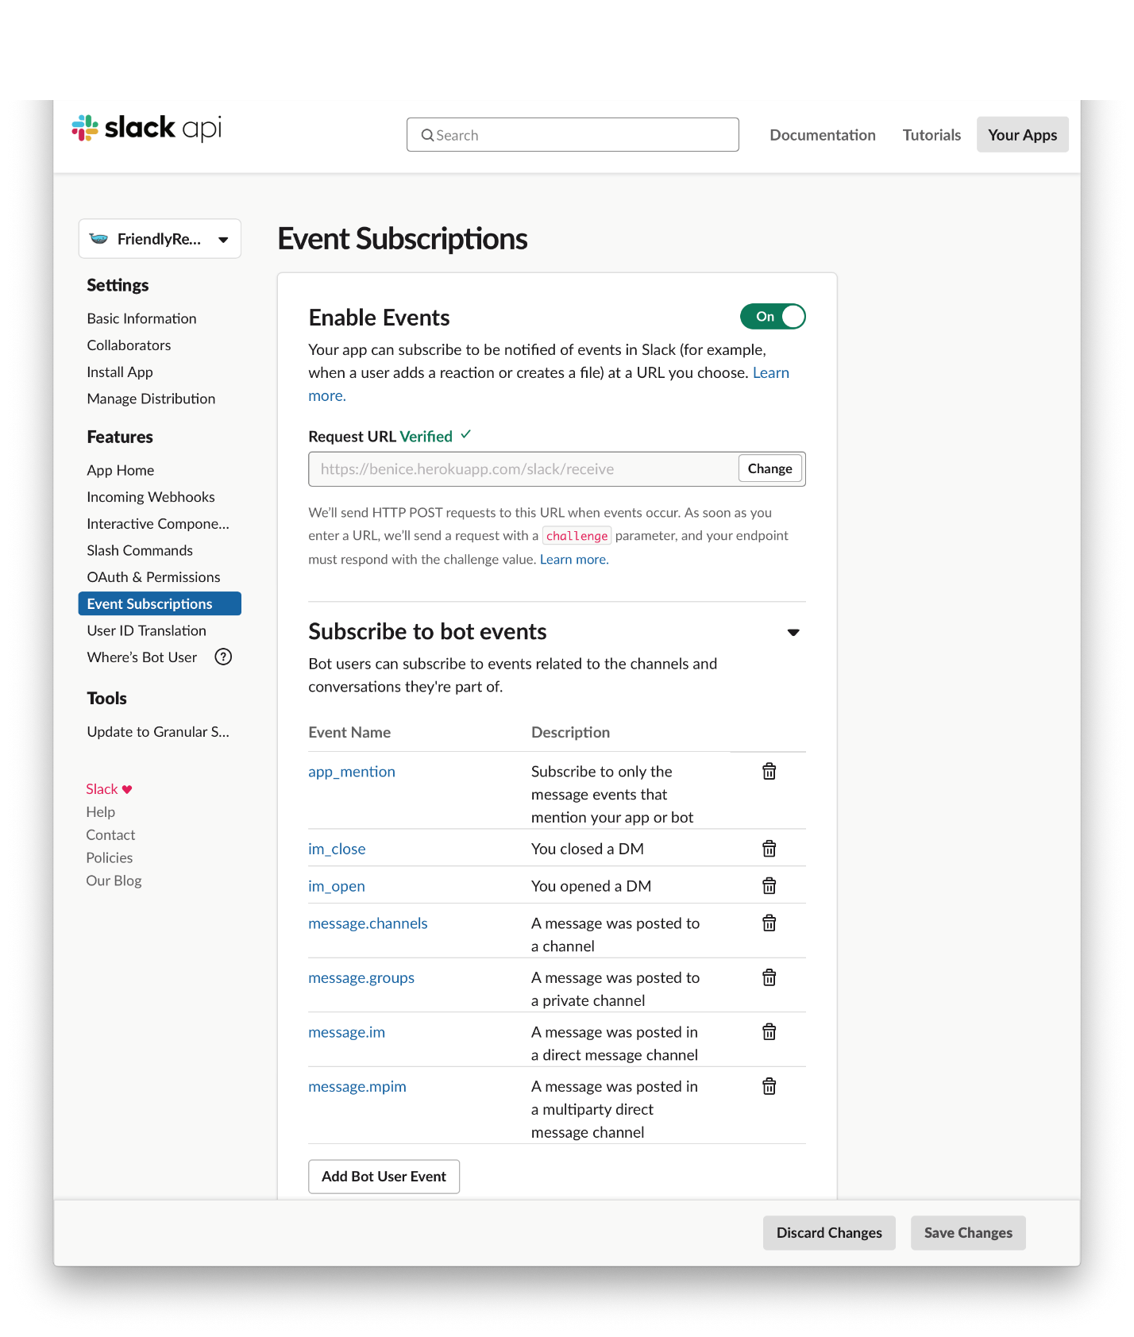](https://github.com/seabirdcassidy/friendly-reminder/blob/master/slack-6.png)

And finally....! Add ProBot to a Slack workspace so you can test it out. Head on over to Install App and click the button. If you are logged into your Slack workspace already it will choose that by default.

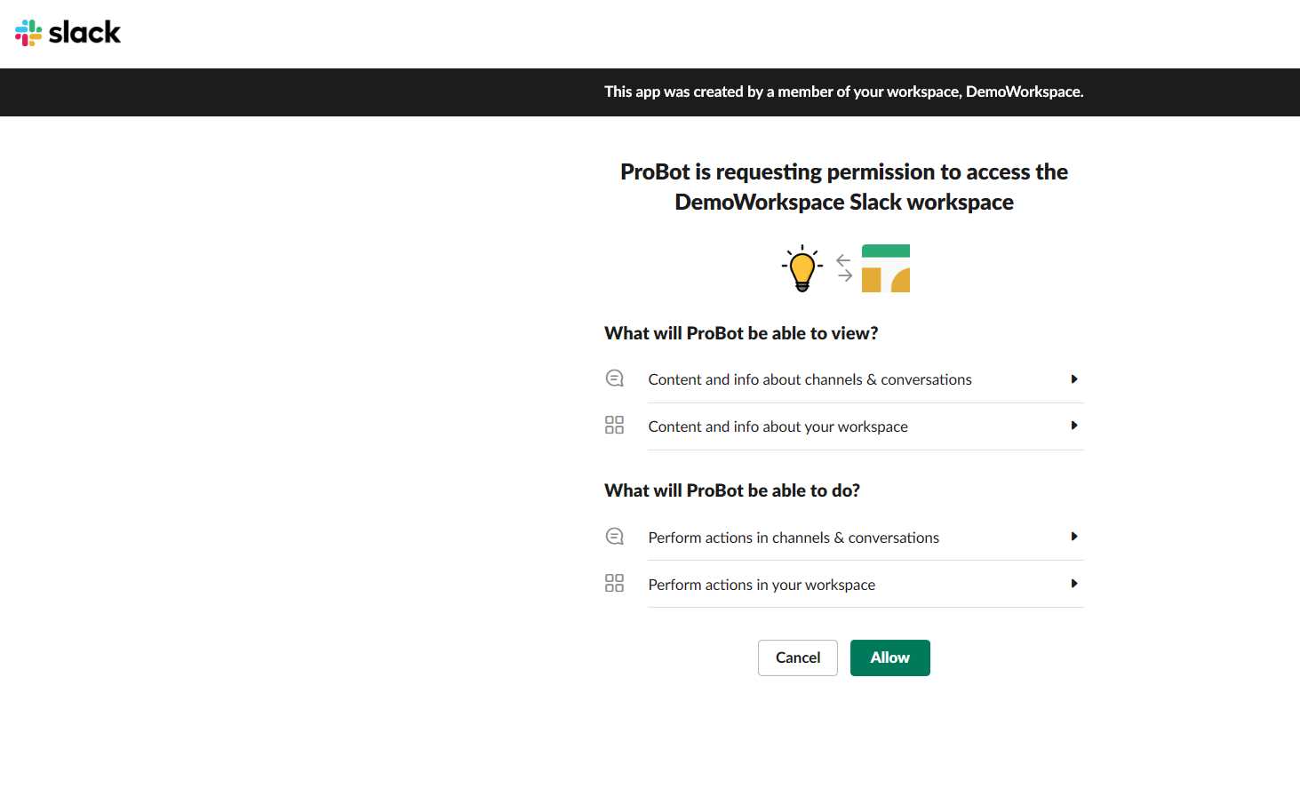

Inside your Slack workspace, you will need to go to a channel that you want ProBotapp in. Then, in the top right corner click on the gear icon. Select "add an app".

[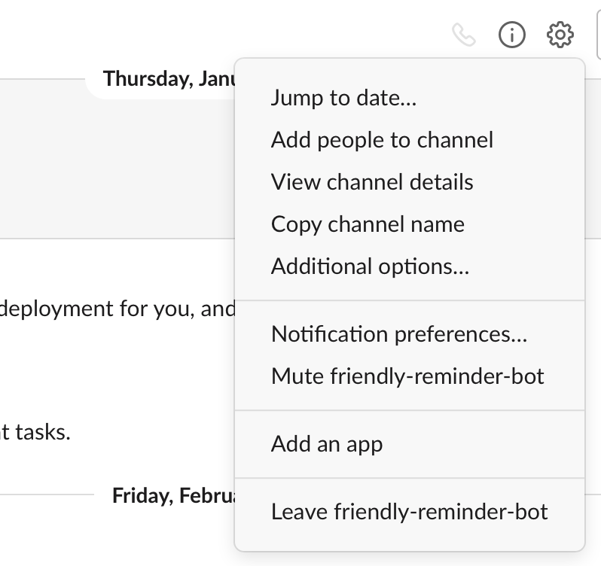](https://github.com/seabirdcassidy/friendly-reminder/blob/master/slack-7.png)

If you want use the ProBot app in any channel you should invite first into channel like below:

->goto channel

->@ ProBot

-> Select ‘Invite to Channel’

