**SQL Bolt SOLUTIONS**

# Lesson 1: SELECT queries 101

Exercise : 1.1

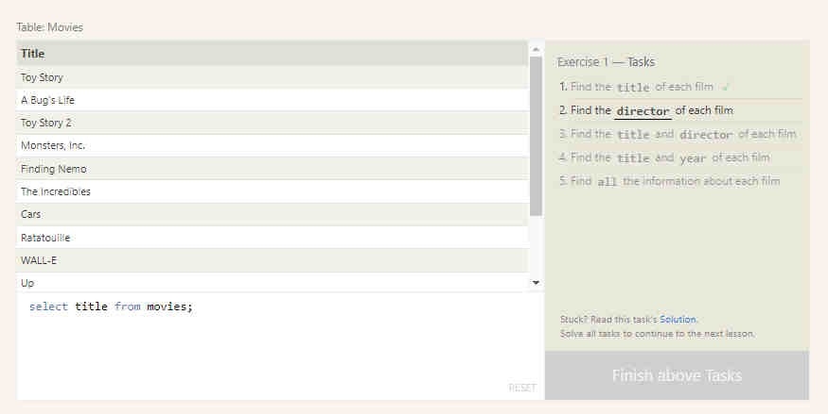

Exercise : 1.2

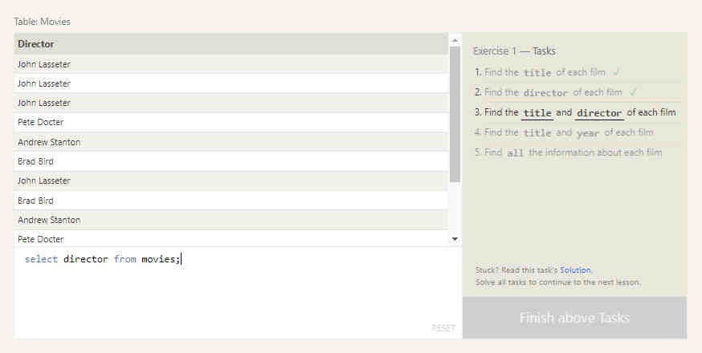

Exercise : 1.3

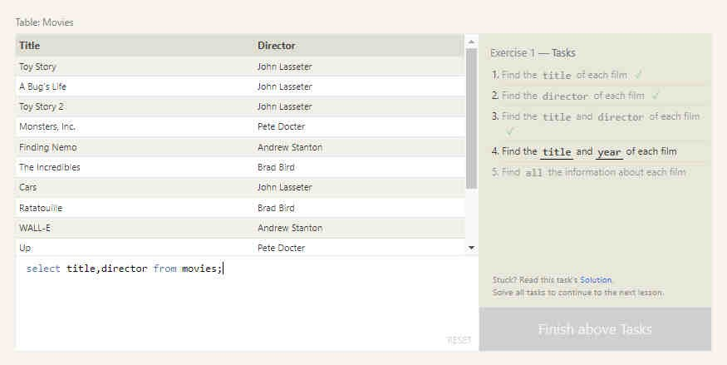

Exercise : 1.4

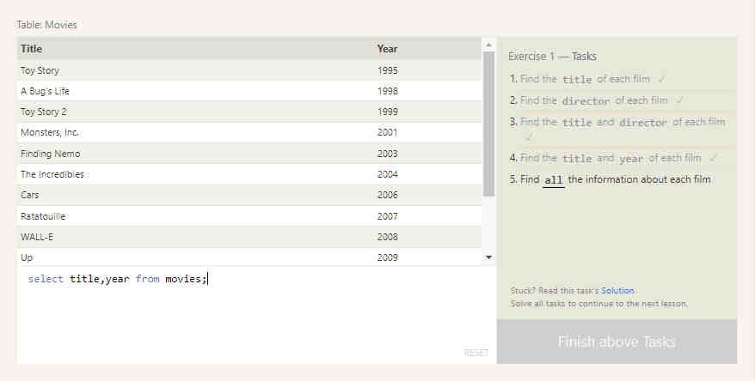

Exercise : 1.5

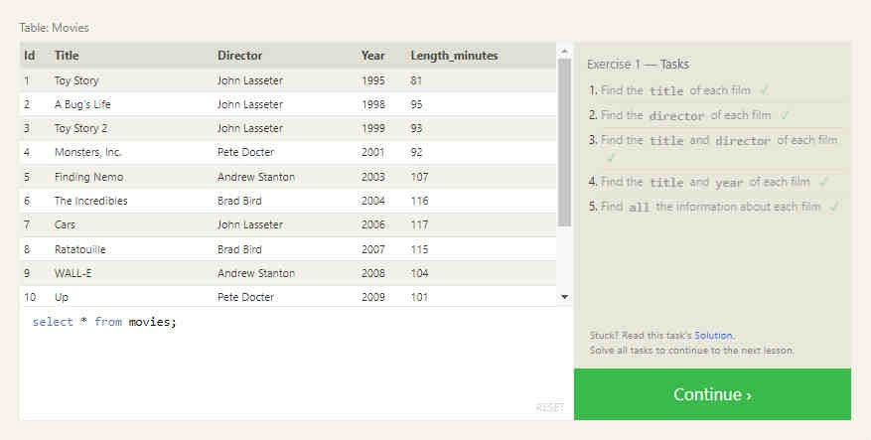

# Lesson 2: Queries with constraints (Pt.1)

Exercise : 2.1

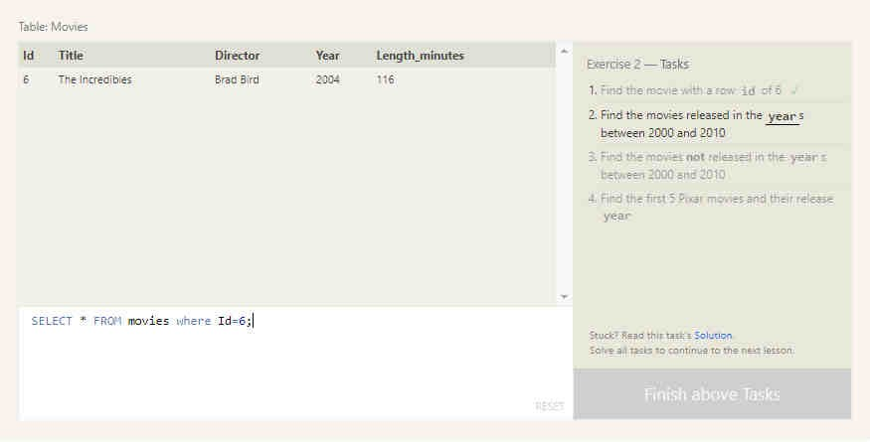

Exercise : 2.2

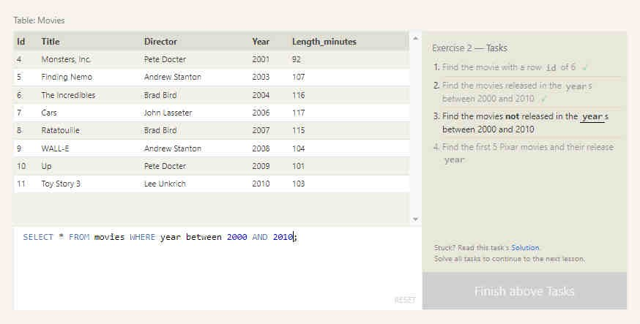

Exercise : 2.3

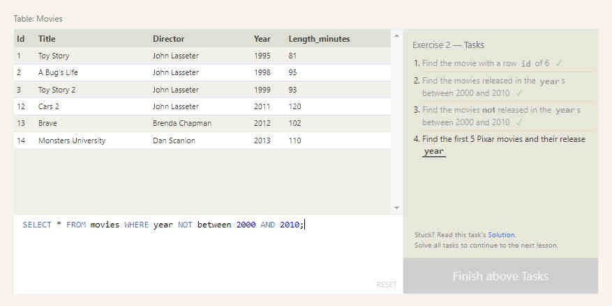

Exercise : 2.4

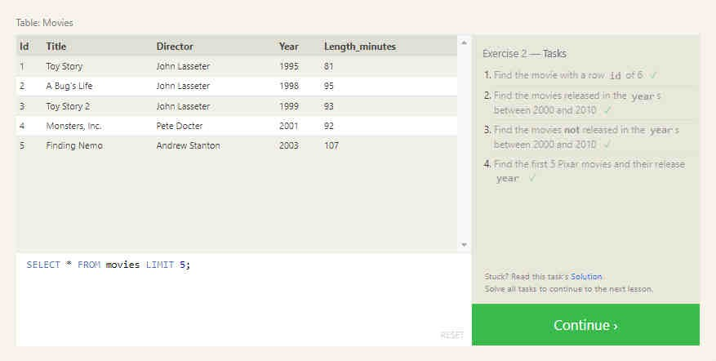

# Lesson 3: Queries with constraints (Pt.2)

Exercise : 3.1

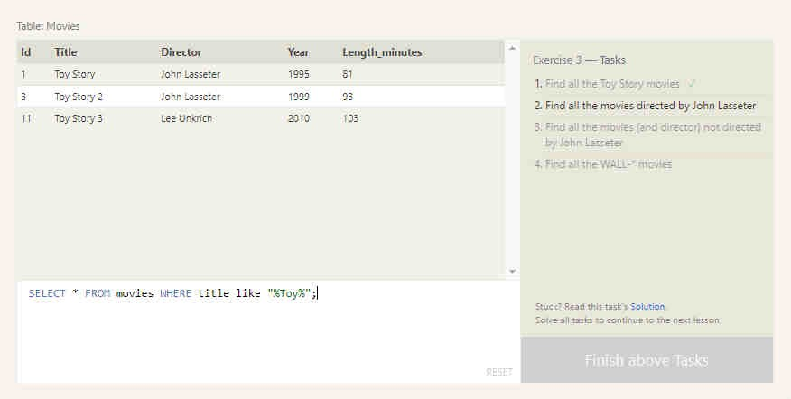

Exercise : 3.2

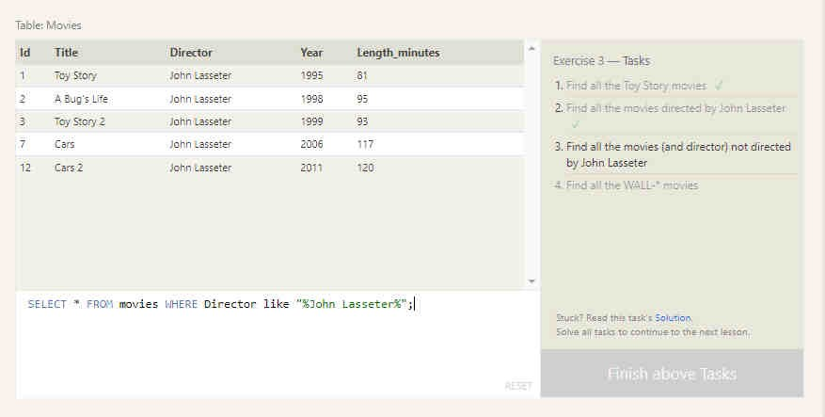

Exercise : 3.3

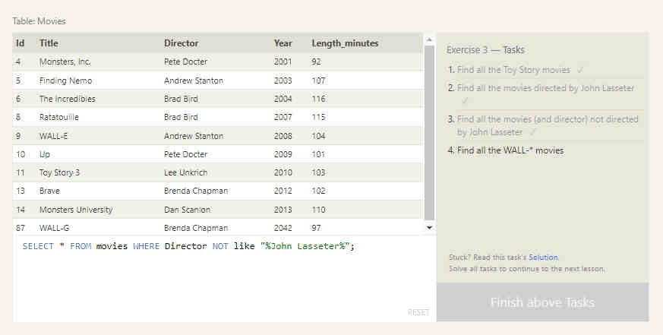

Exercise : 3.4

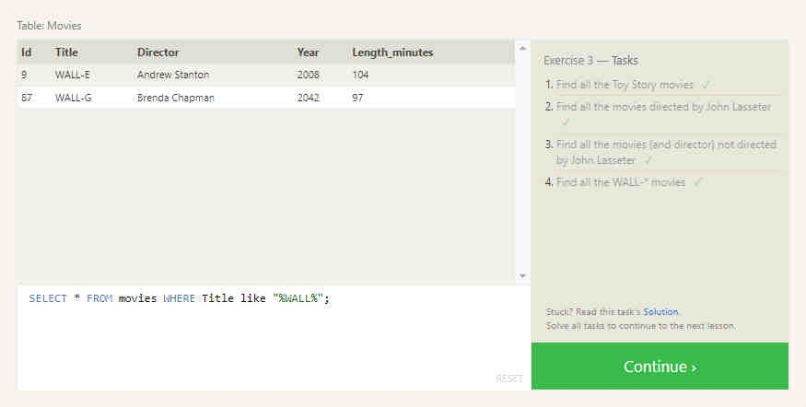

# Lesson 4: Filtering and sorting query results

Exercise : 4.1

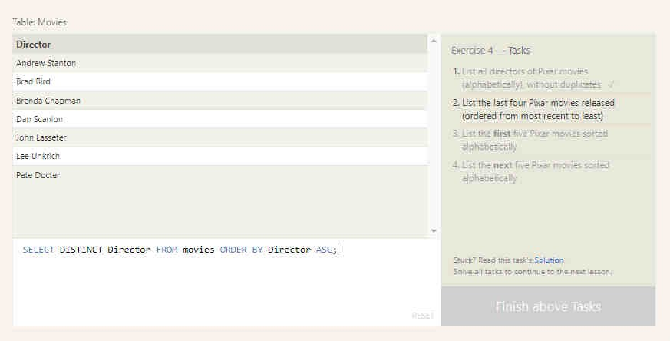

Exercise : 4.2

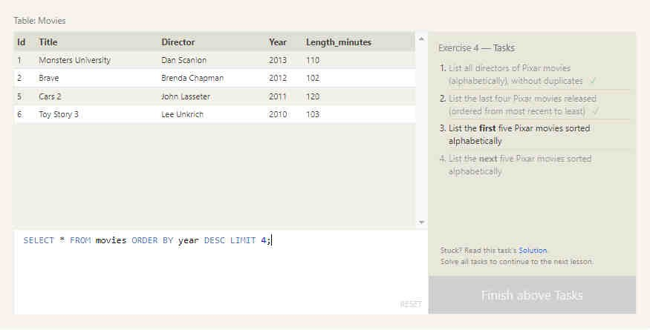

Exercise : 4.3

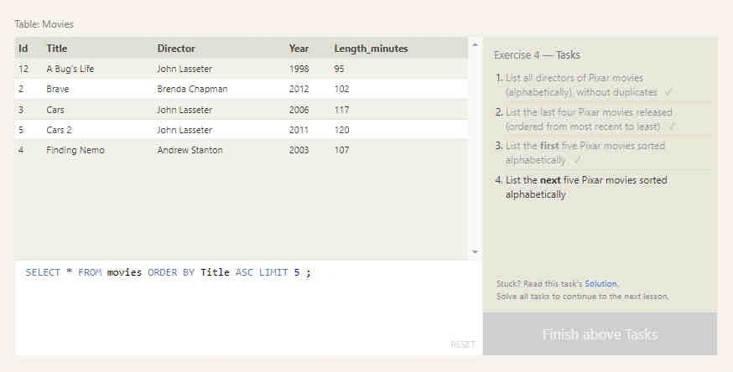

Exercise : 4.4

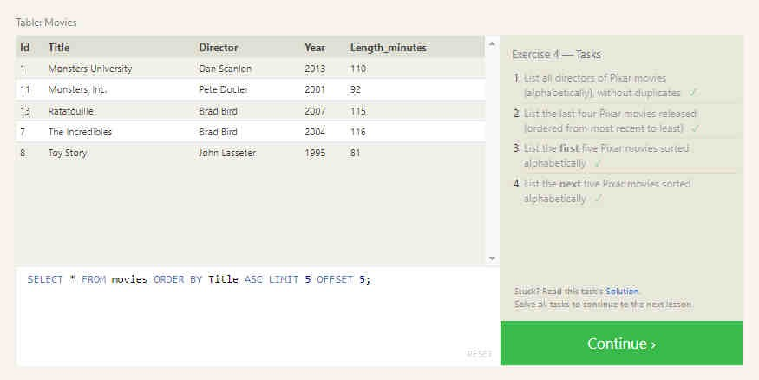

# LESSON 5: SQL Review: Simple SELECT queries

Exercise : 5.1

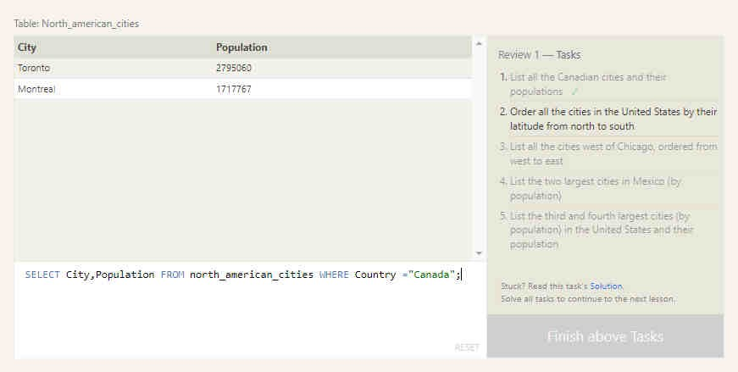

Exercise : 5.2

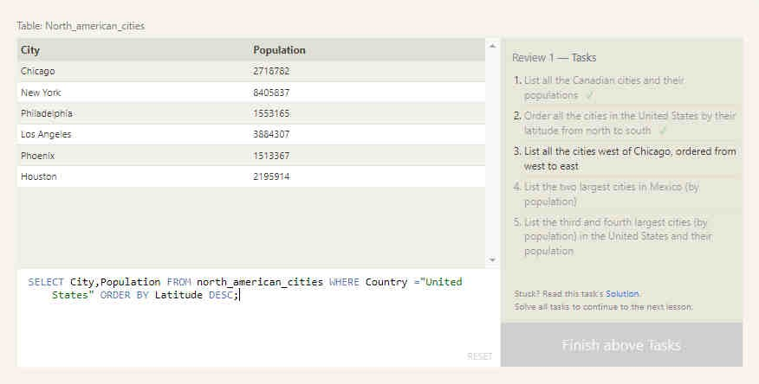

Exercise : 5.3

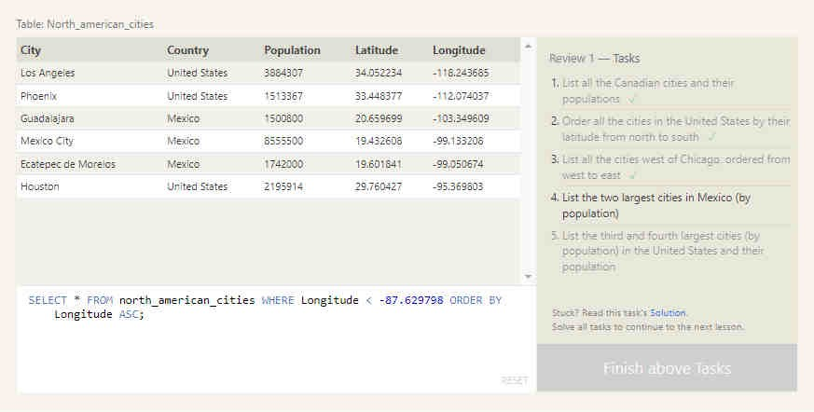

Exercise : 5.4

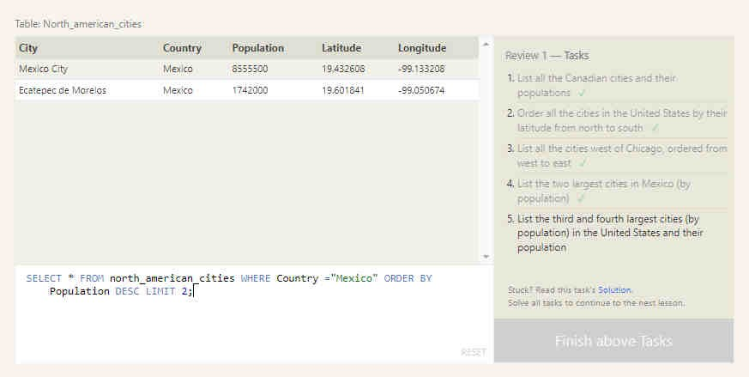

Exercise : 5.5

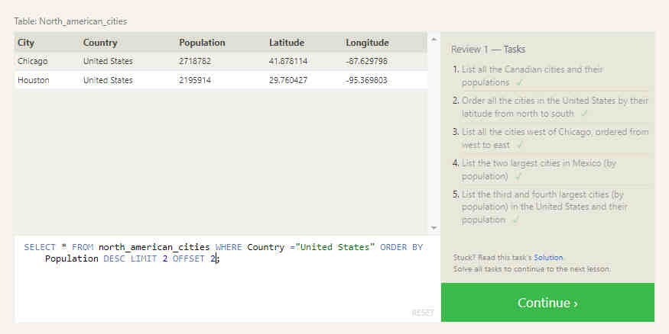

# LESSON 6: Multi-table queries with JOINs

Exercise : 6.1

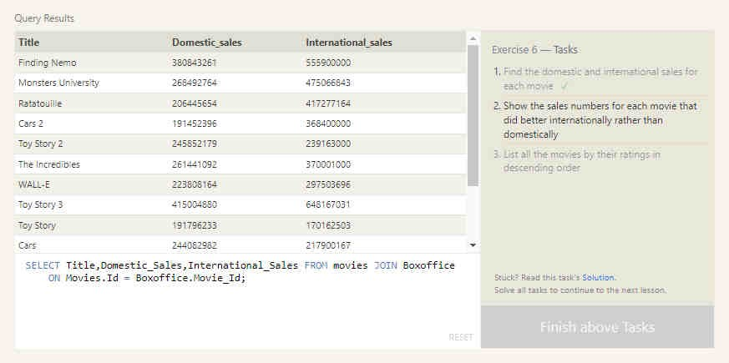

Exercise : 6.2

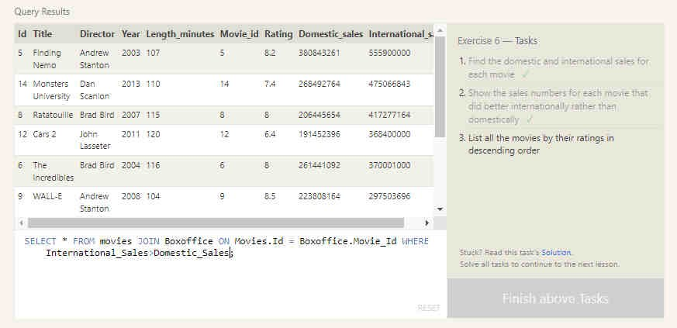

Exercise : 6.3

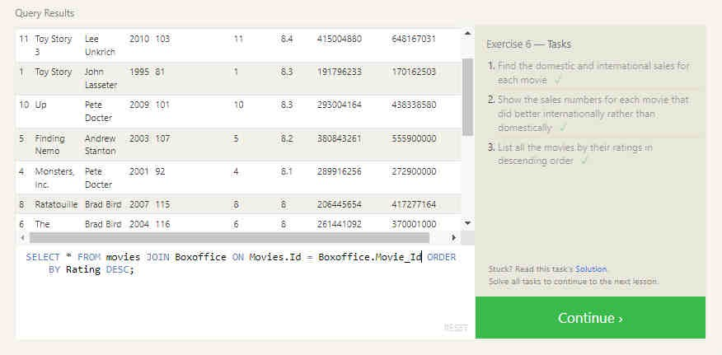

# LESSON 7: OUTER JOINs

Exercise : 7.1

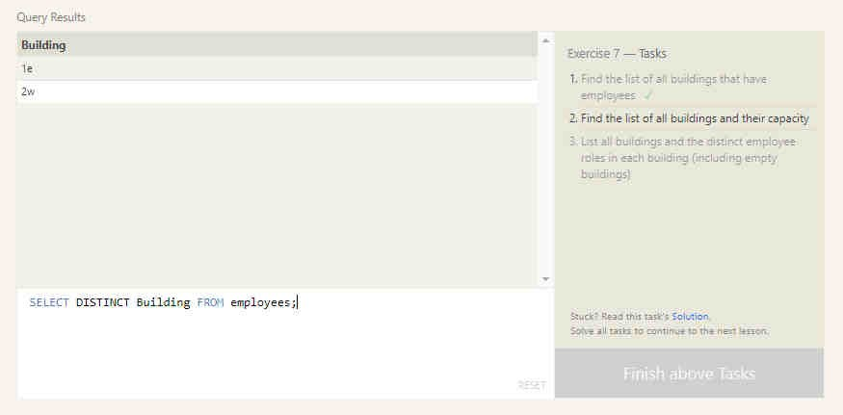

Exercise : 7.2

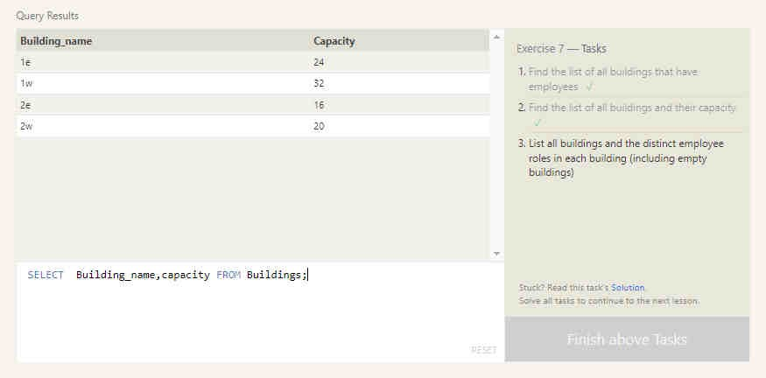

Exercise : 7.3

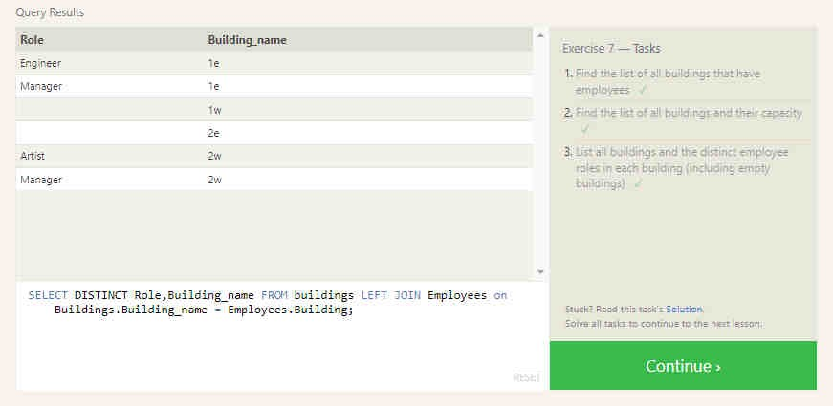

# LESSON 8: A short note on NULLs

Exercise : 8.1

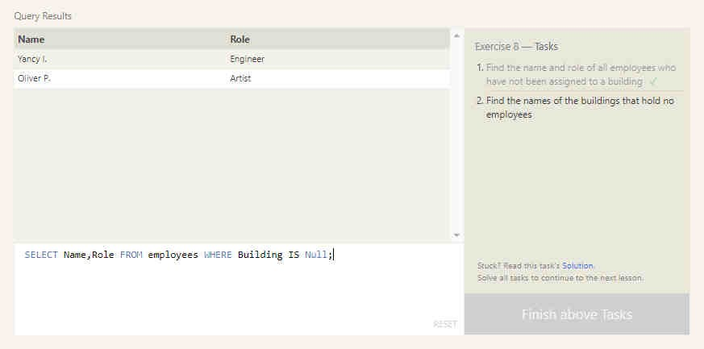

Exercise : 8.2

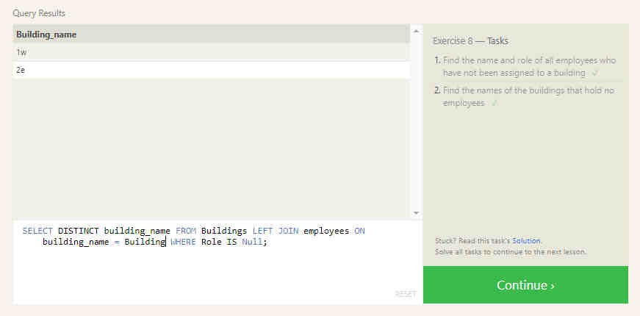

# LESSON 9: Queries with expressions

Exercise : 9.1

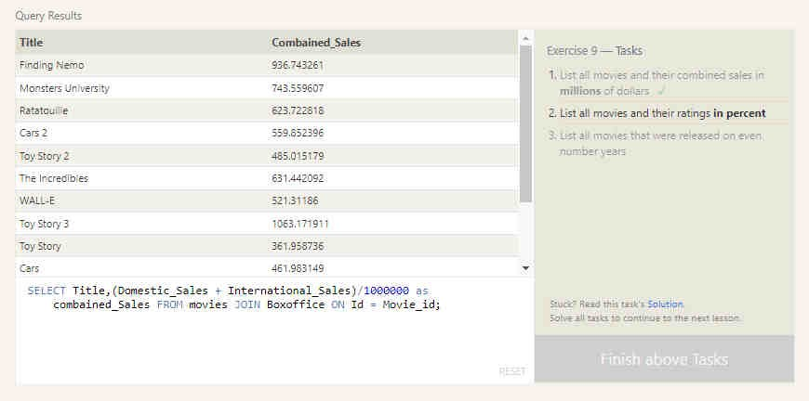

Exercise : 9.2

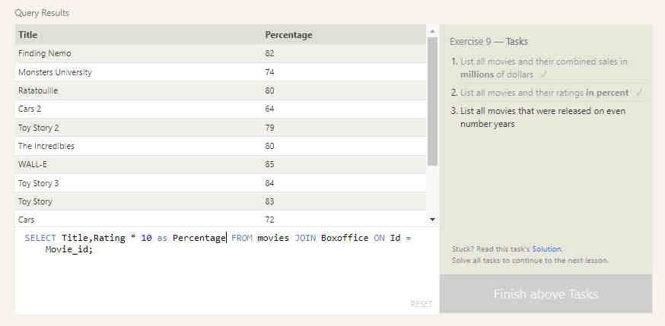

Exercise : 9.3

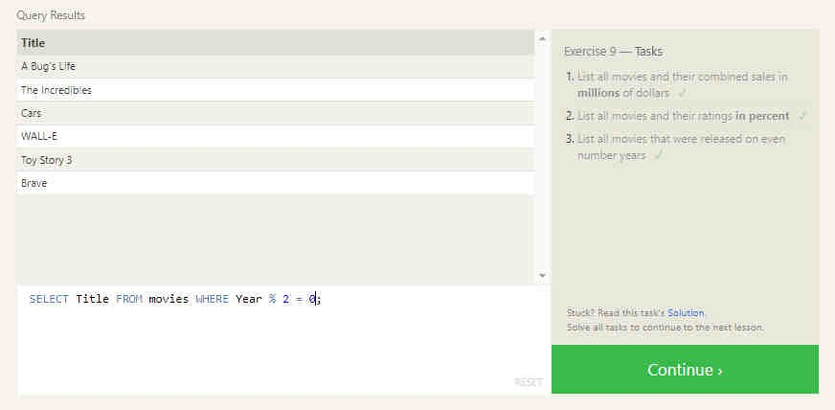

# LESSON 10: Queries with aggregates (Pt.1)

Exercise : 10.1

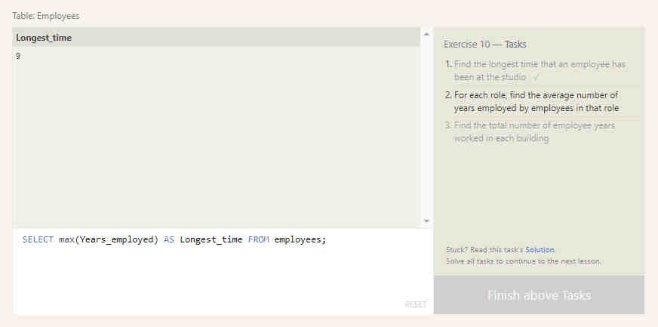

Exercise : 10.2

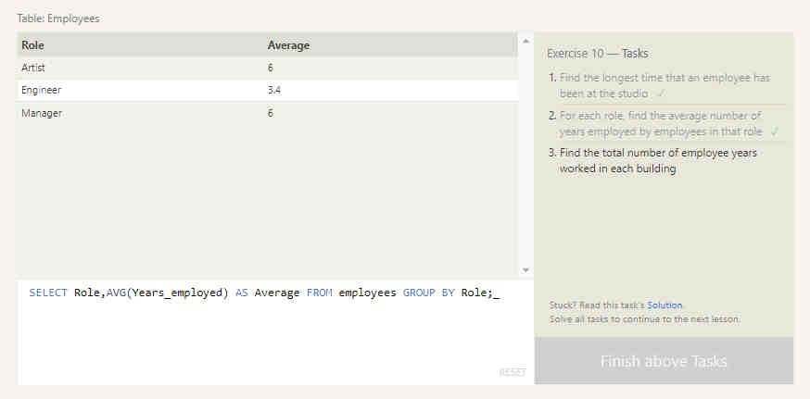

Exercise : 10.3

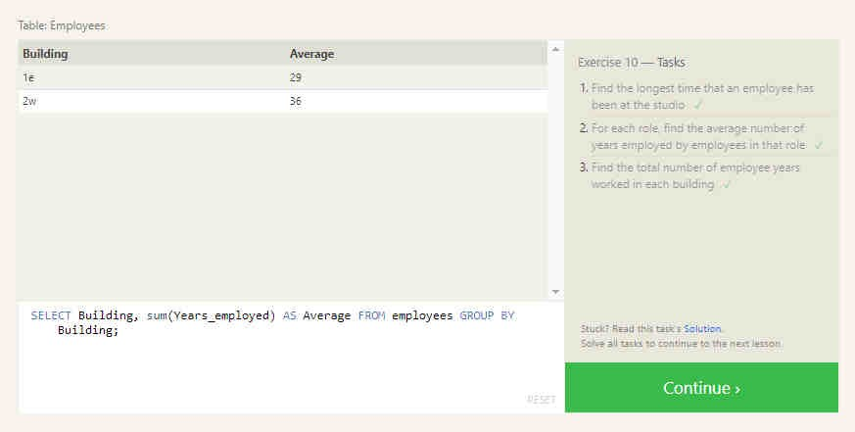

# LESSON 11: Queries with aggregates (Pt.2)

Exercise : 11.1

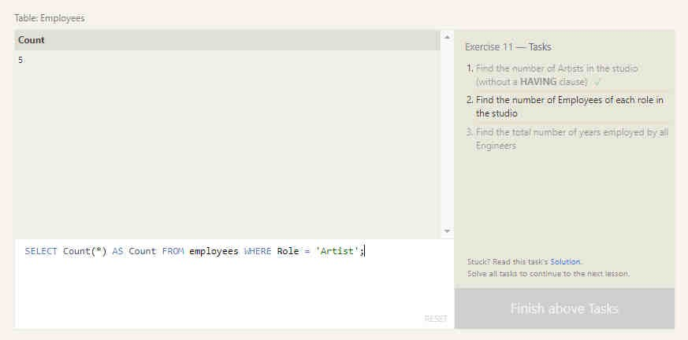

Exercise : 11.2

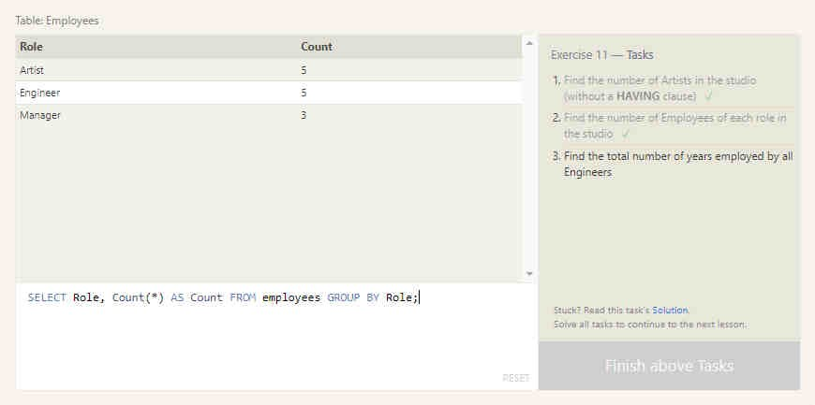

Exercise : 11.3

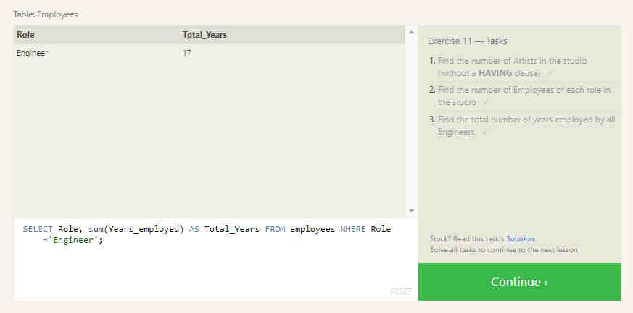

# LESSON 12: Order of execution of a query

Exercise : 12.1

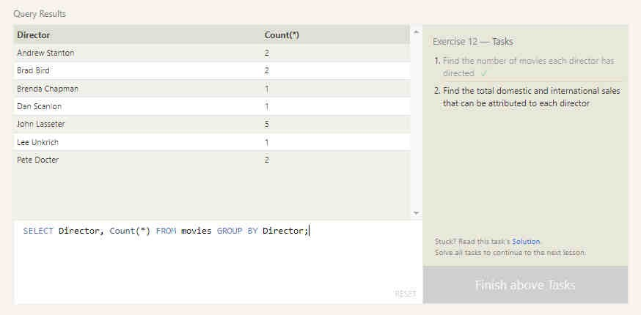

Exercise : 12.2

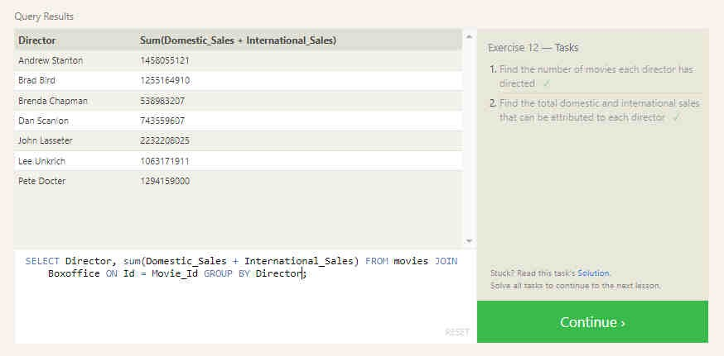

# LESSON 13: Inserting rows

Exercise : 13.1

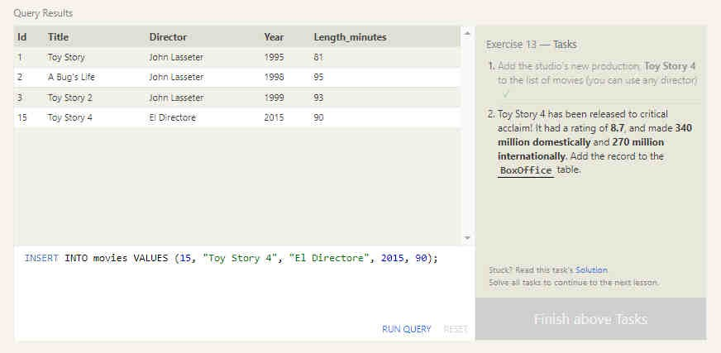

Exercise : 13.2

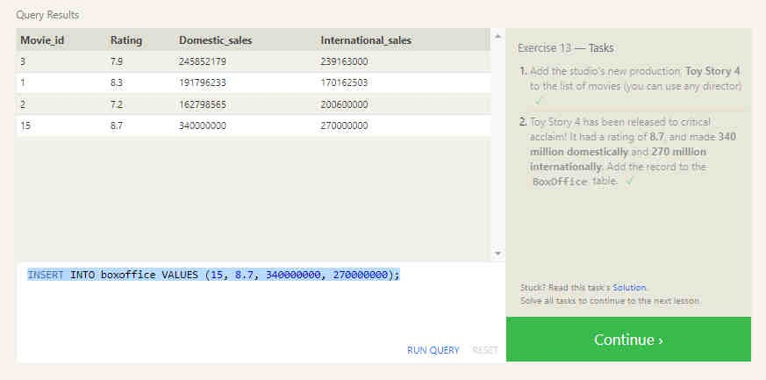

# LESSON 14: Updating rows

Exercise : 14.1

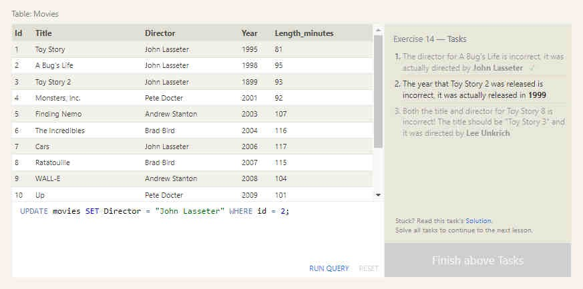

Exercise : 14.2

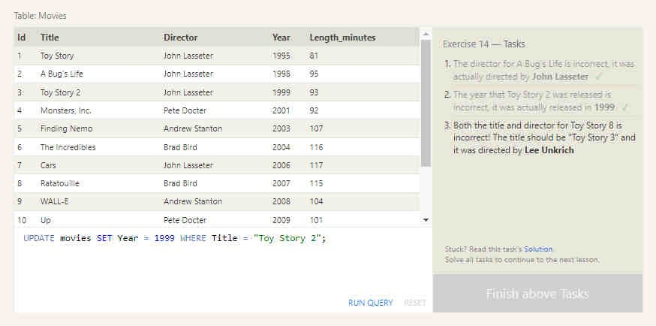

Exercise : 14.3

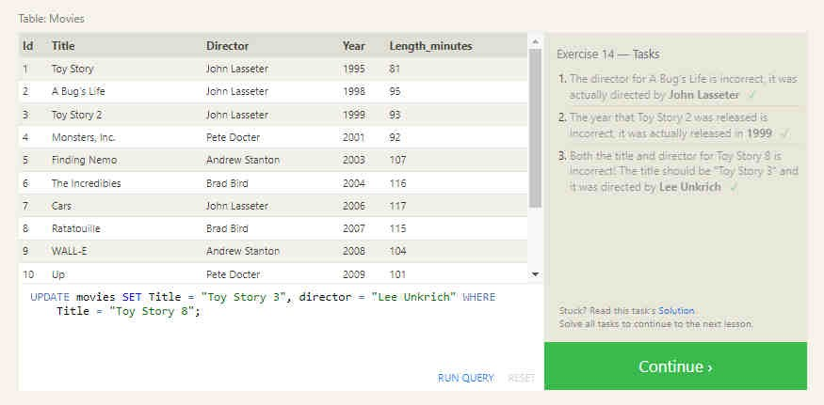

# LESSON 15: Deleting rows

Exercise : 15.1

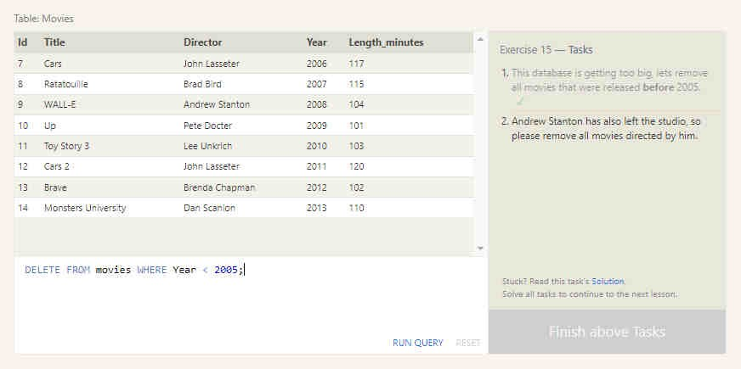

Exercise : 15.2

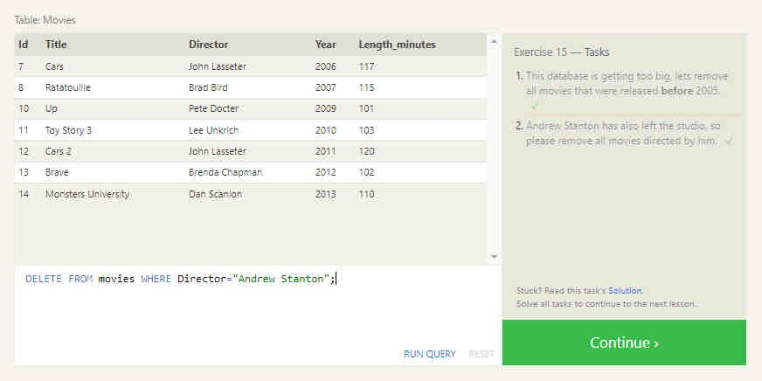

# LESSON 16: Creating tables

Exercise : 16

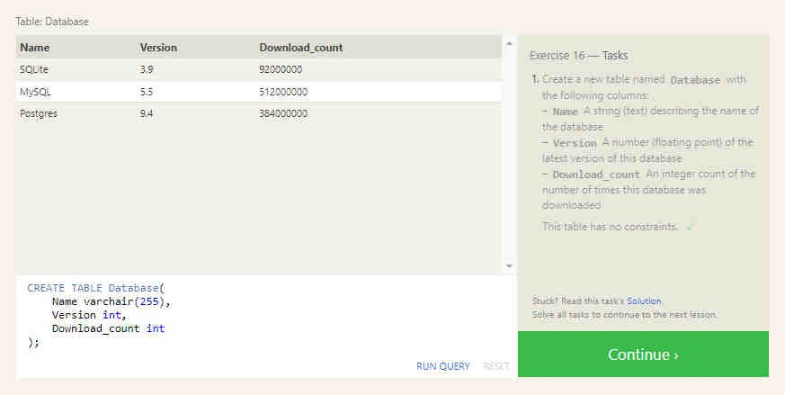

# LESSON 17: Altering tables

Exercise : 17.1

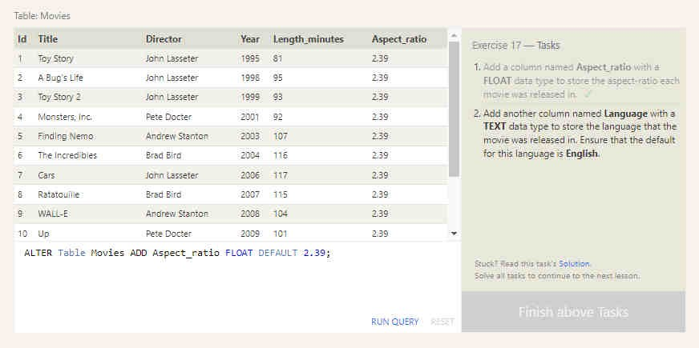

Exercise : 17.2

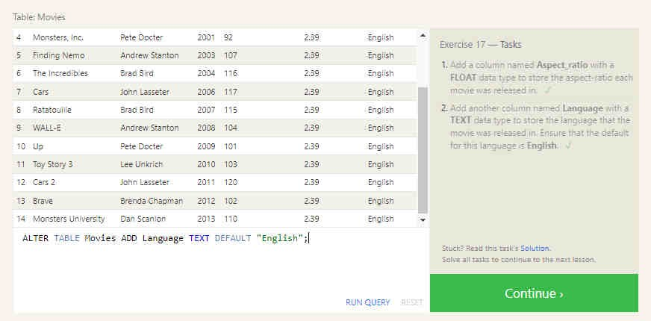

# LESSON 18: Dropping tables

Exercise : 18.1

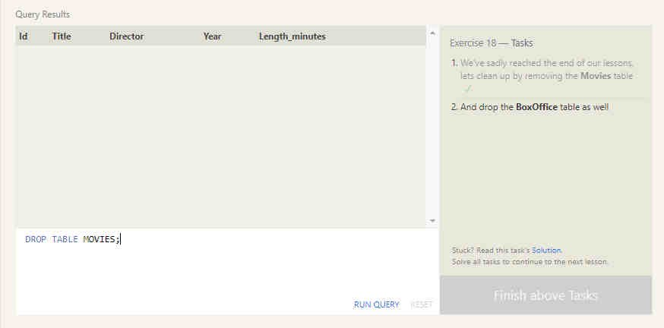

Exercise : 18.2

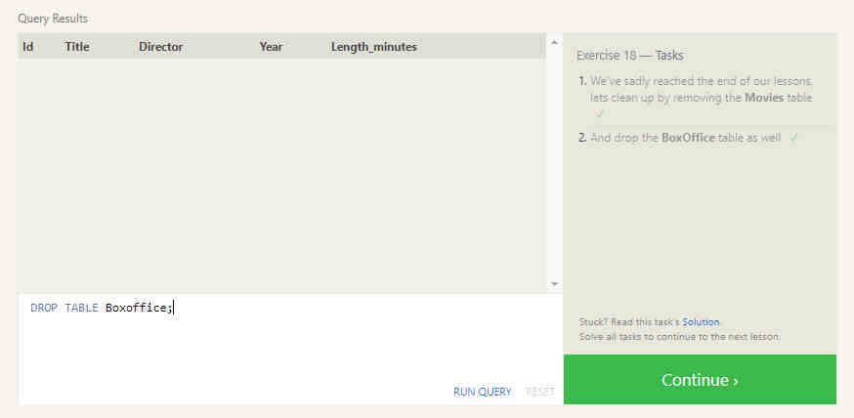

FINISHED

