**Prerequisite:**

1. Minikube (for locally running)
2. Azure Kubernetes Service (for deploy the node to the cloud)
3. Kubernetes installed on your machine
4. Enable kubernetes on your Docker desktop
5. Dockerized image to deploy and push it docker hub

**To know basics of kubernetes** <https://auth0.com/blog/kubernetes-tutorial-step-by-step-introduction-to-basic-concepts/>

To install kubernetes

[curl -LO https://dl.k8s.io/release/v1.22.0/bin/windows/amd64/kubectl.exe](https://dl.k8s.io/release/v1.22.0/bin/windows/amd64/kubectl.exe)

To install minikube

<https://minikube.sigs.k8s.io/docs/start/>

Here there is a basic for building an docker image

<https://docs.google.com/document/d/1NFxwMk-KIecfuidcRi6ApBthJmGWchrUO_FY8xwvaAI/edit?usp=sharing>

<https://www.section.io/engineering-education/deploy-docker-container-to-kubernetes-cluster/>

This link is for reference only

Type docker images on your CLI

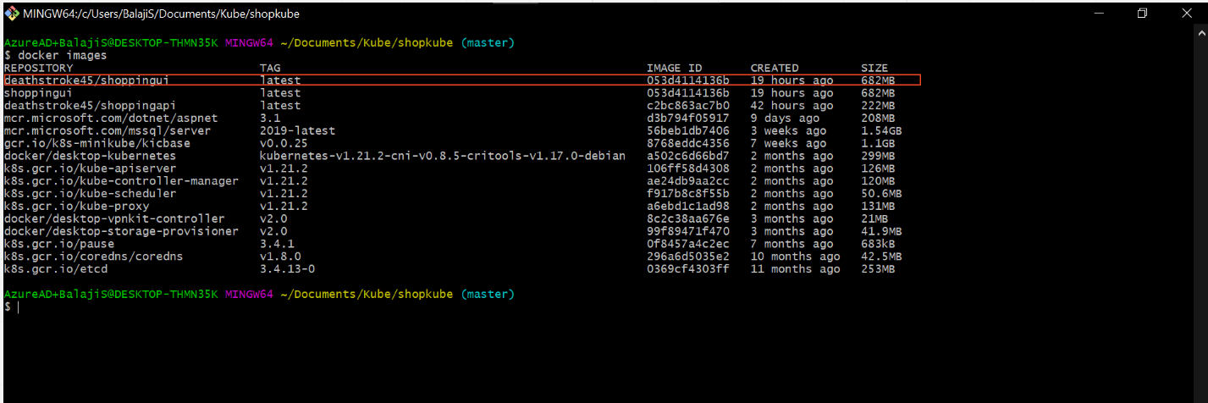

I'm Going to use deathstroke45/shoppingui:latest image to deploy it on kubernetes

Save below template as <something>.yaml

apiVersion: v1

kind: Service

metadata:

name: shopui-service

labels:

app: angular

spec:

ports:

- port: 80

protocol: TCP

targetPort: 8080

selector:

app: angular

type: LoadBalancer

---

apiVersion: v1

kind: Pod

metadata:

name: shopui-app

labels:

app: angular

component: shopui-app

spec:

containers:

- image: deathstroke45/shoppingui:latest

name: ui

ports:

- containerPort: 8080

Replace the image , container port ,name , type , target port that fits your project.

**Basics commands for kubernetes**

* kubectl create ns - for creating a namespace
* kubectl get all -n <namespace name> - get all (service,deployment,pods) in the given namespace
* kubectl get pods -n <namespace name> - get pods in the given namespace
* kubectl get service -n <namespace name> - get service in the given namespace
* kubectl get deployment -n <namespace name> - get deployment in the given namespace
* kubectl logs <pod name> -n <namespace name> - get logs for the given pod (debug purpose) **note:** you can log for the (pod, service ,deployment)just replace instead of pod name
* kubectl describe <pod name> -n <namespace name> - same as logs but it will describe.
* kubectl apply -f <file name> -n <namespace name> - it will apply what are all the things declared inside the file.
* kubectl delete -f <file name> -n <namespace name> - it will delete what are all the things declared inside the file.

**To know more commands:**

<https://phoenixnap.com/kb/wp-content/uploads/2021/06/kubectl-commands-cheat-sheet-by-PhoenixNAP.pdf>

1.minikube start - to start the local kubernetes engine

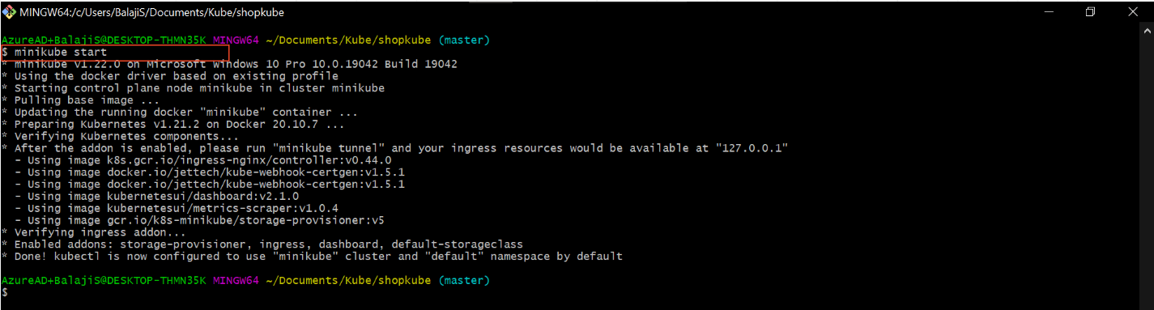

2.kubectl get ns - it will list all the namespaces in the minikube

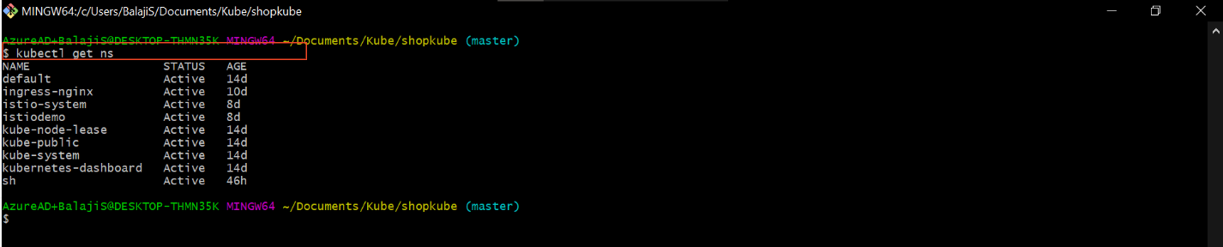

3.kubectl create ns <namespace name>

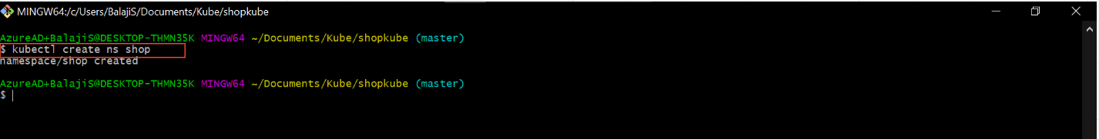

4. kubectl apply -f “<file name of the above template>” -n <namespace name>

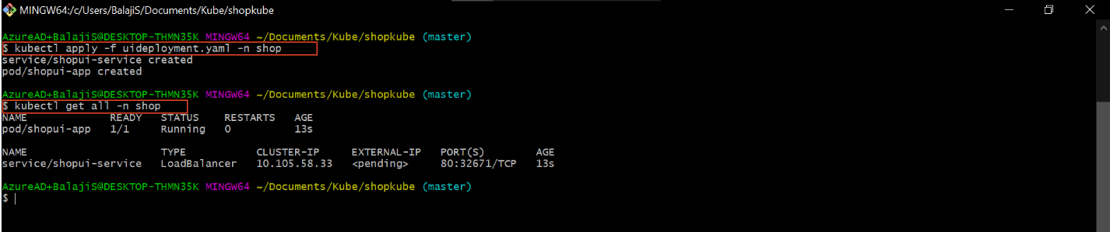

5.kubectl logs <pod name> -n <namespace name>

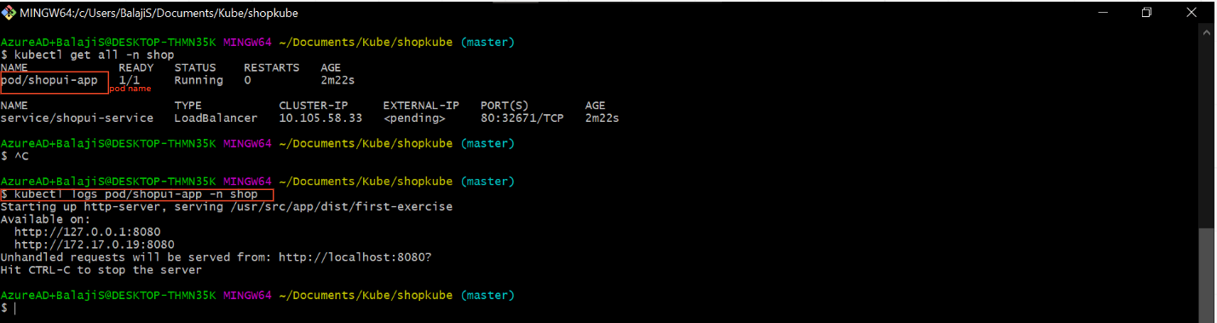

Here the container is successfully created and running

6.minikube service <service name> -n <namespace>

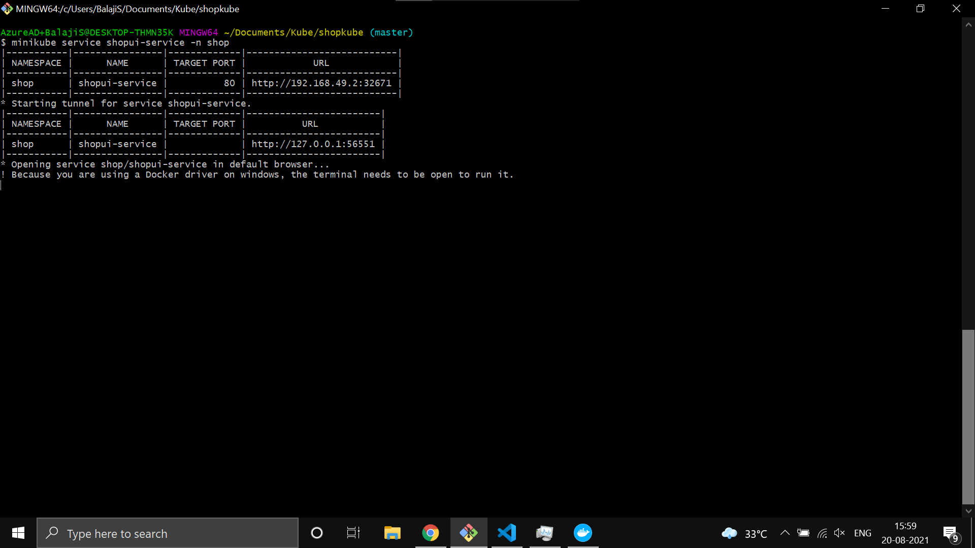

The webpage will start running in your browser automatically.

To do this in cloud refer this

<https://github.com/karthikeyanVK/KluelesswithKube/wiki>