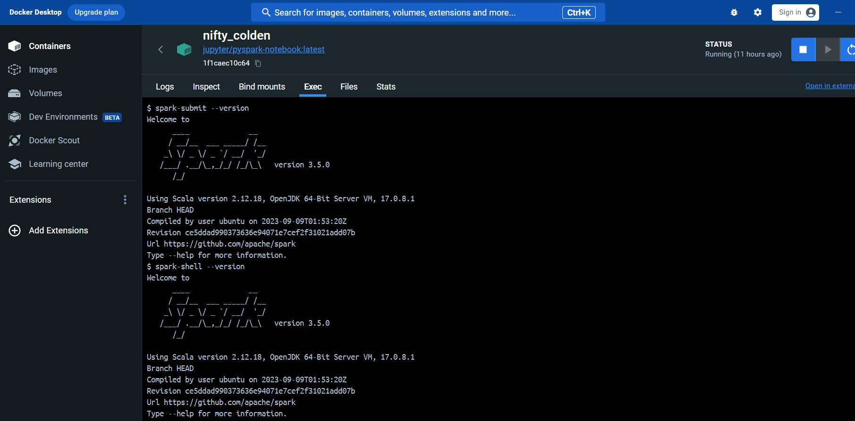

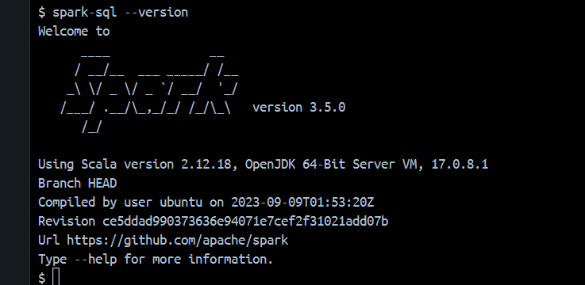

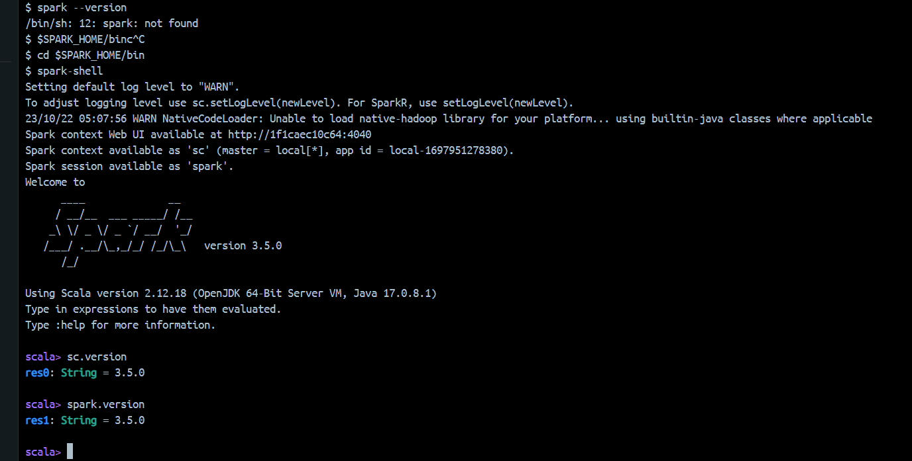

docker run -it --rm -p 8888:8888 -e GRANT_SUDO=yes --user root jupyter/pyspark-notebook

1. cd to **$SPARK_HOME/bin**
2. Launch **spark-shell** command
3. Enter **sc.version** or **spark.version**