**Spark version verification**

Pyspark verification in docker launched jupyter notebook

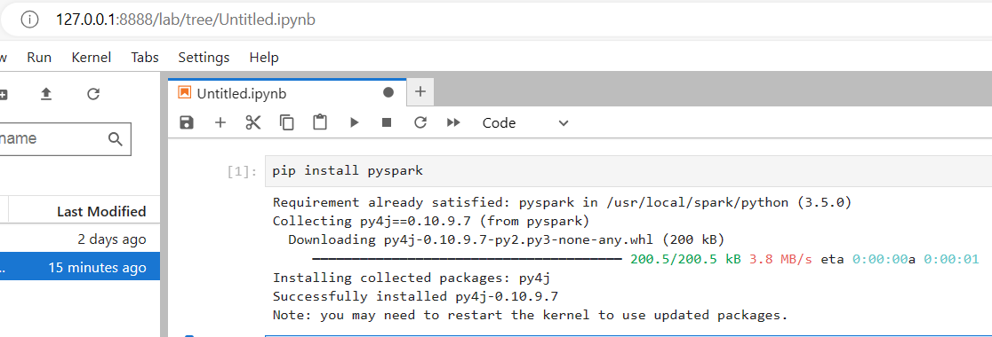

Spark version verification in docker spark-shell

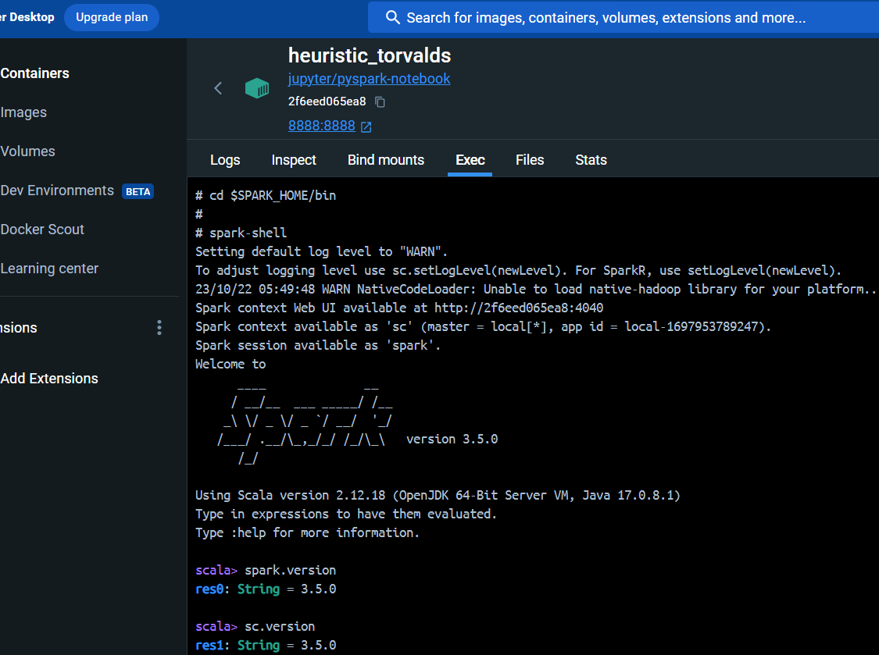

Spark version verification without entering into spark-shell

