Industrial Training – Project Report
(MCA-C651)
on
Cloud-Based Human Resource Management SystemonSalesforce Platform

Submitted in partial fulfillment of the requirements
for the award of the degree of

Master of Computer Applications (MCA)

Uttaranchal School of Computing Sciences



BATCH 2024-2026

Submitted by
Submitted to:
Saloni Kukreti
Mr. Ajay Singh Rawat
UU2420000110
Assistant Professor
MCA -IV (C)
Uttaranchal School of Computing Sciences

ACKNOWLEDGEMENT

The most awaited moment of any endeavor is its successful completion, but nothing can be done successfully if done alone. Success is the outcome of continuous technical mentoring, guidance, and support from various individuals, and I express my sincere gratitude to all those who contributed to the successful completion of this project.
First and foremost, I would like to thank Prof. (Dr.) Sonal Sharma, Director, USCS, for providing a healthy and encouraging environment for study.
I am extremely thankful to Prof.(Dr.) Sameer Dev Sharma, Head of Department, USCS, and my project mentor Mr. Ajay Singh Rawat , for providing me with this opportunity and for their valuable technical mentorship, continuous guidance, and expert insights throughout the project development process. Their support at every stage significantly enhanced my understanding and helped me successfully complete this work.
I also express my sincere gratitude to my colleagues for their valuable discussions and support, which helped me in giving a final shape to this project

Dated: 30-04-2026
Saloni Kukreti
UU2420000110
MCA-IV(C)

STUDENT DECLARATION

I hereby declare that the project titled “Cloud-Based Human Resource Management SystemonSalesforce Platform” is an original work carried out by me under the guidance of Mr. Ajay Singh Rawat in partial fulfillment of the requirements for the award of the degree of Master of Computer Applications (MCA) from Uttaranchal University.
I further declare that this project has not been submitted, either in part or in full, to any other institution or university for the award of any degree or diploma.
All sources of information and references used in this project have been duly acknowledged.

Dated: 30-04-2026
Saloni Kukreti
UU2420000110
MCA-IV(C)

Uttaranchal School of Computing Sciences

CERTIFICATE

This is to certify that the project work entitled “Cloud-Based Human Resource Management SystemonSalesforce Platform” is a bonafide work carried out by Saloni Kukreti (UU2420000110) submitted in partial fulfilment for the award of the degree in MASTER OF COMPUTER APPLICATIONS of Uttaranchal University, Dehradun during the academic year 2025-26.
It is verified that the project files and project report (PDF) are uploaded on GitHub [Paste your GitHub repository link here]

Mr. Ajay Singh Rawat
Assistant Professor

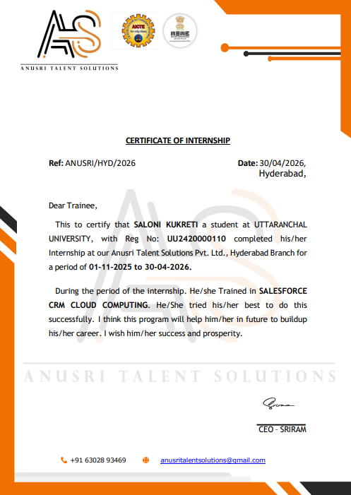

PREFACE

This project report titled “Cloud-Based Human Resource Management SystemonSalesforce Platform” has been prepared as a partial fulfilment for the award of the degree of Master of Computer Applications. The objective of this project is to apply theoretical concepts to real-world problems and to gain practical exposure in design, development, and implementation
This project titled “Cloud-Based Human Resource Management System on Salesforce Platform” is developed to streamline and automate HR operations using the Salesforce ecosystem. The system focuses on managing employee data, attendance, leave requests, and payroll processes efficiently through a centralized cloud-based solution.The primary objective of this project is to reduce manual effort, improve data accuracy, and enable real-time tracking of HR activities. The system allows employees to submit leave requests, which are processed automatically using Salesforce Flow. Based on the approval or rejection of leave requests, automated email notifications are sent to employees. The project is implemented using Salesforce technologies such as Objects, Fields, Validation Rules, Flow Builder, Email Alerts, and Apex (if used). Validation rules ensure data integrity, while automation tools like flows enhance process efficiency. Overall, the system demonstrates how cloud-based platforms like Salesforce can be effectively used to design scalable, secure, and automated HR management solutions.
The project files are uploaded on GitHub [Paste your GitHub repository link here]

Mr. Ajay Singh Rawat Saloni Kukreti
Assistant Professor UU2420000110
USCS MCA-IV(C)
TABLE OF CONTENTS
Sr. No. | Content | Page Number
 | Acknowledgement | i
 | Declaration | ii
 | Certificate of Originality | iii
 | Industrial Training Certificate
1 | Introduction/Objectives | 1
2 | System Analysis | 2
 | - Identification of Need
 | - Preliminary Investigation
 | - Feasibility Study
 | - Project Planning
 | - Project Scheduling (PERT Chart and Gantt Chart both)
 | - Software requirement specifications (SRS)
 | - Software Engineering Paradigm applied
 | - Data models
3 | System Design
 | - Modularisation details
 | - Data integrity and constraints
 | - Database design
 | - User Interface Design
4 | Testing
 | - Testing techniques and Testing strategies used
 | - Test reports for Unit Test Cases and System Test Cases
5 | System Security measures
6 | Cost Estimation of the Project along with Cost Estimation Model
7 | Reports
8 | Future scope and further enhancement of the Project
9 | Appendices
 | - Coding
 | - Bibliography
 | - Plagiarism report

- Introduction
The way companies handle their work has changed a lot because of new digital technologies. This is especially true for the people in charge of Human Resource Management. Old systems were slow. Used a lot of paper. They also used tools that did not work well together which caused problems and delays. People could not always get the information they needed. Now companies want a way to handle Human Resource Management. They want something that is easy to use and can be used by everyone. They want something that's accurate and easy to access. This is where cloud-based Human Resource Management Systems come in. These systems use the internet to make Human Resource Management easier and more efficient. Cloud-based Human Resource Management Systems are what companies need to manage their people. Human Resource Management Systems are very important, for companies. They help companies manage their people and make sure everything runs smoothly.
Cloud-Based Human Resource Management System refers to a system that provides means for managing employee data, attending record, leave applications, and organizational processes in general. The difference between the cloud-based system and other systems lies in the fact that the former facilitates management through the online system and thus the absence of complex equipment. This kind of system is helpful in that it allows the organization to access information in real time and make interaction easy for both employees and managers.
The application for this project is called “Cloud-Based Human Resource Management System on Salesforce.” The cloud-based Human Resource Management System is implemented using Salesforce, which is the cloud computing leader. It allows users to design, develop, and integrate applications in the cloud. It has powerful architecture, high scalability, and customization capabilities. There are many tools provided by Salesforce, including Flow Builder and Lightning App Builder, which can be used for developing applications. There are also programming capabilities that allow developers to use Apex.
This project aims at developing and implementing an integrated HR management system that will automate the main functions of HR, including managing the data related to employees, leave application and approval process, and user rights based on role. This means that there are distinctions in the type of users who can access the system, such as HR employees and regular employees, which ensures the availability of data to the appropriate users while remaining transparent to relevant actions..
Among the critical elements of this system is the Leave Management Module, which facilitates employees applying for leaves while allowing HR staff to either approve or deny their requests. In addition, automation capabilities offered by Salesforce such as approval processes and flows are utilized in ensuring that the request is appropriately channeled and notifications are sent instantly..
In addition to leave management, there are dashboards and reports included in this system, which offer important insights into data belonging to organizations. Through these dashboards, the HR manager will be able to track important metrics like total number of employees, number of pending leave requests, and department-wise distribution of data. On the other hand, employees can use dashboards to check their personal data and leave status among other metrics.
This project takes care of an important component called security. The security framework provided by Salesforce includes profiles, permission sets, org-wide default settings, and role hierarchies among others. These are used to limit user access so that they see only the data pertaining to them. Employees are limited to seeing only their personal records while HR can access all records
Additionally, the system provides insights on how cloud applications can scale and adapt to business needs as well. The modules of attendance, payroll, and employee services can be added easily as the company expands without the need for major overhauls in the system architecture. Cloud-based HRMS applications, therefore, become ideal for businesses needing flexible systems.
Objectives
The main purpose of developing Cloud-Based Human Resource Management System is to provide an efficient, scalable and secure platform to automate the key activities related to human resource management. As businesses become more complex, manual ways of managing human resources become ineffective and inefficient. Therefore, this project will focus on designing a cloud-based system to support human resource management in organizations.
Digitizing employee information management will be one of the core objectives of the project. This will involve the collection and storage of all employee information such as personal information and job roles in an organized manner. Centralizing all employee information will make it easy to manage and update employee records in real-time.
Another significant goal will be to create an efficient leave management solution in which the entire process of applying for leaves and managing those will be automated. Through the automation of the entire process, employees will simply apply for leaves, and the applications will be automatically sent to the HR managers for review. Since the process will be automated, there won’t be any need for any manual processes, and therefore the process will be efficient and without much hassle.
Another important aspect of the implementation of this project will be to develop a role-based access control solution in order to make sure that all data remains secure. In the process of accessing the database of the organization, only certain people having specific rights would be able to gain access. With the help of the Salesforce security features like profiles and role hierarchies, this aspect will be efficiently handled.
Another vital objective of the system is to offer informative dashboards and reporting features that allow users to make informed decisions based on data analysis. The dashboard displays a number of key metrics such as staff composition, leave records and organisational trends. Such features allow HR professionals to get insights on trends and patterns, track their performance and make decisions that guarantee success and growth of the organization.
Automation is another major goal of this project. The automation of HR processes aims to minimise human interaction in order to save time, reduce costs and prevent mistakes. The automation features that are included in this project are the flows and automated approvals for HR tasks such as leave approval, reminders and other related HR functions.
User experience is a significant objective of the system. It requires designing an intuitive interface for both HR professionals and employees to use the system with ease. Users do not require additional training to understand how to use the software.
Scalability is yet another objective that the system will have to achieve. It should be noted that this project has been developed in such a way as to provide scalability for further implementation of other modules into the system. Thus, new capabilities like attendance monitoring, payroll system, or employee self-service portals might be implemented in the near future.
The second goal is connected with practical knowledge of cloud computing technologies and enterprise application development on Salesforce platform. Practical implementation of real-world features like role-based access, workflow automation, and data modeling in the system indicates the ability to develop and design applications for enterprise usage.
To sum up, it should be said that the objectives of this project are associated with achieving higher efficiency, providing proper data security, creating positive user experience, and implementing innovative technologies like cloud computing. In this way, the proposed system not only improves the existing flaws but also offers a better solution to the problems of modern HR practices.

System Analysis
System analysis is a crucial stage in creating software since it involves assessing the problems that exist, finding out the needs of the system and coming up with a strategy to help create an effective solution. The system analysis stage in the development of the Cloud-Based Human Resource Management System involves assessing the conventional HR methods, pointing out their inadequacies and figuring out how to solve these problems through developing a system that addresses these shortcomings.
In order to conduct system analysis, there is a need to assess the HR methods used in different organizations currently and identify their weaknesses and inefficiencies. For instance, most organizations still rely on manual means of conducting HR tasks such as keeping track of employees' leaves and managing their files. This is often time-consuming and prone to various errors, including duplicating data, among others. Through system analysis, the need for an improved method of handling such issues will be determined.
With respect to these problems, the intended system will take advantage of Salesforce’s features to come up with a system that solves these inefficiencies in an efficient manner. Salesforce gives the ability to store data securely, to access them in real-time and to effectively manage the information through customizable objects and automation features. System analysis would then define all the functional and non-functional requirements of the intended system, including user roles, access control, automation processes and reporting.
Another aspect that would be considered during system analysis concerns the identification of the various stakeholders in the intended system. In this case, the key stakeholders in the intended system will be the HR department as well as the employees. The HR department stakeholders would require access rights to manage employee data, approve leave applications and to prepare reports, whereas the employees would need a user-friendly system to make leave application requests, check their records and monitor their status.
Technical feasibility is one of the elements analyzed to establish if the implementation of the project on a cloud computing environment is possible. Salesforce provides a number of declarative capabilities, such as Flow Builder, Lightning App Builder, and Approval Processes. The use of these technologies ensures fast creation of applications without the need to write complex code. On the other hand, developers can always use Apex to develop complex logic and increase functionality. Thus, these aspects confirm the fact that the project can be implemented efficiently and with great flexibility and scalability.
Another type of feasibility discussed in the analysis concerns the economic aspect. Conventional HRM solutions typically require heavy investments into hardware, software, and further maintenance of IT infrastructure. In the case of cloud computing, it is unnecessary to make any of these expenses because the solution does not involve any hardware. It is paid for based on subscription only.
Operational feasibility of the system is estimated to confirm its practical value for an organization. As can be seen from the discussion above, the proposed solution is provided with a very user-friendly design. Besides, automation is considered to contribute to enhanced usability of the application.
To conclude, system analysis is one of the most important steps that contribute to the determination of the system’s structure and features. This stage makes it possible to determine problems that currently exist, understand users’ demands, and assess technological and economical viability of the future solution.

Identification of Need
Determining need is one of the earliest and vital stages in analyzing a system because it establishes the reason for the system's creation. For instance, the need for cloud-based human resource management systems arises from some constraints in the current traditional human resource management process. Most organizations continue to use either outdated or manual systems to collect information about employees. These systems are inefficient, and they cannot be relied upon to provide useful information for the betterment of the firm.
The biggest problem with conventional HR management systems is that they fail to provide an effective way of centralizing information. Most organizations store information about employees in different platforms, including spreadsheets and disconnected application software, making it hard to manage. In addition, it is always tedious to retrieve specific information when you want. Moreover, in organizations with lots of employees, this task would be cumbersome.
Another major issue with traditional HR management systems is the inability to provide efficiency in managing employee leaves. Currently, when a worker wants to take leave, they have to manually send their request through various approvals before the system gives clearance. It means that workers cannot easily check whether their leave request has been approved in time.
Another problem associated with traditional solutions is the absence of sufficient security measures and controls. Employee information is likely to be inadequately secured, resulting in risks of data leaks. There is usually no clear classification of users, which increases the chances for data tampering and its unauthorized access.
Moreover, there are no reporting and analysis opportunities within a traditional HR software system. The company cannot produce valuable statistics and insights from its database due to the lack of relevant features. It becomes impossible to track the performance and absenteeism patterns of employees and monitor departmental structure.
These considerations make it clear why the use of a cloud-based solution is needed to solve these problems. The use of a cloud-based solution developed with Salesforce allows resolving all of the above problems since a centralized, secure, and scalable platform for performing HR-related functions is created.
Additionally, another issue that contributes to the need to develop a cloud-based HRMS arises because of the fact that people tend to work remotely and perform digital transformations more frequently nowadays. In other words, the necessity to provide employees and managers with an opportunity to access the system from any location cannot be met through traditional on-premise solutions.
To summarize, the need for such a project as the development of a cloud-based HRMS is justified through several factors. First, it is due to certain limitations related to traditional solutions. Second, there is an increasing demand in terms of modern business practices.

Preliminary Investigation
Preliminary investigation plays an important role in system analysis because it includes the acquisition of information about the existing system, determination of the need of particular changes, and assessment of the possibility of implementation of proposed changes. This phase allows defining the scope of a project and giving certain direction to its realization.
Preliminary investigation concerning the cloud-based HRM system is aimed at analyzing the way of HR processes management in organizations. This process involves analysis of the ways employee data is kept and modified, the way leave requests are handled, the way report documents are prepared by using available data. With the help of such investigations, it becomes possible to identify problems associated with HRM processes.
In this process, the information can be acquired from different sources including HR representatives, employees, and existing documentation. The analysis of the needs of particular users allows obtaining information useful for designing such a system. For instance, HR managers will want to have a tool that simplifies the management of data, provides comprehensive reports, while ordinary employees will prefer simple interfaces.
It would also entail an assessment of the feasibility of building the system based on Salesforce technology. There are several reasons why Salesforce has been selected to design the HR management system; they include the availability of advanced infrastructures and inherent security measures, as well as the possibility of developing systems using both declarative and programmed approach.
In addition, there will be an assessment of the organizational feasibility. It is necessary to check whether the organization can utilize the proposed HR management system. The system will be quite easy to operate because the design will incorporate automated processes and user-friendly interfaces. There is no need for complicated training because the users will have minimal difficulty in operating the system.
Finally, economic feasibility will be evaluated. In other words, it would be necessary to evaluate the cost of creating and using the HR management system. Salesforce works based on a cloud-based infrastructure, which means that expensive software and hardware are not required.
Moreover, the preliminary investigation encompasses the identification of possible threats and problems with respect to the new system. Such threats and problems might include factors connected to user acceptance, migration of data, and configuration. Taking the above into consideration, necessary steps can be taken so that such threats would be avoided.
At last but not least, the scope of the project is determined based on results obtained from the preliminary investigation. The project scope involves the inclusion of such features in the system as the employee management, leave management, dashboards, security and other. Besides, the project scope leaves some room for possible improvements.
To sum up, the preliminary investigation gives a clear picture of the current state of affairs in relation to the existing system and possible requirements for its enhancement. In such way, the preliminary investigation becomes a foundation for the design and development of the Cloud-based HRM system.

Feasibility Study
Firstly, a feasibility study is an important part of system development that assesses whether a particular solution is feasible and worth implementing. The analysis covers a number of aspects like technical, economic, and operational feasibility, among others, and guarantees that the system can be developed and used successfully. The Cloud-Based Human Resource Management System is no exception, and its feasibility study will help determine whether the system can overcome typical HR challenges effectively at a reasonable cost.
Technical feasibility implies that there is appropriate technology and sufficient resources to complete the system development process. For instance, the system under discussion is developed on Salesforce, a reliable and flexible cloud-based platform. Salesforce offers developers a great variety of tools like Flow Builder, Lightning App Builder, and Approval Process, which helps build custom applications quickly. The system also allows advanced customization through Apex code. In addition, the platform does not require any additional server or other technical components to operate efficiently. Consequently, the technical feasibility is likely to be rather high since the platform is reliable, well-known, and widely used.
One other crucial factor in assessing feasibility of any system implementation is its economic feasibility. Traditionally, HR systems require huge investments in hardware, software, licensing, and maintenance. However, the system under discussion will operate on the basis of subscriptions. As a result, there will be no need to purchase additional infrastructure, because everything will be handled by a cloud provider, whereas automation will lead to a significant decrease in costs. It should be noted that long-term economic feasibility of such an approach will depend on numerous factors related to the benefits gained by organizations through its use.
It is essential to discuss operational feasibility as one more aspect of our feasibility assessment. Operational feasibility refers to the possibility of efficient operation of the system in question and its willingness to users. It is worth noting that the proposed system has been developed in a way to make it as easy as possible to use. Users will be able to work with the system Automation of workflow, introduction of dashboards, and role-based access will minimize the need for training. The system corresponds to current HR practices; thus, it can be easily accepted by users.
One more criterion taken into account in the feasibility study is legal and security feasibility. As HR management systems have to do with sensitive employees' information, it is of importance to ensure adequate data security. Salesforce offers an effective security framework which comprises profiles, permission sets, role hierarchies, and organization-wide defaults. It ensures that all the necessary security measures are taken and that all data is protected and accessible to authorized personnel only.
It is also important to assess the time feasibility of the project to determine if it can be accomplished within the stipulated time. With the help of Salesforce tools, development is accelerated significantly. Declarative development enables quick building and testing. Hence, it can be concluded that the project implementation can be finished on time without any difficulty.

To sum up, according to the performed feasibility study, the Cloud-Based Human Resources Management System is technically feasible, economically feasible, operationally feasible, and secure. Utilizing Salesforce development platform is helpful for increasing the feasibility of the project greatly.

Project Planning
Project planning is an essential stage of the system development life cycle. This stage entails the specification of all the processes involved in the successful completion of the project. These include the scope, objectives, resources, timelines, and activities involved in the development process. Project planning facilitates the organization of the development process effectively and efficiently. In relation to the development of the Cloud-Based Human Resource Management System, project planning enables the systematic design, development, and implementation of the system in Salesforce.
Project planning begins with the definition of the project scope. The system encompasses vital modules including employee management, leave management, dashboards, security, and automation. Each module is specified to guarantee that the scope of the development process remains realistic and feasible in terms of timelines and resources. The scope of the project also entails the definition of user roles such as HR staff and employees.
In the following stage, it is important to define the resources that will be used in completing the project. As the system will be developed using Salesforce, the most important resource will be the platform itself, development tools, and test user accounts. In terms of human resources, the developer (the student) will be involved, along with the support and guidance of instructors and user feedback. Having sufficient resources will help to complete the project successfully without any major challenges.
Managing time efficiently is a critical part of developing a plan for the project. There will be several stages within the process, including system analysis, design, development, testing, and implementation. This will help break down the project into manageable parts and facilitate monitoring.
Another critical factor in project planning is task assignment and management. While the current project might be undertaken on individual basis, it is imperative to have a structured way of task assignment. All the activities ranging from creation of custom objects, field configuration, workflows, and dashboards would be conducted according to a preplanned schedule, in order to manage task dependencies.
Risks are evaluated during project planning as well. Possible risks can be technical difficulties, problems with data consistency, or even delays in development process. In each case, mitigation techniques will be designed to help manage risks more efficiently, through regular testing, data backup, and proper documentation.
Finally, testing of the system is one of the most crucial steps of the project. At this stage, all functions within the system should be properly verified. User roles are tested to evaluate whether workflows are working as planned and whether the access control is managed correctly.
Documentation is another important element of the project planning process. Documentation will enable all aspects of the system to be documented, including its design, functionalities, and user guidelines. Not only does it provide insight into the system's functions, but it also facilitates any improvements to the system in the future.

Lastly, the implementation process comes after the completion of all the processes described above. It will ensure that the system is put into operation and made available for use by the target users. Training will be offered to users to ensure that they make efficient use of the system. Users' feedback will also be considered in developing future systems.

To sum up, the project planning process offers a comprehensive guide for the development of the Cloud-Based Human Resource Management System. Through the scope, resources, time, and tasks involved, project planning will ensure successful completion of the task at hand. Using project planning together with the power of Salesforce, we can create a powerful HR management tool.
  - Project Scheduling

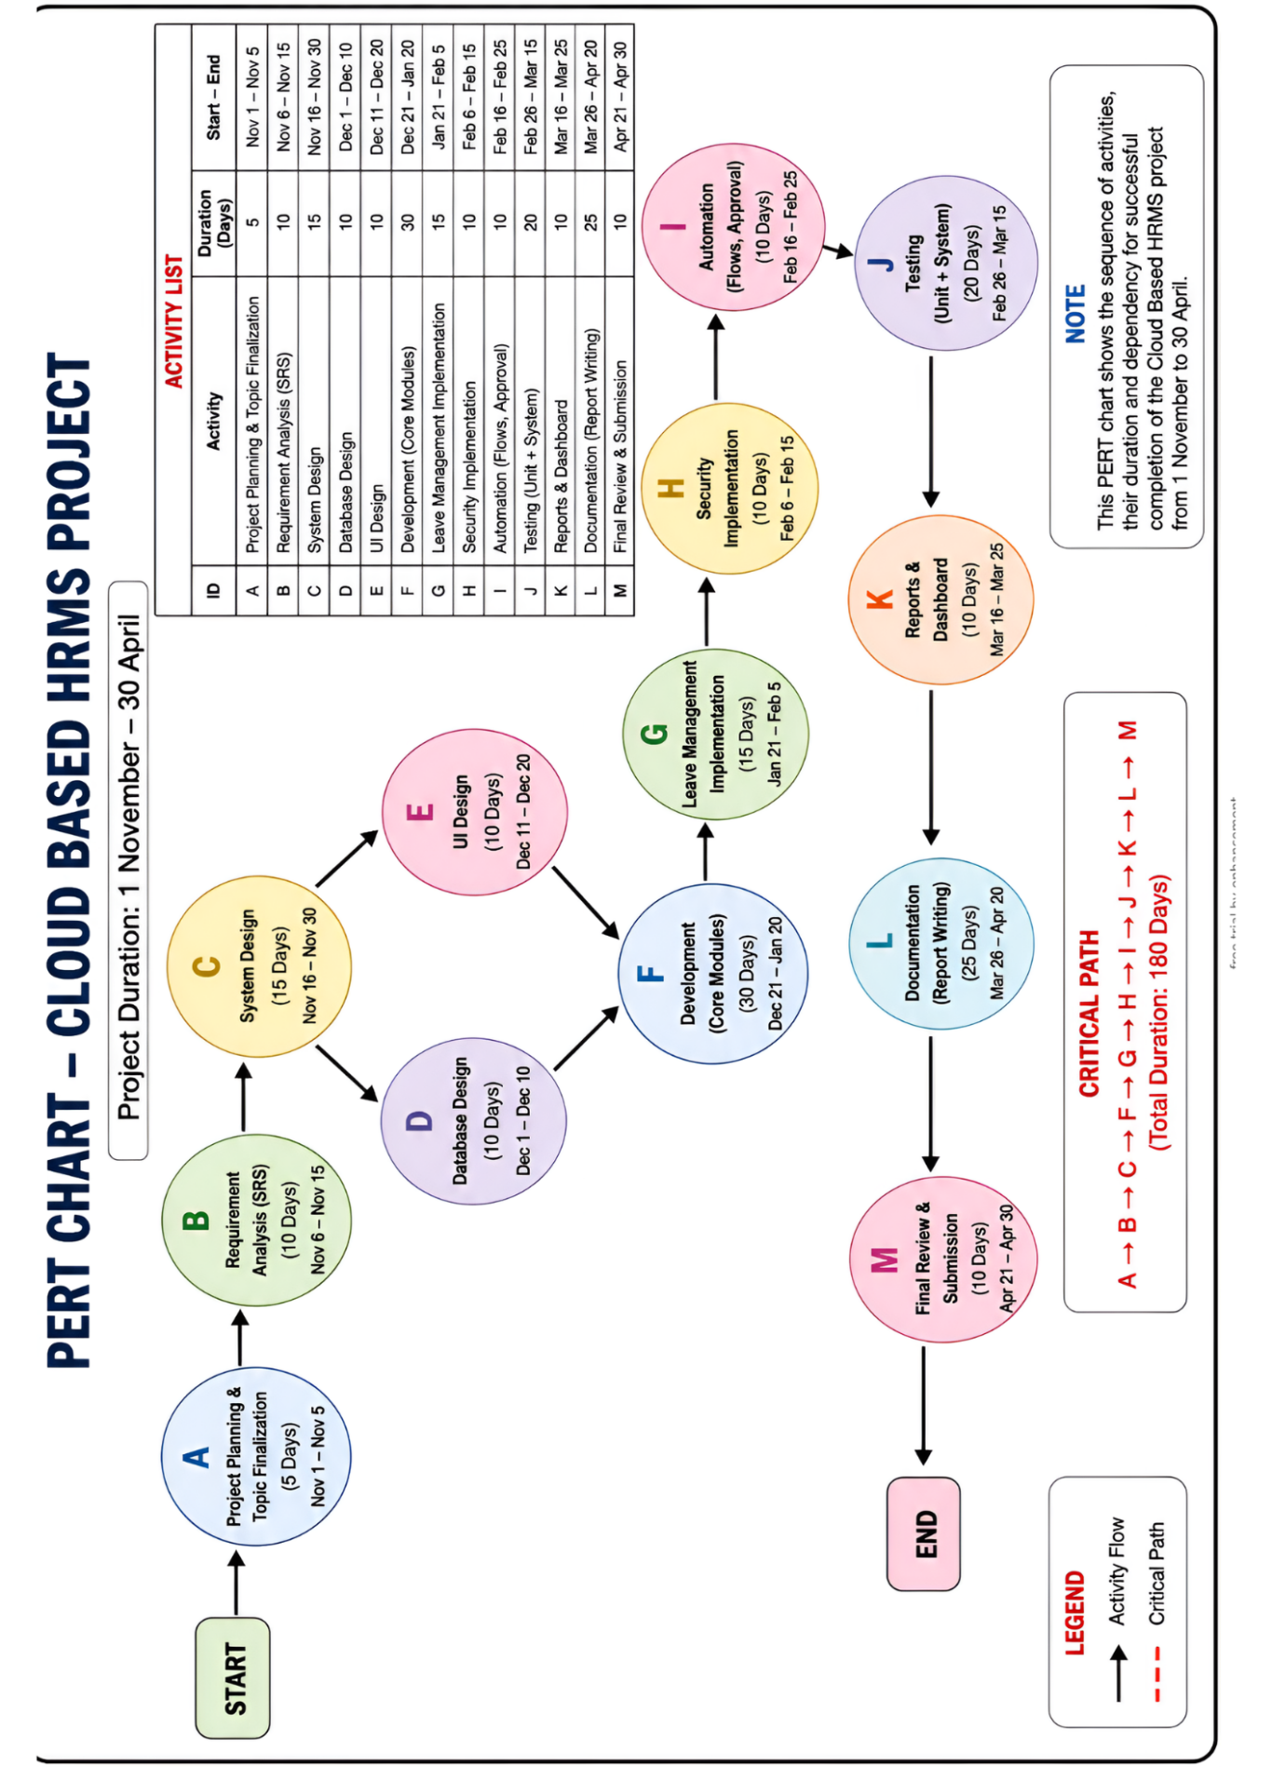

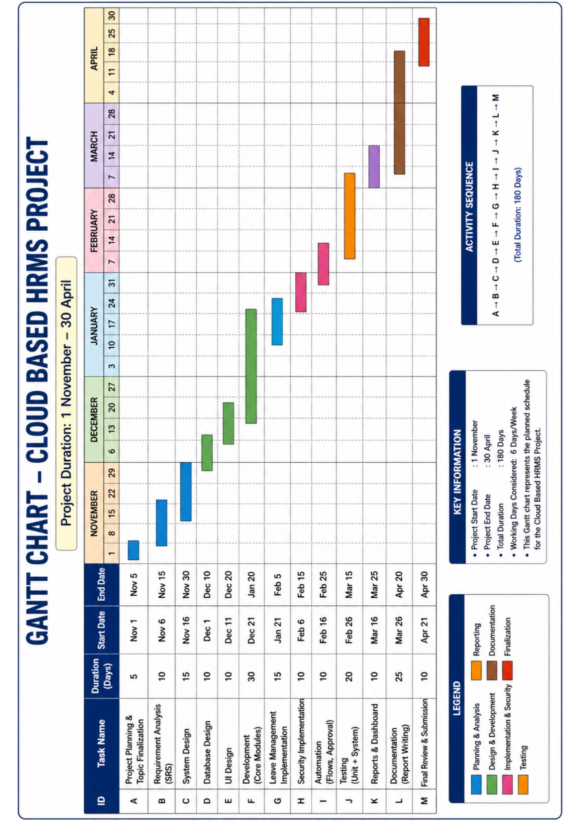

Software Requirement Specifications (SRS)
Software Requirement Specification (SRS) is a well-detailed document that gives specifications regarding the software requirements. The document provides an outline for the development process that gives developers guidelines for the design and development processes of the system. In regard to the Cloud-Based Human Resource Management System, the SRS document will contain all features and performance of the system. The document plays a critical role throughout the development process of the system.
Mainly, the aim of preparing an SRS document is to give details concerning the functionality of the system. The SRS document provides information about all functionalities of the system including the functionalities that make up the system's performance. The cloud-based HR management system is proposed as an employee management system that provides automated leave and role-based access. The proposed system has different modules including employee management module, leave management module, dashboard module, and security module.
In the SRS document, the first step is the definition of user roles and how they interact with the system. In this project, there are two main user categories, which are HR users and employees. User roles are determined by the privileges that they enjoy. HR users are allowed to have more power compared to other users. They can be used to edit records, approve or decline leave applications, and even print out reports from the system. Employees only have limited functions to perform such as making leave applications, checking their records and the processing statuses.
The functional requirements of this application involve what functions the system performs. This involves creating, editing and deleting records of employees, making leave applications, updating records of leave applications and generating relevant reports. Through the leave management function of the application, employees can be used to make applications for leaves, which are approved or declined by the HR department. Status updates of the applications are shown automatically. Users are also notified about different updates. Users are able to use the dashboards provided to view critical metrics.
The SRS not only states the functional requirements but also the non-functional requirements of the system. Non-functional requirements include performance, security, usability, and scalability. The system needs to have fast response times and multiple users concurrently using the system without compromising its performance. There will be security in the system through role-based access control. This means that data will be restricted by the roles of the users accessing the data. Users will be able to use the system effortlessly because of the ease of navigation in the intuitive user interface. Future enhancements like attendance management and payroll management can be included in the system, hence its scalability.
It is equally important for the SRS to outline the system constraints and assumptions. System constraints could include limitations with the Salesforce platform, including licensing and customization. Some of the assumptions would include the availability of the internet connection and the capability of the users to operate a computer.
The document outlines not only the functional requirements for the software but also its non-functional requirements. The non-functional requirements include performance, security, usability, and scalability. The system is supposed to work quickly and simultaneously serve several users without experiencing any loss in performance. The security of the information is assured through the use of role-based access control that gives access to information depending on roles of different users. Usability will be provided by means of developing an intuitive user interface making navigation around the system easy. Finally, it is important to consider the scalability of the system allowing for further enhancement of its functionality, such as integration of attendance tracking and payroll services.
One more aspect of the SRS to discuss is the system's constraints and assumptions. Constraints can be related, among others, to the platform itself (Salesforce). For example, there may be restrictions related to licensing and customizations of the software that are allowed within this platform. The assumptions may include availability of internet connection and knowledge of basic system operations.

Software Engineering Paradigm Applied
Software engineering paradigm can be defined as the methodology of software development process. The development lifecycle consists of phases and each of those phases is implemented according to the approach chosen by the project developers. The software development of Cloud-Based Human Resource Management System requires an organized approach in order to ensure efficiency and satisfaction of all users' requirements.
Main methodology adopted in the development of HRMS system is the Waterfall Model. The Waterfall Model is a sequential process used in software development. In the Waterfall Model, development takes place in a linear way where each stage must be accomplished before the next one can be undertaken. This includes system analysis, design, implementation, testing and deployment among other stages. This particular model of development is ideal for this project because of its nature.
System analysis was done in the first phase to determine the problems and requirements related to the conventional HR system. After the analysis, the second phase was system designing which involves the determination of the structure, data model, and interface. In the third phase, the system was developed using Salesforce with the help of its declarative and customization features. Finally, testing was done to make sure that the system fulfills all the requirements.
The Waterfall Model gives an organized procedure for development but this project applies both Waterfall Model and Agile methodology, especially in the development and testing phases. With Agile, modifications can be done as developers receive feedback from various people involved. In this project, iterations were performed during testing and development stages to enhance the performance of the system.
Using Salesforce reinforces this paradigm because of the rapid development and iterations that come along with using this software. Declarative tools like Flow Builder help developers develop their workflows without much coding. In addition to this, there are testing and debugging tools that help to improve and make sure that the system is reliable.
One more aspect that relates to the applied paradigm is the modular design principle. This means that the system is comprised of several modules, each serving a specific purpose. For example, there are modules for employee management, leave management, dashboarding, and security. Every module is created independently from others, which helps with organizing and maintaining the system.
Finally, the project adheres to best practices in software engineering through documentation, version control, and testing. Documentation allows for systematic recording of all system elements so as to make understanding and maintenance easy. Various tests are undertaken at various stages to ensure any bugs are sorted out and the end system is reliable and efficient.
To sum up, the Cloud-based Human Resource Management System is designed on the basis of a combination of the Waterfall model and Agile practices. In this way, the project strikes a balance between rigidity and flexibility, thus allowing for a systematic development process while improving the design continuously. The choice of Salesforce as the platform for developing the project makes the adoption of the paradigm more effective.

  - Data models
Entity Relationship Diagram (ER Diagram)
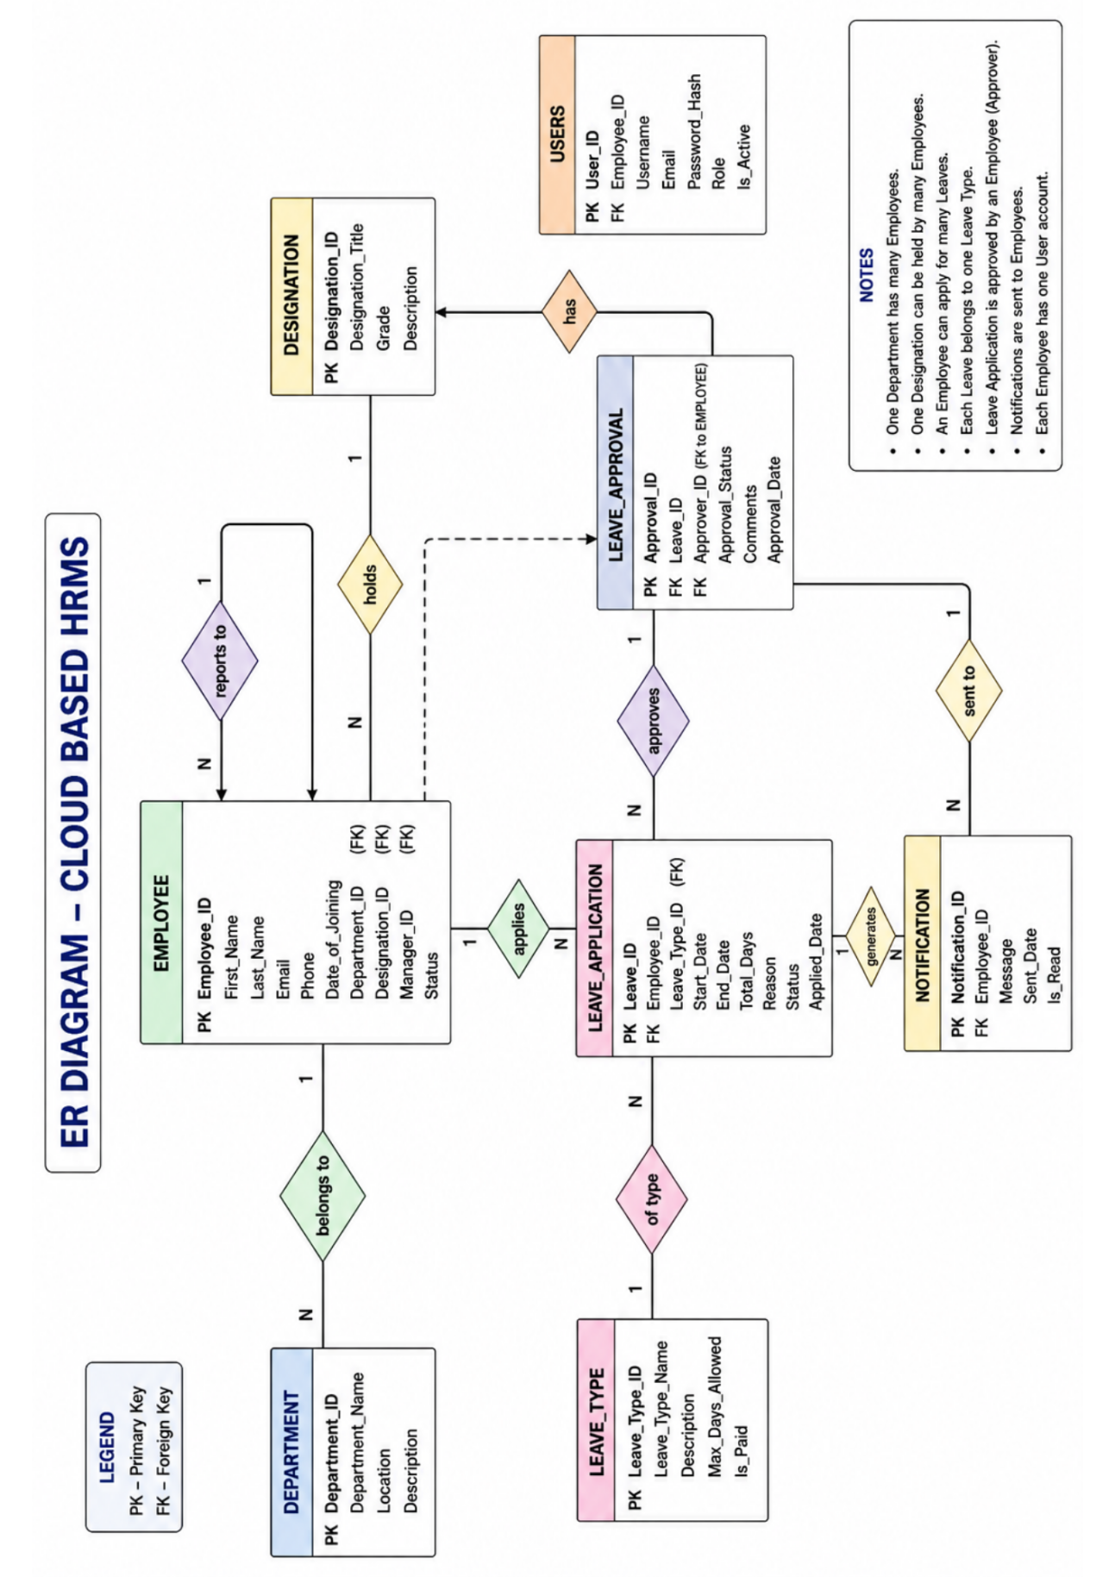

Data Flow Diagram (DFD)
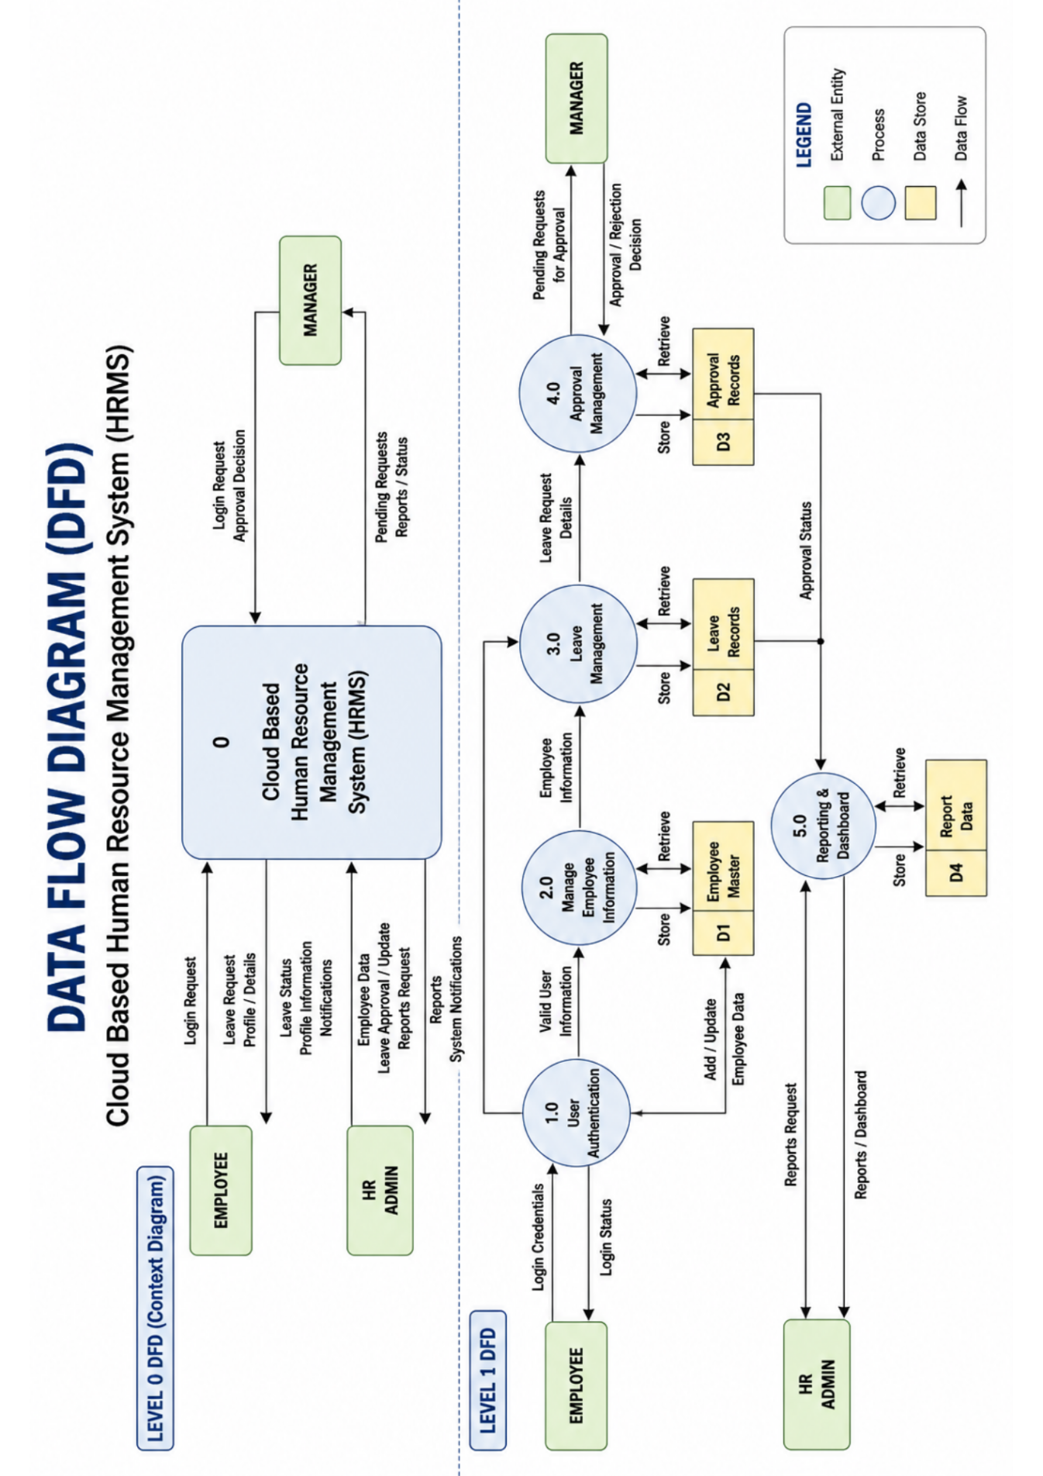
Use Case Diagram
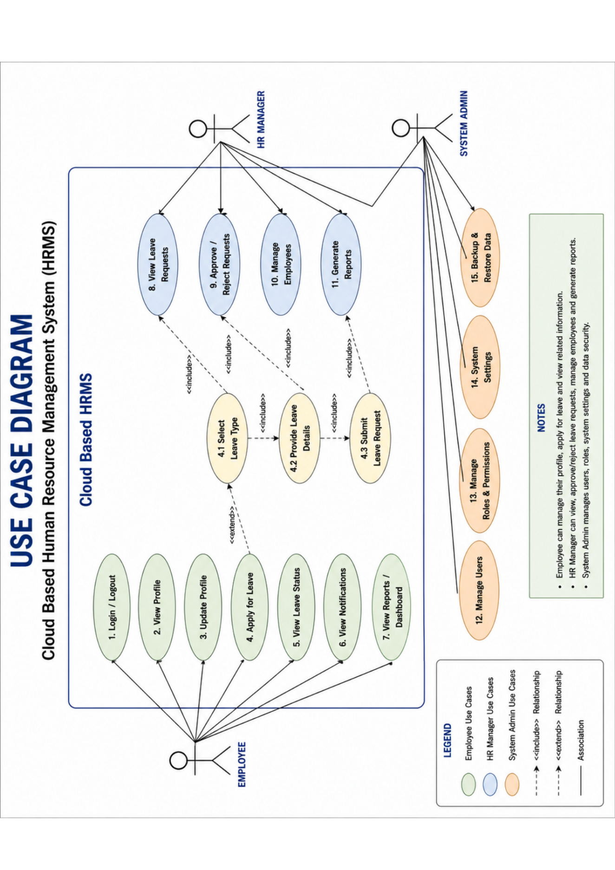

Activity Diagram

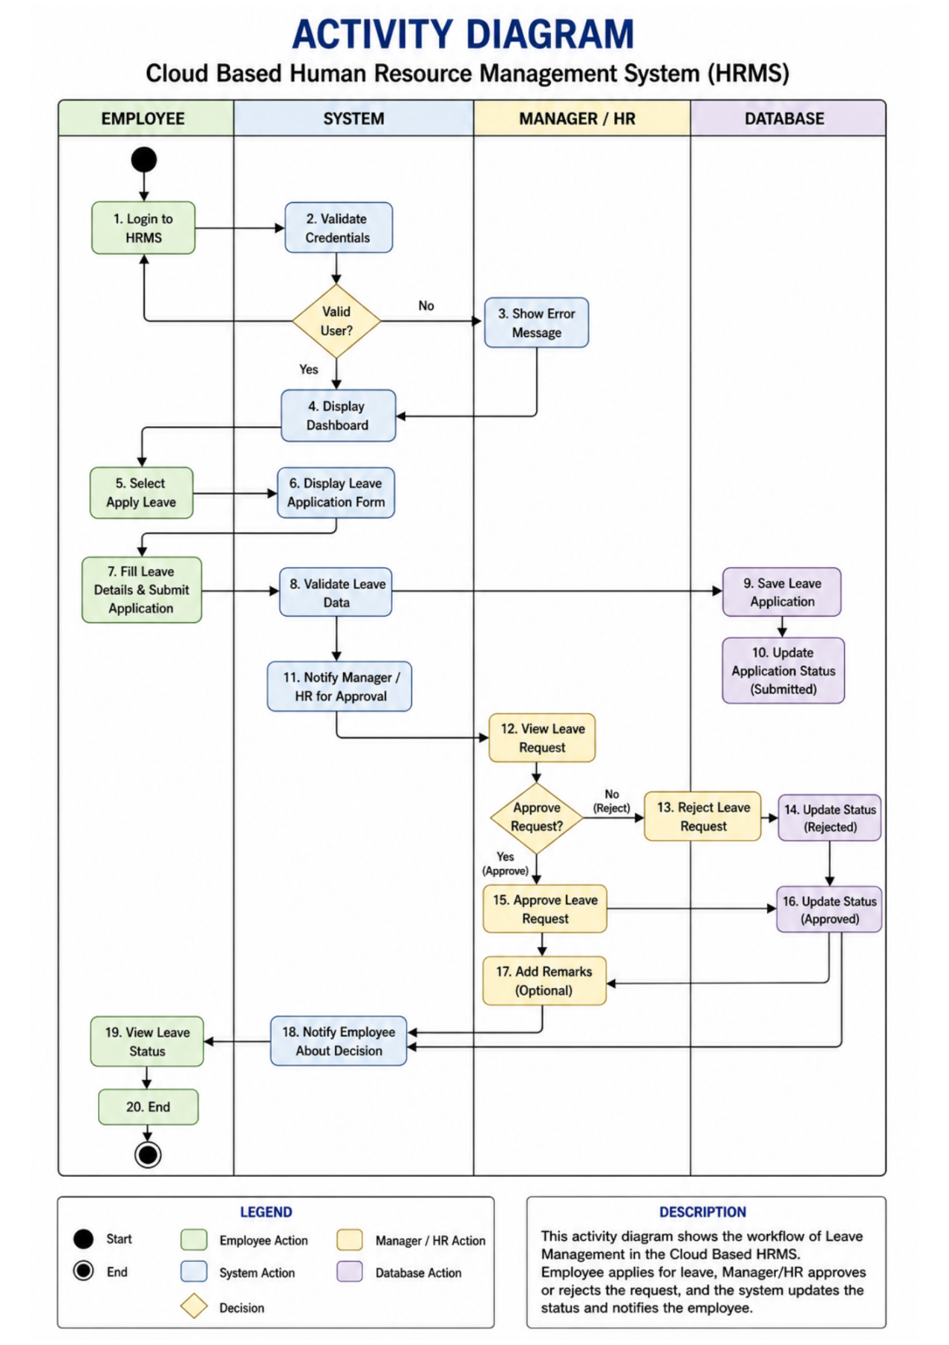

System Design
System design is an essential stage in software development since it determines the manner in which the system will be designed and its components will work in tandem to satisfy the intended needs. In Cloud Based Human Resource Management System, system design entails designing an effective and scalable system that helps facilitate various activities related to HR management, including employee administration and leave handling. The system has been built in such a way that enables easy interaction between various modules and the users.
The application uses Salesforce platform, which provides a cloud-based environment for development of enterprise level applications. One of the features of the system is its multitenancy feature, which allows several people to use the system at the same time.
The architecture of the system relies on a hierarchical design pattern where the system has the presentation layer, the application layer, and the data layer. The presentation layer includes the user interface and relies on Salesforce Lightning Components for development. The presentation layer helps create the responsive and interactive user interface through which the users can execute functions including apply for leaves, view dashboards, and manage employee data. The application layer focuses on handling business logic, automation, and approval processes. Some of the application layer tools include Flow Builder and Approvals.
Role-Based Access Control is one of the most crucial elements of the architecture in the system. In the system, users get different permissions depending on the roles of those users. The role-based access control helps to improve usability and enhance the security of the system. For instance, the HR users have broad access rights while the employee users only have access rights to their own records.
Automation is also an integral part of the system for efficiency purposes in the HR processes. Flowcharts and workflows will be employed for automating functions like leave application approval, notifications, and updating relevant data. This process helps save time and makes the execution of these processes efficient and reliable. The system is designed in a way that allows for easy integration of these automated processes with the other parts of the system.
Scalability is another crucial aspect that must be considered when designing the system. It must be designed in a manner that would allow for future enhancements like attendance, payroll management, and self-service portal functionalities for employees.
To conclude, the design of the Cloud Based HRM System has been presented in a framework that combines the UI, Business Logic and Data management. The combination of the features provided by Salesforce leads to an optimal balance between functionality, efficiency, and security.

  - Modularisation Details
Modularisation involves breaking down a system into smaller units called modules, each with a unique functionality. Modularisation helps in organizing a system, making it easier to develop and maintain. Modularisation is an essential part of the Cloud-Based Human Resource Management System because it helps divide the system into modules that can be developed and maintained separately.
There are several modules within the Cloud-Based Human Resource Management System, each performing distinct functions. The first module is the Employee Management Module. It handles all the aspects related to employees. Some of its functionalities include adding new employees, updating their details, setting up their roles and departments, and linking them to user accounts.
The second module to be analyzed is the Leave Management Module that controls the processes related to the leave application and approval. All employees will be able to apply for leaves using the online platform, and these requests will be then forwarded to HR representatives. This module will automate all the leave management tasks, including updating the status of applications. The advantage of using the modular architecture is that all functions related to the leave management will be concentrated in one place.
Moreover, another significant module used in our platform is the Dashboard and Reporting Module. It will provide valuable data about organizations, generate reports, and create visual dashboards to represent data. They include the number of total employees, statistics about their leaves, and departments' distribution among others.
The Security & Access Control module deals with user permissions and data access. The module applies role-based access control through profiles, permission sets, and role hierarchy. Sensitive data can be secured while making sure that users have access to data related to their roles.
Another module in our system is the Automation module. This module takes care of workflow automation and process management using Salesforce automation tools such as Flow Builder. This allows processes like approval requests and notifications to be automated without mixing up automation logic with other modules.
Advantages of modularization include several aspects in the current project. First, modularization enables developers to concentrate on separate components without having to affect the whole system, thereby increasing efficiency in development. Additionally, testing will become easier, since it will be possible to test each module separately. In addition, scalability is supported through the possibility of adding modules without interfering with the existing functions.

To conclude, modularization is an important element of system architecture, which allows developing a highly organized HR management system.

Data Integrity and Constraints
Data integrity can be defined as the condition wherein data contained in the storage is accurate, consistent, and reliable. The Cloud-Based Human Resource Management System requires that the data be consistent to avoid errors that might arise from inaccurate or inconsistent data. Constraints are conditions that govern how the data in the system should be formatted.
The data in the system is managed to maintain its integrity through controlled data inputting processes. Data types are used to ensure consistency in the data inputted into the system. For example, data types can be used to determine the acceptable range for the input field. For instance, when submitting a leave application form, one must indicate the starting and ending dates for the leave period. Furthermore, the ending date must always be later than the starting date.
Another key aspect of data integrity involves the existence of relationships among objects. Within the system, user-defined objects like Employee__c and Leave_Request__c are related to each other via lookup relationships. The relationships help to maintain logical consistency among the data as well as provide references from one record to another. For instance, each leave request would be associated with a particular employee.
Constraints regarding the data that a user can see and edit depending on his/her role in the organization are put in place to provide access control and protect sensitive data from unauthorized edits. Employees will not be able to edit records for other employees, whereas Human Resource staff will have greater access to the data.
Consistency in data is also ensured by automation. The workflows and flows make sure that data is updated consistently throughout the application. For instance, once a leave application is approved, the system automatically updates the employee’s leave balance. Automation minimizes inconsistencies in data and makes sure that all data is consistent.
The other constraint involves ensuring uniqueness for some of the fields. For example, the employee ID number cannot be repeated in the system because only one employee can have that number. This is enforced using the uniqueness option for fields and validation rules that do not allow for duplicates.
The third constraint involves data security and protection from data breaches. Data should remain protected at all times to maintain its integrity and confidentiality. Features such as data backup, auditing, and data encryption are offered by Salesforce.
Data integrity and constraints form an important part of the cloud-based HRM system. Through validation, relationships, and automation, data integrity is ensured, and this increases accuracy and security. This is important for ensuring that decisions made using the information obtained from the system are sound.

Database Design
Database design is an essential part of software development because it determines how data is modeled, managed, and accessed. As for Cloud-Based Human Resource Management System, it should be noted that the system was built with the help of Salesforce, and this platform offers a robust database design that allows users to work with information efficiently and effectively.
Salesforce uses the concept of objects, fields, and relationships to store and manage data. Objects may be considered equivalent to tables; fields are similar to columns; and relationships can be compared to foreign keys in the context of relational databases. Both standard and custom objects are used to manage and store information in the database. For example, the cloud-based human resource management system utilizes a custom object called Employee__c to store all information related to company employees. It should be emphasized that this object contains such information as the employee name, email address, department, and designation.
Thus, it is important to note that the Employee__c object allows users to store information about each employee of the company. This information may include, but not limited to, the employee's name, email address, department, and designation.
Yet another significant entity would be the Leave_Request__c entity, which will help in managing the process of applying for leave. This entity would have several fields like leave type, start date, end date, reason for leave, and approval status. All the leave requests would be related to an employee using a lookup relationship, making sure that all the leave requests get associated with the right employee. This relationship would play a significant role in helping us manage our database effectively.
The User entity from the standard objects of Salesforce is also used in our application. The relation between the Employee__c object and the User object enables linking of every employee to his/her respective user account in the system.
The connection between objects is extremely important in the database design. Mostly, the use of lookup relations is employed since it provides more freedom when associating objects without being dependent on them. The use of relations makes it easy to manage the database. For example, leave requests can either be standalone or attached to employees' data.
In order to make sure that the entered data is accurate, there should be data validation rules incorporated within the design. These rules help in making sure that certain data requirements have been met. For example, a leave application cannot be made without the relevant dates being provided.
The database is also designed to support efficient retrieval and reporting of information. Optimized indexes and query methods will make it possible to extract data fast, which is essential when preparing reports and dashboards based on real-time and up-to-date data.
Another important aspect that plays an important role in the database design is scalability. It refers to the capacity of the database to grow further by integrating new objects and relationships within the existing structure. Thus, for instance, it is easy to implement such modules as attendance management or payroll into the existing database design.
Thus, the cloud-based HRM system utilizes a very efficient database design, thanks to which all data stored within the system can be managed effectively. Based on Salesforce technology, the object-oriented approach makes it possible to ensure effective data storage and relationships between all entities and high levels of data integrity.

User Interface Design
User Interface (UI) refers to the method in which the user interacts with the application. UI is an important element of any software development since it plays a significant role in increasing usability and ensuring that users perform activities easily and effectively. In the case of the cloud-based HR management system, the User interface is designed to meet the needs of HR personnel and employees.
The use of Salesforce enables the creation of applications with a very dynamic UI. Salesforce uses Lightning Experience that provides a modern user interface platform to support development. With lightning app builder, one can develop a user interface by creating personalized pages and layouts without writing codes extensively.
Simplicity is an important principle in the design of the user interface. The interface is arranged in a way that users can easily navigate. For example, features like Employee record, leave requests, and dashboard are available in the interface in such a way that users can access them بسهولة.
Moreover, the UI design also includes the ability to customize the interface based on role. It provides HR users and employees with different views depending on the specific roles of these people within the company. In other words, HR users will be able to see only those parts of the application, which allow them to perform certain functions related to managing employees and processing applications. As for employees, they can see only information about their personal accounts and submit applications for leave.
The proposed user interface design also allows displaying some information using various charts, graphs, and panels containing summaries. For instance, one can view some basic facts about the number of employees in the company, leave status, etc. Such an approach helps to analyze large amounts of information quickly and easily.
Finally, the interface design includes forms and fields for entering data, which are developed considering usability aspects. Specifically, they contain clear labels, validation messages, and proper structuring. For instance, the form, which allows applying for leave, contains several input fields for specifying leave dates, its type, and the purpose of the leave request..
Another crucial aspect of the UI design is responsiveness. The system can be accessed through desktop computers, laptops, and other devices including mobile phones and tablets. In addition, the UI design supports responsiveness and therefore users can use the system regardless of where they are at any time increasing their productivity.
Consistency and standardization have been considered in the designing process. Elements like buttons, icons, and layouts have been used in a consistent manner within the system. This will make the users familiar with the user interface and therefore increase ease of use.
In addition, accessibility has been incorporated in the process of designing the system. In other words, the user interface has been designed to facilitate the use by people with different technical knowledge the cloud-based human resource management system user interface design is all about simplicity, ease of use, and responsiveness. Through the use of Salesforce Lightning features, the user interface becomes more sophisticated and functional, making interactions between users much easier. The design makes it possible for HR staff and employees to accomplish their work seamlessly.

Testing
Testing is an essential part of the software development life cycle process, which is used to check whether the system works as intended, fulfills users' expectations, and is not erroneous. In this cloud-based Human Resource Management System, testing will be done to check whether all modules such as employee management, leave management, dashboards, and security work as intended. Testing in software development aims at identifying defects, ensuring reliability, and checking that the system is performing effectively.
In this software development project, testing is conducted systematically, starting with individual elements up to the entire system. Testing is mainly aimed at verifying that each feature meets the requirement specifications provided in the Software Requirement Specification (SRS). In addition, testing will also entail validating whether the flows, approvals, validation rules, and roles work correctly since the system is built using Salesforce.
Among other things, testing should guarantee that user interaction with the application is flawless and does not produce any errors. For instance, once an employee enters data on leave, it will automatically be saved in the database, the approval process triggered, and the status updated. In addition, HR specialists should have no problems either approving or rejecting leave requests.
Ensuring data accuracy and consistency is another goal that should be achieved through testing. The system should guarantee that any information introduced into the database by a user will be saved and that relations between different objects will remain intact. Moreover, validation procedures are also tested to ensure that no erroneous data is accepted.
The performance of the system is another aspect that should be tested to prove its effectiveness. As a cloud-based solution, the program is expected to operate flawlessly even when accessed by multiple users at once.

Testing Techniques and Testing Strategies Used
Testing approaches and methodologies include the methods utilized for assessing the system's quality and effectiveness. The approach used to test this particular system involves a variety of testing methodologies to ensure that the functionality and efficiency of the system are adequately tested.
The first testing methodology used is unit testing, which is carried out by testing different parts or modules of the system separately to ensure that each works effectively on its own. This includes testing employee management and leave management individually. For instance, leave application can be tested to determine whether it works with valid inputs while it does not work with invalid inputs.
Integration testing is another key testing technique that tests how the modules interact with each other. In the current system, the integration test would be conducted to make sure that the employee module and the leave management module work properly and trigger their workflows as intended. For example, when an employee applies for leaves, then this application should be linked with that particular employee.
Finally, System testing can be used to test the entire system altogether. System testing includes testing the entire system with all the functions put together. This testing This test technique is carried out to ensure that the system functions as intended.
Black Box Testing technique is also employed in this project. In this technique, testing is done without taking into account the internal structures of the source code. The emphasis here is on input and output. This means that the tester determines whether the appropriate output is produced by examining the input. For instance, when an employee submits a leave application, the appropriate output must be produced.
The other technique involved in this project is known as User Acceptance Testing (UAT). This test technique entails the testing of the system from a user's perspective. It is conducted using HR employees and normal employees (as test users).
The process of automation testing is partly done by Salesforce features such as validation rules and flows. The automated tests run to ensure they trigger and execute the required actions. This is tested to ensure the correct functionality of emails and status updates.
It can be noted from the above discussion that unit testing, integration testing, system testing, and user acceptance testing offer an overall testing process for the Cloud-based Human Resource Management System.

Test Reports for Unit Test Cases and System Test Cases
Test report generation is extremely important as it helps in recording the outcome of the test and proving that the system is working according to the necessary criteria. Test reports are generated for unit tests and system tests in the Cloud-Based Human Resource Management System to ensure that all system functions are tested properly.
Unit Test Case refers to testing of different modules separately. The module of employee management is tested in this way. In order to check if employee records can be generated, modified, and deleted, the necessary test cases are created. These tests are carried out using certain data, which is then compared to the expected output.
Similarly, leave management module will be tested using unit test cases. Unit test cases check if leave applications are successfully made, validation rules are enforced, and the appropriate status update is made on applications. The test case will include information such as test case ID, test case description, test data, expected output, actual output, and test case status.
In System Test Cases, the entire software will be tested as a single unit. An example of a system test case would be if an employee makes a leave application, HR approves the application, and the system updates the employee's leave balance.
Test cases also consider scenarios involving security and access control. Tests would be performed to ascertain whether employees can access or alter other employees' data, but HR staff can access the necessary data.
Test cases related to performance of the system are also captured within the test reports. This is through the use of performance testing where the system is analyzed when subjected to different conditions like the number of users that can be concurrently using the system.
The test reports are prepared in a manner that captures information regarding the testing process. Such documentation serves as proof that the system has been adequately tested and is therefore ready for deployment after solving problems arising from the process.
In summary, test reports are an essential part of testing the Cloud-Based Human Resource Management System. The report documents the unit test cases and the system test cases in order to ensure that the system works effectively as per expectations.

System Security Measures (Implementation of Security for the Project Developed)
The security of a system is a very important part of any system that will deal with any confidential information in any way, specifically Human Resource Management Systems. The Cloud Based Human Resource Management System uses employee data such as personal information, leave details, and data about the organization. As such, security is very important in ensuring that no one else apart from authorized persons accesses the data. In our project, we have used Salesforce security capabilities in implementing the necessary security features.
One of the main ways in which security is provided is through authentication. All users must authenticate themselves before accessing the Human Resource Management system. Authentication takes place through the entry of a unique set of credentials that includes a username and a password. Apart from username and password, there are other security aspects used in the process.
Also, another very important element of the security implementation is the authorization process, where it decides about the user's capability to do something in the system. It can be done with the help of profiles and permission sets, which establish access level. In the case of our project, there will be different profiles for HR employees and regular employees. For instance, HR employees will have access to records of other employees, their permission to approve leaves and access some reports, but regular employees can access their personal record and apply for a leave. Permission sets provide a possibility to expand permissions when needed without changing the profile itself.
Role-based access control is performed with the help of role hierarchy feature, which allows accessing information according to their role. Thus, HR employees will be able to view records of any employee, while regular employees can see only their own records.
Moreover, there are security sessions and limitations on logging in order to increase the security of the system. Session timeout, IP address restrictions, and login hour restrictions are used to limit access to the system and decrease the chances of any security threats to appear.

Furthermore, the application has security measures according to the existing standards. Thanks to its integration with the secure infrastructure of Salesforce, regular updates and vulnerability management as well as compliance with the existing industry standards have become possible.

To conclude, the Cloud-Based Human Resource Management System has numerous security measures implemented for protecting all the information within the system as well as making sure that the system operates safely. Due to the use of the Salesforce secure system, there are many security measures available to protect sensitive data and improve the reliability of the system.
- Project Cost Estimation including Cost Estimation Model
Cost estimation is an important aspect that needs to be considered during the development process of software projects because it enables the determination of resources, time and costs associated with the completion and maintenance of a system. In relation to the Cloud-Based HRMS, cost estimation gives an insight into the costs of designing, building, deployment, and maintenance of the system. As mentioned previously, the project is based on Salesforce technology; therefore, its cost estimation differs from other projects since it relies on licensing, development efforts, and operations as opposed to hardware costs.
Cost estimation of the project can be divided into three main areas – development cost, operational cost, and maintenance cost. Development cost consists of all the costs of building the system, such as custom object creation and configuration, workflow management, and automation. The operational costs refer to the cost of using the platform for which the project is designed, such as Salesforce and internet connectivity costs.
The human resource cost is yet another vital consideration for cost estimation. Developing the system requires time and effort from the developer, such as system analysis, design, implementation, and testing. Even though this system is developed as part of an academic task, in a real-life scenario, there will be costs incurred from developers, testers, and administrators, among others. The cost is estimated based on the amount of time required to develop the software multiplied by the hourly salary of the people involved.
Licensing is another critical aspect of the cost estimation for the project. Salesforce adopts a subscription license model that allocates licenses to different user levels based on their roles. As an instance, HR personnel might require Salesforce licenses, but employees might only need platform licenses. This subscription model is flexible since organizations can adapt to their needs when using the system.
One more point regarding the cost estimates is the price of tools that will be used during the process of creation of the application. As Salesforce itself gives users some built-in tools like Flow Builder or Lightning App Builder, additional costs of development tools will be minimized.
However, indirect costs should also be considered as part of total costs. For example, some costs can appear due to the necessity to train people on using this system or due to difficulties in adopting the application. Even though Salesforce has quite user-friendly interface, training is always needed to use it properly.
Model for Cost Estimation Adopted
The model adopted in this project involves the adoption of the simple form of the COCOMO model for cost estimation purposes. The COCOMO model is a well-known method in software engineering, used to determine the effort and cost estimation based on project size and complexity.
Using the COCOMO model, the effort involved in developing the system will be:
Effort (Person-Months) = a × (KLOC)^b
Where:
KLOC stands for Lines of Code in thousands
a and b are constants depending on the nature of the project.
Considering that the project is quite simple and developed using the cloud computing platform without much coding, it is categorized as the Organic mode in the COCOMO model. This means that the constants for this model are likely to be:
a = 2.4
b = 1.05
Then the development period will be:
Development Time = c × (Effort)^d
Where:
c = 2.5
d = 0.38
Even though the amount of effort spent in the coding process in Salesforce is minimized due to the use of declarative development tools, the model gives some sort of approximation regarding the efforts required.
Total cost is arrived at by multiplying estimated effort and cost per person month. In case of an academic project, this cost is conceptual, but in a real-life situation, this cost would be the cost of employing or paying salaries to the developer(s).
In conclusion, the Cloud-Based Human Resource Management System is economical and affordable. Utilization of Salesforce in this system lowers costs in terms of development and infrastructure and provides an economical approach of building software systems. The application of the COCOMO model makes estimation of effort and time easy, hence efficient planning of the project.
- Reports
The main function of reports in the current system is to transform data into meaningful information. The Human Resources department usually handles large amounts of data related to the employees in the company. Without proper analysis tools, the data may become overwhelming for HR managers. In the current system, the reports are created to organize data in a readable way and make it easy to analyze and interpret.
The Employee Report is one of the reports produced by the system. It contains information on all employees of the company. Such information includes names, departments, positions, and contact information of employees. The report is used to keep an overall record of the workforce in the company. It can be sorted by various parameters like department and position.
There is also the Leave Report, which captures all the leave applications submitted by the employees. The report provides information on various attributes including the type of leave requested, dates, approval status, and personal data related to the employee. The report is very helpful in enabling HR managers to keep an eye on the trend and patterns related to the leaves taken by the workers. Besides, employees can also access the report in order to know about their past leaves and check on their pending requests.
The software also creates the Pending Leave Requests Report that captures all the applications that are yet to be approved. This particular report will be highly beneficial for the HR officers who will be able to use it in managing their work.
Yet another important report available is that of Department-wise Employee Distribution Report, which highlights the number of employees present in each department of the organization. This report helps the management understand the organizational structure and helps them know where their resources are over-utilized and where they are under-utilized.
Alongside the above-mentioned basic reports, there is support for custom report generation as well, wherein the user can prepare reports based on their own requirements. The system of Salesforce is quite flexible when it comes to the preparation of customized reports, as users are allowed to apply filters, classify, and summarize their reports as per their convenience.
Finally, there is an option to incorporate the prepared reports into dashboards, which help visualize the information provided in the reports through the use of charts and graphs. This makes the understanding of the reports much easier as well. For instance, the dashboard can contain information regarding the total number of employees in the organization, leave statistics, department-wise distribution of the employees, and so forth.
Security is another critical factor when it comes to creating reports. The system ensures that the user is able to access only those reports that relate to their job description. For instance, employees will be able to see their leave reports, while HR managers will be able to see organizational reports. The system is, therefore, able to maintain data confidentiality.
Another benefit associated with the use of the reporting system is that it allows for real-time data update. Given that the system operates online, any changes done to the data will reflect immediately in the report generated by the system. The end result is that the user will always be able to access the most up-to-date information.
Additionally, it is worth noting that the report generated using the system can be easily exported into various file formats such as PDF and Excel files..

Future Scope and Further Enhancement of the Project
This Human Resource Management System that has been designed and implemented in this project serves as an excellent basis for the management of employee details, leave process, and workflow in any organization. Like any other software application, however, the system may be enhanced in various aspects as there are more and more advanced technologies being introduced every day as well as changes in the requirements of business companies. Such future enhancements would not only add to the functions of the existing software but also allow it to operate in real-life conditions.
Firstly, a significant enhancement would be the integration of an Attendance Management System into this package. At the moment, the main focus is made on the recording of information related to employees and leave management. The introduction of the Attendance Management Module will add extra functionality to the existing system, making it an HR package capable of monitoring daily activity of workers in terms of arriving and leaving at workstations.
Other enhancements that need to be made include developing the Employee Self-Service Portal on the platform of Salesforce Experience Cloud. The portal will enable employees to log into the system without necessarily interacting with HR officers, update their profile information, apply for leaves, and generate various kinds of reports. All these will enhance the user experience, reduce the workload for HR employees, and increase transparency.
A Payroll Management Module should also be considered for incorporation into the existing application. With such a module, there will be automated processing of salaries through deductions and calculation, as well as creation of payslips. Payroll management will help to incorporate all the data gathered from the leave and attendance management sections of the application. This feature will ensure that the application becomes a comprehensive HR solution.
Another feature worth adding in future versions of the application includes the use of advanced analytics and reports. Even though the application currently generates some kinds of reports and dashboards, it may include predictive analytics capabilities in the future versions. Predictive analytics will aid in predicting the requirements of the workforce in relation to employees' leaves and attendance patterns.
The inclusion of the mobile application is yet another positive improvement. Although Salesforce has mobile capabilities, a separate mobile app might provide a more tailored and user-centric interface. This way, the employees and HR department staff would be able to gain access to the system on their phones, be notified promptly about certain events, and complete various actions remotely. The system would become more convenient since it would be accessible at all times.
One more aspect that should not be neglected concerns security. Various improvements, including MFA and biometric options, can be implemented here. It would provide users with the extra security layer, which would help protect employees' data from any malicious activity.
Another thing to look out for is the connection between the system and third-party systems and APIs. It will be possible to connect the system to other applications within an organization, like accounting software, recruitment software, and communication software. Such connections will allow for easy data transfer and increase efficiency across the organization. Connecting to email services, for instance, will facilitate communication between employees and HR departments.
There could be improvements made in regards to using Artificial Intelligence and Automation within the system. AI and automation features could allow for automatic performance analyses, employee query answering through chatbots, leave recommendation based on historical data, among others. AI will save time and make the system more efficient.
As far as scalability goes, it is also essential to look into the future. As the organizations will continue growing and gaining more employees, the system will need to be scalable enough to handle all that user traffic and data efficiently. Fortunately, Salesforce is a cloud-based solution that can be easily scaled up.
Finally, the user experience may be improved through modifications of the interface and adding new functions depending on feedback. Such continuous updates and improvements will keep the system up-to-date and effective. The inclusion of comments made by HR professionals as well as employees themselves will contribute greatly to the identification of areas that require improvements.
Overall, it may be said that the presented Cloud-Based Human Resource Management System possesses great opportunities for further development and advancement. Additional modules may be added, automation processes may be increased, and more sophisticated technology used. It is evident that all of these steps will contribute significantly to the value of the system and its ability to meet future requirements.

- Appendices
  - Coding
Classes file :
EmployeeController.cls
public with sharing class EmployeeController {
@AuraEnabled(cacheable=true)
public static List<Employees__c> getAllEmployees() {
return [
SELECT Id, Name, Emails__c
FROM Employees__c
];
}
}

LeaveController.cls
public with sharing class LeaveController {
@AuraEnabled(cacheable=true)
public static List<Leave_Request__c> getLeaves() {
return [
SELECT Id, Name, Status__c, Employees__r.Name
FROM Leave_Request__c
];
}
@AuraEnabled
public static void createLeave(String reason, Id empId) {
Leave_Request__c l = new Leave_Request__c(
Name = reason,
Status__c = 'Pending',
Employees__c = empId
);
insert l;
}
@AuraEnabled
public static void approveLeave(Id leaveId) {
Leave_Request__c l = [
SELECT Id, Status__c
FROM Leave_Request__c
WHERE Id = :leaveId
];

l.Status__c = 'Approved';
update l;
}
@AuraEnabled
public static void rejectLeave(Id leaveId) {
Leave_Request__c l = [
SELECT Id, Status__c
FROM Leave_Request__c
WHERE Id = :leaveId
];
l.Status__c = 'Rejected';
update l;
}
}
PayrollController.cls
public with sharing class PayrollController {
@AuraEnabled(cacheable=true)
public static List<Payroll__c> getPayrolls() {
return [
SELECT Id, Name, Base_Salary__c, Deductions__c, Net_Salary__c, Employees__r.Name
FROM Payroll__c
];
}
}
LWC componet file
MainDashboard
mainDashboard.css
:host {
background: #f4f6f9;
display: block;
padding: 10px;
}

/* SECTION BOX */
.section-box {
margin: 25px 20px;
padding: 20px;
background: #ffffff;
border-radius: 12px;
box-shadow: 0 3px 10px rgba(0,0,0,0.08);
border: 1px solid #e0e0e0;
}

/* HEADINGS */
.section-box h2 {
margin-bottom: 15px;
color: #2c3e50;
}

/* CARDS */
.card {
background: #f9f9f9;
padding: 15px;
margin-bottom: 12px;
border-radius: 10px;
box-shadow: 0 2px 6px rgba(0,0,0,0.1);
}

/* COLORS */
.employee-card {
border-left: 5px solid #0070d2;
}

.leave-card {
border-left: 5px solid orange;
}

.payroll-card {
border-left: 5px solid green;
}

/* TEXT */
.name {
font-weight: bold;
font-size: 16px;
}

.email {
color: gray;
}

.net {
color: green;
font-weight: bold;
}

/* HOVER EFFECT */
.card:hover {
transform: translateY(-2px);
transition: 0.2s;
box-shadow: 0 4px 12px rgba(0,0,0,0.15);
}
.btn-space {
margin-top: 15px;
margin-bottom: 20px;
display: inline-block;
}
lightning-input,
lightning-combobox {
margin-bottom: 10px;
}
mainDashboard.html
<template>
<lightning-card title="🚀 Employee Management System">

<!-- 👥 EMPLOYEES -->
<div class="section-box">
<h2>👥 Employees</h2>

<template for:each={employees} for:item="emp">
<div key={emp.Id} class="card employee-card">
<p class="name">{emp.Name}</p>
<p class="email">{emp.Emails__c}</p>
</div>
</template>
</div>

<!-- 📝 LEAVE -->
<div class="section-box">
<h2>📝 Apply Leave</h2>

<lightning-combobox
label="Select Employee"
options={employeeOptions}
value={selectedEmployeeId}
onchange={handleEmployeeChange}>
</lightning-combobox>

<lightning-input
label="Reason"
onchange={handleChange}>
</lightning-input>

<lightning-button
label="Apply Leave"
variant="brand"
class="btn-space"
onclick={submitLeave}>
</lightning-button>

<h3>📋 Leave Requests</h3>

<template for:each={leaves} for:item="l">
<div key={l.Id} class="card leave-card">
<p><b>{l.Employees__r.Name}</b></p>
<p>{l.Name}</p>
<p>Status: {l.Status__c}</p>

<lightning-button
label="Approve"
variant="success"
data-id={l.Id}
onclick={approve}>
</lightning-button>
<lightning-button
label="Reject"
variant="destructive"
data-id={l.Id}
onclick={reject}
class="btn-space">
</lightning-button>
</div>
</template>
</div>

<!-- 💰 PAYROLL -->
<div class="section-box">
<h2>💰 Payroll</h2>

<template for:each={payrolls} for:item="p">
<div key={p.Id} class="card payroll-card">
<p class="name">{p.Employees__r.Name}</p>
<p>Base Salary: ₹{p.Base_Salary__c}</p>
<p>Deductions: ₹{p.Deductions__c}</p>
<p class="net">Net Salary: ₹{p.Net_Salary__c}</p>
</div>
</template>
</div>

</lightning-card>
</template>

mainDashboard.js
import { LightningElement, wire } from 'lwc';
import getAllEmployees from '@salesforce/apex/EmployeeController.getAllEmployees';
import getLeaves from '@salesforce/apex/LeaveController.getLeaves';
import createLeave from '@salesforce/apex/LeaveController.createLeave';
import approveLeave from '@salesforce/apex/LeaveController.approveLeave';
import getPayrolls from '@salesforce/apex/PayrollController.getPayrolls';
import rejectLeave from '@salesforce/apex/LeaveController.rejectLeave';
export default class MainDashboard extends LightningElement {

employees = [];
leaves = [];
payrolls = [];
reason = '';

employeeOptions = [];
selectedEmployeeId;

// EMPLOYEES
@wire(getAllEmployees)
empData({ data }) {
if (data) {
this.employees = data;
this.employeeOptions = data.map(emp => {
return { label: emp.Name, value: emp.Id };
});
}
}

// LEAVES
@wire(getLeaves)
leaveData({ data }) {
if (data) {
this.leaves = data;
}
}

// PAYROLL
@wire(getPayrolls)
payrollData({ data }) {
if (data) {
this.payrolls = data;
}
}

handleChange(event) {
this.reason = event.target.value;
}

handleEmployeeChange(event) {
this.selectedEmployeeId = event.detail.value;
}

submitLeave() {
if (!this.reason || !this.selectedEmployeeId) {
alert("Fill all fields");
return;
}

createLeave({
reason: this.reason,
empId: this.selectedEmployeeId
})
.then(() => location.reload());
}

approve(event) {
approveLeave({ leaveId: event.target.dataset.id })
.then(() => location.reload());
}
reject(event){
const leaveId = event.target.dataset.id;

rejectLeave({ leaveId })
.then(() => location.reload());
}
}

Admin setups :
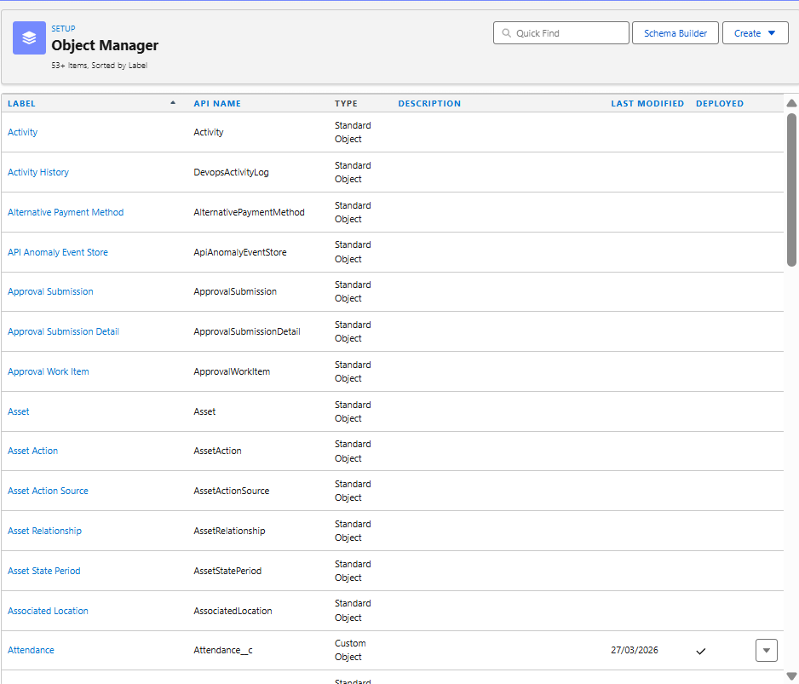
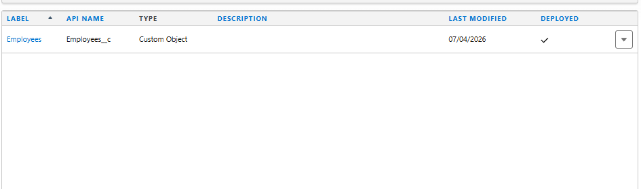

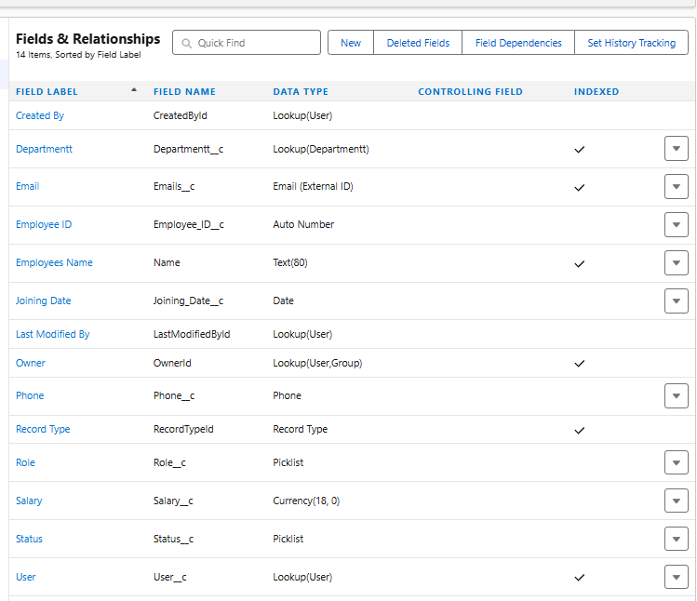

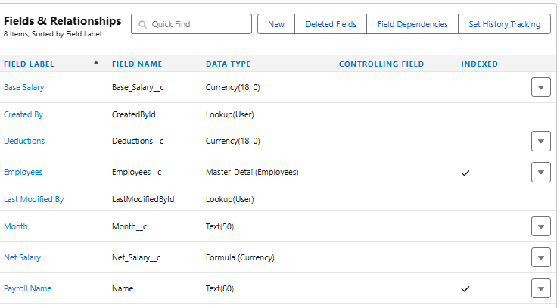

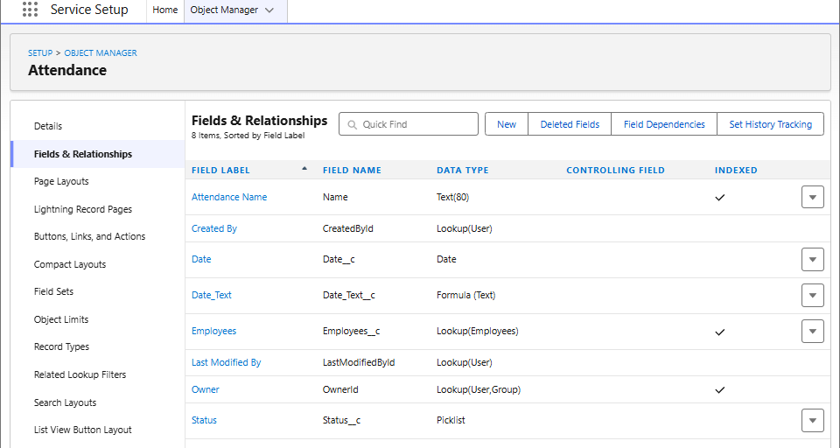

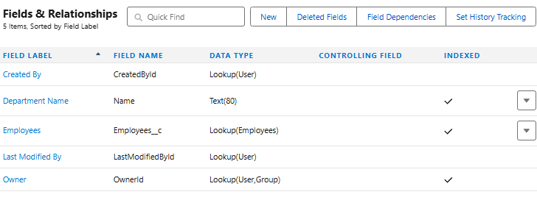
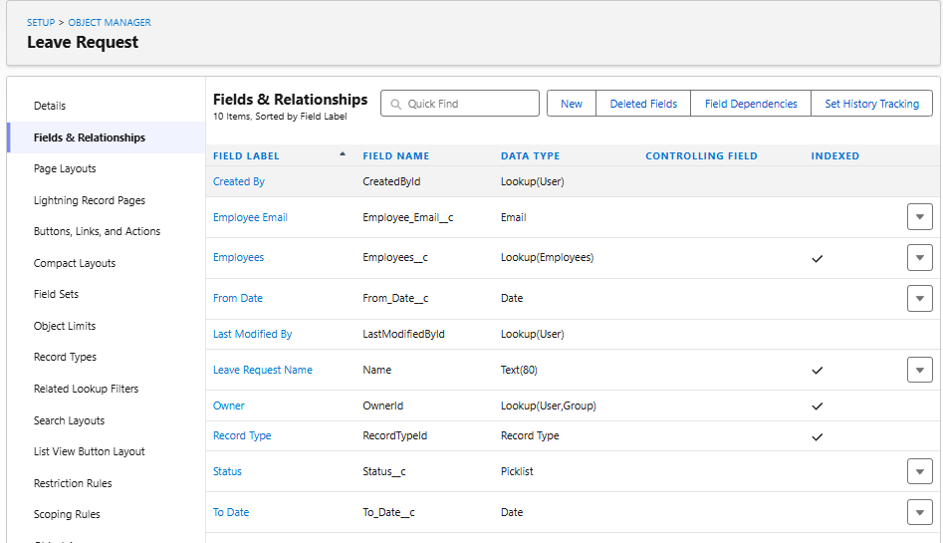
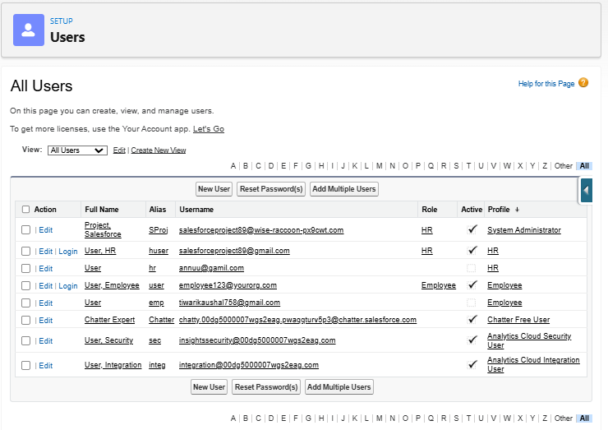
OUTPUT
