Rapport SA – Tina
LEMARQUAND - MONNET

1. Diagram translation
a)
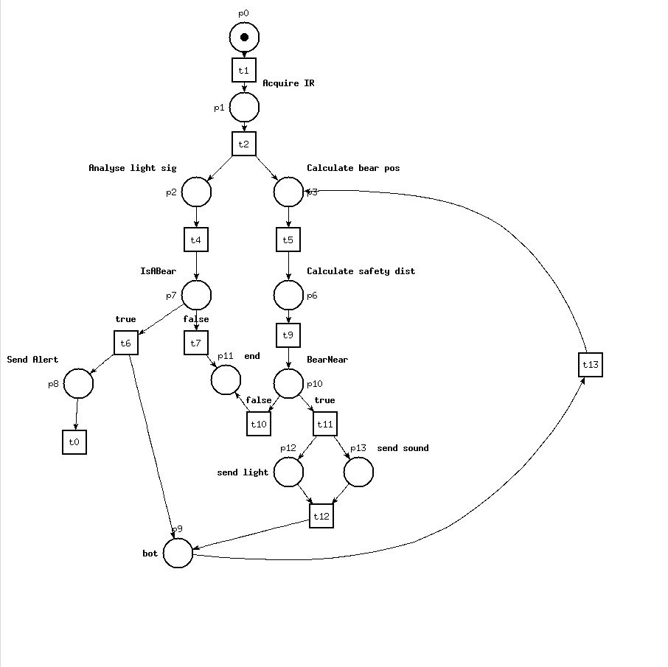
Petri net of the functional diagram Avoid Bear Approach
Verbose reachability analysis:
Bounded diagram
1 dead marking: when 2 tokens are in p11, which is the end state for the diagram. So this one being dead is not fine since this state is not supposed to loop over the net.

b)
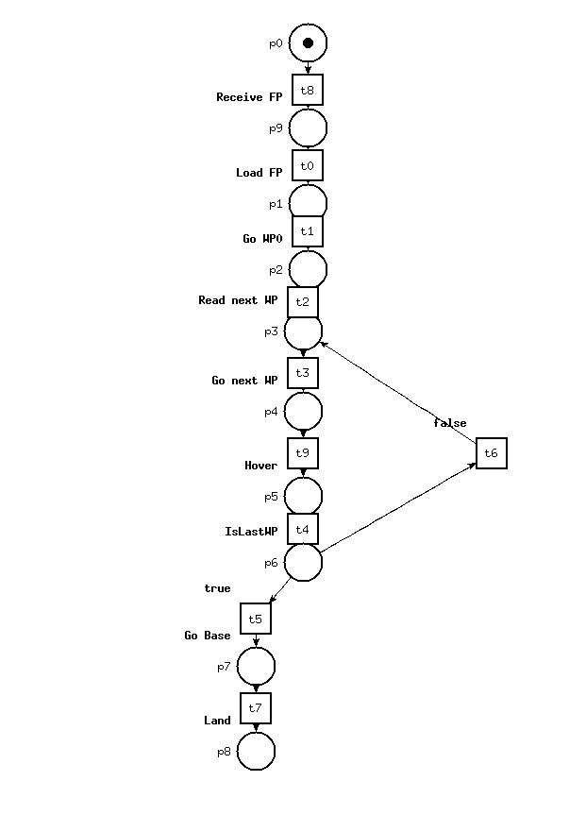
Petri net of the DS Follow Waypoint
Bounded diagram
1 dead marking: p8, which is the end state of the net
c) Connecting the 2 Petri nets
The bear detection and analysis phase is done when the UAV is hovering on a waypoint, so the 1st net will be gone through during the Hover phase of the second one, and the UAV will resume going to the next waypoint once the action is done.

2. Analysis of the combined diagram
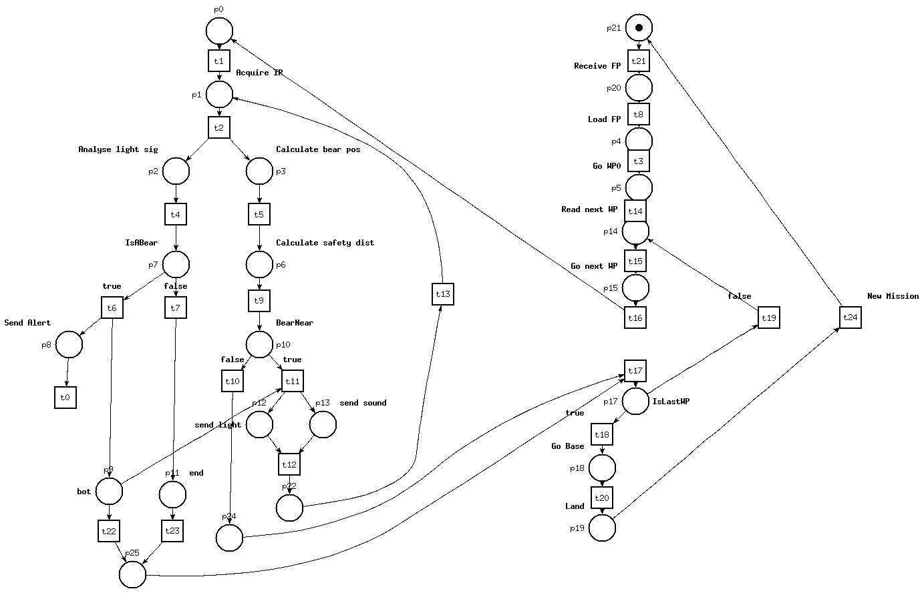
After inserting the Bear Detection function in the Hover phase, we had to fix the logic of the Bear Detection.
1st, if there is no bear, we prevent the distance calculation and get p24 and p25 to exit the Detection phase synchronously (no token left in it).
2nd, if there is a bear, and it's not close, we get the same states (p24 and p25) and exit the phase.
Lastly, if there is a bear and it is near, we loop over the main logic of the detection phase as long as those conditions are true.
The diagram is lively but not bounded, since there can be an accumulation of Send Alerts, because we couldn't synchronise it to be sure it was sent before the UAV exited the Detection phase.

