Experiment 1: Library Management System
Aim
To design a simple library website with login, book search and a book list using HTML.
Procedure
- Analyse the requirements: Admin (add, issue, return books, fine) and User (login, search, borrow history).
- Design the pages: Login, Search Book, Book List and Borrow History.
- Write the HTML code using forms and tables.
- Save the file as library.html and open it in a browser.
- Test the pages and capture the output.
Program
<html>
<head><title>Library</title></head>
<body>
<h2>Library Management System</h2>

<h3>Login</h3>
<form>
Username: <input type="text"><br><br>
Password: <input type="password"><br><br>
Role:
<select>
<option>Student</option>
<option>Admin</option>
</select><br><br>
<input type="submit" value="Login">
</form>

<h3>Search Book</h3>
<input type="text" placeholder="Book name">
<button>Search</button>

<h3>Available Books</h3>
<table border="1">
<tr><th>ID</th><th>Title</th><th>Author</th><th>Status</th></tr>
<tr><td>1</td><td>Java</td><td>Balagurusamy</td><td>Available</td></tr>
<tr><td>2</td><td>Python</td><td>Guido</td><td>Issued</td></tr>
</table>
</body>
</html>

Output

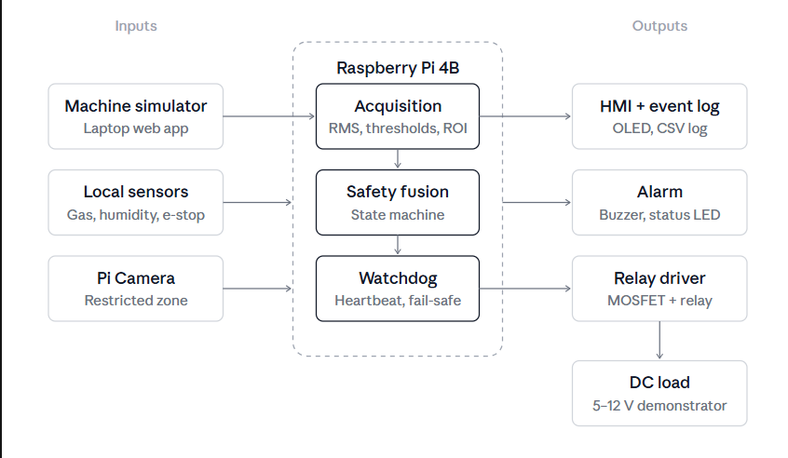Experiment 2: Online Hotel Room Booking System
Aim
To design a simple hotel booking website with room availability check and a booking form using HTML.
Procedure
- Analyse the requirements: User (register, check availability, book, cancel) and Admin (rooms, price).
- Design the pages: Room Availability and Booking Form.
- Write the HTML code using forms and tables.
- Save the file as hotel.html and open it in a browser.
- Test the pages and capture the output.
Program
<html>
<head><title>Hotel Booking</title></head>
<body>
<h2>Hotel Room Booking</h2>

<h3>Check Availability</h3>
<form>
Check-in: <input type="date"><br><br>
Check-out: <input type="date"><br><br>
Guests: <input type="number" min="1"><br><br>
<input type="submit" value="Check">
</form>

<h3>Rooms</h3>
<table border="1">
<tr><th>Room Type</th><th>Price</th><th>Available</th></tr>
<tr><td>Single</td><td>1500</td><td>5</td></tr>
<tr><td>Double</td><td>2500</td><td>3</td></tr>
</table>

<h3>Book Room</h3>
<form>
Name: <input type="text"><br><br>
Room:
<select>
<option>Single</option>
<option>Double</option>
</select><br><br>
<input type="submit" value="Book Now">
</form>
</body>
</html>
Output
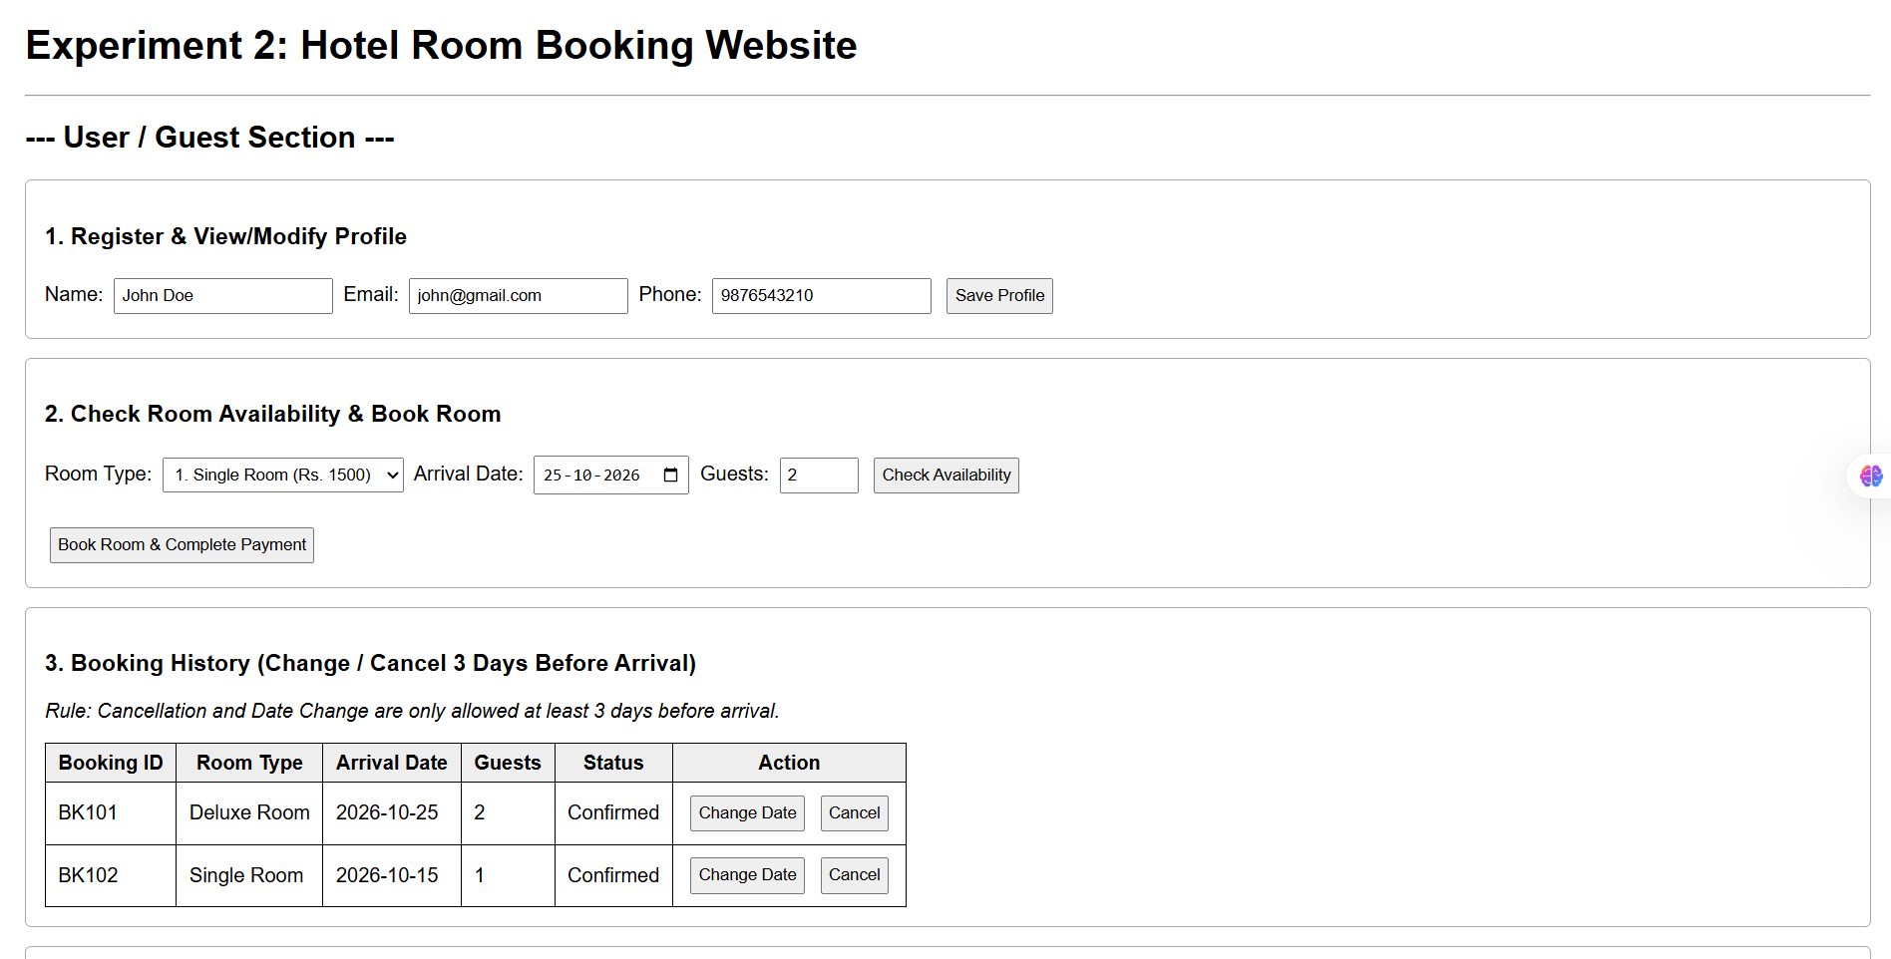Experiment 3: Online Bus Ticket Booking System
Aim
To design a simple bus ticket booking website with bus search and a passenger details form using HTML.
Procedure
- Analyse the requirements: User (search bus, select seat, book, cancel) and Admin (bus details).
- Design the pages: Search Bus, Bus List and Passenger Form.
- Write the HTML code using forms and tables.
- Save the file as bus.html and open it in a browser.
- Test the pages and capture the output.
Program
<html>
<head><title>Bus Booking</title></head>
<body>
<h2>Bus Ticket Booking</h2>

<h3>Search Bus</h3>
<form>
From: <input type="text"><br><br>
To: <input type="text"><br><br>
Date: <input type="date"><br><br>
<input type="submit" value="Search">
</form>

<h3>Available Buses</h3>
<table border="1">
<tr><th>Bus</th><th>Type</th><th>Time</th><th>Seats</th></tr>
<tr><td>KPN</td><td>Volvo</td><td>10:00 PM</td><td>20</td></tr>
<tr><td>SRS</td><td>Sleeper</td><td>11:00 PM</td><td>12</td></tr>
</table>

<h3>Passenger Details</h3>
<form>
Name: <input type="text"><br><br>
Seat No: <input type="number"><br><br>
<input type="submit" value="Book Ticket">
</form>
</body>
</html>
Output
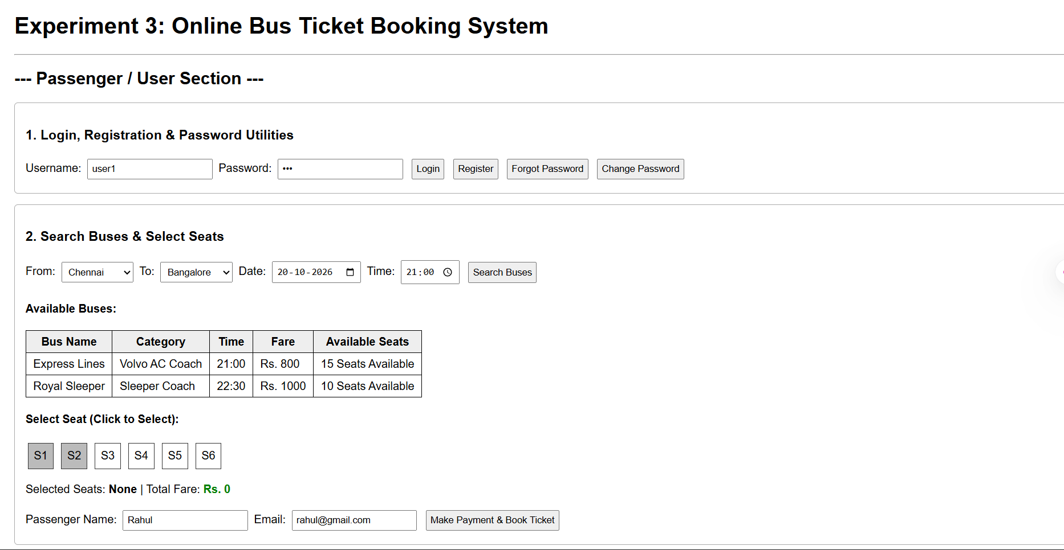Experiment 4: Online Train Reservation System
Aim
To design a simple train reservation website with a journey details form and PNR status check using HTML.
Procedure
- Analyse the requirements: Passenger (login, book ticket, check PNR, cancel) and Admin (train and fare details).
- Design the pages: Journey Details and PNR Status.
- Write the HTML code using forms.
- Save the file as train.html and open it in a browser.
- Test the pages and capture the output.
Program
<html>
<head><title>Train Reservation</title></head>
<body>
<h2>Train Reservation</h2>

<h3>Book Ticket</h3>
<form>
From: <input type="text"><br><br>
To: <input type="text"><br><br>
Date: <input type="date"><br><br>
Passenger Name: <input type="text"><br><br>
Class:
<select>
<option>Sleeper</option>
<option>3AC</option>
<option>2AC</option>
</select><br><br>
<input type="submit" value="Search Trains">
</form>

<h3>Check PNR Status</h3>
<form>
PNR No: <input type="text"><br><br>
<input type="submit" value="Check">
</form>
</body>
</html>
Output
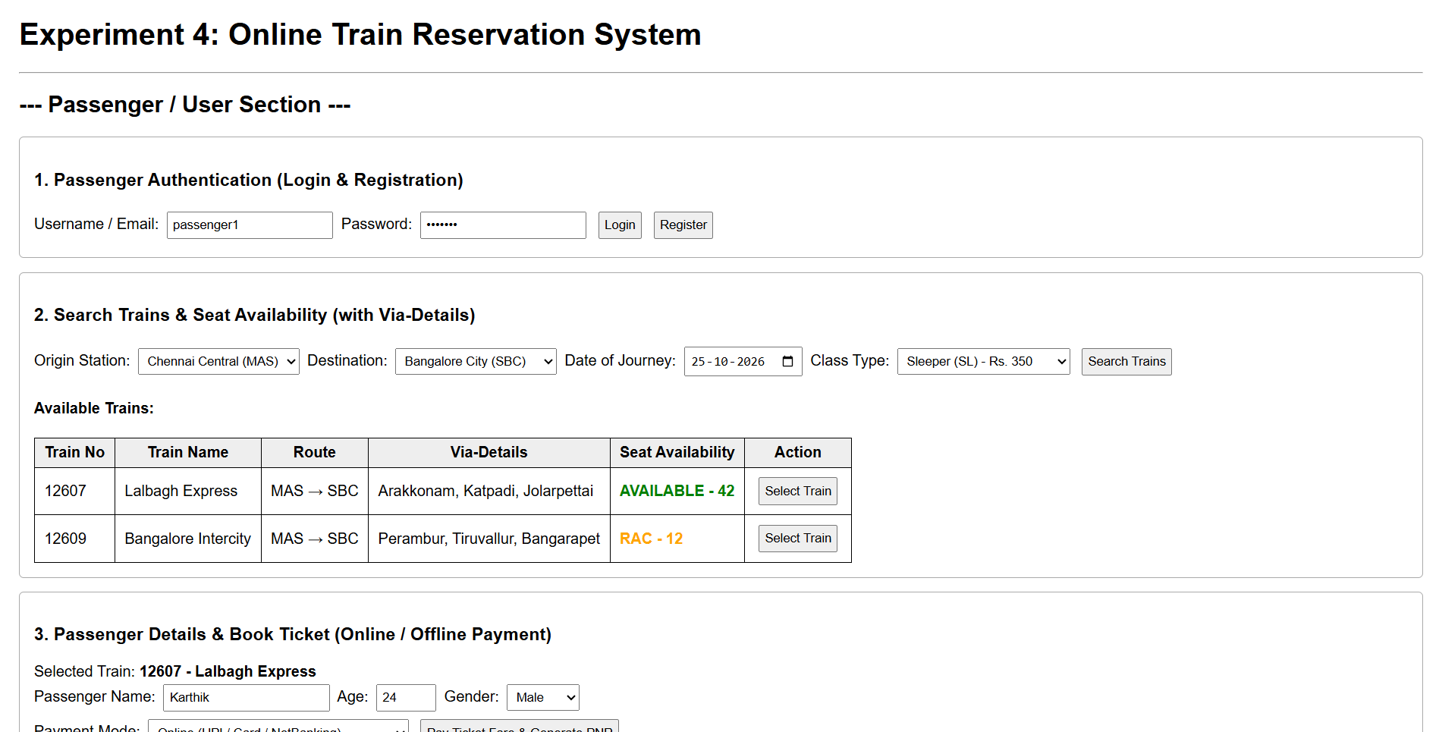Experiment 5: Online Flight Reservation System
Aim
To design a simple flight reservation website with flight search and a ticket booking form using HTML.
Procedure
- Analyse the requirements: User (search flight, book, cancel, print ticket) and Admin (flight details).
- Design the pages: Search Flight and Book Ticket.
- Write the HTML code using forms and tables.
- Save the file as flight.html and open it in a browser.
- Test the pages and capture the output.
Program
<html>
<head><title>Flight Booking</title></head>
<body>
<h2>Flight Reservation</h2>

<h3>Search Flight</h3>
<form>
From: <input type="text"><br><br>
To: <input type="text"><br><br>
Date: <input type="date"><br><br>
Class:
<select>
<option>Economy</option>
<option>Business</option>
</select><br><br>
<input type="submit" value="Search">
</form>

<h3>Flights</h3>
<table border="1">
<tr><th>Flight</th><th>Time</th><th>Fare</th></tr>
<tr><td>AI101</td><td>09:00 AM</td><td>5000</td></tr>
<tr><td>6E202</td><td>01:00 PM</td><td>4500</td></tr>
</table>

<h3>Book Ticket</h3>
<form>
Passenger Name: <input type="text"><br><br>
Seat No: <input type="text"><br><br>
<input type="submit" value="Book">
</form>
</body>
</html>

Output

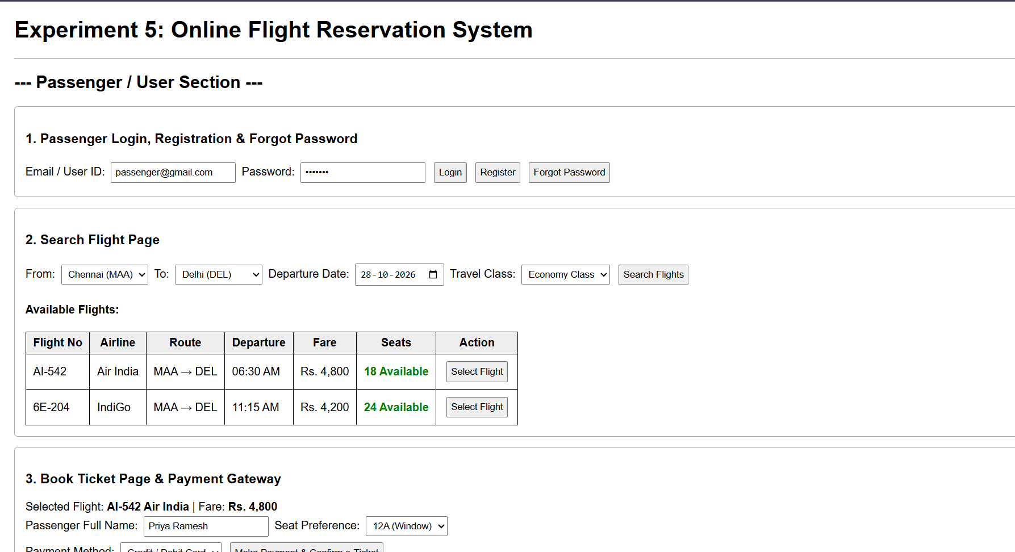Experiment 6: Online Cake Ordering System
Aim
To design a simple cake ordering website with a cake list and an order form using HTML.
Procedure
- Analyse the requirements: Customer (search cake, add to cart, order) and Admin (cake details, orders).
- Design the pages: Cake List and Order Form.
- Write the HTML code using forms and tables.
- Save the file as cake.html and open it in a browser.
- Test the pages and capture the output.
Program
<html>
<head><title>Cake Shop</title></head>
<body>
<h2>Online Cake Shop</h2>

<h3>Search Cake</h3>
<input type="text" placeholder="Cake name">
<select>
<option>All</option>
<option>Birthday</option>
</select>
<button>Search</button>

<h3>Cakes</h3>
<table border="1">
<tr><th>Cake</th><th>Flavor</th><th>Price</th><th></th></tr>
<tr>
<td>Choco Cake</td><td>Chocolate</td><td>500</td>
<td><button>Add to Cart</button></td>
</tr>
<tr>
<td>Fruit Cake</td><td>Fruit</td><td>450</td>
<td><button>Add to Cart</button></td>
</tr>
</table>

<h3>Place Order</h3>
<form>
Name: <input type="text"><br><br>
Address: <textarea></textarea><br><br>
Message on Cake: <input type="text"><br><br>
<input type="submit" value="Order">
</form>
</body>
</html>
Output
