Scenario on E- Commerce website

* Title: Quick and Easy Shop
* Members: Sanjib Sharma, Nabaraj Ghimire, Anzila Gurung
* Date: june 26
* Aim of the Project: To learn and understand about the web application and be able to implement those things on creating an Online Shopping which is used to allow customers to browse and view products, and place orders for those products whereby consumer directly buy goods, services etc. from a seller interactively in real-time without an intermediary service over the internet.
* Problem Statement: Recently, the most of the existing systems were automated. But they were found to be inefficient in meeting the growing demands of population.

Still, people used to visit various shops and bargains with mediator or an agent (seller), to find their required product and even they have to go out for that. It is time consuming and unreliable to get the desired product. There are no sufficient places or options, to find their product so that they can compare the products according to their price, quality, and guarantee aspects if available. Therefore, they could be dealing with expensive and damaged product. Also, they may not be able to find their required product or have to wait for their turn to interact with the seller. Finally, they could find their required product at shop in reasonable rate but they lost their valuable time.

* Project Objectives: Online shopping is the process whereby consumers directly buy goods, services etc. from a seller interactively in real-time without an intermediary service over the internet. Quick and Easy Shop allows you to browse through endless possibilities, and even offers merchandise that's unavailable in stores. Shopping via the internet eliminates the need to sift through a store's products with potential buys like pants, shirts, belts and shoes all slung over one arm etc. Major objectives are:
* To shop while in the comfort of your own home or anywhere without having to step out of the door.
* Sell at lower rate due to less over head.
* Provide home delivery free of cost.
* No wait to see the product if someone else is taking that.
* **DFD(Data Flow Diagrams)**

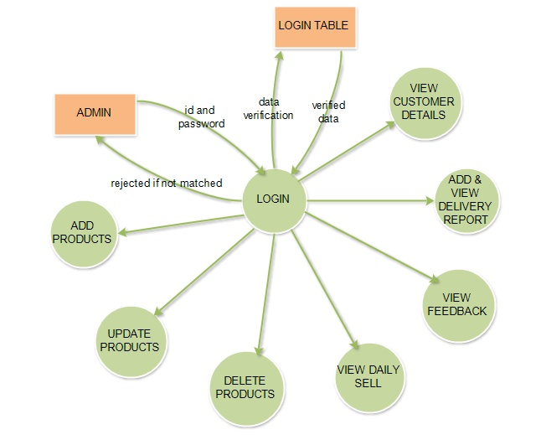Fig: DFD for Administrator

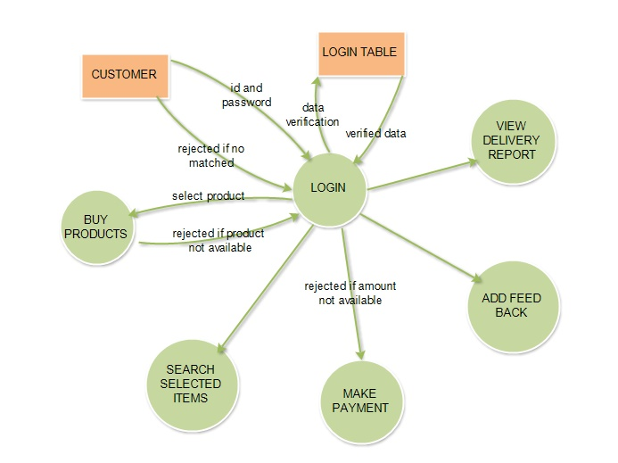 Fig: DFD for Customer