
BRAINWARE UNIVERSITY
School of Engineering
Department of Computer Science & Engineering – Cyber Security & Data Science
398, Ramkrishnapur Road, Barasat, North 24 Parganas, Kolkata - 700 125

Course Code: BTD50112
Course Name: Computer Networks
PBL Assignment – 4
Title: Multi-department University Network Design Using RIP and OSPF.
Objective
Design a multi-router university network and evaluate RIP and OSPF based on routing table formation, convergence, hop count, path selection, and Network scalability.
Real Life Connection
A university has three geographically separately building like: academic, administrative, and research. Each building has its own LAN. Routers are used to connect the buildings. The network administrator wants to compare RIP and OSPF for dynamic routing.
Target
- Design a 3-router network in Cisco Packet Tracer
- Configure IP addresses.
- Configure RIP and OSPF
- Examine routing tables & also observe how routing changes
- Determine the preferred protocol for the university network.
Group Members
Member | Name | Student Code
Member 1 | Sneha Modak | BWU/BTD/24/122
Member 2 | Nabarun Kumar Maity | BWU/BTD/24/077
Member 3 | Om Kumar Gope | BWU/BTD/24/078

Content
1. Front Page 1
2. Question Paper 2
3. Content 3
4. Objective 4
5. Solution (Subnetting) & Design (Packet Tracer) 5
6. Observation 14
7. Conclusion 16
8. Future Scope 17
9. Reference 18

Objective
The objective of this project-based learning (PBL) assignment is to design and simulate a multi-department university network consisting of three geographically separate LANs — Academic, Administrative, and Research — interconnected through routers, and to critically evaluate two dynamic routing protocols, RIP (Routing Information Protocol) and OSPF (Open Shortest Path First), on the same underlying campus network.
Specifically, this project aims to:
- Design a scalable 3-router, 3-LAN university network topology in Cisco Packet Tracer that mirrors a real campus environment.
- Perform structured IP addressing and subnetting for each department LAN as well as for the inter-router backbone links.
- Configure RIP (version 2) on one topology and OSPF (single area, Area 0) on a second topology, and verify end-to-end reachability using ping and traceroute.
- Examine and compare the routing tables generated by each protocol, including the source of each route, administrative distance, and metric.
- Observe protocol behaviour with respect to convergence time, hop-count limitations, and path-selection logic when multiple paths exist.
- Analyse the scalability, efficiency, and suitability of each protocol for a growing university network, and recommend the protocol best suited for long-term deployment.

Solution (Subnetting) & Design (Packet Tracer)

5.1 Addressing Plan & Subnetting
Each department (Academic, Administrative, Research) is assigned an independent Class C LAN so that host addressing within a building can be managed and scaled without affecting other departments. A separate set of subnets is used to interconnect the routers so that LAN broadcast traffic never crosses the backbone. The complete addressing plan is summarised below.
Table 1: Department LAN Subnets
Department / Network | Network Address | Subnet Mask | Usable Host Range | Default Gateway
Network 1 - Academic Bldg | 192.168.10.0 | 255.255.255.0 /24 | .1 - .254 (254 hosts) | 192.168.10.1
Network 2 - Admin Bldg | 192.168.20.0 | 255.255.255.0 /24 | .1 - .254 (254 hosts) | 192.168.20.1
Network 3 - Research Bldg | 192.168.30.0 | 255.255.255.0 /24 | .1 - .254 (254 hosts) | 192.168.30.1
Table 2: Backbone (Inter-router) Subnets - OSPF Topology
Backbone Link | Network Address | Subnet Mask | Router A IP | Router B IP
Network 4 (Router0 - Router1) | 10.10.10.0 | 255.255.255.0 /24 | 10.10.10.1 (R0) | 10.10.10.2 (R1)
Network 5 (Router1 - Router2) | 20.20.20.0 | 255.255.255.0 /24 | 20.20.20.1 (R1) | 20.20.20.2 (R2)
Table 3: Backbone (Inter-router) Subnets - RIP Topology
Backbone Link | Network Address | Subnet Mask | Router A IP | Router B IP
Network 4 (Router0 - Router1) | 10.0.0.0 | 255.255.255.0 /24 | 10.10.10.1 (R0) | 10.10.10.2 (R1)
Network 5 (Router1 - Router2) | 20.0.0.0 | 255.255.255.0 /24 | 20.20.20.1 (R1) | 20.20.20.2 (R2)
Network 6 (Router0 - Router2) | 30.0.0.0 | 255.255.255.0 /24 | 30.30.30.1 (R0) | 30.30.30.2 (R2)

Note: The RIP topology adds a third backbone link (Network 6, Router0 - Router2) so that a triangular, meshed backbone is formed. This deliberately creates two possible paths between the Academic and Research LANs, which is required to observe RIP's hop-count based path selection in Section 6 (Observation).
Table 4: End-host (PC) Addressing
PC / Host | Assigned IP | Subnet Mask | Default Gateway
PC - Academic (x4) | 192.168.10.2 - .5 | 255.255.255.0 | 192.168.10.1
PC - Admin (x2) | 192.168.20.2 - .3 | 255.255.255.0 | 192.168.20.1
PC - Research (x4) | 192.168.30.2 - .5 | 255.255.255.0 | 192.168.30.1

5.2 Network Design in Cisco Packet Tracer
Two parallel topologies were built in Packet Tracer using identical LAN structures (three 2960-24TT switches, each with 2-4 PCs) so that the only variable between the two experiments is the routing protocol and, consequently, the backbone shape needed to test that protocol meaningfully.

5.2.1 OSPF Topology - Linear Backbone
Router0, Router1 and Router2 are connected in a single-area (Area 0) linear chain: Router0 - Router1 - Router2. Each router also connects to its own department LAN through a 2960-24TT switch.
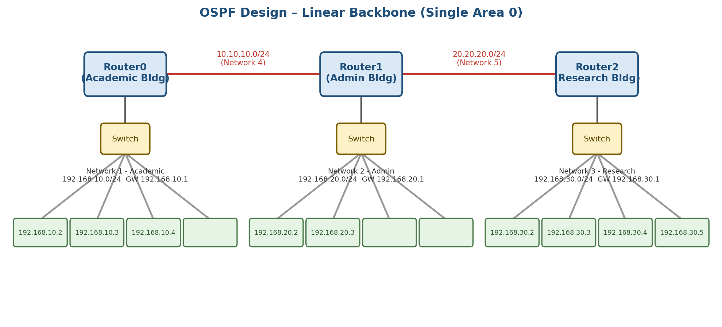
Figure 1: OSPF network design - linear backbone connecting the three department LANs.

5.2.2 RIP Topology - Triangular (Meshed) Backbone
For the RIP experiment, an additional backbone link (Network 6) is added directly between Router0 and Router2, forming a triangle. This provides two independent paths between the Academic and Research networks (a direct 1-hop path and a 2-hop path via Router1), which allows RIP's distance-vector, hop-count based best-path selection to be clearly observed.
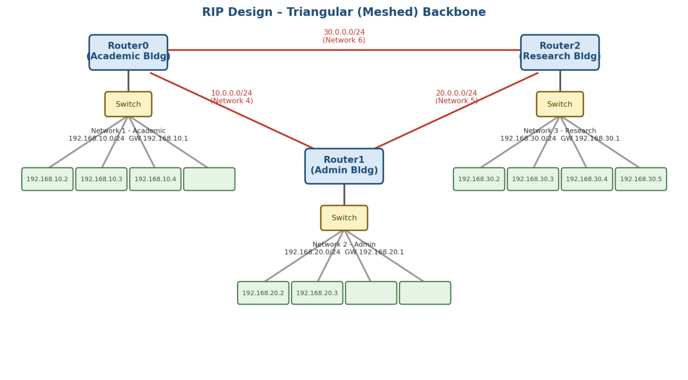
Figure 2: RIP network design - triangular, meshed backbone with redundant paths.

5.3 Router Configuration Summary
The key configuration commands applied on each router are summarised below (interface addressing is applied first in both cases, followed by the routing protocol):

OSPF Configuration (per router)
- interface <backbone-int> -> ip address <network-ip> 255.255.255.0 -> no shutdown
- interface <lan-int> -> ip address <gateway-ip> 255.255.255.0 -> no shutdown
- router ospf 1
- network <lan-network> 0.0.0.255 area 0
- network <backbone-network> 0.0.0.255 area 0

RIP Configuration (per router)
- interface <backbone-int> -> ip address <network-ip> 255.255.255.0 -> no shutdown
- interface <lan-int> -> ip address <gateway-ip> 255.255.255.0 -> no shutdown
- router rip
- version 2
- network <lan-network>
- network <backbone-network>
- no auto-summary

5.4 Packet Tracer Implementation Screenshots
The screenshots below show the final Cisco Packet Tracer implementation of both experiments: the completed RIP and OSPF topologies with their interface IP addresses, followed by the router CLI used to enable each routing protocol on Router0.
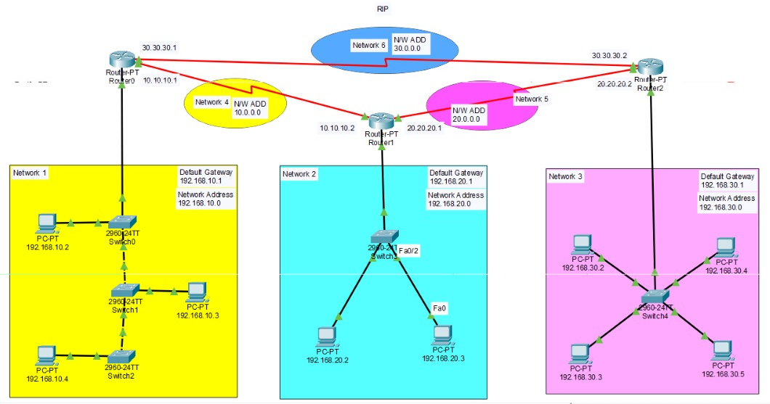
Figure 3: Cisco Packet Tracer - RIP topology with triangular backbone (Networks 4, 5 and 6) and department LANs.
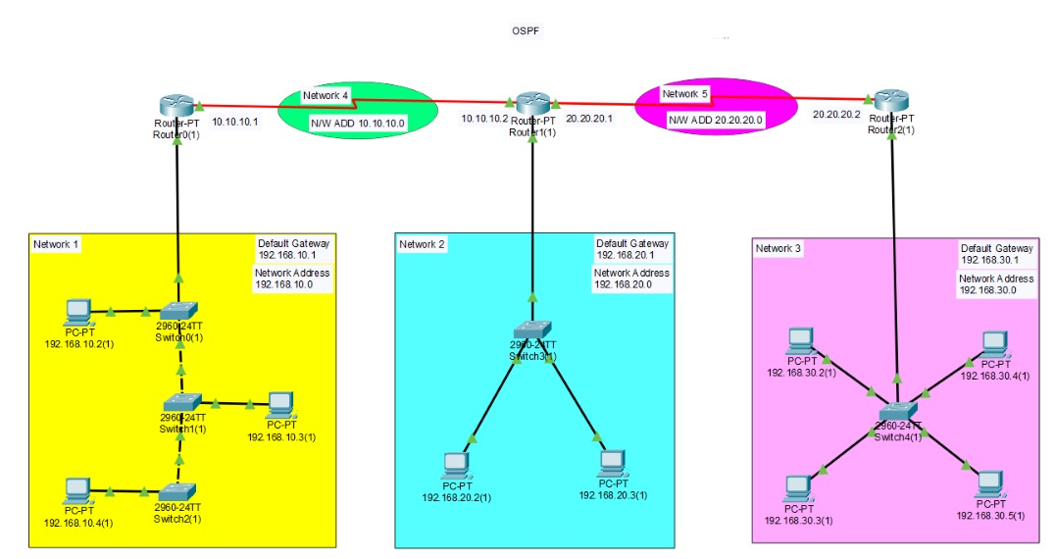
Figure 4: Cisco Packet Tracer - OSPF topology with linear backbone (Networks 4 and 5) and department LANs.
In the OSPF experiment, Router0 was configured with the OSPF process and all five networks (the three department LANs and the two backbone networks) were advertised in Area 0. The console output confirms the OSPF neighbour adjacency moving from LOADING to FULL.
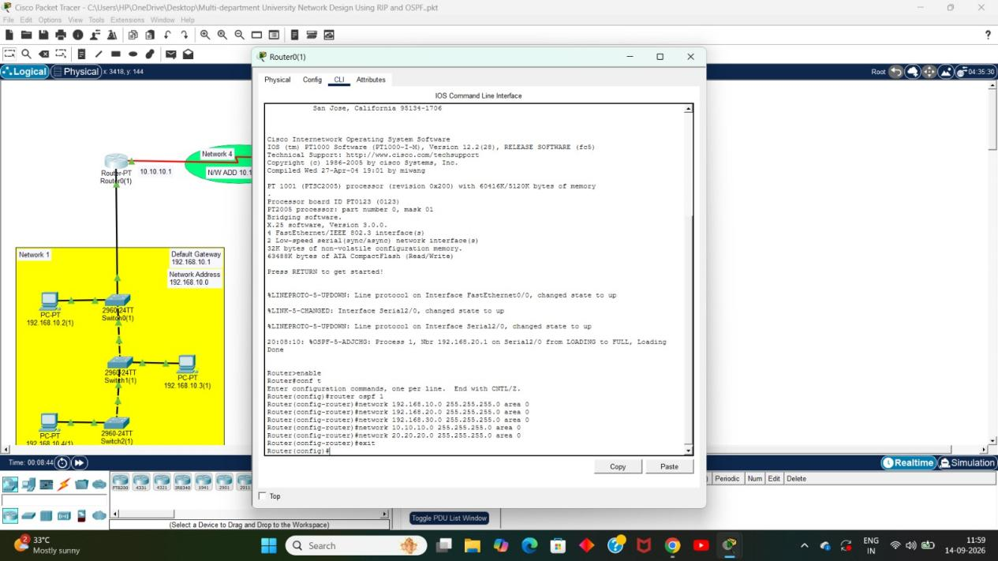
Figure 5: OSPF configuration on Router0 (router ospf 1, all networks in area 0) and adjacency reaching FULL state.
In the RIP experiment, Router0 was configured with the RIP process and its directly connected networks were advertised: the Academic LAN (192.168.10.0) and the backbone networks 10.10.10.0 and 30.30.30.0.
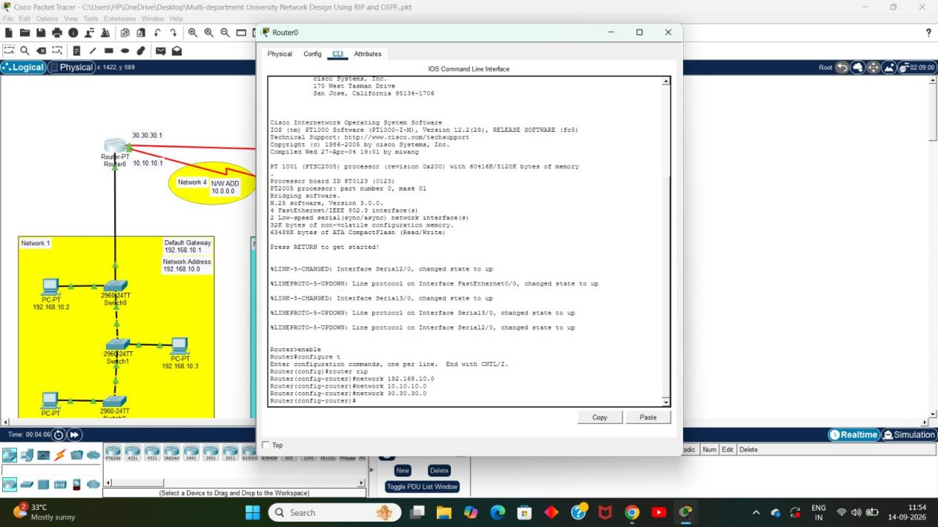
Figure 6: RIP configuration on Router0 - directly connected networks advertised under router rip.

5.5 CLI Configuration Commands
The complete command-line configuration applied on each router in Cisco Packet Tracer is listed below. In every router, the department LAN is connected to FastEthernet0/0 (default gateway of that LAN) and the backbone links use the serial interfaces. The commands are entered from the CLI tab of each router after pressing RETURN to get started.

5.5.1 OSPF Configuration (Linear Backbone)
OSPF process 1 is used with all interfaces placed in Area 0. Wildcard mask 0.0.0.255 is used because every network is a /24.
Router0 - OSPF
Router>enable
Router#configure terminal
Router(config)#hostname Router0
Router0(config)#interface FastEthernet0/0
Router0(config-if)#ip address 192.168.10.1 255.255.255.0
Router0(config-if)#no shutdown
Router0(config-if)#exit
Router0(config)#interface Serial2/0
Router0(config-if)#ip address 10.10.10.1 255.255.255.0
Router0(config-if)#no shutdown
Router0(config-if)#exit
Router0(config)#router ospf 1
Router0(config-router)#network 192.168.10.0 0.0.0.255 area 0
Router0(config-router)#network 10.10.10.0 0.0.0.255 area 0
Router0(config-router)#exit
Router0(config)#end
Router0#copy running-config startup-config

Router1 - OSPF
Router>enable
Router#configure terminal
Router(config)#hostname Router1
Router1(config)#interface FastEthernet0/0
Router1(config-if)#ip address 192.168.20.1 255.255.255.0
Router1(config-if)#no shutdown
Router1(config-if)#exit
Router1(config)#interface Serial2/0
Router1(config-if)#ip address 10.10.10.2 255.255.255.0
Router1(config-if)#no shutdown
Router1(config-if)#exit
Router1(config)#interface Serial3/0
Router1(config-if)#ip address 20.20.20.1 255.255.255.0
Router1(config-if)#no shutdown
Router1(config-if)#exit
Router1(config)#router ospf 1
Router1(config-router)#network 192.168.20.0 0.0.0.255 area 0
Router1(config-router)#network 10.10.10.0 0.0.0.255 area 0
Router1(config-router)#network 20.20.20.0 0.0.0.255 area 0
Router1(config-router)#exit
Router1(config)#end
Router1#copy running-config startup-config

Router2 - OSPF
Router>enable
Router#configure terminal
Router(config)#hostname Router2
Router2(config)#interface FastEthernet0/0
Router2(config-if)#ip address 192.168.30.1 255.255.255.0
Router2(config-if)#no shutdown
Router2(config-if)#exit
Router2(config)#interface Serial2/0
Router2(config-if)#ip address 20.20.20.2 255.255.255.0
Router2(config-if)#no shutdown
Router2(config-if)#exit
Router2(config)#router ospf 1
Router2(config-router)#network 192.168.30.0 0.0.0.255 area 0
Router2(config-router)#network 20.20.20.0 0.0.0.255 area 0
Router2(config-router)#exit
Router2(config)#end
Router2#copy running-config startup-config

5.5.2 RIP Configuration (Triangular Backbone)
RIP version 2 is enabled with auto-summary disabled so that the subnets are advertised exactly as configured. The extra Router0 - Router2 link (Network 6) uses the second serial interface on Router0 and Router2.
Router0 - RIP
Router>enable
Router#configure terminal
Router(config)#hostname Router0
Router0(config)#interface FastEthernet0/0
Router0(config-if)#ip address 192.168.10.1 255.255.255.0
Router0(config-if)#no shutdown
Router0(config-if)#exit
Router0(config)#interface Serial2/0
Router0(config-if)#ip address 10.10.10.1 255.255.255.0
Router0(config-if)#no shutdown
Router0(config-if)#exit
Router0(config)#interface Serial3/0
Router0(config-if)#ip address 30.30.30.1 255.255.255.0
Router0(config-if)#no shutdown
Router0(config-if)#exit
Router0(config)#router rip
Router0(config-router)#version 2
Router0(config-router)#network 192.168.10.0
Router0(config-router)#network 10.10.10.0
Router0(config-router)#network 30.30.30.0
Router0(config-router)#no auto-summary
Router0(config-router)#exit
Router0(config)#end
Router0#copy running-config startup-config

Router1 - RIP
Router>enable
Router#configure terminal
Router(config)#hostname Router1
Router1(config)#interface FastEthernet0/0
Router1(config-if)#ip address 192.168.20.1 255.255.255.0
Router1(config-if)#no shutdown
Router1(config-if)#exit
Router1(config)#interface Serial2/0
Router1(config-if)#ip address 10.10.10.2 255.255.255.0
Router1(config-if)#no shutdown
Router1(config-if)#exit
Router1(config)#interface Serial3/0
Router1(config-if)#ip address 20.20.20.1 255.255.255.0
Router1(config-if)#no shutdown
Router1(config-if)#exit
Router1(config)#router rip
Router1(config-router)#version 2
Router1(config-router)#network 192.168.20.0
Router1(config-router)#network 10.10.10.0
Router1(config-router)#network 20.20.20.0
Router1(config-router)#no auto-summary
Router1(config-router)#exit
Router1(config)#end
Router1#copy running-config startup-config

Router2 - RIP
Router>enable
Router#configure terminal
Router(config)#hostname Router2
Router2(config)#interface FastEthernet0/0
Router2(config-if)#ip address 192.168.30.1 255.255.255.0
Router2(config-if)#no shutdown
Router2(config-if)#exit
Router2(config)#interface Serial2/0
Router2(config-if)#ip address 20.20.20.2 255.255.255.0
Router2(config-if)#no shutdown
Router2(config-if)#exit
Router2(config)#interface Serial3/0
Router2(config-if)#ip address 30.30.30.2 255.255.255.0
Router2(config-if)#no shutdown
Router2(config-if)#exit
Router2(config)#router rip
Router2(config-router)#version 2
Router2(config-router)#network 192.168.30.0
Router2(config-router)#network 20.20.20.0
Router2(config-router)#network 30.30.30.0
Router2(config-router)#no auto-summary
Router2(config-router)#exit
Router2(config)#end
Router2#copy running-config startup-config

Observation
After configuring both topologies in Cisco Packet Tracer and allowing the protocols to converge, the routing tables of Router0, Router1 and Router2 were examined using the "show ip route" command, and reachability was verified with ping and traceroute between department LANs. The following observations were recorded.
Parameter | OSPF (Linear Backbone) | RIP (Triangular Backbone)
Route code seen in routing table | O (OSPF, AD 110) | R (RIP, AD 120)
Metric used | Cost (based on bandwidth) | Hop count
Routing table formation | Learns Router LSAs, builds full topology (link-state database), then runs SPF (Dijkstra) to compute best paths | Learns entire routing table from directly connected neighbours and periodically exchanges full table (distance-vector)
Convergence speed | Fast - triggered updates as soon as a link-state change is flooded | Slow - relies on periodic updates (every 30 s) and hold-down / timeout timers
Hop-count limit | No hard hop limit (suitable for larger campus networks) | Maximum 15 hops; 16 = unreachable, limiting scalability
Path selection (with redundant link) | N/A in this linear design - only one physical path exists | With the added Router0-Router2 link, RIP selects the 1-hop direct path over the 2-hop path via Router1
Bandwidth utilisation | Uses multicast (224.0.0.5/6) only on link-state changes | Broadcasts / multicasts (224.0.0.9) the full table every 30 seconds regardless of change
Scalability for university growth | High - supports areas, VLSM, and hundreds of routers | Low - flat network only, becomes inefficient beyond ~15 hops

6.1 Routing Table Formation
In the OSPF network, each router first exchanged Hello packets to form neighbour adjacencies over the point-to-point backbone links, then flooded Link-State Advertisements (LSAs) to build an identical link-state database on every router. Each router independently ran the Shortest Path First (SPF) algorithm on this database to compute its routing table, with routes marked with the code 'O' and an administrative distance of 110.
In the RIP network, each router learned about remote networks purely from its directly connected neighbours by periodically broadcasting its entire routing table. Routes appeared with the code 'R' and an administrative distance of 120, with the metric expressed simply as the number of router hops to the destination.

6.2 Convergence
When a backbone link was deliberately shut down during simulation, OSPF re-converged almost immediately because the affected router flooded a new LSA describing the topology change, which every other router used to instantly re-run SPF. RIP took noticeably longer to converge because it depends on periodic (30-second) update cycles and hold-down timers before removing or replacing a failed route, resulting in a temporary period of stale/incorrect routing information.

6.3 Hop Count & Path Selection
Because the RIP topology includes a third backbone link directly between Router0 and Router2 (in addition to the path via Router1), it was possible to observe RIP's path-selection behaviour: RIP always preferred the single-hop direct path over the two-hop path through Router1, purely on the basis of hop count, even though both paths were realistically equivalent in bandwidth in the simulated network. OSPF's linear backbone had no redundant path in this design, so its cost-based path selection could only be verified using the calculated interface costs rather than an alternate physical path.

6.4 Network Scalability
As the number of routers and departments increases, RIP's 15-hop limit and full-table broadcasts would quickly become a bottleneck for a growing university network with many buildings. OSPF's link-state, area-based design and lack of a hop-count ceiling make it noticeably better suited to a campus network that is expected to expand over time.

Conclusion
This project successfully designed, implemented, and tested a multi-department university network connecting the Academic, Administrative, and Research buildings using RIP and OSPF in Cisco Packet Tracer. The project helped in understanding how dynamic routing protocols automatically exchange routing information and select suitable paths for communication between different network segments.
The comparison showed that RIP is simple to configure and suitable for small and less complex networks. However, its 15-hop limitation, slow convergence, and periodic routing updates make it less suitable for a large and expanding university network. Its use of hop count as the main routing metric also limits its ability to select the most efficient path when network conditions differ.
In comparison, OSPF provided better performance and scalability. It uses a cost-based metric and responds more efficiently to changes in the network, resulting in faster convergence. It also does not have RIP's 15-hop limitation, making it more suitable for connecting multiple buildings and departments.
Based on the simulation results, including routing table formation, convergence, path selection, hop-count limitations, and scalability, OSPF is recommended as the preferred routing protocol for the proposed university network. RIP can still be used for small branch networks or simple legacy segments, but OSPF is more appropriate for a growing and interconnected university environment.

Future Scope
The current network design can be further extended to make it more similar to a real-world production-grade university network. One major improvement would be the implementation of multi-area OSPF, where Area 0 can be used as the backbone and separate areas can be assigned to the Academic, Administrative, and Research departments. This would improve scalability and reduce unnecessary LSA flooding. VLSM can also be introduced to use IP addresses more efficiently, especially on point-to-point backbone links where smaller subnets such as /30 can be used instead of /24 networks.
The network can also be improved by adding redundant links and technologies such as HSRP or VRRP to provide gateway and link failover in case of a network failure. ACLs and inter-VLAN routing can be implemented to improve security by controlling communication between student, faculty, and administrative devices. In addition, the network can be extended to support IPv6 dual-stack addressing using OSPFv3, preparing the university infrastructure for future IPv6 adoption. For a larger university network connected to an external ISP or another campus, protocols such as EIGRP or BGP can also be studied and compared for external or hybrid routing scenarios. Finally, network monitoring tools such as SNMP and NetFlow can be incorporated, along with simulated traffic loads, to analyze network performance, congestion, and routing behaviour under more realistic conditions.

Reference
Sure — here is a complete 15-reference list, keeping your original 13 and adding 2 more academic/research sources. I’ve also cleaned up the formatting so it looks suitable for a B.Tech project report.
- Cisco Networking Academy, CCNA: Introduction to Networks – Routing Fundamentals, Cisco Systems.
- Cisco Systems, Inc., Cisco Packet Tracer Software Documentation, Cisco Systems.
- B. A. Forouzan, Data Communications and Networking, McGraw-Hill Education.
- G. Malkin, “RIP Version 2,” RFC 2453, Internet Engineering Task Force (IETF), 1998.
- J. Moy, “OSPF Version 2,” RFC 2328, Internet Engineering Task Force (IETF), 1998.
- T. Lammle, CCNA Routing and Switching Study Guide, Sybex.
- Brainware University, Computer Networks – Course Code BTD50112, Study Material.
- M. Jayakumar, N. Ramya Shanthi Rekha, B. Bharathi et al., “A Comparative Study on RIP and OSPF Protocols,” 2015 International Conference on Innovations in Information, Embedded and Communication Systems (ICIIECS), 2015.
- N. W. A. Majid and S. Fuada, “RIP vs. OSPF Routing Protocols: Which One Is the Best for a Real-Time Computer Network?” SIMETRIS, Vol. 11, No. 1, 2020.
- J. V. M. Guimarães, Estudo Comparativo dos Protocolos de Roteamento RIP e OSPF Usando o Simulador Cisco Packet Tracer, Universidade Federal de Uberlândia, 2021. (Repositório Institucional da UFU)
- A. Ajani, B. Jimada-Ojuolape, A. Ahmed, T. Aduragba, and M. O. Balogun, “Comparative Performance Evaluation of Open Shortest Path First (OSPF) and Routing Information Protocol (RIP) in Network Link Failure and Recovery Cases,” 2017 IEEE 3rd International Conference on Electro-Technology for National Development (NIGERCON), pp. 280–288, 2017. (ResearchGate)
- V. Hadjioannou, “On the Performance Comparison of RIP, OSPF, IS-IS and EIGRP Routing Protocols,” arXiv, 2015.
- D. B. Oppong, J. D. Lartey, J. A. Kani, and P. Danquah, “Simulated Comparison of Packet Transmission over Large-Scale Network: Open Shortest Path First (OSPF) versus Routing Information Protocol (RIP),” Journal of Applied Science and Information Technology. (CSIR JASIT)
- Z. A. Yau and K. C. Arun, “Comparative Performance Evaluation of RIP with OSPF Routing Protocol,” Journal of Applied Technology and Innovation, Vol. 5, No. 3, 2021. (JATI)
- S. Warpe, M. Giri, and S. Jain, “Simulation-Based Performance Evaluation of Layer 3 Routing Protocols: RIP, EIGRP, and OSPF,” International Journal of Artificial Intelligence and Machine Learning, Vol. 6, No. 2, pp. 399–404, 2026. (Svedberg Open)

