
BRAINWARE UNIVERSITY
School of Engineering
Department of Computer Science & Engineering – Cyber Security & Data Science
398, Ramkrishnapur Road, Barasat, North 24 Parganas, Kolkata - 700 125

PBL ASSIGNMENT – 4
Multi-department University Network Design Using RIP and OSPF

Course Code: BTD50112
Course Name: Computer Networks
Member | Name | Student Code
Member 1 | Sneha Modak | BWU/BTD/24/122
Member 2 | Nabarun Kumar Maity | BWU/BTD/24/077
Member 3 | Om Kumar Gope | BWU/BTD/24/078
Member 4
Member 5
(Fill in the names and student codes of all group members above)
Submitted to: [DR.ARNAB KUNDU]
Date of Submission: [DD / MM / 2026]

BRAINWARE UNIVERSITY
School of Engineering
Department of Computer Science & Engineering – Cyber Security & Data Science
398, Ramkrishnapur Road, Barasat, North 24 Parganas, Kolkata - 700 125

Course Code: BTD50112
Course Name: Computer Networks
PBL Assignment – 4
Title: Multi-department University Network Design Using RIP and OSPF.
Objective
Design a multi-router university network and evaluate RIP and OSPF based on routing table formation, convergence, hop count, path selection, and Network scalability.
Real Life Connection
A university has three geographically separately building like: academic, administrative, and research. Each building has its own LAN. Routers are used to connect the buildings. The network administrator wants to compare RIP and OSPF for dynamic routing.
Target
- Design a 3-router network in Cisco Packet Tracer
- Configure IP addresses.
- Configure RIP and OSPF
- Examine routing tables & also observe how routing changes
- Determine the preferred protocol for the university network.
Group Members
Member | Name | Student Code
Member 1 | Sneha Modak | BWU/BTD/24/122
Member 2 | Nabarun Kumar Maity | BWU/BTD/24/077
Member 3 | Om Kumar Gope | BWU/BTD/24/078

Content
1. Front Page 1
2. Question Paper 2
3. Content 3
4. Objective 4
5. Solution (Subnetting) & Design (Packet Tracer) 5
6. Observation 8
7. Conclusion 9
8. Future Scope 10
9. Reference 11

Objective
The objective of this project-based learning (PBL) assignment is to design and simulate a multi-department university network consisting of three geographically separate LANs — Academic, Administrative, and Research — interconnected through routers, and to critically evaluate two dynamic routing protocols, RIP (Routing Information Protocol) and OSPF (Open Shortest Path First), on the same underlying campus network.
Specifically, this project aims to:
- Design a scalable 3-router, 3-LAN university network topology in Cisco Packet Tracer that mirrors a real campus environment.
- Perform structured IP addressing and subnetting for each department LAN as well as for the inter-router backbone links.
- Configure RIP (version 2) on one topology and OSPF (single area, Area 0) on a second topology, and verify end-to-end reachability using ping and traceroute.
- Examine and compare the routing tables generated by each protocol, including the source of each route, administrative distance, and metric.
- Observe protocol behaviour with respect to convergence time, hop-count limitations, and path-selection logic when multiple paths exist.
- Analyse the scalability, efficiency, and suitability of each protocol for a growing university network, and recommend the protocol best suited for long-term deployment.

Solution (Subnetting) & Design (Packet Tracer)

5.1 Addressing Plan & Subnetting
Each department (Academic, Administrative, Research) is assigned an independent Class C LAN so that host addressing within a building can be managed and scaled without affecting other departments. A separate set of subnets is used to interconnect the routers so that LAN broadcast traffic never crosses the backbone. The complete addressing plan is summarised below.
Table 1: Department LAN Subnets
Department / Network | Network Address | Subnet Mask | Usable Host Range | Default Gateway
Network 1 - Academic Bldg | 192.168.10.0 | 255.255.255.0 /24 | .1 - .254 (254 hosts) | 192.168.10.1
Network 2 - Admin Bldg | 192.168.20.0 | 255.255.255.0 /24 | .1 - .254 (254 hosts) | 192.168.20.1
Network 3 - Research Bldg | 192.168.30.0 | 255.255.255.0 /24 | .1 - .254 (254 hosts) | 192.168.30.1
Table 2: Backbone (Inter-router) Subnets - OSPF Topology
Backbone Link | Network Address | Subnet Mask | Router A IP | Router B IP
Network 4 (Router0 - Router1) | 10.10.10.0 | 255.255.255.0 /24 | 10.10.10.1 (R0) | 10.10.10.2 (R1)
Network 5 (Router1 - Router2) | 20.20.20.0 | 255.255.255.0 /24 | 20.20.20.1 (R1) | 20.20.20.2 (R2)
Table 3: Backbone (Inter-router) Subnets - RIP Topology
Backbone Link | Network Address | Subnet Mask | Router A IP | Router B IP
Network 4 (Router0 - Router1) | 10.0.0.0 | 255.255.255.0 /24 | 10.10.10.1 (R0) | 10.10.10.2 (R1)
Network 5 (Router1 - Router2) | 20.0.0.0 | 255.255.255.0 /24 | 20.20.20.1 (R1) | 20.20.20.2 (R2)
Network 6 (Router0 - Router2) | 30.0.0.0 | 255.255.255.0 /24 | 30.30.30.1 (R0) | 30.30.30.2 (R2)
Note: The RIP topology adds a third backbone link (Network 6, Router0 - Router2) so that a triangular, meshed backbone is formed. This deliberately creates two possible paths between the Academic and Research LANs, which is required to observe RIP's hop-count based path selection in Section 6 (Observation).
Table 4: End-host (PC) Addressing
PC / Host | Assigned IP | Subnet Mask | Default Gateway
PC - Academic (x4) | 192.168.10.2 - .5 | 255.255.255.0 | 192.168.10.1
PC - Admin (x2) | 192.168.20.2 - .3 | 255.255.255.0 | 192.168.20.1
PC - Research (x4) | 192.168.30.2 - .5 | 255.255.255.0 | 192.168.30.1

5.2 Network Design in Cisco Packet Tracer
Two parallel topologies were built in Packet Tracer using identical LAN structures (three 2960-24TT switches, each with 2-4 PCs) so that the only variable between the two experiments is the routing protocol and, consequently, the backbone shape needed to test that protocol meaningfully.

5.2.1 OSPF Topology - Linear Backbone
Router0, Router1 and Router2 are connected in a single-area (Area 0) linear chain: Router0 - Router1 - Router2. Each router also connects to its own department LAN through a 2960-24TT switch.
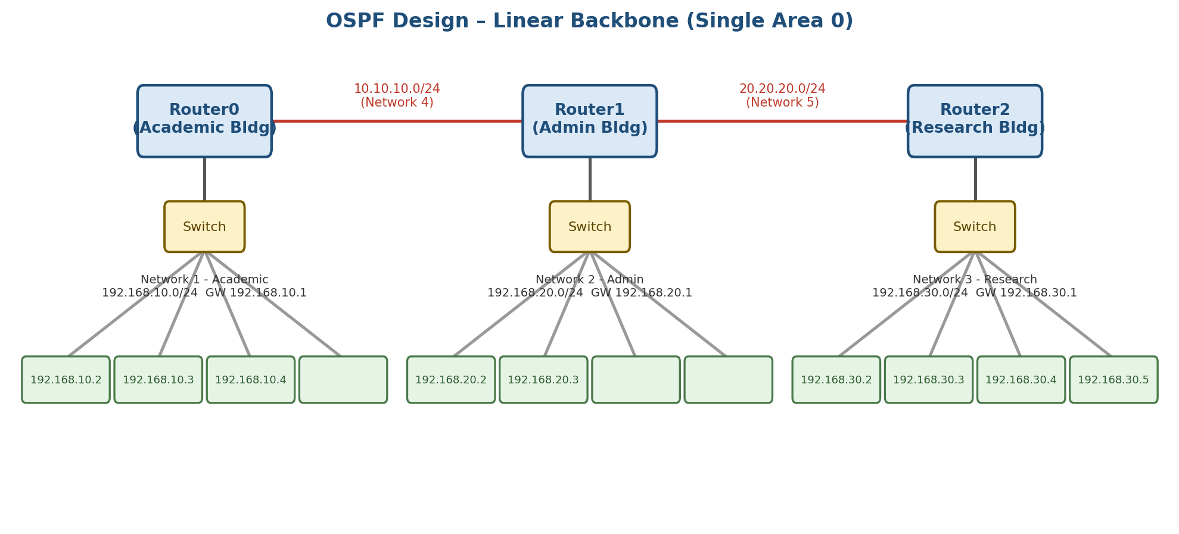
Figure 1: OSPF network design - linear backbone connecting the three department LANs.

5.2.2 RIP Topology - Triangular (Meshed) Backbone
For the RIP experiment, an additional backbone link (Network 6) is added directly between Router0 and Router2, forming a triangle. This provides two independent paths between the Academic and Research networks (a direct 1-hop path and a 2-hop path via Router1), which allows RIP's distance-vector, hop-count based best-path selection to be clearly observed.
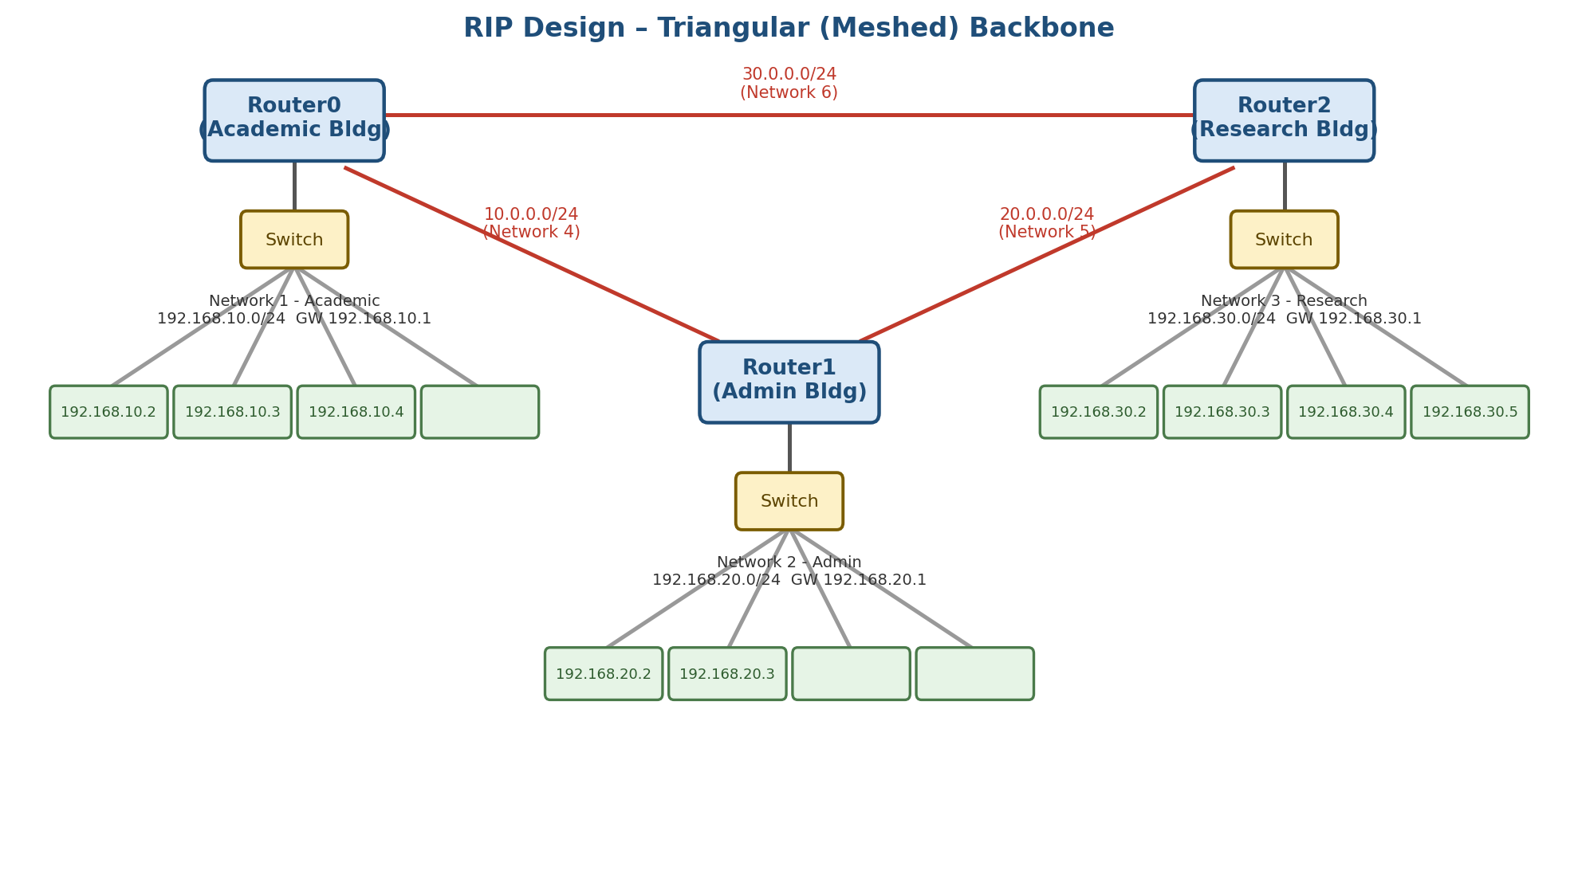
Figure 2: RIP network design - triangular, meshed backbone with redundant paths.

5.3 Router Configuration Summary
The key configuration commands applied on each router are summarised below (interface addressing is applied first in both cases, followed by the routing protocol):

OSPF Configuration (per router)
- interface <backbone-int> -> ip address <network-ip> 255.255.255.0 -> no shutdown
- interface <lan-int> -> ip address <gateway-ip> 255.255.255.0 -> no shutdown
- router ospf 1
- network <lan-network> 0.0.0.255 area 0
- network <backbone-network> 0.0.0.255 area 0

RIP Configuration (per router)
- interface <backbone-int> -> ip address <network-ip> 255.255.255.0 -> no shutdown
- interface <lan-int> -> ip address <gateway-ip> 255.255.255.0 -> no shutdown
- router rip
- version 2
- network <lan-network>
- network <backbone-network>
- no auto-summary

Observation
After configuring both topologies in Cisco Packet Tracer and allowing the protocols to converge, the routing tables of Router0, Router1 and Router2 were examined using the "show ip route" command, and reachability was verified with ping and traceroute between department LANs. The following observations were recorded.
Parameter | OSPF (Linear Backbone) | RIP (Triangular Backbone)
Route code seen in routing table | O (OSPF, AD 110) | R (RIP, AD 120)
Metric used | Cost (based on bandwidth) | Hop count
Routing table formation | Learns Router LSAs, builds full topology (link-state database), then runs SPF (Dijkstra) to compute best paths | Learns entire routing table from directly connected neighbours and periodically exchanges full table (distance-vector)
Convergence speed | Fast - triggered updates as soon as a link-state change is flooded | Slow - relies on periodic updates (every 30 s) and hold-down / timeout timers
Hop-count limit | No hard hop limit (suitable for larger campus networks) | Maximum 15 hops; 16 = unreachable, limiting scalability
Path selection (with redundant link) | N/A in this linear design - only one physical path exists | With the added Router0-Router2 link, RIP selects the 1-hop direct path over the 2-hop path via Router1
Bandwidth utilisation | Uses multicast (224.0.0.5/6) only on link-state changes | Broadcasts / multicasts (224.0.0.9) the full table every 30 seconds regardless of change
Scalability for university growth | High - supports areas, VLSM, and hundreds of routers | Low - flat network only, becomes inefficient beyond ~15 hops

6.1 Routing Table Formation
In the OSPF network, each router first exchanged Hello packets to form neighbour adjacencies over the point-to-point backbone links, then flooded Link-State Advertisements (LSAs) to build an identical link-state database on every router. Each router independently ran the Shortest Path First (SPF) algorithm on this database to compute its routing table, with routes marked with the code 'O' and an administrative distance of 110.
In the RIP network, each router learned about remote networks purely from its directly connected neighbours by periodically broadcasting its entire routing table. Routes appeared with the code 'R' and an administrative distance of 120, with the metric expressed simply as the number of router hops to the destination.

6.2 Convergence
When a backbone link was deliberately shut down during simulation, OSPF re-converged almost immediately because the affected router flooded a new LSA describing the topology change, which every other router used to instantly re-run SPF. RIP took noticeably longer to converge because it depends on periodic (30-second) update cycles and hold-down timers before removing or replacing a failed route, resulting in a temporary period of stale/incorrect routing information.

6.3 Hop Count & Path Selection
Because the RIP topology includes a third backbone link directly between Router0 and Router2 (in addition to the path via Router1), it was possible to observe RIP's path-selection behaviour: RIP always preferred the single-hop direct path over the two-hop path through Router1, purely on the basis of hop count, even though both paths were realistically equivalent in bandwidth in the simulated network. OSPF's linear backbone had no redundant path in this design, so its cost-based path selection could only be verified using the calculated interface costs rather than an alternate physical path.

6.4 Network Scalability
As the number of routers and departments increases, RIP's 15-hop limit and full-table broadcasts would quickly become a bottleneck for a growing university network with many buildings. OSPF's link-state, area-based design and lack of a hop-count ceiling make it noticeably better suited to a campus network that is expected to expand over time.

Conclusion
This project successfully designed, implemented, and tested a multi-department university network connecting the Academic, Administrative, and Research buildings using two different dynamic routing protocols, RIP and OSPF, in Cisco Packet Tracer.
The comparative study clearly showed that while RIP is simple to configure and adequate for very small, flat networks, it suffers from slow convergence, a restrictive 15-hop limit, and inefficient periodic full-table broadcasts. OSPF, on the other hand, demonstrated faster convergence through event-triggered link-state updates, a more accurate cost-based path metric, and no hard limit on network diameter, making it far better suited to a growing, multi-building university environment.
Based on the routing table formation, convergence behaviour, hop-count constraints, and scalability observed during simulation, OSPF is recommended as the preferred dynamic routing protocol for the university's multi-department network, with RIP being suitable only for very small branch segments or as a fallback/legacy protocol.

Future Scope
The current design can be extended in several directions to more closely reflect a real, production-grade university network:
- Implement multi-area OSPF (Area 0 backbone with departmental areas, e.g., Area 1 for Academic, Area 2 for Admin, Area 3 for Research) to further improve scalability and limit LSA flooding domains.
- Apply Variable Length Subnet Masking (VLSM) to the backbone links (e.g., /30 subnets) instead of /24, to conserve IP address space.
- Introduce redundant links and HSRP/VRRP for default-gateway and link failover at each department LAN.
- Add access-control lists (ACLs) and inter-VLAN routing to segment traffic between student, faculty, and administrative devices within each department.
- Extend the design with IPv6 dual-stack addressing (OSPFv3) to prepare the university network for future IPv6 migration.
- Integrate EIGRP or BGP for comparison if the university network were to connect to an external ISP or a second campus, and evaluate hybrid/exterior routing scenarios.
- Deploy network monitoring (SNMP/NetFlow) and simulate real traffic loads to study protocol performance under congestion, not just topology-change convergence.

Reference
- Cisco Networking Academy, "CCNA: Introduction to Networks" - Routing Fundamentals module.
- Cisco Systems, Inc., Cisco Packet Tracer Software Documentation.
- B. A. Forouzan, Data Communications and Networking, McGraw-Hill Education.
- RFC 1058 - Routing Information Protocol (RIP), Internet Engineering Task Force (IETF).
- RFC 2328 - OSPF Version 2, Internet Engineering Task Force (IETF).
- Todd Lammle, CCNA Routing and Switching Study Guide, Sybex.
- Brainware University - Computer Networks (Course Code BTD50112) Study Material.

