Introduction
Using the Food and Drug Administration Adverse Event Reporting System (FAERS), this pharmacovigilance analysis examines whether bisphosphonate medication has significantly higher adverse event rates relating to hepatobiliary reactions, particularly liver-related side effects, as compared to other osteoporosis medications. Bisphosphonates are usually the first choice for osteoporosis treatment. Nitrogen-containing bisphosphonates include alendronate, risedronate, ibandronate, pamidronate, and zoledronic acid. Non-nitrogen containing bisphosphonates include etidronate, clodronate, and tiludronate. In addition, there is little information regarding Bisphosphonate use and liver toxicity, so this study aims to uncover the details.

Data
The data used for the analysis is from the public dashboard of FAERS, FAERS is a database used by the Food and Drug Administration (FDA) in the United States to collect post marketing safety data on approved drugs and therapeutic biologic products. Drug manufacturers are required to send any safety reports to the FDA, while health care professionals and consumers may voluntary do so. The FDA regularly analyzes the received reports for potential safety signals, which would warrant further evaluation and regulatory actions if necessary. Data from 2013-2022 between age Group 18-85 and Bisphosphonate users are being considered.

Method
Reports underwent screening for other adverse reactions, concomitant medications, already affected patients, and indications for medication use that may also contribute to liver side effects. To focus our results on the drug most likely to have caused the adverse event, I limited our analysis to reports in which the drug was considered the primary suspect.
The literature review suggests that few drug classes can cause liver toxicity, so in order to make our results comparable, we compared Bisphosphonate users to two other drug classes which have been associated with liver toxicity.
Comparison group 1: NSAID (Supplementary table 1)
​Comparison group 2: Antibiotic users, based on the most commonly used and having high toxicity (Supplementary table 2)
Comparison group 3: Other drugs used for Osteoporosis (Supplementary table 3)​​.
I used the pipeline below to create final reports for each group for comparison.
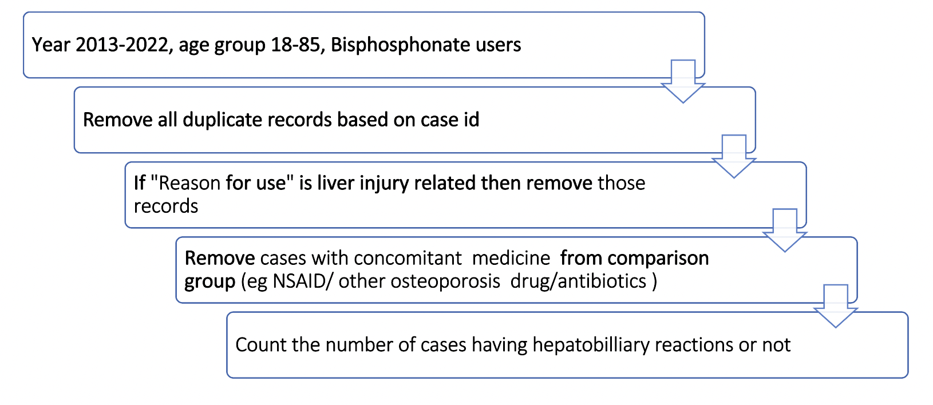“Reason for use”: variable that indicate why the subject was using primary suspect drug, if this variable contains any mention of liver related issue those cases are removed to decrease bias. Keywords to detect presence of any liver related side effects (Supplementary table 4)

Disproportionality analysis was performed to find liver related adverse events associated with Bisphosphonate by comparing Bisphosphonate with the all the three-comparison category from FAERS database using the reporting odds ratio (ROR).

Contingency table used for calculating ROR
 | Interested drug | Compare Drugs | Total
Adverse event P | a | b | a+b
All other adverse events | c | d | c+d
Total | a+c | b+d | a+b+c+d

a = The number of reports of Interested drug with the adverse event of interest (P)
b = The number of reports of compare drugs with the adverse event of interest (P)
c = The number of reports of Interested drug with all other adverse events
d = The number of reports of all other drugs with all other adverse events.

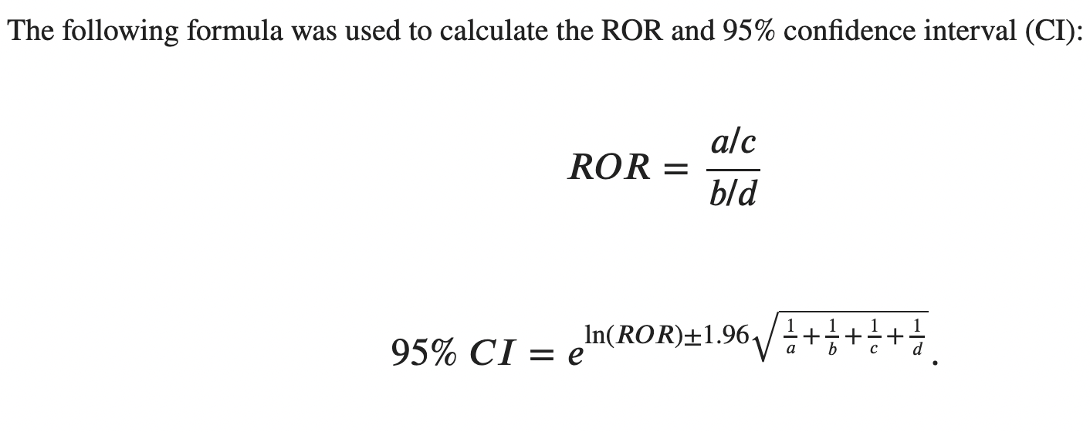

Result

Result 1: The odds of reporting Hepatobiliary reactions among Bisphosphonate users are 0.58 times the odds of reporting Hepatobiliary reactions among NSAID users​, which is expected based on our previous literature review.

 | Bisphosphonate user | NSAID | Total
Hepatobiliary reaction | 1370 | 13608 | 14978
All other AE | 29117 | 168712 | 197829
Total | 30487 | 182320 | 212807

Result 2: The odds of reporting Hepatobiliary reactions among Bisphosphonate users are 0.54 times the odds of reporting Hepatobiliary reactions among Antibiotic drug users​.

 | Bisphosphonate user | Antibiotic drugs | Total
Hepatobiliary reaction | 1405 | 7059 | 8464
All other AE | 29631 | 81006 | 110637
Total | 31036 | 88065 | 119101

Result 3: The odds of reporting Hepatobiliary reactions among Bisphosphonate users are 4.66 times the odds of reporting Hepatobiliary reactions among Other Osteoporosis drug users.

 | Bisphosphonate user | Other Osteoporosis drug | Total
Hepatobiliary reaction | 1674 | 1393 | 3067
All other AE | 28770 | 111583 | 140353
Total | 30444 | 112976 | 143420

Result 4: Confidence Interval for each ROR
group | ROR | CI_low | CI_high
Bisphos_NSAID | 0.58334518 | 0.551062612 | 0.617518938
Bisphos_oth_osteo | 4.660821911 | 4.335938304 | 5.010048428
Bisphos_antibio | 0.544131692 | 0.513067611 | 0.577076573

Result 5: ROR of Hepatobiliary reactions among Bisphosphonate users and other Osteoporosis drug for each of the category
Categories | ROR
drug-induced liver injury | 12.52
liver disorder | 3.82
liver injury | 16.93
cirrhosis | 4.58
hepatitis | 7.61
jaundice | 6.16
hepatocellular carcinoma | 2.97
metastases to liver | 4.96
hepatic | 6.24

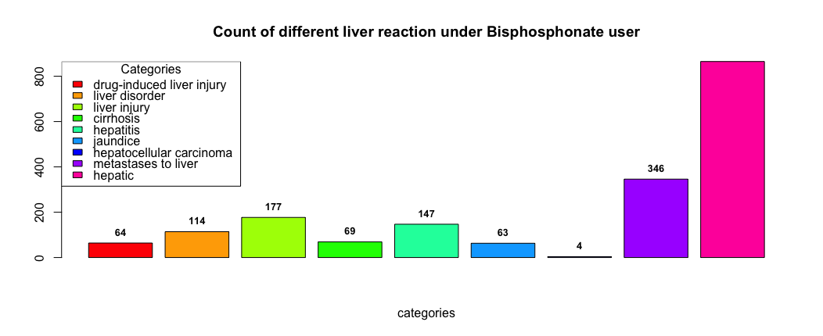
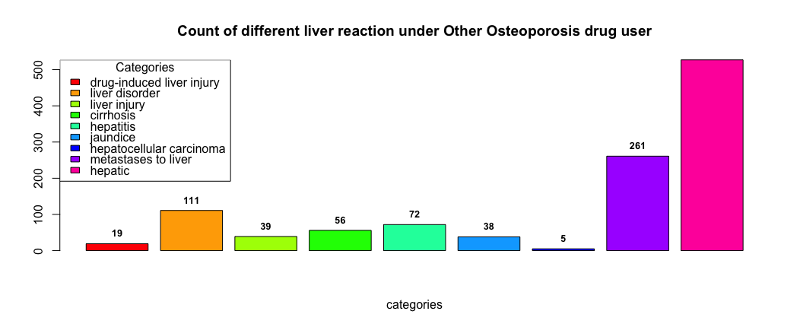
Descriptive Statistics: Supplementary Table 5

Conclusion

Based on the results above it can be concluded that users of Bisphosphonate drug class have a significant higher chance of reporting adverse events related to liver compared to Other Osteoporosis drug classes. The ROR is observed to be high for each of the categories. In all the dataset percentage of females are higher compared than male and the mean age group is above 55 years. ( Supplementary Table 5)

Supplementary Table 1

NSAID for comparison
Aspirin
Celecoxib
Diclofenac
Etodolac
Fenoprofen
Flurbiprofen
Ibuprofen
Indomethacin
Ketorolac
Mefenamic Acid
Meloxicam
Nabumetone
Naproxen
Nimesulide
Oxaprozin
Piroxicam
Rofecoxib
Sulindac
Tolmetin
Pirprofen
Ketoprofen
Benoxaprofen
acetaminophen

Supplementary Table 2

Antibiotic for comparison
amoxicillin
cefadroxil
cefuroxime
minocycline
azithromycin
clarithromycin
erythromycin
ciprofloxacin
levofloxacin
moxifloxacin
sulfasalazine

Supplementary Table 3

Other Osteoperosis drug
Denosumab
Raloxifene
Teriparatide
Abaloparatide
Calcitonin

Supplementary Table 4 : Excel file attached for list of keywords https://michiganstate-my.sharepoint.com/:x:/g/personal/talukda1_msu_edu/EVciB2FMAVZHswJFxlTaw6ABy73ex-T-8IsojPJYZPRjbQ?e=9rWKXL

Supplementary Table 5
