Predictive Analytics and Model Strategy Formulation
Customer Churn Prediction Project — Week 4 Report
Prepared by: Nabeeha
GitHub Repository: github.com/Nabeeha87/customer-churn-prediction-

1. Background: Predictive Analytics and Its Relevance to the Project
Predictive analytics uses historical data, statistical algorithms, and machine learning techniques to identify the likelihood of future outcomes. Rather than only describing what has already happened, it estimates what is likely to happen next, allowing an organization to act before an event occurs rather than react after it. In a subscription or service-based business, one of the highest-value applications of predictive analytics is customer churn prediction — estimating which customers are likely to discontinue service in the near future.
This project uses the Telco Customer Churn dataset, which contains demographic details, account information (tenure, contract type, billing method), and service usage attributes (internet service, add-on services) for a telecom provider's customer base, along with a labeled churn/no-churn outcome for each customer. Because churn is a binary outcome (a customer either leaves or stays) with a known historical record, it is well suited to supervised predictive modelling: the project trains a model on customers whose outcome is already known, and applies it to score current, active customers.
The strategic relevance is direct: acquiring a new customer typically costs significantly more than retaining an existing one, so even a modestly accurate churn model that flags at-risk customers early gives the business a window to intervene — through targeted offers, proactive support, or contract renegotiation — before the customer actually leaves. This document sets out the strategy for building, validating, and refining that predictive model, addressing the feedback from Week 3 by adding a fuller explanation of each stage along with the process flow diagram and project timeline.

2. Strategic Use-Case of Predictive Analytics in This Project
The predictive model produced by this project is intended to serve three connected strategic purposes:
- Early warning: Identify customers with a high probability of churn far enough in advance that the retention team can intervene, rather than discovering churn only in monthly reporting after the fact.
- Root-cause insight: Model coefficients and feature importances (e.g., contract type, tenure, monthly charges, tech support usage) reveal which factors most strongly associate with churn, informing product and pricing decisions beyond just the prediction itself.
- Cost-effective retention: Because acquisition cost outweighs retention cost, even a moderate lift in churn-catch rate translates into measurable savings, making the model's business case straightforward to justify.
These three purposes shape the modelling choices throughout this report: the project favors models that balance predictive strength with a reasonable degree of interpretability, and it evaluates models specifically on their ability to correctly catch churners (recall) rather than on raw accuracy alone.

3. Types of Predictive Models Considered

3.1 Regression-Based Models
Logistic regression is the natural starting point for a binary churn outcome. It models the log-odds of churn as a linear combination of the input features and outputs a calibrated probability of churn for each customer. Its coefficients are directly interpretable — a positive coefficient on 'month-to-month contract' versus a negative one on 'tenure' immediately tells a non-technical stakeholder which factors raise or lower churn risk. This makes it the project's baseline model, against which more complex models are compared.

3.2 Decision Trees
A decision tree splits customers into groups based on a sequence of feature thresholds (for example: is tenure < 12 months? then is contract month-to-month?). Trees naturally capture interactions and non-linear boundaries that logistic regression cannot, and the resulting tree diagram is itself an easy artifact to present to business stakeholders. However, a single tree tends to overfit the training data and can be unstable, which is why it is used here mainly as an interpretable diagnostic step rather than the final production model.

3.3 Ensemble Methods
Ensemble methods combine many individual models to produce a stronger, more stable prediction than any single model alone. Random Forest builds many decision trees on bootstrapped samples and random feature subsets, then averages their votes, which substantially reduces the overfitting problem of a single tree. Gradient Boosting (implemented via libraries such as XGBoost or LightGBM) builds trees sequentially, with each new tree focused on correcting the errors of the ones before it, and typically achieves the strongest raw predictive performance on structured, tabular data such as this churn dataset. The project treats ensemble methods as the primary candidates for the final production model, with logistic regression retained as an interpretable benchmark.

Algorithm | Strengths for This Project | Limitations
Logistic Regression | Fast, interpretable coefficients let stakeholders see which factors (e.g., contract type, tenure) drive churn; strong baseline | Assumes a linear relationship between features and log-odds of churn; underperforms on complex, non-linear interactions
Decision Tree | Captures non-linear splits and interactions (e.g., tenure combined with contract type); easy to visualize for business reporting | Prone to overfitting on training data; unstable — small data changes can produce a very different tree
Random Forest (Ensemble) | Averages many decision trees to reduce variance and overfitting; handles mixed categorical/numeric features well; provides feature importance | Less interpretable than a single tree; slower to train and score at scale
Gradient Boosting (e.g., XGBoost/LightGBM) | Typically the strongest performer on structured/tabular churn data; sequentially corrects prior errors, often highest recall/F1 | Sensitive to hyperparameters and can overfit if not tuned; longer training time and more complex to explain
Table 1. Comparison of candidate algorithms, their strengths for this project, and their limitations.

4. Algorithm Selection Justification
Given the project objective — maximizing the correct identification of likely churners while keeping the model explainable enough for business stakeholders — the selection strategy is staged rather than single-shot:
- Establish logistic regression as the interpretable baseline, since it directly quantifies the effect of each customer attribute on churn probability and sets a minimum performance bar.
- Fit a decision tree to check whether meaningful non-linear interactions exist in the data (for example, whether the effect of monthly charges on churn differs by contract type) that the baseline is missing.
- Train Random Forest and Gradient Boosting models, since ensemble methods generally outperform single models on tabular business data of this kind and are also able to expose feature importances for interpretability.
- Select the final model based on validation-set performance (Section 8) rather than on training accuracy, and retain the runner-up model as a fallback in case the top model does not generalize well to new data after deployment.
This staged approach ensures that model complexity is only added when it demonstrably improves the ability to catch churners, and that the final choice is justified by evidence rather than by defaulting to the most sophisticated algorithm available.

5. Model Development Workflow in Python
The end-to-end workflow will be implemented in Python, primarily using pandas for data handling, scikit-learn for preprocessing, model training and evaluation, and XGBoost/LightGBM for gradient boosting. The workflow below shows the sequence of stages, including the iterative refinement loop that connects performance evaluation back into model training — this loop is the mechanism by which the model is refined over the remaining project weeks rather than built once and left unchanged.

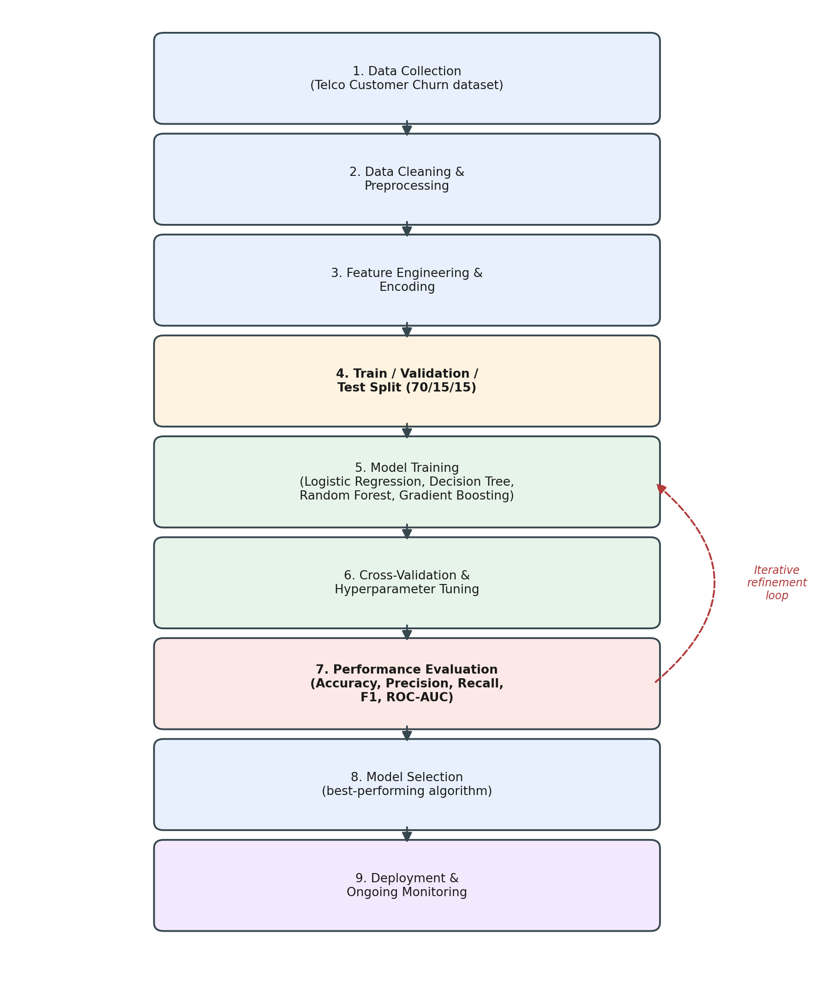
Figure 1. Model development workflow, from data collection through deployment, with the iterative refinement loop.
Key Python components at each stage:
- Data cleaning: pandas for loading and inspecting the Telco Customer Churn CSV; missing-value handling (e.g., blank TotalCharges for new customers) via imputation.
- Preprocessing: scikit-learn's OneHotEncoder/ColumnTransformer for categorical variables (contract type, payment method), StandardScaler for numeric variables (tenure, monthly charges), assembled into a single Pipeline object so preprocessing is applied identically to training and future data.
- Splitting: train_test_split (with stratify=y to preserve the churn/non-churn ratio in every split) to create training, validation, and held-out test sets.
- Model training: LogisticRegression, DecisionTreeClassifier, and RandomForestClassifier from scikit-learn; XGBClassifier from xgboost, each wrapped in the same preprocessing Pipeline.
- Tuning & validation: GridSearchCV or RandomizedSearchCV with StratifiedKFold cross-validation to tune hyperparameters (e.g., tree depth, number of estimators, learning rate) without leaking test data into the tuning process.
- Evaluation: scikit-learn's classification_report, confusion_matrix, and roc_auc_score to compare candidate models on the same held-out test set.

6. Data Splitting Plan
The dataset will be split into three parts to keep model tuning and final evaluation honest:
- Training set (70%): used to fit each candidate model's parameters.
- Validation set (15%): used during hyperparameter tuning and for comparing candidate models before a final choice is made; combined with cross-validation within the training portion for more stable estimates.
- Test set (15%): untouched until the very end, used exactly once to report the final, unbiased estimate of how the selected model will perform on genuinely new customers.
All splits use stratified sampling on the churn label, since churners are a minority class in this dataset (churn datasets are typically imbalanced, often in the range of a 25-30% positive rate); stratification ensures every split reflects the same churn/non-churn proportion as the full dataset, preventing a split from accidentally containing too few (or too many) churners to evaluate the model meaningfully.

7. Model Training and Validation Approach
Each candidate algorithm from Section 3 is trained on the training set using the shared preprocessing pipeline, so that every model sees identically cleaned and encoded features. Rather than tuning hyperparameters against the test set — which would leak information and produce an overly optimistic result — the project uses k-fold cross-validation (k = 5) within the training data: the training set is split into 5 folds, each model is trained on 4 folds and validated on the remaining fold, and this is repeated 5 times so every fold serves as the validation fold once. The average cross-validated score for each hyperparameter combination is used to select the best configuration for each algorithm, and stratified folds are used throughout to preserve the churn ratio in every fold.
Once each algorithm's best configuration has been chosen via cross-validation, the finalists are compared against each other on the separate validation set (not yet the test set) to pick a single algorithm to carry forward. Only the winning model is then evaluated once on the held-out test set, giving a final, unbiased performance estimate to report.

8. Performance Evaluation Metrics
Because churn is an imbalanced classification problem, accuracy alone can be misleading — a model that simply predicts 'no churn' for every customer could still score 70-75% accuracy while catching zero actual churners. The project therefore reports a fuller set of metrics for every candidate model:
Metric | What It Measures | Why It Matters for Churn Prediction
Accuracy | Proportion of all predictions (churn and non-churn) that are correct | Useful as a general check, but misleading alone since churners are typically a minority class
Precision | Of customers predicted to churn, the proportion who actually churned | High precision limits wasted retention spend on customers who were never going to leave
Recall (Sensitivity) | Of customers who actually churned, the proportion the model correctly flagged | Critical here — missing a true churner (false negative) means a lost customer with no intervention
F1-Score | Harmonic mean of precision and recall | Balances the precision/recall trade-off, useful for comparing models on imbalanced churn data
ROC-AUC | Model's ability to rank churners above non-churners across all thresholds | Threshold-independent view of overall discriminative power; good for comparing candidate algorithms
Confusion Matrix | Full breakdown of true/false positives and negatives | Shows exactly where the model errs, guiding threshold selection and business-driven trade-offs
Table 2. Evaluation metrics used to compare candidate models, and why each matters for churn prediction specifically.
Recall and F1-score are weighted most heavily in the final model-selection decision, since the direct business cost of missing a true churner (a false negative — the customer leaves with no intervention attempted) is generally higher than the cost of a false positive (a small retention offer sent to a customer who was not actually going to churn).

9. Limitations, Assumptions, and Potential Biases

9.1 Assumptions
- Stationarity: the relationships between customer attributes and churn observed in past data are assumed to continue holding for current and future customers; if the business changes its pricing or contract structure, the model may need retraining.
- Label accuracy: the labeled historical churn outcomes are assumed to be recorded accurately and consistently; mislabeled churn events would bias the model without being detectable from the data alone.
- Feature completeness: the available features (tenure, contract, billing, service usage) are assumed to capture the main drivers of churn; unobserved factors such as a competitor's marketing campaign or a customer's personal financial situation are not present in the dataset and cannot be modeled.

9.2 Limitations
- Static snapshot: the dataset is a single snapshot rather than a rolling record, so the model cannot capture trends over time (e.g., a customer's usage declining over several months before they churn) — only their attributes at one point.
- Class imbalance: as noted above, churners are a minority class; even with stratification and appropriate metrics, models trained on imbalanced data can still under-predict the minority class, so techniques such as class weighting or resampling (e.g., SMOTE) may be tested as refinements.
- Interpretability trade-off: ensemble models such as Random Forest and Gradient Boosting are less directly interpretable than logistic regression; feature-importance scores approximate but do not fully replace a causal explanation of why a given customer is flagged.

9.3 Potential Biases and Mitigation
- Sampling bias: if certain customer segments (e.g., a specific region or demographic group) are underrepresented in the historical data, the model may perform less reliably for that segment. Mitigation: evaluate metrics separately across key segments, not only in aggregate, and flag segments where performance drops noticeably.
- Proxy bias: a model can learn to associate churn with a feature that is a proxy for a sensitive attribute (e.g., certain payment methods correlating with age or income) rather than a genuine behavioral driver. Mitigation: review the top feature importances for proxies before deployment and consult with stakeholders on whether any flagged feature should be excluded.
- Temporal drift: a model tuned only on historical data can become stale as customer behavior shifts. Mitigation: the contingency plan in Section 10 includes scheduled re-evaluation against fresh data.

10. Contingency Plan for Iterative Improvement
Model development is not treated as a single pass. The following contingencies are built into the remaining project timeline:
- If validation performance is weak: if all candidate models underperform on recall for the churn class, apply class-weighting (class_weight='balanced' in scikit-learn) or SMOTE oversampling on the training set only, then re-run cross-validation.
- If overfitting is detected: if cross-validated performance is notably higher than validation/test performance, reduce model complexity (e.g., limit tree depth, increase regularization) or gather more training data if available.
- If models are tied on performance: if two models perform similarly on recall/F1, prefer the more interpretable one (e.g., Random Forest over Gradient Boosting) unless the performance gap is business-meaningful, since stakeholder trust and explainability are part of the project's strategic goals.
- Post-deployment monitoring: once deployed, periodically re-score a sample of recent customers and compare predicted versus actual churn to detect drift, and schedule retraining if performance degrades below an agreed threshold.
This iterative loop — train, evaluate, adjust, re-evaluate — is represented in Figure 1 as the dashed feedback arrow from Performance Evaluation back into Model Training, and is expected to run across Weeks 5 through 8 of the project as outlined in the timeline below.

11. Project Timeline
The table below places this week's model strategy work in the context of the full eight-week project, showing what has been completed and what remains.
Phase | Week | Key Activities | Deliverable / Milestone
Planning & Framework | Week 1 | Define project scope, dataset (Telco Customer Churn), success metrics and strategic use-case | Strategic data analytics framework document
Data Understanding & Cleaning | Week 2 | Exploratory data analysis, handling missing values/outliers, encoding categorical fields, timeline and flow diagram for cleaning pipeline | Data-cleaning strategy report with flow diagram
Preprocessing & Risk Planning | Week 3 | Finalize preprocessing pipeline, identify risk factors, define concrete mitigation actions and worked examples | Refined project strategy report
Model Strategy Formulation | Week 4 (current) | Select candidate algorithms, define train/validation/test split, plan cross-validation, evaluation metrics and bias review | This document: Predictive Analytics & Model Strategy report
Model Building | Week 5 | Implement preprocessing and baseline models (Logistic Regression, Decision Tree) in Python/scikit-learn | Baseline model notebook + initial metrics
Model Tuning | Week 6 | Train ensemble models (Random Forest, Gradient Boosting), hyperparameter tuning via GridSearchCV/RandomizedSearchCV | Tuned model with cross-validated scores
Evaluation & Validation | Week 7 | Compare models on hold-out test set, confusion matrix and ROC-AUC analysis, bias/fairness check across customer segments | Model evaluation report
Finalization & Deployment Plan | Week 8 | Select final model, document limitations, propose monitoring/retraining plan, prepare final submission and GitHub repo | Final project report + GitHub repository
Table 3. Eight-week project timeline showing completed phases and planned remaining work.

12. Conclusion
This report sets out a staged, evidence-based strategy for building a customer churn prediction model: starting from an interpretable logistic regression baseline, testing whether a decision tree reveals meaningful non-linear structure, and then training ensemble methods (Random Forest and Gradient Boosting) as the primary candidates for production use. The plan uses stratified train/validation/test splitting and k-fold cross-validation to select and tune models honestly, and evaluates candidates primarily on recall and F1-score given the imbalanced nature of churn data and the higher business cost of missing an actual churner. The report also documents the assumptions, limitations, and potential biases inherent in the modelling approach, along with concrete mitigation steps and a contingency plan for iterative refinement across the remaining weeks of the project, directly addressing the feedback received on the Week 3 submission by including the process flow diagram (Figure 1) and full project timeline (Table 3).

