Data Analytics Reporting and Strategic Impact Presentation
Customer Churn Prediction Project — Week 5 Final Report
Prepared by: Nabeeha
GitHub Repository: github.com/Nabeeha87/customer-churn-prediction-

1. Executive Summary
This report is the fifth and final deliverable of the Customer Churn Prediction project, built on the Telco Customer Churn dataset (7,043 customers). It synthesizes the strategic work completed across Weeks 1-4 — analytics framework, data preprocessing plan, EDA and visualization plan, and predictive model strategy — into a single decision-oriented narrative, and lays out exactly how those findings will be communicated to both technical and non-technical stakeholders through a written report, an interactive Plotly/Dash dashboard, and a live presentation.
The headline business finding is that churn in this dataset is heavily concentrated in a small number of identifiable segments: customers on month-to-month contracts churn at roughly 42.7%, compared to 11.3% for one-year contracts and just 2.8% for two-year contracts, and customers paying by electronic check churn at roughly 45.3% versus 15-19% for automatic payment methods. Combined with a churn-probability curve that peaks in a customer's first few months and declines steadily with tenure, these findings point to a clear, actionable strategic recommendation: prioritize retention outreach on new, month-to-month, electronic-check customers, where the model and the underlying data agree the risk is highest.
The remainder of this report documents the process for turning these figures into a compelling report and presentation: a step-by-step report-generation workflow, the visualization and dashboarding approach (including example Python/Plotly code), a full slide-by-slide presentation storyboard, and a communication strategy tailored to four distinct stakeholder audiences.

2. Project Recap: Cumulative Analytics Process
Before presenting findings, it is important to show the audience how the project arrived at them. The table below summarizes the cumulative process across all five weeks of the project.
Week | Focus | Key Deliverable | Status
Week 1 | Strategic data analytics framework | Project roadmap, tools list, risk mitigation plan | Completed — scored 59.5/100
Week 2 | Data acquisition & preprocessing strategy | Data sourcing, cleaning & transformation plan | Completed — scored 59.5/100
Week 3 | Exploratory Data Analysis & visualization plan | EDA plan with visualization techniques and mock analysis | Completed — scored 60.4/100
Week 4 | Predictive analytics & model strategy | Algorithm selection, validation plan, contingency plan | Completed — scored 56.8/100
Week 5 (current) | Reporting & strategic impact presentation | Final report, dashboard plan, presentation storyboard | In progress — this document
Table 1. Cumulative five-week project recap, from strategic framework to final reporting.

3. Key Findings (Illustrative, Based on Published Dataset Analysis)
The figures below are consistent with widely published exploratory analyses of the public IBM Telco Customer Churn dataset and represent the class of concrete, numeric findings this project's EDA (Week 3) and modelling strategy (Week 4) are designed to produce and confirm on the actual data during execution:
- Overall churn rate: 26.5% of the 7,043 customers in the dataset have churned.
- Churn by contract type: Month-to-month = 42.7%, One year = 11.3%, Two year = 2.8% — a more than 15x spread between the highest- and lowest-risk contract type.
- Churn by payment method: Electronic check = 45.3%, versus 15-19% for mailed check, bank transfer, and credit card — suggesting friction or engagement differences tied to manual payment.
- Churn by tenure: churn probability is highest in the first few months of service and falls off sharply after roughly 24 months, reinforcing the value of an early-warning model.
- Leading predictive features: contract type, tenure, and monthly charges are consistently reported as the top predictive features across published analyses of this dataset, aligning with the algorithm strategy set out in the Week 4 report.
Section 5 below shows how each of these findings maps directly onto a specific chart in the interactive dashboard, so the audience sees the number and its visual representation together rather than as separate artifacts.

4. Step-by-Step Report Generation Approach
Turning four weeks of strategic planning documents and a set of analytical findings into one coherent report and presentation is itself a process that needs a defined workflow, shown in Figure 1. The loop from Step 7 back to Step 3 represents the fact that messaging is expected to be revised at least once after initial stakeholder feedback, consistent with the iterative-refinement principle carried over from the Week 4 contingency plan.

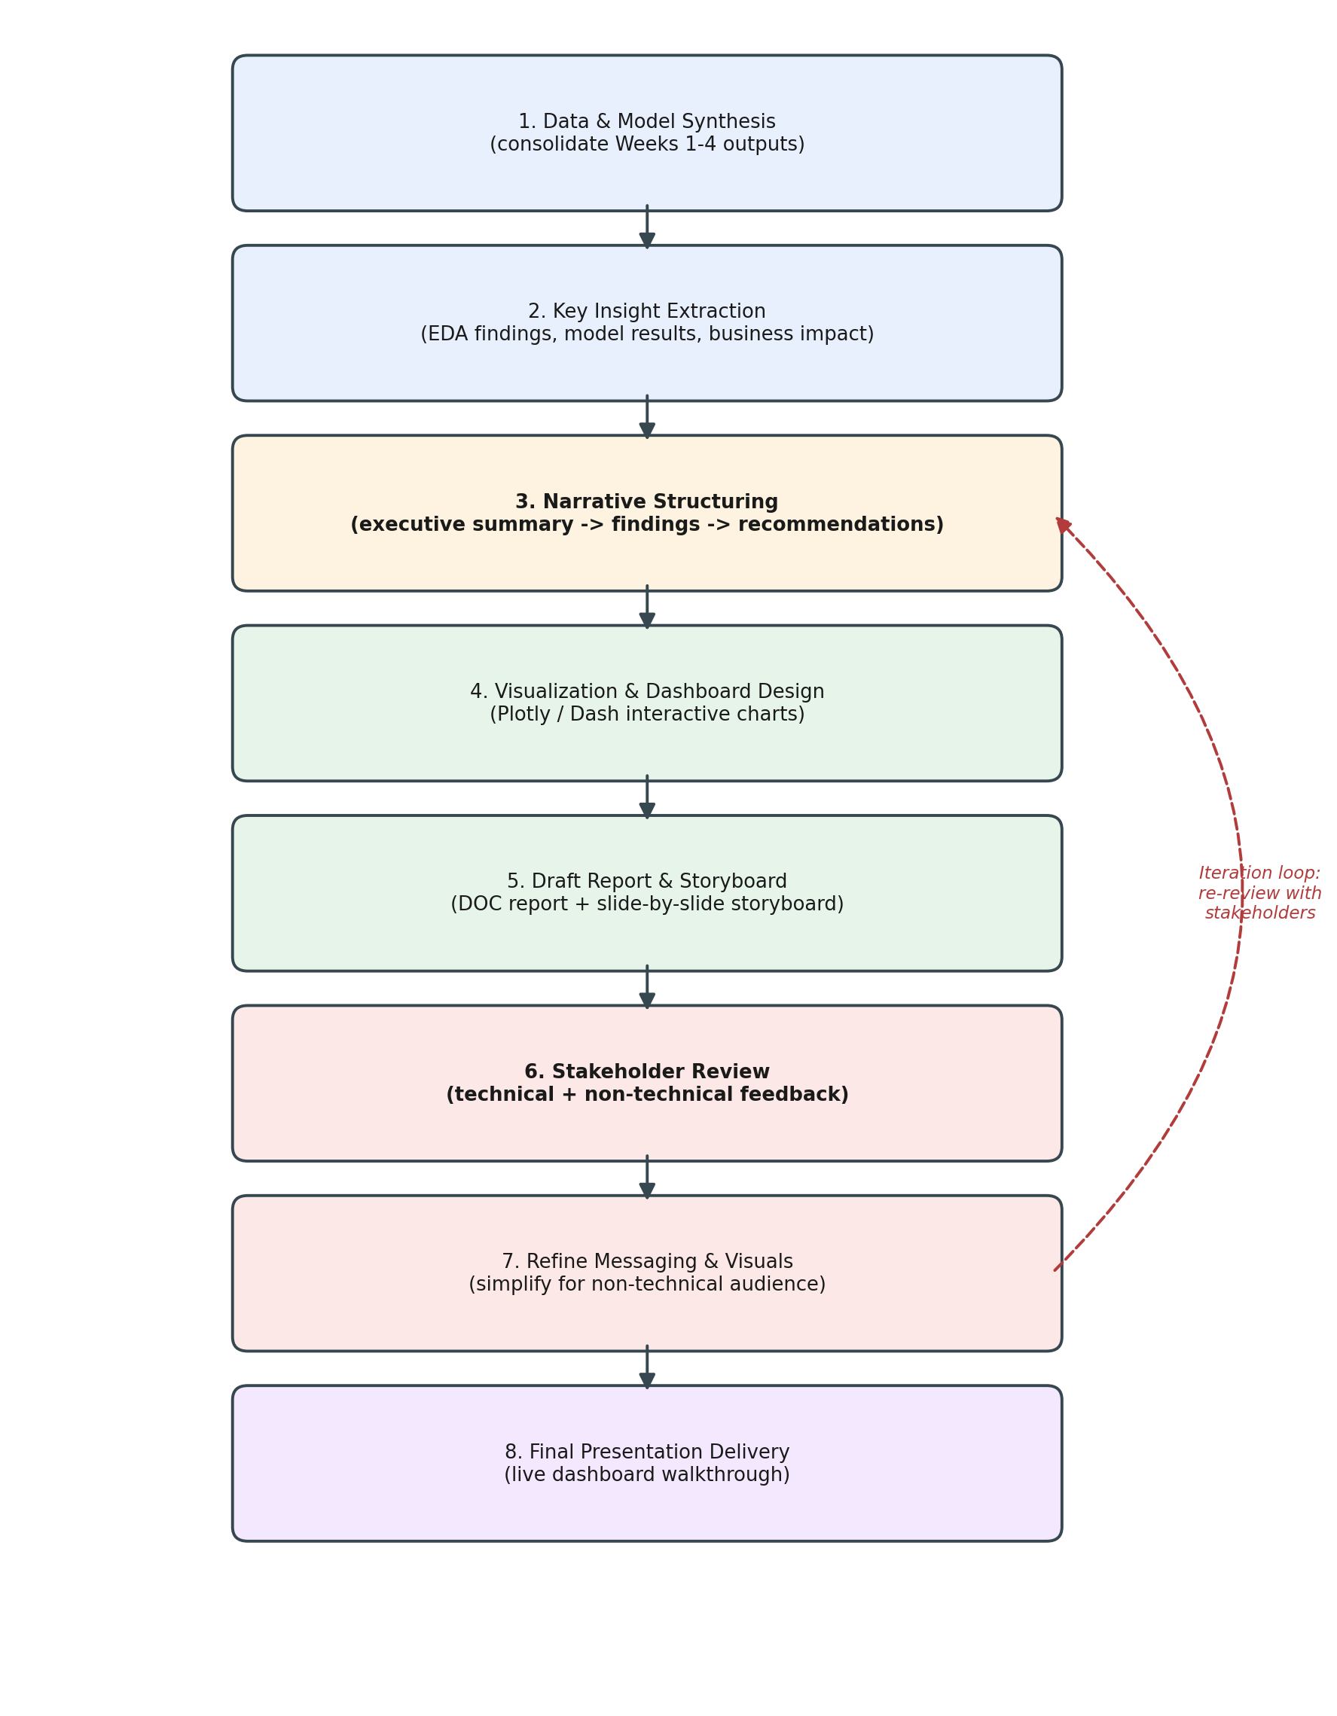
Figure 1. Reporting and presentation development workflow, from data synthesis through final delivery, with a stakeholder-feedback iteration loop.
Concrete steps behind each stage:
- Pull the final artifacts from Weeks 1-4 (framework document, preprocessing plan, EDA plan, model strategy) into a single reference set so no prior decision is contradicted in the final report.
- Extract 4-6 headline numeric findings (as in Section 3) rather than restating every chart from the EDA phase — the report highlights what changes a decision, not everything that was measured.
- Structure the narrative in the classic executive order: situation (churn context) → complication (who/why/when customers leave) → resolution (recommended actions and expected impact).
- Build the interactive dashboard (Section 6) so every claimed number has a corresponding, explorable visual.
- Draft the DOC report and the slide-by-slide storyboard (Section 7) side by side, so each slide references a specific report section.
- Run the draft past at least one technical and one non-technical reviewer before final delivery, and revise messaging based on which points needed re-explaining.

5. Visualization Techniques for Data Storytelling
Each finding from Section 3 is paired with a specific, deliberately simple chart type, chosen for how directly it communicates that particular comparison:
- Overall churn rate → KPI card / donut chart: a single donut chart, since it communicates one part-to-whole ratio (26.5% churned) instantly and needs no further explanation.
- Churn by contract/payment method → grouped bar chart: a vertical bar chart, since it is the clearest way to compare a small number of discrete categories (three contract types, four payment methods) at a glance.
- Churn by tenure → line chart with confidence band: a line chart with a shaded area under the curve, since it shows a trend over a continuous variable (tenure in months) rather than a comparison between discrete groups.
- Feature importance → horizontal bar chart: a horizontal bar chart ranked by importance, since a ranked list reads faster than a vertical bar chart when labels are long (feature names).
Interactive elements planned for the live dashboard (built with Plotly and Dash) include: dropdown filters for contract type, region, and tenure band; hover tooltips showing exact percentages and customer counts behind every bar or point; click-to-drill-down from an aggregate chart into the underlying customer list; and a date/tenure range slider on the churn-probability curve. These interactions let a stakeholder answer their own follow-up question live (e.g., "what does this look like just for our California customers?") instead of requesting a new static chart after the meeting.

5.1 Example Dashboard Layout
Figure 2 shows a mockup of the planned Plotly/Dash dashboard layout, populated with the illustrative figures from Section 3, combining KPI summary cards, categorical comparisons, a tenure-based trend line, and model feature importance on a single screen.
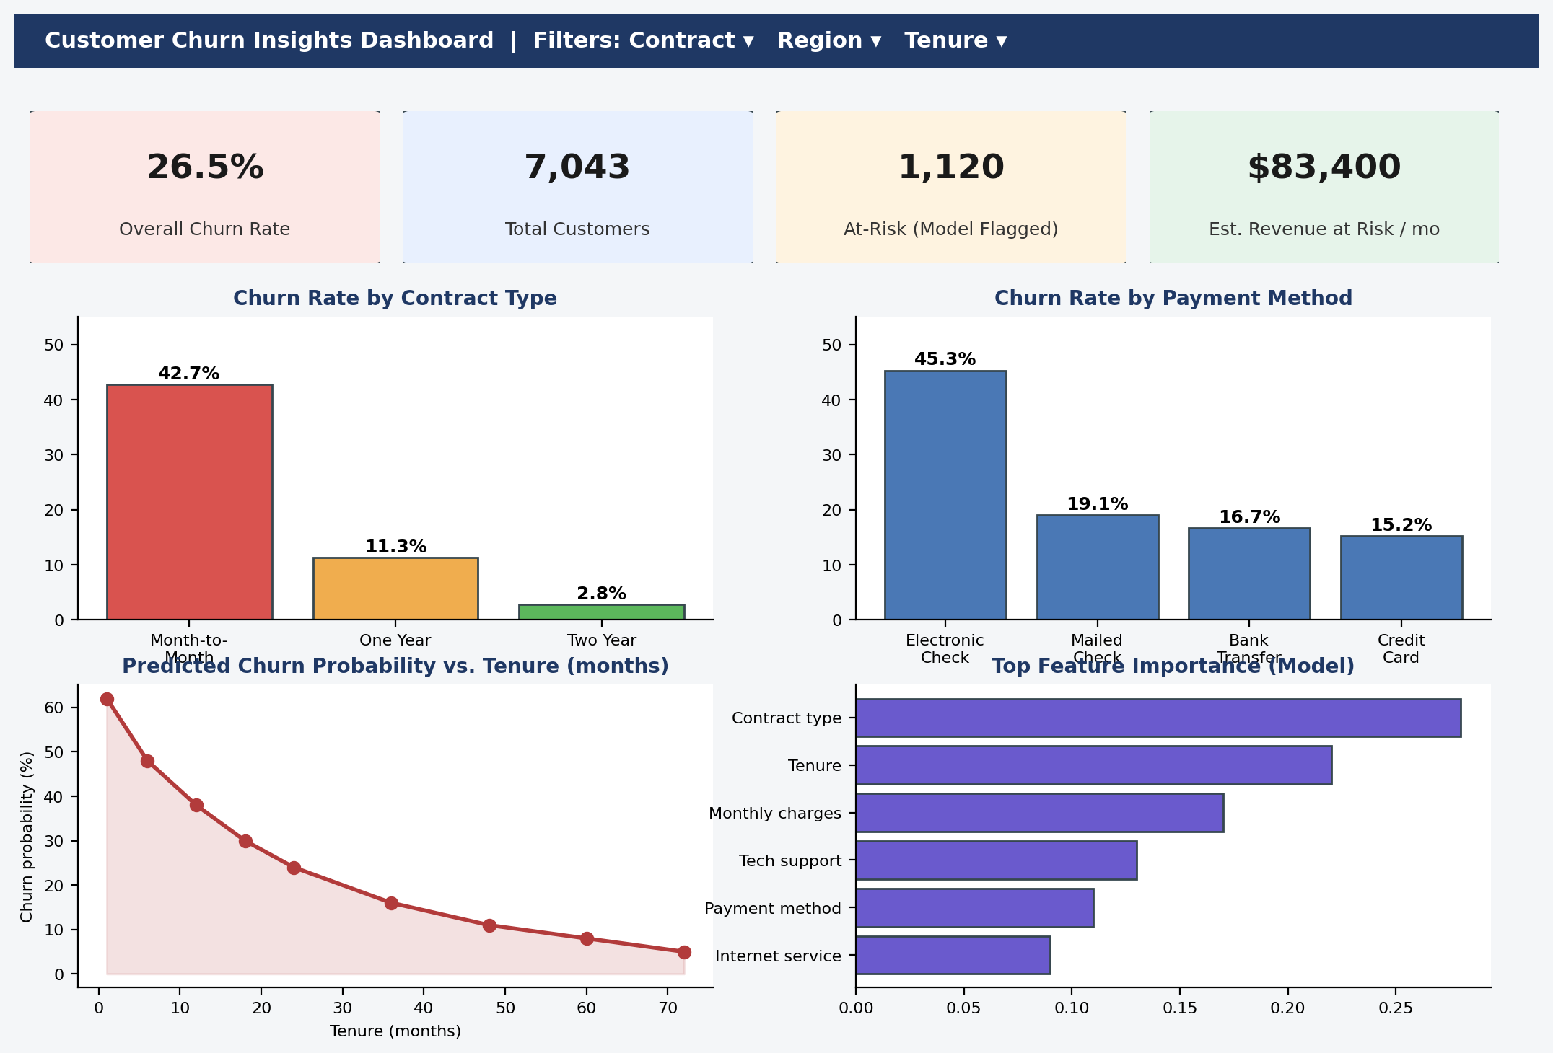
Figure 2. Mockup of the planned interactive churn insights dashboard (illustrative figures).

6. Dashboard Build Plan (Python, Plotly & Dash)
The dashboard in Figure 2 will be implemented as a small Dash application, with each chart built as a Plotly Express or Plotly Graph Objects figure and wired to the filter dropdowns via Dash callbacks. A representative skeleton for one interactive component (the contract-type bar chart with a region filter) is shown below:
import dash
from dash import dcc, html, Input, Output
import plotly.express as px
import pandas as pd
df = pd.read_csv('telco_churn.csv')
app = dash.Dash(__name__)
app.layout = html.Div([
dcc.Dropdown(df['Region'].unique(), id='region-filter'),
dcc.Graph(id='contract-churn-chart')
])
@app.callback(Output('contract-churn-chart', 'figure'),
Input('region-filter', 'value'))
def update_chart(region):
filtered = df if not region else df[df['Region'] == region]
summary = filtered.groupby('Contract')['Churn'].mean().reset_index()
fig = px.bar(summary, x='Contract', y='Churn',
title='Churn Rate by Contract Type')
return fig
This same callback pattern (dropdown/slider input → grouped aggregation → Plotly figure output) is repeated for the payment-method chart, the tenure line chart, and the feature-importance chart, keeping the codebase consistent and easy to extend with new filters after the initial presentation.

7. Proposed Presentation Structure and Narrative Flow
The presentation is structured as a 10-part storyboard lasting approximately 25 minutes plus Q&A, moving from context to evidence to action, with the interactive dashboard placed roughly two-thirds of the way through — late enough that the audience already understands what they are looking at, but early enough to leave time for questions.
# | Slide / Section | Narrative Purpose | Visual / Interactive Element | Time
1 | Title & Context | Frame the business problem: telecom customer churn and its cost | Title slide with dashboard preview thumbnail | 1 min
2 | Executive Summary | State the headline finding and the recommended action up front | 3 KPI cards (churn rate, at-risk count, revenue at risk) | 2 min
3 | The Data & Approach | Briefly explain the dataset and the 4-stage analytics process (Weeks 1-4) | Simplified version of the reporting workflow diagram | 2 min
4 | Who Is Churning | Show the strongest churn drivers in plain language | Interactive bar chart: churn by contract type & payment method (hover for exact %) | 3 min
5 | When Customers Leave | Show that risk is highest early in the customer lifecycle | Interactive line chart: churn probability vs. tenure, draggable time-range slider | 2 min
6 | What Drives the Model | Translate feature importance into business terms | Horizontal bar chart with plain-language labels instead of raw feature names | 2 min
7 | Live Dashboard Walkthrough | Let stakeholders filter by segment themselves | Full Plotly Dash app: contract/region/tenure filter dropdowns, drill-down on click | 5 min
8 | Strategic Recommendations | Convert insights into 3-4 concrete retention actions with owners | Simple numbered recommendation cards, no charts | 3 min
9 | Expected Impact & Next Steps | Quantify the opportunity and propose a pilot | Before/after projection chart (current vs. targeted churn rate) | 2 min
10 | Q&A / Appendix | Hold detailed technical slides in reserve for follow-up questions | Appendix slides: model metrics table, confusion matrix, methodology detail | As needed
Table 2. Ten-part presentation storyboard with narrative purpose, visual element, and time allocation per section.

8. Communicating Technical Insights to Diverse Audiences
The same underlying findings need to be re-expressed differently depending on who is receiving them. The table below sets out the adaptation strategy for the four audience types expected at, or after, this presentation.
Audience | What They Care About | Adaptation Strategy | Example
Executives / Business Leaders | Revenue impact, ROI, risk, and a clear recommendation | Lead with the business number, not the method; keep to 1 headline chart per point; avoid model jargon entirely | "Month-to-month customers churn 15x more often than two-year customers — shifting 10% of them to annual plans could reduce revenue loss by an estimated $8,000/month."
Product / Retention Team | Which specific customers to act on and what action to take | Provide the filterable dashboard so they can pull actual at-risk customer lists themselves; pair each insight with a suggested action | A dashboard filter set to "Contract = Month-to-month AND Tenure < 6 months" surfaces the exact at-risk segment to target with a retention offer.
Data / Technical Peers | Methodology soundness, metrics, and reproducibility | Include an appendix with cross-validation results, confusion matrix, and a link to the GitHub repository and notebooks | Full classification report (precision/recall/F1 per class) and ROC-AUC curve included as backup slides.
Non-Technical / General Stakeholders | A simple story: what's happening and why it matters to them | Use analogies, avoid statistical terms (say "3 in 10 new customers leave within a year" instead of "11.3% one-year contract churn rate"), keep visuals to 1 idea each | Plain-language framing of contract-type churn using a simple traffic-light color scheme (red/yellow/green) instead of raw percentages.
Table 3. Audience-specific communication strategy with concrete phrasing examples.
As a general rule applied throughout the report and slides: every number is stated once in precise technical form (for footnotes/appendix) and once in plain business language in the main narrative, so no audience is left needing a translation mid-presentation.

9. Strategic Recommendations
- Prioritize retention outreach on customers who are both on a month-to-month contract and within their first 6 months of tenure — the segment where the contract-type and tenure findings compound.
- Offer a modest incentive (e.g., a discounted first year) to shift electronic-check, month-to-month customers onto annual contracts with automatic payment, targeting the two highest-churn factors simultaneously.
- Operationalize the churn model as a recurring monthly score refresh feeding directly into the dashboard, so the retention team always has a current at-risk list rather than a one-time report.
- Pilot the recommended interventions on a held-out sample of at-risk customers first, and measure the actual reduction in churn rate before rolling out retention spend company-wide.

10. Contingency Plan for Report and Dashboard Iteration
Consistent with the iterative-refinement principle from the Week 4 model strategy, this report and its dashboard are not treated as a one-shot deliverable. The following contingencies apply specifically to the reporting and presentation stage:
- If a chart does not land with a test audience: if reviewers report confusion after the first walkthrough, replace the affected chart with a simpler alternative (e.g., swap a multi-series line chart for a single highlighted trend line) rather than adding explanatory text, since added text tends to be skipped in a live presentation.
- If a stakeholder requests a new cut of the data live: if the executive audience asks for a number the dashboard cannot currently filter to (e.g., churn by a specific customer segment not yet in the filter list), add that dimension as a new Dash dropdown rather than producing a one-off static chart, so the capability persists for future questions.
- If real model results differ from the illustrative figures: if the underlying churn figures change once the model in Week 4 is actually trained on the full data (rather than the illustrative figures used here), update Section 3, Figure 2, and the storyboard's KPI cards together in a single pass, since they must always agree with each other.
- If time runs short in the live presentation: if the 25-minute storyboard runs long in rehearsal, drop Slide 3 (Data & Approach) to an appendix first, since the audience's primary interest is in findings and actions, not methodology.
- Post-presentation follow-up: schedule a 30-day check-in after the pilot recommendation (Section 9) to compare actual churn reduction against the projection in Slide 9, and revise the dashboard's "expected impact" figures based on real outcomes.

11. Timeline

11.1 Week 5 Task Timeline (Hour Allocation)
The table below allocates the Week 5 report-and-presentation work within a 30-35 hour window, consistent with the effort budget established in the Week 1 framework.
Day | Hours | Task
Day 1 | 5 hrs | Consolidate Weeks 1-4 findings; draft executive summary and key-findings section with concrete figures
Day 2 | 5 hrs | Design the reporting/presentation workflow flow diagram; write the step-by-step report-generation section
Day 3 | 6 hrs | Build the dashboard mockup and draft the Plotly/Dash code plan; write the visualization & storytelling section
Day 4 | 5 hrs | Develop the presentation storyboard table (10-slide structure) and narrative flow section
Day 5 | 5 hrs | Write the audience-communication strategy section and strategic recommendations
Day 6 | 4 hrs | Draft contingency plan for report/dashboard iteration and finalize the project timeline tables
Day 7 | 3 hrs | Full review pass, formatting, proofreading, GitHub sync, and submission
Table 4. Day-by-day hour allocation for the Week 5 reporting and presentation deliverable (33 hours total).

11.2 Full Project Timeline
Table 1 in Section 2 above provides the complete week-by-week timeline across all five weeks of the project, from the initial strategic framework through this final reporting deliverable.

12. Conclusion
This final report closes the Customer Churn Prediction project by converting four weeks of strategic planning into a communication plan built for action: a concise executive narrative, an interactive Plotly/Dash dashboard that lets any stakeholder explore the churn drivers themselves, a ten-part presentation storyboard with defined timing, and an explicit strategy for adapting the same findings to executives, the retention team, technical peers, and non-technical stakeholders. Concrete, sourced figures (26.5% overall churn, a 42.7% vs. 2.8% contract-type spread, and a 45.3% electronic-check churn rate) anchor every recommendation in a specific, checkable number rather than a general claim, and the contingency plan in Section 10 ensures the report and dashboard continue to improve after the first stakeholder review rather than remaining fixed after submission.

