1. **Credit Due Date to be removed**

**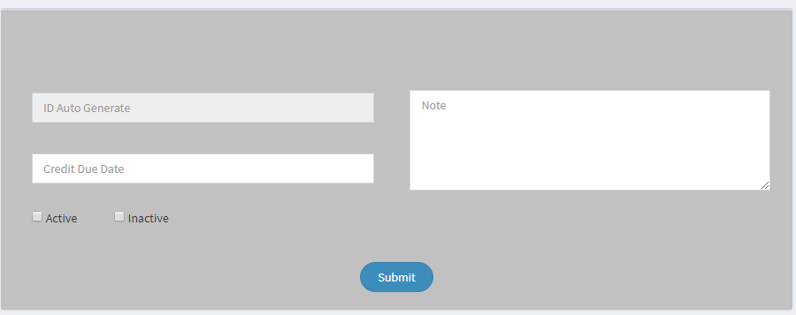  
  
No Database of this Credit Due Date Form…**

**2) Salesperson per and fixed separate text field**



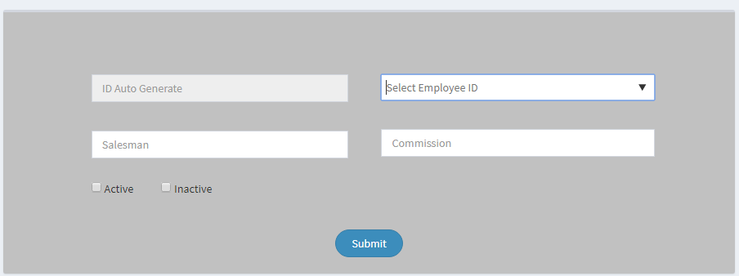

**This Salesperson form is not match with above database columns…**

**3)**

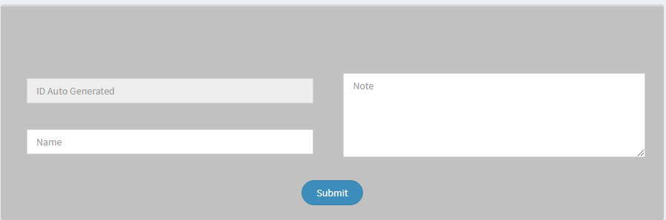

**No Database of this Cancellation Request Form…**

**4) Terms & Conditions to be change both**

**There are 2 tables of Terms & Conditions (i) 00000_mst_terms_condition (ii) 00000_mst_terms_condition_detail**

1. 
2. 

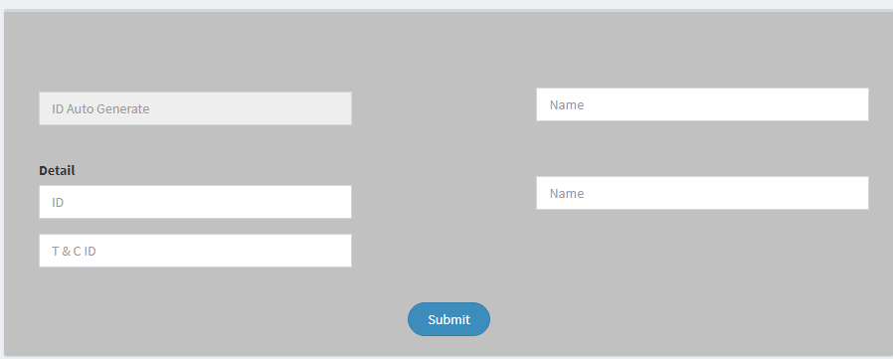

**This terms & Conditions form is not match with both database columns and there is no form of terms and conditions Details..**

**5) Room Type**



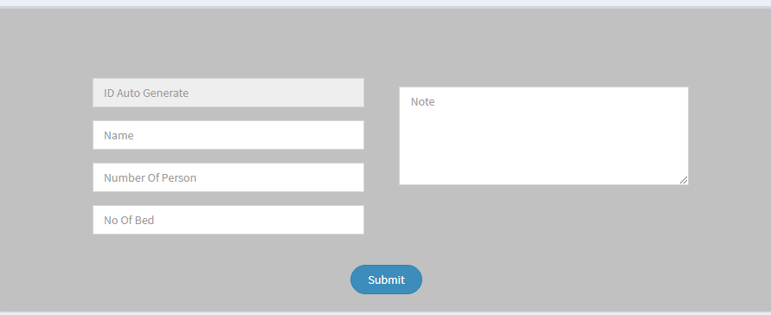

**This Room Type form is not match with above database columns.**