Readme file
Student number: ST10066882

Nabeel Van Niekerk

Group 2

Third Year

Lecturer: Rudolf Holzhausen

Table of Contents
Nabeel Van Niekerk 0
Group 2 0
Project Overview 2
Farmer 2
Employee 2
Prerequisites 2
Running the Application 2

Figure 1:Drop Down Select Extract All 2
Figure 2:Example of Extracting project contents From Zip File 3
Figure 3:Project File will open project in Visual Studio 3
Figure 4:Green Arrow to run project In Visual Studio 3

Project Overview
The following project is a website portal where Farmers and employees can log to perform their respective functions. Below are the following functions that each role in the application can perform:

Farmer
- Create products and add them to the database.
- View their respective projects that they added to the database.

Employee
- Create new profiles for Farmers.
- View all the Farmers in the database.
- View all the products each farmer has added.
- Filter products created by farmer.
Note all Data is preserved in a SQL Server Database and has the appropriate authentication to only allow valid user entry to the database.

Prerequisites
To Run the Project, you will need to install Visual Studio Community edition 2022 you can do so by clicking on the following link: https://visualstudio.microsoft.com/downloads/.
You will also need to have .Net 8.0 which you can install by clicking on the following link: https://dotnet.microsoft.com/en-us/download.
You Must also have the project Zip file called ST10066882 Nabeel Van Niekerk POE PART 2.zip.

Running the Application
- You First want to extract the zip file.
  - This is done by Right-clicking on the folder and selecting the “Extract all” option.
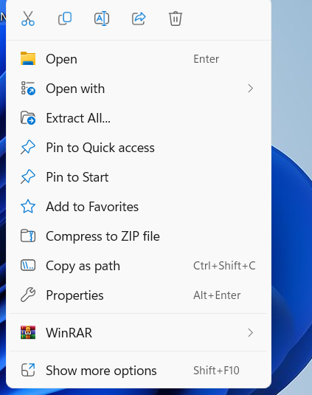
Figure 1:Drop Down Select Extract All
  - You must the choose where do you want to place the project and if you want to rename it.
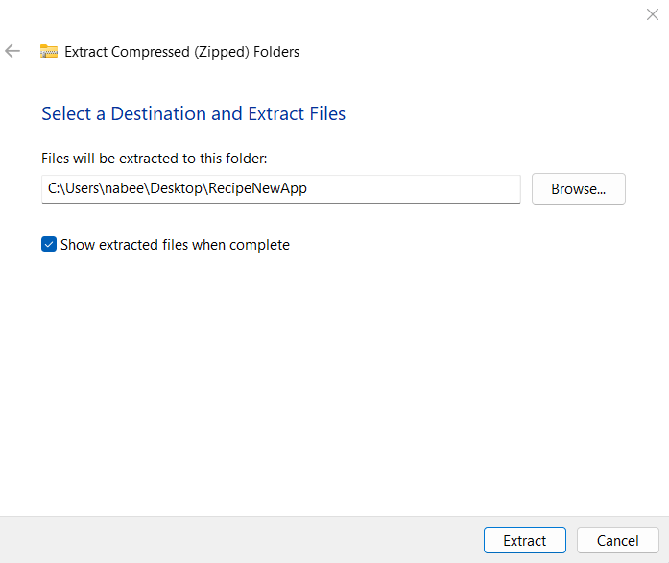
Figure 2:Example of Extracting project contents From Zip File
- Next Open the project folder and look for the following file and double click on it to open the project in visual studio.
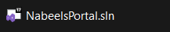
Figure 3:Project File will open project in Visual Studio
- Next To run the web Application you can find a Green Arrow on top and click on it.
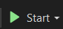
Figure 4:Green Arrow to run project In Visual Studio

Note if project doesn’t run and fails attempt the following:
- Clean solution and rebuild solution you can find both options in the Build tab in Visual Studio.
- Check the connection String and make necessary changes so that it runs on your machine.
- Might need to restore NuGet Packages to do so do the following:
  - Right click on the solution inn solution explorer.
  - Select “Restore NuGet Packages”.

