**#SYEDNABEELDANISH**

**#CS142007 #7B**

**BLOG:**

**CRISTIANO RONALDO:**

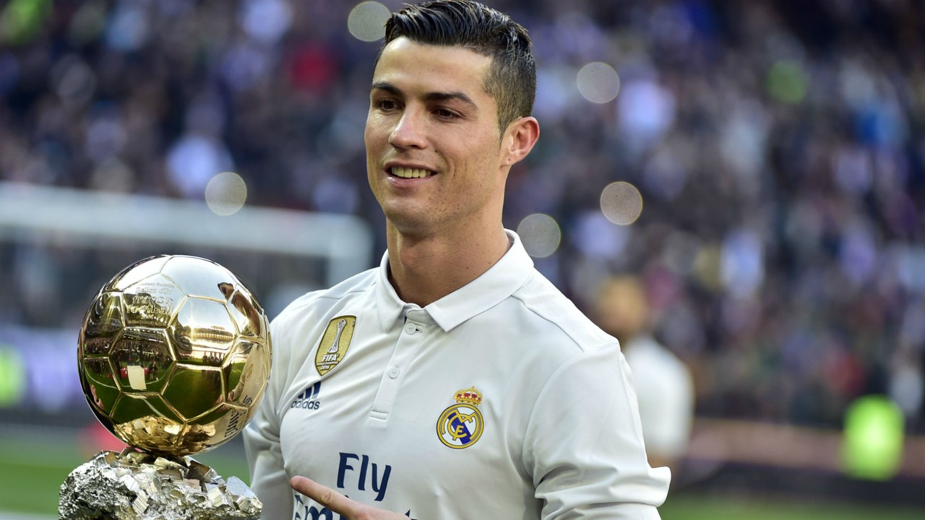Real Madrid forward Cristiano Ronaldo has said that at a certain point in his career he decided to focus less on showing off his skills and more on scoring goals.

Between 2003 and 2009, Ronaldo scored 118 goals in 291 matches for Manchester United, but drew criticism early on at Old Trafford for often attempting fancy step-overs.

Since moving to Madrid, the Portugal captain has upped his rate considerably and is on 411 goals in 401 outings for the club, while in recent times the former winger has often played as a center-forward.

"In a game the most important thing is to win," Ronaldo said. "And goals helps to win. You can mix -- first goals, and after tricks and assists after. What the people want is goals, so I try to score goals."

Asked if it had been difficult to focus on being efficient, Ronaldo said he still found time to bring out some skills, but it could not be his first priority.

"I still do it, not the same as at Manchester, but I still do it," he said. "Now I prefer goals, am focused more on goals. Skills comes third.”