I trained my model with 64 batch size 0.0005 learning rate, and 100 epochs. The accuracy I obtained is 65 %. training loss is 0.015026529441773892.

Epoch19 accuracy on test data: 65.72000122070312

Epoch19 loss on test data: 0.015026529441773892

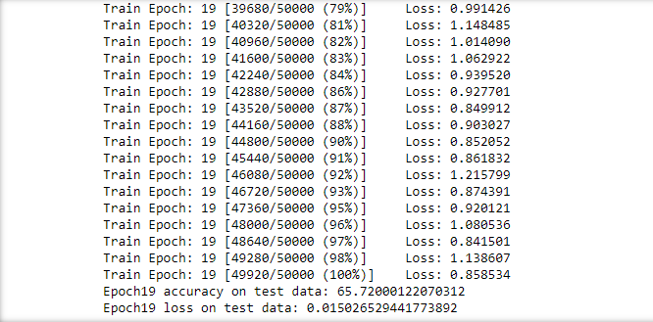

Accuracy curve on validation data against epoch number

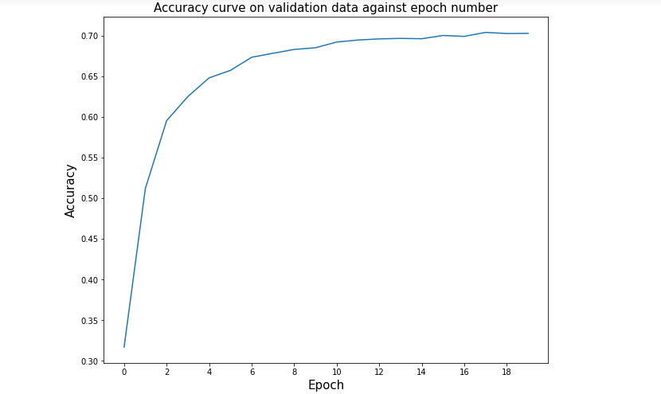

Validation loss against epoch number

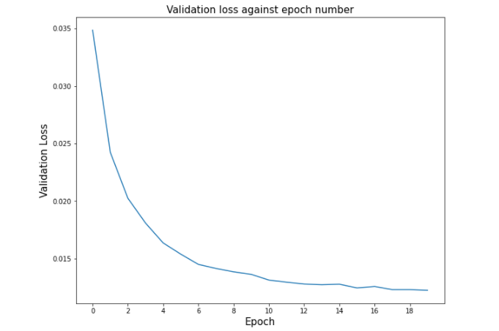

Precision curve for all classes on validation data against epoch number

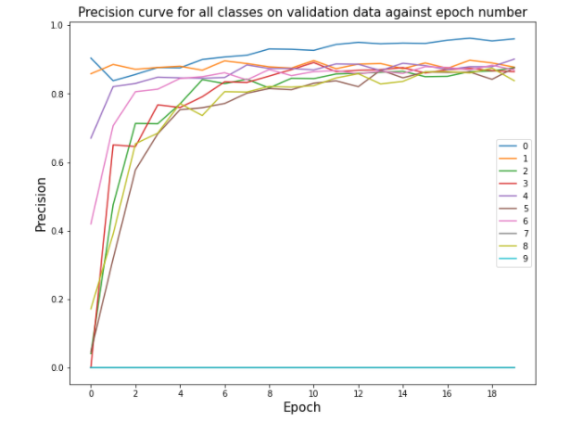

Recall curve for all classes on validation data against epoch number

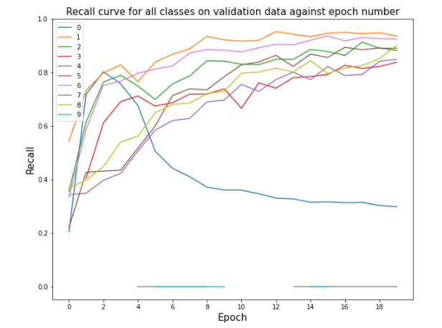

F1 Score curve for all classes on validation data against epoch number

