**Lane Detection using Hough Transform**

In this project I have detected lane lines in images using Python and OpenCV. Image taken for road lane detection is given below.

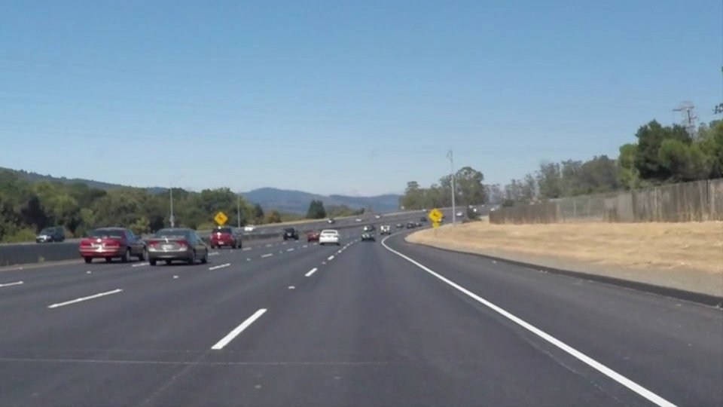

Binary Image showing the output of step 2 is given below.

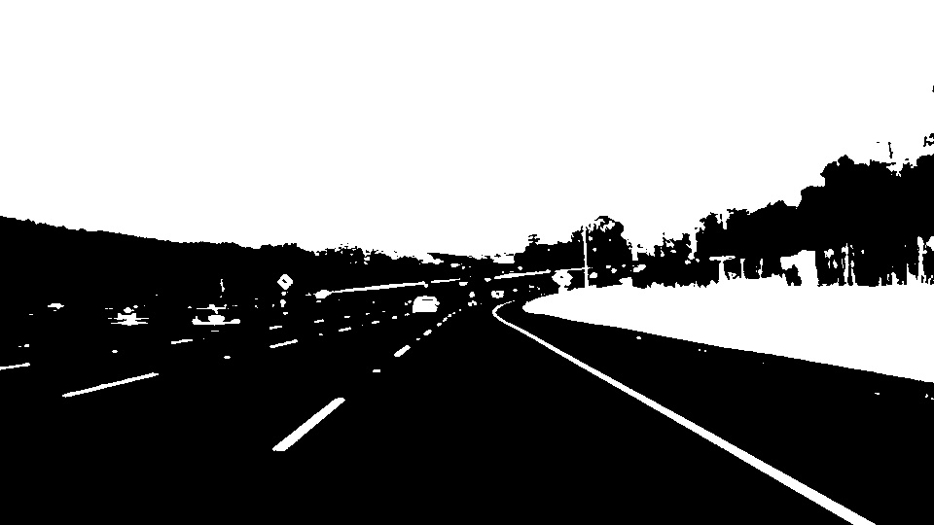

Filtered image - yellow and white colored pixels by varying different hue and saturation values.

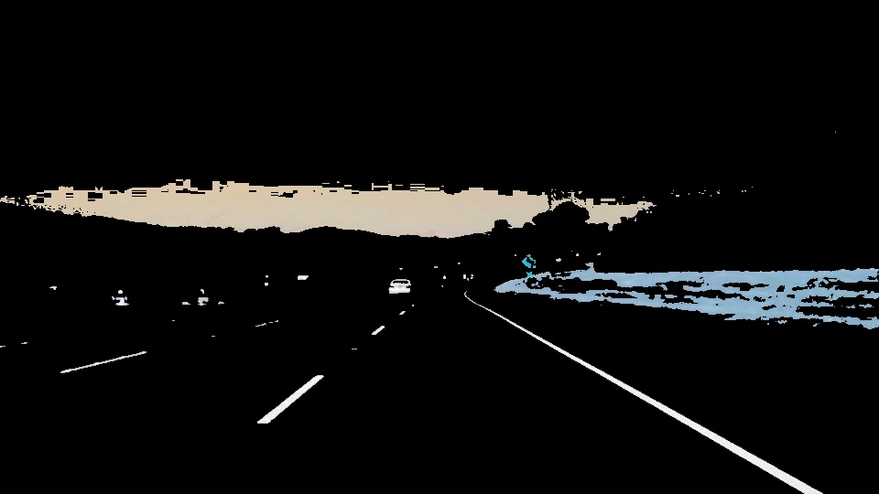

Edges detected using canny edge detector where low threshold=0.1, high threshold=0.5. I got strong edges on these threshold values. That’s why I select these values.

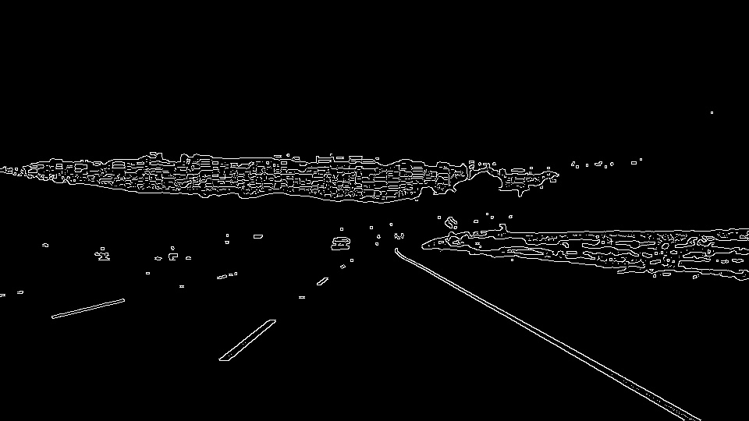

Then I find the Region of Interest where I first define the polygon by vertices. As we know that the lanes will be in the lower half of the image, usually in a trapezoid covering the bottom corners and the center. Therefor I select that particular region of interest and set other area to zero.

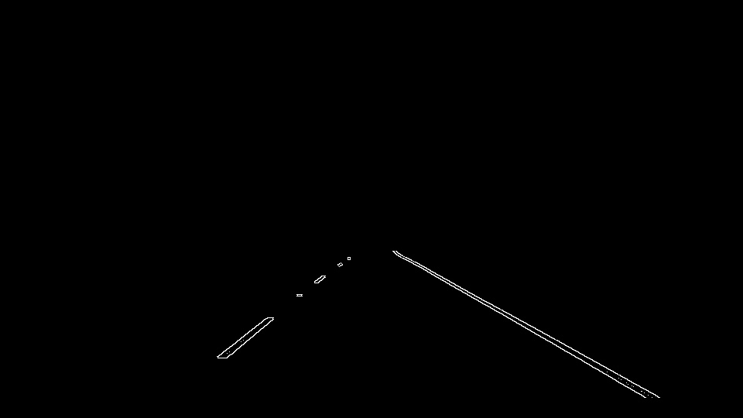

Then I computed Hough transform where I select rho=1, theta= np.pi /90, threshold=10, minLineLength=15, maxLineGap=10 and then I apply linear regression on it to draw lines. Line obtained after Hough transform and linear regression on group of two lines.

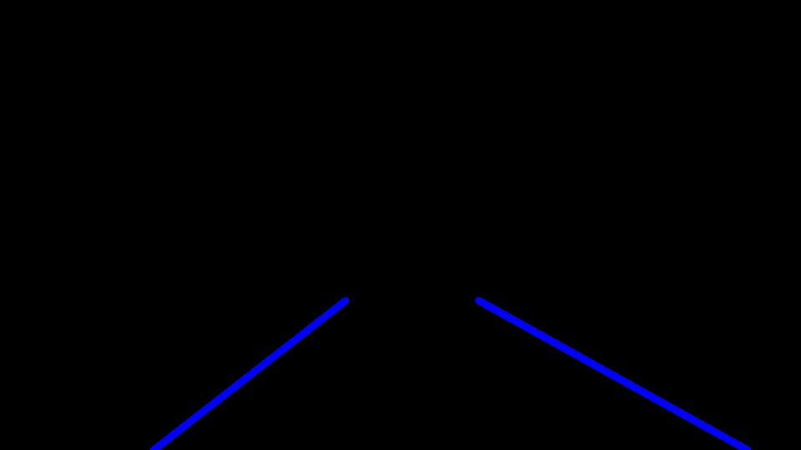

Final output after drawing these lines on original image.

