Help Document:   
API Automation Testing

This document explained everything that we used in this framework and automated scripts.

***Preconditions:***

Before you import and run this script, JDK (Java) should be installed in your machine and Maven, TestNG plugins in your eclipse then only you’ll get successful import project or else you’ll see issues.

***Packages and classes information:***

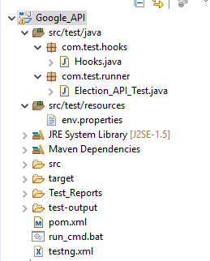

*Package1:* com.test.hooks - This package contain only one class called **Hooks**

**Hooks:** It is a reusable class where we defined few methods and reporting initialization as well as few global variables.

*Package2:* com.test.runner- This package contains only one class called **“Election API Test”.**

**Election API Test:**  This class will be the runner class and it has code for automating API, you can run this file directly using TestNG.

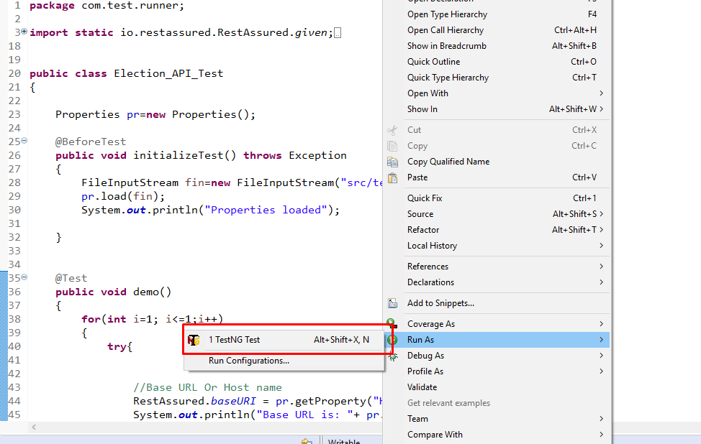

*Package3:* Under the resources we have one file called **env.properties** and this file useful to declare data example base URL and other based on requirement.

***How to run script from command prompt:***

Use below steps:

1. Open command prompt
2. Navigate to project repository location in cmd

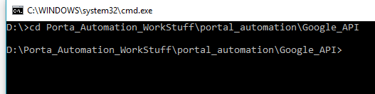

1. Enter cmd called “***mvn –test***”

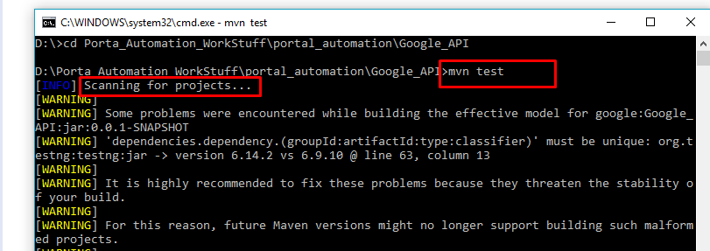

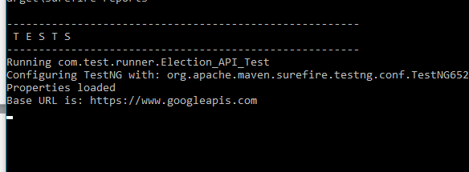

After the MVN –Test command you’ll be able to see something like above and you’ll see the TESTS option like above then it will execute program as well.

***How to Import this project in Eclipse:***

Please find below steps

1. Choose file
2. Import
3. Existing Maven project under the Maven

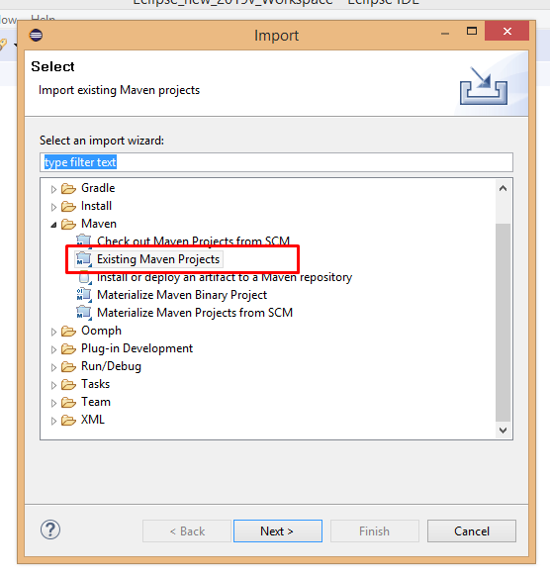

1. Browse file and observe result and click on Ok.

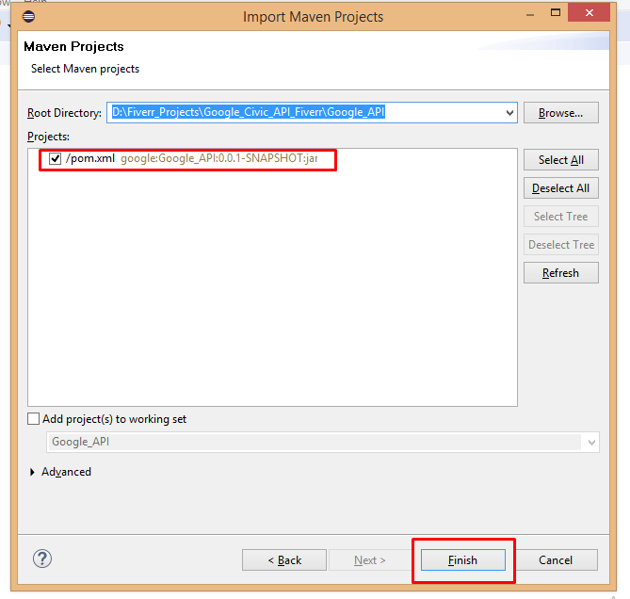

1. Make sure you wait till project is loaded successfully without any errors.
2. You may get this below symbol/error after importing if any dependency is incompatible with your environment, we should update the version number and save the project it will be sort.

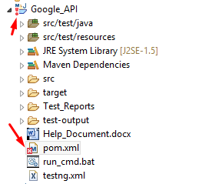

1. After the successful import you should be able to see the below structure without any error marks.

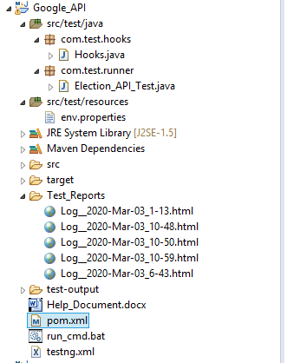

1. ***Note: Open run_cmd.bat file and change the location path as per your system path.***

***Test Output Look like below:*** Need to refresh this Test_Reports folder after the execution***.***

After the execution test out may look like below screenshots with clear information.

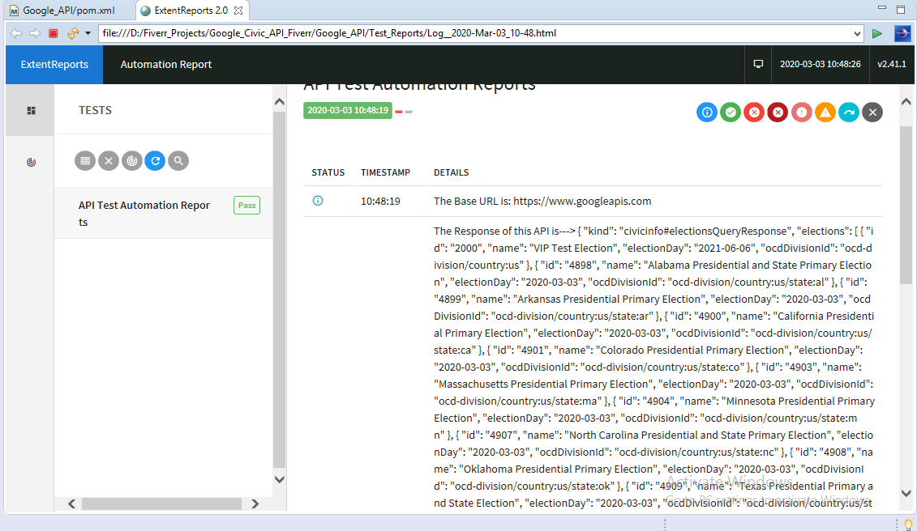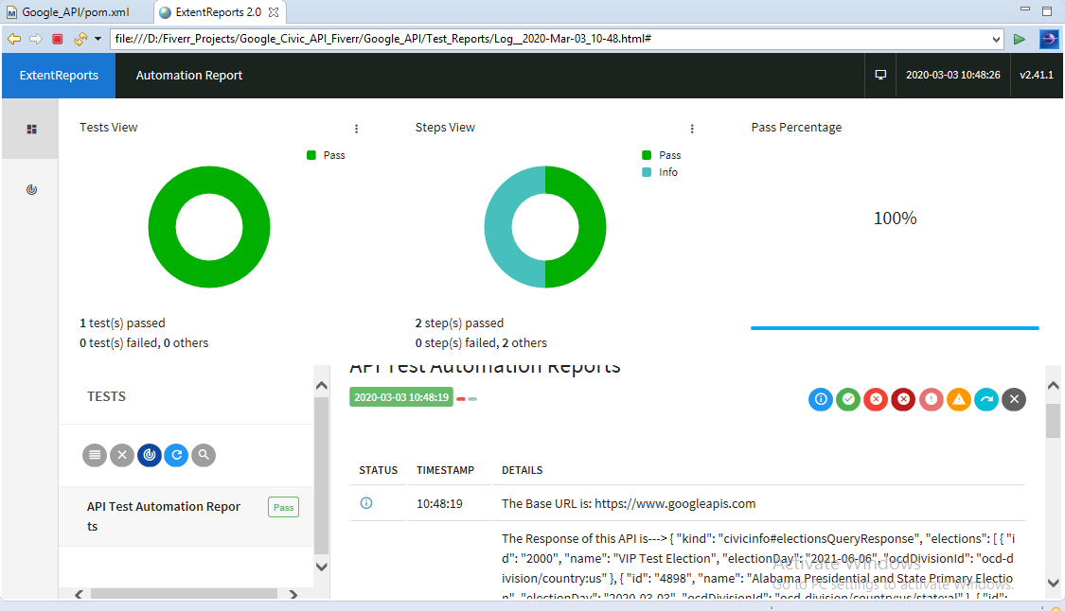

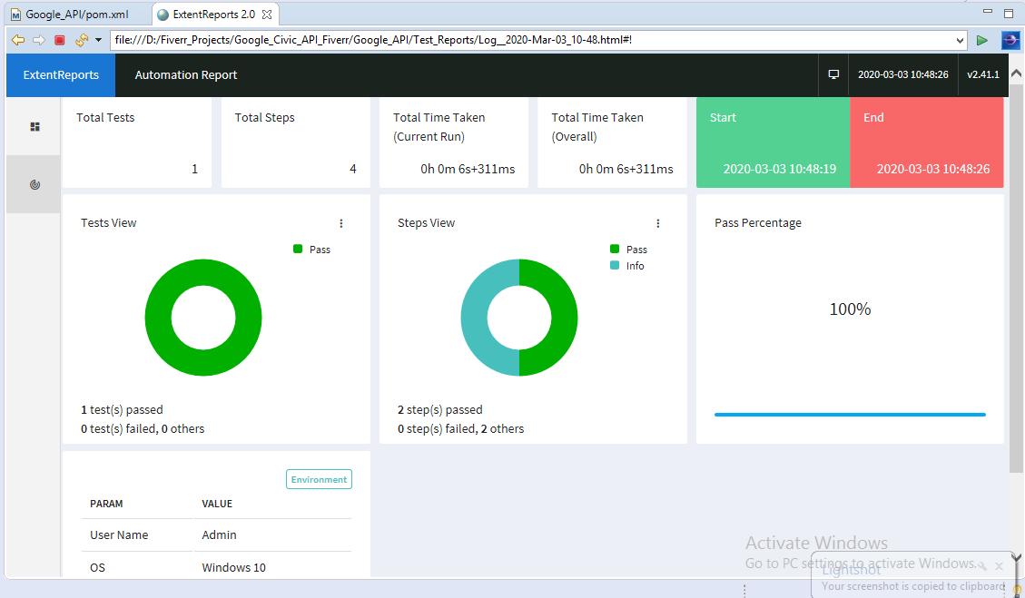

***How to Setup test in Jenkins:***

Find below steps in-order to execute the program from Jenkins.

1. Before you start Integrating your project in Jenkins, make sure your system install JDK (jdk8v recommended) and Apache Maven (3.5.3) and both should be configured under Environment variables.

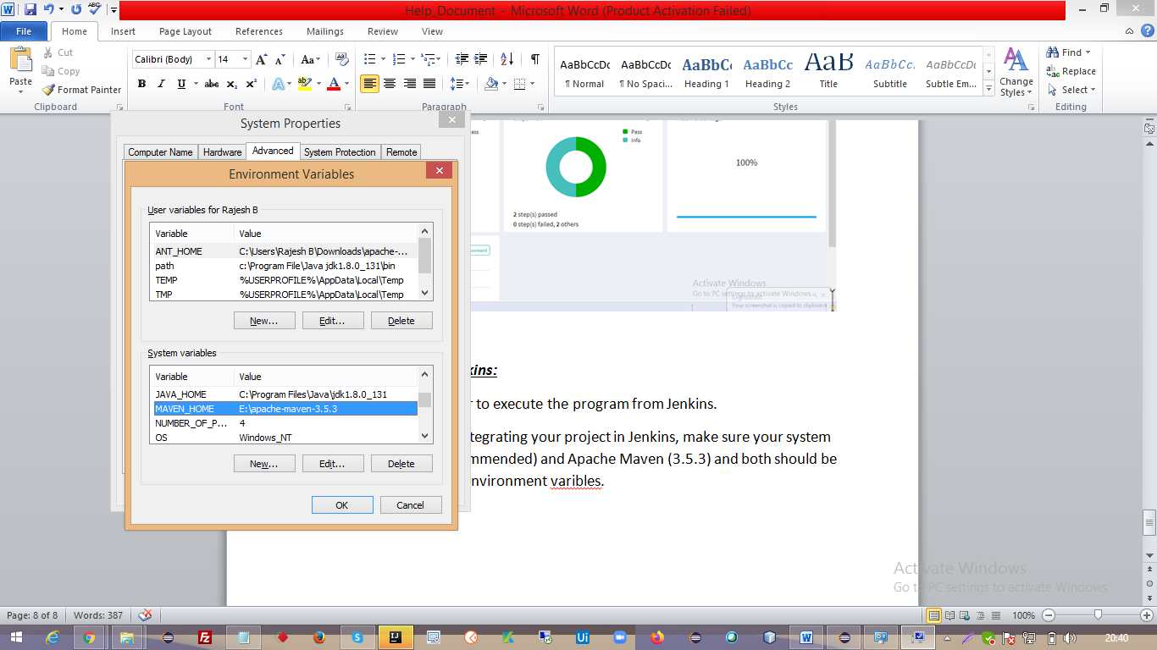

1. Open pom.xml and add maven surefire plugin with profile name as below.

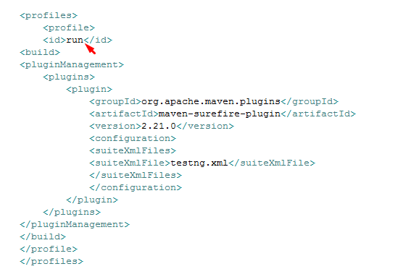

So if you can observe, we given profile name as ***run*** this we should configure in Jenkins in order to activate our script.

***Steps from Jenkins side:***

1. Enter project name and choose Maven

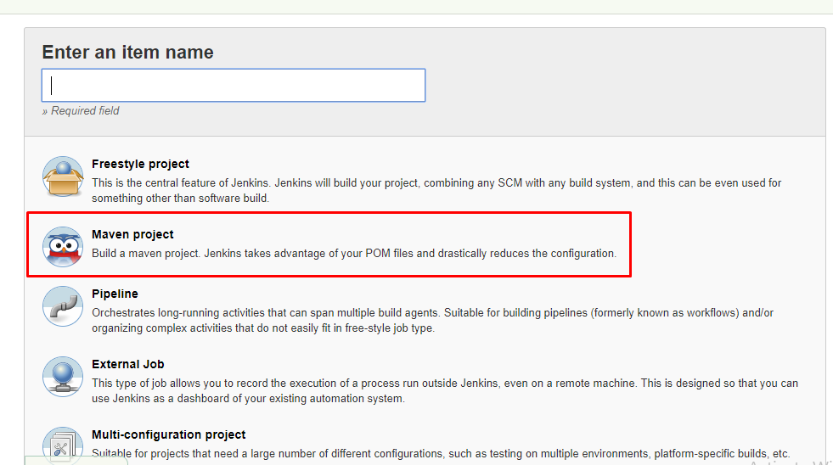

1. Please Enter your description

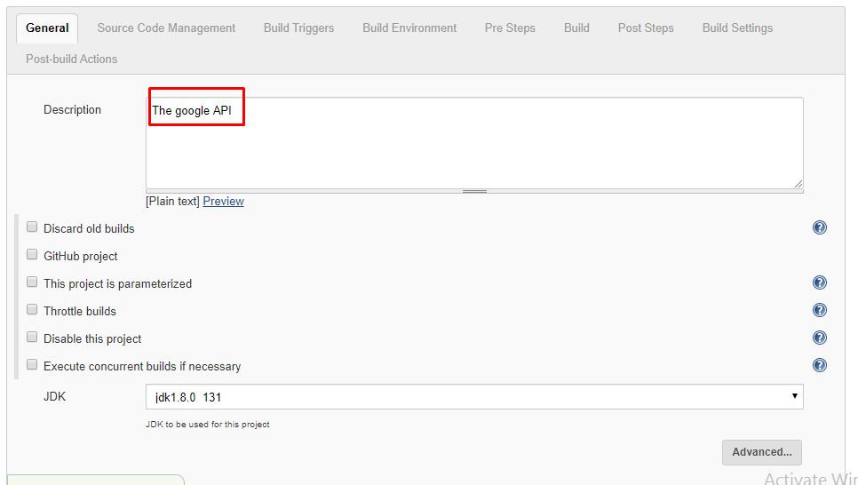

1. Please Choose/Enter as below

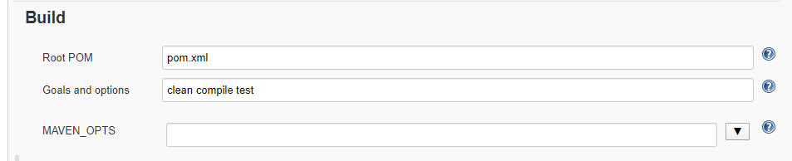

1. Choose custom workspace

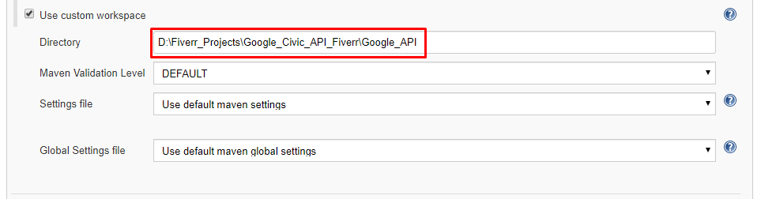

1. Under Build Triggers please enter the schedule time

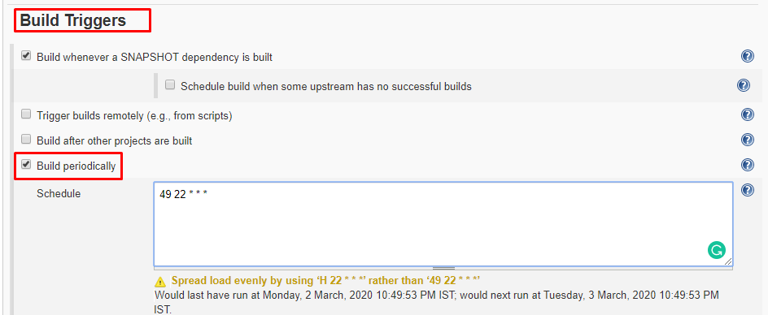

1. Under the post build actions choose TestNG Results

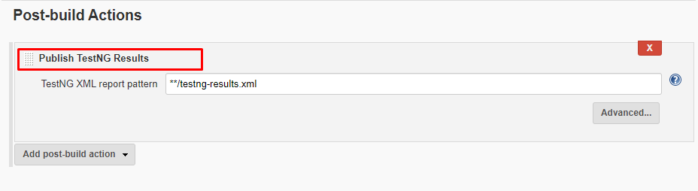

1. Save the project
2. You’ll be able to see below kind of reports after the execution

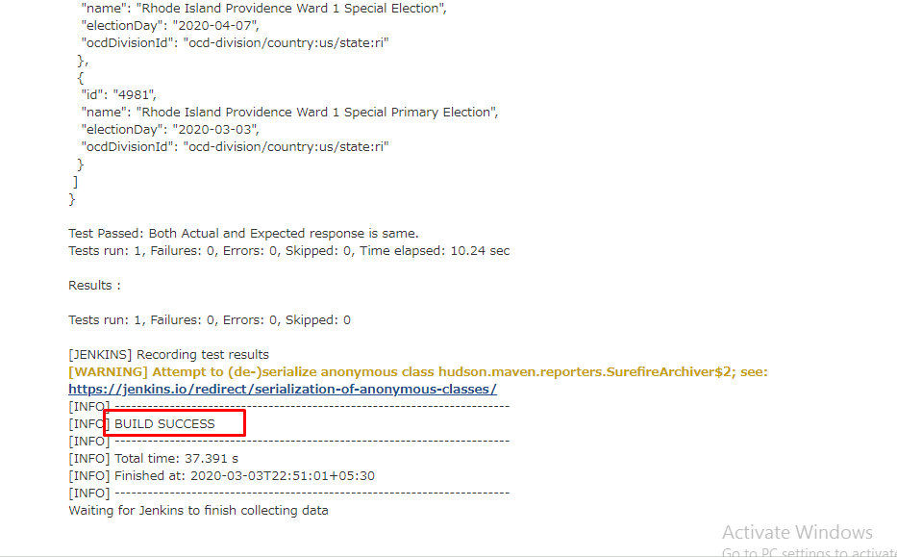

And other type of results too.