|  |  |
| --- | --- |
| Name: M Nabeel Zaib | EE-272L Digital Systems Design |
| Reg. No.: 2023-EE-67 | Marks Obtained: ____________ |

**Lab Manual**

|  |  |  |  |  |  |
| --- | --- | --- | --- | --- | --- |
| **DSD Lab Manual Evaluation Rubrics** | | | | | |
|  |  |  |  |  |  |
| **Assessment** | **Total Marks** | **Marks Obtained** | **0-30%** | **30-60%** | **70-100%** |
| Code Organization (CLO1) | 3 |  | No Proper Indentation and descriptive naming, no code organization.  Zero to Some understanding but not working | Proper Indentation or descriptive naming or code organization.  Mild to Complete understanding but not working | Proper Indentation and descriptive naming, code organization.  Complete understanding, and proper working |
| Simulation (CLO2) | 5 |  | Simulation not done or incorrect, without any understanding of waveforms | Working simulation with errors, don't cares's(x) and high impedance(z), partial understanding of waveforms | Working simulation without any errors, etc and complete understanding of waveforms |
| FPGA (CLO2) | 2 |  | Not implemented on FPGA and questions related to synthesis and implementation not answered. | Correctly Implemented on FPGA or questions related to synthesis and implementation answered. | Correctly Implemented on FPGA and questions related to synthesis and implementation answered. |

|  |  |  |  |  |
| --- | --- | --- | --- | --- |
| **a** | **b** | **c** | **x** | **y** |
| **0** | **0** | **0** | **1** | **0** |
| **0** | **0** | **1** | **0** | **0** |
| **0** | **1** | **0** | **0** | **0** |
| **0** | **1** | **1** | **1** | **0** |
| **1** | **0** | **0** | **0** | **0** |
| **1** | **0** | **1** | **1** | **0** |
| **1** | **1** | **0** | **0** | **1** |
| **1** | **1** | **1** | **1** | **1** |

**TASK 1**

**Part A**

Truth table of the given circuit.

**Part B**

Maximum combinational delay in Synthesis

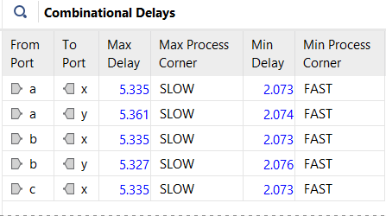

**Path a to y has the maximum combinational delay with 5.361 .**

**PART C**

The module uses 2 LUTs and 3 inputs (a, b,c ) output ports are x and y

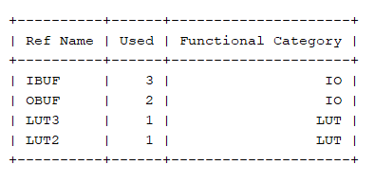

**Task 2**

System Verilog code for the circuit using structural modeling.

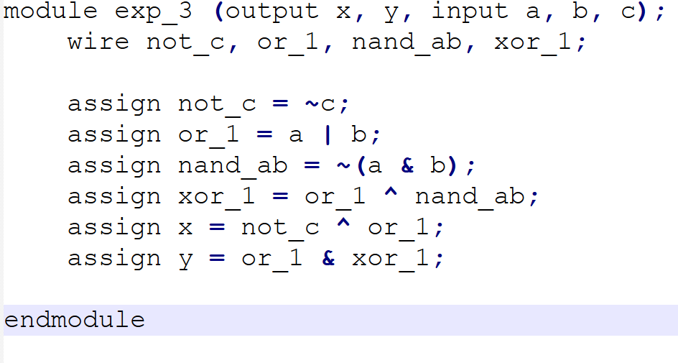

**Task 3**

**Schematic diagram** 