QA Test Report
Loan receipt from the Fiori app and a classic driver report
Item | Value
Document | QA-20261105-library-books-loans
App | library-books-loans
Date | 05.11.2026
Author | RAP Studio · AI agent
Request | Print the Adobe loan receipt form ZF_LOAN_RECEIPT from the Fiori app and from a classic report as well.
Status | Delivered

1. Summary
Area | Result
Activation | 0 errors
Code checks (ATC) | 0 errors, 0 warnings, 7 infos
Test cases | 5 of 5 passed
Screenshots | 4 (section 4)

2. Test cases
ID | Test | Expected | Actual | Status | Evidence
FT-01 | Classic report: preview for Priya Sharma | Receipt of The Hobbit rendered (default member Priya Sharma) | 4 list lines | Pass | Fig. 2
FT-02 | Classic report: unknown member | Message: no loan found | No loan found for Nobody; 1 list line | Pass | Fig. 3
FT-03 | Loans with the receipt fields | Loans with the receipt file name | HTTP 200, 3 entries | Pass
FT-04 | Console class prints the receipt | Receipt rendered and queued | [rap] activated /Users/nabheet/DevZone/ABAP/apps/library-books-loans in 155 ms: 2 tables, 6 views, 2 behavior definitions, 5 classes, 2 services; 0 error(s), 0 warning(s) | Pass
FT-05 | The Fiori elements app | Books list report | page opens | Pass | Fig. 4

3. How the tests ran
Each test case was run on the app in RAP Studio; the commands can be repeated in the app folder with rap:
FT-01 rap program ZLOAN_RECEIPT_REPORT P_PREV=X
FT-02 rap program ZLOAN_RECEIPT_REPORT P_MEMBER=Nobody
FT-03 rap odata GET zui_library/Loan?%24top=3&%24select=MemberName,DueDate,ReceiptFileName
FT-04 rap class zcl_loan_receipt_print
FT-05 rap ui apps/library-fe/

4. Evidence
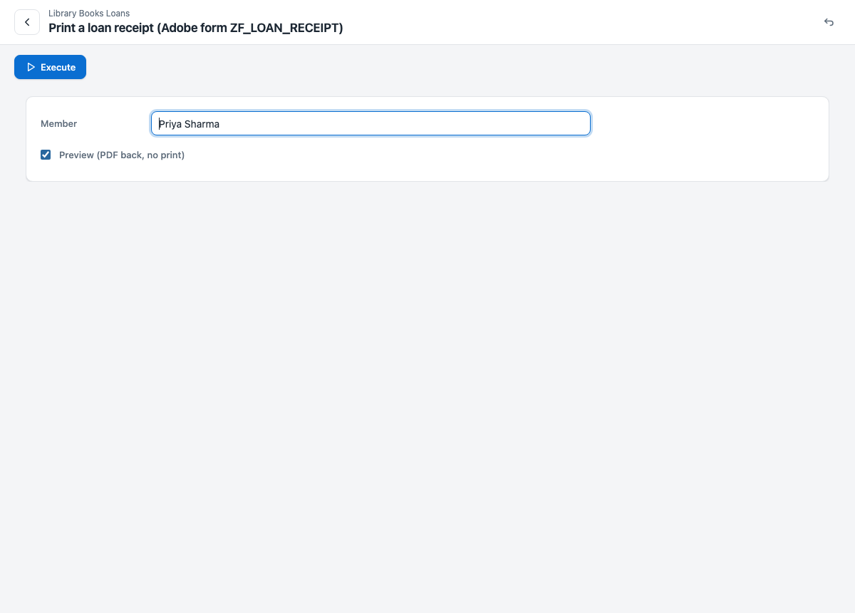
Figure 1: Selection screen of ZLOAN_RECEIPT_REPORT
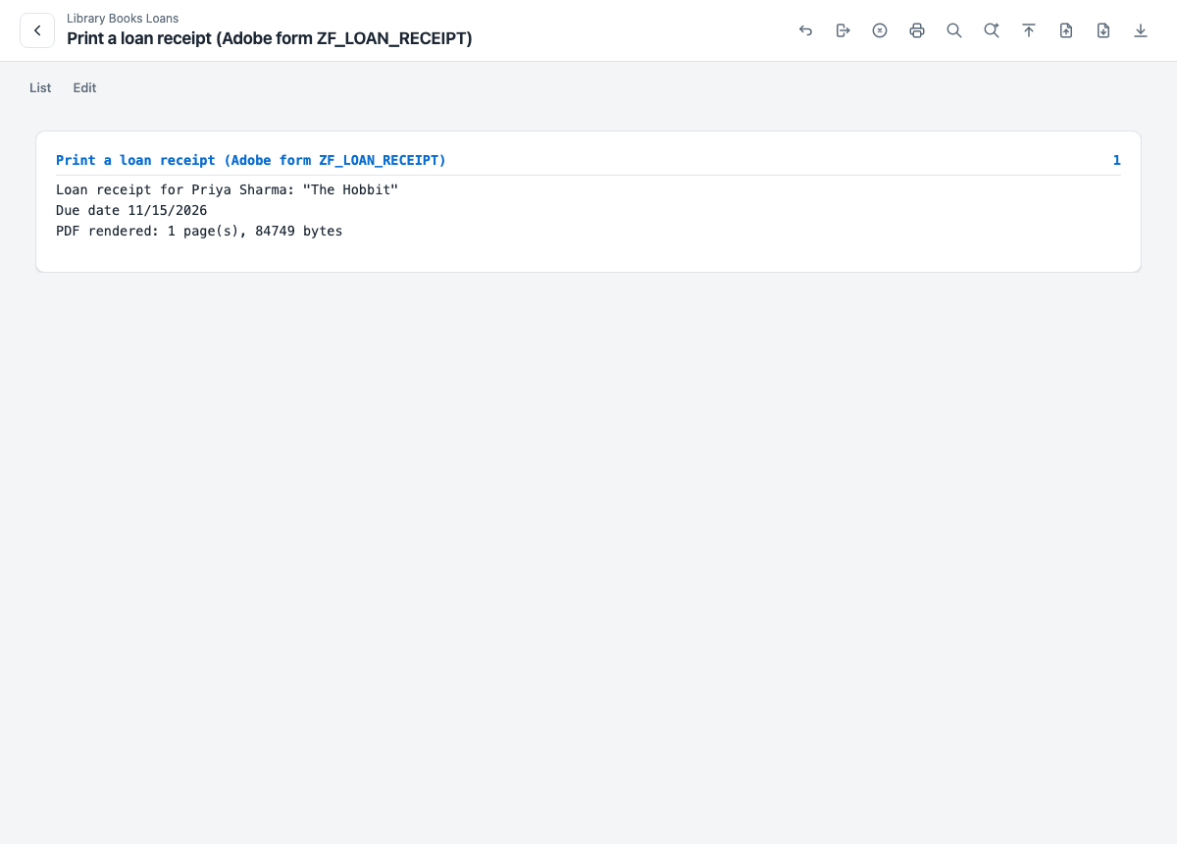
Figure 2: FT-01: Classic report: preview for Priya Sharma
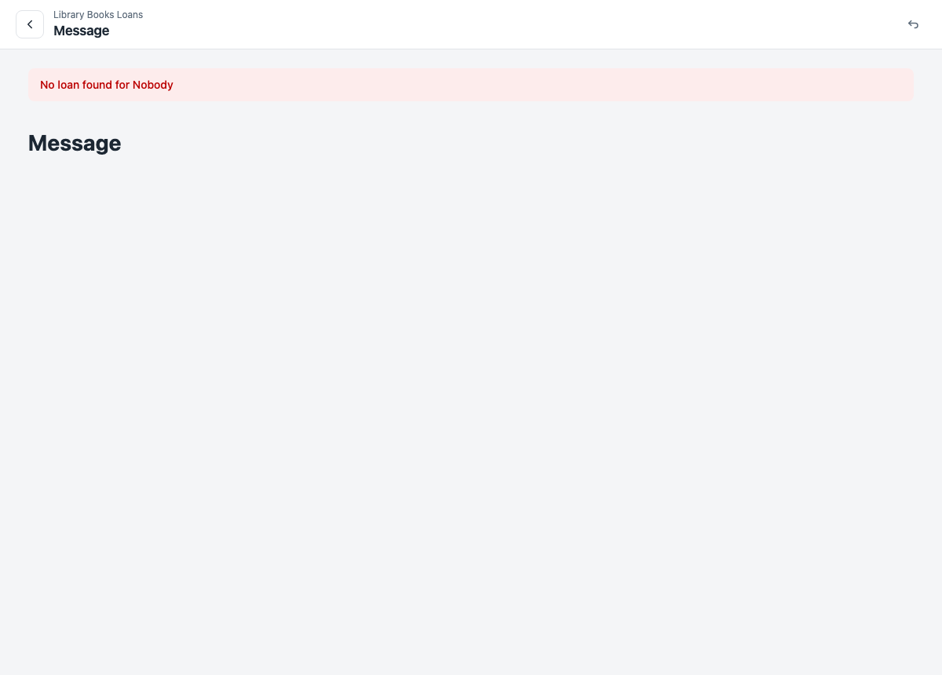
Figure 3: FT-02: Classic report: unknown member
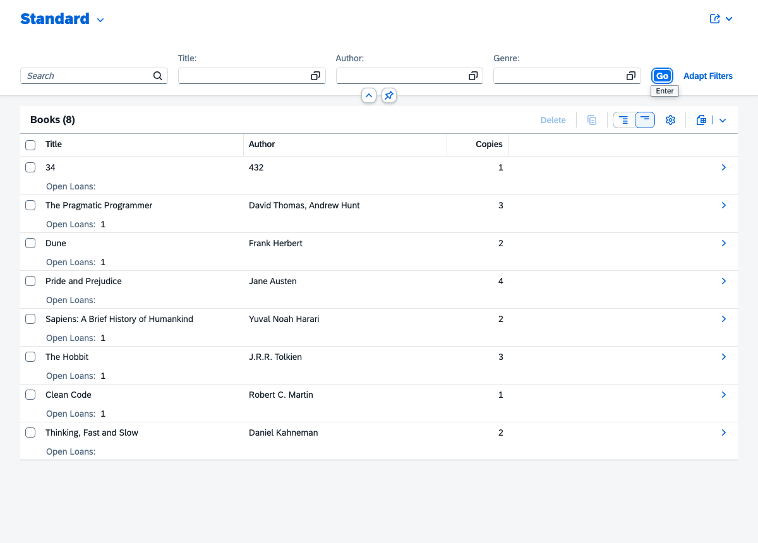
Figure 4: FT-05: The Fiori elements app

5. Sign-off
Role | Name | Date | Result
Developer | RAP Studio · AI agent | 05.11.2026 | Delivered
QA
Approver

