QA Test Report
Adobe form ZF_LOAN_RECEIPT - book loan receipt
Item | Value
Document | QA-20261105-library-books-loans
App | library-books-loans
Date | 05.11.2026
Author | RAP Studio · AI agent
Request | Build an Adobe form (XDP layout) ZF_LOAN_RECEIPT for a book loan with book and borrower data, loan dates, days overdue and a late fee computed by a calculate script, a Page n of m footer and a fillable Remarks field, using a form data provider, plus a console class that reads a loan, renders the PDF with cl_fp_ads_util=>render_pdf and puts it into the print queue.
Status | Delivered

1. Summary
Area | Result
Activation | 0 errors
Code checks (ATC) | 0 errors, 0 warnings, 5 infos
Test cases | 5 of 5 passed
Screenshots | 1 (section 4)

2. Test cases
ID | Test | Expected | Actual | Status | Evidence
FT-01 | Print the receipt of the most overdue open loan | The loan of 'Sapiens' (Lukas Becker, due 2026-10-26) is rendered as a 1-page PDF and a print queue item is created | [rap] activated /Users/nabheet/DevZone/ABAP/apps/library-books-loans in 128 ms: 2 tables, 6 views, 2 behavior definitions, 5 classes, 2 services; 0 error(s), 0 warning(s) | Pass
FT-02 | Form data of open loans (data provider) | Two open loans with book title and author; ReferenceDate is today because ReturnDate is empty | HTTP 200, 2 entries | Pass
FT-03 | Form data of a returned loan | The Hobbit, due 2026-10-15, returned 2026-10-20; ReferenceDate equals the return date (5 days overdue, fee 2.50 EUR in the form) | HTTP 200, 1 entry | Pass
FT-04 | Borrower without loans (empty result) | No form data: HTTP 200 with an empty list (0 entries) | HTTP 200, 0 entries | Pass
FT-05 | The app's start page | The library app with the book list | page opens | Pass | Fig. 1

3. How the tests ran
Each test case was run on the app in RAP Studio; the commands can be repeated in the app folder with rap:
FT-01 rap class zcl_loan_receipt_print
FT-02 rap odata GET zfdp_loan_receipt/LoanReceipt?%24filter=MemberName%20eq%20%27Lukas%20Becker%27&%24select=BookTitle,Author,DueDate,ReturnDate,ReferenceDate
FT-03 rap odata GET zfdp_loan_receipt/LoanReceipt?%24filter=MemberName%20eq%20%27Mia%20Chen%27&%24select=BookTitle,DueDate,ReturnDate,ReferenceDate
FT-04 rap odata GET zfdp_loan_receipt/LoanReceipt?%24filter=MemberName%20eq%20%27Nobody%27
FT-05 rap ui

4. Evidence
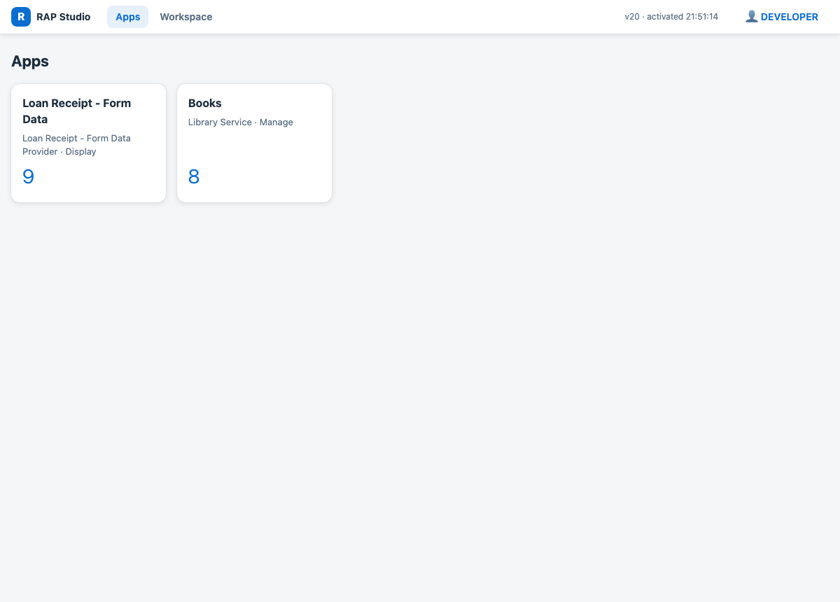
Figure 1: FT-05: The app's start page

5. Sign-off
Role | Name | Date | Result
Developer | RAP Studio · AI agent | 05.11.2026 | Delivered
QA
Approver

