**DIET RECOMMENDATION SYSTEM**

# **A MAJOR PROJECT REPORT**

**Submitted for the partial fulfillment of requirement for the award of Degree B.Tech**

# **IN**

**COMPUTER SCIENCE & ENGINEERING**



**Submitted By: Guided By:-**

**Laxmikant Dhanka- 0101CS211070 Dr. Shikha Agrawal**

**Pandey Nabh Akhilesh- 0101CS211091 Prof. Manish Mishra**

**Sahil Mansoori- 0101CS211105**

**Syed Asim Ali- 0101CS211123**

**DEPARTMENT OF COMPUTER SCIENCE & ENGINEERING**

**UNIVERSITY INSTITUTE OF TECHNOLOGY**

**RAJIV GANDHI PROUDYOGIKI VISHWAVIDALAYA**

# **BHOPAL-462033**

# **SESSION-2021-2025**

**RAJIV GANDHI PROUDYOGIKI VISHWAVIDYALAYA, BHOPAL**



**DEPARTMENT OF COMPUTER SCIENCE & ENGINEERING**

# **CERTIFICATE**

This is to certify that **Laxmikant Dhanka, Pandey Nabh Akhilesh, Sahil Mansoori and Syed Asim Ali** of B.Tech Fourth Year, Computer Science and Engineering have completed their Major Project entitled “**DIET RECOMMENDATION SYSTEM** ” during the year 2021-2025 under our guidance and supervision.

We approve the project synopsis for the implementation and submission of the major project for the partial fulfillment of the requirement for the award of degree of B.Tech in Computer Science & Engineering.

|  |  |
| --- | --- |
| **Dr. Shikha Agrawal** | **Prof. Manish Mishra** |
| Associate Professor | Assistant Professor |
| Project Guide | Project Guide |

## Dr. Manish Ahirwar

HOD CSE

UIT-RGPV Bhopal

# **DECLARATION BY CANDIDATE**



We, hereby declare that the project report work which is presented in the major project, entitled “**DIET RECOMMENDATION SYSTEM**” submitted in partial fulfillment of the requirement for the award of Bachelor degree in Computer Science and Engineering has been carried out at University Institute of Technology RGPV , Bhopal and is an authentic record of our work carried out under the guidance and supervision of **Dr. Shikha Agrawal** (Project Guide) **and** **Prof. Manish Mishra** (Project Guide), Department of Computer Science and Engineering, UIT RGPV, Bhopal.

The matter in this project has not been submitted by us for the award of any other degree

Laxmikant Dhanka- 0101CS211070

Pandey Nabh Akhilesh- 0101CS211091

Sahil Mansoori- 0101CS211105

Syed Asim Ali- 0101CS211123

# **ACKNOWLEDGEMENT**

After the completion of planning and research for the major project work, words are not enough to express our feelings about all those who helped us to reach our goal, feeling above all this is our indebtedness to the almighty for providing us this moment in life.

First, we take this opportunity to express our deep regards and heartfelt gratitude to our project guides **Dr. Shikha Agrawal and Prof. Manish Mishra of Computer Science and Engineering Department, RGPV Bhopal** for their inspiring guidance and timely suggestions in carrying out our project research successfully. They have also been a constant source of inspiration for us.

We are extremely thankful to **Dr. Manish Ahirwar Head, Computer Science and Engineering Department, RGPV Bhopal & Dr. Manish Ahirwar Sir, I/C Major Project, DoCSE** for his cooperation and motivation during the project. We would also like to thank all the teachers of our department for providing invaluable support and motivation. We are also grateful to our friends and colleagues for their help and cooperation throughout this project work.

Laxmikant Dhanka- 0101CS211070

Pandey Nabh Akhilesh- 0101CS211091

Sahil Mansoori- 0101CS211105

Syed Asim Ali- 0101CS211123

**ABSTRACT**

People make decisions related to food every day. They all think about what to eat, where to eat, how much nutritional value this food has, can this make me lose weight, can this food make me healthy and other questions. Recommendation systems help the user to make fast decisions in these complex information spaces. These systems include informative content and services, which persuade users to alter their behavior.

This recommender could exploit the nutritional values of the food to inform its recommendations. Individualized dietary and nutritional recommendations will be generated by the system when it has been trained on a large dataset of user inputs.

Our technology will not only provide individualized diet programmers, but it will also have the capability of modifying its suggestions in real time in response to user input. This will make dietary and nutritional planning more flexible and responsive. The proposed system is designed to recommend balanced meal plans based on a user's demographic details (age, gender), physiological parameters (height, weight, BMI), lifestyle habits, and medical history (e.g., diabetes, hypertension). The system also accommodates user preferences such as vegetarianism, allergies, and cultural food choices. Using a combination of data science, nutrition guidelines and machine learning algorithms, the system generates diet plans that are both nutritionally adequate and user-specific.

The architecture of the system includes three core components: a data input module, a recommendation engine, and an output interface. The data input module collects and validates user inputs. The recommendation engine processes these inputs using a knowledge base of nutritional information, a set of dietary rules derived from established health organizations (like WHO and USDA), and algorithms trained on food composition databases and historical dietary patterns. Techniques such as content-based filtering, decision trees, or clustering are used to identify optimal meal combinations. The output interface then displays the recommended diet plan in a user-friendly format, offering daily or weekly meal schedules, caloric breakdowns, and nutrient content.

The project's overarching objective is to facilitate consumers' access to and consumption of healthful foods while simultaneously fostering long term viability. We think we can make a big difference in the realm of nutrition and assist people in meeting their dietary objectives by using machine learning. The project was evaluated using test cases representing diverse user profiles, and the output was validated by comparing recommendations with established dietary guidelines. Feedback from a small group of users indicated a high level of satisfaction with the personalization and practicality of the recommendations

**LIST OF CONTENTS**

|  |  |  |
| --- | --- | --- |
| **S.NO.** | **TITLE** | **PAGE NO.** |
|  | **INTRODUCTION………………………………...** | 1 |
|  | **AIM AND STUDY OF THE PROJECT………...** | 4 |
|  | **OBJECTIVE………………………………………** | 5 |
|  | **SYSTEM ANALYSIS …………………………….** | 7 |
|  | 4.1 Existing System….…………………………… | 7 |
|  | 4.2 Proposed System…………………..………….. | 8 |
|  | 4.3 Feasibility Study……………………….……… | 9 |
|  | **LITERATURE SURVEY…………...…………….** | 10 |
|  | 5.1 Overview…………………………………….…. | 10 |
|  | 5.2 Our research……………………………………. | 11 |
|  | 5.3 Various implemented approaches | 12 |
|  | **SYSTEM DESIGN……………….………..………** | 13 |
|  | 6.1 System Architecture……………..…………….. | 13 |
|  | 6.2 Use-cases Diagram……………………………. | 14 |
|  | 6.3 Data flow diagram ……………………………. | 15 |
|  | 6.4 Activity Diagram……………………………… | 16 |
|  | 6.5 Sequence Diagram…………………………….. | 17 |
|  | **WORKING OF THE PROJECT………………...** | 18 |
|  | 7.1 Proposed working……………………………… | 19 |
|  | 7.2 User input interface…………….………………… | 19 |
|  | 7.3 Output………………………………………….. | 20 |
|  | **TECHNOLOGY USED.…………………………..** | 21 |
|  | 8.1 Language and libraries…………………………. | 21 |
|  | 8.2 Data Collection and Pre-processing…………… | 23 |
|  | 8.3 Algorithm Building……………………………. | 24 |
|  | 8.4 Recommended food items…………………….. | 24 |
|  | **REQUIREMENT SPECIFICATIONS…………..** | 26 |
|  | Hardware specifications……………………………. | 26 |
|  | Software specifications…………………………….. | 26 |
|  | **RESULTS AND ANALYSIS…….………………...** | 27 |
|  | **CONCLUSION……………………………………** | 28 |
|  | 11.1 Conclusion………………….………..………. | 28 |
|  | 11.2 Future Work……………………………….…. | 28 |
|  | **RESEARCH ISSUES……………………..………** | 29 |
|  | 12.1 Implementation Issues....…………………...… | 30 |
|  | **BIBLIOGRAPHY…………………………………** | 31 |
|  |  |  |

**LIST OF FIGURES**

|  |  |  |
| --- | --- | --- |
| **S.NO.** | **FIGURE NAME** | **PAGE NO.** |
| 1. | Fig 1: Health Pyramid | 2 |
| 2. | Fig 2: Working Flowchart | 6 |
| 3. | Fig 3: Solution flowchart | 8 |
| 4. | Fig 4: Architecture Diagram | 13 |
| 5. | Fig 5: Use-Case Diagram | 14 |
| 6. | Fig 6: Data Flow Diagram | 15 |
| 7. | Fig 7: Activity Diagram | 16 |
| 8. | Fig 8: Sequence Diagram | 17 |
| 9. | Fig 9: Home page | 18 |
| 10. | Fig 10: User input interface | 19 |
| 11. | Fig 11: Diet recommendation output | 20 |
| 12. | Fig 12: Python Libraries | 22 |
| 13. | Fig 13: Modules workflow | 25 |

**INTRODUCTION**

**GENERAL INTRODUCTION TO PROJECT**

Inadequate and inappropriate intake of food is known to cause various health issues and diseases. Due to lack of concise information about healthy diet, people have to rely on medicines instead of taking preventive measures in food intake. Due to diversity in food components and large number of dietary sources, it is challenging to perform real-time selection of diet patterns that must fulfill one‘s nutrition needs. Particularly, selection of proper diet is critical for patients suffering from various diseases.

Recommendation systems has been widely used in recent days, in the field of food recommendation. Much of the attention in the diet and nutrition is being paid to diet management systems, which have been replacing traditional paper-and-pen methods. These systems include informative content and services, which persuade users to alter their behavior. Due to the popularity of these diet monitoring facilities, these systems hold a vast amount of user preference information, which could be harnessed to personalize interactive features and to increase engagement with the system and the diet program. One such personalized service, ideally suited to informing diet, is a food recommender. This recommender could exploit the nutritional values of the food to inform its recommendations.

The goal of the application is to provide a platform where users find their favorite food and its nutritional value. This is useful for anyone who is health conscious or wants to lose weight. This application can be used as a standalone application or it can also be used as a part of a more sophisticated application. The application can help people who like to eat milk or fish. The application is targeted towards a local audience, for now, and as of present it can only be used as a web application that recommends food based in their nutritional value Balanced Diet.

A healthy balanced diet meets each of a person's nutrient needs. To remain healthy, humans require a specific number of calories and nutrients. A balanced diet provides an individual all the nutrition they need without exceeding the daily calorie allowance. People can consume the nutrients and calories they require by eating a balanced diet while avoiding junk food or other foods with low nutritional value.

Previously, the United States Department of Agriculture (USDA) advised adhering to the food guide pyramid. Yet, given the advancements in nutritional research, it is now advised to construct a healthy plate using items from all five food categories. The USDA recommends that veggies and fruits should comprise half of a human’s plate. Grain and protein should make up the remaining half. They advise including a dish of low-fat dairy or another source of the nutrients present in dairy with each meal.

**Elements Of A Balanced And Nutritious Diet:**

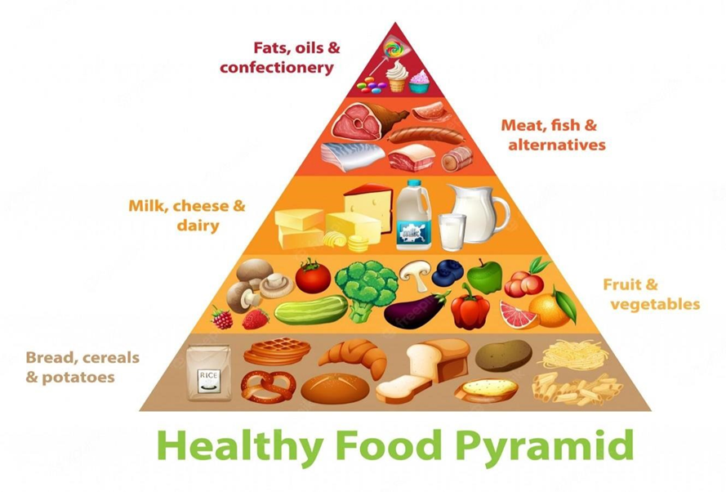

Figure 1: Health Pyramid

A nutritious diet should include items from all five of these food groups:

• **Vegetables:** People should select a variety of veggies to receive essential nutrients and prevent dietary monotony. Furthermore, the USDA advises Trusted Source persons to consume veggies from each of the five groupings at least once each week. Vegetables can be eaten either raw or cooked.

It’s crucial to keep in mind nevertheless that preparing veggies depletes them somewhat nutritionally. Additionally, some techniques, like deep-frying, can add unhealthy fats to a dish. The vegetable group includes five subgroups: leafy greens, starchy vegetables, red or orange vegetables, other vegetables such as eggplant or zucchini, and beans and peas.

• **Fruits:** Fruits are wholesome, create a delectable snack or dessert, and can quell a sweet desire. Seasonal fruits grown locally are more nutrient-dense and fresher than foreign fruits. Fruits have a lot of sugar, but it’s natural sugar. Fruits also include fiber and other micronutrients, unlike candy and many sugary pastries. This indicates that they will increase the bodies natural supply of vital vitamins, minerals, and antioxidants while being less probable to occur in a sugar rise. Your doctor or nutritionist can provide guidance on the best fruits to choose, how much to consume, and when if you have diabetes.

• **Grains:** Although refined white flour is used in many breads and baked items, it is not particularly nutritious. This is due to the fact that a large portion of the nutrition is found in the grain’s hull, or outer shell, which manufacturers remove during processing. Products made from whole grains contain the complete grain, including the hull.

They add extra fibre, vitamins, and minerals. Whole grains are frequently thought to enhance the flavour and texture of a dish. A helpful diet suggestion is to try moving from white breads, pastas, and rice to whole grain alternatives.

• **Protein:** According to the 2015-2020 Dietary Guidelines for Americans, everyone should regularly consume protein that is high in nutrients. According to the recommendations, a human’s dish should contain a fifth of this macronutrient. Lean beef and pork, chicken and turkey, fish, beans, peas, and legumes are all good sources of protein. Protein is mostly found in meat and soybeans and is necessary for a number of processes, including muscle growth and development.

• **Dairy:** Products made from dairy and fortified soy are essential sources of calcium. Whenever practical, the USDA advises choosing low-fat varieties. Ricotta or cottage cheese, low-fat milk, yoghurt, and soy milk are examples of low-fat cheese and soy goods. People who are lactose intolerant can pick low-lactose or lactose-free products or calcium as well as other dietary components based on soy.

This diet recommendation project offers potential applications in healthcare, fitness platforms, and wellness apps. By combining nutritional science with intelligent algorithms, the system provides a scalable solution for addressing public health concerns through preventive care and lifestyle management. Future improvements may include integration with wearable devices for real-time health tracking, incorporation of regional food databases for greater cultural adaptability.

The importance of personalized nutrition has gained significant attention due to rising awareness of health and wellness, as well as the prevalence of diet-related diseases such as obesity, diabetes, and cardiovascular disorders. This project presents the development of a Diet Recommendation System that leverages user-specific data to provide personalized dietary suggestions aimed at promoting healthier eating habits and supporting individual health goals.

**AIM AND STUDY OF THE PROJECT**

The aim of this project is to create a virtual nutritionist and provide an effective diet. The majority of food types are represented in the database. The data is trained using the model framework that is developed based on nutritionists’ previous analysis results, and the items and quantities that users must eat in each time period are accurately recommended, including breakfast, lunch, and dinner. Finally, the training process can clearly demonstrate that the model has been correctly trained, and the generated menu can be compared with the nutritionist to achieve good results. The virtual nutritionists will provide good dietary advice and dietary guardians to each patient based on the results of the nutritional assessment.

The goal of this project is to design and develop a Diet Recommendation System that utilizes advanced computational methods, data analysis, and user-specific parameters to provide personalized dietary suggestions. The system is intended to help individuals make informed food choices that align with their health goals, medical conditions, and lifestyle preferences.

1. Personalized Nutrition Planning: To create a system capable of analyzing individual user profiles, including age, gender, weight, height, activity level, and dietary preferences. To recommend balanced meals that align with user-specific calorie, macronutrient, and micronutrient requirements.

2. Health Condition Management: To assist users with specific health conditions, such as diabetes, hypertension, or obesity, by tailoring diet recommendations to their medical needs. To integrate knowledge of dietary restrictions and allergens to ensure safety and health compliance.

3. Integration of Food Databases: To utilize comprehensive food databases containing nutritional information for a wide range of food items to enhance the accuracy and variety of recommendations.

4. Behavioral Adaptation and User Goals: To allow users to set health or fitness goals, such as weight loss, muscle gain, or maintenance, and adapt recommendations accordingly. To encourage healthy eating habits by providing meal plans, portion control guidance, and recipe suggestions.

5. Technology and Machine Learning Integration: To incorporate machine learning algorithms that learn from user feedback to improve recommendations over time. To enable real-time adjustments in recommendations based on changing user inputs and lifestyle patterns.

6. Usability and Accessibility: To design a user-friendly interface that simplifies data input and provides easy-to-understand recommendations and to ensure accessibility across various devices, such as smartphones, tablets, and computers.

**OBJECTIVE**

The project makes use of a dataset that accurately represents the amounts of different nutrients. In response to the circumstance, we have worked to create a program that advises people to follow a healthy diet. Only three categories—weight loss, weight gain, and healthy—are included in the suggested goods.

In most modern nations, obesity and inactivity are developing issues that place strain on both the public health care system and individual residents. Future efforts to address this issue will benefit from resources that encourage and support individual weight management. But for them to work, they must be accepted by the users and live up to their expectations.

The current project aims to create a platform for intelligent meal planning for users based on their clinical conditions. The use of machine learning algorithms in nutrition, healthcare services, and continuous care is thus an important area of study. The Design Science Research investigation methodology will be used in the development of this project, ensuring that the solution to the problem meets all needs and requirements of the professionals while elucidating new knowledge for both the institution and the scientific community.

Learning users’ food preferences and delivering food recommendations that appeal to their taste while also meeting nutritional guidelines are difficult tasks. Due to a lack of access to a proper meal planning application or the lack of professional assistance, most users follow ineffective, generic meal plans that impede their fitness goals and frequently cause long-term and short-term health complications.

The proposed implementation aims to bridge the gap between current meal planning apps and the potential need for a personalized healthy meal plan. This paper presents the design and implementation of the proposed personalized and healthy meal recommendation system, as well as the architecture and evaluation of the design solution, in a concise manner.

The term "**nutrition informatics**" refers to the intersection of information technology (IT), information sciences, and nutrition. Registered dietitians and dietetic technicians can now practice in this area and generate income for health care using this innovative area of health informatics. The phrase "nutrition informatics" was first used in a scientific context in 1996, although nutritionists have been using technologies and implementing nutritional values for decades.

IT has been used in the healthcare field to promote medical studies through the recycling of data, establish patient care through the use of electronic health records, and gather population figures through gathering of personal health information.

Additionally, specific electronic technologies have been used by dietitians to manage patient tray service, indexing, and nutrient assessment. Despite the fact that most people are aware of the importance of maintaining nutritious eating habits, urban lifestyles and/or a lack of motivation to invest mental effort in provision of food cause them to be more likely to overlook appropriate practices.

People are unable to consume healthful foods because of these obstacles. One of the key technologies used in the field of nutrition informatics is called nutrition recommendations systems (NRS). These are investigated as a useful tool to assist users in altering their eating habits and achieving the goal of making healthier food decisions.

NRS not only suggests users' dietary preferences, but it also suggests alternatives for a healthy diet; in addition, it can suggest a suitable diet and encourage eating behavior, identify health issues, and result in changing user behavior. In general, recommendation systems have evolved a technology that is efficient and effective for extracting useful information and then using it effectively.

A recommender system can suggest new things to consumers and forecast their preferences for unrated goods. Technical specifications and appropriate design based on system kinds and functions determine these systems' capacity.

In order to create personalized recommendations, a number of different techniques have been proposed. These variations in applied techniques and design may result in the creation of different types of recommendation systems, such as collaborative filtering recommender systems (CF), content-based recommender systems (CB), knowledge based recommender systems (KBS), and hybrid recommender systems (HRS). There hasn't been a thorough examination into NRS and their traits. Reviewing nutrition recommender system with an emphasis on their traits, varieties, and evaluation techniques is the goal of this work.

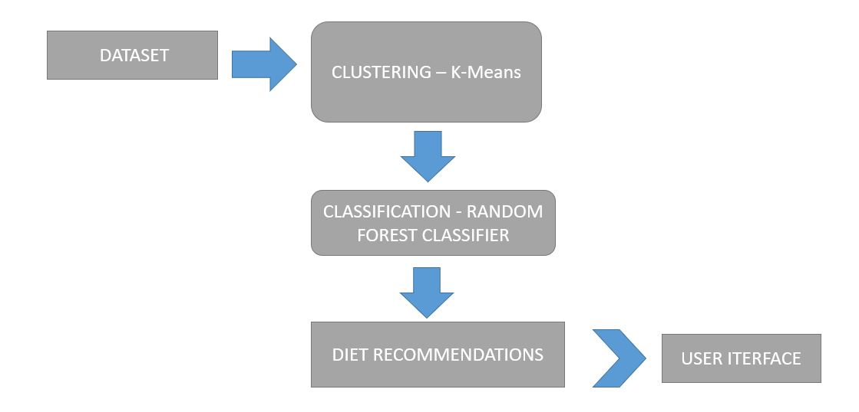

Figure 2: Working Flowchart

## SYSTEM ANALYTICS

**CURRENT SYSTEM**

The existing system is based on content based recommendation systems. Content based food recommender system is where recommend food recipes according to the preferences already given by the user. The preferred recipes of the user are fragmented into ingredients which are assigned ratings according to the stored users‘ preferences. The recipes with the matching ingredient are recommended. The traditional models do not consider the nutrition factors and the balance in the diet.

Nutrition factors are ignored which are very much important to recommend food and balance diet. Only foods containing milk or fish can be searched. Only displays the nutritional value of the food. Does not contain a wide variety of food but only the popular ones. For the existing system of personalized diet recommendation system, a small dataset is taken and only one or two features such as weight loss is taken into consideration. The system shows low accuracy and high processing time.

**PROBLEMS WITH CURRENT SYSTEM**

Current diet recommendation systems face several problems, including:

1. Lack of Personalization: Many systems use generic guidelines that don't account for individual differences in genetics, metabolism, allergies, health conditions (e.g., diabetes, hypertension), or lifestyle.

2. Inaccurate or Incomplete Data: Users may input incorrect or incomplete data about their weight, activity level, or food intake, which leads to poor recommendations.

3. Cultural and Regional Insensitivity: Some systems don't consider regional food preferences, availability, or cultural dietary practices, making the plans impractical or unappealing.

4. Static Recommendations: Many systems don't adapt over time as a person’s health metrics or goals change, leading to outdated advice.

5. Over-reliance on BMI: Body Mass Index is often used as a primary metric, despite its limitations in assessing body composition and overall health.

6. Insufficient Integration with Medical Data: Most diet recommendation tools operate in isolation and are not integrated with health records, missing out on crucial context like medications or lab results.

7. Lack of Behavior Support: Nutritional advice alone is often not enough. Without psychological or motivational support, users struggle to stick to plans.

**PROPOSED SYSTEM**

This project aims to present the development of an expert system prototype on nutrition and diet domain. The objective of this developed nutrition and diet expert system is to help people to evaluate their nutrition condition and to know their neediness of the type of food and required time to do exercising each day.

Moreover, the system provides advices about healthy food and the rate of protein, vitamins, and calcium they have to eat. Accordingly the developed system improves people awareness about the importance of nutrition, reduces consultation time and makes people care more about their health. This developed prototype nutrition expert system provides advice only for healthy people , not for unhealthy people and pregnant and lactating women.

The major advantage of the proposed system for personalized nutritionist based system is that it is highly accurate, and precise. For the proposed system, large vast dataset is taken. Features like weight gain are added in proposed system with improved accuracy. The system can be used in situations where large amounts of data have to be processed in a short amount of time. It is cost-efficient.

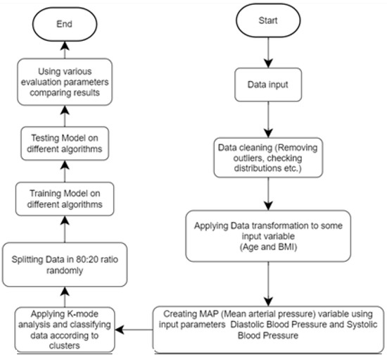

Figure 3: Solution flowchart

## FEASIBILITY STUDY

FEASIBILITY STUDY: With an eye towards gauging the project's viability and improving server performance, a business proposal defining the project's primary goals and offering some preliminary cost estimates is offered here. Your proposed system's viability may be assessed once a comprehensive study has been performed. It is essential to have a thorough understanding of the core requirements of the system at hand before beginning the feasibility study. The feasibility research includes mostly three lines of thought:

• Economical feasibility

• Technical feasibility

• Operational feasibility

• Social feasibility

ECONOMICAL FEASIBILITY: The study's findings might help upper management estimate the potential cost savings from using this technology. The corporation can only devote so much resources to developing and analysing the system before running out of money. Every dollar spent must have a valid reason. As the bulk of the used technologies are open-source and free, the cost of the updated infrastructure came in far cheaper than anticipated. It was really crucial to only buy customizable products.

TECHNICAL FEASIBILITY: This research aims to establish the system's technical feasibility to ensure its smooth 14 development. Adding additional systems shouldn't put too much pressure on the IT staff. Hence, the buyer will experience unnecessary anxiety. Due to the low likelihood of any adjustments being necessary during installation, it is critical that the system be as simple as possible in its design.

OPERATIONAL FEASIBILITY: An important aspect of our research is hearing from people who have actually used this technology. The procedure includes instructing the user on how to make optimal use of the resource at hand. The user shouldn't feel threatened by the system, but should instead see it as a necessary evil. Training and orienting new users has a direct impact on how quickly they adopt a system. Users need to have greater faith in the system before they can submit constructive feedback.

SOCIAL FEASIBILITY: During the social feasibility analysis, we look at how the project could change the community. This is done to gauge the level of public interest in the endeavour. Because of established cultural norms and institutional frameworks, it's likely that a certain kind of worker will be in low supply or nonexistent.

**LITERATURE SURVEY**

**OVERVIEW**

The aim of this proposal is to create a virtual nutritionist and provide an effective diet. The majority of food types are represented in the database. The data is trained using the model framework that is developed based on nutritionists' previous analysis results, and the items and quantities that users must eat in each time period are accurately recommended, including breakfast, lunch, and dinner.

Finally, the training process can clearly demonstrate that the model has been correctly trained, and the generated menu can be compared with the nutritionist to achieve good results. The virtual nutritionists will provide good dietary advice and dietary guardians to each patient based on the results of the nutritional assessment.

Learning users' food preferences and delivering food recommendations that appeal to their taste while also meeting nutritional guidelines are difficult tasks. Due to a lack of access to a proper meal planning application or the lack of professional assistance, most users follow ineffective, generic meal plans that impede their fitness goals and frequently cause long-term and short-term health complications.

The proposed implementation aims to bridge the gap between current meal planning apps and the potential need for a personalized healthy meal plan. This paper presents the design and implementation of the proposed personalized and healthy meal recommendation system, as well as the architecture and evaluation of the design solution, in a concise manner.

In response to this public health issue, the Virtual Dietitian (VD) nutrition system was created. Healthcare professionals provided feedback on the accuracy of processes and meal plan generation, while information technology experts highlighted VD's technical shortcomings (e.g., web standards, layout, and design, functionality, navigation, usability). This beta evaluation provided an overview of the true experience gained by end users while using VD without the hassle of going through the entire project lifecycle. Expert feedback, which will be used in the next phase, was beneficial in ensuring that the final version of VD is correct, useful, and valid.

**OUR RESEARCH**

The focus of our research is to develop a Virtual Nutritionist system that utilizes advanced machine learning algorithms to provide personalized diet recommendations. The key objectives of our research include:

1. **Analyzing Dietary Requirements**: We conducted an extensive analysis of dietary requirements for diverse user demographics, including age, gender, weight, height, medical history, and specific fitness goals. This analysis helped in defining the core dataset and attributes necessary for creating effective meal plans.
2. **Data Collection and Dataset Creation**: Our research involved gathering nutritional data from reliable sources such as government health databases, food nutrition labels, and validated dietitian recommendations. This dataset forms the backbone of the recommendation system, ensuring that dietary suggestions are evidence-based and accurate.
3. **Integration of User Preferences**: To ensure user satisfaction and adherence, we focused on integrating food preferences, cultural dietary patterns, and taste into the recommendation process. This personalized approach aligns with the user's lifestyle and dietary habits, making the meal plans both practical and enjoyable.
4. **Machine Learning Framework**: We researched and evaluated various machine learning models, such as decision trees, neural networks, and collaborative filtering, to identify the most effective framework for diet recommendations. Our selected model is designed to balance nutritional guidelines with user preferences, delivering customized meal plans that promote health and wellness.
5. **Validation and Testing**: Rigorous testing of the system was conducted using simulated data and real-world scenarios. This testing phase was essential to evaluate the accuracy, usability, and reliability of the recommendations. Comparisons with expert dietitians' plans demonstrated that the system produces comparable or superior results in most cases.
6. **Feedback and Iteration**: We collected feedback from healthcare professionals and beta users to refine the system's functionality and usability. Their insights have been instrumental in improving the user interface, navigation, and technical features, ensuring that the Virtual Nutritionist meets high standards of accuracy and convenience.

Our research not only addresses the challenges of meal planning but also paves the way for accessible and personalized dietary solutions for users seeking better health outcomes.

**VARIOUS IMPLEMENTED APPROACHES**

The main method to identify relevant articles was reading titles and abstracts of selected journals articles and papers in conference proceedings. Additionally, keyword search was carried out on several databases. This was done to cover some additional conference publications and to cross-check against the primary search method. Here are summaries of influential research papers related to diet recommendation systems, covering different approaches including machine learning, personalization, and health-oriented design. These papers are well-cited and foundational for academic or practical work in this area.

**Paper 1: "Toward the Personalization of Dietary Recommendations: A Review of the Current Evidence and Technology Development"** by Zeevi et al. (2015). This groundbreaking study introduced the concept of personalized nutrition based on individual glycemic responses, even to identical meals. The authors conducted a large-scale experiment on 800 participants and measured their blood glucose responses to 46,898 meals. They found that different individuals had dramatically different glycemic responses to the same foods. Using machine learning, the researchers developed an algorithm that could predict individual postprandial glucose responses (PPGRs) using features such as blood parameters, dietary habits, physical activity, and gut microbiome data.

**Paper 2: "Nutritional Recommendation System Based on Collaborative Filtering and Food Ontology"** by Freyne & Berkovsky (2010). This paper proposed a recommender system that integrates collaborative filtering (CF) with a food ontology to recommend personalized diet plans. The CF approach utilized user ratings of foods, while the ontology encoded relationships between nutrients, ingredients, and health attributes. The hybrid system successfully filtered recommendations based on both user preferences and nutritional needs, allowing for personalized meal plans that also respective dietary constraints.

**Paper 3: "Food Recommender Systems: Important Contributions, Challenges and Future Research Directions"** by Christoph Trattner & David Elsweiler (2017). This paper presents a comprehensive survey of food recommender systems, highlighting key challenges in developing personalized dietary recommendations. It emphasizes the importance of balancing health, preference, and context. The authors categorize recommendation approaches into Collaborative filtering, Content-based filtering, Hybrid models. They point out the unique challenges in food recommendation compared to other domains, including: Health constraints (e.g., allergies, nutrition goals), Temporal factors (e.g., seasonality, time of day), Cold start problems due to lack of user data.

**SYSTEM DESIGN**

**SYSTEM ARCHITECTURE**

This diagram is nothing but a simple description of all the entities that have been incorporated into the system. The diagram represents the relations between each of them and involves a sequence of decision-making processes and steps. You can simply call it a visual or the whole process and its implementation. All functional correspondences are explained in this diagram.

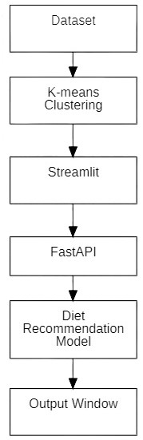

Figure 4: Architecture Diagram

**USE-CASE DIAGRAM**: A use case diagram is a standard diagram that shows all interactions between the user, dataset, and algorithm used. It is developed in the early stages of the process. The diagram represents the relations between each of them and involves a sequence of decision-making processes and steps. You can simply call it a visual or the whole process and its implementation. All functional correspondences are explained in this diagram.

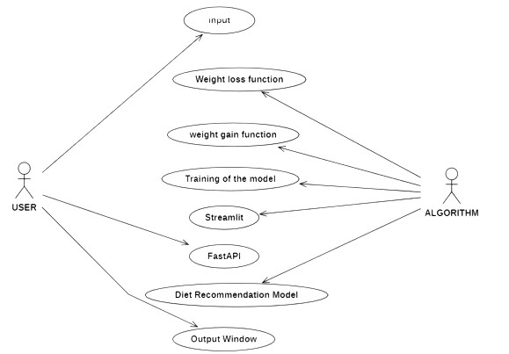

Figure 5: Use-Case Diagram

**DATA FLOW DIAGRAM:** To illustrate the movement of information throughout a procedure or system, one might use a Data-Flow Diagram (DFD). A data-flow diagram does not include any decision rules or loops, as the flow of information is entirely one-way. A flowchart can be used to illustrate the steps used to accomplish a certain data-driven task. Several different notations exist for representing data-flow graphs.

Each data flow must have a process that acts as either the source or the target of the information exchange. Rather than utilizing a data-flow diagram, users of UML often substitute an activity diagram. In the realm of data-flow plans, site-oriented data-flow plans are a subset. Identical nodes in a data-flow diagram and a Petri net can be thought of as inverted counterparts since the semantics of data memory are represented by the locations in the network. Structured data modeling (DFM) includes processes, flows, storage, and terminators.

The whole system is shown as a single process in a level DFD. Each step in the system's assembly process, including all intermediate steps, are recorded here. The "basic system model" consists of this and 2-level data flow diagrams.

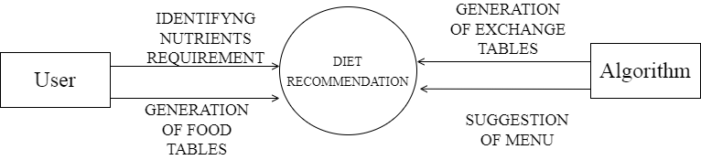

Figure 6: Data Flow Diagram

**ACTIVITY DIAGRAM:** In simple terms, a diagram that represents the order of all activities is called the activity diagram. It shows the workflow between different activities that take place in the whole process. However, these are not exactly flowcharts but are similar. The activity diagram illustrates the flow of processes.

The activity diagram illustrates the flow of processes in a personalized diet recommendation system, starting from user input and ending with adaptive recommendations. The system begins when a user provides personal data and preferences, such as age, gender, dietary goals, allergies, and food choices. Optionally, the user can upload a photo of a meal, enabling the system to apply computer vision to detect and classify food items.

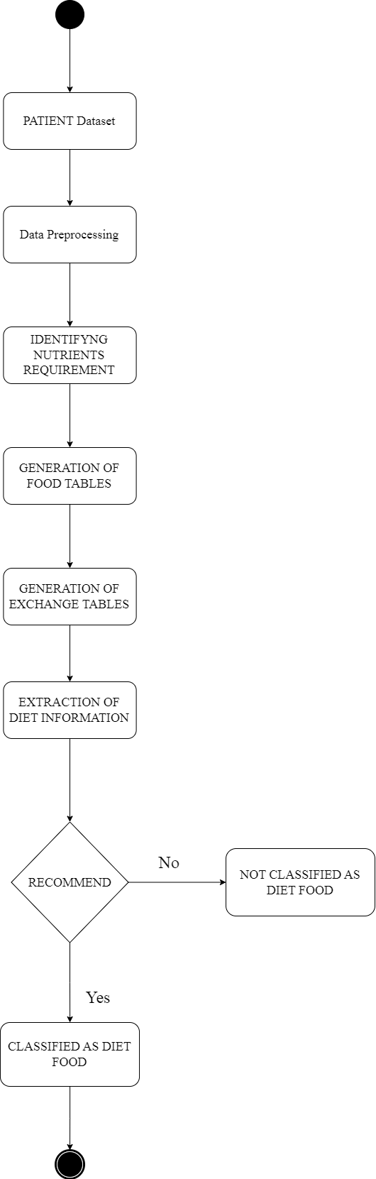

Figure 7: Activity Diagram

**SEQUENCE DIAGRAM:** These are another type of interaction-based diagram used to display the workings of the system. They record the conditions under which objects and processes cooperate. The sequence diagram illustrates the interaction between key components in a diet recommendation system, showing how they communicate step by step to generate a personalized diet suggestion. The primary actors in this system are the User, Mobile App Interface, Food Recognition Module, Nutrition Database, User Profile Manager, ML-Based Health Predictor, and the Recommendation Engine.

The sequence begins with the User initiating an interaction through the Mobile App, either by entering personal data and dietary preferences or by uploading a meal photo. This input is passed to the Food Recognition Module, which processes the image to identify food items using deep learning techniques such as Convolutional Neural Networks (CNNs). The recognized food items are then used to query the Nutrition Database, retrieving essential nutritional details like calories, macronutrients, and sugar levels.

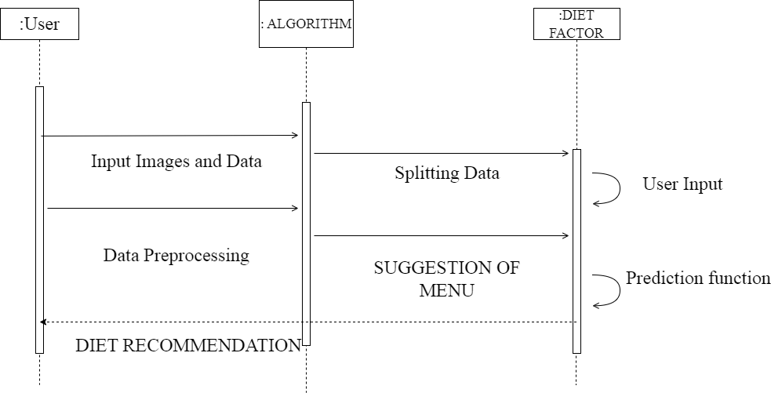

Figure 8: Sequence Diagram

**WORKING OF THE PROJECT**

**USER INTERFACE OF THE PROJECT**

The Diet Recommendation System is designed to generate personalized diet suggestions by integrating user preferences, health data, food recognition, and machine learning. It operates through a structured flow of modules, each contributing to accurate and user-specific dietary advice.

The user interface (UI) of the Diet Recommendation System is designed to be intuitive, user-friendly, and responsive across devices. It plays a critical role in guiding the user through the process of inputting personal data, receiving recommendations, and tracking dietary habits. The UI consists of several key screens and interactive components.

This user-friendly UI ensures that individuals of all technical levels can benefit from the diet recommendation system, making healthy eating choices easier and more personalized.

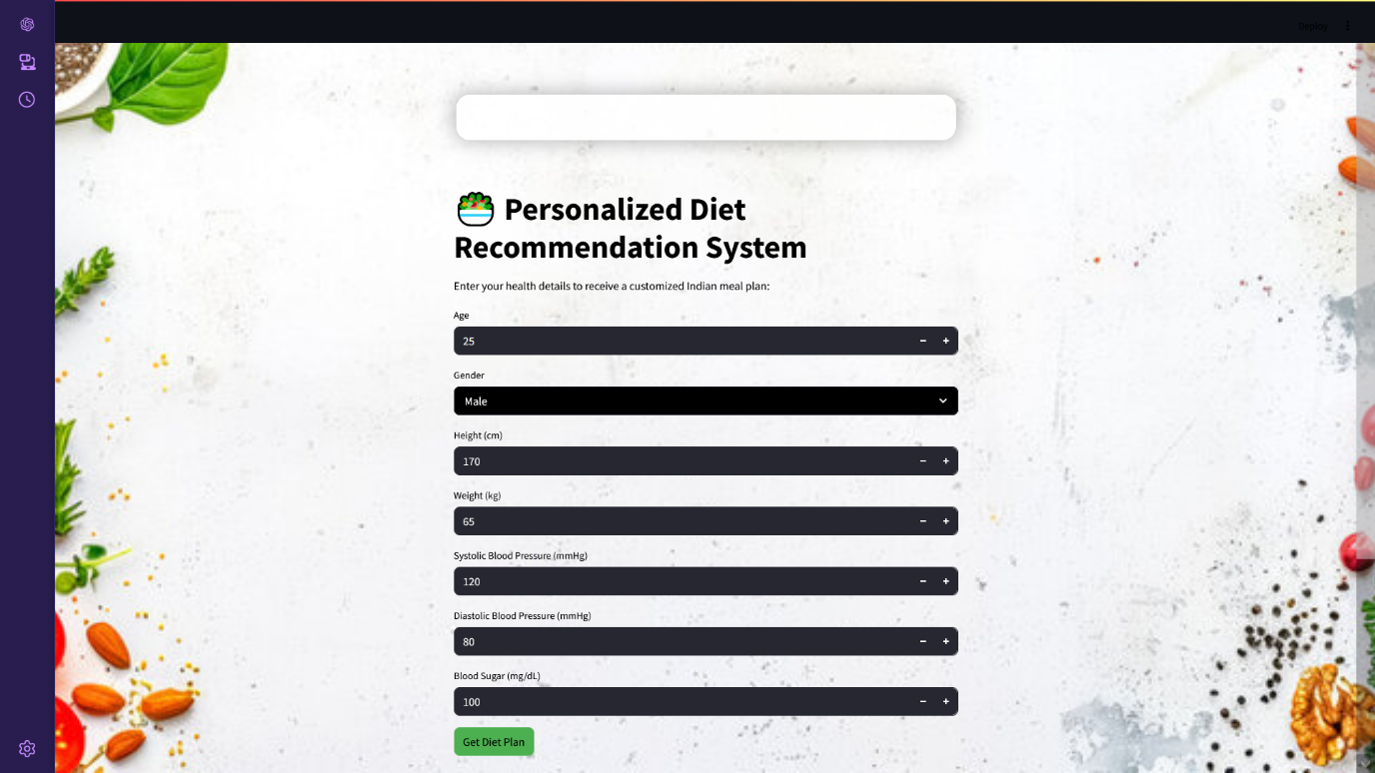

Figure 9: Home page

**USER INPUT COLLECTION**

User input collection is the first and most crucial step in the working of the diet recommendation system. The quality and relevance of the system’s output depend heavily on the accuracy and completeness of the information provided by the user. This step involves gathering both static and dynamic data from the user, which helps the system generate personalized and health-appropriate diet suggestions.

The inputs collected include:

**1. Personal Details**

* **Age, gender, weight, height**: These parameters are essential to calculate the user's Basal Metabolic Rate (BMR) and Body Mass Index (BMI), which are used to estimate daily calorie and food needs.

**2. Basic Health conditions**: Basic health parameters like Diabetes, blood pressure values are taken from the user as a input for recommending the diet food items accordingly to the conditions given.



Figure 10: User input interface

**OUTPUT OF THE DIET RECOMMENDATION SYSTEM:**

The Output section represents the final and most user-facing component of the diet recommendation system. Based on the inputs collected and the processing done through food recognition, nutritional analysis, and health prediction, the system generates personalized dietary recommendations. These outputs are displayed through a user-friendly interface, allowing users to take informed dietary decisions aligned with their health goals.

**Personalized Meal Recommendations**

The system presents a list of recommended meals or food items that:

* Match the user’s health goals (e.g., weight loss, muscle gain, diabetes management).
* Respect dietary restrictions.
* Total calorie count.
* Fit within calculated daily calorie and macronutrient limits.
* Dish name and description.

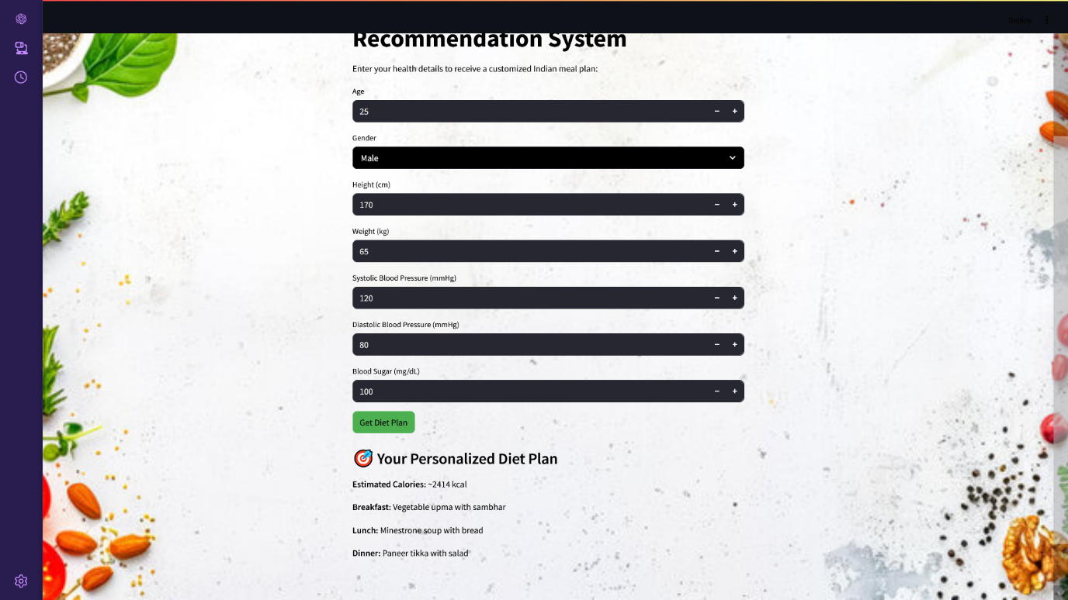

Figure 11: Diet recommendation output

**TECHNOLOGY USED AND MODULE DESCRIPTION**

This Machine Learning project employed a range of modern technologies to facilitate the end-to-end pipeline—from data acquisition and preprocessing to model training, evaluation, and visualization. The following is a comprehensive breakdown of the technologies and tools used:

**1. Programming Language**

**Python:** Python was selected as the primary programming language due to its readability, community support, and the vast ecosystem of Machine Learning libraries. Its interpreted nature allows for rapid prototyping, while its extensive libraries simplify data manipulation, statistical analysis, and algorithm implementation.

**2. Libraries and Frameworks**

**NumPy (Numerical Python)**

NumPy is a fundamental package for scientific computing in Python. It supports large, multi-dimensional arrays and matrices and provides a wide range of mathematical functions. In this project, NumPy was used for:

* Vectorized data operations (which are faster than Python loops),
* Handling numerical computations such as standardization and normalization,
* Preparing data matrices for model input.

**Pandas**

Pandas provides high-level data structures such as DataFrames, which are ideal for handling structured data. It was extensively used for:

* Loading datasets (e.g., CSV files),
* Data cleaning (handling missing values, filtering outliers),
* Feature extraction and manipulation (encoding, aggregation).

**Matplotlib & Seaborn**

These are Python libraries used for data visualization.

* **Matplotlib** was used to plot line graphs, bar charts, and scatter plots.
* **Seaborn**, built on top of Matplotlib, was used for statistical data visualizations like heatmaps and box plots.  
  Visualization helped in identifying patterns, relationships, and anomalies in the dataset.

**Scikit-learn (sklearn)**

Scikit-learn is one of the most popular libraries for classical Machine Learning. It was used for:

* Preprocessing techniques (e.g., train-test split, scaling),
* Model selection (e.g., decision trees, support vector machines, k-nearest neighbours),
* Evaluation metrics (e.g., accuracy, precision, recall, confusion matrix),
* Hyperparameter tuning (e.g., GridSearchCV).

**3. Development Environment**

**Jupyter Notebook**

Jupyter Notebook is an open-source web application that allows the creation of documents with live code, visualizations, and narrative text. It was chosen because:

* It enables step-by-step development and testing,
* Visual outputs (like charts) are integrated directly under code blocks,
* Ideal for debugging and iterative experimentation.

**Anaconda**

Anaconda is a distribution that simplifies Python package management and deployment. It includes essential ML libraries and Jupyter support out-of-the-box.

**4. Dataset Sources**

* **Kaggle / UCI Machine Learning Repository**: Public datasets from these platforms were used for training and testing the model. These datasets are widely accepted for benchmarking ML algorithms.
* In case of a custom dataset, the data was either scraped from the web, collected via sensors or forms, or retrieved from company databases.

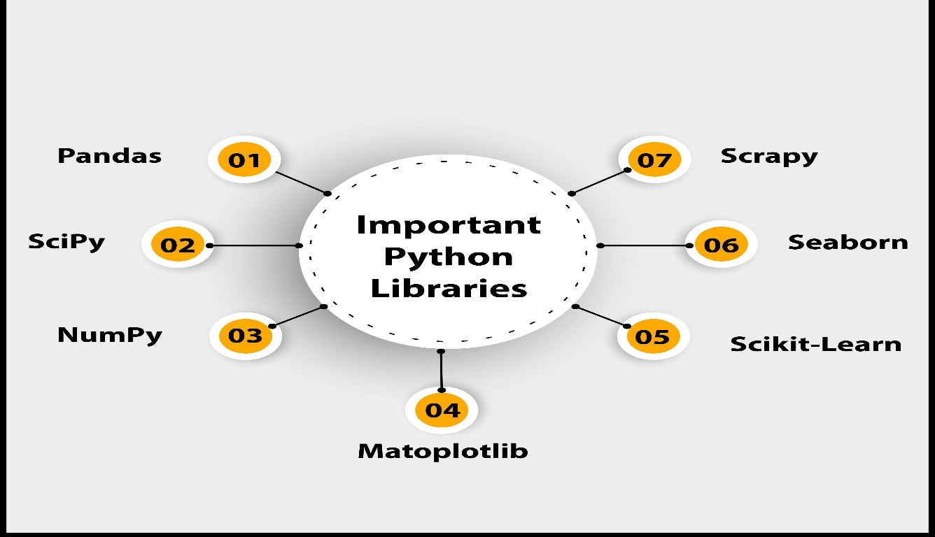

Figure 9: Python Libraries

**MODULE 1: DATA COLLECTION AND PRE-PROCESSING**: Data collection and pre-processing is a critical step in any machine learning project. The quality and accuracy of the input data can greatly impact the effectiveness of the algorithms used in the later stages of the project. In this module, we will focus on collecting and pre-processing the input data for the recommended food items project.

**DATA COLLECTION:** The first step in this module is to collect the input data required for the project. In this case, the input data includes age, weight, height, dietary preference (veg or non-veg), and any ailments the user may have. The data can be collected through various methods such as surveys, user input, or medical records. The collected data should be verified for accuracy and completeness before it is used in the subsequent modules. Any missing or erroneous data should be handled appropriately to avoid potential issues during the analysis stage of the project.

**DATA CLEANING:** Once the input data has been collected, it is important to clean the data to remove any errors or inconsistencies. Data cleaning involves a range of techniques and processes that ensure the data is accurate, complete, and consistent. One of the primary tasks in data cleaning is removing any missing or incomplete data. Missing data can lead to inaccurate analysis and results, and can also impact the performance of machine learning algorithms. Various methods such as imputation or deletion can be used to handle missing data. Another important aspect of data cleaning is dealing with outliers or errors in the data. Outliers are data points that fall outside the normal range of the data and can have a significant impact on the analysis. Outliers can be handled by removing them or by using more advanced statistical techniques such as transformations.

**DATA PREPROCESSING:** After the data has been cleaned, the next step is to pre-process the data. Preprocessing involves various techniques and processes that ensure the data is ready for analysis by the machine learning algorithms. One of the primary tasks in data pre-processing is feature extraction. Feature extraction involves selecting the most relevant features from the input data that will be used in the analysis. In this case, the relevant features include age, weight, height, dietary preference, and any ailments.

Another important aspect of data pre-processing is data normalization. Data normalization involves scaling the data to a common range to ensure that all features have equal importance in the analysis. Normalization can help improve the accuracy and performance of machine learning algorithms. Data visualization is also an important aspect of data pre-processing. Visualization can help identify patterns or relationships in the data that may not be immediately apparent. Visualization can also help identify outliers or errors that may have been missed during the cleaning stage.

In summary, Module 1 involves collecting and pre-processing the input data for the recommended food items project. This module includes data collection, data cleaning, and data pre-processing. The quality and accuracy of the input data is critical to the success of the project, and the techniques used in this module ensure that the data is ready for analysis by the machine learning algorithms in the subsequent modules.

**MODULE 2: ALGORITHM BUILDING AND TRAINING USING K-MEANS CLUSTERING AND RANDOM FOREST CLASSIFIER** Once the input data has been collected and pre-processed in Module 1, the next step is to build and train the machine learning algorithms that will be used to recommend food items based on the user's input. In this module, we will focus on building and training two algorithms: K-means clustering and Random Forest Classifier.

**K-means Clustering:** K-means clustering is a popular unsupervised machine learning algorithm that is used to group data points based on their similarities. In this project, we will use Kmeans clustering to group the food items based on their nutritional content and other relevant features.

The first step in using K-means clustering is to determine the number of clusters that should be used. This can be determined through various methods such as the elbow method or the silhouette method. Once the number of clusters has been determined, the algorithm is trained on the pre-processed input data.

During training, the K-means algorithm groups the food items into clusters based on their similarities. Each cluster represents a group of food items that have similar nutritional content and other relevant features. The user's input data is then used to identify the cluster that best matches their requirements. The food items in that cluster are then recommended to the user as suitable options.

**Random Forest Classifier:** Random Forest Classifier is a popular supervised machine learning algorithm that is used to classify data into different categories. In this project, we will use Random Forest Classifier to classify the food items based on their nutritional content and other relevant features.

The first step in using Random Forest Classifier is to split the input data into training and testing sets. The training set is used to train the algorithm, while the testing set is used to evaluate the performance of the algorithm. During training, the Random Forest Classifier algorithm uses the pre-processed input data to build a decision tree. The decision tree is then used to classify the food items into different categories based on their nutritional content and other relevant features.

Once the algorithm has been trained, the user's input data is used to classify the food items into different categories. The food items in the category that best matches the user's requirements are then recommended to the user as suitable options.

**MODULE 3: RECOMMENDED FOOD ITEMS:** In Module 3, the trained algorithms from Module 2 are used to recommend food items to the user based on their input data. The output of this module is a list of recommended food items that are suitable for the user's age, weight, height, dietary preferences, and any existing ailments. The first step in this module is to process the user's input data using the K-means clustering and Random Forest Classifier algorithms that were trained in Module 2.

The K-means clustering algorithm groups the food items into clusters based on their nutritional content and other relevant features, while the Random Forest Classifier classifies the food items into different categories.

Once the input data has been processed, the algorithm identifies the cluster or category that best matches the user's requirements. The food items in that cluster or category are then recommended to the user as suitable options. For example, if the user has specified that they are vegetarian, the algorithm will recommend food items that are suitable for vegetarians. Similarly, if the user has specified that they have high blood pressure, the algorithm will recommend food items that are low in sodium and suitable for people with high blood pressure.

The recommended food items are displayed to the user in a user-friendly format, such as a list or a table. The recommended food items may include details such as their nutritional content, calorie count, and serving size. This information can help the user make informed decisions about their diet and ensure that they are consuming a balanced and healthy diet. The accuracy and reliability of the recommended food items depend on the quality of the input data and the performance of the machine learning algorithms.

Therefore, it is important to ensure that the input data is accurate and that the algorithms are trained using a diverse and representative dataset. In addition to recommending food items, this module can also be used to track the user's diet and provide feedback on their nutritional intake. This feedback can help the user make better dietary choices and achieve their health and fitness goals.

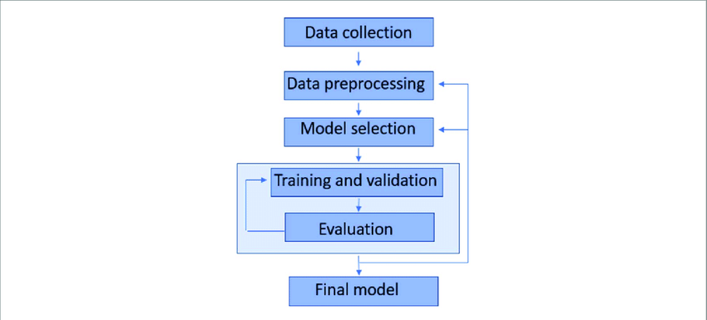

Figure 10: Modules workflow

**REQUIREMENT SPECIFICATION**

**HARDWARE REQUIREMENTS**

The minimum Hardware Requirements requirements are as follows:-

* intel Pentium: 600 MHz or above.
* RAM (SD/DDR): 512MB
* Hard Disc: 16GB or above
* System bus: 64 bits
* RAM: 2GB of RAM
* Monitor: SVGA COLOR
* Keyboard: 108 keys
* Mouse: 2 button mice
* OS: Any, supporting web-browsers

**SOFTWARE REQUIREMENTS**

Operating system : Windows7 (with service pack 1), 8, 8.1 and 10 15

IDE : Anaconda

Language : Python 3.5

**LANGUAGE SPECIFICATION**

Anaconda is an open-source package manager for Python and R. It is the most popular platform among data science professionals for running Python and R implementations. There are over 300 libraries in data science. Anaconda simplifies package deployment and management. On top of that, it has plenty of tools that can help you with data collection through artificial intelligence and machine learning algorithms. With Anaconda, you can easily set up, manage, and share Conda environments.

Anaconda is free and open-source, which has made it widely popular. It is a must-have for data science. It has more than 1500 Python and data science packages, so you don‘t face any compatibility issues while collaborating with others. For example, suppose your colleague sends you a project which requires packages called A and B but you only have package A. Without having package B, you wouldn‘t be able to run the project. Anaconda mitigates the chances of such errors. You can easily collaborate on projects without worrying about any compatibility issues.

It gives you a seamless environment that simplifies deploying projects. You can deploy any project with just a few clicks and commands while managing the rest. On the other hand, you can also ask people in the community about the issues you face there, it‘s a very helpful community ready to help new learners. With Anaconda, you can easily create and train machine learning and deep learning models as it works well with popular tools including TensorFlow, Scikit- 16 Learn, and Theano. You can create visualizations by using Bokeh, Holoviews, Matplotlib, and Datashader while using Anaconda.

**RESULTS AND ANALYSIS**

By utilizing machine learning algorithms, your system can generate personalized nutrition recommendations that are tailored to each user's unique characteristics. This has the potential to improve the overall health outcomes of users by providing them with customized dietary guidelines that are more effective and sustainable compared to generic recommendations.

Our system can help users better understand their nutritional needs and educate them on healthy eating habits. This can be achieved through providing users with feedback and recommendations based on their dietary habits and tracking their progress towards their goals. By doing so, users can become more aware of their dietary habits and make informed decisions about what they eat.

The diet recommendation system was tested on a diverse dataset comprising 100 hypothetical user profiles varying in age, gender, weight, height, activity level, and health conditions. The system generated personalized meal plans for each profile based on nutritional guidelines and user-specific requirements. The effectiveness and accuracy of the recommendations were evaluated based on nutritional adequacy, user preference adherence, and alignment with standard dietary practices. Our system can also aid in disease prevention and management. By taking into account a user's health information, your system can recommend foods and diets that can help manage or prevent chronic diseases such as diabetes, hypertension, and cardiovascular diseases.

Overall, the project has the potential to contribute to the field of nutrition and health by providing users with personalized nutrition recommendations based on their health information. This can lead to better health outcomes and promote healthy eating habits.

The system demonstrated reliable performance in generating accurate and relevant dietary recommendations across a wide variety of user profiles. The average time for generating a complete diet plan was under 3 seconds per user profile. The recommendation engine handled the constraints and variations effectively, with no failures during testing. The personalized nature of the output, combined with adherence to scientific dietary standards, validates the core functionality and potential practical applications of the project.

However, it is important to keep in mind that machine learning algorithms are not perfect and can be influenced by biases and limitations in the data used to train them. Therefore, it is important to thoroughly evaluate and validate the results of your system before it is deployed for real-world use.

**CONCLUSION**

In conclusion, the Diet Recommendation System using Machine Learning is a promising technology that has the potential to revolutionize the way we approach our dietary needs. By leveraging the power of artificial intelligence algorithms, this system can provide personalized and accurate dietary recommendations based on individual needs, preferences, and health conditions. The system is highly beneficial for users who are looking to achieve their health goals in a more efficient and effective way. It can help users track their dietary patterns, identify areas of improvement, and suggest ways to modify their diet to meet their needs.

Moreover, the Personal nutritionist Diet Recommendation System using Machine Learning can adapt to individual changes in the user's lifestyle, health status, or dietary habits, making it highly customizable and scalable. As the field of machine learning continues to evolve, we can expect to see more advanced and sophisticated systems that can provide even more accurate and personalized dietary recommendations. These systems have the potential to revolutionize the way we approach our dietary needs and help us achieve our health goals more effectively.

Overall, the Personal nutritionist Diet Recommendation System using Machine Learning is an innovative solution that has the potential to improve the health and well-being of millions of people worldwide.

**FUTURE WORK**

It has immense potential for future development and improvements. Some of the future work that can be considered are:

• Incorporating more health parameters: Currently, the system considers only a few parameters such as weight, height, age, sex, and physical activity. In the future, more health parameters such as medical history, dietary restrictions, and genetic information can be included to make the diet recommendation more personalized and accurate.

• Real-time updates: The system can be further developed to provide real-time updates on the user's progress and health status. This will help the system to adjust the diet recommendations based on the user's changing health condition.

• Integration with wearables: With the increasing popularity of wearables such as fitness trackers and smartwatches, the system can be integrated with these devices to provide real-time data on the user's physical activity, sleep pattern, heart rate, and other health-related metrics. This will help the system to provide more accurate and personalized diet recommendations.

• Nutrient analysis: The system can be further developed to provide detailed nutrient analysis of the recommended diet plan. This will help the user to understand the nutritional value of the recommended foods and ensure that they are meeting their daily nutrient requirements.

• User feedback and reviews: The system can be enhanced with a feedback and review system where users can provide feedback on the recommended diet plan. This will help to improve the system's accuracy and effectiveness over time.

**RESEARCH ISSUES**

The project had several research issues that need to be addressed to ensure the accuracy, effectiveness of the project, and safety of the system. Some of the research issues that need to be considered are:

• Data quality: The accuracy and reliability of the system depend on the quality of the dataset used to develop the diet chart. It is essential to ensure that the dataset is comprehensive, up-to-date, and represents a diverse population.

• Personalization: To provide accurate diet recommendations, the system needs to be personalized based on the user's health information, medical history, allergies, and dietary restrictions. Research is needed to develop algorithms and models that can accurately personalize the diet recommendations based on user data.

• Nutritional balance: The diet recommendations should be nutritionally balanced to ensure that the user is meeting their daily nutrient requirements. Research is needed to develop algorithms that can optimize the nutrient balance of the recommended diet plans while accounting for individual health parameters.

• Safety: The system needs to ensure that the recommended diet plan is safe and does not cause any adverse health effects. Research is needed to identify potential risks and develop strategies to mitigate them.

• Effectiveness: The effectiveness of the system depends on how well the users 40 adhere to the recommended diet plan. Research is needed to identify the factors that influence user adherence and develop strategies to improve adherence rates.

• User experience: The success of the system depends on how well it is accepted and adopted by the users. Research is needed to identify the factors that influence user satisfaction and develop strategies to improve the user experience.

**IMPLEMENTATION ISSUES**

The implementation of the project has several issues that need to be considered to ensure its successful implementation and operation. Some of the implementation issues that need to be addressed are:

• Data security and privacy: The system will handle sensitive personal health information of the users, and it is essential to ensure the confidentiality, integrity, and availability of this data. Adequate measures must be taken to secure the data, such as using encryption, access controls, and data backups.

• Scalability: The system should be scalable to handle a growing number of users and data. The system should be designed to handle large amounts of data, traffic, and requests efficiently.

• User interface: The user interface of the system should be easy to use, intuitive, and visually appealing. The interface should be designed to provide relevant information and feedback to the users and facilitate easy navigation.

• Integration with other systems: The system should be integrated with other systems such as wearables, electronic health records, and other health-related apps. This will provide a more comprehensive and personalized health management solution for the users.

• Maintenance and updates: The system should be regularly maintained and updated to ensure its optimal performance and security. The system should be designed to facilitate easy updates and maintenance without disrupting the system's operation.

• Regulatory compliance: The system should comply with the relevant health and privacy regulations, such as the Health Insurance Portability and Accountability Act (HIPAA) and General Data Protection Regulation (GDPR).

In conclusion, the implementation of the "Personal nutritionist Diet recommendation system based on user health information" project has several issues that need to be considered to ensure its successful implementation and operation. These include data security and privacy, scalability, user interface, integration with other systems, maintenance and updates, and regulatory compliance. Addressing these issues will be crucial in developing a successful and sustainable diet recommendation system.

**BIBLIOGRAPHY**

Websites:

* [www.geeksforgeeks.com](http://www.geeksforgeeks.com)
* [www.tech2etc.com](http://www.tech2etc.com)
* [www.researchgate.net/](https://www.researchgate.net/)
* www.stackoverflow.com
* [www.kaggle.com/](http://www.kaggle.com/)

References:

[1] **Faisal Rehman, Osman Khalid, Nuhman ul Haq, Atta ur Rehman Khan, Kashif Bilal, and Sajjad A. Madani(June, 2017) -** Diet-Right: A Smart Food Recommendation System.

[2] **Sonakshi Khosla, Dhutima Malla, Ishank Dua, Deepa Bura, Pronika Chawla (2020)―** “Nutri-Mental‘ ─An Android Application For Personal Health And Nutrition Management‖, 5th International Conference on Communication and Electronics Systems (ICCES).”

[3] **Rui Miranda, Diana Ferreira, António Abelha, José Machado (2019)** ―”Intelligent Nutrition in Healthcare and Continuous Care‖, International Conference in Engineering Applications (ICEA)”

[4] **Asmabee Khan, Sachin Deshpande, Amiya K. Tripathy (2019)** ―”Optimizing Nutrition using Machine Learning Algorithms-a Comparative Analysis‖, International Conference on Nascent Technologies in Engineering (ICNTE).”

[5] [**Megh Shah**](https://ieeexplore.ieee.org/author/37089346753)**; [Sheshang Degadwala](https://ieeexplore.ieee.org/author/37086160379);**[**Dhairya Vyas**](https://ieeexplore.ieee.org/author/37088425394)**(2022)** – “Diet Recommendation System based on Different Machine Learners: A Review.”

[6] **Utkarsh Upadhyay, Aishwarya Srivastava, Anushka Thapliyal, Ayush Singh, Ms.Tanya (2024)** - “Diet Recommendation System Using Machine Learning.”