Problem Set: Numerical Solution of One-Dimensional Heat Equation using Method of Lines (MOL)
This problem set is based on the paper:
Nannthini Kumaragurubaran, Shazirawati Mohd Puzi (2023), 'Numerical Solution of One-Dimensional Heat Equation using Method of Lines', Proceedings of Science & Mathematics, Vol. 15, pp. 150–160.
For each problem, you must:
(a) Solve using MATLAB.
(b) Solve using Python (preferably with NumPy/Matplotlib).
Clearly comment your code and compare results with the analytical solution where requested.
- Problem 1 – Derivation of MOL Semi-Discrete System
Consider the one-dimensional heat equation
∂u/∂t − K ∂²u/∂x² = 0, 0 ≤ x ≤ 1, t ≥ 0,
with K = 0.5, Dirichlet boundary conditions u(0,t) = 0, u(1,t) = 0, and initial condition u(x,0) = sin(πx).
Tasks:
(i) Discretize the spatial domain [0,1] into N = 20 equal subintervals with Δx = 0.05.
(ii) Using the second-order central finite difference, derive the semi-discrete ODE system
du_i/dt = K (u_{i+1} − 2u_i + u_{i−1}) / (Δx)², i = 1, 2, …, N−1.
(iii) Write down the system in vector form dU/dt = F(U), where U = [u_1, u_2, …, u_{N−1}]ᵀ.
(a) In MATLAB, create a script that computes F(U) for a given vector U.
(b) In Python, write an equivalent function using NumPy arrays.
- Problem 2 – Explicit Euler Time Marching (MOL Implementation)
Use the semi-discrete ODE system from Problem 1 and apply the explicit Euler method in time.
Take:
• K = 0.5,
• N = 20 (Δx = 0.05),
• Final time T = 1,
• Time step Δt = 0.0025.
The explicit Euler update is:
U^{k+1} = U^{k} + Δt · F(U^{k}).
Tasks:
(i) Implement the time-stepping loop from t = 0 to t = 1.
(ii) Store the numerical solution U at t = 0.2 and t = 1.
(iii) Reconstruct u(x,t) including the boundary values u(0,t) = 0 and u(1,t) = 0.
(a) In MATLAB, write a complete script that:
– Initializes U from u(x,0) = sin(πx),
– Performs Euler iterations,
– Stores U at t = 0.2 and t = 1.
(b) In Python, write an equivalent script and verify that the numerical values at t = 0.2 and t = 1
are similar to the MATLAB results (up to rounding errors).
- Problem 3 – Comparison with Analytical Solution and Error Metrics
For the given initial and boundary conditions, the analytical solution of the heat equation is:
u_exact(x,t) = exp(−π² K t) · sin(πx).
Using the numerical solution from Problem 2:
Tasks:
(i) Compute u_exact(x,t) at all grid points for t = 0.2 and t = 1.
(ii) Compute the following error measures at each time:
• Relative error at each node: RE_i = |u_num_i − u_exact_i| / |u_exact_i|,
and report the mean relative error.
• L2 norm of the error: L2 = sqrt(Σ (u_num_i − u_exact_i)²).
• L∞ norm of the error: L∞ = max_i |u_num_i − u_exact_i|.
(iii) Tabulate and briefly interpret the errors at t = 0.2 and t = 1.
(a) In MATLAB, implement functions to compute RE, L2, and L∞.
(b) In Python, implement the same error calculations and print the results in a clear format.
- Problem 4 – Effect of Time Step Size Δt on Accuracy
Fix N = 20 (Δx = 0.05), K = 0.5, and final time t = 0.6. Vary the time step Δt.
Consider three time step sizes:
Δt₁ = 0.002,
Δt₂ = 0.0015,
Δt₃ = 0.001.
Tasks:
(i) For each Δt, run the explicit Euler MOL solver to reach t = 0.6.
(ii) For each Δt, compute L2 and L∞ errors at t = 0.6 compared to u_exact(x,0.6).
(iii) Create a table summarizing Δt, L2, and L∞.
(iv) Plot u_num(x,0.6) and u_exact(x,0.6) on the same graph for each Δt.
(v) Discuss how decreasing Δt affects the error and visual agreement with the analytical solution.
(a) In MATLAB, generate the table and plots (similar to the paper’s figures and Table 2).
(b) In Python, generate equivalent figures using Matplotlib and print the error table.
- Problem 5 – CFL Stability Condition Check
The Courant-Friedrichs-Lewy (CFL) stability condition for the explicit scheme is approximately:
Δt ≤ (Δx)² / (2K).
For K = 0.5 and Δx = 0.05:
Tasks:
(i) Compute the maximum stable time step Δt_max from the CFL condition.
(ii) Choose a time step Δt_unstable > Δt_max (for example, 5 times larger).
(iii) Run the MOL–Euler solver with Δt_unstable up to t = 0.6 and observe the behavior
(does the solution blow up, oscillate, or behave strangely?).
(iv) Compare with a stable run using Δt = 0.001.
(v) Briefly explain your observations in terms of numerical stability.
(a) In MATLAB, print Δt_max, show sample values of u(x,t) for both stable and unstable runs, and plot them.
(b) In Python, repeat the same experiment and compare results with MATLAB qualitatively.
- Problem 6 – Parameter Study: Effect of Thermal Diffusivity K
In this problem, you will study how changing the thermal diffusivity K affects the solution.
Use:
• N = 20, Δx = 0.05,
• Final time t = 0.6,
• Stable Δt chosen using the CFL condition for each K.
Consider K ∈ {0.1, 0.5, 1.0}.
Tasks:
(i) For each K, compute a stable Δt using the CFL condition and run the MOL–Euler scheme.
(ii) Plot u_num(x,0.6) for all three K values on the same graph.
(iii) Using the analytical solution u_exact(x,t) = exp(−π² K t) sin(πx), compute L2 errors for each K.
(iv) Discuss how increasing K changes the shape of u(x,t) and the rate of decay.
(a) In MATLAB, generate the plots and error table.
(b) In Python, reproduce the same study and verify consistency with MATLAB.
- Problem 7 – Alternative Boundary Conditions (Extension)
As an extension of the paper, consider the same 1D heat equation but with Neumann boundary conditions:
∂u/∂x(0,t) = 0, ∂u/∂x(1,t) = 0,
and an initial condition u(x,0) = cos(πx).
Tasks:
(i) Derive the finite difference approximations for the Neumann boundary conditions using ghost points.
(ii) Modify the MOL semi-discrete system accordingly.
(iii) Implement the modified MOL–Euler solver to compute u(x,t) for 0 ≤ t ≤ 0.5.
(iv) Plot u(x,t) at t = 0, 0.2, and 0.5.
(v) Comment on the qualitative behavior of the solution under Neumann vs Dirichlet boundary conditions.
(a) In MATLAB, implement and plot the Neumann-boundary case.
(b) In Python, implement the same and compare visually with MATLAB plots.
- Problem 8 – Code Validation and Documentation
In this final problem, you will organize and document your MATLAB and Python implementations.
Tasks:
(i) For MATLAB:
– Create a main script (e.g., main_heat_MOL.m) that allows the user to choose:
▸ K,
▸ Δx (via N),
▸ Δt,
▸ final time T,
and then runs the MOL–Euler solver and plots the solution.
– Add comments explaining each section of the code.
(ii) For Python:
– Create a main script (e.g., main_heat_MOL.py) with similar options using input() or a configuration block.
– Use functions for:
▸ building the spatial grid and initial condition,
▸ computing F(U),
▸ running the Euler time loop,
▸ computing error norms.
(iii) Prepare a short README (in plain text or Markdown) summarizing:
– The mathematical model,
– The numerical method (MOL + Euler),
– How to run the MATLAB and Python codes,
– How the results relate to the original paper.
- Problem 9 – MATLAB & Python Figure Reproduction
In this problem, you will generate and compare graphical results similar to the figure below, which shows the numerical MOL + explicit Euler solution and the analytical solution at t = 0.2 and t = 1.0 for the 1D heat equation with K = 0.5, u(0,t) = u(1,t) = 0, and u(x,0) = sin(πx).
Tasks:
(i) Using your MOL–Euler solver from Problem 2, compute the solution at t = 0.2 and t = 1.0.
(ii) For each time, plot u_num(x,t) and u_exact(x,t) on the same axes.
(iii) Arrange your plots in a 1×2 subplot layout: left for t = 0.2, right for t = 1.0.
(iv) Add legends, grid, axis labels, and titles similar to the figure below.
(v) Export the figure as an image file (e.g., PNG) and include it in your report.
(a) In MATLAB, write a script that generates this 1×2 subplot figure.
(b) In Python, reproduce the same figure using Matplotlib and compare with the MATLAB output.

Reference figure (numerical vs analytical solution at t = 0.2 and t = 1.0):
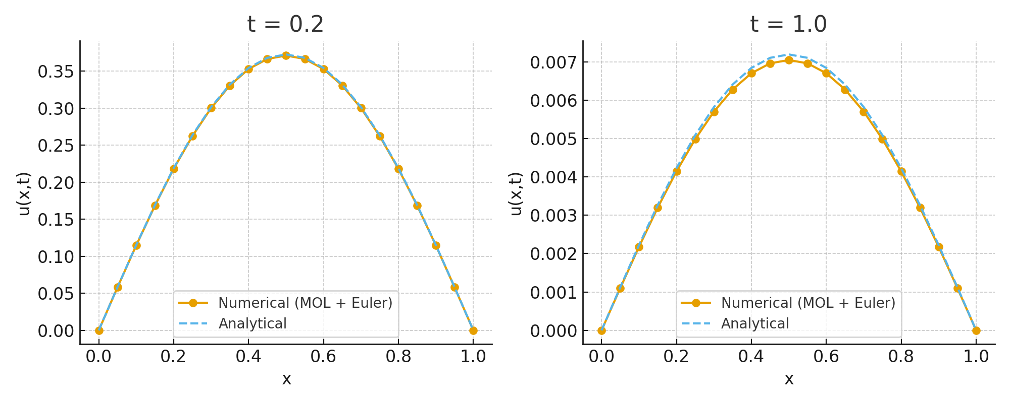

Appendix A: Sample MATLAB Code for MOL Heat Equation and Figure
The following MATLAB script implements the Method of Lines (MOL) with explicit Euler time stepping for the one-dimensional heat equation, and generates the 1×2 subplot figure used in Problem 9 (numerical vs analytical solutions at t = 0.2 and t = 1.0).
% MATLAB script: MOL + Explicit Euler for 1D Heat Equation
% and figure generation for t = 0.2 and t = 1.0
clear; clc; close all;
%% Parameters
K = 0.5; % thermal diffusivity
L = 1.0; % length of the rod
N = 20; % number of spatial subintervals
dx = L / N; % spatial step size
x = linspace(0, L, N+1); % grid including boundaries
Tfinal = 1.0; % final time
dt = 0.0025;% time step (stable for given K, dx)
numSteps = round(Tfinal/dt);
%% Initial condition u(x,0) = sin(pi x)
u = sin(pi*x);
%% Times at which we want to store the solution
t_store = [0.2, 1.0];
u_store = cell(size(t_store));
t = 0;
%% Time-stepping loop (MOL + explicit Euler)
for n = 1:numSteps
u_new = u;
% Apply Dirichlet BCs: u(1) = 0, u(end) = 0
for i = 2:N
u_new(i) = u(i) + dt*K*(u(i+1) - 2*u(i) + u(i-1))/dx^2;
end
u = u_new;
t = t + dt;
% Store solution when t is close to requested times
for k = 1:length(t_store)
if isempty(u_store{k}) && abs(t - t_store(k)) < dt/2
u_store{k} = u;
end
end
end
%% Exact solution function
u_exact = @(x,t,K) exp(-(pi^2)*K*t) .* sin(pi*x);
%% Plot numerical vs analytical at t = 0.2 and t = 1.0
figure;
for k = 1:length(t_store)
ts = t_store(k);
u_num = u_store{k};
u_ex = u_exact(x, ts, K);
subplot(1,2,k);
plot(x, u_num, 'o-','LineWidth',1.2); hold on;
plot(x, u_ex, '--','LineWidth',1.2);
xlabel('x');
ylabel('u(x,t)');
title(sprintf('t = %.1f', ts));
legend('Numerical (MOL + Euler)', 'Analytical', 'Location','best');
grid on;
end
sgtitle('1D Heat Equation: Numerical vs Analytical Solutions');
%% Optional: save figure
% saveas(gcf, 'MOL_Heat_Equation_MATLAB_Figure.png');

