Problem Set, MATLAB Code, Figures, and Data for 1D Heat Equation

Problem Statement
Problem 1 — Implement the Exact Analytical Solution
Solve the one-dimensional heat equation
u_t - u_xx = f(x,t)
on the domain 0 ≤ x ≤ 1 and 0 ≤ t ≤ 0.1 using the exact analytical solution:
u(x,t) = x^2 / (1 + t)
Tasks:
1. Derive f(x,t) from the exact solution.
2. Generate a space–time plot of u(x,t).
3. Generate line plots of u(x,t) at t = 0, 0.02, 0.05, 0.1.
4. Create a table of numerical values of u(x,t) at selected points.
5. Compare with numerical finite-difference approximation (optional).

MATLAB Code
Listing 1: MATLAB script used to generate the figures below.
% heat_exact_plots.m
% Plots for the exact solution u(x,t) = x^2 / (1 + t)
clear; clc; close all;
Nx = 100;
Nt = 100;
x = linspace(0, 1, Nx+1);
t = linspace(0, 0.1, Nt+1);
[X, T] = meshgrid(x, t);
U = X.^2 ./ (1 + T);
figure;
surf(X, T, U, 'EdgeColor', 'none');
xlabel('x'); ylabel('t'); zlabel('u(x,t)');
title('Exact Solution u(x,t) = x^2 / (1 + t)');
colorbar;
figure;
hold on;
times_to_plot = [0.0, 0.02, 0.05, 0.1];
for k = 1:length(times_to_plot)
tt = times_to_plot(k);
plot(x, x.^2 ./ (1 + tt), 'DisplayName', sprintf('t = %.2f', tt));
end
xlabel('x'); ylabel('u(x,t)');
legend('Location','best');

Figures
Figure 1: Surface plot of u(x,t) = x^2/(1+t)
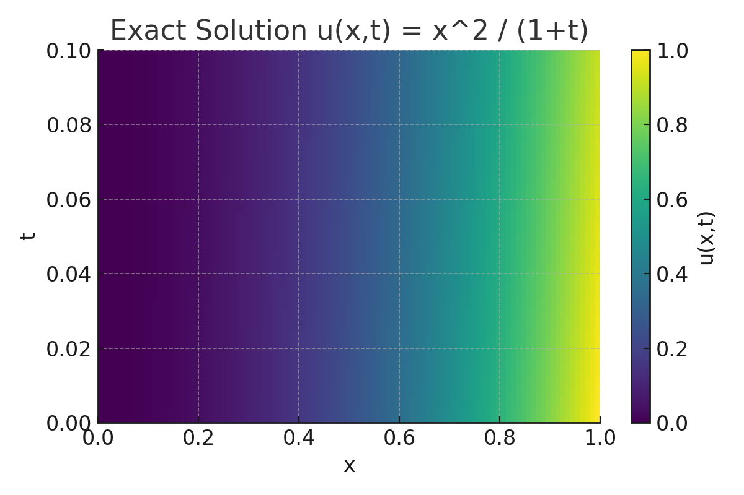
Figure 2: Line plots at t = 0, 0.02, 0.05, 0.1
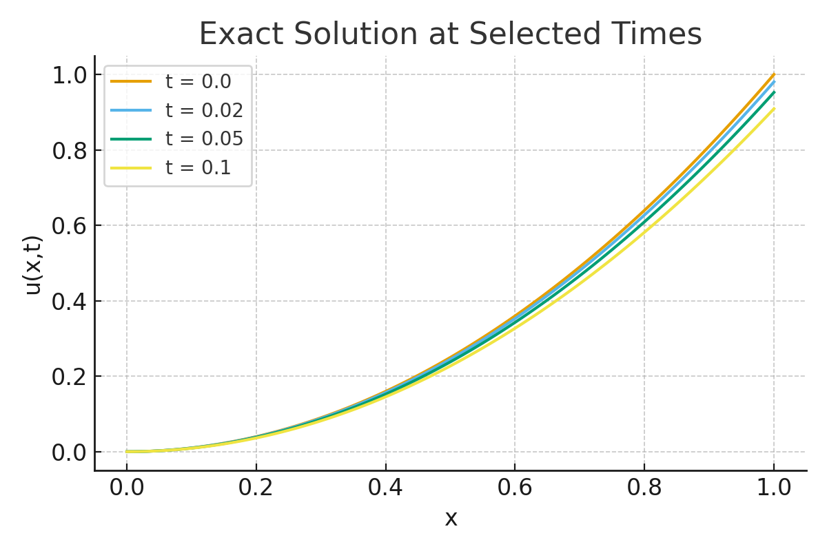

Table of Sample Data
Table 1: Values of u(x,t) = x^2/(1+t) at selected space-time points.
t \ x | 0.00 | 0.25 | 0.50 | 0.75 | 1.00
0.00 | 0.000000 | 0.062500 | 0.250000 | 0.562500 | 1.000000
0.02 | 0.000000 | 0.061275 | 0.245098 | 0.551471 | 0.980392
0.05 | 0.000000 | 0.059524 | 0.238095 | 0.535714 | 0.952381
0.10 | 0.000000 | 0.056818 | 0.227273 | 0.511364 | 0.909091

